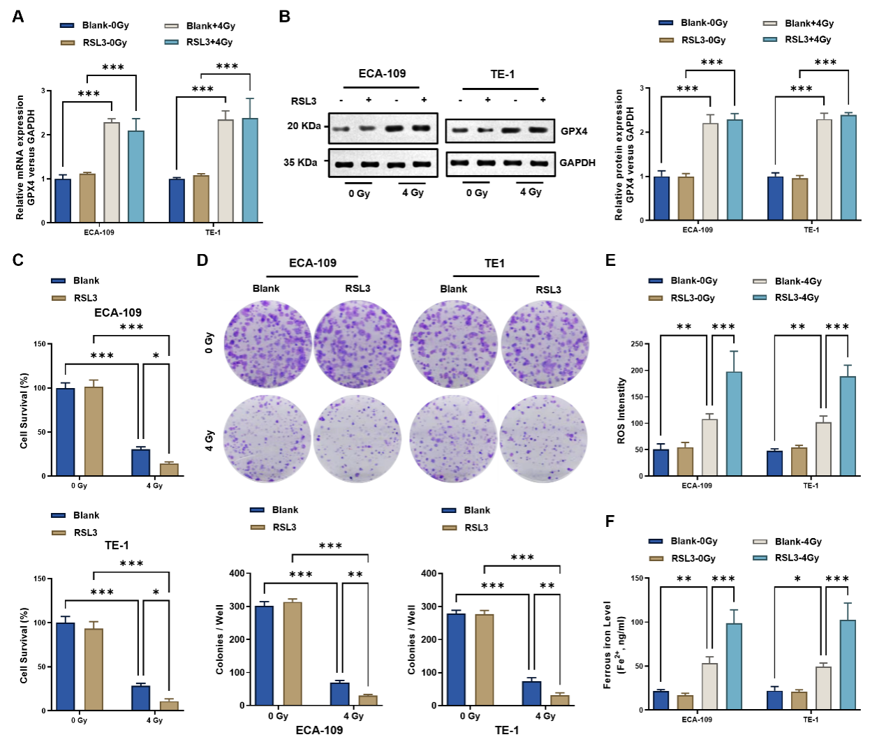
Supplementary Fig. 1 The GPX4 inhibitor RSL3 significantly enhances radiosensitivity in ESCC cells (ECA109 and TE-1). (A) qPCR analysis indicated that the significant upregulation of GPX4 mRNA induced by 4 Gy irradiation was unaffected by RSL3 treatment. (B) Western blot analysis confirmed that 4 Gy irradiation markedly increased GPX4 protein expression, which remained unaltered by RSL3. (C) CCK-8 assays demonstrated that while RSL3 alone had no significant impact on cell viability, it significantly enhanced the viability suppression induced by 4 Gy irradiation. (D) Colony formation assays revealed that RSL3 alone did not affect colony formation but markedly potentiated the inhibitory effects of 4 Gy irradiation. (E) RSL3 alone did not alter ROS levels, but it significantly augmented the 4 Gy-induced increase in ROS accumulation. (F) RSL3 alone had no effect on ferrous ion levels, yet it significantly exacerbated the 4 Gy-induced elevation in ferrous ions.
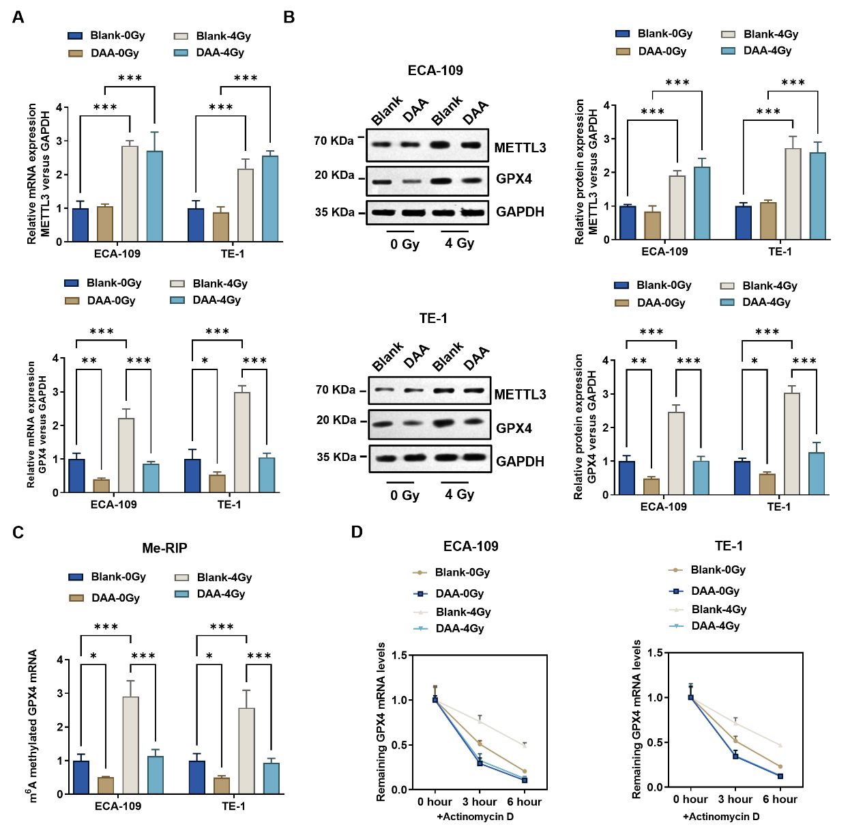
Supplementary Fig. 2 Pharmacological inhibition of METTL3 regulates the m6A modification and expression of GPX4 mRNA. (A) qPCR analysis showed that 4 Gy irradiation significantly upregulated METTL3 and GPX4 mRNA expression. Treatment with the METTL3 inhibitor DAA did not alter METTL3 expression but successfully abrogated the 4 Gy-induced upregulation of GPX4 mRNA. (B) Western blot analysis demonstrated that 4 Gy irradiation significantly increased METTL3 and GPX4 protein levels. DAA treatment did not affect METTL3 expression but abolished the irradiation-induced increase in GPX4 protein. (C) MeRIP-qPCR assays indicated that 4 Gy irradiation significantly enhanced the m6A modification of GPX4 mRNA, an effect reversed by DAA. (D) Actinomycin D assays revealed that the 4 Gy-induced enhancement of GPX4 mRNA stability was negated by DAA treatment.
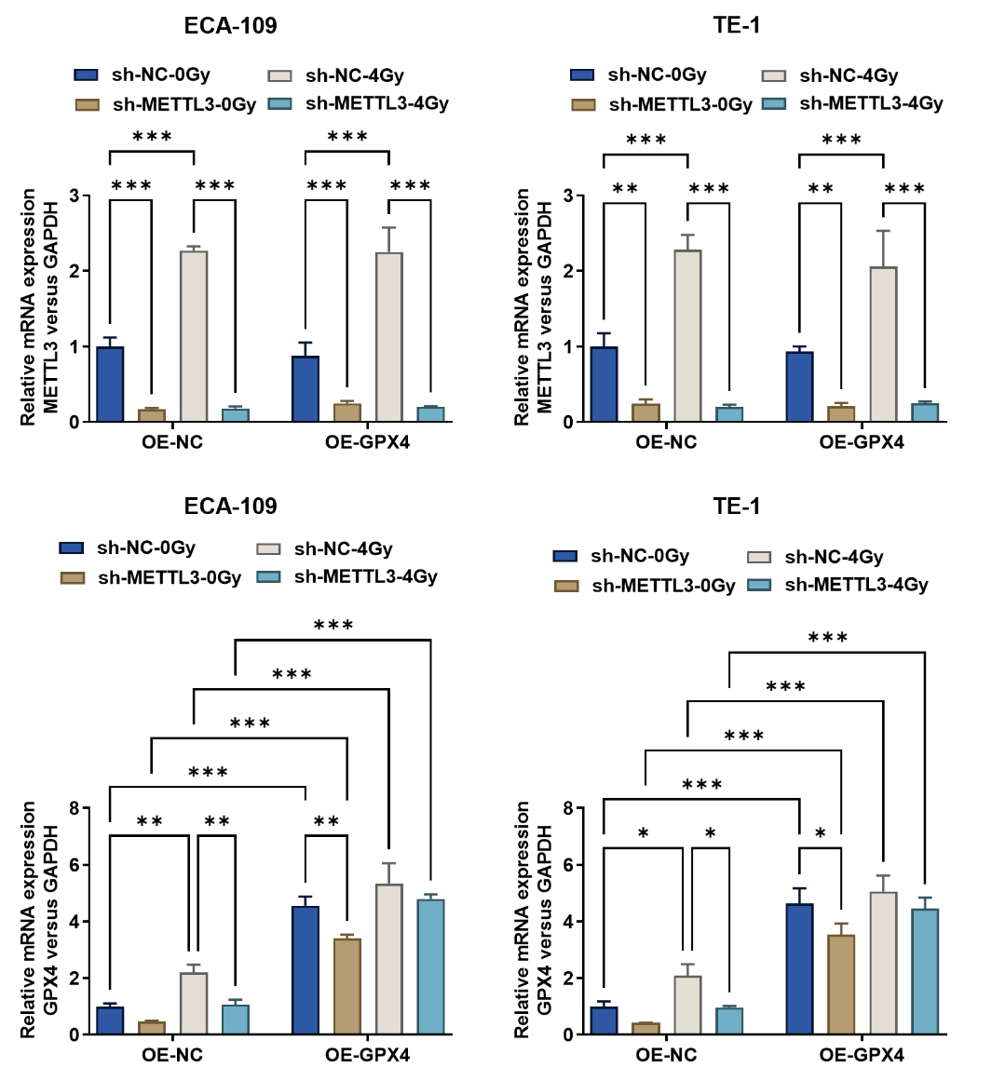
Supplementary Fig. 3 Real-time qPCR validation of METTL3 knockdown and GPX4 overexpression efficiencies in ESCC cell lines (ECA109 and TE-1) under 0 Gy and 4 Gy conditions.
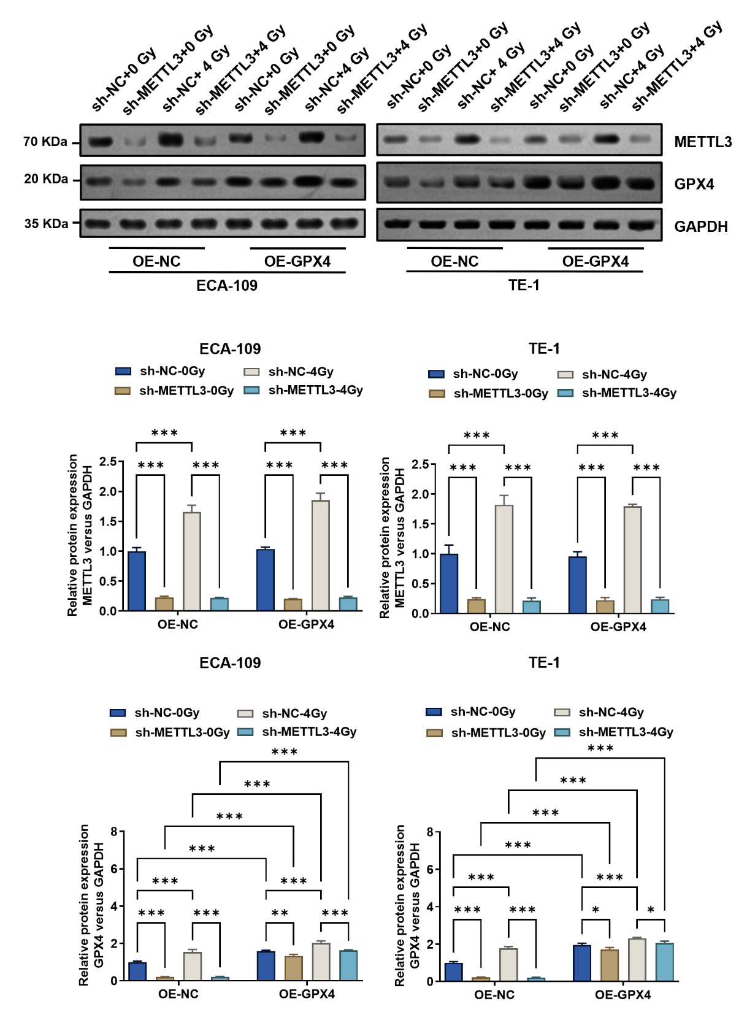
Supplementary Fig. 4 Western blot validation of METTL3 knockdown and GPX4 overexpression efficiencies in ESCC cell lines (ECA109 and TE-1) under 0 Gy and 4 Gy conditions.
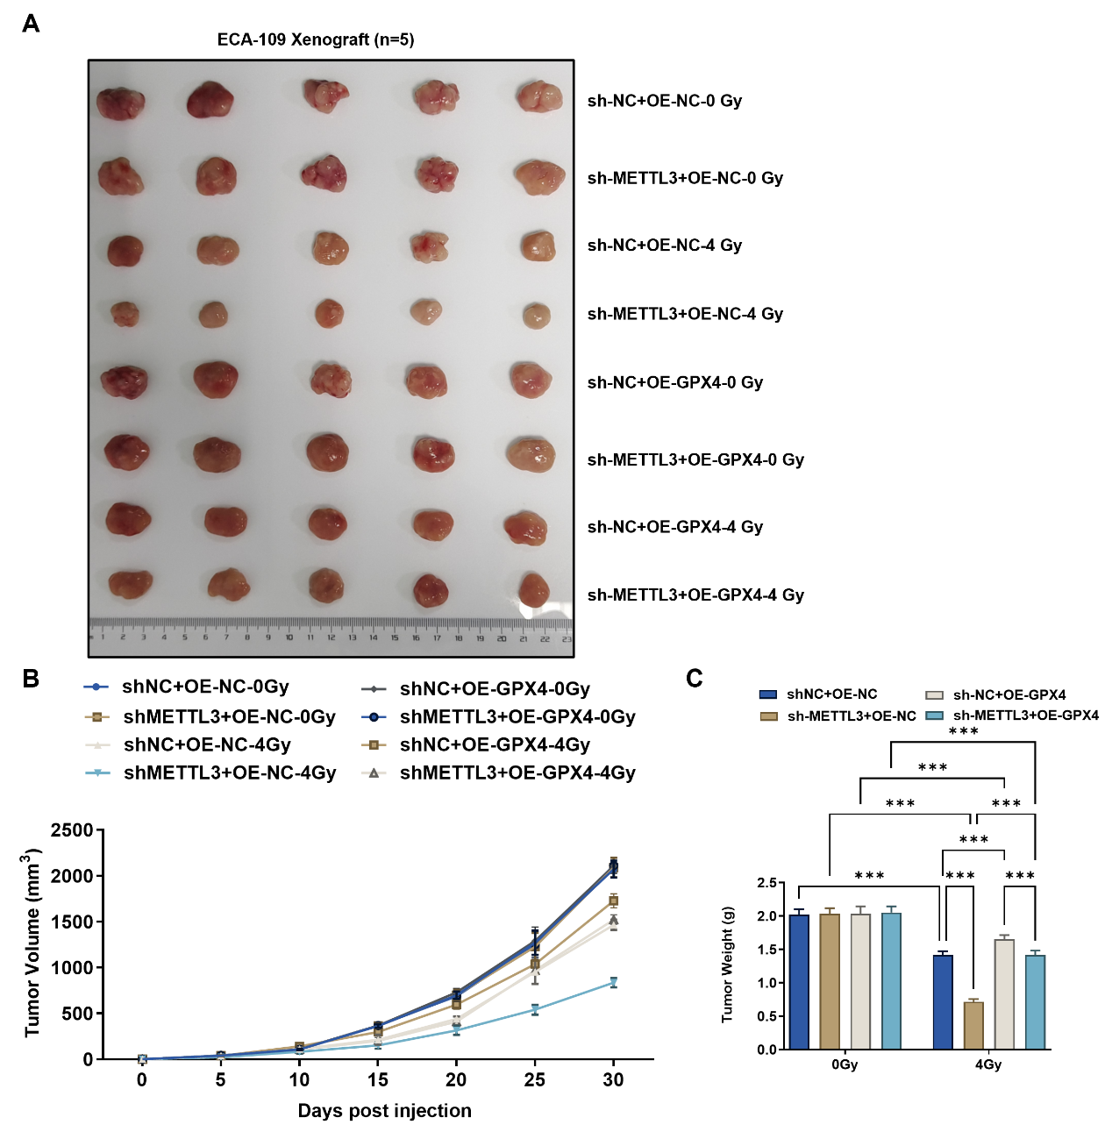
Supplementary Fig. 5 In vivo validation of the METTL3/GPX4 axis in regulating ferroptosis and radioresistance in ESCC. Nude mice bearing subcutaneous ECA109 xenografts were irradiated with 4 Gy on day 5 post-implantation, alongside non-irradiated controls. The competing effects of METTL3 knockdown and GPX4 overexpression were evaluated. (A) Representative images of the resected tumors. (B–C) Tumor growth curves (B) and tumor weights (C) indicated that under control conditions (0 Gy), METTL3 knockdown or GPX4 overexpression did not significantly impact tumor growth. Following 4 Gy irradiation, METTL3 knockdown markedly suppressed tumor growth, while GPX4 overexpression promoted tumor growth and effectively reversed the suppressive effect of METTL3 knockdown.

