Supplementary Information (SI)

Association of combined stress hyperglycemia ratio and glycemic variability with 30-day and 360-day mortality after coronary revascularization
The files includes:

Suppplementary figures:
Comparison of 30-day mortality rates between the SHR and GV groups
30-day mortality
 | Group | Total | Mortality (%) | P Value
SHR | Q1 | 234 | 2.56 | 0.007
 | Q2 | 234 | 2.99
 | Q3 | 234 | 3.42
 | Q4 | 233 | 7.73
GV | Q1 | 234 | 0.85 | <0.001
 | Q2 | 234 | 3.42
 | Q3 | 234 | 3.85
 | Q4 | 233 | 8.58
360-day mortality
 | Group | Total | Mortality (%) | P Value
SHR | Q1 | 234 | 9.4 | 0.129
 | Q2 | 234 | 7.69
 | Q3 | 234 | 10.68
 | Q4 | 233 | 12.88
GV | Q1 | 234 | 3.85 | <0.001
 | Q2 | 234 | 6.84
 | Q3 | 234 | 11.11
 | Q4 | 233 | 18.88
TableSA1. Comparison of 30-day mortality rates between the SHR and GV groups
The associations of SHR and GV with 30-day and 360-day mortality
Categorical
 | P for trend | Q1 | Q2 | Q3 | Q4
30-day mortality
SHR
unadjusted | 0.0216* | 1 | 1.294 (0.447-3.750) | 2.020 (0.669-6.099) | 3.089 (1.219-7.826)*
Model 1 | 0.0146* | 1 | 1.458 (0.497-4.274) | 2.159 (0.709-6.577) | 3.376 (1.315-8.664)*
Model 2 | 0.052 | 1 | 1.431 (0.465-4.403) | 2.102 (0.605-7.311) | 3.251 (1.104-9.576)*
GV
unadjusted | 0.092 | 1 | 2.550 (0.518-12.545) | 2.515 (0.533-11.853) | 3.450 (0.773-15.386)
Model 1 | 0.0891 | 1 | 2.546 (0.509-12.726) | 2.770 (0.578-13.274) | 3.505 (0.777-15.823)
Model 2 | 0.0657 | 1 | 3.055 (0.576-16.217) | 2.850 (0.525-15.458) | 4.426 (0.844-23.201)
360-day mortality
SHR
unadjusted | 0.0784 | 1 | 1.302 (0.728-2.328) | 1.501 (0.788-2.861) | 1.861 (1.059-3.270)*
Model 1 | 0.0181* | 1 | 1.551 (0.854-2.819) | 1.616 (0.831-3.145) | 2.251 (1.255-4.036)†
Model 2 | 0.0923 | 1 | 1.368 (0.717-2.606) | 1.437 (0.716-2.884) | 1.906 (0.988-3.674)†
GV
unadjusted | 0.0066† | 1 | 1.165 (0.492-2.758) | 2.087 (0.96-4.538)* | 2.225 (1.037-4.777)*
Model 1 | 0.0059† | 1 | 1.196 (0.497-2.881) | 2.329 (1.045-5.191)* | 2.327 (1.065-5.083)*
Model 2 | 0.0557 | 1 | 1.166 (0.469-2.902) | 1.995 (0.838-4.747) | 1.927 (0.806-4.604)
TableSA2. Model 1: adjusted for age, gender, body mass index
Model 2:adjusted for model 1 plus diastolic blood pressure , SOFA , APSⅢ , blood calcium , hemoglobin , Albumin, Estimated Glomerular Filtration Rate, congestive heart failure, diabetes, metastatic solid tumor
* P < 0.05, †P < 0.01, ‡P < 0.001

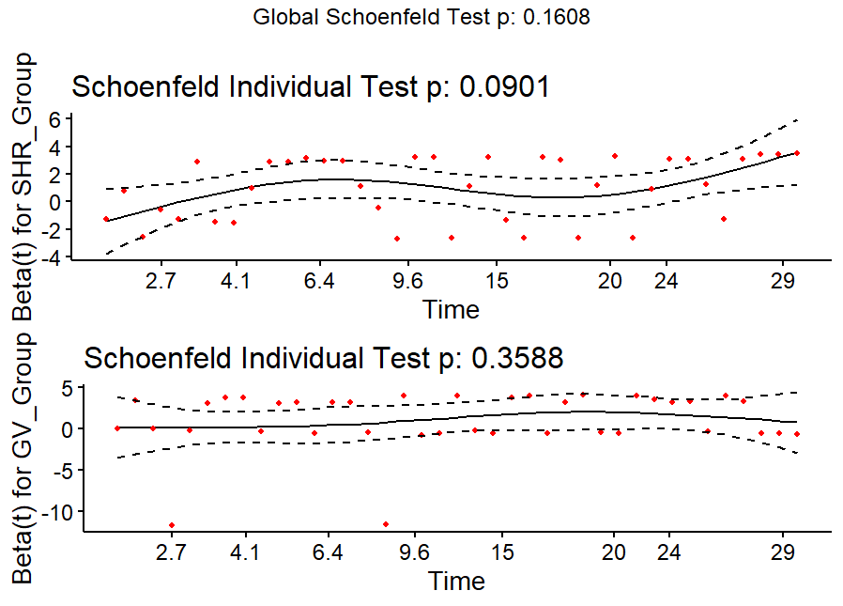
Figure SB1. Schoenfeld residual plots for unadjusted 30-day postoperative mortality
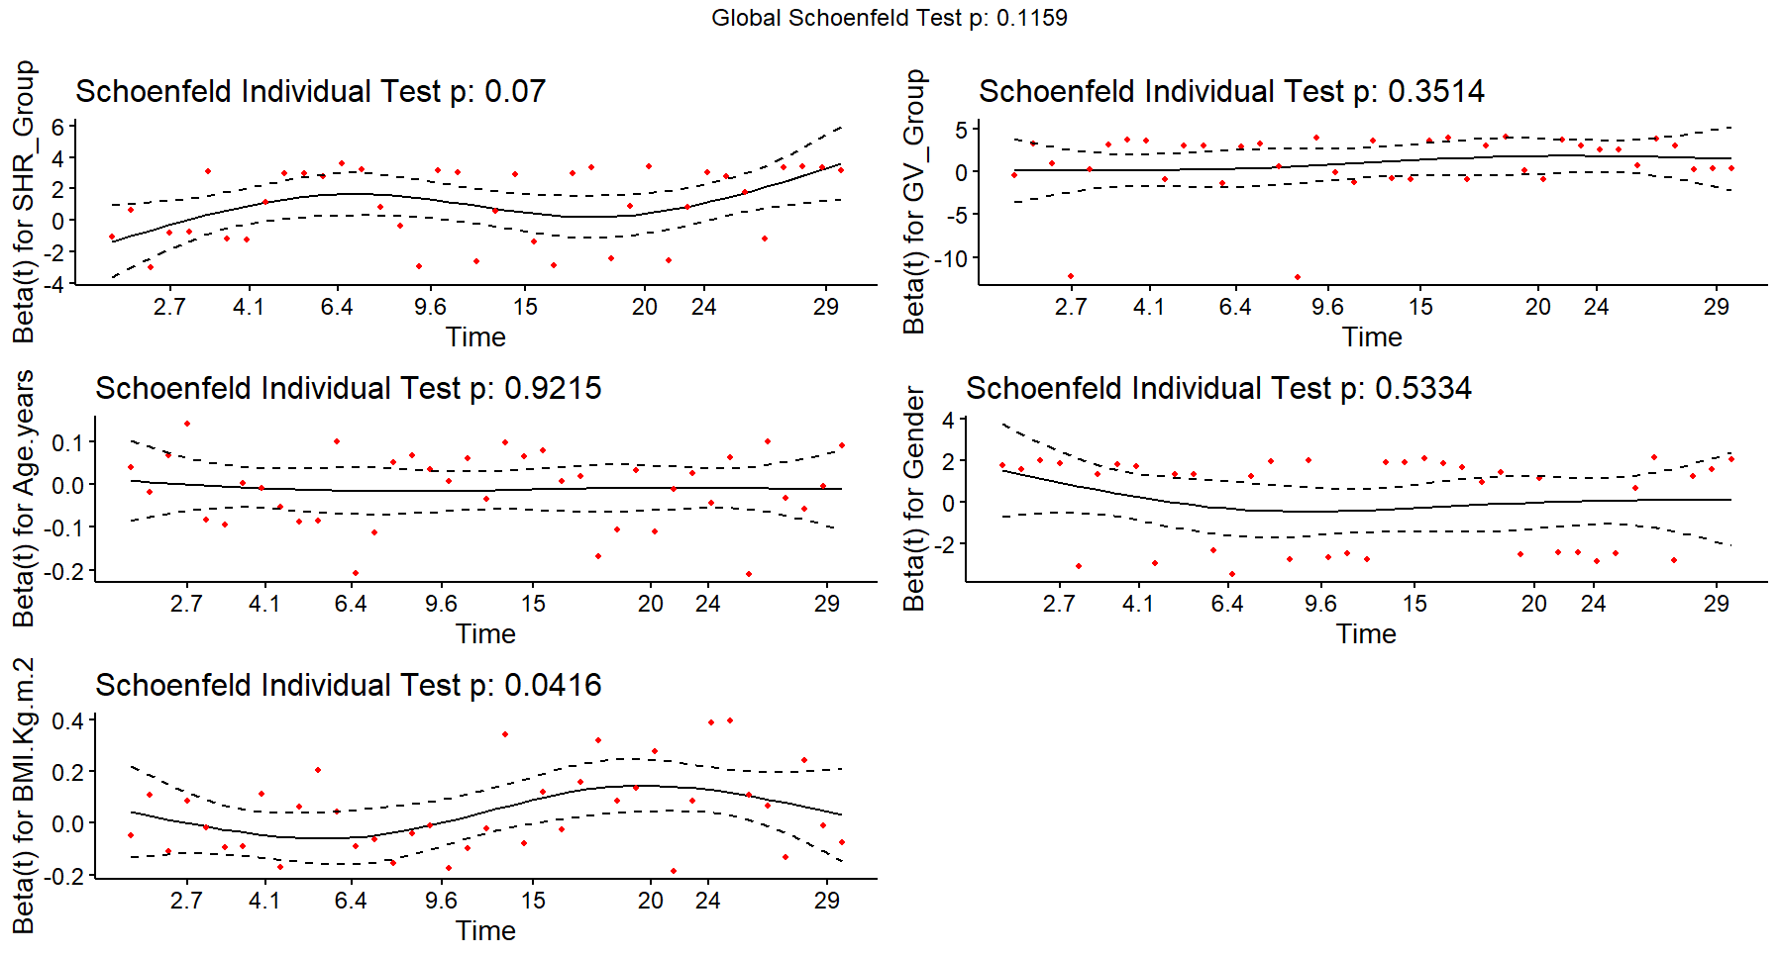
Figure SB2. Schoenfeld residual plots assessing the proportional hazards assumption for 30-day outcomes adjusted for gender, age, and BMI
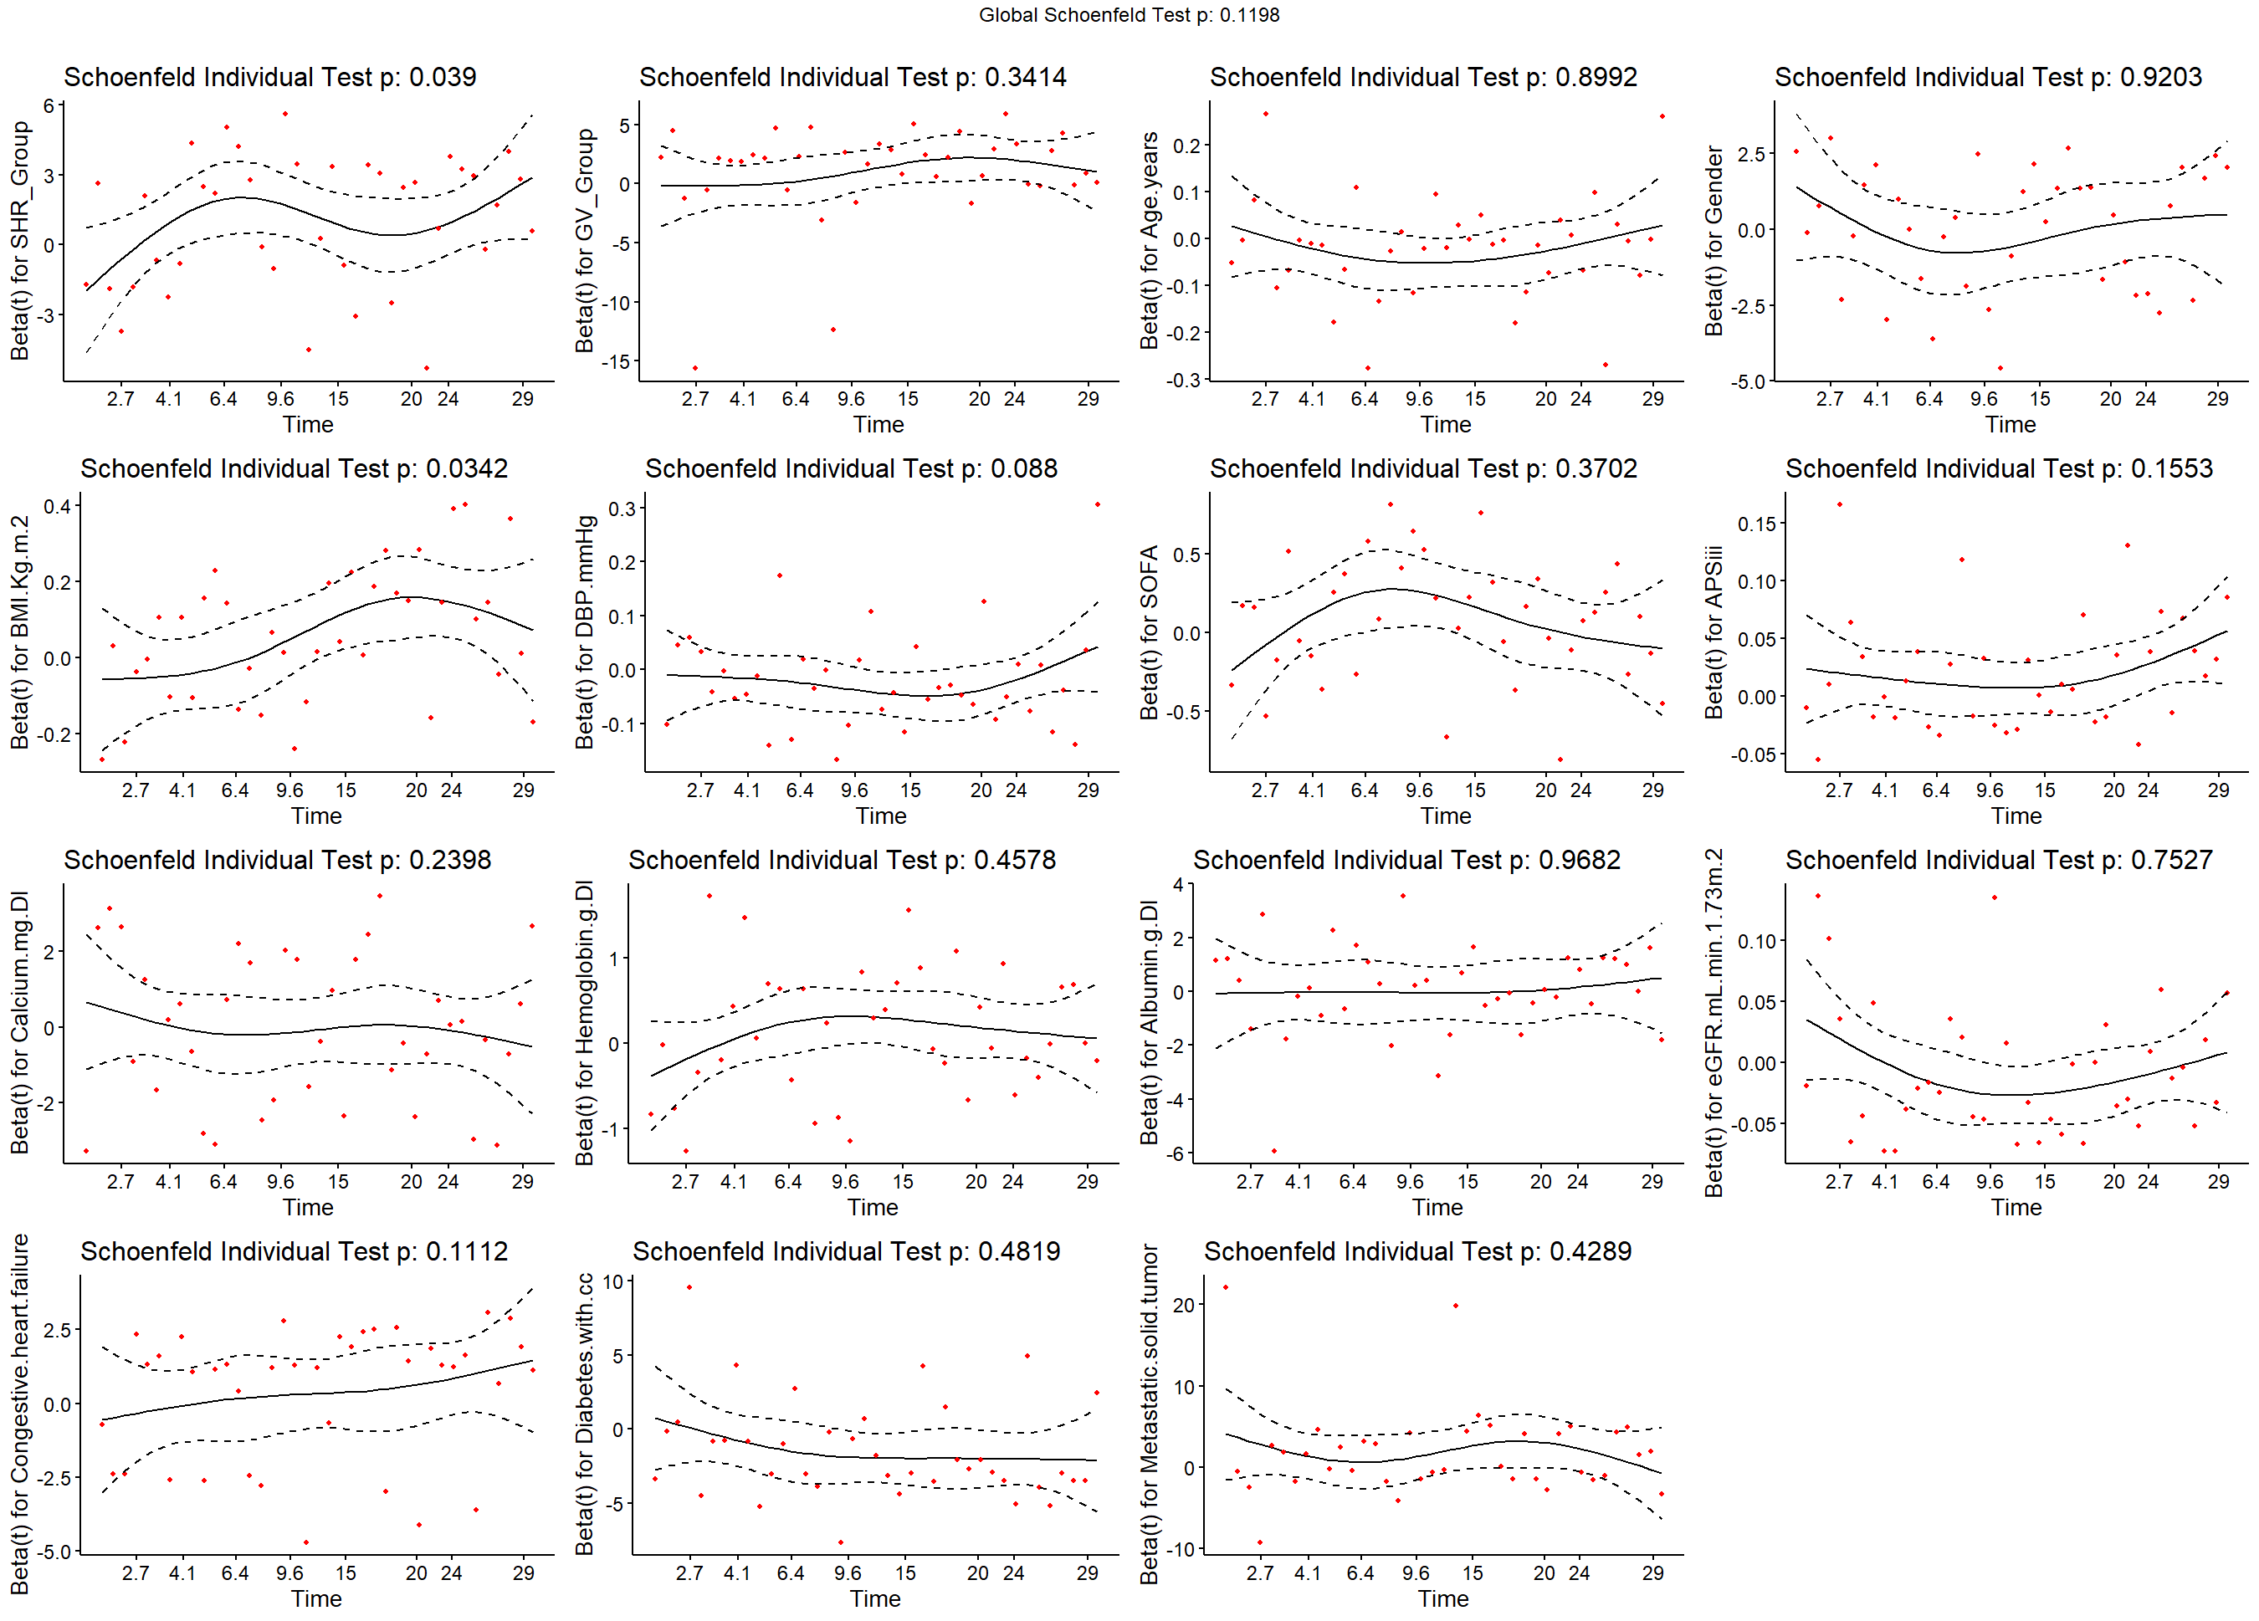
Figure SB3. Schoenfeld residual plots assessing the proportional hazards assumption for 30-day outcomes adjusted for gender, age, BMI, DBP, SOFA, APSIII, calcium, hemoglobin, albumin, eGFR, congestive heart failure, diabetes with complications, metastatic solid tumor

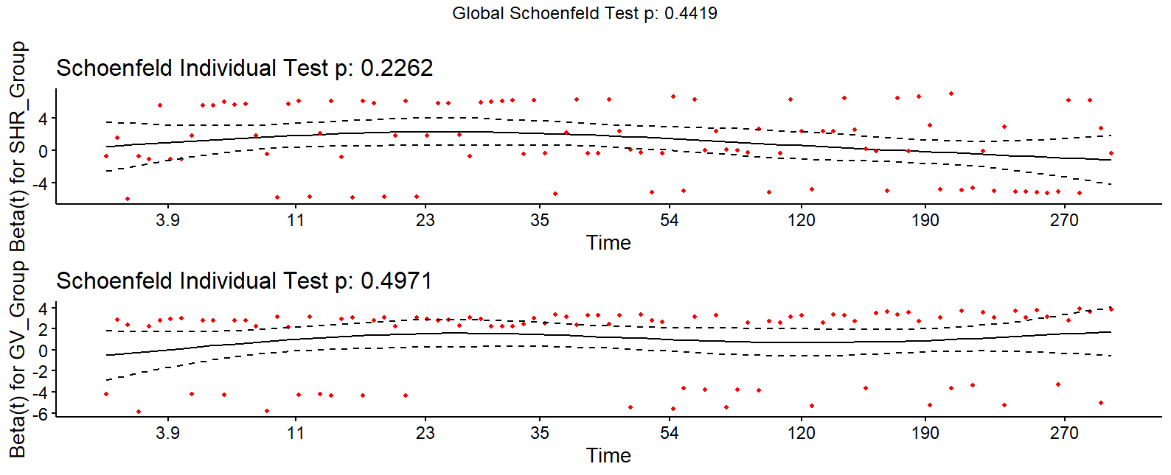
Figure SB4. Schoenfeld residual plots for unadjusted 360-day postoperative mortality

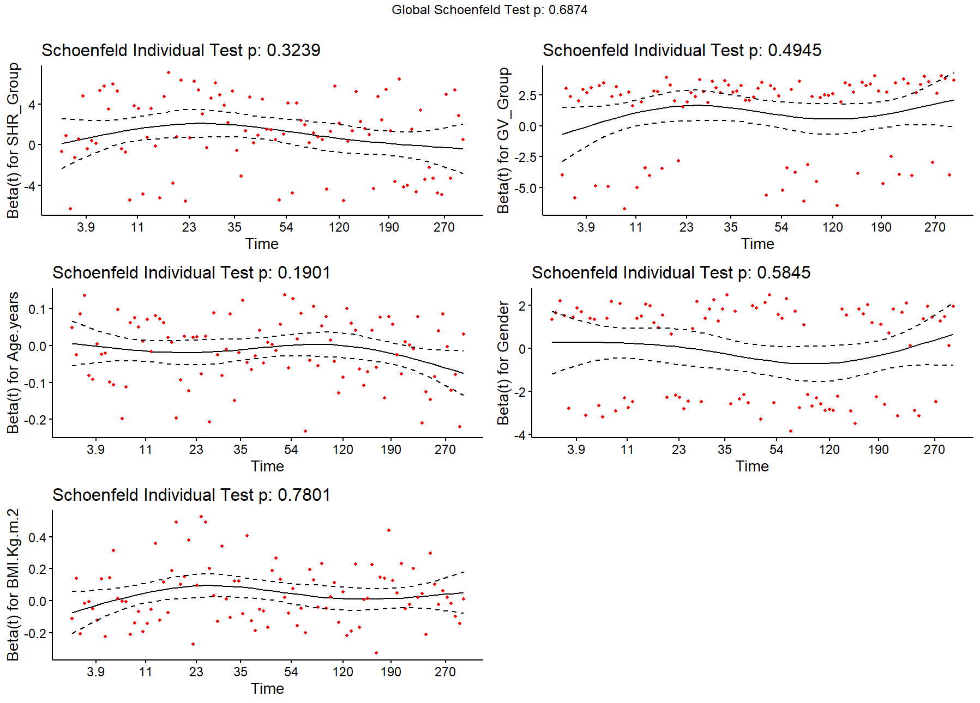
Figure SB5. Schoenfeld residual plots assessing the proportional hazards assumption for 360-day outcomes adjusted for gender, age, and BMI
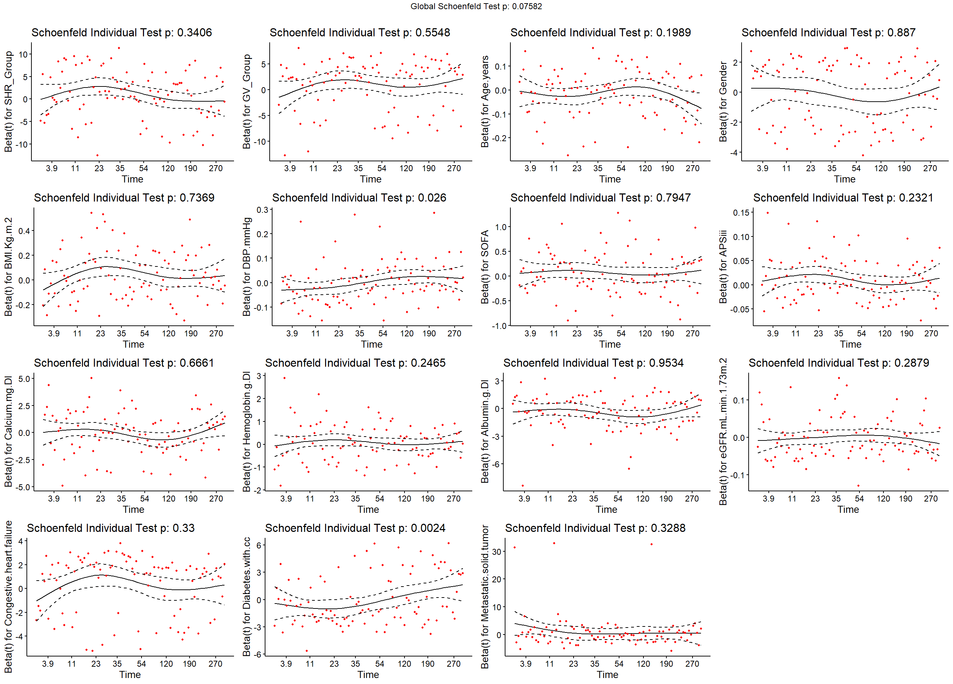
Figure SB6. Schoenfeld residual plots assessing the proportional hazards assumption for 360-day outcomes adjusted for gender, age, BMI, DBP, SOFA, APSIII, calcium, hemoglobin, albumin, eGFR, congestive heart failure, diabetes with complications, metastatic solid tumor
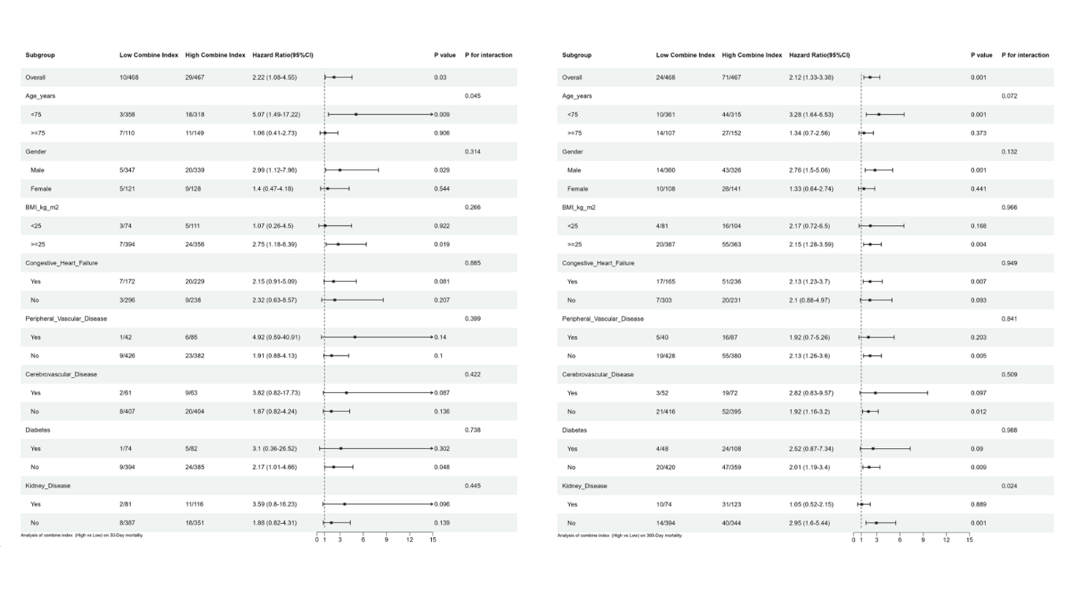
Figure SC: Forest plots for subgroup analyses of the combine index of SHR and GV with 30 day mortality and 360 day mortality...
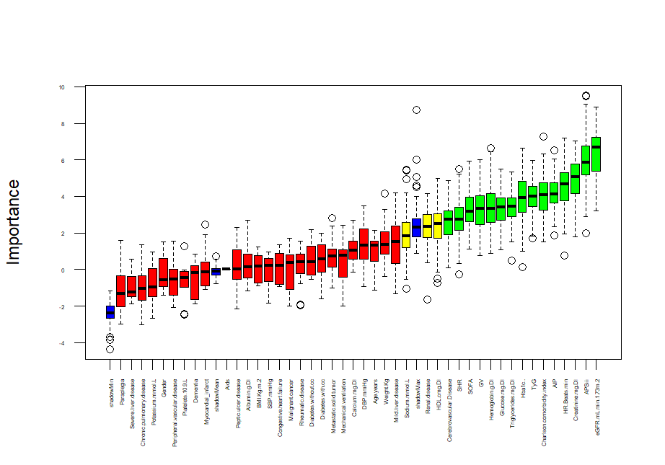
Figure SD1. Boxplots of variables selected by the Boruta algorithm for 30-day outcome validation. validated variables: Hba1c, Triglycerides.mg.Dl, HR.Beats.min, SOFA, APSIII, Cerebrovascular.Disease, Charlson.comorbidity.index, Creatinine.mg.Dl, Hemoglobin.g.Dl, Glucose.mg.Dl, eGFR.mL.min.1.73m.2, SHR, GV, TyG, AIP
candidate variables：Mild.liver.disease, Sodium.mmol.L, HDL.cmg.Dl
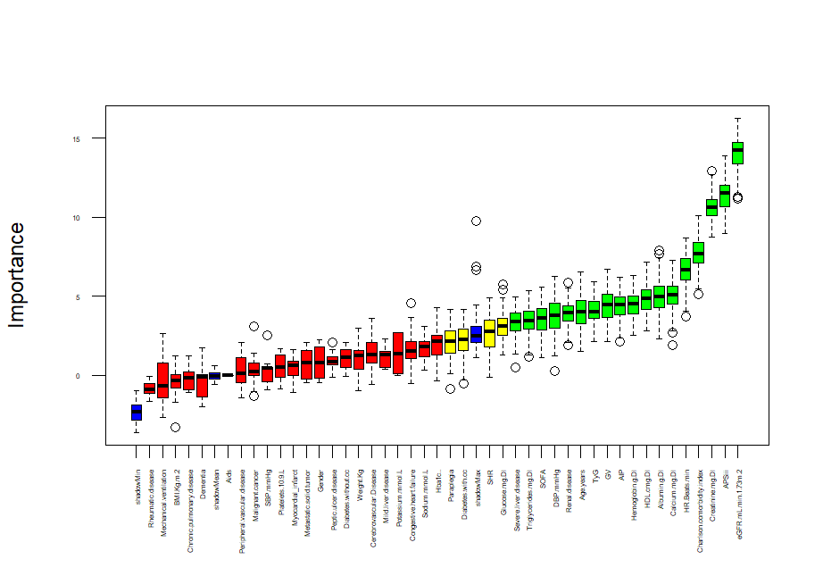
Figure SD2. Boxplots of variables selected by the Boruta algorithm for 360-day outcome validation. validated variables: Age.years, Triglycerides.mg.Dl, DBP.mmHg, HR.Beats.min, SOFA, APSIII, Renal.disease, Severe.liver.disease, Charlson.comorbidity.index, Calcium.mg.Dl, Creatinine.mg.Dl, Hemoglobin.g.Dl, Albumin.g.Dl, eGFR.mL.min.1.73m.2, GV, TyG, HDL.cmg.Dl, AIP
candidate variables：Diabetes.with.complication, Paraplegia, Glucose.mg.Dl, SHR

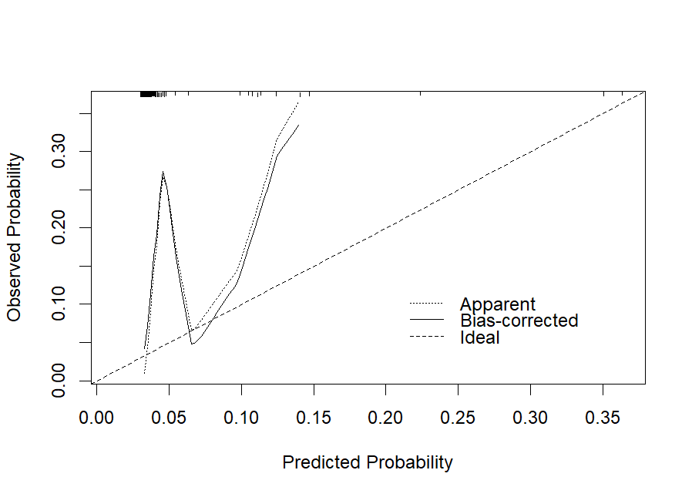
Figure SE1. Calibration curves for predicting 30-day postoperative mortality in the logistic regression model on the test set.
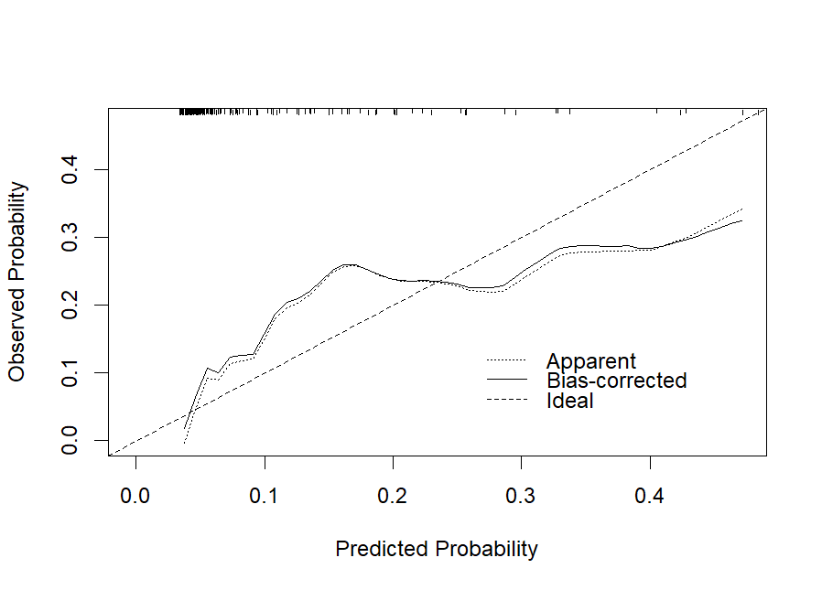
Figure SE2. Calibration curves for predicting 360-day postoperative mortality in the Random Forest model on the test set.
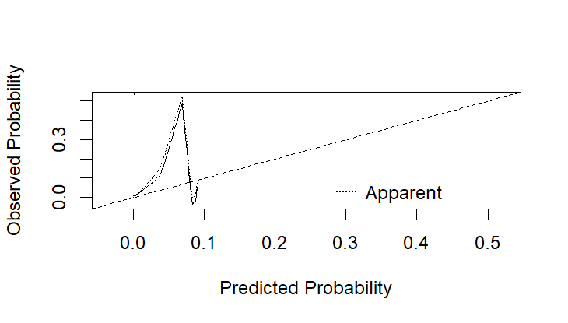
Figure SE3. Calibration curves for predicting 30-day postoperative mortality in the logistic regression model on the external validation set.
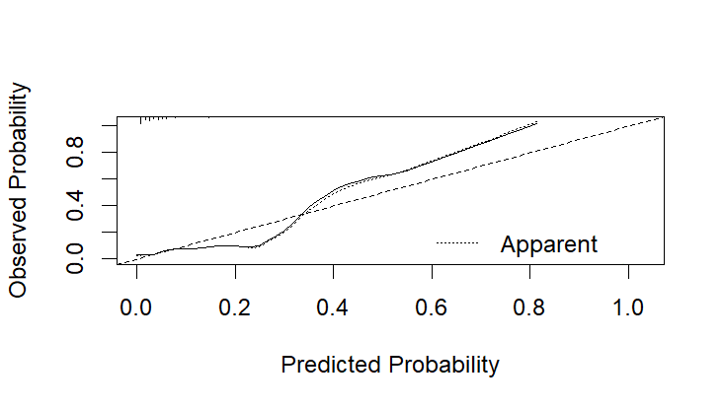
Figure SE4. Calibration curves for predicting 360-day postoperative mortality in the Random Forest model on the external validation set.
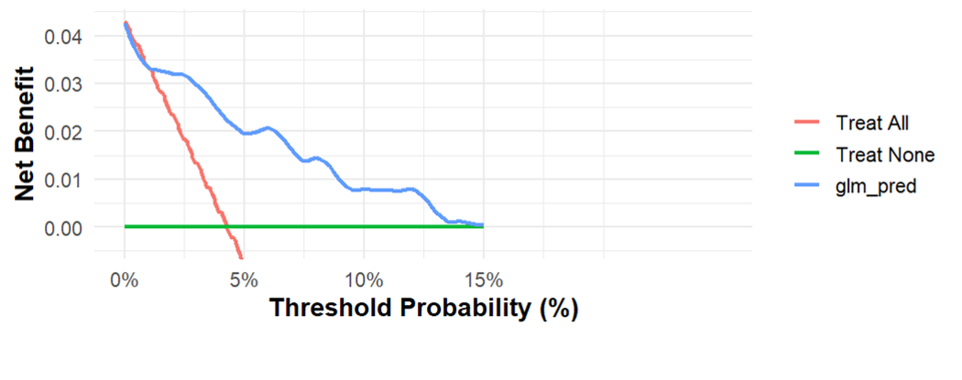
Figure SF1. Decision curve analysis (DCA) for predicting 30-day postoperative mortality using the logistic regression model in the test set.
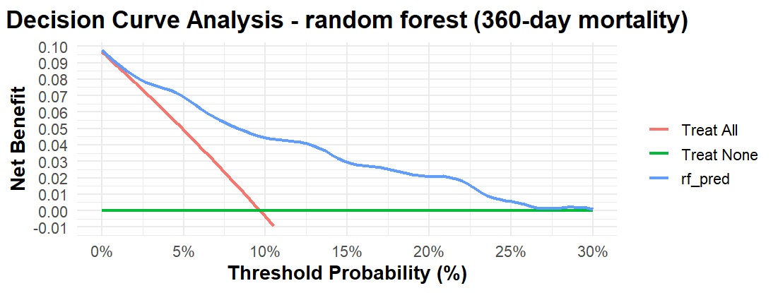
Figure SF2. Decision curve analysis (DCA) for predicting 360-day postoperative mortality using the Random Forest model in the test set.

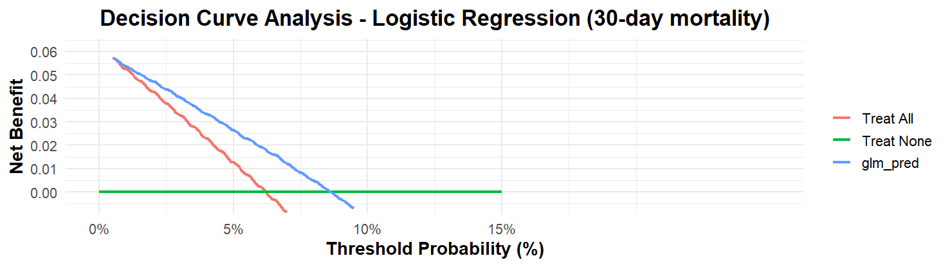
Figure SF3. Decision curve analysis (DCA) for predicting 30-day postoperative mortality using the logistic regression model in the external validation set.
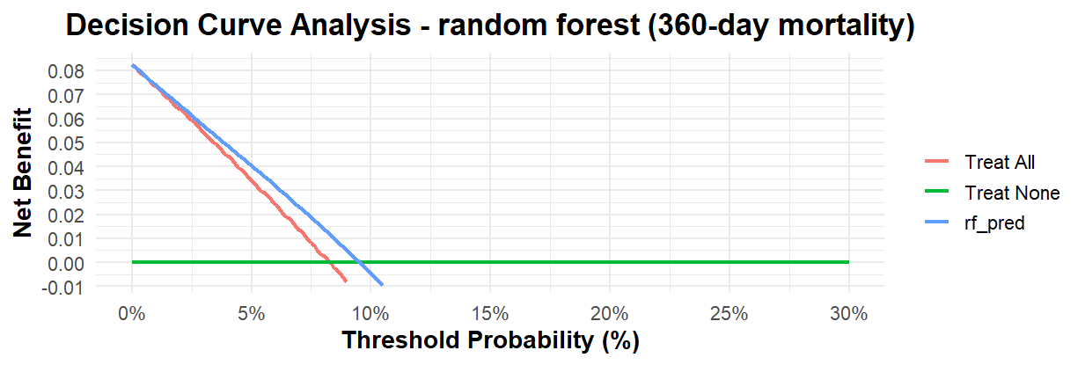
Figure SF4. Decision curve analysis (DCA) for predicting 360-day postoperative mortality using the Random Forest model in the external validation set.

