Automated Modeling of Population Pharmacokinetic Models Using nlmixr2auto: A Clinical Trial and Real-World Data Study
(Supplemental Material)

Zhonghui Huang¹, Matthew Fidler², Bern-Thomas Nyang’wa^{3,4} Joseph F Standing^{1,4}, Frank Kloprogge⁵

¹Great Ormond Street Institute of Child Health, University College London, London, UK
²Novartis Pharmaceuticals Corporation, Fort Worth, Texas, USA
³Médecins sans Frontieres, Public Health Department, Amsterdam, The Netherlands
⁴Institute for Global Health, University College London, London, UK.
⁵Great Ormond Street Hospital for Children, London, UK

Corresponding author: Zhonghui Huang
Affiliation: Great Ormond Street Institute of Child Health, University College London, London, UK
E-mail: zhonghui.huang.20@ucl.ac.uk

Supplementary Figure 1 Convergence curves of ACO, GA, and TS on the aprindine dataset. Stars indicate the best solution with fitness value and iteration number annotated. Mean fitness is calculated with infinite values excluded
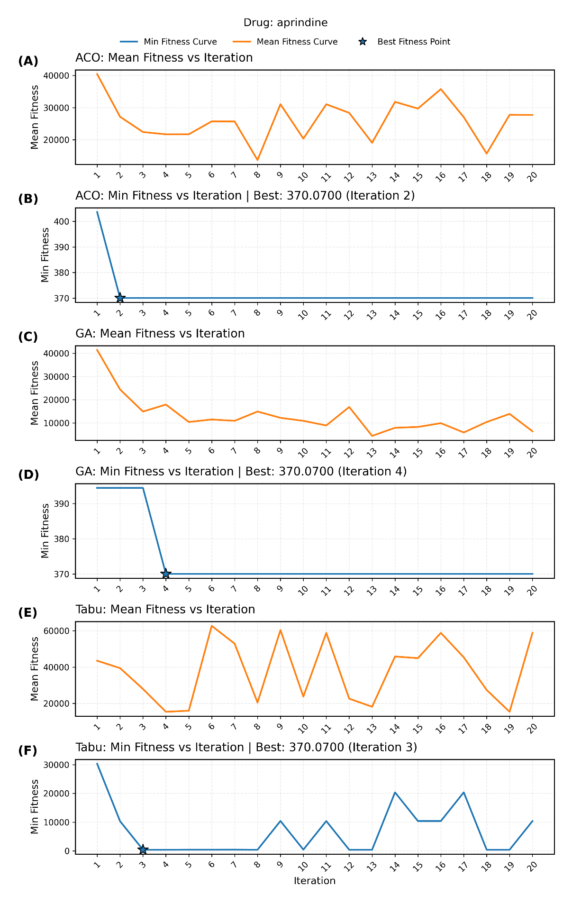
Supplementary Figure 2 Convergence curves of ACO, GA, and TS on the bedaquiline dataset. Stars indicate the best solution with fitness value and iteration number annotated. Mean fitness is calculated with infinite values excluded
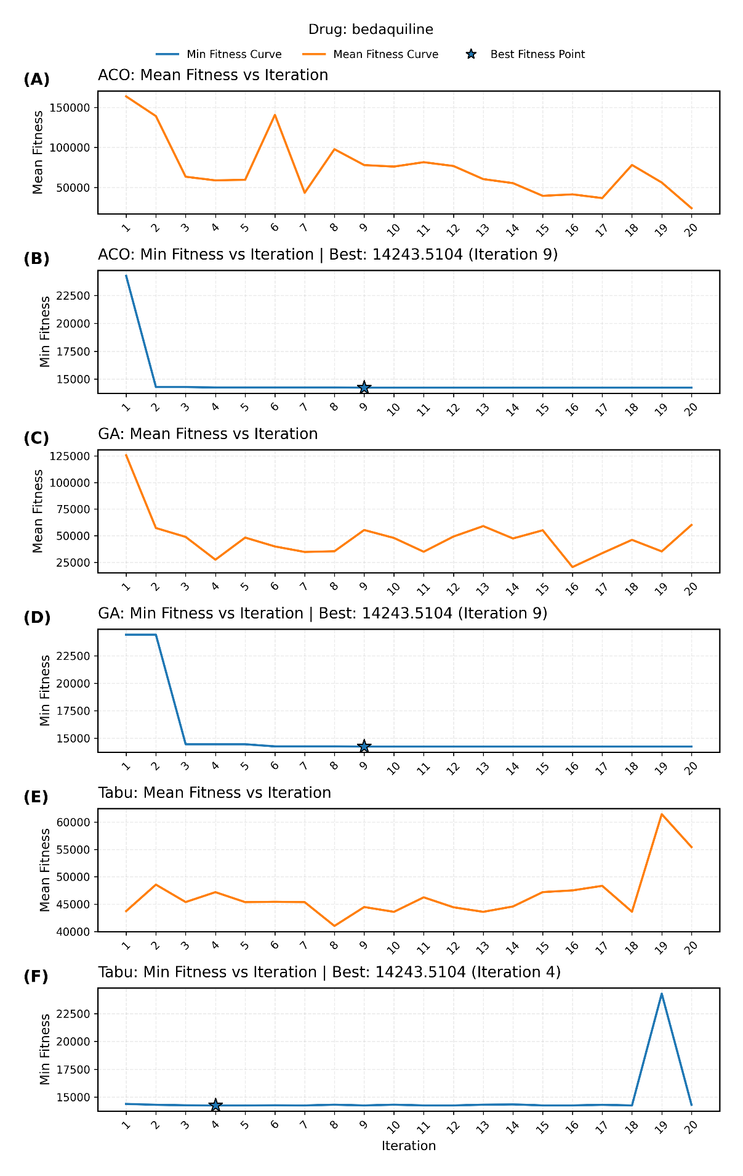

Supplementary Figure 3 Convergence curves of ACO, GA, and TS on the cefaclor dataset. Stars indicate the best solution with fitness value and iteration number annotated. Mean fitness is calculated with infinite values excluded
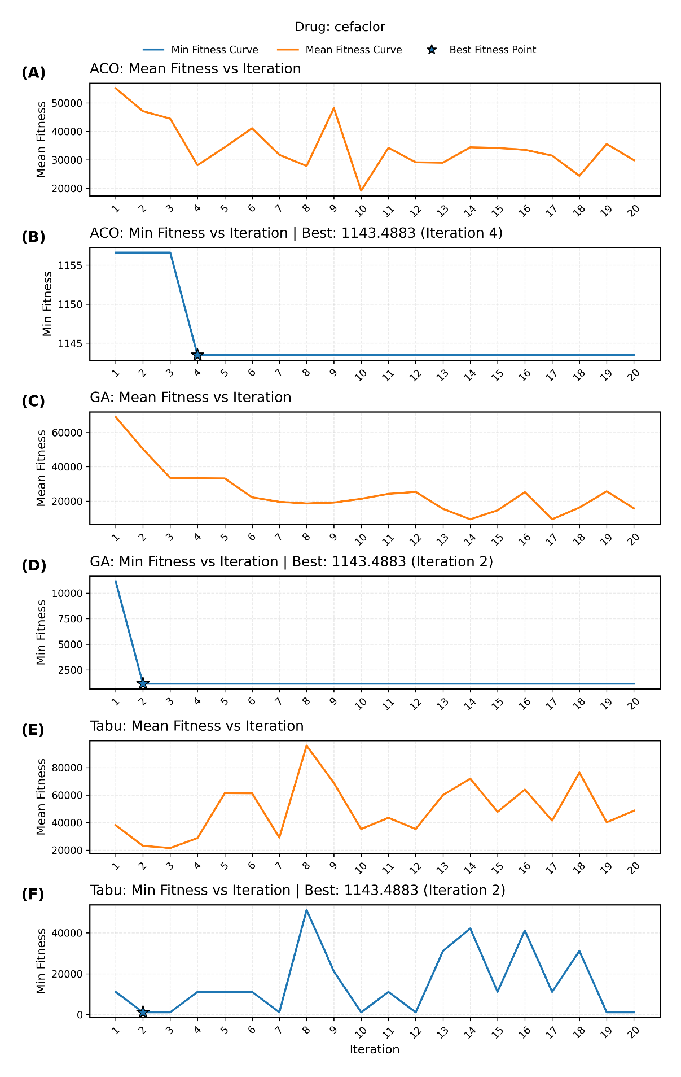
Supplementary Figure 4 Convergence curves of ACO, GA, and TS on the cefaclor dataset. Stars indicate the best solution with fitness value and iteration number annotated. Mean fitness is calculated with infinite values excluded
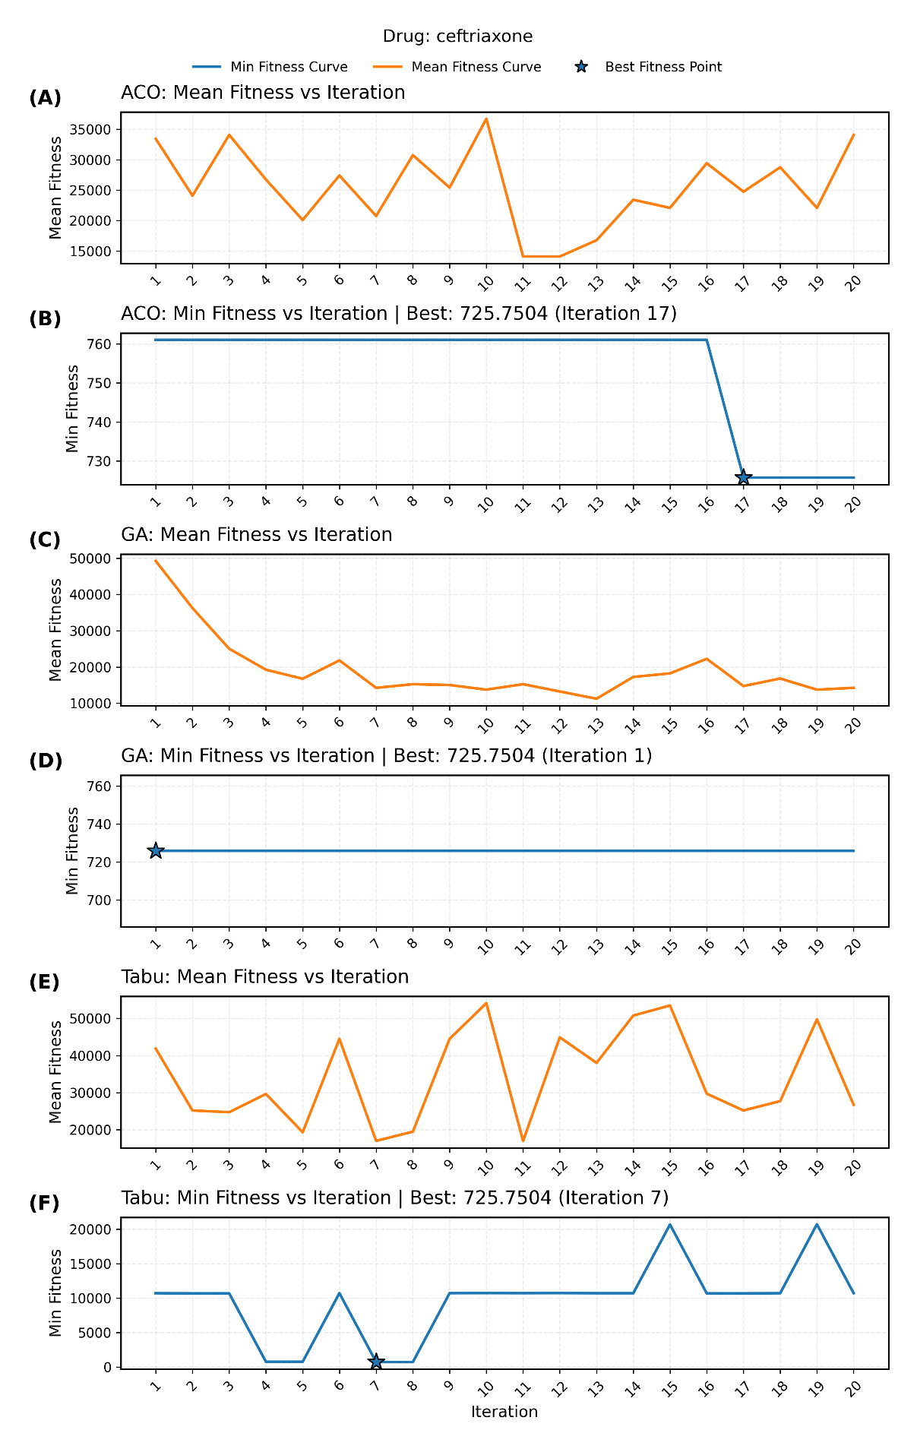

Supplementary Figure 5 Convergence curves of ACO, GA, and TS on the cephalexin dataset. Stars indicate the best solution with fitness value and iteration number annotated. Mean fitness is calculated with infinite values excluded
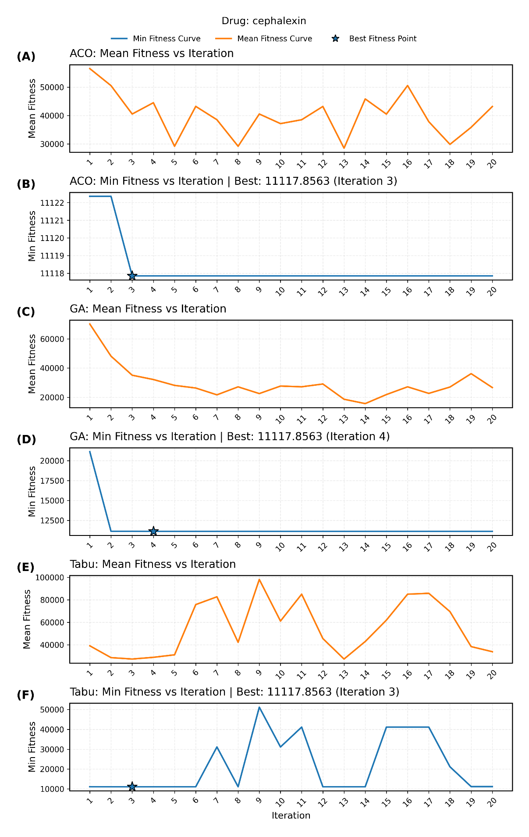

Supplementary Figure 6 Convergence curves of ACO, GA, and TS on the clofazimine dataset. Stars indicate the best solution with fitness value and iteration number annotated. Mean fitness is calculated with infinite values excluded
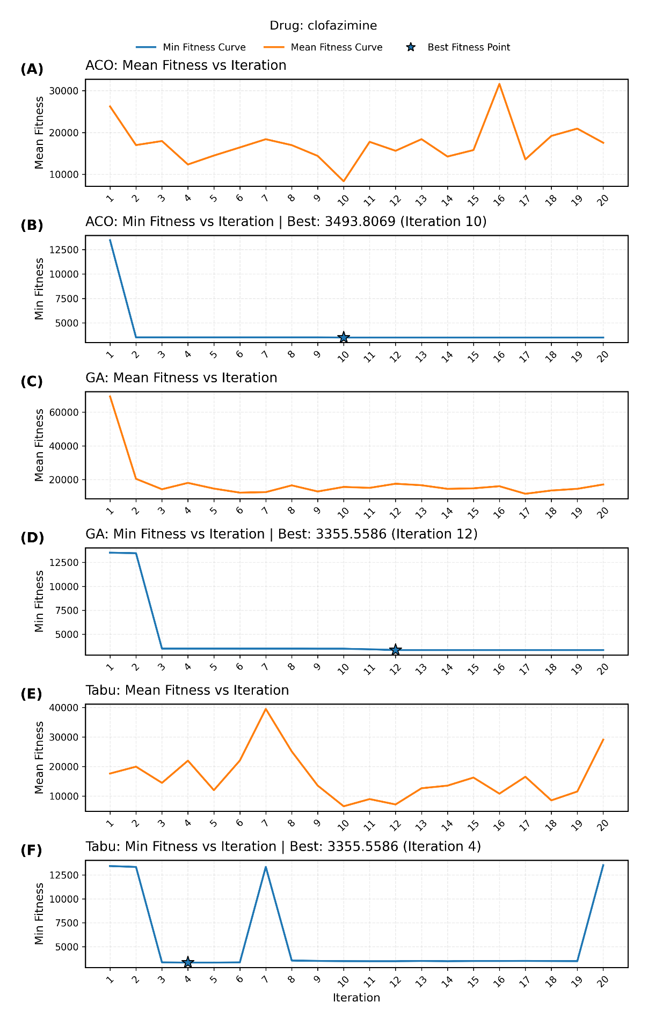
Supplementary Figure 7 Convergence curves of ACO, GA, and TS on the diazepam dataset. Stars indicate the best solution with fitness value and iteration number annotated. Mean fitness is calculated with infinite values excluded
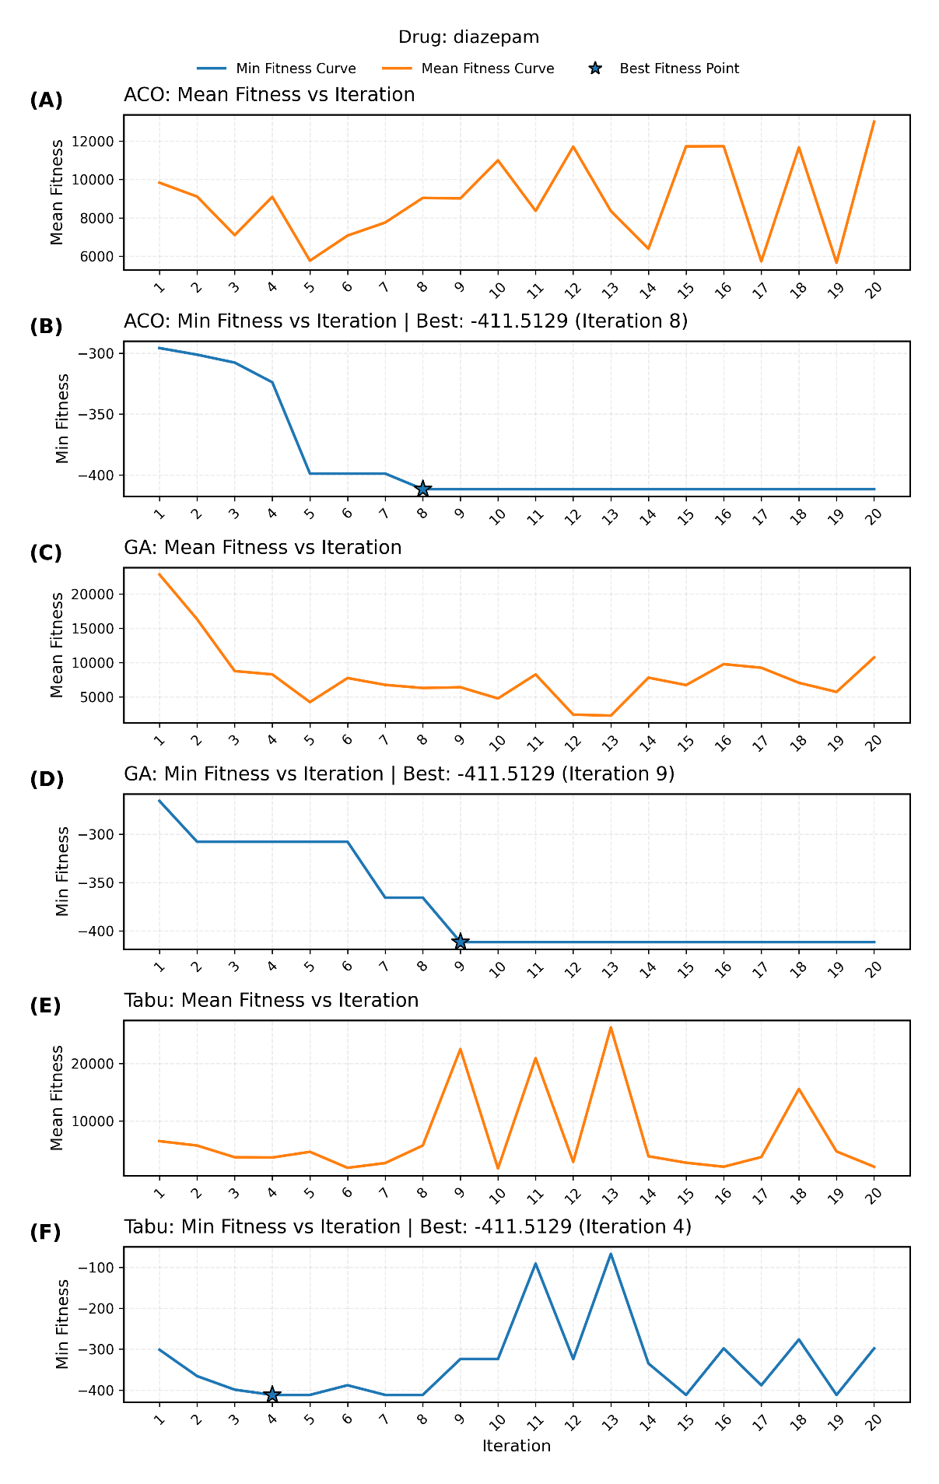
Supplementary Figure 8 Convergence curves of ACO, GA, and TS on the fluorouracil dataset. Stars indicate the best solution with fitness value and iteration number annotated. Mean fitness is calculated with infinite values excluded
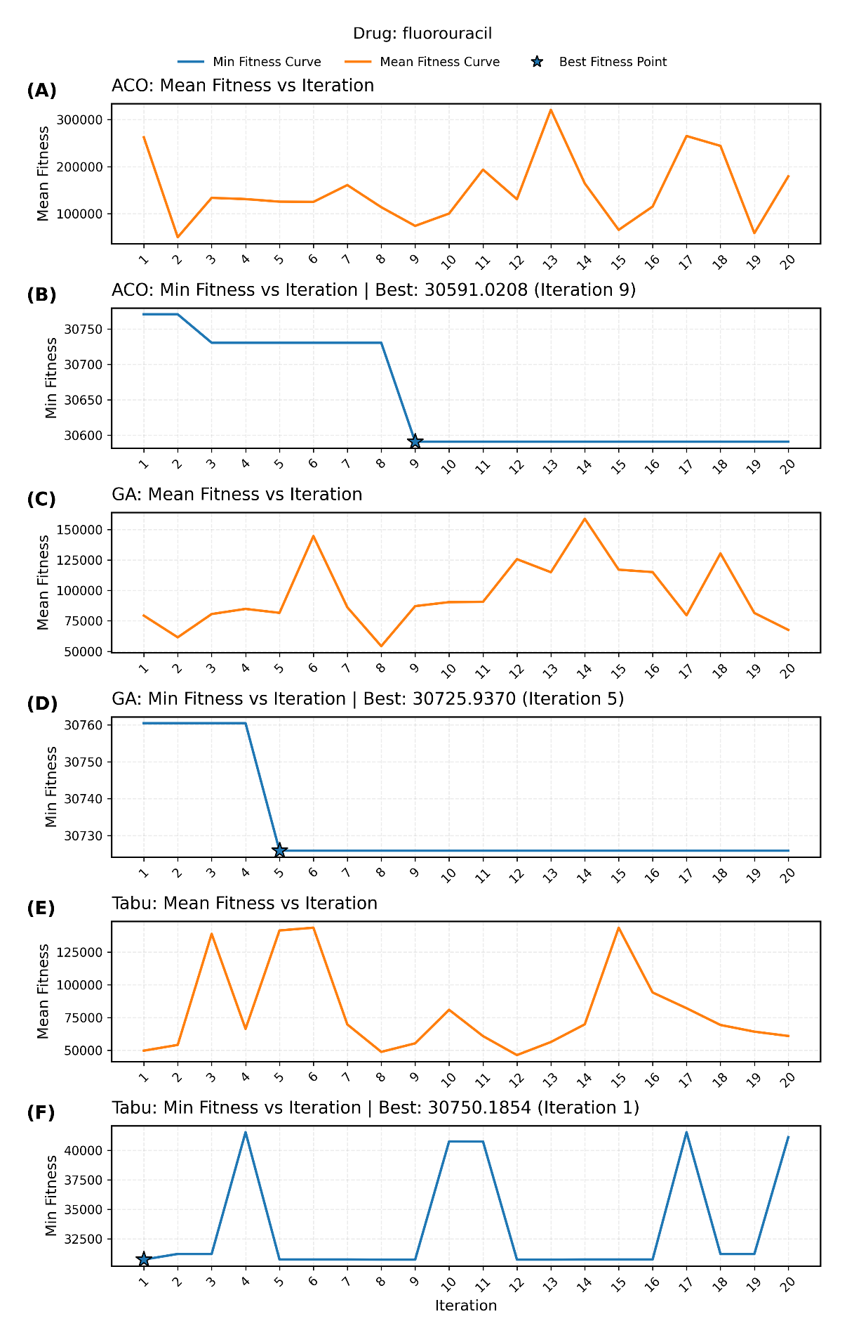
Supplementary Figure 9 Convergence curves of ACO, GA, and TS on the imipenem dataset. Stars indicate the best solution with fitness value and iteration number annotated. Mean fitness is calculated with infinite values excluded
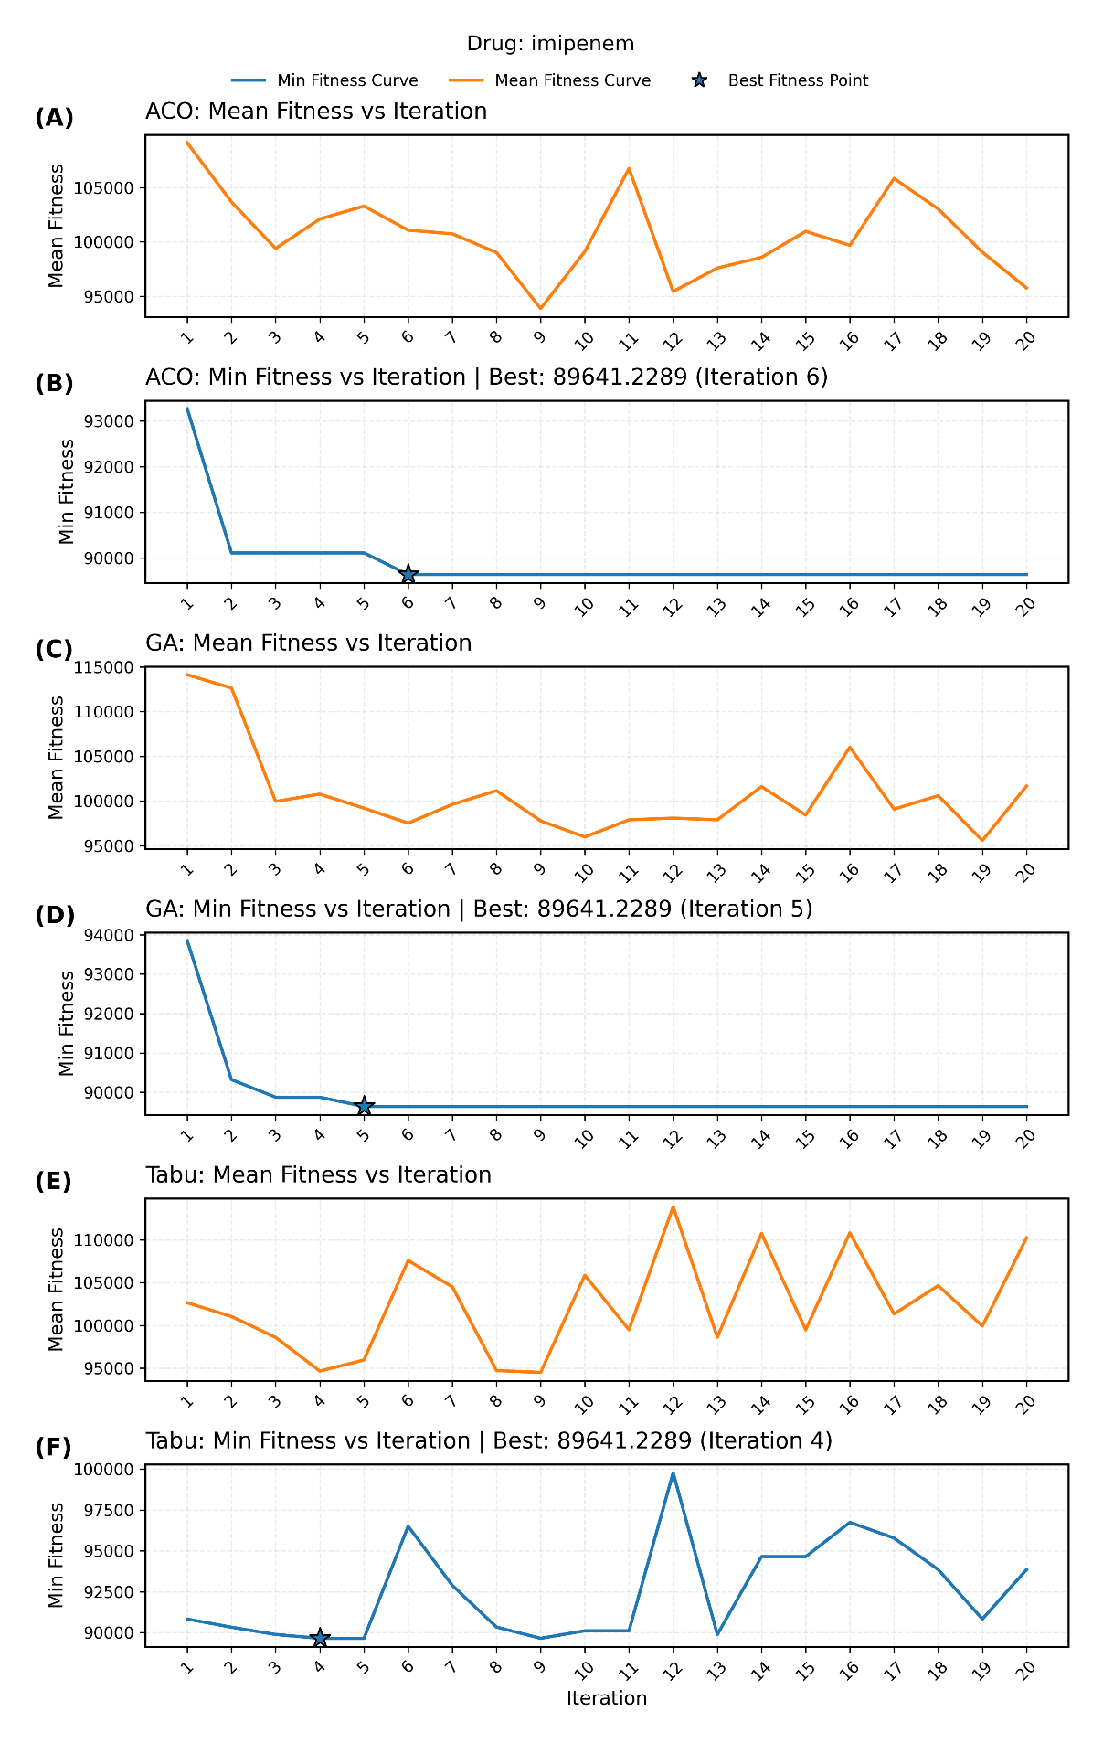
Supplementary Figure 10 Convergence curves of ACO, GA, and TS on the linezolid (844567) dataset. Stars indicate the best solution with fitness value and iteration number annotated. Mean fitness is calculated with infinite values excluded
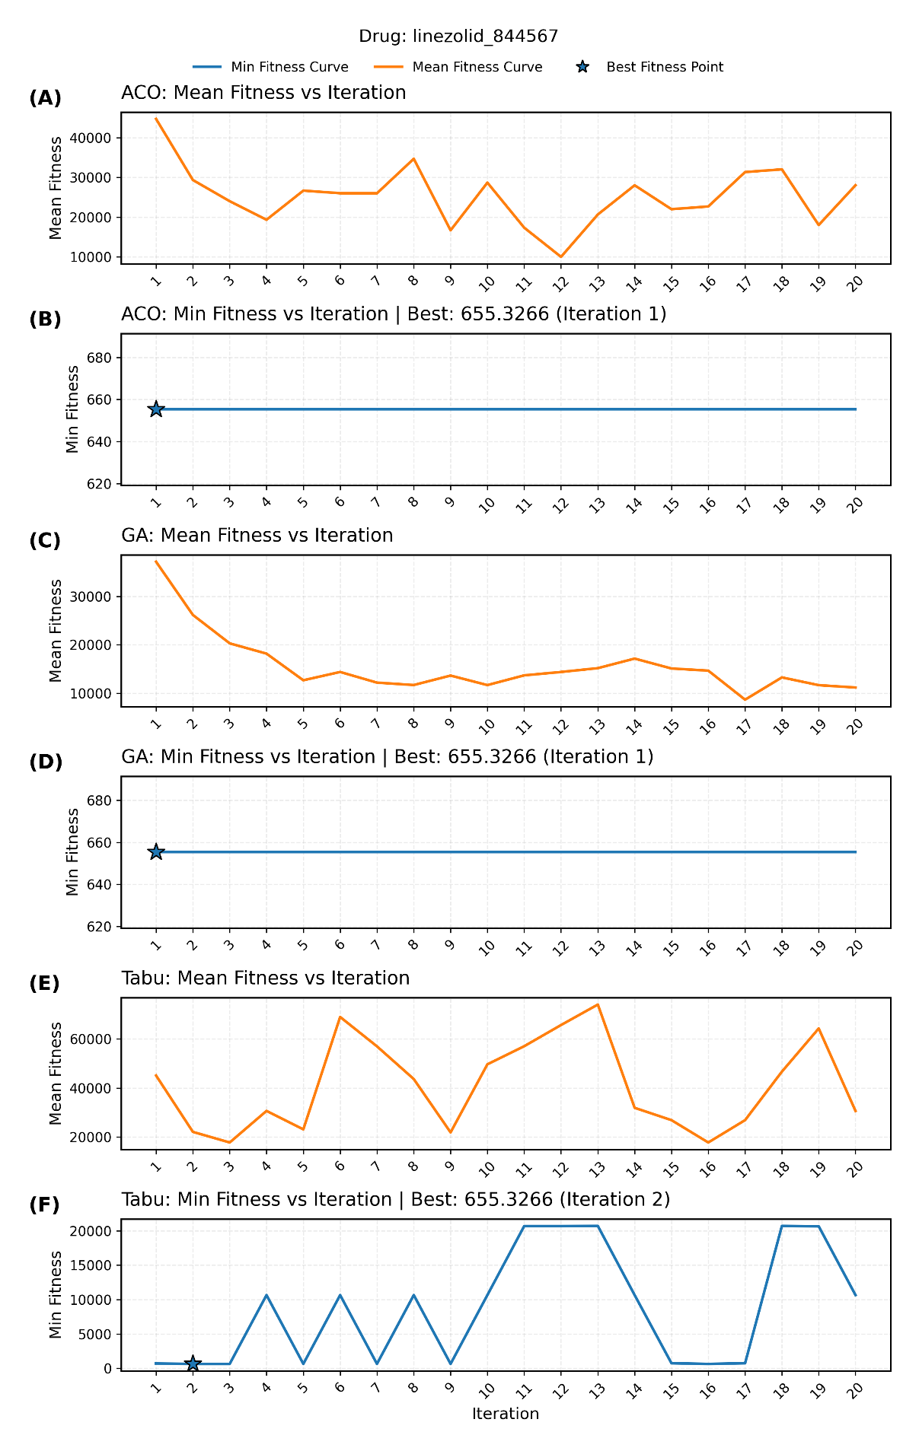
Supplementary Figure 11 Convergence curves of ACO, GA, and TS on the linezolid dataset. Stars indicate the best solution with fitness value and iteration number annotated. Mean fitness is calculated with infinite values excluded
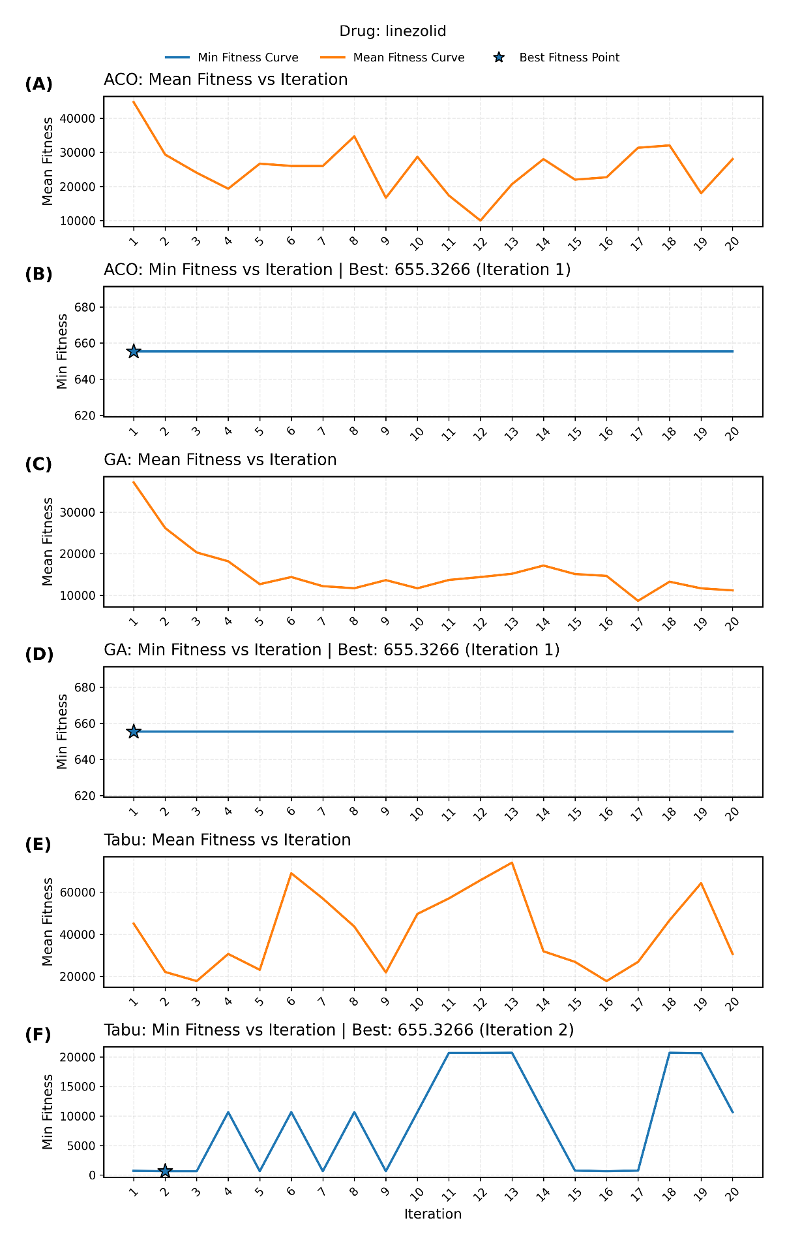
Supplementary Figure 12 Convergence curves of ACO, GA, and TS on the oxprenolol (iv) dataset. Stars indicate the best solution with fitness value and iteration number annotated. Mean fitness is calculated with infinite values excluded
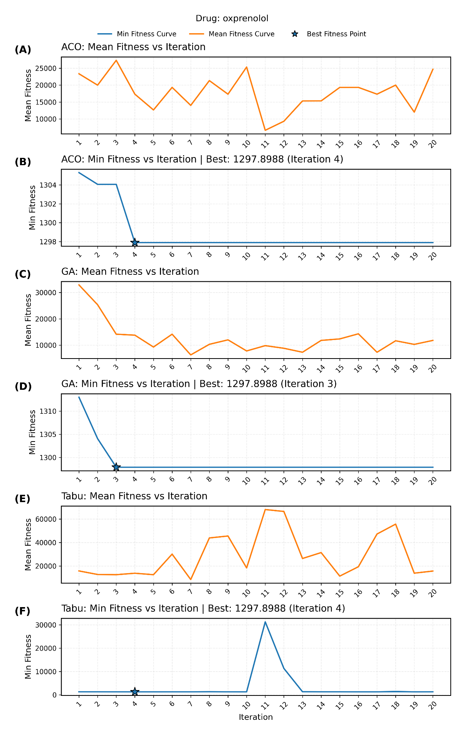
Supplementary Figure 13 Convergence curves of ACO, GA, and TS on the oxprenolol (oral) dataset. Stars indicate the best solution with fitness value and iteration number annotated. Mean fitness is calculated with infinite values excluded
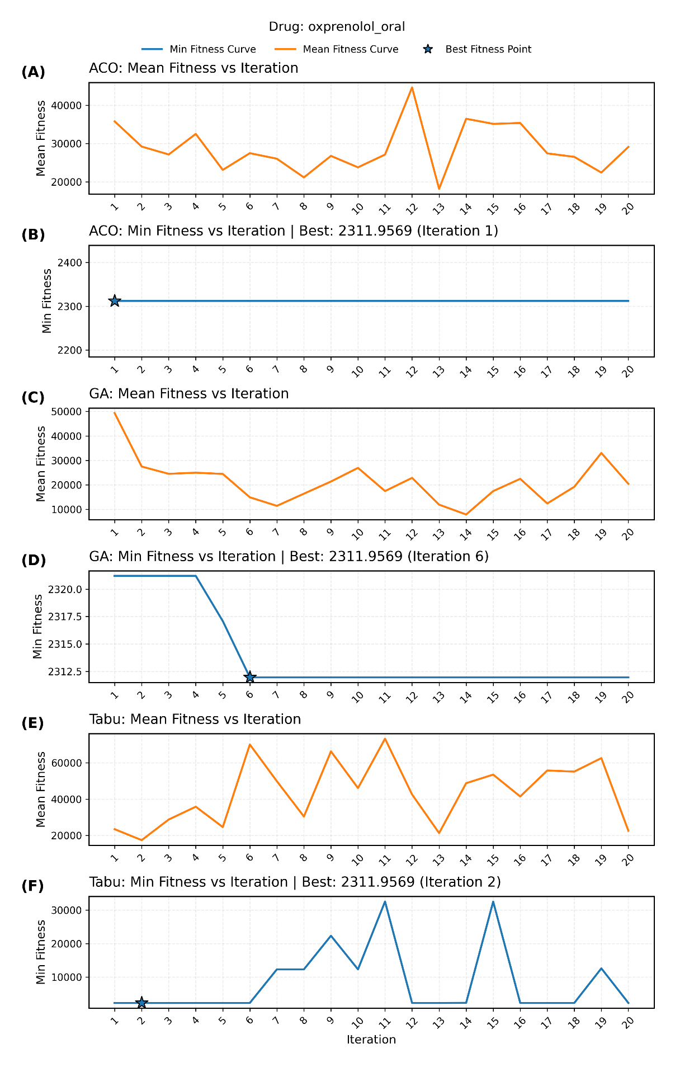
Supplementary Figure 14 Convergence curves of ACO, GA, and TS on the paclitaxel dataset. Stars indicate the best solution with fitness value and iteration number annotated. Mean fitness is calculated with infinite values excluded
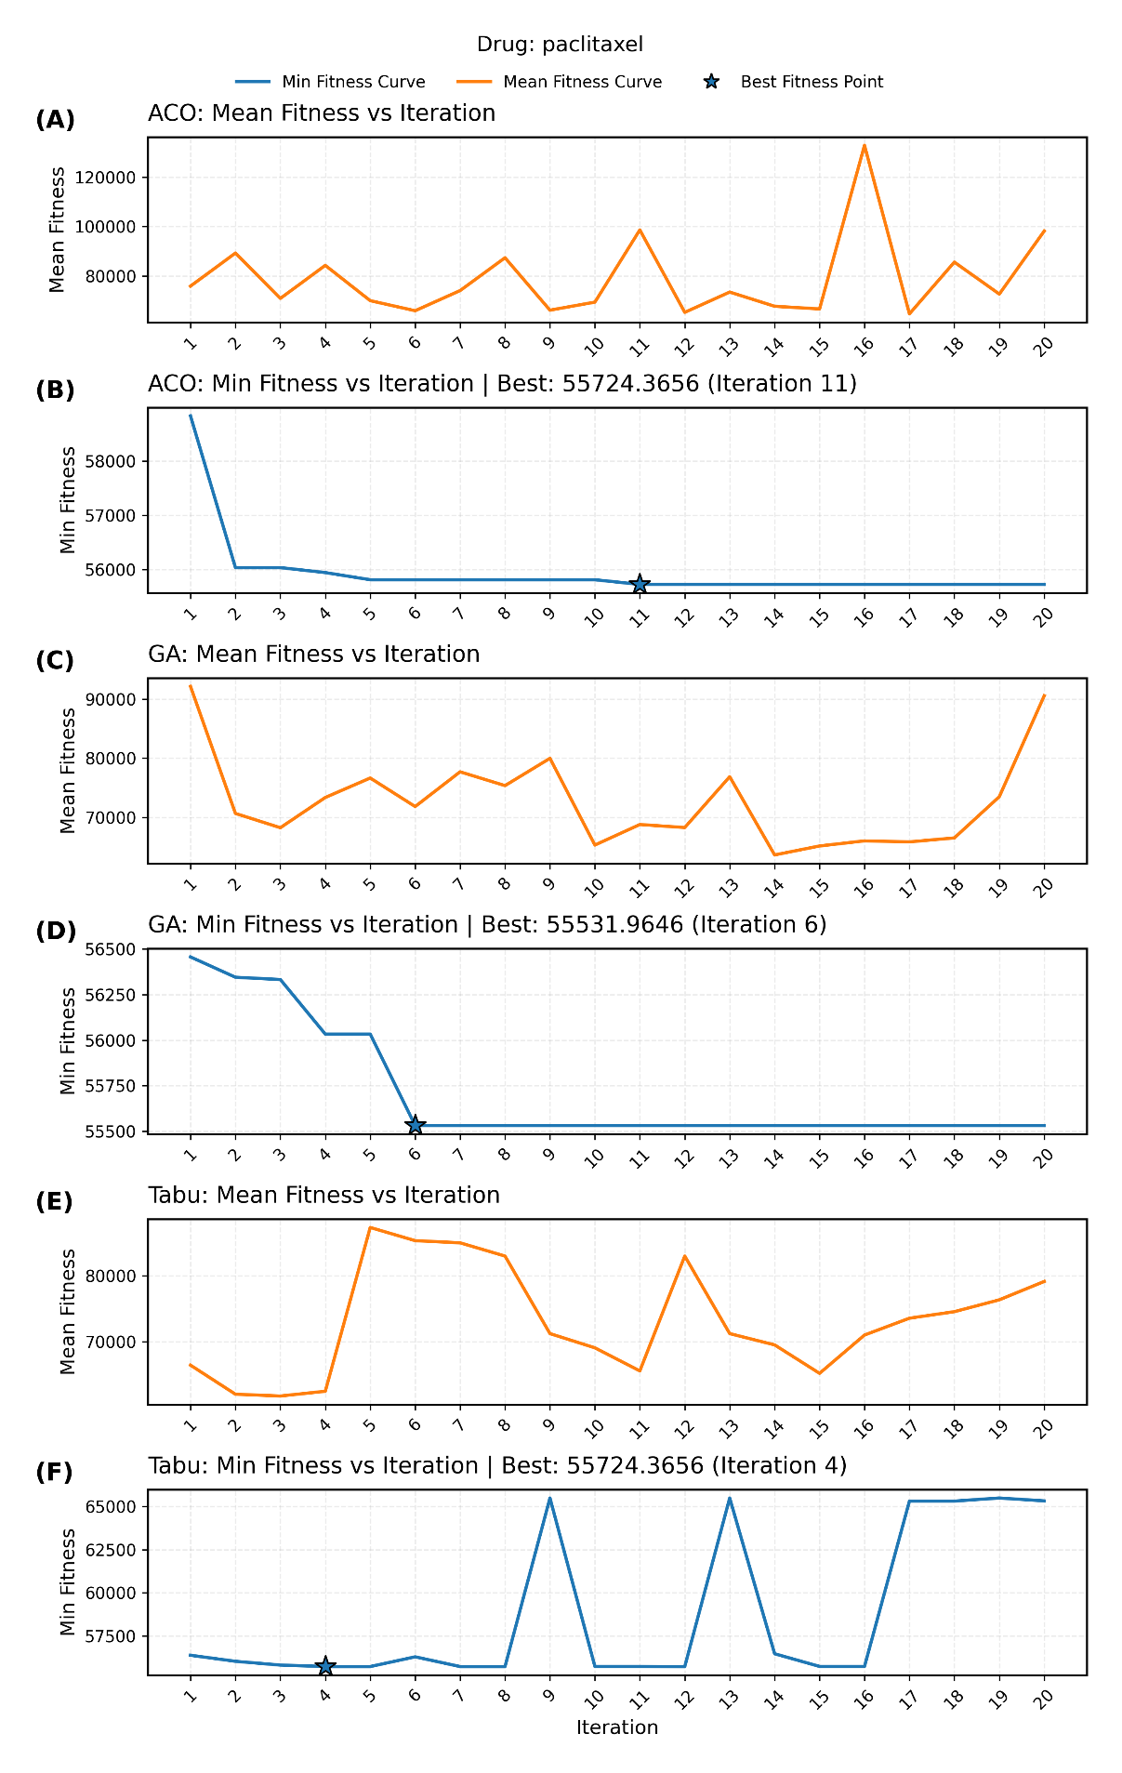
Supplementary Figure 15 Convergence curves of ACO, GA, and TS on the pheno_sd dataset. Stars indicate the best solution with fitness value and iteration number annotated. Mean fitness is calculated with infinite values excluded
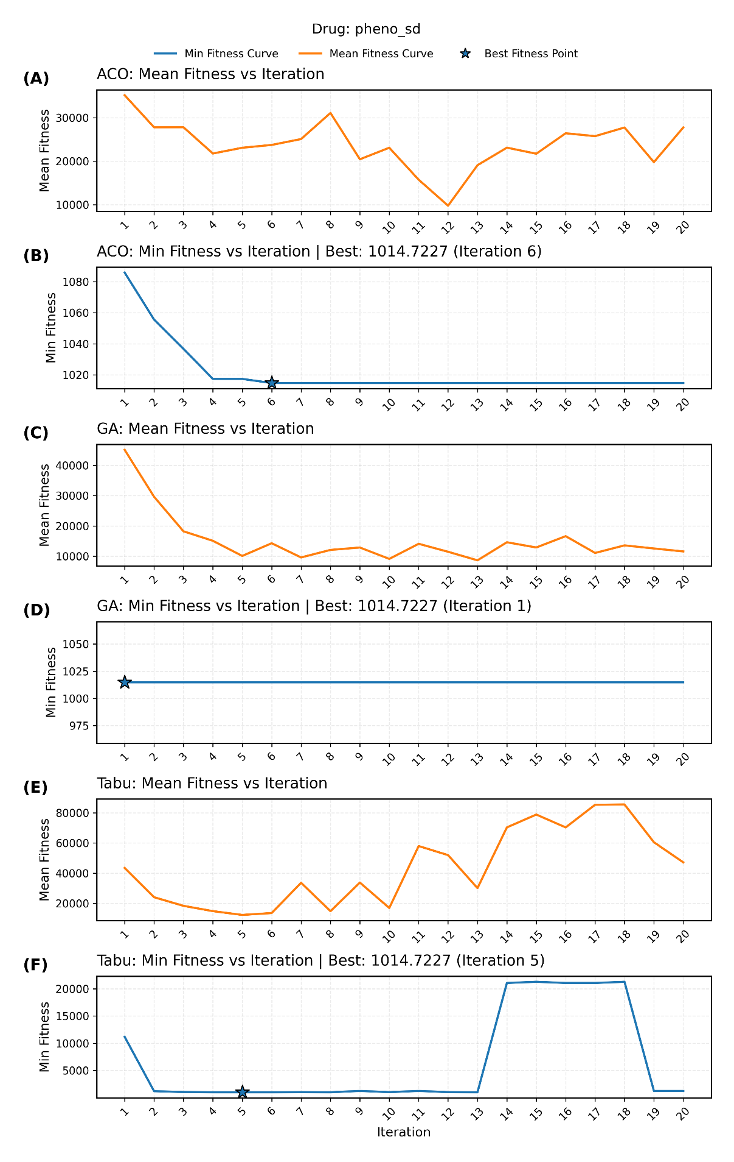
Supplementary Figure 16 Convergence curves of ACO, GA, and TS on the pindolol dataset. Stars indicate the best solution with fitness value and iteration number annotated. Mean fitness is calculated with infinite values excluded
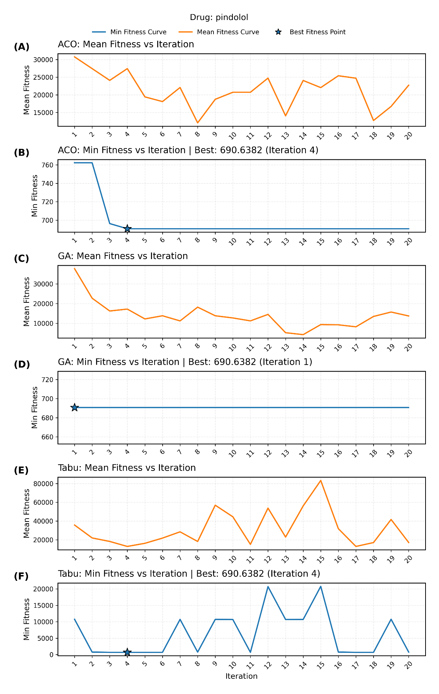
Supplementary Figure 17 Convergence curves of ACO, GA, and TS on the polymyxinB dataset. Stars indicate the best solution with fitness value and iteration number annotated. Mean fitness is calculated with infinite values excluded
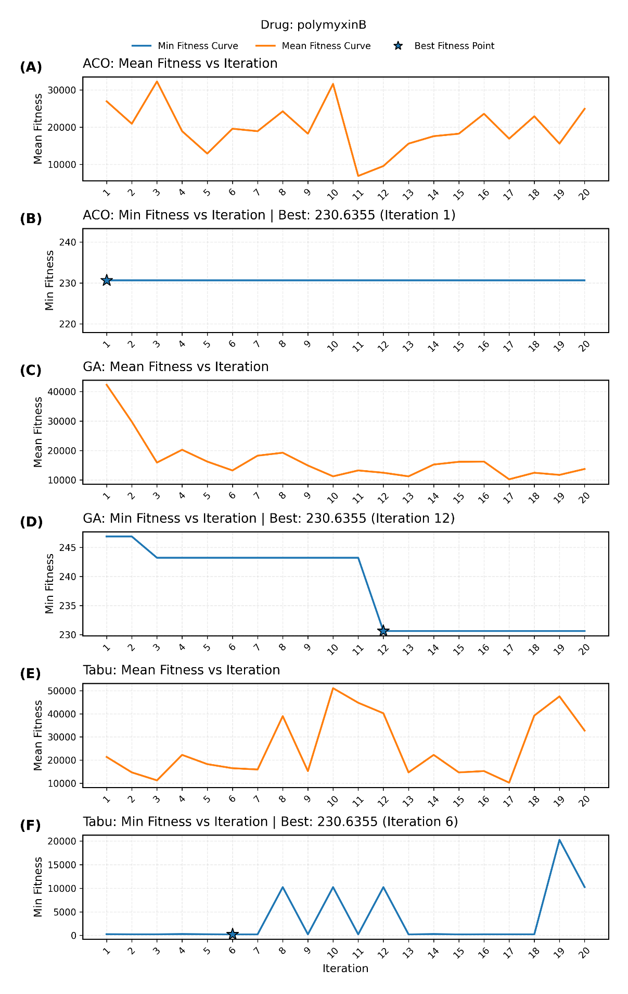
Supplementary Figure 18 Convergence curves of ACO, GA, and TS on the pretomanid dataset. Stars indicate the best solution with fitness value and iteration number annotated. Mean fitness is calculated with infinite values excluded
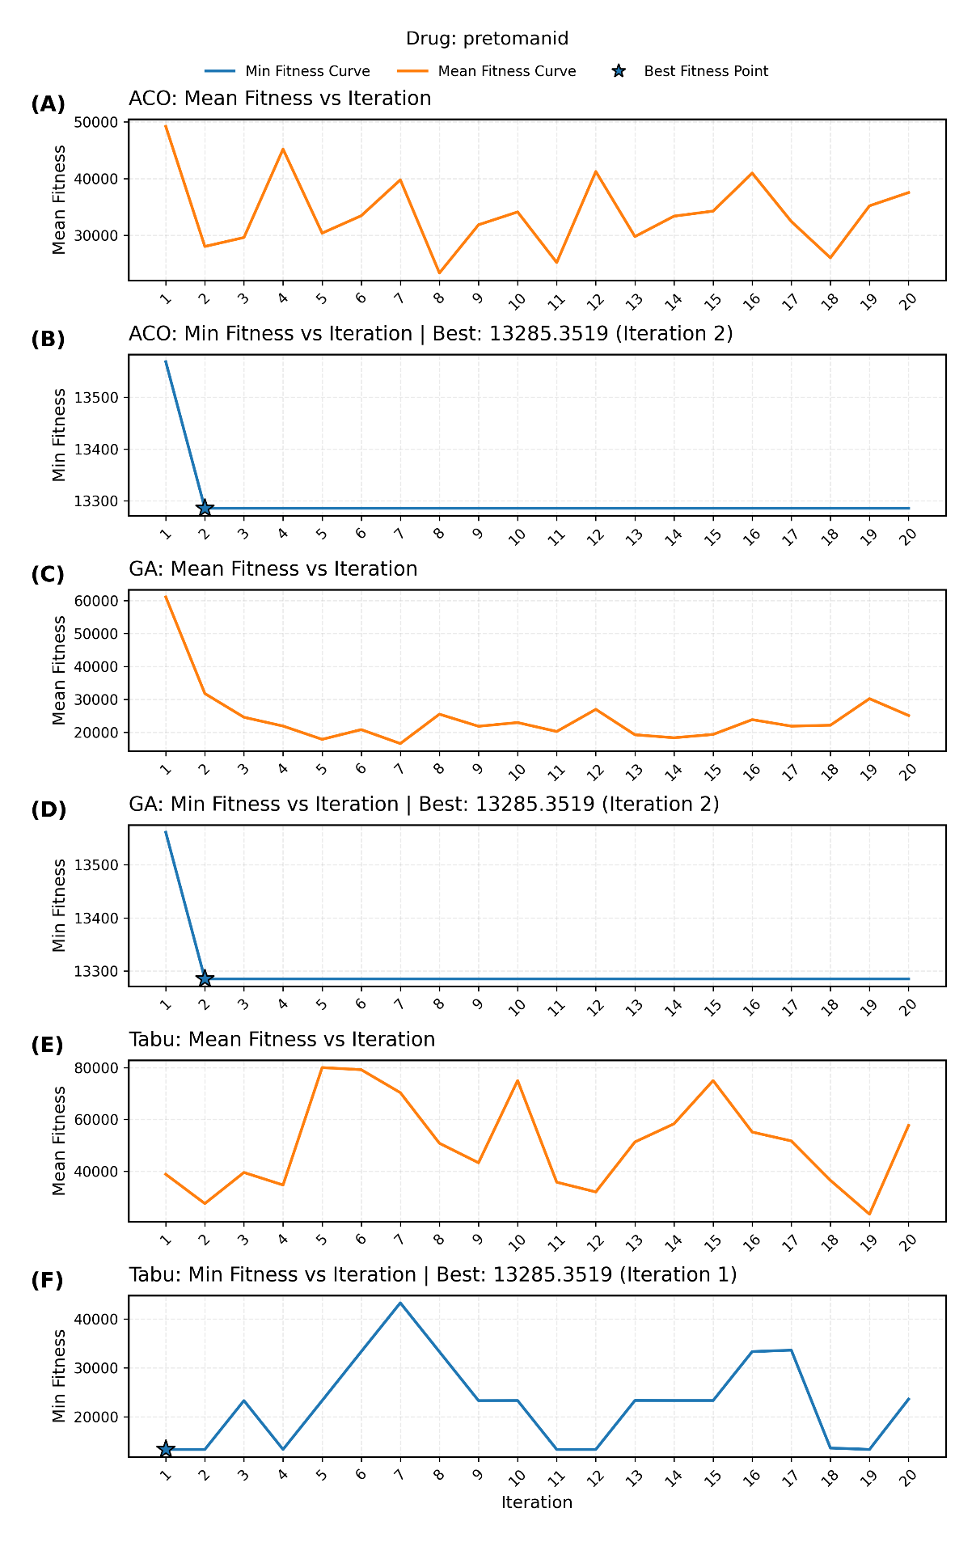
Supplementary Figure 19 Convergence curves of ACO, GA, and TS on the relebactam dataset. Stars indicate the best solution with fitness value and iteration number annotated. Mean fitness is calculated with infinite values excluded
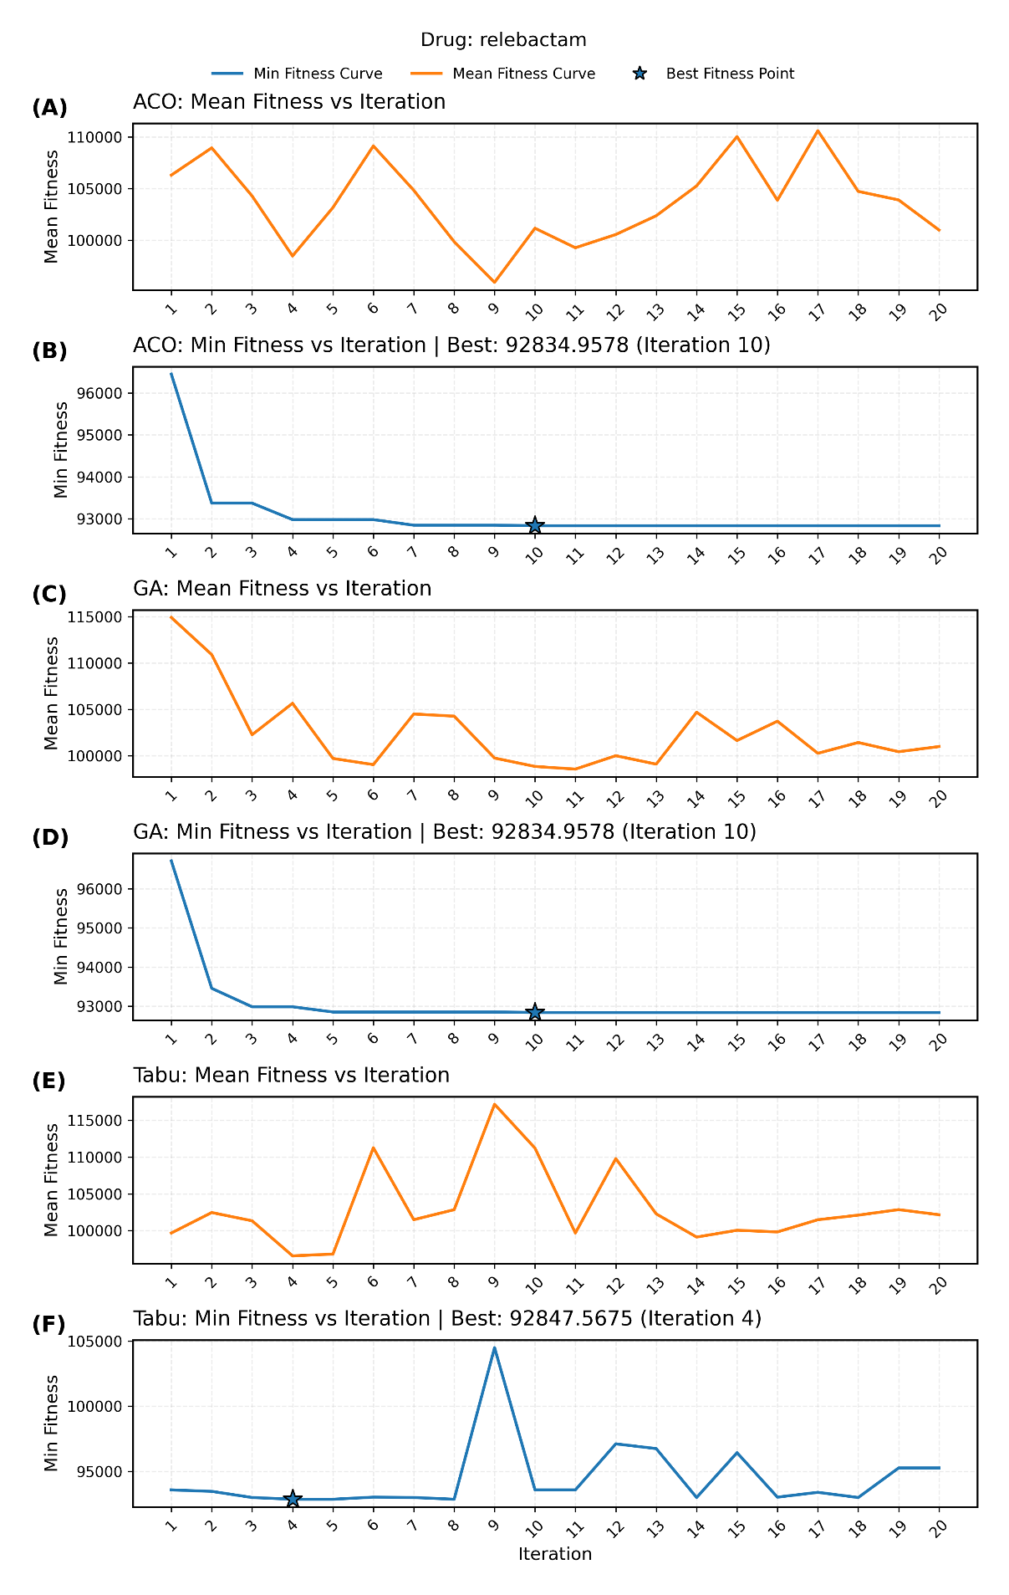

Supplementary Figure 20 Convergence curves of ACO, GA, and TS on the relebactam dataset. Stars indicate the best solution with fitness value and iteration number annotated. Mean fitness is calculated with infinite values excluded
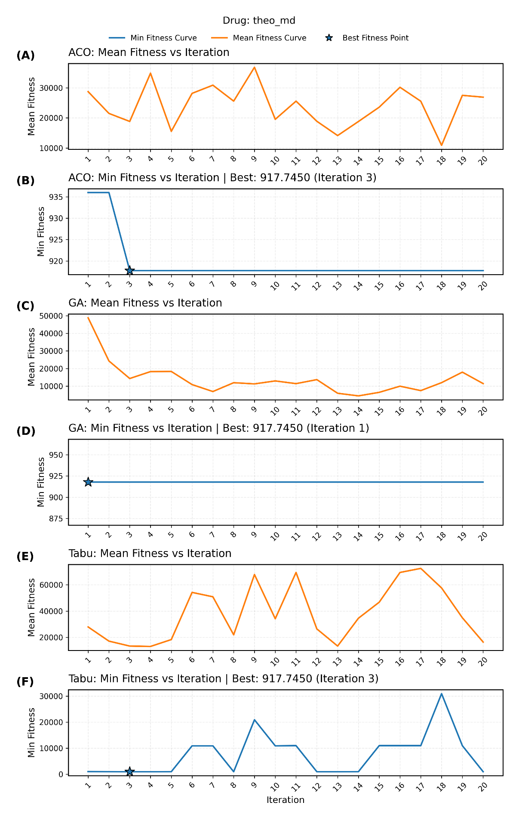
Supplementary Figure 21 Convergence curves of ACO, GA, and TS on the tobramycin dataset. Stars indicate the best solution with fitness value and iteration number annotated. Mean fitness is calculated with infinite values excluded
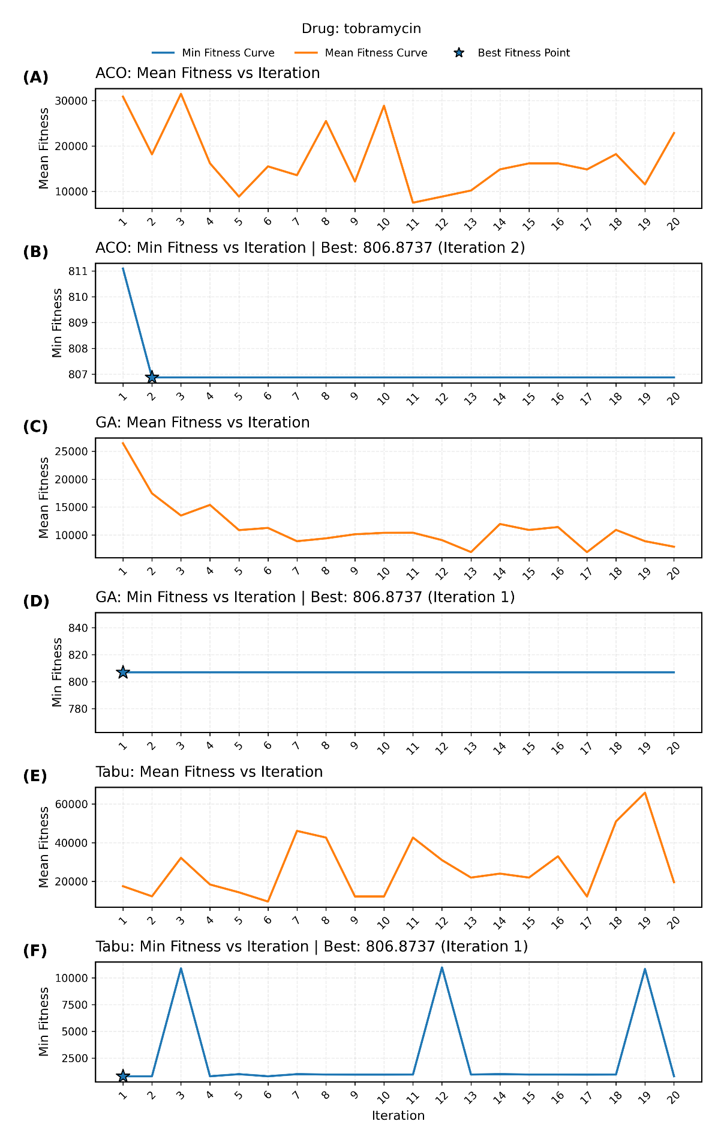
Supplementary Figure 22 Convergence curves of ACO, GA, and TS on the tobramycin dataset. Stars indicate the best solution with fitness value and iteration number annotated. Mean fitness is calculated with infinite values excluded
