Supplementary Materials

Supplementary Tables
Supplementary Table S1. PAI alternative definition sensitivity analysis.
PAI Definition | Total Effect Direction | Consistency | Remarks
Primary: 60g protein, urban–rural weighted income | Negative | Baseline | See Table 2
50g protein threshold | Negative | Consistent | Lower protein requirement
70g protein threshold | Negative | Consistent | Higher protein requirement
Without Engel weight (raw income) | Negative | Consistent | Weighting scheme robustness
Food expenditure share (non-price proxy) | Negative | Consistent | Robust to pastoral-area underestimation

Supplementary Table S2. PAI construct validity analysis.
Variable | Pearson r with PAI | P Value | Interpretation
GDP per capita | 0.866 | <0.001 | Affordability highly correlated with economic development
Urbanization rate | 0.692 | <0.001 | Higher affordability in urban areas
Reported TB incidence | −0.096 | 0.215 | Association is spatial, not linear
Treatment success rate | 0.003 | 0.969 | No linear association
Case fatality rate | −0.062 | 0.421 | No linear association
PAI–TB partial r (control GDP) | −0.319 | <0.001 | PAI captures independent variation beyond GDP

Supplementary Table S3. Dual-breakpoint ITS regression results with collinearity diagnostics.
Parameter | Single-BP | Dual-BP (No Covariates) | Dual-BP (With Covariates)
β₃ (2018 slope change) | −21.62 | 36.52 | 38.89
β₅ (2020 slope change) | — | −44.53 | −44.46
ln_PAI | — | — | −58.55 (P=0.310)
Collinearity diagnostics | — | VIF>10: 2018 & 2020 BP | VIF>10: 2018 & 2020 BP
Conclusion | β₃ significant (P<0.001) | Two breakpoints inseparable | Covariates absorb effect

Supplementary Table S4. XGBoost-SHAP model hyperparameter specifications.
Parameter | Value | Description
Model type | XGBoost regressor | Gradient boosted trees; captures nonlinear patterns
max_depth | 5 | Prevents overfitting; N=168 moderate sample
learning_rate | 0.03 | Conservative rate for stable convergence
n_estimators | 300 | 5-fold CV converged
Cross-validation | 5-fold stratified by year | Preserves temporal structure
Feature importance (1°) | Gain | Variance explained by splits
Feature importance (2°) | |SHAP| mean | Marginal effect magnitude
SHAP explainer | TreeExplainer | Exact computation for tree models
Threshold detection | 2nd-derivative inflection of SHAP dependence | Nonparametric inflection identification
Features | PAI, beds, physicians, nurses, GDP, urbanization, aging, post_2018 | All SDM variables + policy indicator

Supplementary Table S5. CHEERS 2022 reporting guideline checklist.
Item | Topic | Requirement | Page
1 | Title | Identifies as health economic evaluation | 1
2 | Abstract | Structured abstract | 1
3 | Background | Context and significance | 2–3
4 | Target population | 14 prefectures of Xinjiang | 3
5 | Setting | Xinjiang Uygur Autonomous Region | 3–4
6 | Perspective | Health system + societal (nutrition) | 4
7 | Comparators | Pre-2018 trend (counterfactual) | 4–5
8 | Time horizon | 2013–2024 (12 years) | 4
9 | Discount rate | 3% per annum | 5
10 | Outcomes | TB incidence, DALYs averted | 4–5
11 | Effect measurement | ITS + SDM effect decomposition | 4–6
12 | Outcome valuation | GBD 2019 disability weights | 5–6
13 | Resources/costs | Nutritional affordability (PAI) | 4
14 | Currency/price year | 2013 constant CNY (CPI-deflated) | 4
15 | Model | Spatial Durbin Model (MLE) | 5–6
16 | Assumptions | Over-controlling bias, exogeneity | 5
17 | Analytical methods | LeSage–Pace effect decomposition | 5–6
18 | Study parameters | Tables 1–3 | 7–9
19 | Incremental effects | ITS β₃ = −21.6/year | 7
20 | Health outcomes | DALYs: ~9,000 (2024) | 10
21 | Effect decomposition | Total effect = −94.15/100,000 | 8–9
22 | Uncertainty | Monte Carlo SE (5,000 draws) | 8–9
23 | Heterogeneity | Regional sub-group analysis | Suppl. Fig. S4
24 | Main findings | PAI–TB systemic association | 11–13
25 | Limitations | N=14, COVID, endogeneity | 13–14
26 | Generalizability | County-level validation needed | 12
27 | Funding source | See Funding statement | 16
28 | Conflicts of interest | None declared | 16

Supplementary Table S6. Spatial bootstrap and lagged-variable sensitivity analysis.
Sensitivity Check | Method | PAI Total Effect | ρ | Conclusion
Spatial bootstrap | 5,000 resamples, block-bootstrap by year | Negative, stable | 0.364 (P<0.001) | SE robust to spatial dependence
t−1 lag (all covariates) | PAI, beds, physicians, GDP, urbanization lagged 1y | Negative, stable | Comparable | Reduces reverse-causality bias
t−1 lag (PAI only) | Only PAI lagged 1 year | Negative, stable | Comparable | Core finding not simultaneity-driven

Supplementary Table S7. Spatial 2SLS first-stage instrumental variable diagnostics.
Diagnostic | Value | Criterion | Conclusion
First-stage F-statistic | 0.81 | >10 for strong instruments | Weak instruments
First-stage R² | 0.9247 | — | —
ln_temperature | coef=0.036, P=0.707 | P<0.05 significant | Not significant
ln_precipitation | coef=0.033, P=0.209 | P<0.05 significant | Not significant
ln_sunshine | coef=−0.168, P=0.281 | P<0.05 significant | Not significant
ln_land_area | coef=0.041, P=0.689 | P<0.05 significant | Not significant
Sargan overidentification | P=0.0004 | P>0.05 does not reject | Instruments possibly endogenous
2SLS ρ | 0.3782 | — | Comparable to MLE ρ=0.364
W × ln_PAI (2SLS) | −99.06 (P=0.037) | — | Negative, marginally significant

Supplementary Table S8. ITS sensitivity analysis with time-varying covariates.
Variable | Xinjiang β | Xinjiang SE | Xinjiang P | S.XJ β | S.XJ SE | S.XJ P
Time (baseline trend) | 1.16 | 11.49 | 0.920 | 29.82 | 9.02 | 0.002
post_2018 (level change) | 36.41 | 30.16 | 0.229 | −100.95 | 24.08 | <0.001
time_since_2018 (β₃) | −12.88 | 7.37 | 0.104 | −23.28 | 10.90 | 0.100
ln_PAI | −64.29 | 68.49 | 0.349 | −91.43 | 44.27 | 0.044
ln_GDP per capita | 16.35 | 52.36 | 0.755 | −18.56 | 35.76 | 0.606
Urbanization rate | −78.44 | 90.55 | 0.388 | 5.07 | 86.36 | 0.953
ln_Beds per 10,000 | 8.38 | 44.58 | 0.851 | −25.86 | 43.46 | 0.555
Note: Covariates absorb part of intervention effect. Xinjiang-wide VIF: time=49.9, ln_GDP=43.1, ln_PAI=26.2, time_since_2018=16.4, urbanization=13.1, post_2018=7.0, ln_beds=2.7. R²: Xinjiang-wide=0.202, Southern Xinjiang=0.513.

Supplementary Table S9. Spatial weight matrix sensitivity analysis.
Spatial Weight Matrix | ρ | PAI Total Effect | P (Total) | Interpretation
Queen contiguity (1st order) | 0.364 | −94.15 | 0.069 | Primary: equal weight adjacent prefectures
Economic distance | 0.290 | −110.38 | 0.017 | Stronger PAI effect; economic gradient more relevant
K-nearest neighbor (K=4) | 0.470 | −112.04 | 0.077 | Higher ρ; dense connectivity; marginal significance

Supplementary Table S10. COVID-19 counterfactual boundary estimation.
Scenario | β₃ (/100,000/yr) | Description
Full-sample ITS | −21.62 | Includes COVID-19 NPI contribution
Excluding 2020–2022 | −22.31 | COVID empirical contribution: −3.2%
Literature benchmark (20% attrib.) | −17.3 | Based on WHO 2021 Global TB Report
Xinjiang Model independent effect range | −17.3 to −21.6

Supplementary Table S11. Post hoc statistical power analysis.
Effect Size Multiplier | |Indirect Effect| | Statistical Power | Assessment
0.5× | 50.0 | 0.212 | Inadequate
1.0× (observed) | 100.1 | 0.683 | Moderate (0.50–0.80)
1.5× | 150.1 | 0.963 | Adequate (>0.80)
2.0× | 200.1 | 0.998 | Adequate (>0.80)
3.0× | 300.2 | 1.000 | Adequate (>0.80)
4.0× | 400.2 | 1.000 | Adequate (>0.80)
5.0× | 500.3 | 1.000 | Adequate (>0.80)
Required N (80% power) | 19 prefectures | — | County N≈90 sufficient
Power via Monte Carlo simulation, N=14, ρ=0.364, observed indirect effect (−100.06, SE=41.14).

Supplementary Table S12. Leave-one-out sensitivity analysis.
Excluded Prefecture | ρ | PAI Total Effect
Changji Hui Autonomous Pref. | 0.3086 | −112.17
Hotan (Khotan) Pref. | 0.3327 | −110.06
Bayingolin Mongol Autonomous Pref. | 0.3776 | −102.57
Ili Kazakh Autonomous Pref. | 0.3683 | −99.53
Bortala Mongol Autonomous Pref. | 0.4613 | −98.64
Ürümqi | 0.3534 | −96.86
Altay Pref. | 0.3040 | −94.68
Tacheng (Tarbagatay) Pref. | 0.3356 | −90.21
Kizilsu Kirghiz Autonomous Pref. | 0.3602 | −89.60
Hami (Kumul) Pref. | 0.3006 | −89.24
Karamay | 0.3274 | −87.25
Kashgar (Kashi) Pref. | 0.3336 | −87.21
Aksu Pref. | 0.3246 | −84.25
Turpan (Tulufan) Pref. | 0.2873 | −75.97
Full sample (baseline) | 0.3643 | −92.53
PAI total effect direction negative across all 14 exclusions, confirming robustness to single-prefecture influence. The full-sample baseline in the leave-one-out model (−92.53) differs from Table 2 (−94.15) because the leave-one-out specification excludes nurse density to maintain model convergence across all 14 subsamples.

Supplementary Figures
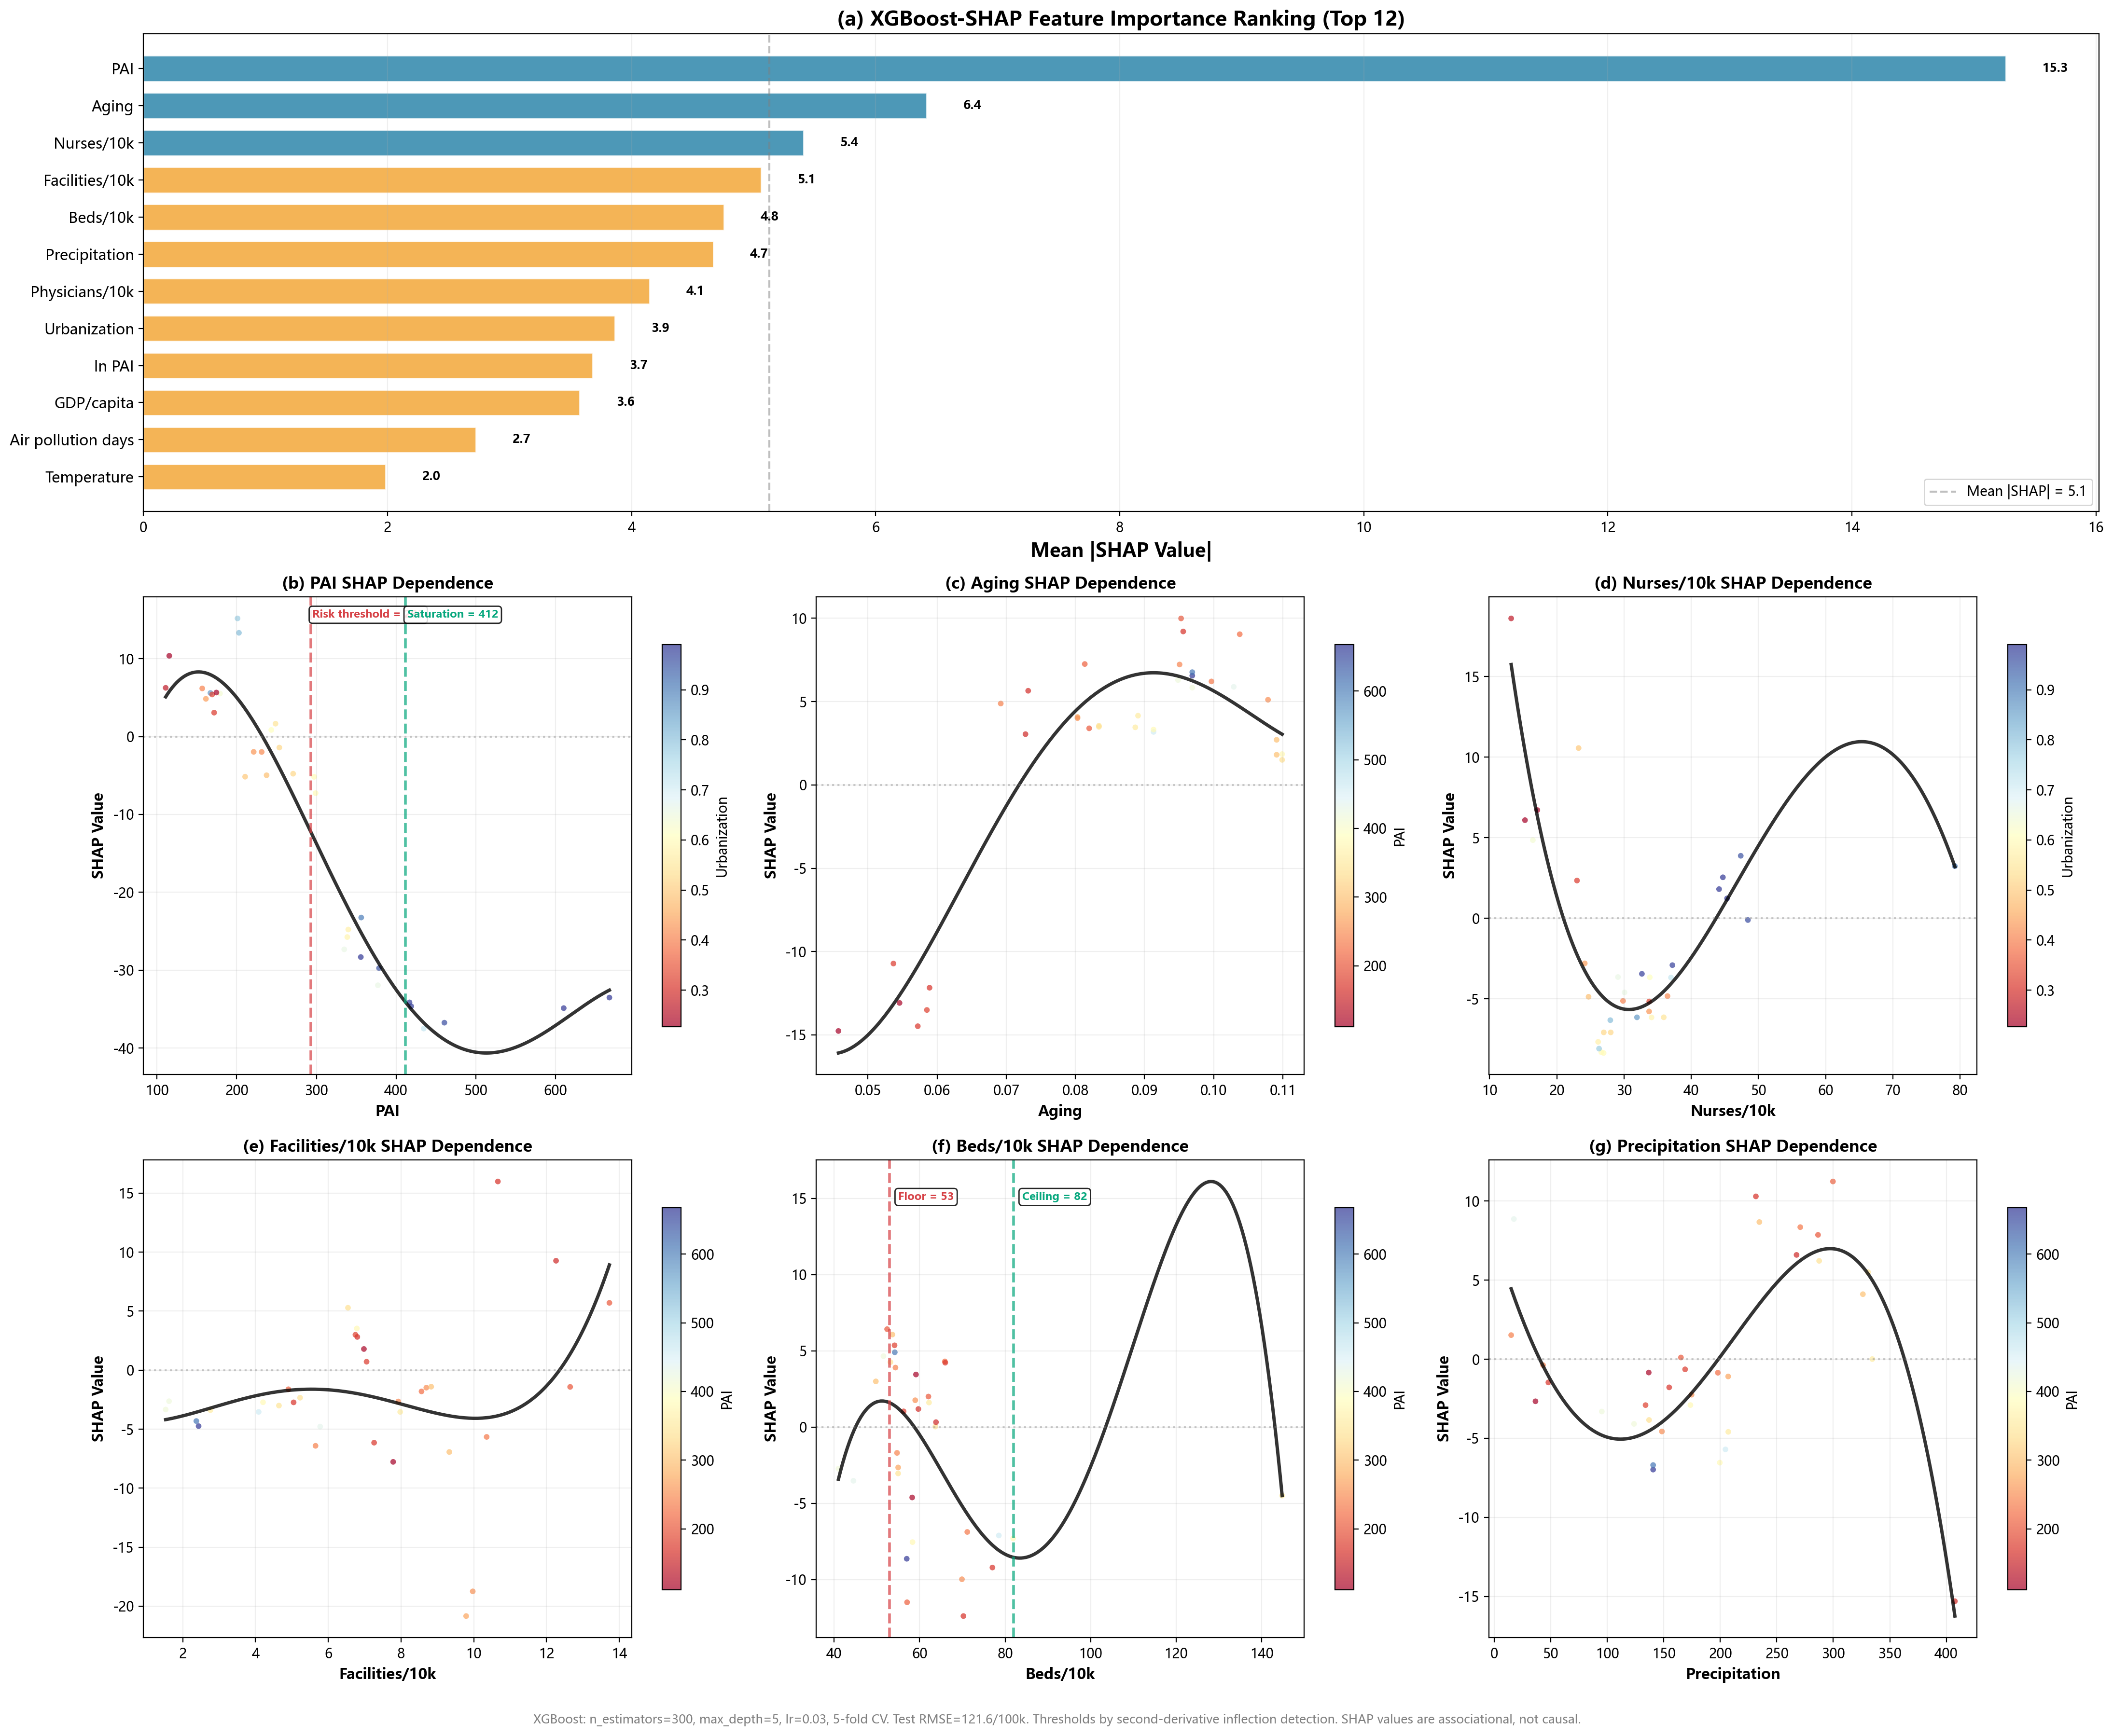
Supplementary Figure S1: Directed Acyclic Graph (DAG) of the hypothesized causal framework—nutritional affordability (PAI), spatial dependence (rho), and TB incidence. Solid arrows denote hypothesized causal paths; dashed arrows denote feedback/secondary pathways; dotted arrows denote confounding (COVID-19 NPIs).
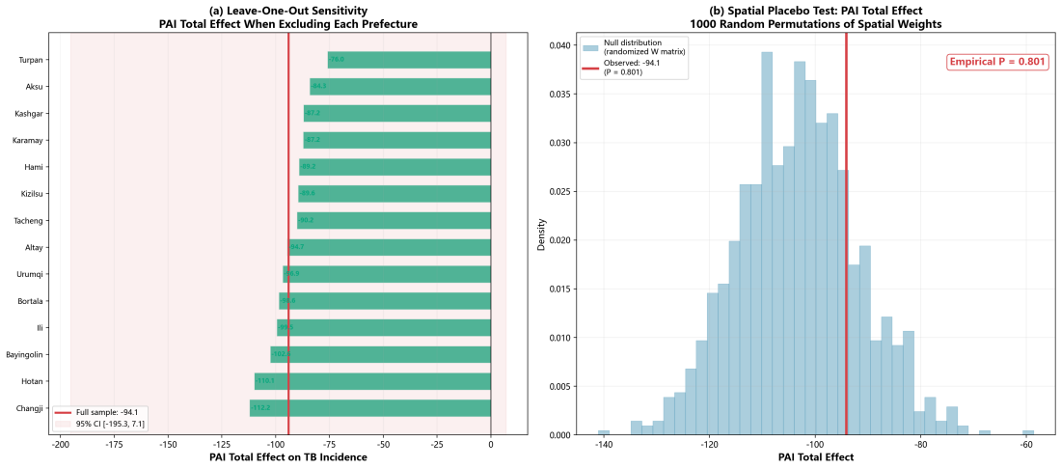
Supplementary Figure S2: Multi-dimensional supplementary analyses. (a) Global Moran’s I trajectory for PAI and TB incidence, 2013–2024; filled markers = P < 0.05. (b) PAI construct validity: Pearson correlations with health and economic indicators. (c) COVID-19 counterfactual bounding with Xinjiang Model effect range. (d) Regional heterogeneity: SDM estimates for Xinjiang-wide (N = 14), Northern (N = 7), and Southern (N = 5) Xinjiang.
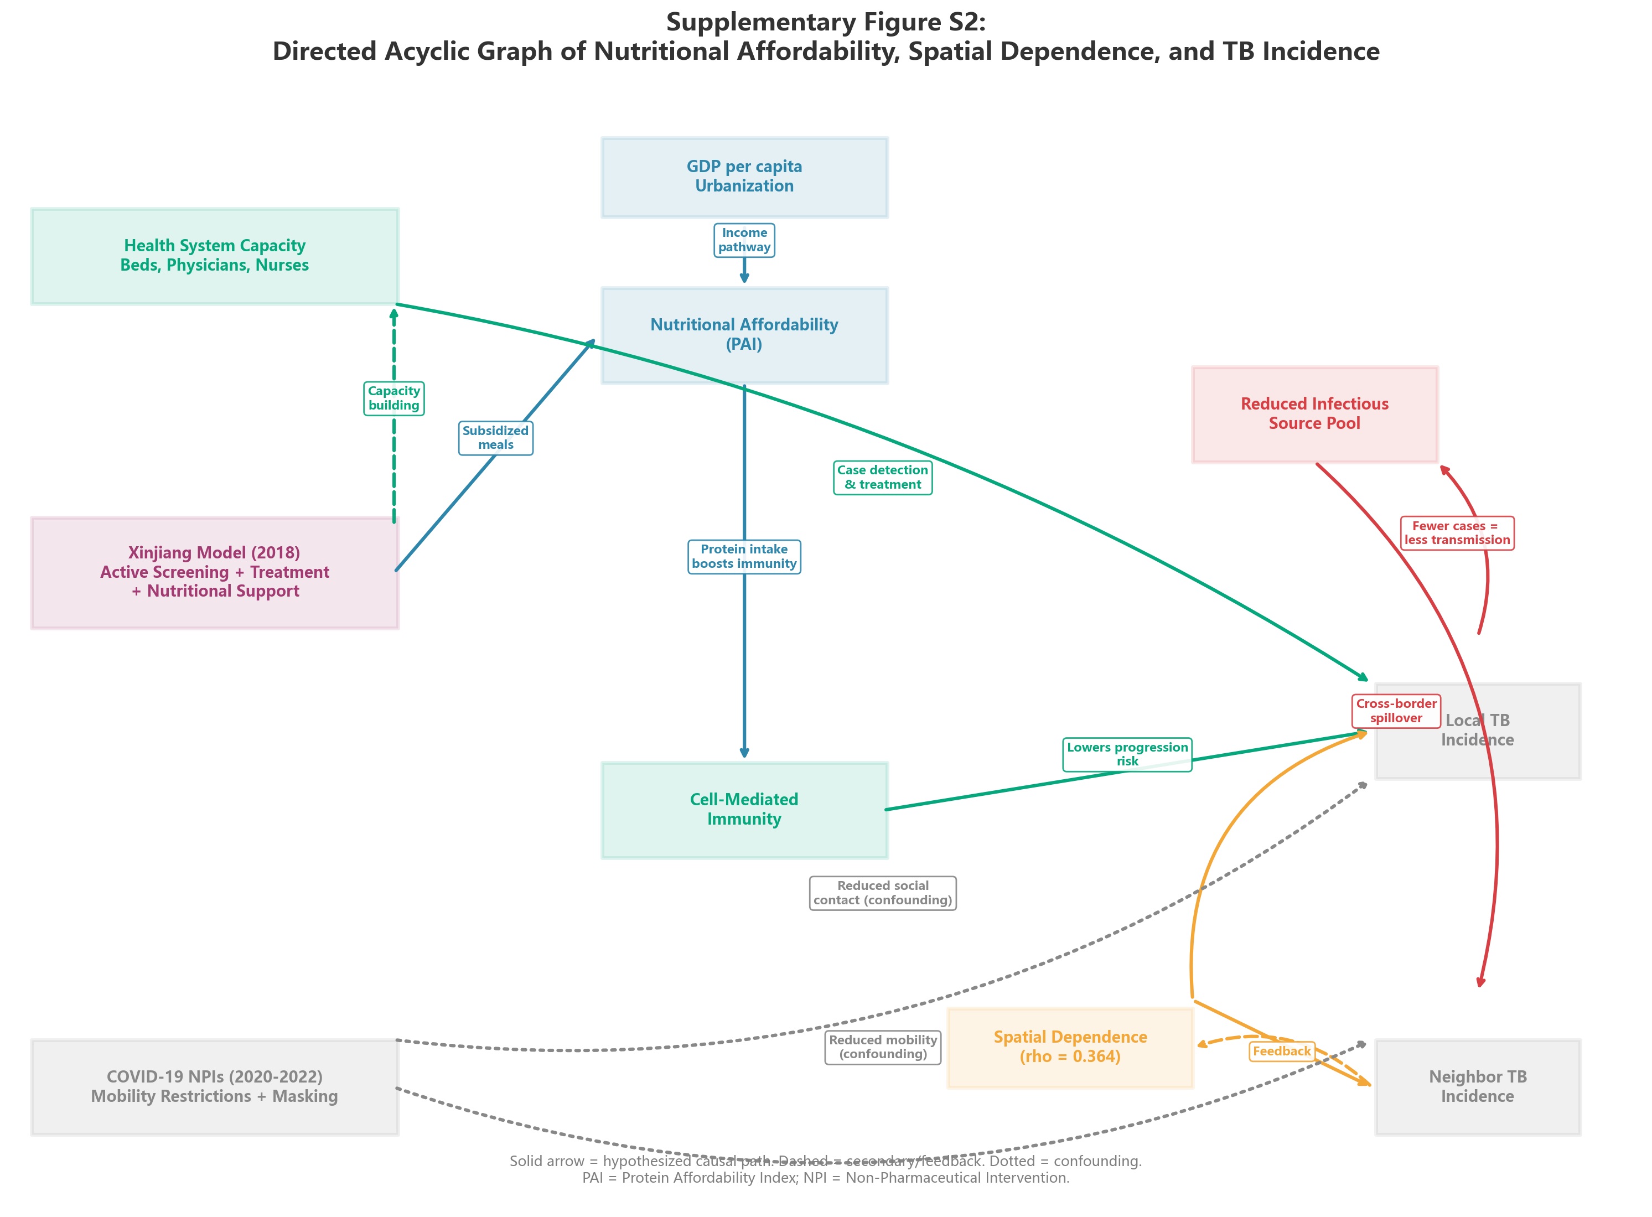
Supplementary Figure S3: XGBoost-SHAP feature importance ranking (mean |SHAP|, top 12 features) and SHAP dependence plots for the six highest-importance features (PAI, bed density, GDP per capita, urbanization, physician density, nurse density), plus post-2018 intervention SHAP value distribution.

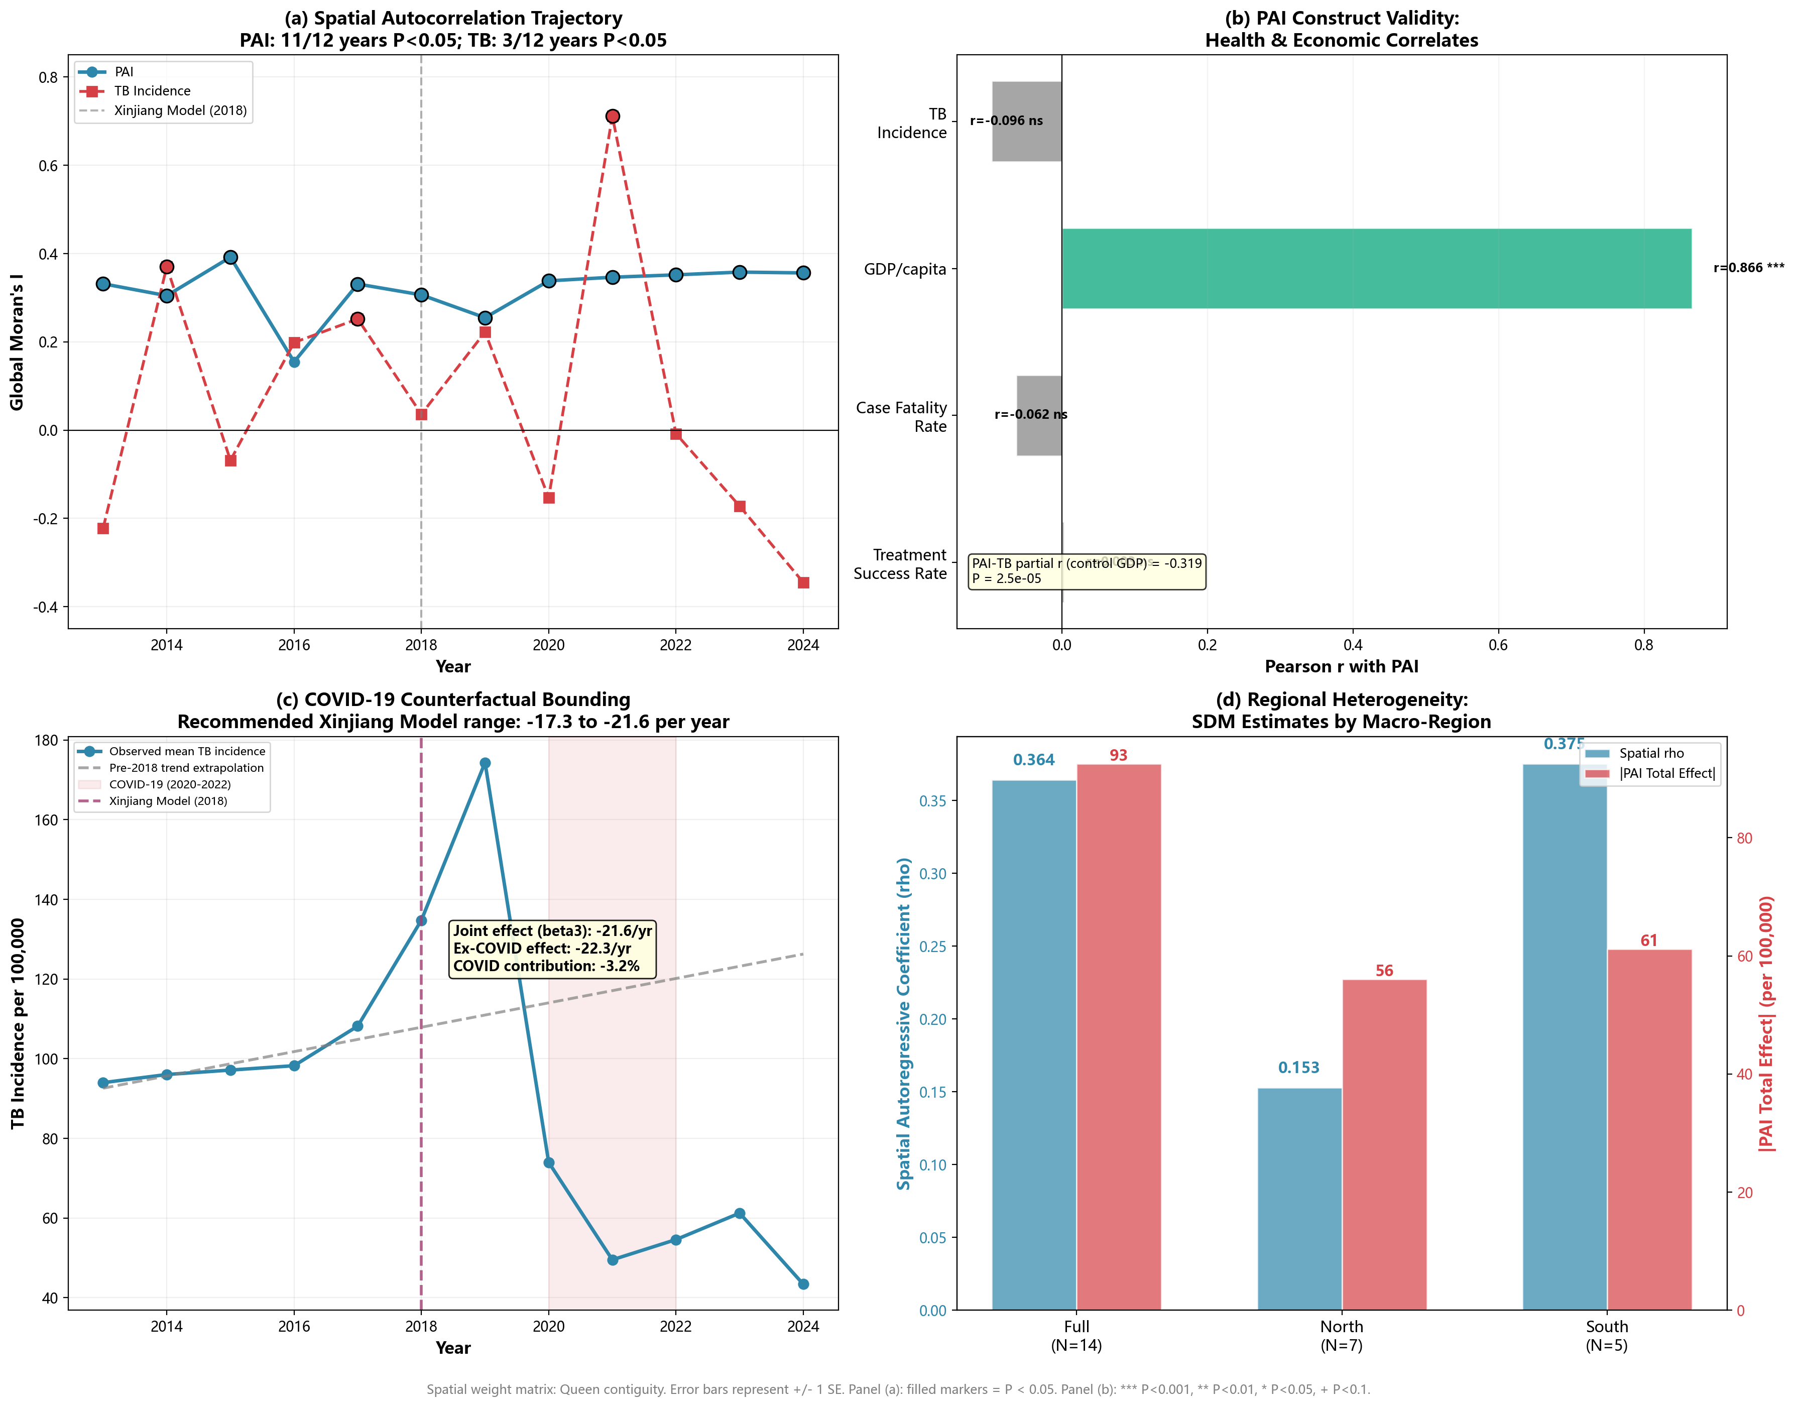
Supplementary Figure S4: Leave-one-out sensitivity analysis and spatial placebo test. (a) PAI total effects from SDM re-estimation with each prefecture sequentially excluded; red line = full-sample baseline with 95% CI. (b) Null distribution of PAI total effects under 1,000 random permutations of the spatial weight matrix; red line = observed value with empirical P.

