Cortisol, oxytocin, and fronto-limbic connectivity responses to acute psychosocial stress in adolescent depression with and without comorbid anxiety
Supplementary Material
M. Sc. Ricarda Jacob^{1*}, PD Dr. Irina Jarvers¹, Dr. Alexandra Otto¹, apl. Prof. Dr. Stephanie Kandsperger¹, Dr. Angelika Ecker¹, Dr. Daniel Schleicher¹, Dr. Wilhelm M. Malloni², Prof. Dr. Inga D. Neumann³, Prof. Dr. Romuald Brunner¹

1 Department of Child and Adolescent Psychiatry and Psychotherapy, University of Regensburg, Universitätsstraße 84, 93053 Regensburg, Germany
2 Department of Cognitive Neuroscience, University of Regensburg, Regensburg, Germany
3 Department of Behavioural and Molecular Neurobiology, University of Regensburg, Regensburg, Germany
Correspondence: Ricarda Jacob, Department of Child and Adolescent Psychiatry and Psychotherapy, University of Regensburg, Universitätsstraße 84, 93053 Regensburg, Germany. E-mail: ricarda.jacob@medbo.de

Contents
Supplementary Figures
Figure S1. Distribution of voxel-to-voxel functional-connectivity values before and after denoising
Figure S2. Distribution of subject-level quality-control measures
Supplementary Tables
Table S1. Distribution of Depressive Diagnoses by Subgroup (ICD-10 Severity)
Table S2. Comorbid ICD-10 Diagnoses Within the Patient Group (n = 58), by Main Diagnostic Chapter
Table S3. Functional MRI Quality-Control Indices (CONN)
Table S4. 25-Node Network (after Hossein et al., 2023)
Table S5. Repeated-Measures ANOVA Results for Subjective Affect and Dissociation Measures
Table S6. Resting-State Connectivity Clusters Showing Group Differences Before Stress Induction
Table S7. Amygdala Seed-to-Voxel Clusters for the Time × Group Interaction
Table S8. Hippocampus Seed-to-Voxel Cluster for the Time × Group Interaction
Table S9. Insula Seed-to-Voxel Clusters for the Time × Group Interaction

References

Methods

Supplementary Table S1
Distribution of Depressive Diagnoses by Subgroup (ICD-10 Severity)
Diagnosis (ICD-10) | MDD (n = 38) | COM (n = 20)
Depressive episode (F32) | 34 (89.5) | 18 (90.0)
F32.1 – moderate | 29 (76.3) | 17 (85.0)
F32.2 – severe, without psychotic symptoms | 4 (10.5) | 1 (5.0)
F32.3 – severe, with psychotic symptoms | 1 (2.6) | 0 (0.0)
Recurrent depressive disorder (F33) | 4 (10.5) | 2 (10.0)
F33.1 – moderate | 4 (10.5) | 2 (10.0)

Note. Values are n (%). ICD= International Statistical Classification of Diseases and Related Health Problems; MDD = major depressive disorder without comorbid anxiety; COM = comorbid group (depression with comorbid anxiety disorder). Percentages are within-subgroup. ICD-10 severity codes were derived by crossing the diagnosis (F32 vs. F33) with the recorded severity level. No cases of mild severity (.0) or recurrent severe subtypes (F33.2/F33.3) were present.
Supplementary Table S2
Comorbid ICD-10 Diagnoses Within the Patient Group (n = 58), by Main Diagnostic Chapter
ICD-10 chapter | Diagnoses, n
F3 Mood (affective) disorders | 58
F4 Neurotic, stress-related, and somatoform disorders | 28
F5 Behavioral syndromes associated with physiological disturbances and physical factors (Eating disorders) | 3
F6 Disorders of adult personality and behaviour | 3
F8 Disorders of psychological development | 6
F9 Behavioural and emotional disorders, childhood onset | 15
Note. All patients met criteria for an affective disorder (F3) as an inclusion criterion. Because patients could receive more than one diagnosis, values represent the number of diagnoses rather than unique patients; within-block counts may therefore exceed the number of affected individuals. The most frequent comorbid conditions were social phobia (F40.1, n = 14), attention-deficit/hyperactivity disorder (F90, n = 7), reading/spelling disorder (F80/F81, n = 6), and obsessive-compulsive disorder (F42, n = 5). Diagnoses were assigned according to ICD-10 based on clinical diagnosis.

Functional MRI quality control
Quality control was performed in CONN after preprocessing and denoising. Two of CONN’s three quality-control indices were computed: data validity (removal of biases in functional-connectivity estimates) and data sensitivity (participant selection and effective sample size; Supplementary Table S1). Denoising effectively removed global and distance-dependent confounds, shifting the voxel-to-voxel connectivity distribution to a near-zero centre (Supplementary Figure S2).
Supplementary Table S3. Functional MRI quality-control indices (CONN).
QC index | Score | Detail
Data validity | 97.6% | FC distribution peak r = −0.004 ± 0.013, width = 0.226 ± 0.019 (n = 91)
Data sensitivity | 100% | n = 90 after excluding one extreme outlier (> 3 IQR); single-subject sensitivity = 27.2% (df = 110.1)
Note. FC = functional connectivity; IQR = interquartile range. Scores range from 0 to 100. The final analysis sample is reported in the main text.

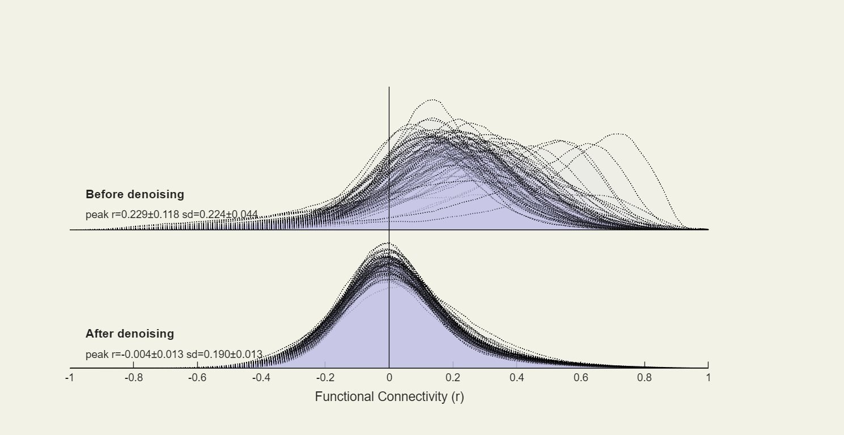
Supplementary Figure S1. Distribution of voxel-to-voxel functional-connectivity values before and after denoising, across all participants. Before denoising, the distribution was positively shifted and broad (peak r = 0.229 ± 0.118, SD = 0.224 ± 0.044); after denoising it was centred near zero with reduced spread (peak r = −0.004 ± 0.013, SD = 0.190 ± 0.013), indicating effective removal of global and distance-dependent confounds.

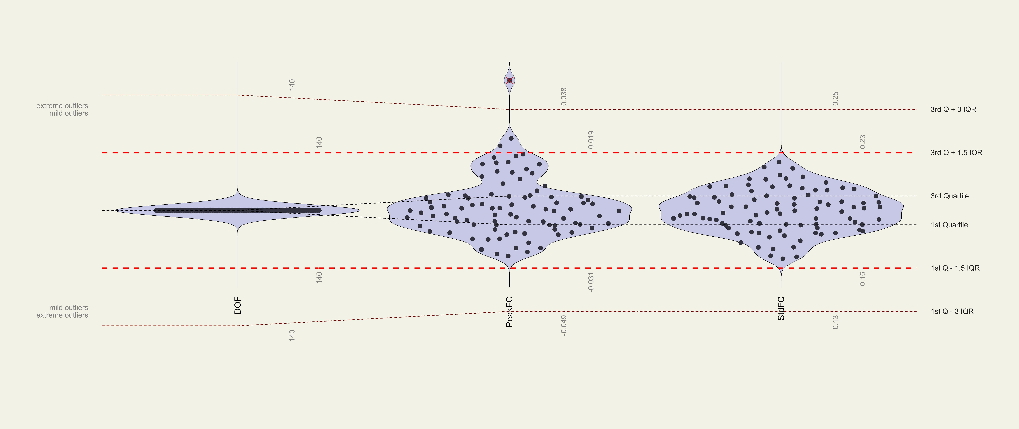
Supplementary Figure S2. Distribution of subject-level quality-control measures (degrees of freedom, DOF; peak of the functional-connectivity distribution, PeakFC; standard deviation of the functional-connectivity distribution, StdFC). Dotted and dashed lines mark the 1.5 and 3 interquartile-range thresholds. One participant exceeded the 3-IQR criterion on PeakFC and was flagged as an extreme outlier.

Functional connectivity analysis
Supplementary Table S4.
25-node network (after Hossein et al., 2023)
Cortical nodes (n = 11; bilateral masks)
# | Region
1 | Anterior cingulate cortex (cingulate gyrus, anterior division)
2 | Frontal medial cortex
3 | Frontal orbital cortex
4 | Frontal pole
5 | Inferior frontal gyrus, pars opercularis
6 | Inferior frontal gyrus, pars triangularis
7 | Insular cortex
8 | Middle frontal gyrus
9 | Paracingulate gyrus
10 | Subcallosal cortex
11 | Superior frontal gyrus
Subcortical nodes (n = 14; left and right hemispheres separately)
# | Region | Hemisphere
12 | Amygdala | L
13 | Amygdala | R
14 | Accumbens | L
15 | Accumbens | R
16 | Hippocampus | L
17 | Hippocampus | R
18 | Caudate | L
19 | Caudate | R
20 | Putamen | L
21 | Putamen | R
22 | Pallidum | L
23 | Pallidum | R
24 | Thalamus | L
25 | Thalamus | R

All nodes were derived from the Harvard-Oxford atlas as implemented in CONN, consistent with the six a priori fronto-limbic ROIs.

Results

Supplementary Table S5
Repeated-Measures ANOVA Results for Subjective Affect and Dissociation Measures
Measure | Effect | F (df) | p | η_{p}²
VAS stressed | Time | 4.28 (4.41, 370.26) | .001 | .049
 | Time × Group | 5.53 (4.41, 370.26) | < .001 | .062
 | Group | 5.16 (1, 84) | .026 | .058
 | SPAIK (covariate) | 9.93 (1, 84) | .002 | .106
VAS anxious | Time | 1.35 (4.03, 338.36) | .251 | .016
 | Time × Group | 1.39 (4.03, 338.36) | .237 | .016
 | Group | 0.29 (1, 84) | .592 | .003
 | SPAIK (covariate) | 9.93 (1, 84) | .002 | .106
VAS angry | Time | 1.98 (2.63, 220.99) | .126 | .023
 | Time × Group | 6.75 (2.63, 220.99) | < .001 | .074
 | Group | 11.88 (1, 84) | < .001 | .124
 | SPAIK (covariate) | 1.43 (1, 84) | .236 | .017
VAS ashamed | Time | 0.88 (2.28, 191.18) | .430 | .010
 | Time × Group | 3.34 (2.28, 191.18) | .032 | .038
 | Group | 0.69 (1, 84) | .410 | .008
 | SPAIK (covariate) | 4.39 (1, 84) | .039 | .050
VAS guilty | Time | 1.37 (2.12, 178.32) | .256 | .016
 | Time × Group | 5.12 (2.12, 178.32) | .006 | .057
 | Group | 0.73 (1, 84) | .396 | .009
 | SPAIK (covariate) | 3.57 (1, 84) | .062 | .041
PANAS positive affect | Time | 14.30 (1, 84) | < .001 | .145
 | Time × Group | 0.06 (1, 84) | .807 | .001
 | Group | 9.08 (1, 84) | .003 | .098
 | SPAIK (covariate) | 4.69 (1, 84) | .033 | .053
PANAS negative affect | Time | 2.14 (1, 84) | .147 | .025
 | Time × Group | 0.17 (1, 84) | .678 | .002
 | Group | 9.46 (1, 84) | .003 | .101
 | SPAIK (covariate) | 5.94 (1, 84) | .017 | .066
DSS-4 | Time | 0.08 (1, 84) | .781 | .001
 | Time × Group | 0.91 (1, 84) | .342 | .011
 | Group | 6.02 (1, 84) | .016 | .067
 | SPAIK (covariate) | 0.03 (1, 84) | .856 | .000
Note. Within-subject factor Time (nine timepoints for VAS scales, two for PANAS and DSS-4); between-subject factors Group (healthy controls vs. patients) and biological sex; covariates were the SPAIK total score (social anxiety) and the PDS score (pubertal status). Greenhouse-Geisser-corrected degrees of freedom are reported for the VAS scales owing to violations of sphericity. N = 90 (HC: n = 34; patients: n = 56). VAS = visual analogue scale; PANAS = Positive and Negative Affect Schedule; DSS-4 = Dissociation-Tension Scale; SPAIK = Social Phobia and Anxiety Inventory for Children. η_{p}² = partial eta squared. Significant values ​​are marked in bold.
Supplementary Table S6
Resting-State Connectivity Clusters Showing Group Differences Before Stress Induction
Seed | Region | Side | k | Peak MNI (x, y, z) | Peak T(82) | p-FDR
ACC | Parietal operculum / planum temporale | R | 188 | 44, −32, 16 | −4.56 | .006
 | Central opercular cortex | L | 188 | −52, −18, 18 | −4.84 | .006
Hippocampus | Insula / frontal opercular cortex | R | 563 | 42, 18, −10 | −5.05 | < .001
 | Dorsal ACC / paracingulate cortex | R | 129 | 4, 18, 36 | −4.61 | .025
Insula | Central / parietal (sensorimotor) operculum | L | 221 | −42, −20, 24 | −5.38 | .003
Note. All clusters reflect lower connectivity in patients than in controls. Seeds were entered into seed-to-voxel analyses; clusters were thresholded at a voxel-level p < .001 (uncorrected) and a cluster-level p < .05 (FDR-corrected). k = cluster size in voxels (2 mm isotropic); coordinates are in MNI space and refer to the peak voxel. ACC = anterior cingulate cortex; L = left; R = right; p-FDR = false-discovery-rate-corrected p value.

Supplementary Table S7
Amygdala Seed-to-Voxel Clusters for the Time × Group Interaction
Region | Side | k | Peak MNI (x, y, z) | Peak T(82) | p-FDR | Change in patients
Ventromedial prefrontal cortex (frontal medial / subcallosal) | Midline | 78 | −2, 36, −20 | −4.37 | .041 | Decrease
Frontal orbital / anterior insular cortex | R | 81 | 42, 18, −12 | 5.30 | .041 | Increase
Note. Clusters from a seed-to-voxel analysis with the amygdala as seed, testing the time × group interaction (stress × group). Thresholds: voxel level p < .001 (uncorrected) and cluster level p < .05 (FDR-corrected). k = cluster size in voxels (2 mm isotropic); coordinates are in MNI space and refer to the peak voxel. “Change in patients” denotes the direction of the stress-related connectivity change (post minus pre) in patients relative to controls. L = left; R = right; p-FDR = false-discovery-rate-corrected p value.

Supplementary Table S8
Hippocampus Seed-to-Voxel Cluster for the Time × Group Interaction
Region | Side | k | Peak MNI (x, y, z) | Peak T(82) | p-FDR | Change in patients
Frontal orbital / anterior insular cortex | R | 120 | 42, 20, −12 | 5.04 | .023 | Increase
Note. Cluster from a seed-to-voxel analysis with the hippocampus as seed, testing the time × group interaction (stress × group). Thresholds: voxel level p < .001 (uncorrected) and cluster level p < .05 (FDR-corrected). k = cluster size in voxels (2 mm isotropic); coordinates are in MNI space and refer to the peak voxel. “Change in patients” denotes the direction of the stress-related connectivity change (post minus pre) in patients relative to controls. R = right; p-FDR = false-discovery-rate-corrected p value.

Supplementary Table S9
Insula Seed-to-Voxel Clusters for the Time × Group Interaction
Region | Side | k | Peak MNI (x, y, z) | Peak T(82) | p-FDR | Change in patients
Angular gyrus / lateral occipital cortex | R | 161 | 58, −56, 34 | 5.04 | .011 | Increase
Temporal pole / anterior middle temporal gyrus | L | 146 | −56, 4, −28 | 4.31 | .011 | Increase
Central opercular cortex | L | 104 | −46, −20, 24 | 4.71 | .035 | Increase
Note. Clusters from a seed-to-voxel analysis with the insula as seed, testing the time × group interaction (stress × group). Thresholds: voxel level p < .001 (uncorrected) and cluster level p < .05 (FDR-corrected). k = cluster size in voxels (2 mm isotropic); coordinates are in MNI space and refer to the peak voxel. “Change in patients” denotes the direction of the stress-related connectivity change (post minus pre) in patients relative to controls. L = left; R = right; p-FDR = false-discovery-rate-corrected p value.

References
Hossein, S., Cooper, J. A., DeVries, B. A. M., Nuutinen, M. R., Hahn, E. C., Kragel, P. A., & Treadway, M. T. (2023). Effects of acute stress and depression on functional connectivity between prefrontal cortex and the amygdala. Molecular Psychiatry, 28(11), 4602–4612. https://doi.org/10.1038/s41380-023-02056-5

