Supplementary Materials
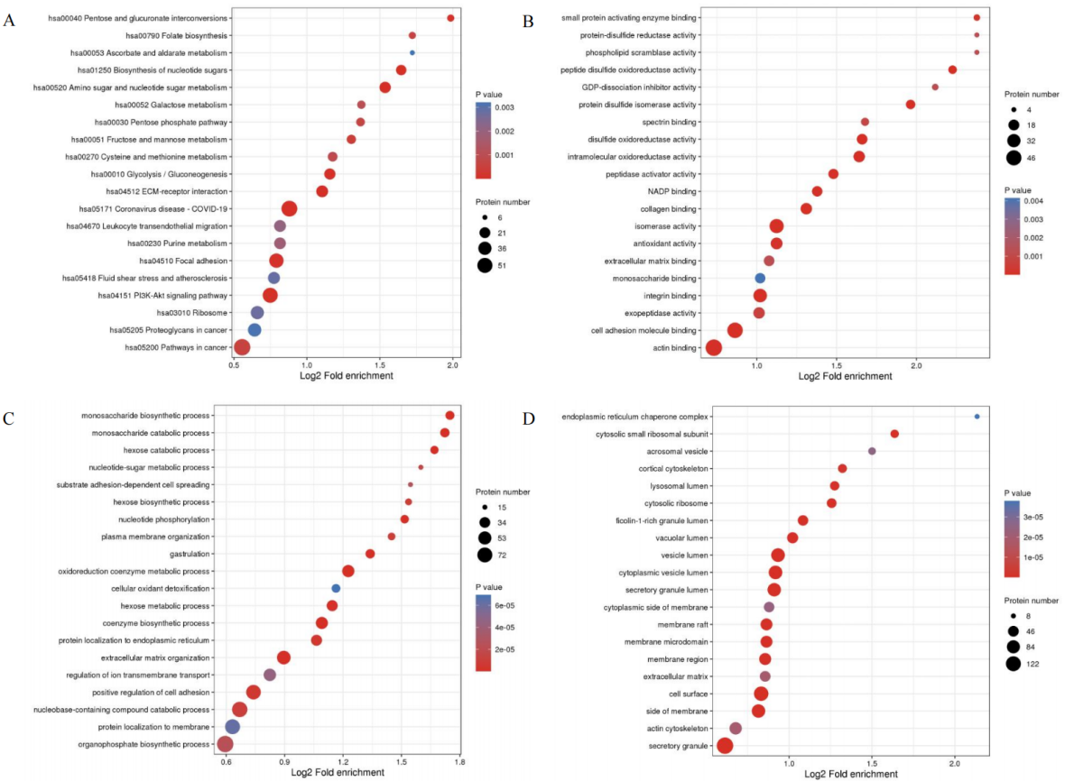
Fig S1. Functional Enrichment Analysis of Tissue Differentially Expressed Proteins. A. KEGG pathway enrichment bubble plot; B. GO molecular function enrichment bubble plot; C. GO biological process enrichment bubble plot; D. GO cellular component enrichment bubble plot
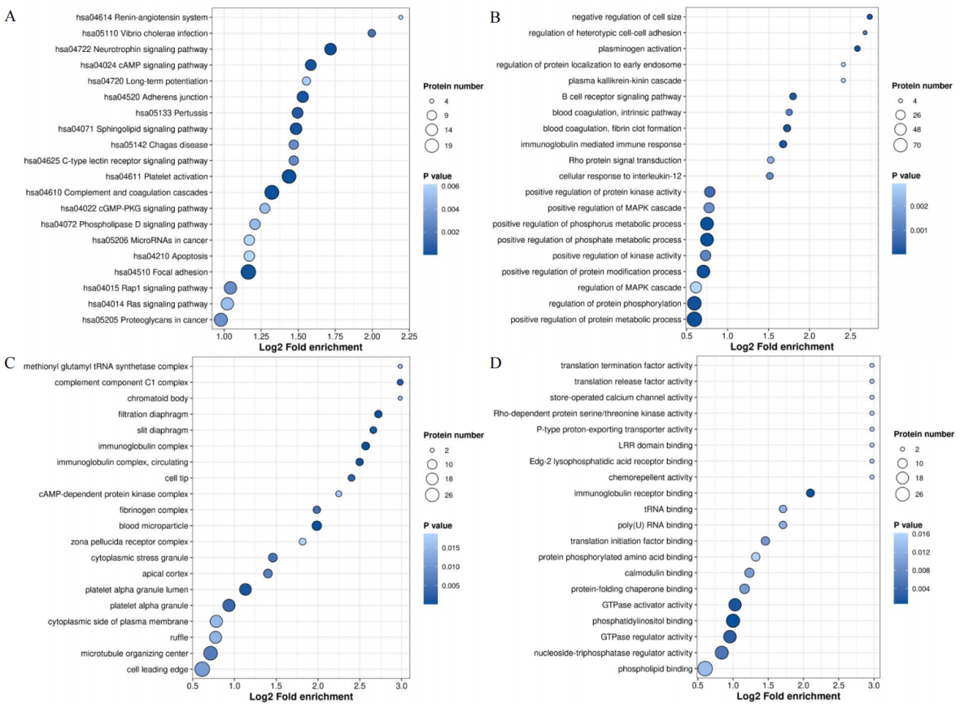
Fig S2. Functional Enrichment Analysis of Plasma Differentially Expressed Proteins. A. KEGG pathway enrichment bubble plot; B. GO biological process enrichment bubble plot; C. GO cellular component enrichment bubble plot; D. GO molecular function enrichment bubble plot

