Supplemental data

Title:
Intimate relationships among soil bacteria: actinomycetes and mycolic acid-containing bacteria

Authors:
Manami Kato†,[a] Shumpei Asamizu†*,[a,b] and Hiroyasu Onaka* [a,b]

Affiliation:
[a] Graduate School of Agricultural and Life Sciences, The University of Tokyo, 1-1-1 Yayoi, Bunkyo, Tokyo 113-8657, Japan
[b] Collaborative Research Institute for Innovative Microbiology, The University of Tokyo 1-1-1 Yayoi, Bunkyo, Tokyo 113-8657, Japan

†These authors contributed equally to this work.

*Corresponding authors:
Shumpei Asamizu, Email: asamizu@mail.ecc.u-tokyo.ac.jp
Hiroyasu Onaka, Email: aonaka@mail.ecc.u-tokyo.ac.jp

Contents of supplemental data

Supplemental table 1
Natural product discovery from combined culture.
Supplemental figure 1
Methods for bacterial isolation from Hegura Island environmental samples used in this study.
Supplemental figure 2
Methods to assay the bacterial coaggregation used in this study.
Supplemental table 2
Taxonomy of the 166 strains and definitions used in this study.
Supplemental table 3
List of strains in the combined clade shown in Figure 1.
Supplemental figure 3
Scanning electron microscope image of co-isolated filamentous or cocci-shaped actinomycetes and other bacteria in co-culture.
Supplemental figure 4
Analysis of the colonies obtained by co-isolation experiments from combined-culture of Streptomyces lividans TK23 and Tsukamurella pulmonis TP-B0596.
Supplemental figure 5
Analysis of the colonies obtained by co-isolation experiments from co-culture of Streptomyces lividans TK23 and Bacillus subtilis 168.
Supplemental figure 6
Analysis of the colonies obtained by co-isolation experiments from combined culture of Streptomyces sp. HEK138A and Mycobacterium sp. HEK138M.
Supplemental figure 7
Analysis of the colonies obtained by co-isolation experiments from combined culture of Streptomyces sp. HEK138A and Mycobacterium sp. HEK138M from soil.
Supplemental figure 8
HPLC profile of the metabolites from combined culture between the natural co-isolated pair.
Supplemental figure 9
Identification of active compound from HEK138A and M.
Supplemental table 4
Sources and methods for the initial isolation from the Hegura Island environmental samples of tested bacteria used in this study.
References

Supplemental table 1. Natural product discovery from combined culture. Natural products discovered from combined culture of actinomycetes with Tsukamurella pulmonis TP-B0596 (MACB) are listed in this table.
strain | induced natural products | original producing strain | references
Actinosynnema mirum NBRC 14064 | mirilactams C-E |  | ¹
Amycolatopsis sp. 26-4 | amycolapeptins A and B |  | ²
Catenuloplanes sp. RD067331 | catenulobactins A and B |  | ³
Micromonospora wenchangensis HEK797 | dracolactams A and B |  | ⁴
Saccharothrix sp. A1506 | saccharothriolide C-2 |  | ⁵
Streptomyces albogriseolus HEK740 | streptogramin B and L-156,587 |  | ⁶
Streptomyces cinnamoneus NBRC 13823 | arcyriaflavin E |  | ⁷
Streptomyces davawensis JCM 4913 | desferrioxamine derivatives |  | ⁸
Streptomyces endus S-522 | alchivemycin A and B |  | ⁹
Streptomyces nigrescens HEK616 | streptoaminals |  | ^{10, 11}
 | 5-alkyl-1,2,3,4-tetrahydroquinolines |  | ^{10, 12, 13}
Streptomyces sp. CJ-5 | chojalactones A-C |  | ¹⁴
Streptomyces sp. KUSC_F05 | longicatenamides A-D |  | ¹⁵
Streptomyces sp. NZ-6 | niizalactams A-C |  | ¹⁶
Umezawaea sp. RD066910 | umezawamides |  | ¹⁷
heterologous expression in S. lividans TK23 | goadsporin A-C | from Streptomyces sp. TP-A0584 | ^{18, 19}
heterologous expression in S. lividans TK23 | staurosporin | from Streptomyces sp. TP-A0274 | ¹⁹
heterologous expression in S. lividans TK23 | rebeccamycin | from Lechevalieria aerocolonigenes ATCC 39243 | ¹⁹
heterologous expression in S. lividans TK23 | streptoaminals | from Streptomyces nigrescens HEK616 | ¹⁰
heterologous expression in S. lividans TK23 | 5-alkyl-1,2,3,4-tetrahydroquinolines | from Streptomyces nigrescens HEK616 | ¹⁰

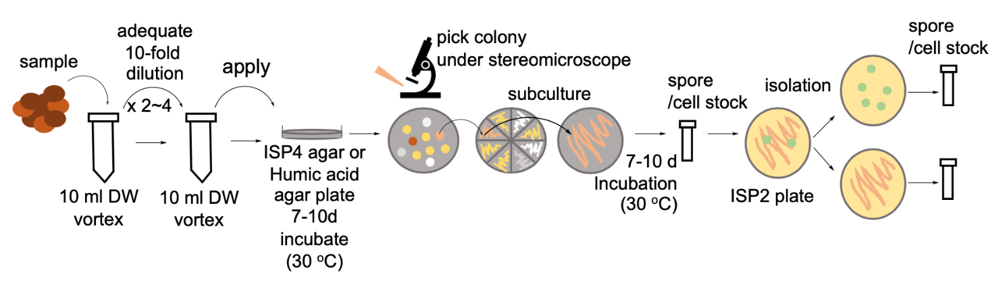
Supplemental figure 1
Methods for bacterial isolation from Hegura Island environmental samples used in this study. General dilution methods were used in this study.

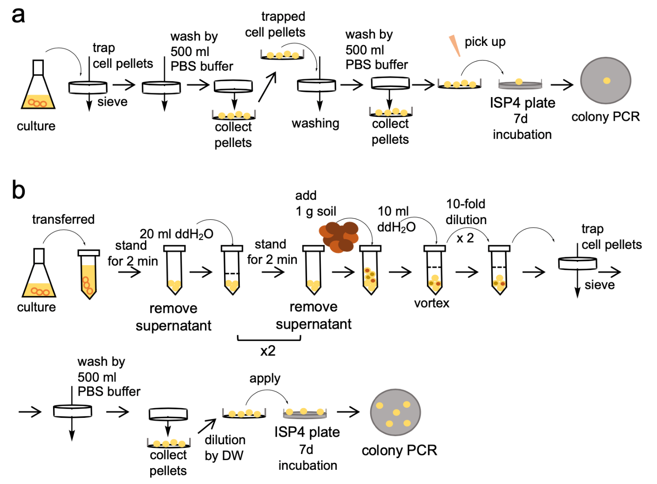
Supplemental figure 2
Methods to assay the bacterial coaggregation used in this study. (a) Cell pellets from liquid co-culture were captured by stainless-steel sieve and washed with phosphate-buffered saline to remove planktonic cells. Then the captured cell pellets were picked up by tweezers and inoculated on the agar medium to confirm that the cell pellet contained both filamentous actinomycetes and mycolic acid-containing bacteria. (b) Cell pellets form liquid co-culture were washed with ddH₂O twice to remove excess planktonic cells and collected sedimented cells were suspended with sterilized soil. Cells suspended in soil were diluted in ddH₂O and pellets were captured by stainless-steel sieve. Then the captured cell pellets were diluted in ddH₂O and inoculated on the agar medium.
Ten milliliters of sterilized ddH₂O was added to the 1 g of sample and suspended with agitation (on a shaker at 300 rpm) for 10 min. The suspended solution (1 ml) was further diluted by addition of 9 ml of sterilized ddH₂O and suspended with agitation for 10 min (on a shaker at 300 rpm). Then, the solution was passed through a stainless-steel sieve to trap the pellet, and 500 ml of PBS buffer was additionally passed to thoroughly wash the bacterial pellets that were trapped in the sieve. This step was necessary to remove excess cells of HEK138M prior to inoculation on the agar plate. Subsequently, the bacterial pellets were recovered from the sieve and suspended in ddH₂O. Cell suspension (100 µL) was inoculated onto an ISP4 agar plate and further incubated at 30°C for 7 days. The images of growing colonies were obtained by stereomicroscope, and selective PCR was performed to determine the strain content of the growing colonies.

Supplemental table 2. Taxonomy of the 182 isolated strains from Hegura Island based on partial 16S rRNA gene sequences and definitions used in this study.

Supplemental table 3
List of strains in the combined clade shown in Figure 1.

Strepotmyces spp. Group 1
Streptomyces gilvifuscus HEK217
Streptomyces rameus HEK174
Streptomyces fradiae HEK219
Streptomyces neyagawaensis HEK299
Streptomyces bottropensis HEK56
Streptomyces scabies HEK53
Streptomyces spp. Group 2
Streptomyces malachitospinus HEK348
Streptomyces violaceorubidus HEK325
Streptomyces tendae HEK14
Streptomyces coelescens HEK126
Streptomyces tuirus HEK58
Streptomyces olivaceus HEK143
Streptomyces albogriseolus HEK182
Streptomyces griseoflavus HEK263
Streptomyces iakyrus HEK15
Streptomyces ambofaciens HEK180
Streptomyces nigra HEK46
Streptomyces spp. Group 3
Streptomyces badius HEK513
Streptomyces gelaticus HEK253
Streptomyces atratus HEK825
Streptomyces parvus HEK402
Streptomyces sundarbansensis HEK231
Streptomyces bacillaris HEK211
Streptomyces californicus HEK341
Streptomyces fulvissimus HEK886
Streptomyces griseus HEK950
Streptomyces flavogriseus HEK308
Streptomyces baarnensis HEK597
Streptomyces panaciradicis HEK666
Streptomyces pratensis HEK782
Streptomyces spp. Group 4
Streptomyces lydicus HEK497
Streptomyces monticola HEK574
Streptomyces sioyaensis HEK934
Streptomyces yogyakartensis HEK417
Streptomyces amphotericinicus HEK747
Streptomyces qinglanensis HEK208
Streptomyces ramulosis HEK967
Streptomyces angustmyceticus HEK277
Streptomyces platensis HEK633
Microbacterium spp. Group
Microbacterium maritypicum HEK898
Microbacterium paraoxydans HEK943
Microbacterium yannicii HEK924
Microbacterium testaceus HEK540
Agromyces spp. Group
Agromyces allii HEK874
Agromyces aureus HEK999
Agromyces hippuratus HEK834
Micromonospora spp. Group
Micromonospora harpali HEK31
Micromonospora spongicola HEK82
Micromonospora saelicesensis HEK663-1
Micromonospora humi HEK441
Micromonospora aurantiaca HEK539
Micromonospora coxensis HEK204
Micromonospora marina HEK794
Micromonospora siamensis HEK981

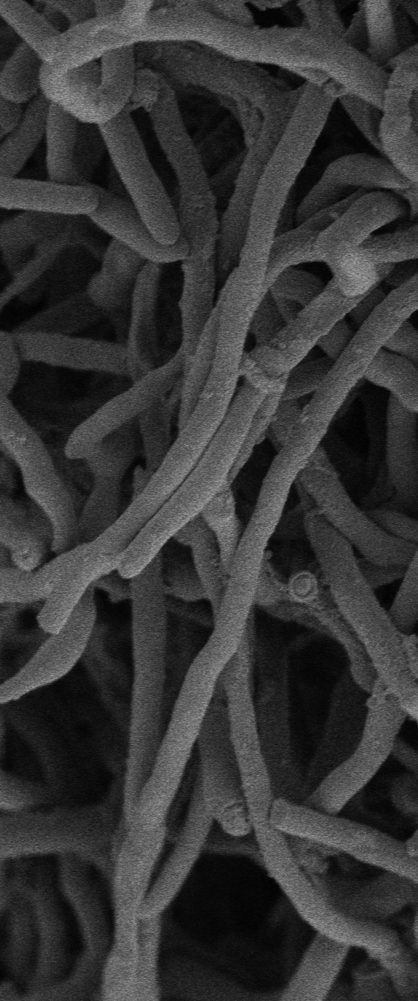
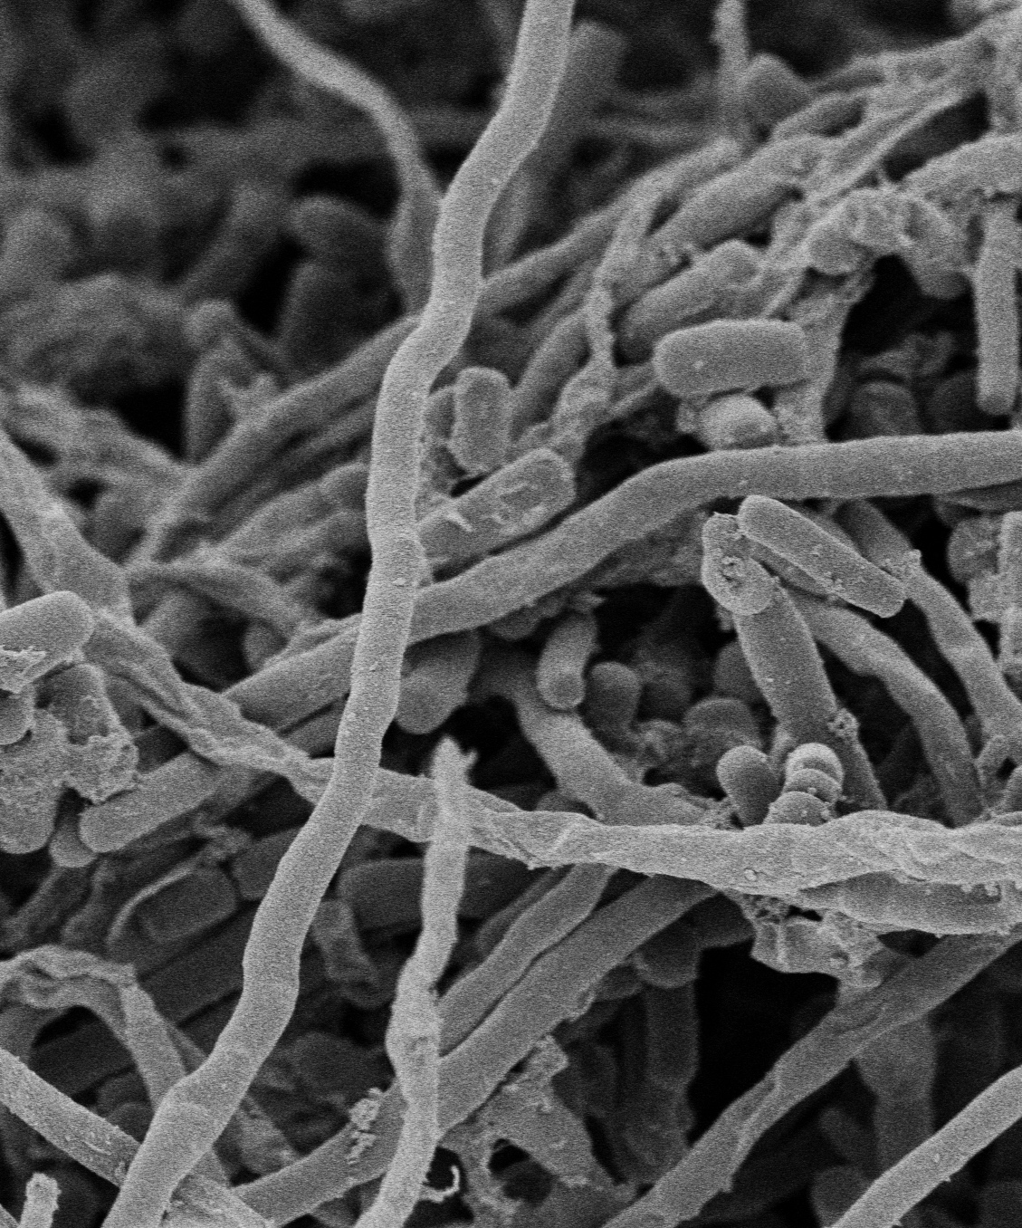
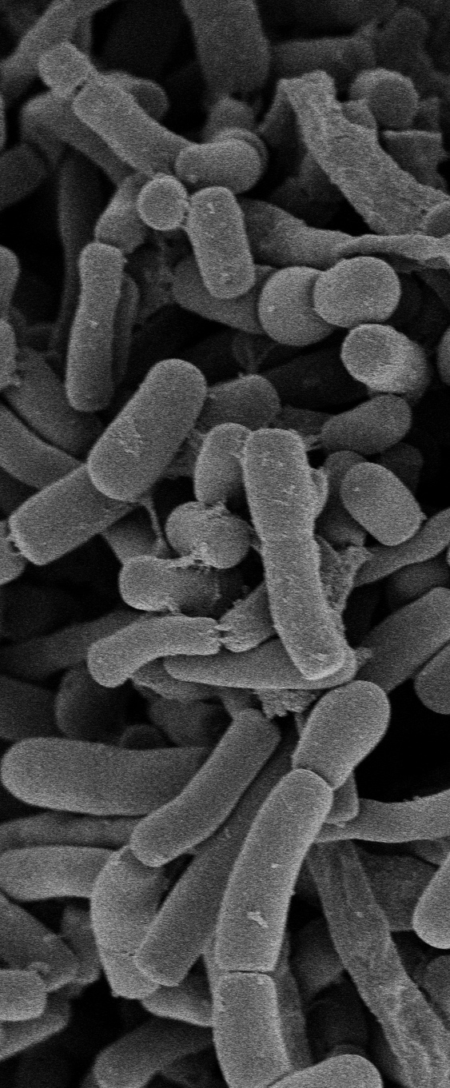
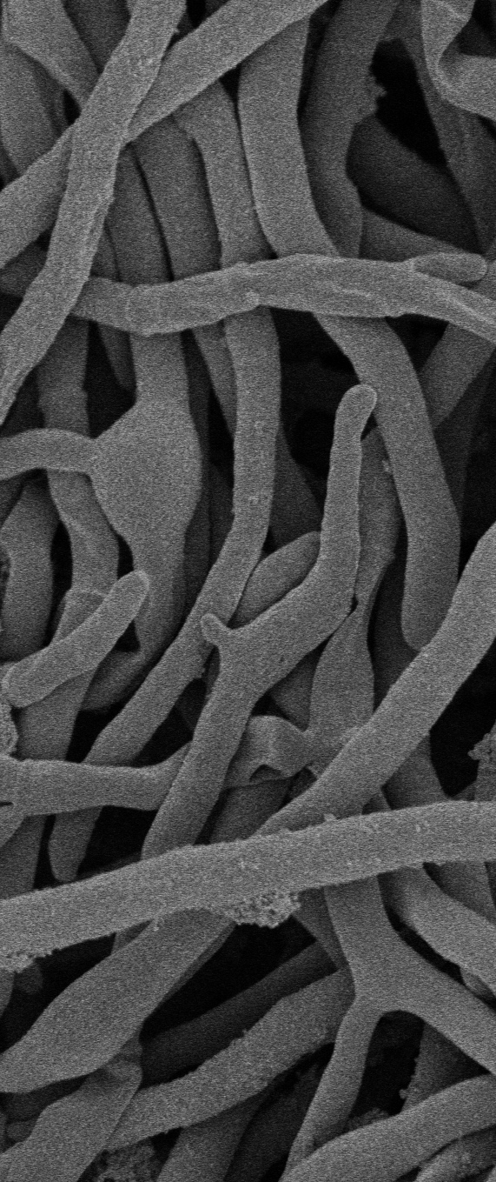
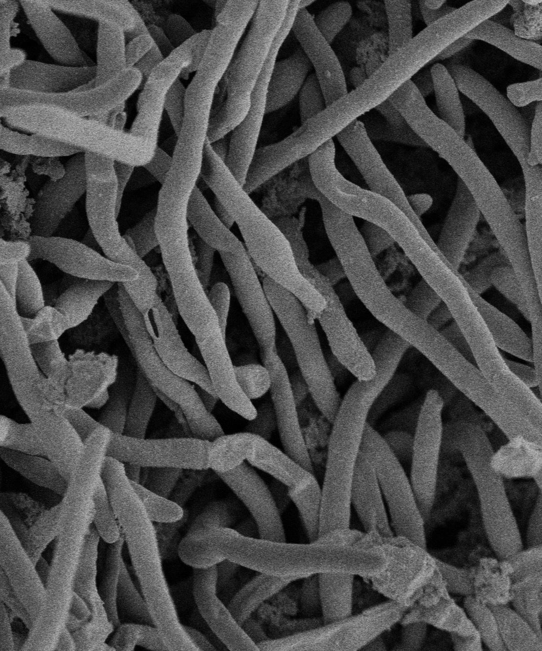
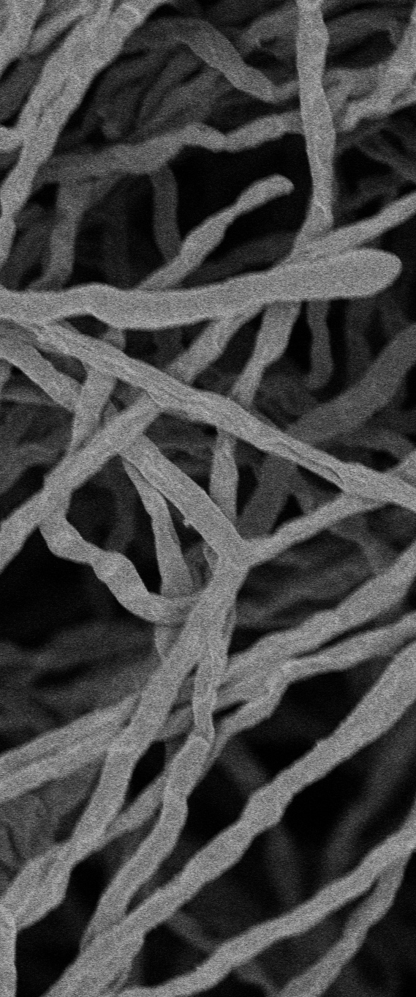
a
A1
A1+A2
A2
b
A1
A1+A2
A2

Supplemental figure 3
Scanning electron microscope image of co-isolated filamentous or cocci-shaped actinomycetes and other bacteria in co-culture. (a) Left image: monoculture of HEK332A1. Middle image: co-culture of HEK332A1/A2. Right image: monoculture of HEK332A2. (b) Left image: monoculture of HEK423A1. Middle image: co-culture of HEK423A1/A2. Right image: monoculture of HEK423A2. (Scale bar = 2 µm)

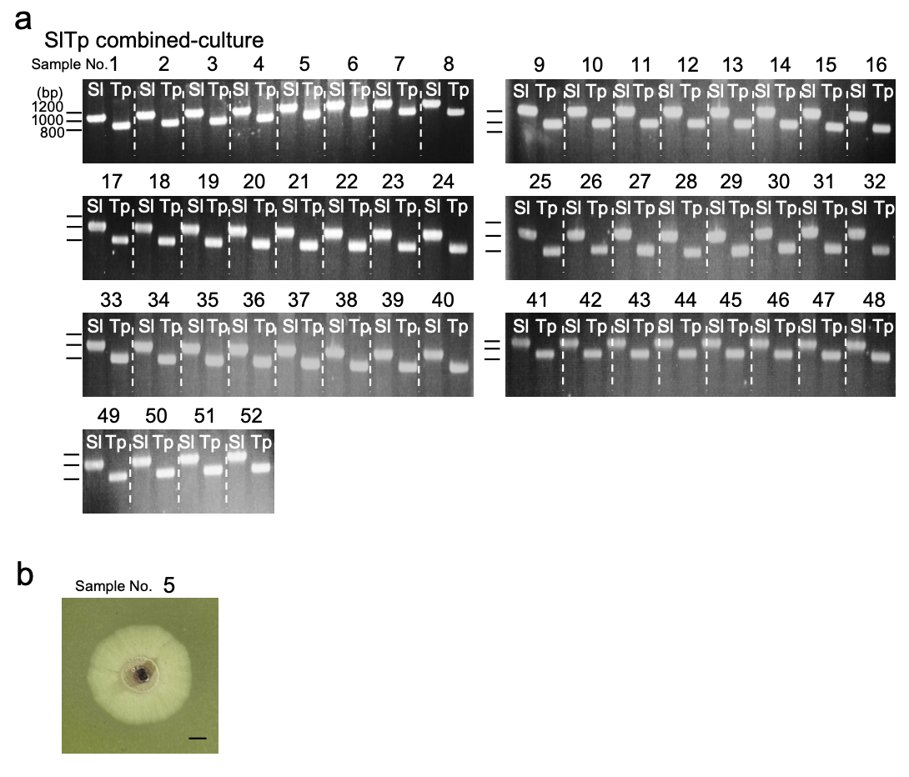
Supplemental figure 4
Analysis of the colonies obtained by co-isolation experiments from combined-culture of Streptomyces lividans TK23 and Tsukamurella pulmonis TP-B0596. (a) Agarose gel electrophoresis of selective colony PCR products. Fifty-two colonies were tested using primers to amplify specific regions of the 16S rRNA gene for S. lividans TK23 (Sl) and T. pulmonis TP-B0596 (Tp). (b) Example of stereomicroscope image of the colony containing both Sl and Tp. (Scale bar: 1 mm)

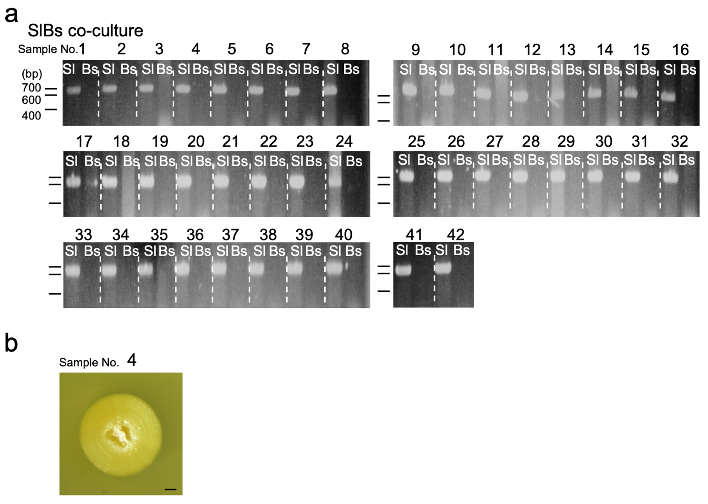
Supplemental figure 5
Analysis of the colonies obtained by co-isolation experiments from co-culture of Streptomyces lividans TK23 and Bacillus subtilis 168. (a) Agarose gel electrophoresis of selective colony PCR products. Forty-two colonies were tested using primers to amplify specific regions of the 16S rRNA gene for S. lividans TK23 (Sl) and B. subtilis 168 (Bs). (b) Example of stereomicroscope image of the colony containing both Sl and Bs. (Scale bar: 1 mm)

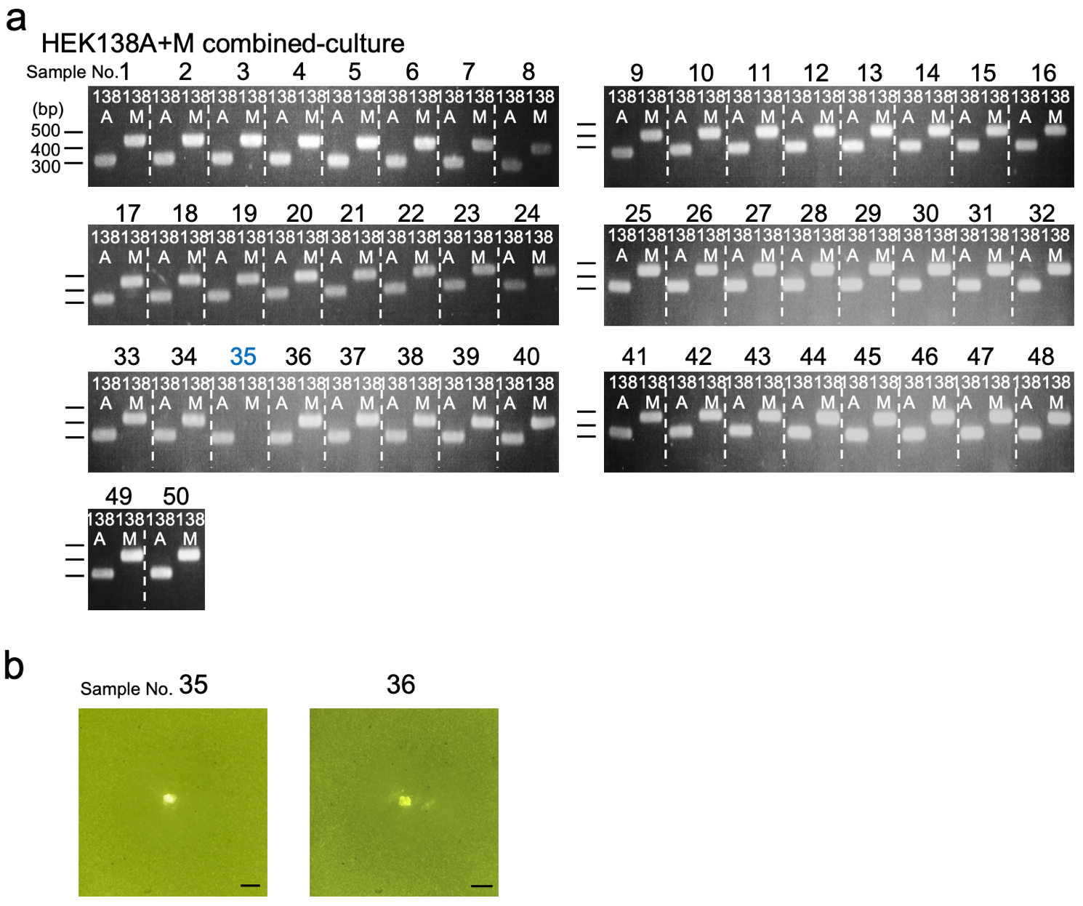
Supplemental figure 6
Analysis of the colonies obtained by co-isolation experiments from combined culture of Streptomyces sp. HEK138A and Mycobacterium sp. HEK138M. (a) Agarose gel electrophoresis of selective colony PCR products. Fifty colonies were tested using primers to amplify specific regions of the 16S rRNA gene for Streptomyces sp. HEK138A (138A) and Mycobacterium sp. HEK138M (138M). (b) Example of stereomicroscope image of the colony containing both 138A and 138M (No. 36), and stereomicroscope image of the colony containing 138A (No. 35). (Scale bar: 1 mm)

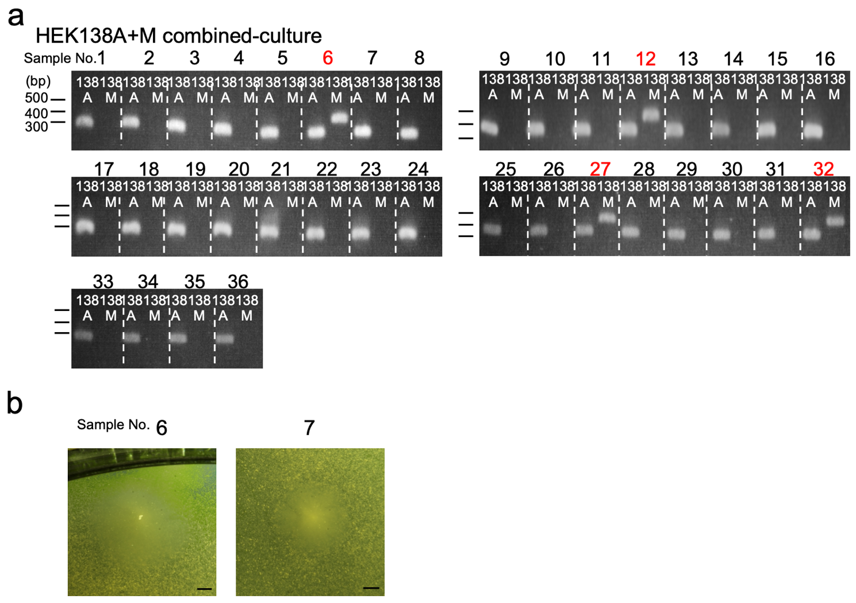
Supplemental figure 7
Analysis of the colonies obtained by co-isolation experiments from combined-culture of Streptomyces sp. HEK138A and Mycobacterium sp. HEK138M from soil. (a) Agarose gel electrophoresis of selective colony PCR products. Thirty-six colonies were tested using primers to amplify specific regions of the 16S rRNA gene for Streptomyces sp. HEK138A (138A) and Mycobacterium sp. HEK138M (138M). (b) Example of stereomicroscope image of the colony containing both 138A and 138M (No. 6), and stereomicroscope image of the colony containing 138A (No. 7). (Scale bar: 1 mm)

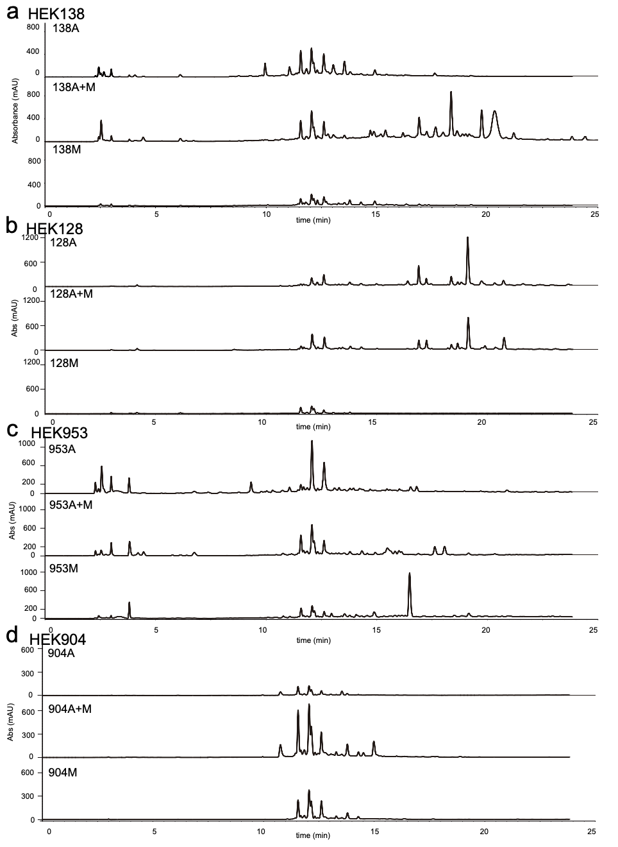
Supplemental Figure 8
High pressure liquid chromatography traces identical to the main manuscript Fig. 4 with different scale showing the whole chromatograms.

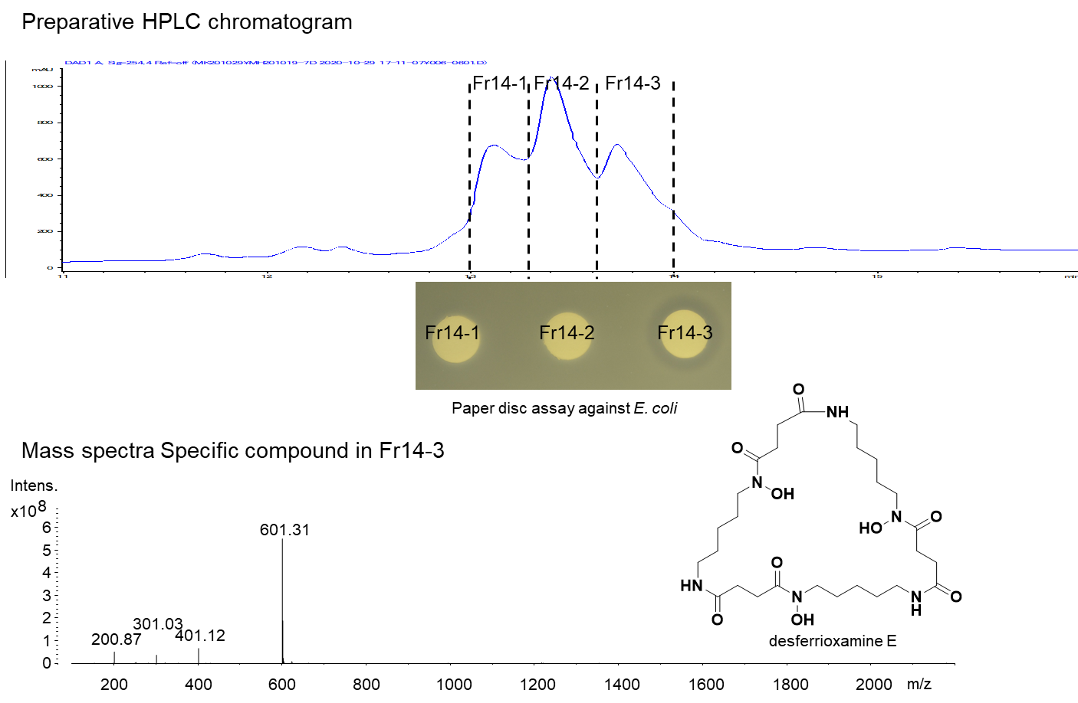
Supplemental Figure 9
Identification of active compound from HEK138A and M. HEK138A and 138M were precultured in 10 ml of V-22 medium in a test tube at 30°C, 180 rpm for 2 days. Then 1 ml of HEK138A and HEK138M were inoculated into 100 ml of A-3M medium in a K-1 flask at 30°C, 200 rpm for 5 days. A total of 0.7 L of the culture broth was extracted with an equal volume of BuOH to give 1.6 g of crude extract. The crude extract was dissolved in 20 ml of DMSO, and the active fraction was collected by using preparative high pressure liquid chromatography (HPLC; Agilent) equipped with a Cosmosil 5C18-AR-II column (10.0 i.d. ×250 mm). The mobile phase was 5% acetonitrile for the first 3 min, then increased to 95% by linear gradient from 3 to 27 min, and then maintained at 95% until 30 min. Flow rate was 3.0 ml/min, and the column temperature was 40°C. The sample (100 µl) was applied and the peaks eluted at 13.0–14.0 min showed growth inhibition against Escherichia coli. To further identify the active compound, preparative HPLC was performed 26 times and the peaks eluted at 13.0–14.0 min were collected. The collected fraction was dried in vacuo, and dissolved in 1.3 ml of DMSO. The sample (100 µl) was applied again to the preparative HPLC and the peak eluted at 13.8–14.0 min was collected twice and combined. The collected fraction was dried in vacuo, and the sample was dissolved in 100 μl of DMSO. The sample (20 µl) was used for bioassay. For mass spectrometry analysis, the sample was diluted 10-fold and 5 µl was applied for LC-ESI-MS (amaZon SL, Bruker). The HPLC system was equipped by Cosmosil 5C18-AR-II column (2.0 i.d. × 150 mm, Nacalai Tesque). Acetonitrile and H₂O (MilliQ) containing 0.1% formic acid was used as the mobile phase. Acetonitrile was maintained at 5% for the first 0.5 min, then increased to 95% by linear gradient from 0.5 to 13.5 min, and then maintained at 95% until 15 min. The flow was 0.45 ml/min and the column temperature was 40°C. The active compound was determined to be desferrioxamine E (nocardamine) based on the MS/MS fragmentation pattern.²⁰ Nocardamine is known to show weak growth inhibition against E. coli.²¹

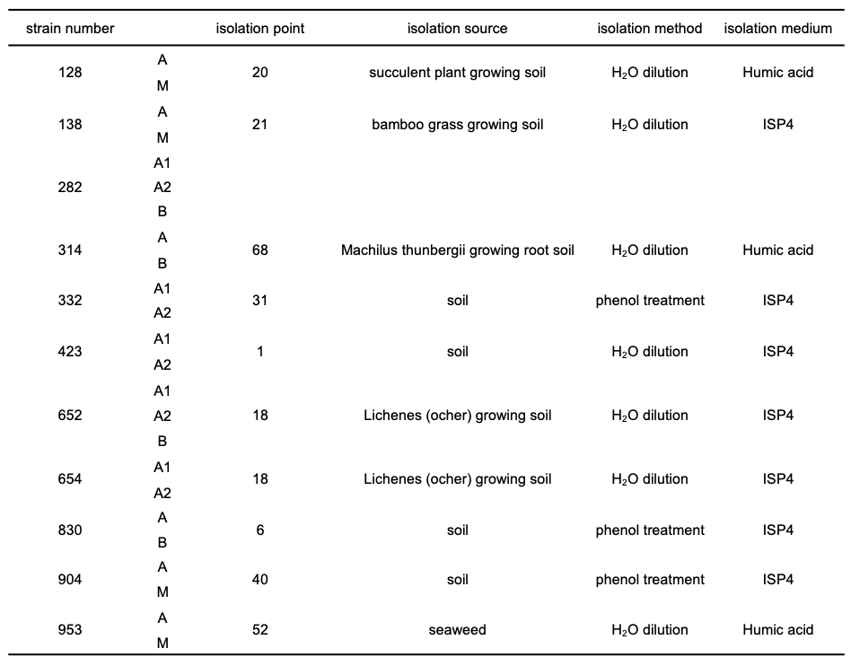
Supplemental table 4. Sources and methods for the initial isolation from the Hegura Island environmental samples of tested bacteria used in this study.

References

1. Hoshino, S.; Ozeki, M.; Wong, C. P.; Zhang, H.; Hayashi, F.; Awakawa, T.; Morita, H.; Onaka, H.; Abe, I., Mirilactams C-E, Novel Polycyclic Macrolactams Isolated from Combined-Culture of Actinosynnema mirum NBRC 14064 and Mycolic Acid-Containing Bacterium. Chem Pharm Bull (Tokyo) 2018, 66 (6), 660-667.
2. Pan, C. Q.; Kuranaga, T.; Cao, X.; Suzuki, T.; Dohmae, N.; Shinzato, N.; Onaka, H.; Kakeya, H., Amycolapeptins A and B, Cyclic Nonadepsipeptides Produced by Combined-culture of Amycolatopsis sp. and Tsukamurella pulmonis. J Org Chem 2021, 86 (2), 1843-1849.
3. Hoshino, S.; Ozeki, M.; Awakawa, T.; Morita, H.; Onaka, H.; Abe, I., Catenulobactins A and B, Heterocyclic Peptides from Culturing Catenuloplanes sp. with a Mycolic Acid-Containing Bacterium. J Nat Prod 2018, 81 (9), 2106-2110.
4. Hoshino, S.; Okada, M.; Awakawa, T.; Asamizu, S.; Onaka, H.; Abe, I., Mycolic Acid Containing Bacterium Stimulates Tandem Cyclization of Polyene Macrolactam in a Lake Sediment Derived Rare Actinomycete. Org Lett 2017, 19 (18), 4992-4995.
5. Jiang, Y. L.; Lu, S.; Hirai, G.; Kato, T.; Onaka, H.; Kakeya, H., Enhancement of saccharothriolide production and discovery of a new metabolite, saccharothriolide C-2, by combined-culture of Saccharothrix sp. and Tsukamurella pulmonis. Tetrahedron Lett 2019, 60 (15), 1072-1074.
6. Oku, N.; Takemura, S.; Onaka, H.; Igarashi, Y., NMR characterization of streptogramin B and L-156,587, a non-synergistic pair of the streptogramin family antibiotic complexes produced inductively by a combined culture of Streptomyces albogriseolus and Tsukamurella pulmonis. Magn Reson Chem 2021.
7. Hoshino, S.; Zhang, L.; Awakawa, T.; Wakimoto, T.; Onaka, H.; Abe, I., Arcyriaflavin E, a new cytotoxic indolocarbazole alkaloid isolated by combined-culture of mycolic acid-containing bacteria and Streptomyces cinnamoneus NBRC 13823. J Antibiot (Tokyo) 2015, 68 (5), 342-4.
8. Hagihara, R.; Katsuyama, Y.; Sugai, Y.; Onaka, H.; Ohnishi, Y., Novel desferrioxamine derivatives synthesized using the secondary metabolism-specific nitrous acid biosynthetic pathway in Streptomyces davawensis. J Antibiot (Tokyo) 2018, 71 (11), 911-919.
9. Igarashi, Y.; Kim, Y.; In, Y.; Ishida, T.; Kan, Y.; Fujita, T.; Iwashita, T.; Tabata, H.; Onaka, H.; Furumai, T., Alchivemycin A, a bioactive polycyclic polyketide with an unprecedented skeleton from Streptomyces sp. Org Lett 2010, 12 (15), 3402-5.
10. Ozaki, T.; Sugiyama, R.; Shimomura, M.; Nishimura, S.; Asamizu, S.; Katsuyama, Y.; Kakeya, H.; Onaka, H., Identification of the common biosynthetic gene cluster for both antimicrobial streptoaminals and antifungal 5-alkyl-1,2,3,4-tetrahydroquinolines. Org Biomol Chem 2019, 17 (9), 2370-2378.
11. Sugiyama, R.; Nishimura, S.; Ozaki, T.; Asamizu, S.; Onaka, H.; Kakeya, H., Discovery and Total Synthesis of Streptoaminals: Antimicrobial [5,5]-Spirohemiaminals from the Combined-Culture of Streptomyces nigrescens and Tsukamurella pulmonis. Angew Chem Int Ed Engl 2016, 55 (35), 10278-82.
12. Sugiyama, R.; Nakatani, T.; Nishimura, S.; Takenaka, K.; Ozaki, T.; Asamizu, S.; Onaka, H.; Kakeya, H., Chemical Interactions of Cryptic Actinomycete Metabolite 5-Alkyl-1,2,3,4-tetrahydroquinolines through Aggregate Formation. Angew Chem Int Edit 2019, 58 (38), 13486-13491.
13. Sugiyama, R.; Nishimura, S.; Ozaki, T.; Asamizu, S.; Onaka, H.; Kakeya, H., 5-Alkyl-1,2,3,4-tetrahydroquinolines, new membrane-interacting lipophilic metabolites produced by combined culture of Streptomyces nigrescens and Tsukamurella pulmonis. Org Lett 2015, 17 (8), 1918-21.
14. Hoshino, S.; Wakimoto, T.; Onaka, H.; Abe, I., Chojalactones A-C, cytotoxic butanolides isolated from Streptomyces sp. cultivated with mycolic acid containing bacterium. Org Lett 2015, 17 (6), 1501-4.
15. Jiang, Y. L.; Matsumoto, T.; Kuranaga, T.; Lu, S.; Wang, W. C.; Onaka, H.; Kakeya, H., Longicatenamides A-D, Two Diastereomeric Pairs of Cyclic Hexapeptides Produced by Combined-culture of Streptomyces sp. KUSC_F05 and Tsukamurella pulmonis TP-B0596. J Antibiot 2021.
16. Hoshino, S.; Okada, M.; Wakimoto, T.; Zhang, H.; Hayashi, F.; Onaka, H.; Abe, I., Niizalactams A-C, Multicyclic Macrolactams Isolated from Combined Culture of Streptomyces with Mycolic Acid-Containing Bacterium. J Nat Prod 2015, 78 (12), 3011-7.
17. Hoshino, S.; Wong, C. P.; Ozeki, M.; Zhang, H.; Hayashi, F.; Awakawa, T.; Asamizu, S.; Onaka, H.; Abe, I., Umezawamides, new bioactive polycyclic tetramate macrolactams isolated from a combined-culture of Umezawaea sp. and mycolic acid-containing bacterium. J Antibiot (Tokyo) 2018, 71 (7), 653-657.
18. Ozaki, T.; Kurokawa, Y.; Hayashi, S.; Oku, N.; Asamizu, S.; Igarashi, Y.; Onaka, H., Insights into the Biosynthesis of Dehydroalanines in Goadsporin. Chembiochem 2016, 17 (3), 218-223.
19. Onaka, H.; Ozaki, T.; Mori, Y.; Izawa, M.; Hayashi, S.; Asamizu, S., Mycolic acid-containing bacteria activate heterologous secondary metabolite expression in Streptomyces lividans. J Antibiot (Tokyo) 2015, 68 (9), 594-7.
20. Traxler, M. F.; Watrous, J. D.; Alexandrov, T.; Dorrestein, P. C.; Kolter, R., Interspecies interactions stimulate diversification of the Streptomyces coelicolor secreted metabolome. mBio 2013, 4 (4).
21. Anke, H., Metabolic Products of Microorganisms .163. Desferritriacetylfusigen, an Antibiotic from Aspergillus-Deflectus. J Antibiot 1977, 30 (2), 125-128.

