Supporting Information

Continuous heat harvesting under both fluctuated and continuous temperature gradients by a mixed ion/electron thermoelectric generator using an ionogel blended with carbon nanotube ionogels

Figure S1. Open-circuit voltage (V_{oc}) profile of a SWNT/SDS film under temperature gradient (ΔT).

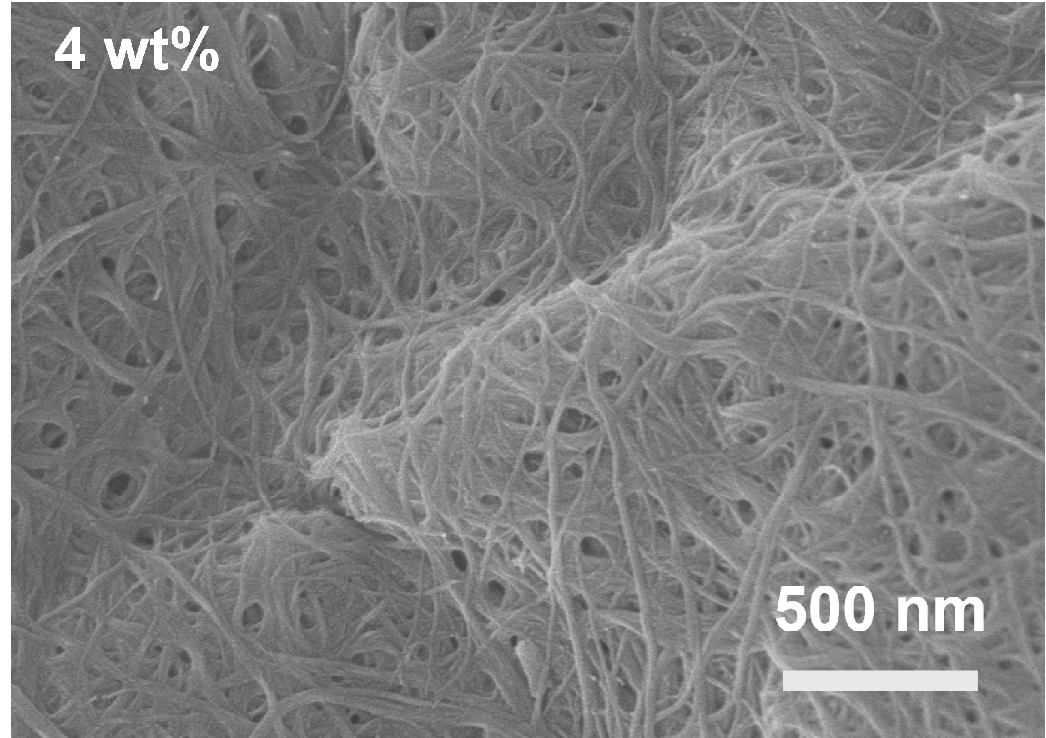
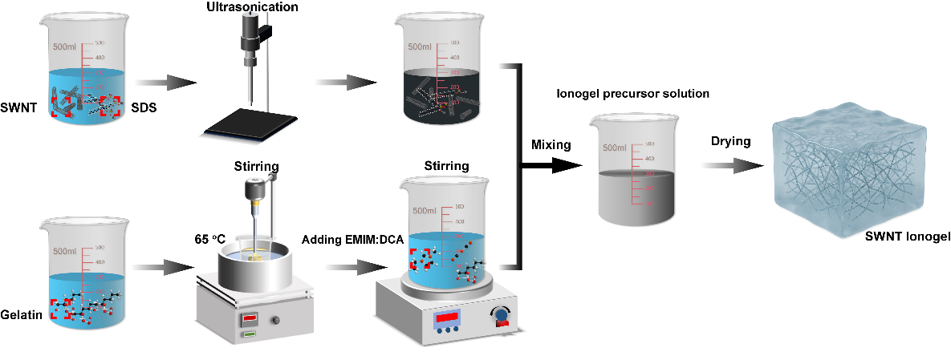
Figure S2. Schematic procedure for the preparation of a SWNT ionogel.

Figure S3. SEM images of SWNT networks prepared from an ionogel with the SWNT loading of 4 wt% by rinsing away gelatin, EMIM:DCA, and SDS with hot water of 80 ºC.

Figure S4. (a) Raman spectra of ionogels with and without SWNTs. ATR-FTIR spectra of ionogels with and without SWNT in the ranges of (a) 400-4000 cm⁻¹ and (b) 2050-2300 cm⁻¹.

Figure S5. (a) The storage (G') and loss (G'') moduli and (b) the dynamic viscosity as the functions of the frequency for the ionogels with the SWNT loading of 0.5 wt% and 0.
Figure S6. (a) Nyquist plots of ionogels with different SWNT loadings. The SWNT loadings are indicated.

Figure S7. (a) The electronic and ionic conductivities in the log scale of SWNT ionogels as the functions of the SWNT loadings. The electronic and ionic conductivities were estimated by analysing the Nyquist plots with the equivalent circuit shown in the inset of Figure 1e, which has an electronic resistor in series with an ionic resistor.

Figure S8. Electronic and ionic conductivities in (a) the linear and (b) log scales of SWNT ionogels as functions of the SWNT loading. The conductivity values in (a) and (b) were estimated by analyzing the Nyquist plots with the equivalent circuit shown in the inset of (a), which has an electronic resistor in parallel with an ionic resistor.

Figure S9. Analysis of the electronic conductivities of the SWNT ionogels by the percolation model. The volume fractions were calculated by considering the loadings and the densities of the components. The densities are 1.9 g/cm³ for SWNT, 1.35 g/cm³ for gelatin, 1.1 g/cm³ for EMIM:DCA, and 1.0 g/cm³ for SDS. The d value is assumed as 2 for three-dimensional electron transportation in the SWNT ionogels. The formula for the electronic conductivity (σ_{e}) in terms the percolation model is σ_{e} = σ₀ (ϕ - ϕ_{c})^{d}, where σ₀ is the fitting parameter, ϕ denotes the SWNT volume fraction, ϕ_{c} represents the critical volume fraction, and d is the transport index.

Figure S10. Fitting of the V_{oc} decay of the ionogels with the SWNT loadings of (a) 0.05 wt%, (b) 0.10 wt%, (c) 0.50 wt%, (d) 0.80 wt%, (e) 1.0 wt%, and (f) 2.0 wt% with the exponential decay function, V_{oc} = V₀ e^{-(t-t0)/τ} + V_{ocs}, where V₀ is the initial voltage when t = t₀, τ is the time constant, and V_{ocs} is the steady voltage.

Figure S11. The variations of the time constant with the SWNT loading.

Figure S12. Open-circuit voltage profiles of SWNT ionogels under the relative humidities (RHs) of 40%, 55% and 70%. The SWNT loading is 0.1 wt%, and the temperature gradient is 3 K.

Figure S13. Variation of the capacitance with the rGO loading. The capacitances were calculated in term of C = τ/R_{e} at the stage II. The R_{e} values were calculated from the electronic conductivity of ionogels, and the τ values were estimated by fitting the V_{oc} decay curves at the stage II.

Figure S14. Temperature gradient and open-circuit voltage profiles of an ionogel with the SWNTs loading of 0.1 wt% under the temperature gradients of (a) 0.40 K, (b) 0.85 K, (c) 1.4 K, (d) 2.0 K, (e) 2.5 K, and (f) 3.0 K.

Figure S15. (a) Open-circuit voltage profiles under various temperature gradients. (b) Variation of the ratio of the steady voltage to the peak voltage with the temperature gradient. The SWNT loading of the ionogel is 0.10 wt%. The peak-to-steady voltage ratio decreases exponentially with a decay function: y = 0.54·e^{-1.03·x} +0.62.

Figure S16. Output voltage (V_{op}) profiles on the external loads with different resistances connected to ionogels with the SWNT loadings of (a) 0.02 wt%, (b) 0.05 wt%, (c) 0.10 wt%, (d) 0.20 wt%, (e) 0.50 wt%, and (f) 1.0 wt%. The temperature gradient is 3 K. The external resistances are 1 kΩ, 5 kΩ, 10 kΩ, 25 kΩ, and 40 kΩ. The V_{oc} profiles are also presented.

Figure S17. Average output power as a function of the external resistance (R_{ex}) for the MTEGs using ionogels with the SWNT loadings of (a) 0.02 wt%, (b) 0.05 wt%, (c) 0.10 wt%, (d) 0.16 wt%, (e) 0.20 wt%, and (f) 0.50 wt%.

Figure S18. (a) Variations of V_{ops} with R_{ex} for the MTEGs with the SWNT loadings of 0.05 wt% and 0.50 wt%. (b) Dependences of V_{ops} and P_{s} on I_{ops} for the MTEGs with the SWNT loadings of 0.05 wt% and 0.50 wt%.

Figure S19. (a) Long-term output voltage profiles on the external load of 25 kΩ connected to a control ITEC and an MTEG with the SWNT loading of 0.1 wt% under the temperature gradient of 3 K. (b) V_{oc} evolutions of the ionogels with the SWNT loading of 0% or 0.1 wt% under the temperature gradient of 3 K.
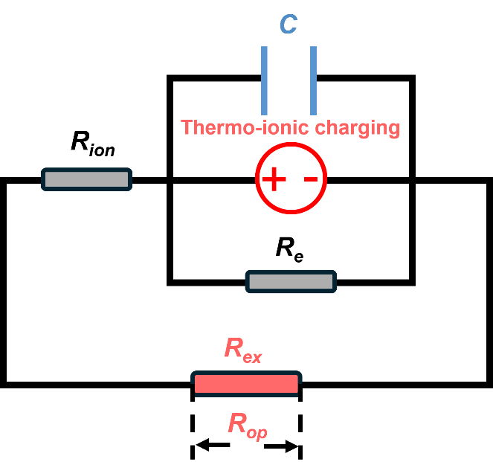
Figure S20. Equivalent circuit for an MTEG connected with an external load.

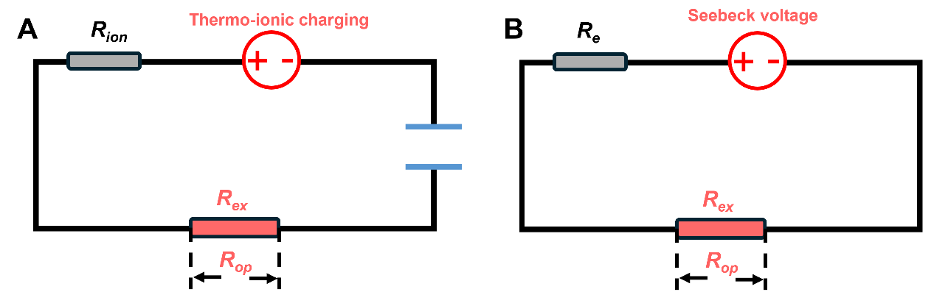
Figure S21. Equivalent circuits for (A) an ITEC and (B) a TEG connected with an external load.

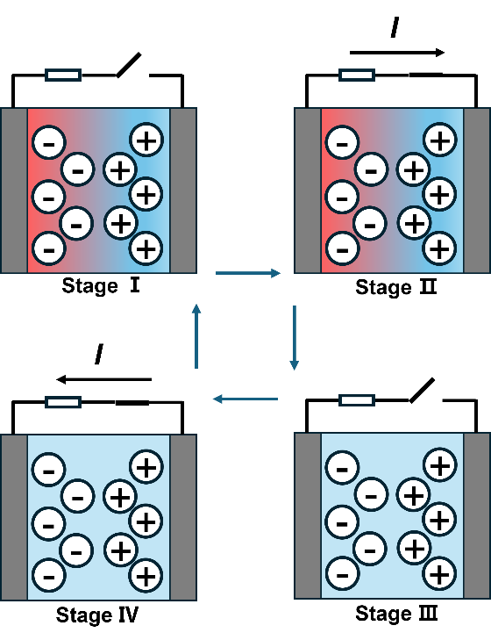
Figure S22. Schematic illustration of the working principle of an ionic thermoelectric capacitor (ITEC). It can be classified into 4 stages under a thermal cycle. At Stage I, a temperature gradient is applied, and the thermovoltage is built up between the two electrodes. This arises from the Soret effect of the ions, that is, the accumulations of the cations and anions at the cold and hot ends of the ionic material, respectively. The external load is disconnected. At the stage II, an external load is connected to the ITEC, electrons and holes flow from the external circuit to the two electrodes to balance the accumulated cations and anions there. At the stage III, the heater is turned off, and the external load is disconnected. While the accumulated cations and anions are retrieved, the electrons and holes remaining at the two electrodes generate a negative voltage. At the stage IV, the external load is reconnected to the ITEC again, the electrons and holes retrieve to the external load. As a result, the voltage gradually decreases to zero.

