Automated Model Selection in Population Pharmacokinetics Using Metaheuristic Algorithms
(Supplemental Material)

Zhonghui Huang¹, Matthew Fidler², Joseph F Standing^{1,3}, Frank Kloprogge⁴
¹Great Ormond Street Institute of Child Health, University College London, London, UK
²Novartis Pharmaceuticals Corporation, Fort Worth, Texas, USA
³Great Ormond Street Hospital for Children, London, UK
⁴Institute for Global Health, University College London, London, UK.
Corresponding author: Zhonghui Huang
Affiliation: Great Ormond Street Institute of Child Health, University College London, London, UK
E-mail: zhonghui.huang.20@ucl.ac.uk

Supplementary Table 1 A binary encoding scheme for a 12-gene chromosome in genetic algorithm-driven PopPK modelling
Gene position | Model feature | Binary encoding
1-2 | Number of compartments | 00 or 01 = 1-compartment model;  10 = 2-compartment model;  11 = 3-compartment model
3 | MM elimination | 0 = Linear;  1 = MM
4 | IIV on K_{m} | 0 = No IIV on K_{m};  1 = Include IIV on K_{m}
5 | IIV on V_{c} | 0 = No IIV on central volume;  1 = Include IIV on V_{c}
6 | IIV on V_{p} | 0 = No IIV on V_{p};  1 = Include IIV on V_{p}
7 | IIV on V_{p2} | 0 = No IIV on V_{p2};  1 = Include IIV on V_{p2}
8 | IIV on Q | 0 = No IIV on Q;  1 = Include IIV on Q
9 | IIV on Q₂ | 0 = No IIV on Q₂;  1 = Include IIV on Q₂
10 | IIV on K_{a} | 0 = No IIV on K_{a};  1 = Include IIV on K_{a}
11 | IIV correlation structure | 0 = No correlation (diagonal Ω matrix);  1 = Include correlations (full Ω matrix)
12-13 | Residual error model | 00 or 01 = Additive error;  10 = Proportional error;  11 = Combined (additive + proportional)

Supplementary Table 2 A binary encoding scheme for a 12-gene chromosome in genetic algorithm-driven PopPK modelling

Decision node | Option / edge | Initial pheromone | Probability
Number of compartments | 1 = 1-compartment model | φ₀ | 1/3
 | 2 = 2-compartment model | φ₀ | 1/3
 | 3 = 3-compartment model | φ₀ | 1/3
MM elimination | 0 = Linear | φ₀ | 0.5
 | 1 = MM | φ₀ | 0.5
IIV on K_{m} | 0 = No IIV on K_{m} | φ₀ | 0.5
 | 1 = Include IIV on K_{m} | φ₀ | 0.5
IIV on V_{c} | 0 = No IIV on V_{c} | φ₀ | 0.5
 | 1 = Include IIV on V_{c} | φ₀ | 0.5
IIV on V_{p} | 0 = No IIV on V_{p} | φ₀ | 0.5
 | 1 = Include IIV on V_{p} | φ₀ | 0.5
IIV on V_{p2} | 0 = No IIV on V_{p2} | φ₀ | 0.5
 | 1 = Include IIV on V_{p2} | φ₀ | 0.5
IIV on Q | 0 = No IIV on Q | φ₀ | 0.5
 | 1 = Include IIV on Q | φ₀ | 0.5
IIV on Q₂ | 0 = No IIV on Q₂ | φ₀ | 0.5
 | 1 = Include IIV on Q₂ | φ₀ | 0.5
IIV on K_{a}† | 0 = No IIV on K_{a} | φ₀ | 0.5
 | 1 = Include IIV on K_{a} | φ₀ | 0.5
IIV correlation structure | 0 = No correlation (diagonal Ω matrix) | φ₀ | 0.5
 | 1 = Include correlations (full Ω matrix) | φ₀ | 0.5
Residual error model | 1 = Additive error | φ₀ | 1/3
 | 2 = Proportional error | φ₀ | 1/3
 | 3 = Combined (additive + proportional) | φ₀ | 1/3

Supplementary Figure 1. Example workflow of a stepwise algorithm for PopPK model development. Models highlighted in yellow indicate those chosen along the example path, whereas models in grey represent alternative candidates not selected. The illustrated path is: a three-compartment structural model was retained, followed by Michaelis-Menten (MM) elimination, inclusion of IIV on CL and Vc, expansion of IIV to CL, Vc,Vp,and Q, enabling correlations among random effects, and comparison of residual-error models
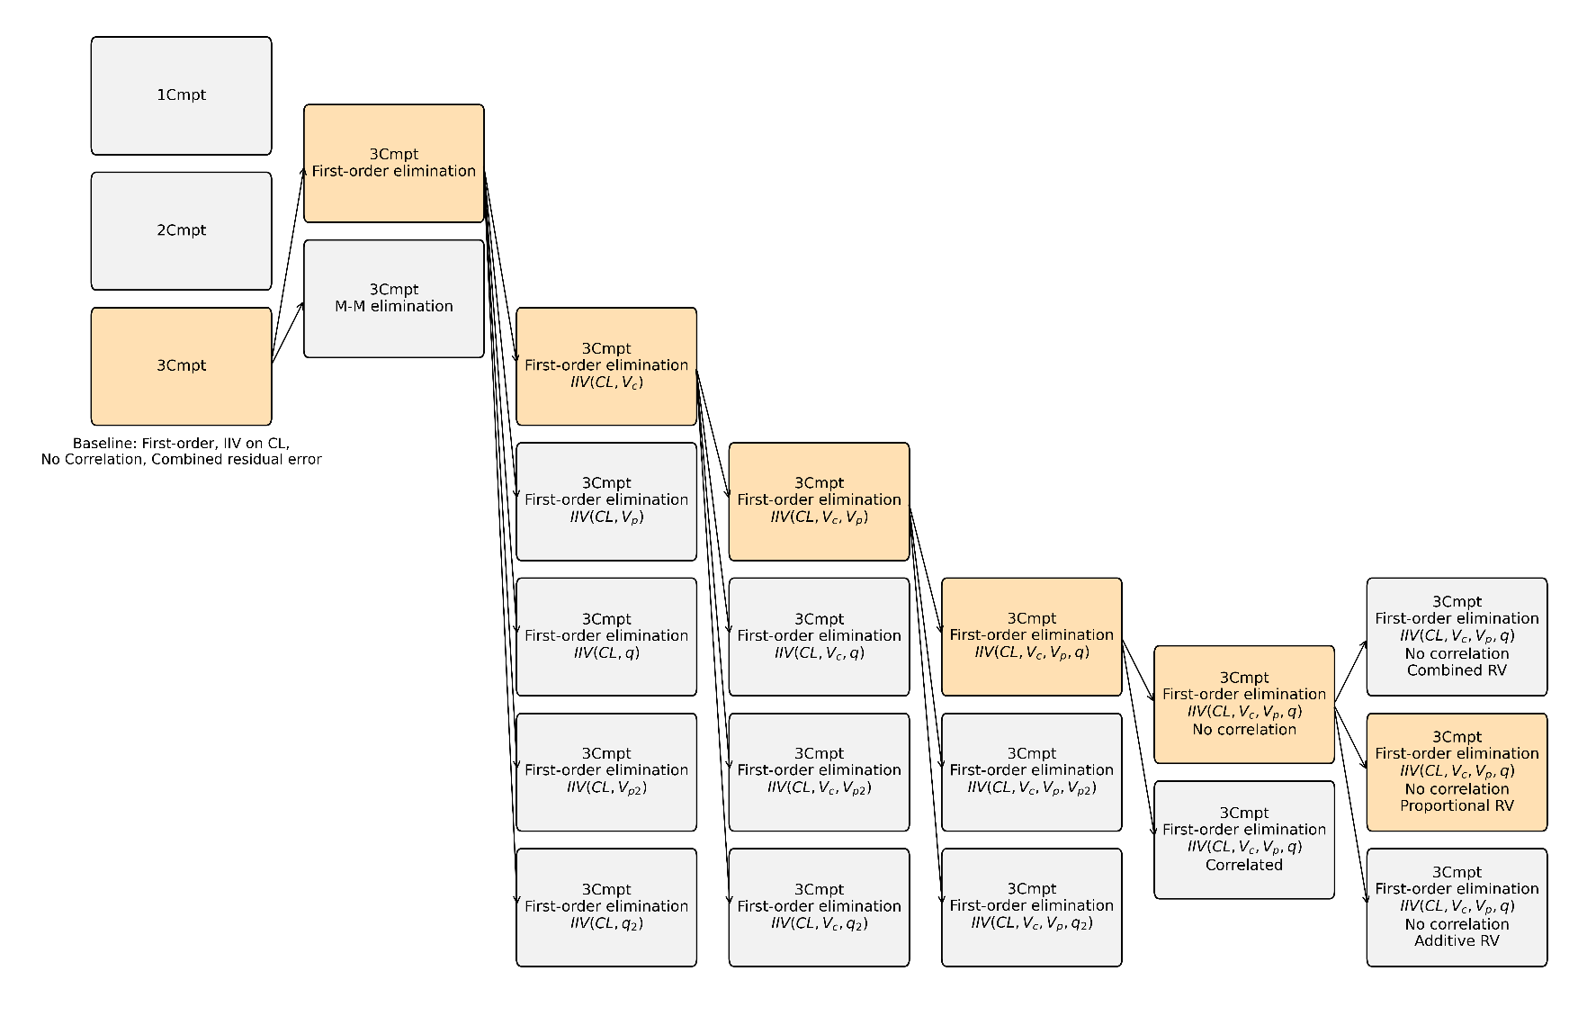

Supplementary Figure 2 Flowchart of the genetic algorithm used for population pharmacokinetic model selection, including population initialization, fitness evaluation and ranking, local search, selection, crossover, mutation, and termination.
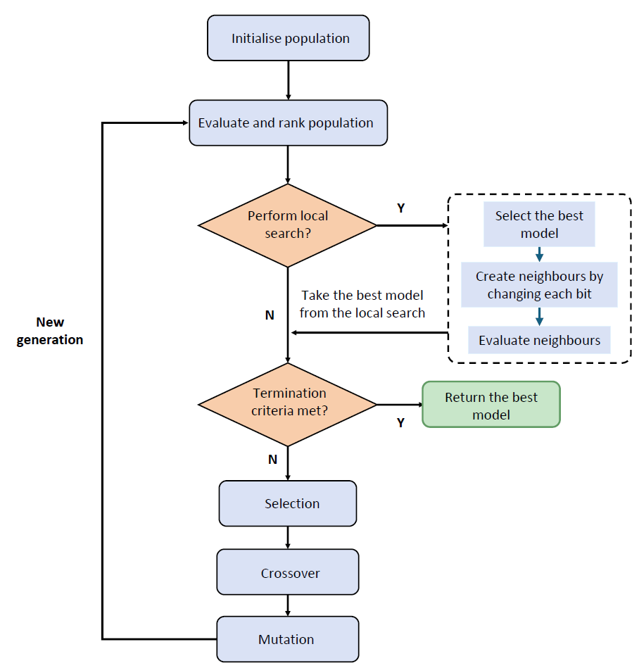

Supplementary Figure 3. Schematic illustration of the tournament selection procedure in the GA. The figure uses a population size of 8 as an example to demonstrate how fitness values are calculated and individuals are compared sequentially with randomly selected competitors to determine parents for the next generation.

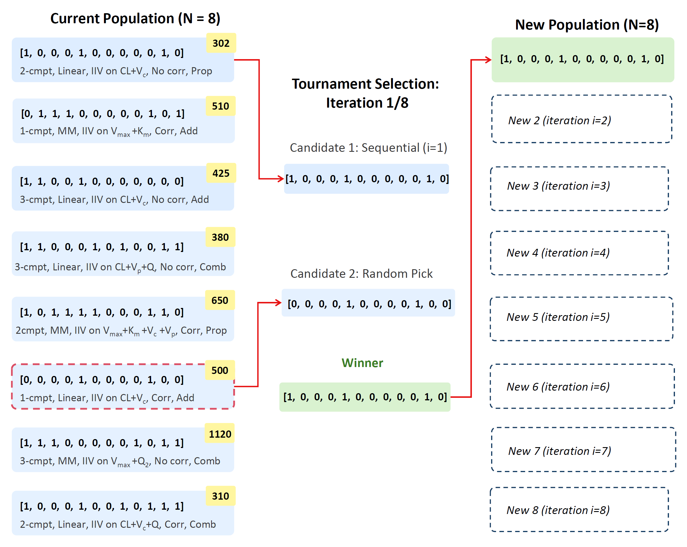

Supplementary Figure 4. Schematic illustration of crossover operators in GA-based PopPK model development: single-point (top) and two-point (bottom) crossover generate offspring model feature combinations through recombination of parental encoding.
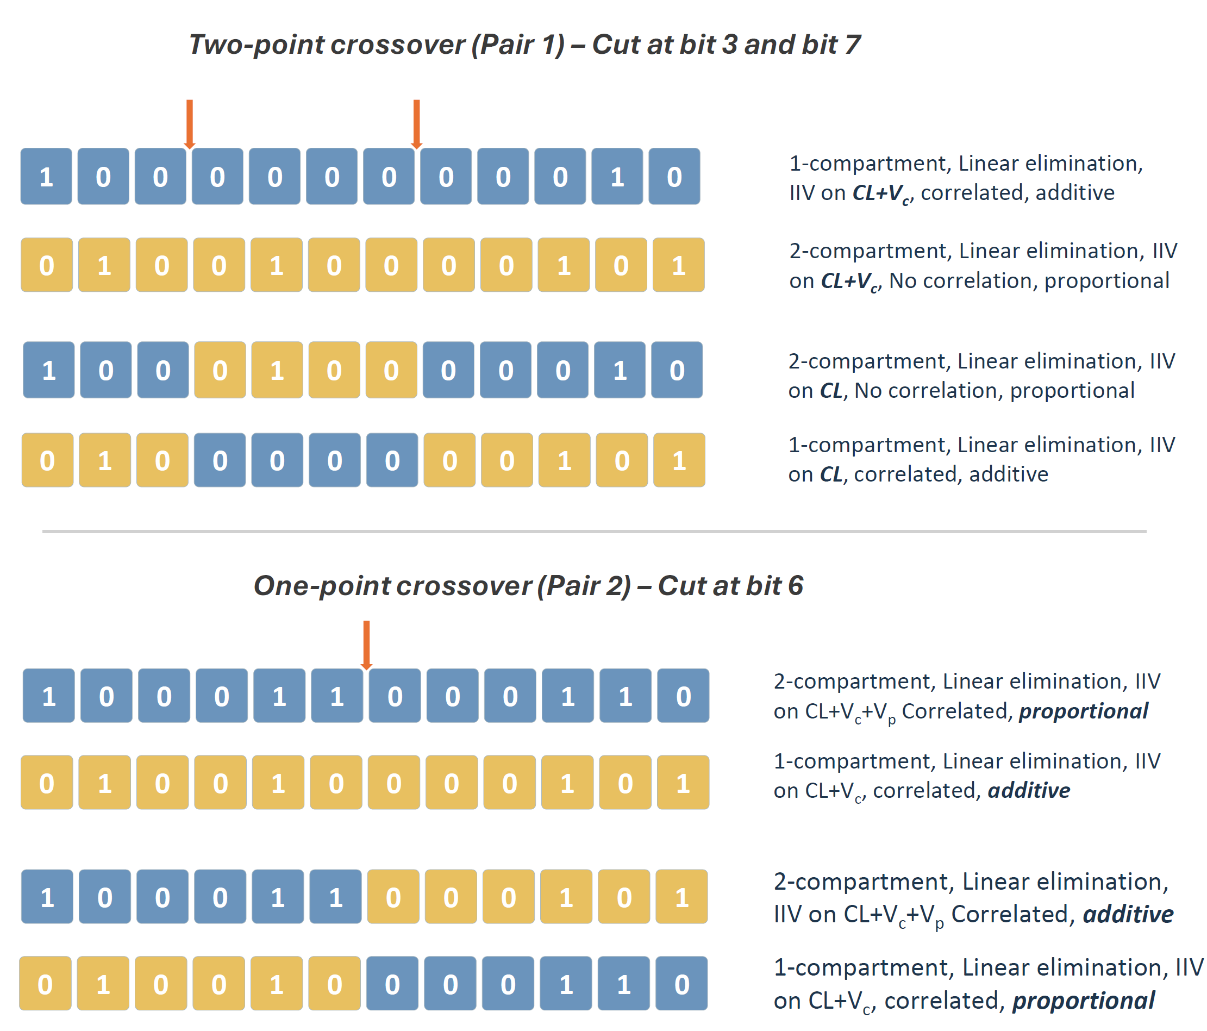

Supplementary Figure 5. Schematic example of mutation in the GA process. Orange highlights indicate mutated gene sites and mutation may occur at multiple positions, generating offspring with altered PopPK model features.
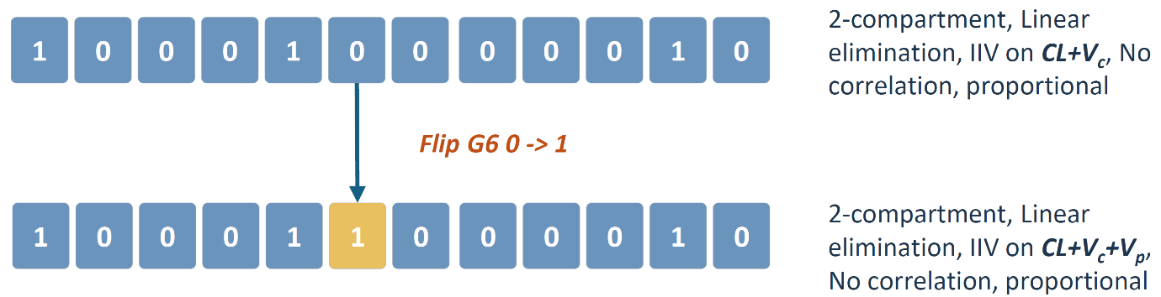

Supplementary Figure 6 Flowchart of the ant colony optimization algorithm used for population pharmacokinetic model selection, including pheromone initialization, ant-based model generation, model evaluation and ranking, pheromone updating, probabilistic edge sampling, and termination.
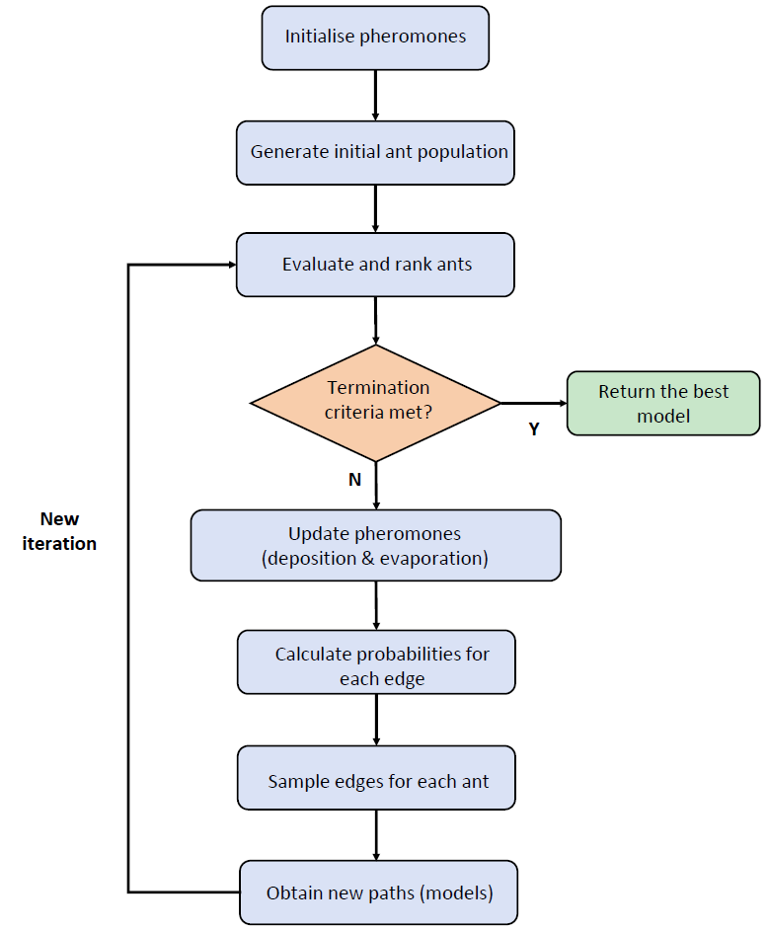

Supplementary Figure 7 Flowchart of the tabu search algorithm used for population pharmacokinetic model selection, including neighborhood generation and evaluation, selection of the best neighbor, tabu-list updating, perturbation, restart-point selection, and termination.
