Supporting Information
Procedure-specific examined lymph node reference targets in surgically resected T1a-bN0M0 non-small cell lung cancer: a SEER derivation–validation competing-risk analysis Sai Zhou, Yong Liu, Shenhai Wei

Supplementary Methods

Reproducible allocation
Each procedure-specific cohort and each tumor-size subgroup was split independently using a 2:1 training/validation ratio. Allocation was stratified by outcome category and used the fixed random seed 20240613. The held-out validation subset was not used to select or modify the candidate threshold.

Threshold-search procedure
In training cohorts, ELN was treated as a categorical variable in multivariable Fine–Gray regression. ELN-specific adjusted SHR estimates were plotted and a locally weighted smooth curve was used to visualize attenuation of the risk decline. The earliest clinically interpretable integer beyond which the fitted curve approached a plateau was fixed as the candidate threshold. This curve-based approach was exploratory and was separated from formal validation.

Formal validation, sensitivity, and post hoc analyses
Only the threshold prespecified in the corresponding training cohort was considered a formal internal-validation test. Full-cohort estimates were sensitivity analyses. Because no single threshold was identified in the T1a training cohort, subsequent T1a cutoff analyses in the held-out subset were post hoc exploratory analyses and were not used to designate a target. For T1b, ELN ≥7 was the formal validation target; ELN ≥6, ≥8, and ≥9 were sensitivity analyses.

Supplementary Tables
Supplementary Table S1. Variable definitions and analytic coding.
Variable | Definition | Coding
Age | Age at diagnosis, years | Continuous
Sex | Male or female | Binary
Race | White, Black, or other | Categorical
Tumor site | Upper, middle, or lower lobe | Categorical
Laterality | Left or right | Binary
Histology | Squamous carcinoma, adenocarcinoma, or other | Categorical
Operation | Wedge resection, segmentectomy, or lobectomy | Categorical
ELN | Number of regional lymph nodes examined pathologically | Continuous/categorical/binary by analysis
Survival time | Months from diagnosis to death or last follow-up | Time scale
Outcome | Alive, lung cancer-specific death, or other-cause death | Competing-risk coding
Rural–urban category | Metropolitan or nonmetropolitan | Binary
Tumor size | Maximum tumor diameter, mm | Continuous
Size group | T1a 1–10 mm; T1b 11–20 mm | Binary

Supplementary Table S2. Training/validation allocation and validation-set event counts.
Cohort | Total n | Training n | Validation n | Lung cancer deaths | Other-cause deaths | Training-derived target
Wedge resection | 3,772 | 2,514 | 1,258 | 209 | 243 | ≥6
Segmentectomy | 1,132 | 754 | 378 | 50 | 51 | ≥6
Lobectomy | 11,697 | 7,798 | 3,899 | 459 | 561 | ≥9
T1a | 3,209 | 2,139 | 1,070 | 107 | 135 | Not identified
T1b | 13,392 | 8,928 | 4,464 | 609 | 720 | ≥7

Supplementary Table S3. Standardized mean differences between training and validation cohorts.
Variable | Wedge | Segmentectomy | Lobectomy | T1a | T1b
Age | 0.003 | 0.017 | 0.016 | 0.006 | 0.020
Sex | 0.017 | 0.019 | 0.049 | 0.022 | 0.039
Race | 0.081 | 0.077 | 0.017 | 0.032 | 0.033
Tumor site | 0.035 | 0.096 | 0.028 | 0.041 | 0.021
Laterality | 0.005 | 0.040 | 0.007 | 0.009 | 0.012
Histology | 0.028 | 0.045 | 0.012 | 0.029 | 0.016
ELN count | 0.102 | 0.035 | 0.006 | 0.070 | 0.009
Tumor size | 0.071 | 0.104 | 0.015 | 0.002 | 0.023
Outcome category | 0.002 | 0.004 | 0.000 | 0.002 | 0.001
For categorical variables, the maximum absolute category-specific standardized mean difference is shown. Values <0.10 generally indicate good balance; the maximum observed value was approximately 0.10.

Supplementary Table S4. Formal internal-validation results.
Cohort | Validation n | Threshold | Below n | At/above n | Adjusted SHR (95% CI) | P value
Wedge resection | 1,258 | ≥6 | 1,042 | 216 | 0.617 (0.391–0.973) | 0.038
Segmentectomy | 378 | ≥6 | 227 | 151 | 0.430 (0.205–0.902) | 0.025
Lobectomy | 3,899 | ≥9 | 2,033 | 1,866 | 0.743 (0.614–0.899) | 0.002
T1b | 4,464 | ≥7 | 2,275 | 2,189 | 0.697 (0.581–0.836) | <0.001

Supplementary Table S5. Post hoc exploratory and sensitivity cutoff analyses.
Analysis | Subset n | Threshold | Below n | At/above n | Adjusted SHR (95% CI) | P value
T1a post hoc | 1,070 | ≥2 | 266 | 804 | 0.415 (0.260–0.662) | <0.001
T1a post hoc | 1,070 | ≥6 | 566 | 504 | 0.575 (0.366–0.904) | 0.017
T1a post hoc | 1,070 | ≥7 | 621 | 449 | 0.410 (0.249–0.677) | <0.001
T1a post hoc | 1,070 | ≥9 | 724 | 346 | 0.384 (0.215–0.686) | 0.001
T1b sensitivity | 4,464 | ≥6 | 2,006 | 2,458 | 0.671 (0.561–0.804) | <0.001
T1b sensitivity | 4,464 | ≥8 | 2,531 | 1,933 | 0.730 (0.606–0.879) | <0.001
T1b sensitivity | 4,464 | ≥9 | 2,751 | 1,713 | 0.691 (0.569–0.839) | <0.001
The T1a estimates are post hoc and do not establish a unique target. Choosing the apparently strongest T1a cutoff from the held-out subset would convert validation into a second exploratory analysis.

Supplementary Table S6. Full-cohort sensitivity analyses.
Cohort | Full-cohort n | Threshold | Adjusted SHR (95% CI) | P value
Wedge resection | 3,772 | ≥6 | 0.689 (0.542–0.874) | 0.002
Segmentectomy | 1,132 | ≥6 | 0.464 (0.302–0.712) | <0.001
Lobectomy | 11,697 | ≥9 | 0.747 (0.669–0.835) | <0.001
T1b | 13,392 | ≥7 | 0.681 (0.614–0.755) | <0.001

Supplementary Table S7. Fine–Gray reporting checklist.
Reporting item | Implementation
Event of interest | Lung cancer-specific death
Competing event | Death from causes other than lung cancer
Censoring | Alive at last follow-up
Effect measure | Adjusted subdistribution hazard ratio with 95% CI
Training/validation separation | Independent outcome-stratified 2:1 split
Threshold selection | Training cohorts only
Formal validation | Single prespecified threshold tested in held-out cohort
Covariate adjustment | Age, sex, race, site, laterality, histology, tumor size; surgical procedure in size models
Sensitivity analyses | Full-cohort models and alternative cutoffs
Interpretation | Association with cumulative lung cancer mortality; not a direct causal effect

Supplementary Figures
Supplementary Figure S1. Full-cohort sensitivity analysis of prespecified ELN thresholds. These estimates were supportive and were not used as internal-validation results.
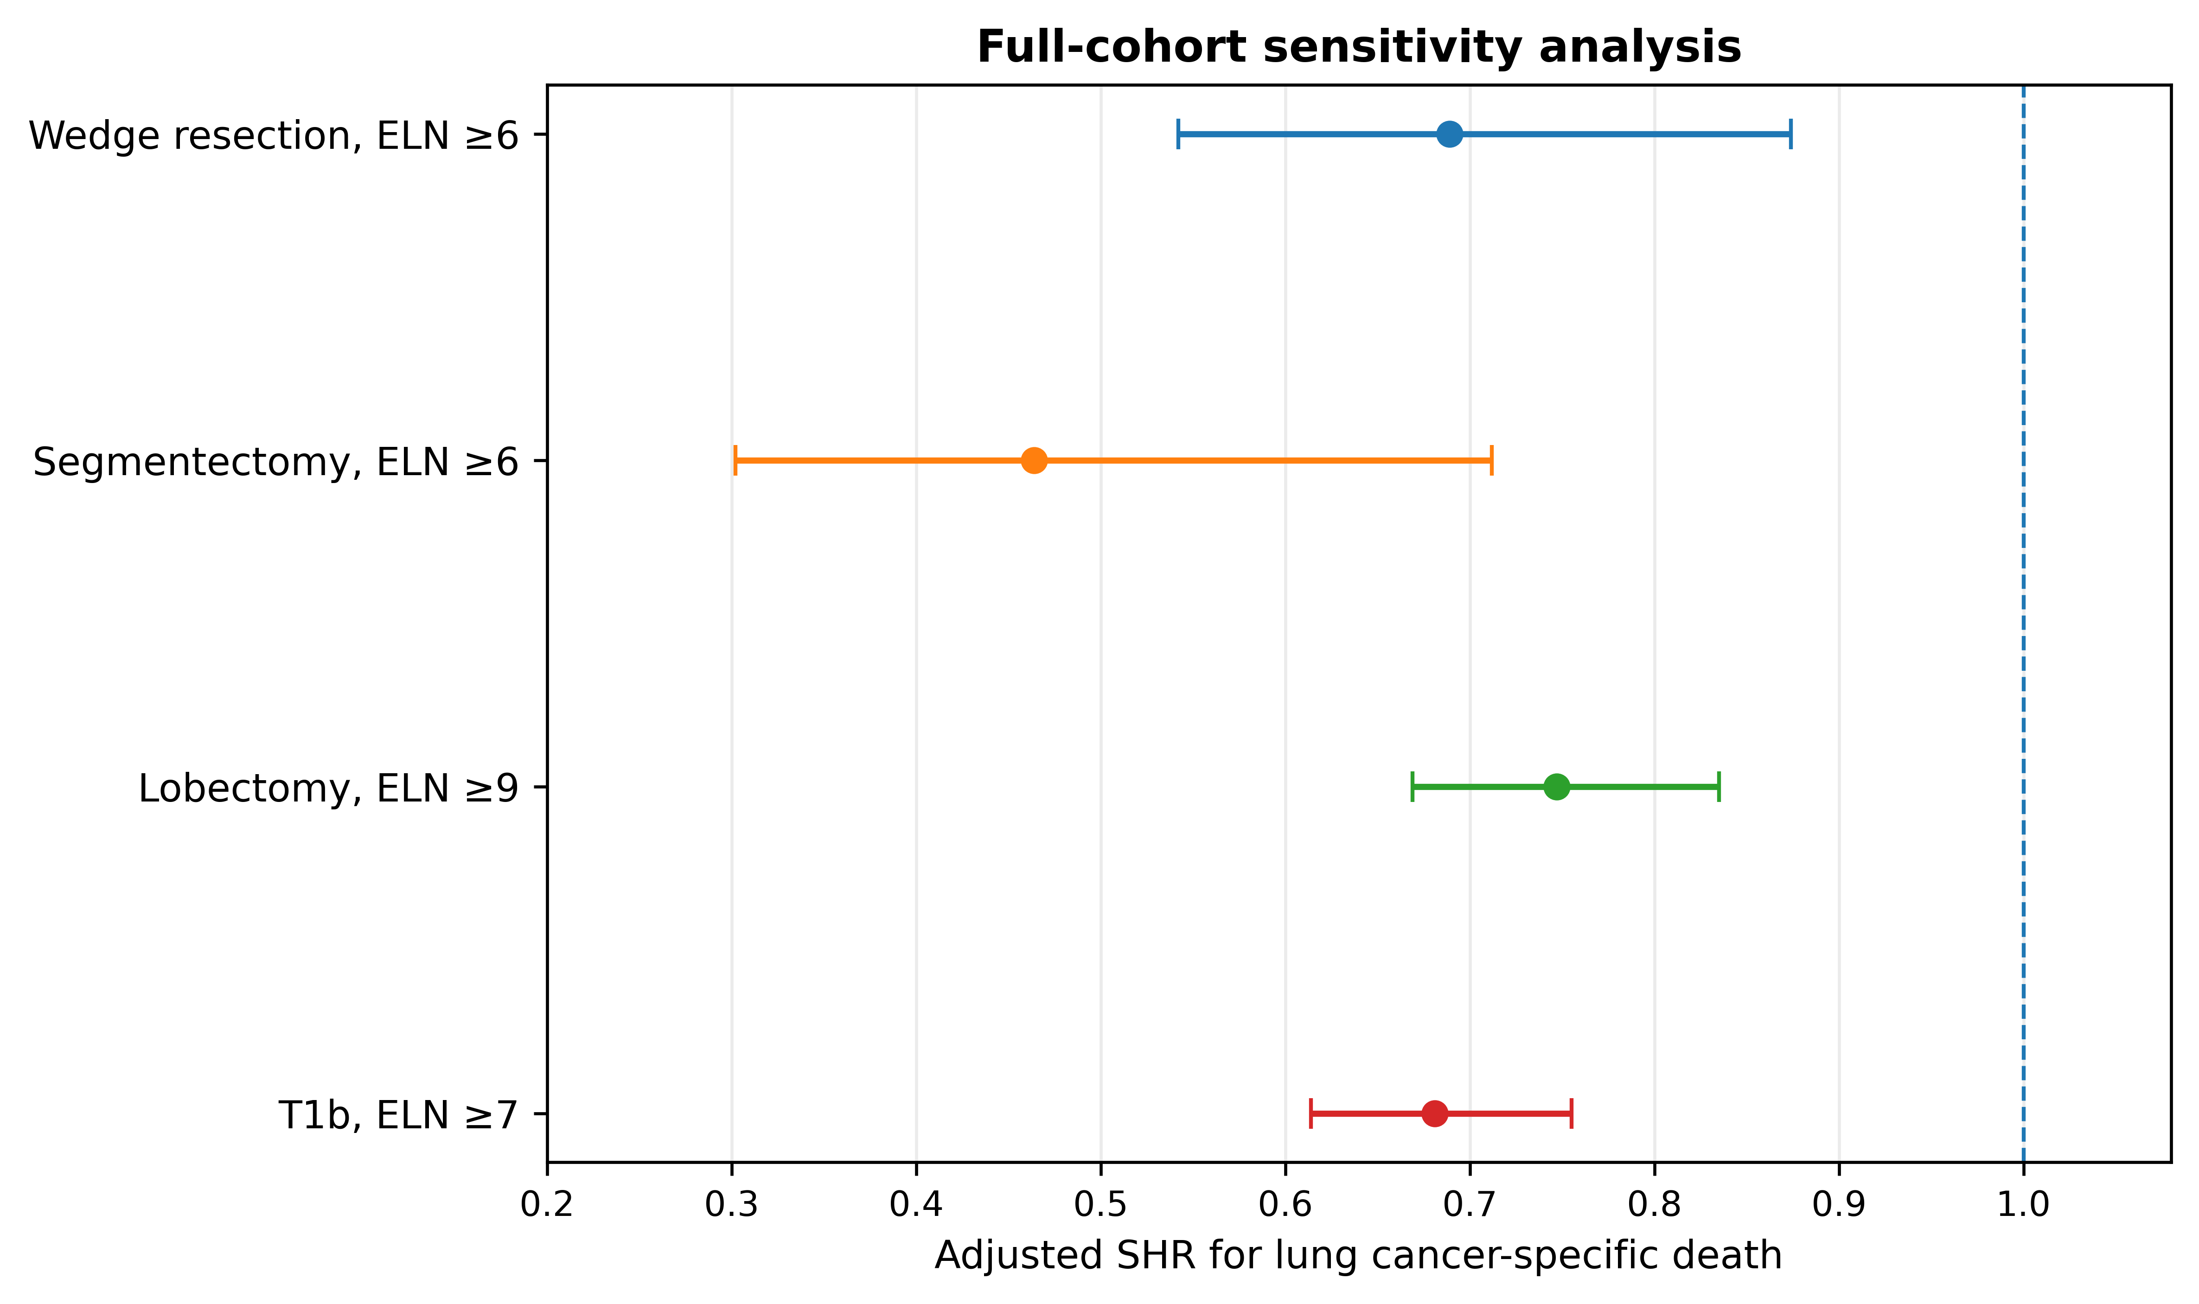
Supplementary Figure S2. Post hoc T1a exploratory cutoffs and T1b sensitivity cutoffs. The T1a analyses did not define a unique target, and the formal T1b validation target was ELN ≥7.
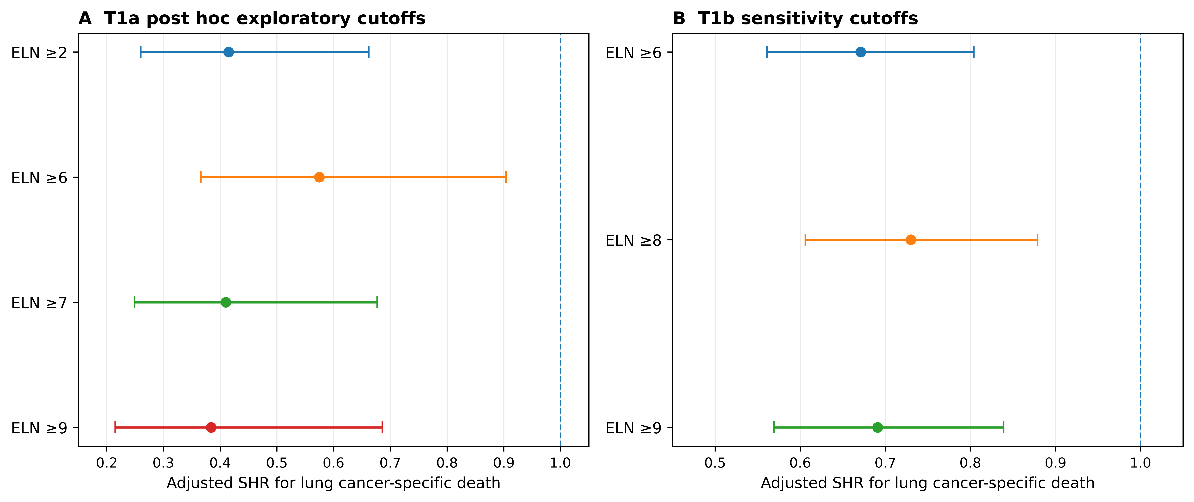

Supplementary Interpretation
The internal-validation estimates are less precise than the full-cohort estimates because only one third of each procedure-specific cohort was reserved for validation. This loss of precision is most relevant for segmentectomy, which had the smallest cohort and the fewest validation events.
Procedure-specific targets should not be interpreted as biological dose-response cutoffs. The lower segmentectomy target is plausibly related to smaller tumors, enrichment for T1a disease, and lower expected intrapulmonary nodal yield. The underlying association between ELN count and LCSS is most plausibly mediated by more accurate N0 classification and reduced understaging.

