Supplemantary Material
Table S1. Reporter-Type Stratified Sensitivity Analysis
Reporter type | Outcome | n (65-84y) | n (<65y) | ROR (95% CI) | Fisher p
Healthcare Professional (n=35,725) | Fall | 206 | 161 | 2.67 (2.17–3.28) | <0.001
 | Overall composite | 446 | 559 | 1.67 (1.47–1.89) | <0.001
Consumer (n=150,784) | Fall | 593 | 421 | 2.81 (2.48–3.18) | <0.001
 | Overall composite | 1,020 | 1,124 | 1.81 (1.66–1.97) | <0.001

Table S2. Age-Stratified Analysis of Fall (65–74 / 75–84 / ≥85 years, each vs. <65y reference)
Age stratum | Outcome | n | n (<65y) | ROR (95% CI) | Fisher p
65–74 (n=45,072) | Fall | 484 | 585 | 2.30 (2.04–2.59) | <0.001
 | Overall composite | 959 | 1,692 | 1.58 (1.46–1.71) | <0.001
75–84 (n=17,363) | Fall | 315 | 585 | 3.91 (3.41–4.49) | <0.001
 | Overall composite | 507 | 1,692 | 2.18 (1.97–2.41) | <0.001
≥85 (n=1,750) | Fall | 57 | 585 | 7.13 (5.41–9.40) | <0.001
 | Overall composite | 79 | 1,692 | 3.43 (2.72–4.32) | <0.001

Fig S1. Chart of Study Population
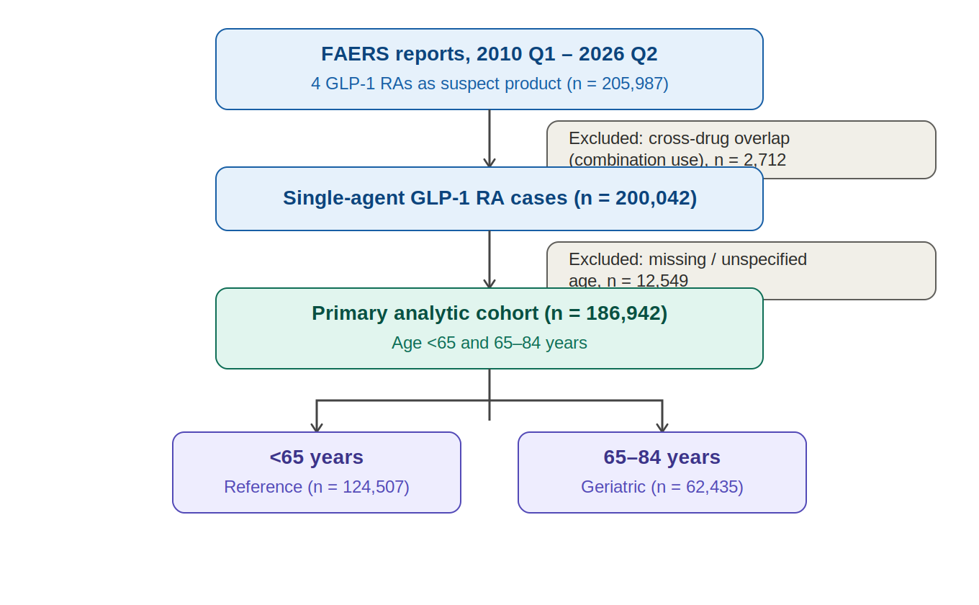
Fig. S2. Calendar-Year Trend in the Fall Reporting Odds Ratio (2016–2026)
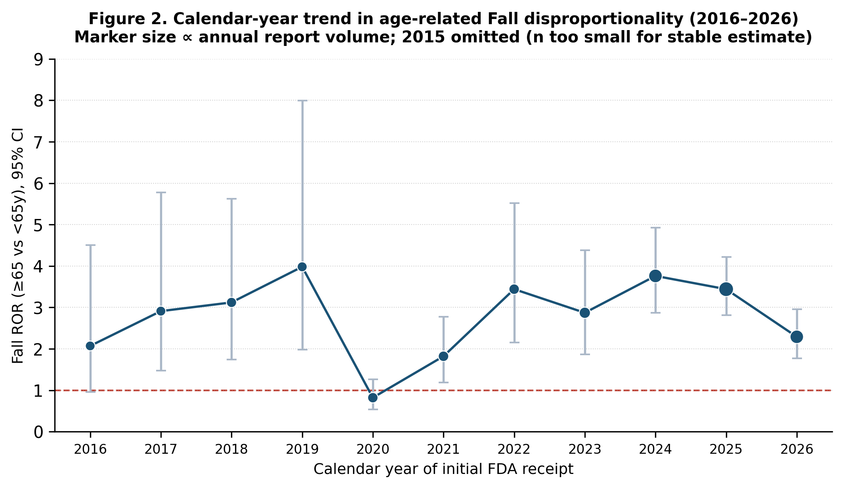
Fig. S2 Calendar-year trend in the Fall reporting odds ratio (≥65 vs <65 years), 2016–2026. Marker size is proportional to annual report volume; 2015 omitted due to very small counts.

