Supplementary Materials

Simulation-Based Evaluation of Clustering Performance and Allele Frequency Classification in Spatially Structured Populations
M Guivarch¹, E Génin^{1,2}, AF Herzig¹*, A Saint Pierre¹*
1. Univ. Brest, Inserm, EFS, UMR 1078, GGB, Brest, France
2. CHU Brest, F-29200 Brest, France
* Equal Contribution

Supplementary Note A
Metrics for evaluating the accuracy of clustering inference
Adjusted Mutual Information
The Adjusted Mutual Information (AMI) considers clustering partitions as random variables. Let $U=\left(U_{1},…, U_{K}\right)$ and $V=\left(V_{1},…, V_{R}\right)$ be two partitions of the same $n$ data points. Then for any point, its cluster label for partition $U$and partition $V$ are two categorical variables. Mutual information (MI) compares partitions $U$ and $V$ by measuring their dependence. It specifically quantifies to what extent knowing one partition reduces uncertainty about the other one. Formally, $MI=H\left(U\right)+H\left(V\right)-H\left(U,V\right)$, where $H$ is the entropy of the partitions, which measures their uncertainty. They are here defined by the formulae:
- $H\left(U\right)= -\sum_{i=1}^{K}{P\left(U_{i}\right)logP\left(U_{i}\right)}$, with $P\left(U_{i}\right)=\frac{|U_{i}|}{n}$ being the probability that a data point picked at random falls into cluster $U_{i}$ in partition $U$,
- $H\left(V\right)= -\sum_{i=1}^{K}{P\left(V_{i}\right)logP\left(V_{i}\right)}$, with $P\left(V_{i}\right)=\frac{|V_{i}|}{n}$ being the probability that a data point picked at random falls into cluster $V_{i}$ in partition $V$,
- $H\left(U,V\right)=-\sum_{i=1}^{K}{\sum_{j=1}^{R}{P\left(U_{i},V_{j}\right)logP\left(U_{i}, V_{j}\right)}}$, with $P\left(U_{i}, V_{j}\right)=\frac{|{U_{i}∩V}_{j}|}{n}$ being the probability that a data point picked at random falls into cluster $V_{j}$ in partition $V,$ and into cluster $U_{i}$ in partition $U$.
Mathematically, MI can be rewritten:
$$MI=\sum_{i=1}^{K}{\sum_{j=1}^{R}{P\left(U_{i},V_{j}\right)log\frac{P\left(U_{i}, V_{j}\right)}{P\left(U_{i}\right)P(V_{j})}}}$$
If both $U$ and $V$ are independent partitions, $MI=0$ whereas if one perfectly determines the other, MI is maximal.
However, two independent partitions can have overlapping clusters purely by chance, in which case MI is biased. This is corrected by AMI, which is adjusted for chance by subtracting the expected mutual information under a random labelling model $E\left[MI\right]$, and normalizing by the maximum achievable agreement $\max\left(H\left(U\right),H\left(V\right)\right)$.
Thus,
$$AMI=\frac{MI-E[MI]}{max⁡(H(U),H(V))-E[MI]}$$
Here a value of 0 corresponds to a dependence expected by chance, and 1 to a perfect agreement.
Adjusted Rand Index
The adjusted rand index (ARI) compares pairwise agreements between partitions, i.e. numbers of elements being in the same cluster in both partitions. Let $n_{i,j}= \left|{U_{i}∩V}_{j}\right|$ be the number of elements being in $U_{i}$ for $U$ and $V_{j}$ for $V$. Then the total number of pairs of elements being in the same cluster in both partitions is $A=\sum_{i,j}{\left({n_{i,j} \atop 2}\right)}.$ Similarly to the AMI score, ARI is adjusted for chance and its formula is:
$$ARI=\frac{A-E(A)}{\max{agreement}-E(A)}$$
where:
- $\max{agreement}$ is $\frac{1}{2}\left[\sum_{i}{\left({|U_{i}| \atop 2}\right)}+\sum_{j}{\left({|V_{j}| \atop 2}\right)}\right]$
- $E\left(A\right)=\frac{\sum_{i}{\left({\left|U_{i}\right| \atop 2}\right)}\sum_{j}{\left({\left|V_{j}\right| \atop 2}\right)}}{\left({n \atop 2}\right)}$
ARI scores also vary between 0 (expected score under random partition) and 1 (full agreement).
Silhouette score
Contrary to AMI and ARI, the silhouette score is an internal metrics: it measures the quality of a single partition using the input data rather than the similarity between two partitions. Let $i$ be a datapoint in the input dataset and let $C$ be its cluster. If $a\left(i\right)$ is the average distance between $i$ and the other points in its cluster, and $b\left(i\right)$ is the average distance between $i$ and the closest cluster $C^{'}≠C$ from$i.$ Then the individual silhouette score is:
$$s\left(i\right)= \frac{b\left(i\right)-a(i)}{max⁡\{a\left(i\right),b\left(i\right)\}}$$
Then, the global silhouette score is the mean $s=\frac{1}{n}\sum_{i=1}^{n}{s(i)}$. A score close to 0 indicates that clusters are almost fully overlapping, while 1 indicates complete separation.
Davies-Bouldin index
The Davies-Bouldin (DB) index is also an internal score. Let $D_{k}$ measure the average distance between points of cluster $k$ to its centroid in the feature space (intra-cluster dispersion) and $m_{k,l}$ measure the average distance between cluster $k$ and cluster $l$ centroids. Then, the DB index is defined by:
$$DB=\frac{1}{K}\sum_{k=1}^{K}{\max_{l≠k}{\frac{{(D}_{k}+D_{l})}{m_{k,l}}} }$$
Here, for any cluster $k$, $\max_{l≠k}{\frac{{(D}_{k}+D_{l})}{m_{k,l}}}$ is the worst-case similarity with another cluster measured by intra and inter cluster dispersion ratios. These ratios are then averaged to obtain the Davies-Bouldin index.
Hence the best scores are achieved when the mean ratio is close to $0$ (intra-cluster dispersion ${(D}_{k}+D_{l})$ very small compared to intercluster dispersion ($m_{k,l})$ and can diverge to infinity.

Supplementary Note B
Link between spectral dimensionality reduction methods
Suppose that we want to apply dimensionality reduction to an input data $X∈M_{n,p}\left(R\right)$. Let $X$ be a centred matrix in which rows represent individuals and columns variables, e.g., genotypes. Let $D∈M_{n}\left(R\right)$ be the Euclidean distance between individuals based on values of $X.$ Then, applying PCA on $X$ and MDS on $D$ gives equivalent results. PCA on $X$, or conversely, classical MDS on $D,$ are both instances of kernel PCA, a broad dimensionality reduction method based on a specific subclass of similarity matrices $S∈M_{n}\left(R\right)$ satisfying two properties:
- Symmetry: $S=S^{T}$, meaning that for any two individuals $i$ and $j$, the genetic proximity of $i$ to $j$ is equal to the genetic proximity from $j$ to $i$
- Positive semi-definiteness (PSD): Meaning that for any vector $x∈R^{n}$, $x^{T}Sx≥0.$
Then $S$ can be interpreted as the matrix of a special similarity function $k$, called a kernel. More specifically, for any $1≤i,j≤n,$we have $S_{i,j}=k\left(x_{i},x_{j}\right)$, where $x_{i}$ and $x_{j}$ are vectors corresponding to the $i$-th and $j$-th rows of $S$, each representing the values taken by individuals $i$ and $j$.
Strictly speaking, a kernel is a similarity between individuals represented in a high dimensional non-linear space, called a Hilbert space.
To compute these proximities in Hilbert spaces, we use inner products. Let $k$ be a kernel function, then there exists a Hilbert space $H$ and a map $ϕ:R^{n}→H$ such that for any vectors $x_{i,}{, x}_{j}∈R^{n},$ $k\left(x_{i}, x_{j}\right)={〈ϕ\left(x_{i}\right), ϕ\left(x_{j}\right)〉}_{H}$.
In the case of haplotype similarity matrices, the Hilbert space corresponds to patterns of shared haplotype structures. In this space, individuals are close when they share similar haplotype patterns.
Even for PCA on the matrix $X$ and for classical MDS $D,$ principal components are built using implicit similarity matrices. In these methods, it is built from any centred data matrix $X$ by fixing $S=\frac{1}{n}X^{T}X$, which is always symmetric and PSD. Conversely, this similarity represents the linear kernel $k\left(x,y\right)=x^{T}y.$
The strength of kernel PCA is to be able to reduce dimensionality from any such PSD symmetric similarity matrix, each inducing its own kernel.
In a similar ways, it has been shown that many other spectral dimensionality reduction methods, such as graph Laplacian and Isomap, are particular cases of kernel PCA using specific kernels¹.

Supplementary Note C
Brief primer on the Dirichlet Process that will be used by FineSTRUCTURE
A Dirichlet Process (DP) is a stochastic process. In contrast with probability distributions, the realizations of a DP are not random variables but directly discrete probability distributions (e.g. a Poisson, Exponential, or any other discrete probability laws). A DP is defined by a concentration parameter α and a base distribution $G_{0}$​. Hence, if $F\sim DP\left(α, G_{0}\right)$, $F$ is a probability distribution centred around the base distribution $G_{0}$ and is not a random variable.
DP are especially useful in Bayesian settings, where parameters themselves follow probability distributions. Most of the times, these distributions are completely unknown, and it is not specified that they follow a given family of probability distributions. DP are useful in this context because they model the probability distribution itself, without a priori on its closed form.
DP are particularly effective for clustering since they provide a solution to model the complex probability distributions of clusters and their numbers knowing the input data.
In the case of clustering, we suppose that every individual has a latent parameter $θ_{i}$ coming from its true, unknown cluster (e.g. a cluster‐specific genetic pattern). If two $θ_{i}^{'}s$ have the same value, the individual come from the same cluster. We do not know the real distributions of these parameters, but we can assume:
$F\sim DP\left(α, G_{0}\right), and θ_{i}\sim F$.
An advantage of DP is that Blackwell and Macqueen² have shown that we can analytically give an expression of the marginal without knowing $F$:
$$θ_{n+1}|θ_{1}, …, θ_{n}\sim \frac{1}{n+α}\sum_{j=1}^{n}{δ_{θ_{j}}}+\frac{α}{n+α}G_{0}$$
This formulation means that if $n_{k}$ parameters among $θ_{1}, …, θ_{n}$ took the same value $x_{k}$, then $P\left(θ_{n+1}=x_{k}|θ_{1}, …, { θ}_{n}\right)=\frac{n_{k}}{n+α}$.
The probability that $θ_{n+1}$ takes a new value $x,$ sampled from the probability distribution $G_{0}$ is
$$P\left(θ_{n+1}=x|θ_{1}, …, { θ}_{n}\right)=\frac{α}{n+α}$$
It is called the “rich-get-richer” paradigm because the probability of taking a given value increases with the number of other parameters having already taken that value before.
Applying this to clustering, let $Z_{i}$ be a random variable taking values that indicate the cluster index of individual $i$. Then, using a DP process, the prior probability of clustering assignments is:
$$P\left(Z_{n+1}=r | Z_{1}, …, Z_{n}\right)=\left\{\begin{aligned}\frac{n_{r}}{n+α} if n_{r} individuals in cluster r \\ \frac{α}{n+α} if r is a previously unseen cluster\end{aligned}\right.$$
This is called the Chinese-Restaurant Process.
Because $P\left(Z_{n+1},…, Z_{1}\right)=P\left(Z_{n+1} | Z_{n}, …, Z_{1}\right)×…×P\left(Z_{2}|Z_{1}\right)×P\left(Z_{1}\right)$, we can easily derive the mutual probability $P\left(Z_{n+1},…, Z_{1}\right)$ from the expression above. We can note that the only prior term $P\left(Z_{1}\right)$ can be retrieved because $Z_{1}$ necessarily defines the first cluster $k_{1},$ so $P\left(Z_{1}=k_{1}\right)=\frac{α}{0+α}=1$

Mathematically, at any step $i$, $P\left(Z_{i}=k | Z_{i-1}, …,Z_{1}\right)=\left\{\begin{aligned}\frac{n_{k}^{\left(i-1\right)}}{α+i-1} if k is occupied \\ \frac{α}{α+i-1} if k is not occupied \end{aligned}\right.$
Where $n_{k}^{\left(i-1\right)}$ is the number of individuals in cluster $k$. Because the denominator is $α+i-1$ in both cases, the denominator of P$\left(Z_{n+1} | Z_{n}, …, Z_{1}\right)×…×P\left(Z_{2}|Z_{1}\right)×P\left(Z_{1}\right)$ is $\prod_{i=1}^{n+1}{(α+i-1)}.$
Let us compute the numerator of the probability of having $K$ clusters, each containing $n_{1}, …, n_{K}$ individuals.
Because $K$ new clusters are created during the process, there is an $α^{K}$ term coming from the numerator of the $\frac{α}{α+i-1}$ part. Also, the second individual joining a given cluster $k$ will contribute to the numerator of the joint probability with a factor $1$ (from the $\frac{n_{k}^{\left(i-1\right)}}{α+i-1}$ term) the second a factor 2, and so on until the $n_{k}-th$ individual contributing a factor $n_{k}-1$. Hence, cluster $k$ contributes to the numerator of the joint probability with a factor $\left(n_{k}-1\right)!$
Finally:
$P\left(Z_{n+1},…, Z_{1}\right)=\frac{α^{K}\prod_{k=1}^{K}{\left(n_{k}-1\right)!}}{\prod_{i=1}^{n+1}{(α+i-1)}}$
Hence, this expression defines a prior probability distribution $P\left(Z\right)$

Supplementary Note D
The FineSTRUCTURE algorithm
FineSTRUCTURE aims to find the partition that best explains a chunkcounts similarity matrix $X.$ It uses the Metropolis-Hastings algorithm, which is a classical Markov chain Monte Carlo (MCMC) approach.
The MCMC starts with a given initial partition, defined either by setting one group per individual (default), or one group for all individuals ($-I 1$ option). Then FineSTRUCTURE suggests three categories of moves:
- Merging two clusters
- Splitting a cluster
- Moving a single individual to another cluster
FineSTRUCTURE suggests new partitions $Z^{'}$, that differ from the current partition $Z,$ by one of these moves, with a certain proposal probability $q\left(Z^{'} | Z\right)$. The suggested new partition $Z^{'}$ is then accepted with the following probability:
$$p_{acceptance}=min\left(1, \frac{P\left(Z^{'} | X\right)}{P\left(Z|X\right)}×\frac{q\left(Z | Z'\right)}{q\left(Z' | Z\right)}\right)$$
This is the Metropolis-Hastings acceptance probability. This sampling process is repeated for a certain number of iterations specified by the user. Intuitively, the acceptance probability guarantees that moves leading to more credible partitions are more likely to be accepted, and overall, the distribution of these sampled partitions converges to the theoretical distribution $P\left(Z | X\right)$.
At the end of this process, FineSTRUCTURE only keeps the clustering partition $Z^{*}$ maximizing the posterior probability $P\left(Z^{*} | X\right)$.
In this model, $p_{acceptance}$ directly depends on the posterior probabilities of clustering assignments, $P\left(Z | X\right)$. FineSTRUCTURE computes these posterior probabilities by decomposing $P\left(Z | X\right)∝P\left(Z\right)×P\left(X | Z\right)$. The prior $P\left(Z\right)$ over clustering is given by a Dirichlet Process prior (see Supplementary Note C).
The second term is the likelihood $P\left(X | Z\right)$ which measures how well a given clustering $Z$ explains the observed chunkcounts data $X.$ Each individual $i$ is in a certain cluster $q_{i}$ and $x_{i,j}$ is the expected number of chunks that $i$ copies from a certain individual $j.$ The model assumes that the copying process depends on the clustering partition. Let us call $P_{q_{i}q_{j}}$ the probability that any individual from cluster $q_{i}$ copies from an individual in cluster $q_{j}$. Then knowing that $i$ copies from someone in cluster $q_{j}$, the probability that $i$ copies from $j$ is: $\frac{P_{q_{i}q_{j}}}{{\hat{n}}_{q_{j}}}$ where ${\hat{n}}_{q_{j}}$ is the number of individuals in cluster $q_{j}.$ The full likelihood is then:
$$P\left(X | Z,P\right)=\prod_{i=1}^{N}{{\prod_{j=1}^{N}{\left(\frac{P_{q_{i}q_{j}}}{{\hat{n}}_{q_{j}}}\right)}}^{\frac{x_{i,j}}{c}}}$$
Where $c$ is a term which adjusts for the fact that chunks are not independent.
While FineSTRUCTURE MCMC process eventually converges to the distribution $P\left(Z | X\right)$, there is no guarantee on the number of iterations needed. To prevent results to be biased by the initial partition, FineSTRUCTURE uses burn-in iterations. These iterations are not directly used to sample partitions, but rather to let enough iterations for the MCMC to escape potential local minima due to the initial partition.
By default, the number of burn-in is fixed to 1,000 and can be changed using the -x parameter. The -y parameter sets the number of iterations the MCMC will run for after the burn-in step, with a default value of $-y 1,000$. These iterations are called default iterations.
Finally, FineSTRUCTURE suggests an optional -z parameter, which decreases correlations between successive sampled iterations by only keeping one every $z$ iterations. The higher $z$, and the lower the correlation between successive sampled iterations. Because this option however operates at the cost of decreasing the number of sampled iterations, it is not taken advantage of by default, and its value is set to be $-z 1$.
The MCMC is not deterministic, because it suggests and accepts moves based on probability distributions. Reproducibility is however guaranteed by setting a seed, using the -s option.
Finally, the -e option outputs coincidence matrices. For every pair of individuals, it records the proportion of clustering partitions sampled by the MCMC in which both individuals fall into the same cluster. To assess the convergence of the MCMC chain, common practice is to let at least two FineSTRUCTURE iterations run in parallel using different seeds. Then, coincidence matrices are computed while the chains are still running. Similar patterns of both coincidence matrices reflect similar groupings on average for both chains, meaning convergence of the clustering step is a realistic approximation.
It is noticeably the case for our datasets using FineSTRUCTURE default iterations (Supplementary Figure S19). Individuals from neighbouring demes tend to be clustered together and in similar ways between different chains. Because the number of groups increased with the number of iterations despite these convergence patterns, we launched other iterations of FineSTRUCTURE with $-x 10,000$ burn-in and $-y 90,000$ samples used to compare with results on default parameters.
The same increase in the number of groups was observed. The average AMI score was also similar in both settings and for all migration rates. No clear advantage in terms of AMI score was observed for iterations using more burn-in and samples compared to default parameters (Supplementary Figure S20).
Default parameter commands format used:
- finestructure -s 1 -I 1 file.chunkcounts file.xml
- finestructure -m T 1 000 000 file.chunkcounts file.xml file.tree (tree-building phase)
Longer MCMC iterations commands format:
- finestructure -s 1 -I 1 -x 10 000 -y 90 0000 file.chunkcounts file.xml
- finestructure -m T 1 000 000 file.chunkcounts file.xml file.tree (tree-building phase)

Supplementary Note E
The Mclust algorithm
Mclust belongs to a family of models called Gaussian Mixture Models. It assumes that the initial data (individuals in rows and features/PCs in columns) were generated by overlapping Gaussian distributions (fully determined by their mean vectors $μ$ and covariance matrices $Σ)$, and that each cluster is represented by one Gaussian component. This assumption comes from the fact that many continuous probability distributions are well approximated as mixtures of a finite number of Gaussians^{3,4}.
Mclust clustering operates in the following steps:
- Initialization: The number of clusters $K$ is specified by the user. Then, Mclust defines an optimized initial partition using the model-based hierarchical agglomerative clustering (MBHAC) algorithm. This initial partition will only serve as an optimized starting point for the EM algorithm (defined in the following steps).
- Expectation (E-step): Using the current estimated partition, Mclust computes the posterior probabilities of belonging to each cluster for every individual.
- Maximization (M-step): These posterior probabilities are used to update the mean vector and covariance matrix of each Gaussian. Different constraints on the form of the covariance matrix define the different categories of Mclust models used.
- Iteration: Steps 2 and 3 are alternatively repeated until reaching convergence. Once convergence of this EM algorithm is reached, individuals are assigned to the cluster maximizing their posterior clustering membership probabilities.

Mathematically, let $x_{i}$ be a vector representing the features of a given individual i ($i$-th row of a dataset). Let also $θ$ be the vector of all the parameters of the model, e.g. values and constraints for the Gaussian components means and covariance.
Then, mathematically, Mclust assumes that ${p(x}_{i}\left|θ\right)= \sum_{k=1}^{K}{π_{k}f_{k}\left(x_{i}|μ_{k},Σ_{k}\right)}$, where:
- all the $π_{k}$ sum to 1 and are the prior probabilities of belonging to cluster k
- $f_{k}\left(.|μ_{k},Σ_{k}\right)$ is the probability density of the Gaussian representing the k-th cluster, with mean vector $μ_{k}$and covariance matrix $Σ_{k}$.
While the observed vector $x_{i}$ is modelled as a mixture of Gaussian distributions, the model can be expressed using latent—i.e. unobserved—variables $z_{i,k}∈\left\{0,1\right\}$ indicating whether individual $i$ belongs to cluster $k.$ Under this representation, the model can be rewritten
$$p\left(x_{i}, z_{i} | θ\right)=\prod_{k=1}^{K}{{\left[π_{k}f_{k}\left(x_{i}|μ_{k},Σ_{k}\right)\right]}^{z_{i,k}} }$$
For all $n$ individuals, the likelihood becomes
$$p\left(x,z | θ\right)=\prod_{i=1}^{n}{\prod_{k=1}^{K}{{\left[π_{k}f_{k}\left(x_{i}|μ_{k},Σ_{k}\right)\right]}^{z_{i,k}}}}$$
And the complete-data log-likelihood is then expressed as:
$$l\left(θ\right)= \sum_{i=1}^{n}{\sum_{k=1}^{K}{z_{i,k}[log π_{k} +log f_{k}\left(x_{i}|μ_{k},Σ_{k}\right) ]}}$$

Initialization step using MBHAC
MBHAC starts with assigning every individual to its own cluster. At each step, MBHAC considers each candidate merge of clusters. It then selects the merge that result in the smallest decrease of the likelihood $l\left(θ\right)$. It is therefore a greedy clustering approach. Randomness appears when several candidate merges minimize the decrease in likelihood. In that case, one of these merges is selected at random.
MBHAC iterates this way until building a complete hierarchical tree. If the number of clusters specified by the user is $K$, then the initial partition that will be used in later steps is the cut of the tree for $K$ groups.
Clustering using the EM algorithm
The EM algorithm uses the MBHAC initial partition to compute a first estimation of the parameters $μ_{k}, π_{k}$, $Σ_{k}.$ Then it alternates between the E-step and the M-step until convergence.
- E-step
The real clusters that generated the data are unknown, so the values of $z_{i,k}$ are also unknown. The expectation step estimates them by their expectations, which is obtained by:

$${\hat{z}}_{i,k}=E\left(z_{i,k}|x_{i}\right)=P\left(z_{i}=k | x_{i}\right)=\frac{\hat{ π_{k}}f_{k}\left(x_{i}|\hat{μ_{k}}, \hat{Σ_{k}}\right)}{\sum_{r=1}^{K}{{\hat{ π}}_{r}f_{r}\left(x_{i}|\hat{μ_{r}}, \hat{Σ_{r}}\right)}}$$
These probabilities represent soft clustering memberships, i.e., ${\hat{z}}_{i,k}$ is the estimated probability that individual $i$ belongs to cluster $k$. Then the likelihood is replaced by its expectation:
$$Q\left(θ\right)= \sum_{i=1}^{n}{\sum_{k=1}^{K}{{\hat{z}}_{i,k}[log \hat{ π_{k}} +log f_{k}\left(x_{i}|\hat{μ_{k}}, \hat{Σ_{k}}\right) ]}}$$

- M-step
For each cluster $k,$ these posterior probabilities ${\hat{z}}_{i,k}$ and the likelihood $Q\left(θ\right)$ are then used to update$\hat{μ_{k}}$, $\hat{π_{k}}$, and $\hat{Σ_{k}}$. Their formulae are:
- $\hat{μ_{k}}=\frac{\sum_{i=1}^{n}{{\hat{z}}_{i,k}}x_{i}}{\sum_{i=1}^{n}{{\hat{z}}_{i,k}}}$, giving the estimated “mean” of cluster $k.$
- $\hat{π_{k}}=\frac{1}{n}\sum_{i=1}^{n}{{\hat{z}}_{i,k}}$, giving the estimated proportion of individuals belonging to cluster $k$
In practice, updating the estimated covariance matrix $\hat{Σ_{k}}$ is more delicate, and a single estimation can potentially lead to several downfalls, such as making the likelihood diverge to infinity, or highly increasing both computation time per cluster and the risk of overfitting. To gain power while preventing these behaviours, Mclust defines several possible models of the covariance, each leading to its own update formula of $Σ_{k}$. Each of these implementations will define a different “model”.
All these models are defined using the fact that covariance matrices are symmetric and can therefore be diagonalized in the following way: $Σ_{k}=Q_{k}Λ_{k}Q_{k}^{T}$, where the columns of $Q_{k}$are orthonormal eigenvectors of$Σ_{k}$, and $Λ_{k}$ is the diagonal matrix of the corresponding eigenvalues. This decomposition of the covariance matrix can also be rewritten as$Σ_{k}={λ_{k}Q}_{k}A_{k}Q_{k}^{T}$, where $A_{k}$ is obtained by dividing every eigenvalue in $Λ_{k}$by their geometric mean $λ_{k}$.
This decomposition holds a deep geometric interpretation of $Σ_{k.}$ If we represent the data points in the feature space, the covariance matrix actually defines an ellipsoid centred around the mean vector $μ_{k}.$ Then$Q_{k}$ gives the axes along which the ellipsoid stretches, $A_{k}$corresponds the relative size of the stretches along each axis, and $λ_{k}$ controls the absolute size of the ellipsoid (see Supplementary Figure S17 for an example of ellipsoids on simulated data). We refer to these parameters as respectively the orientation, shape and volume of the covariance matrix.
For example, datasets with two uncorrelated variables would produce a circle-shaped covariance structure, whereas strong correlations between variables would induce a strongly stretched ellipsoid. The covariance models tested are defined by the user by providing three letters, the first one fixes constraints on size, the second one on shape and the third on orientation.
Letter E is used to fix a similar value (of volume, shape or orientation) for all covariance matrices, V is used to define a model in which all covariance matrices have their own value, and I is specifically used to set spherical covariance (impacting shape and orientation).
For instance, EEV is the model for which all covariance matrices have the same size (E) and same shape (E), but a different orientation (V). Overall, the choice of the right model for the covariance is a trade-off between flexibility and stability.
More flexible models such as VVV allow each cluster to have its own volume, shape and orientation, which can capture more complex covariance settings. However, these models involve many parameters and may be unstable or overfitted. More constrained models such as EII or EEE force common values for all clusters, which reduces the number of parameters updated and can improve estimation stability when clusters are roughly similar.
Therefore, different models may be more suited depending on the dimensionality, sample size, cluster separation, size, shape, or orientation. One of the main strengths of Mclust is its probabilistic formulation which allows to evaluate and compare several models using the Bayesian information criteria (BIC). In practice, Mclust runs several models (different covariance) on different range of $K$ values in parallel. The model selected is the one maximizing $BIC=2×l\left(\hat{θ}\right)+m×log\left(n\right)$, where $m$ is the number of free parameters of the model and $n$ is the number of individuals.

Supplementary Note F
The Leiden algorithm
Pairwise similarity matrices can be considered as graphs, where nodes correspond to individuals and similarities to edge weights. The Leiden algorithm takes advantage of this graph structure to iteratively detect clusters. It operates in three steps:
- Local moving step: Nodes are moved together into clusters (called communities) based on a graph objective function (e.g. Constant Potts Model).
- Refinement step: Each group is considered independently. Within each group, nodes are assumed to form their own subcluster. A node is moved to another subcluster if it is strongly connected with the node in the other subcluster. This step will “break” the original groups into more strongly connected ones. The new groups (also referred to as communities) are used for the next step.
- Aggregation step: Create a new graph in which each community is a node.
The new graph defined by the aggregation step is then in turn used as input for a new local moving step, and the whole process is iterated.
The objective functions
The objective function to be maximized is typically the Constant Potts Model (CPM), defined, for each clustering partition $P,$ by
$H\left(P\right)=\sum_{C∈P }{E(C,C)}-γ\left({|C| \atop 2}\right)$.
Here, each $C$ is a cluster of $P$, $E\left(C,C\right)$ is the total edge weight between elements of the cluster $C$, $γ$ is called the resolution parameter, and $\left({|C| \atop 2}\right)$ is the total number of internal edges between elements of $C.$ Intuitively, the component of $C$ in $H\left(P\right)$ is positive if $E\left(C,C\right)-γ\left({\left|C\right| \atop 2}\right)≥0$, i.e., $E\left(C,C\right)≥γ\left({\left|C\right| \atop 2}\right)$. This occurs when the observed edge weights of $C$ is larger than the “expected” edge weight $\left({\left|C\right| \atop 2}\right)$ scaled by the resolution parameter $γ$. Higher $γ$ values increase the constraint term $γ\left({\left|C\right| \atop 2}\right),$ and communities with smaller groups will tend to be favoured by the algorithm. A very close variant of the CPM, called modularity can also be used to derive the algorithm. It is defined by the formula:
$$H\left(P\right)=\frac{1}{2m}\sum_{C∈P }{\left[E(C,C)-γ\frac{K_{C}^{2}}{2m}\right]}$$
Here, $m$ is the total edge weight of the whole graph and $K_{c}^{2}$ is the square of the weighted sum of degrees in cluster $C$, which represents the squared connectivity of cluster $C$. Intuitively, the full term $\frac{K_{C}^{2}}{2m}$ is the expected number of internal edges in cluster $C$ if we randomly shuffled the edges while preserving the degree of each node in cluster $C.$ As in CPM, denser clusters are favoured over sparse ones and increasing the resolution parameter increases the number of clusters. However, contrary to CPM, modularity depends on the total edge weights, which means two identical clusters can get different scores in different graphs.
Local moving step
In the local moving step, the Leiden algorithm starts by assigning each node to its own cluster, resulting in the partition $\left\{\left\{1\right\},\left\{2\right\}, …, \left\{n\right\}\right\}$.
Then, for each node $i$, the algorithm computes the change in CPM objective function that would result by moving $i$ to each of the other communities. Node $i$ is moved to the community of node $\left\{j\right\}$ that generates the largest increase of the CPM function $H\left(P\right)$, provided that this increase is positive.
Because this move could influence all other neighbours of $i$ (nodes sharing strong connections with $i$) to join the new cluster $\left\{i,j\right\}$, they will all be submitted to this same procedure once again.
This local moving phase is repeated iteratively until no single-node move improves the CPM function.
Refinement step
The local moving step maximizes the CPM score greedily by moving nodes between cluster. However, it does not guarantee that the resulting communities are well connected internally. The refinement step ensures this is the case by identifying well connected groups within each cluster. Specifically, for each cluster $C∈P^{*}$, it starts by assigning every node in $C$ into its own subcluster. Then:
- The algorithm selects a subset $R$of nodes that are sufficiently well connected in $C$, and a subset $T$ of subclusters of $C$ that are also well-connected, according to a connectivity criterion.
- A node $v∈R$ can only be moved to a subcluster $c∈T$ if doing so increases the CPM function $H$, we note this increase $ΔH\left(v→c\right)≥0$. Then $v$ is moved to $c$ with probability $exp\left(\frac{1}{θ}ΔH(v→c)\right),$where $θ$ is a randomness parameter.
- Once this is done for all nodes $v∈R$, $C$ is replaced by all its subclusters.
In all these stages, $R$ ensures that only well-connected nodes are clustered and $T$ that they fall into internally well-connected subclusters. Then the moves are only accepted if they increase the CPM objective score. Unlike the local phase, these moves are not greedy (the move with the best increase in CPM is not always chosen) to avoid local minima.
Aggregation step
Once the partition has been refined, the new clusters are considered as nodes in a new graph $G^{'}$. Local moving and refinement steps can in turn be achieved in $G^{'}$.
All three steps are repeated until no increase of CPM score can be achieved by merging nodes in the local moving phase or when the total number of iterations defined by the user has been reached.

Supplementary Figures

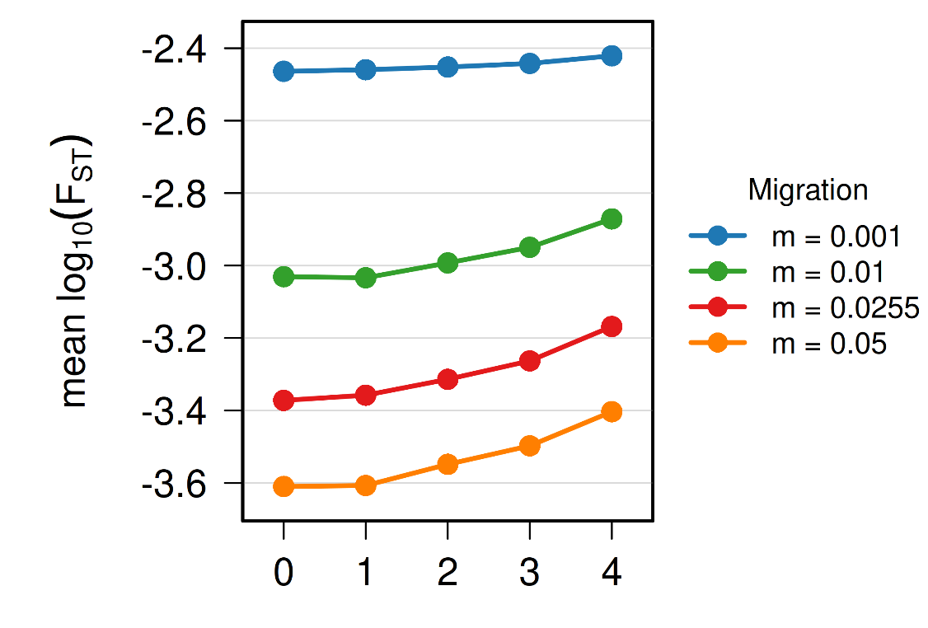
Fig. S1: Mean Fst between demes as a function of their spatial Manhattan distance (shortest path along the grid, moving only horizontally and vertically) on the deme grid, for each migration-rate scenario. Each point represents the average across pair of demes. Higher $F_{ST}$ reflects greater genetic differentiation. Results are reported for random sampling scheme.

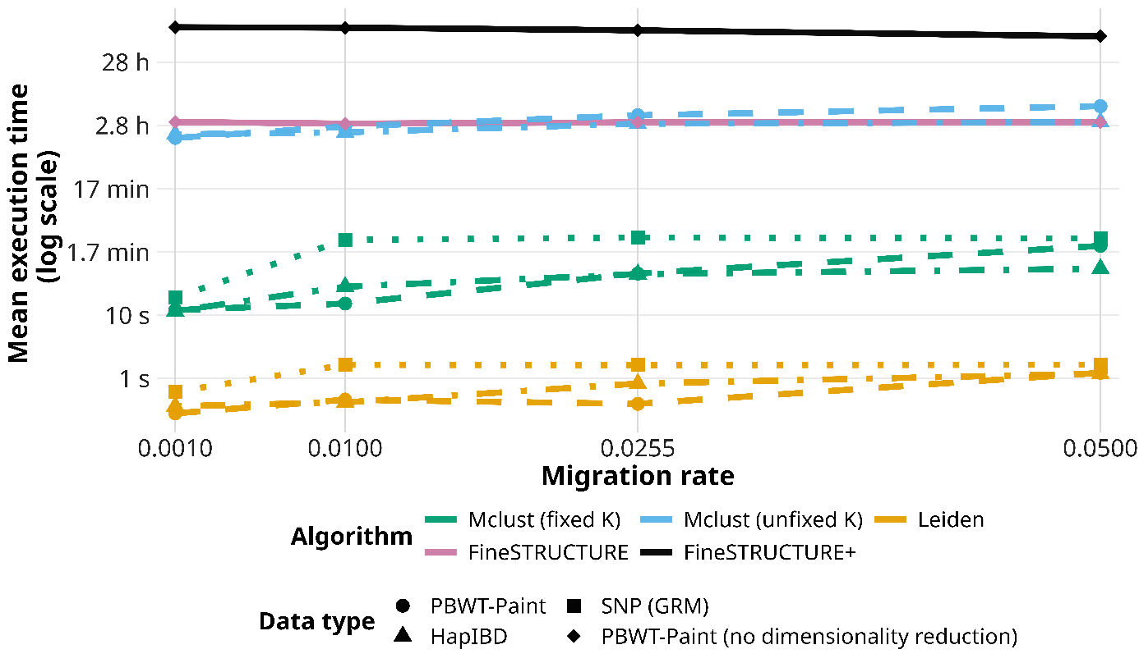

Fig. S2: Average running times of the various algorithms: Mclust (fixed K) corresponds to the average running time of Mclust with the number of groups K being fixed to 25. Mclust (unfixed K) corresponds to the average running time of Mclust with K selected from a range of 2 to 100, based on the BIC. Leiden (best resolution) corresponds to the average running time of Leiden iterations across all nine resolution parameter values. FineSTRUCTURE corresponds to the average running time of FineSTRUCTURE iterations with default parameters (1,000 MCMC burn-in, 1,000 iterations, and every iteration retained). FineSTRUCTURE+ corresponds to the average running time of FineSTRUCTURE using more MCMC iterations (10,000 MCMC burn-in, 90,000 iterations, and one iteration retained every 1,000 samples).
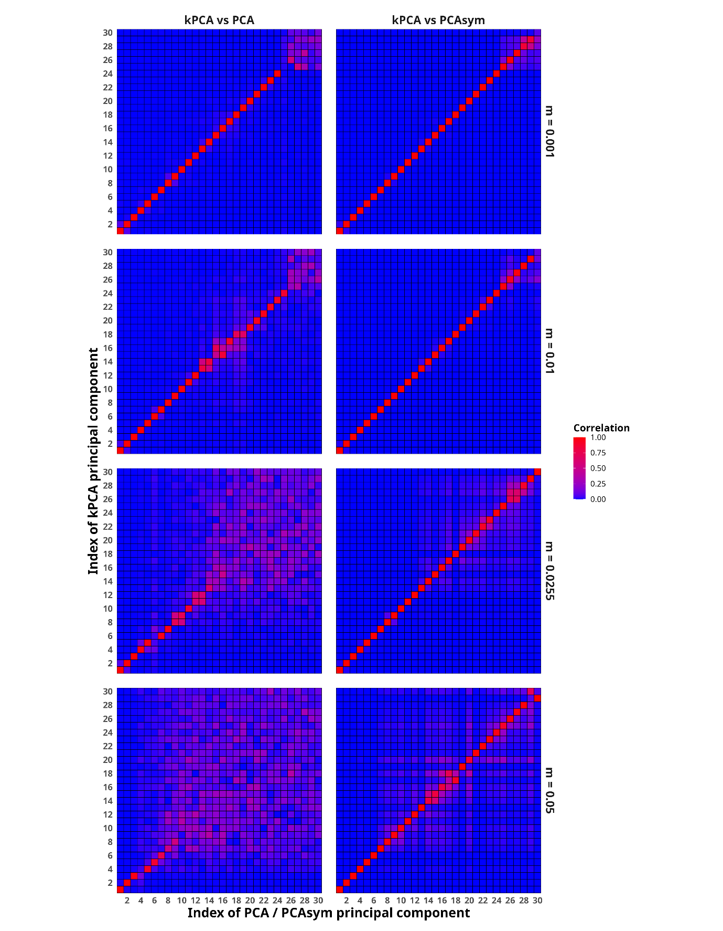
Fig. S3: Absolute correlations between each of the 30 first PCs obtained from kPCA and compared to PCA and PCAsym. Results are reported for PBWT-Paint chunkcounts matrices on random sampling scheme.
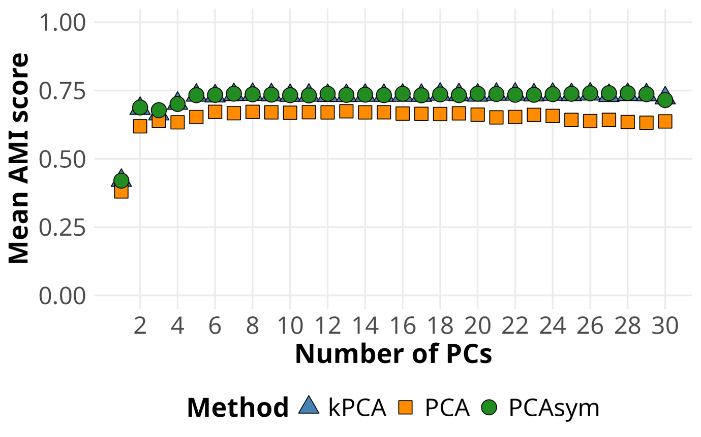
Fig. S4: Mean AMI scores with gold standard partition over 10 runs of Mclust clustering using each of the preprocessings (kPCA, PCA and PCAsym) and different number of PCs. Results are reported for PBWT-Paint chunkcounts matrices on random sampling scheme and a migration rate of 0.05.

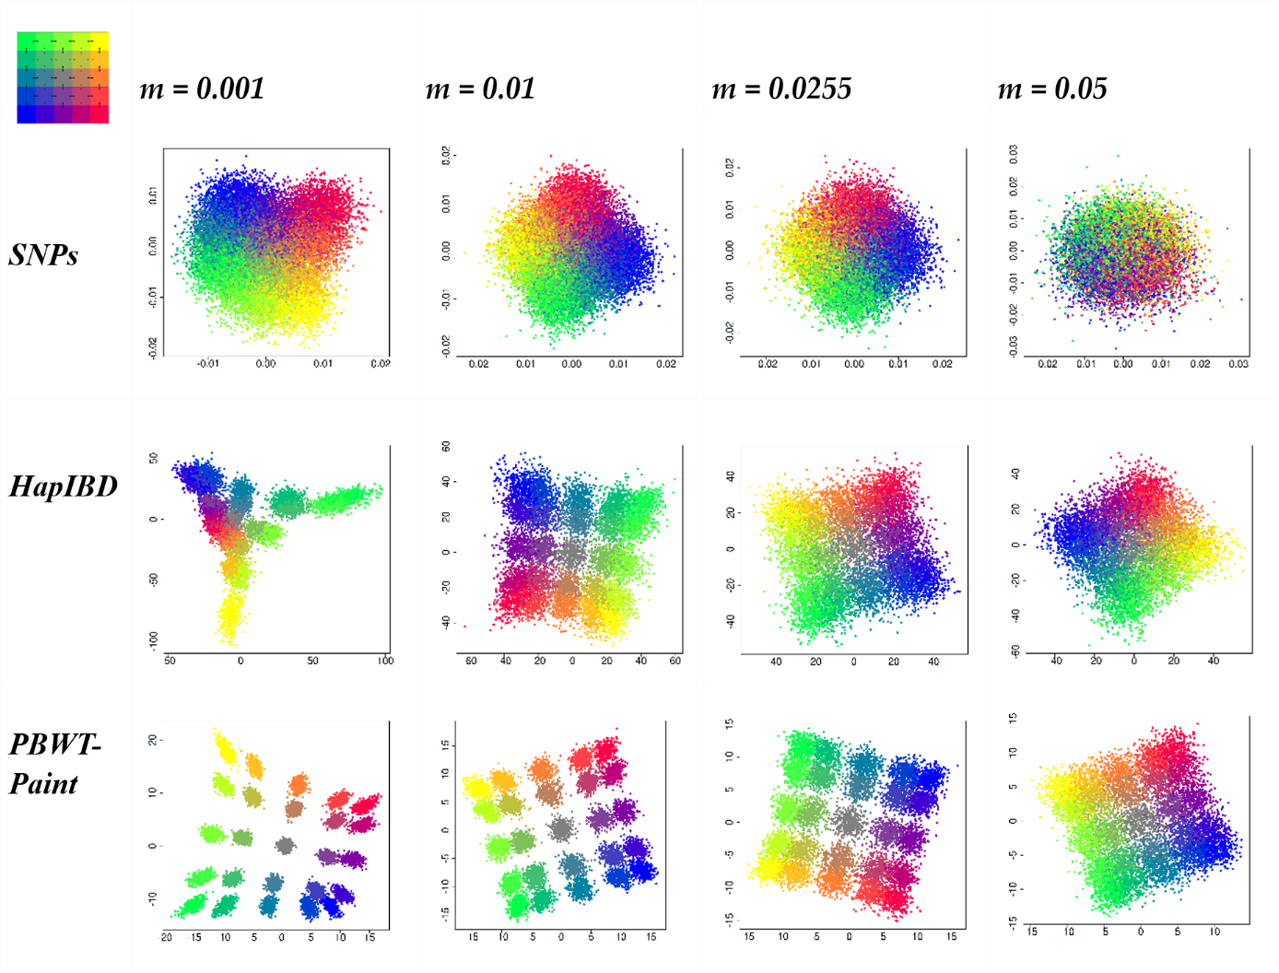
Fig. S5: First two principal components (PCs) computed on common variants (MAF > 0.01) using different dimensionality reduction and data pre-processing methods. Points correspond to individuals and colours indicate deme membership, as illustrated on the top left map. Colours are taken from Zaidi and Mathieson (2020). Results are reported for random sampling scheme across migration rate scenarios ranging from m=0.001 to m = 0.05. ”SNPs”: First two PCs from PCA performed on LD- pruned common variants. ”HapIBD”: First two PCs from kernel PCA (kPCA) on the HapIBD similarity matrix. ”PBWT-Paint”: First two PCs from kPCA on the PBWT-Paint similarity matrix.

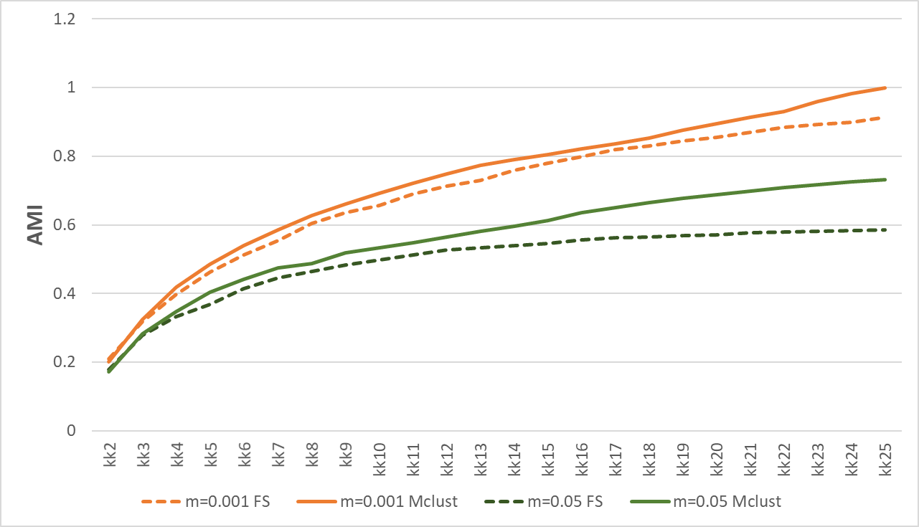
Fig. S6: Mean AMI score averaged over 100 iterations for Mclust and 10 iterations for FineSTRUCTURE across different number of clusters. Results are shown for two migration rates scenario: m=0.001 and m=0.05.

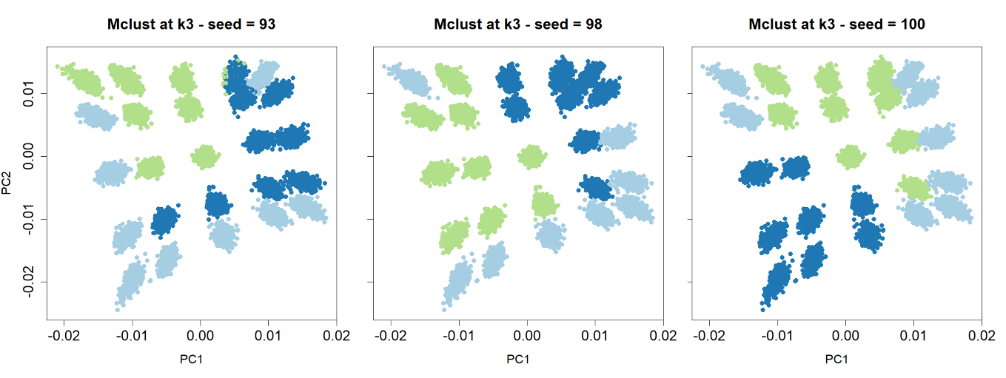
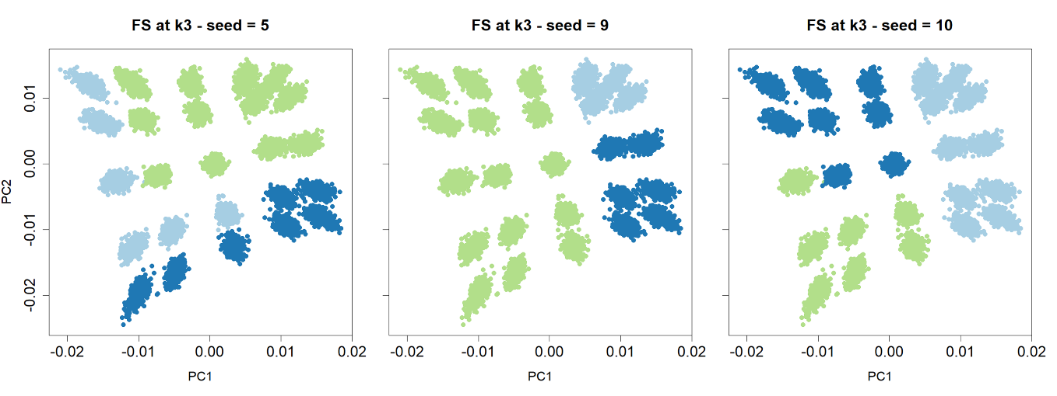
Fig. S7: First two principal components (PCs) obtained from a kernel PCA performed on the PBWT-Paint similarity matrix. Clustering results are shown for Mclust (top panels) and FineSTRUCTURE (FS) (bottom panels). Each point represents an individual, and colours indicate cluster membership when the number of clusters is fixed at k=3. Results are shown for 3 different random seeds (over 100 for Mclust and 10 for FS) under the random sampling scheme with a migration rate m=0.001.

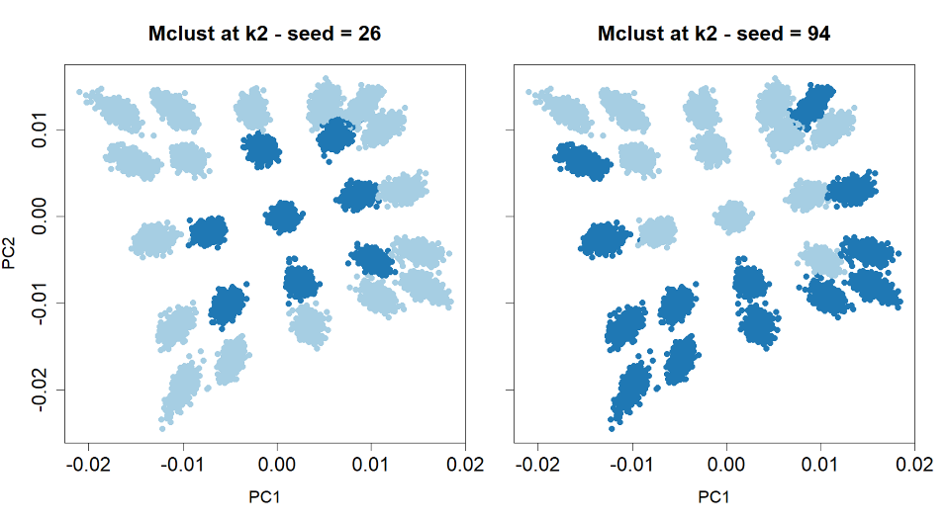
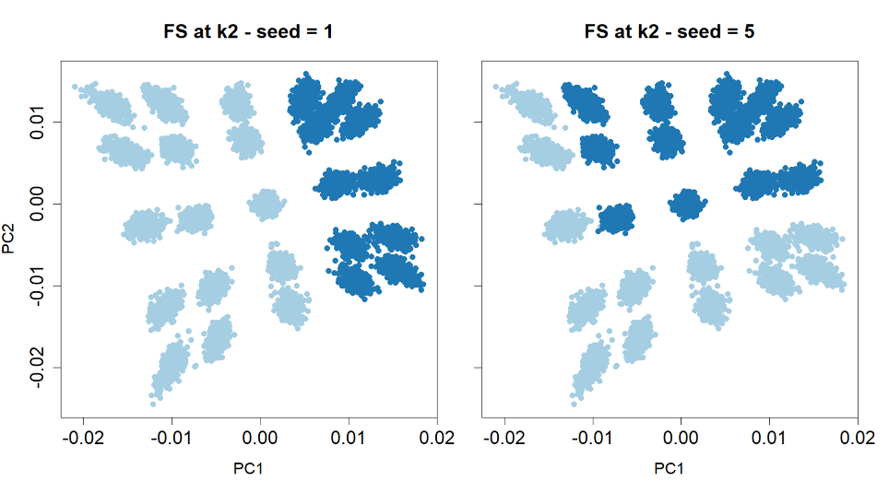
Fig. S8: First two principal components (PCs) obtained from a kernel PCA performed on the PBWT-Paint similarity matrix. Clustering results are shown for Mclust (top panels) and FineSTRUCTURE (FS) (bottom panels). Each point represents an individual, and colours indicate cluster membership when the number of clusters is fixed at k=2. Results are shown for 2 different random seeds (over 100 for Mclust and 10 for FS) under the random sampling scheme with a migration rate m=0.001.
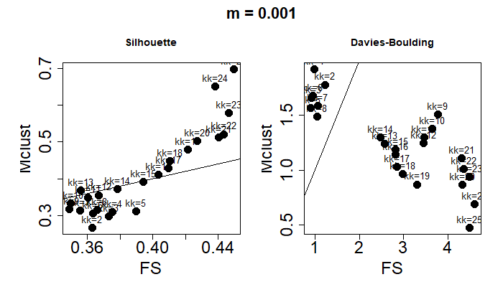
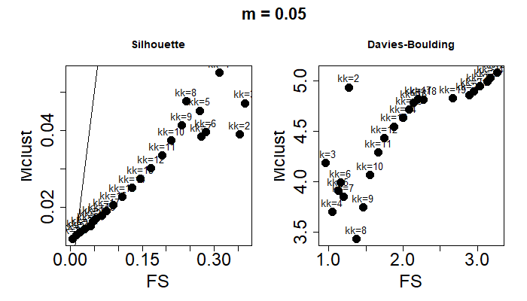
Fig. S9: Silhouette (left) and Davies-Bouldin (right) scores averaged over 100 iterations for Mclust and 10 iterations for FS. Partitions were set equal to 2 to 25 groups and the migration rate m was set equal to 0.001 and 0.05.

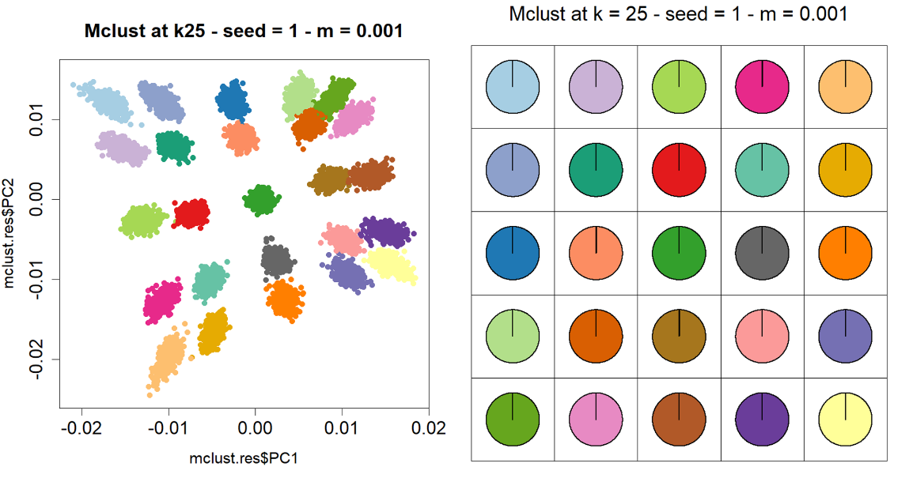
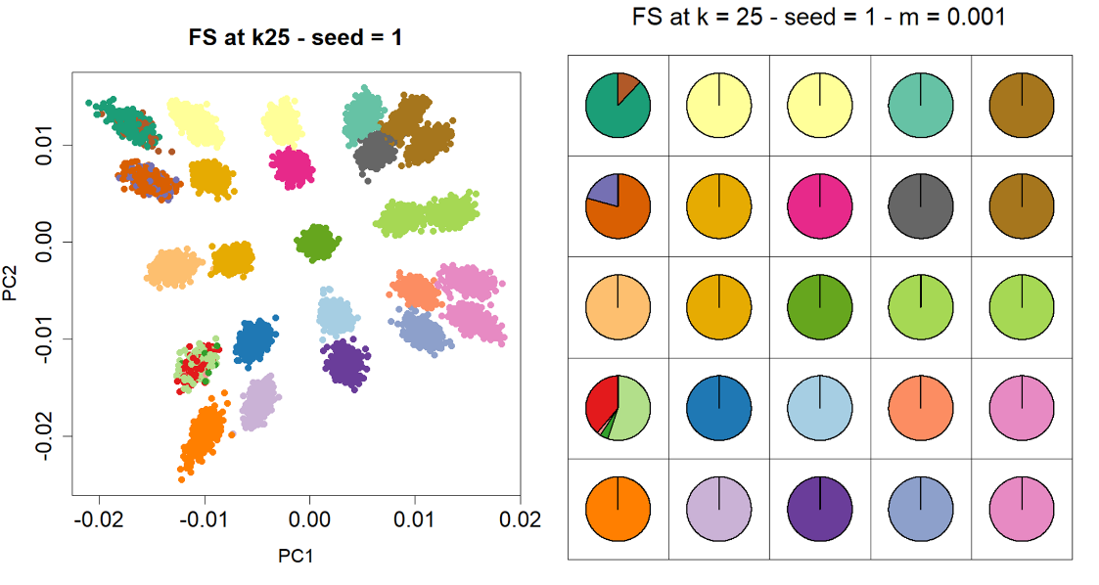
Fig. S10: Clustering results are shown for Mclust (top panels) and FineSTRUCTURE, i.e. FS (bottom panels) based on PCA obtained from a kernel PCA performed on the PBWT-Paint similarity matrix. Results are reported for the random sampling scheme under a migration rate of m=0.001. The first random seed is shown for each clustering algorithm. Colours indicate cluster membership when the number of clusters is fixed at k=25. Left: Projection of individuals on the first two principal components (PCs). Right: Pie chart of the proportion of individual by deme belonging to each cluster.

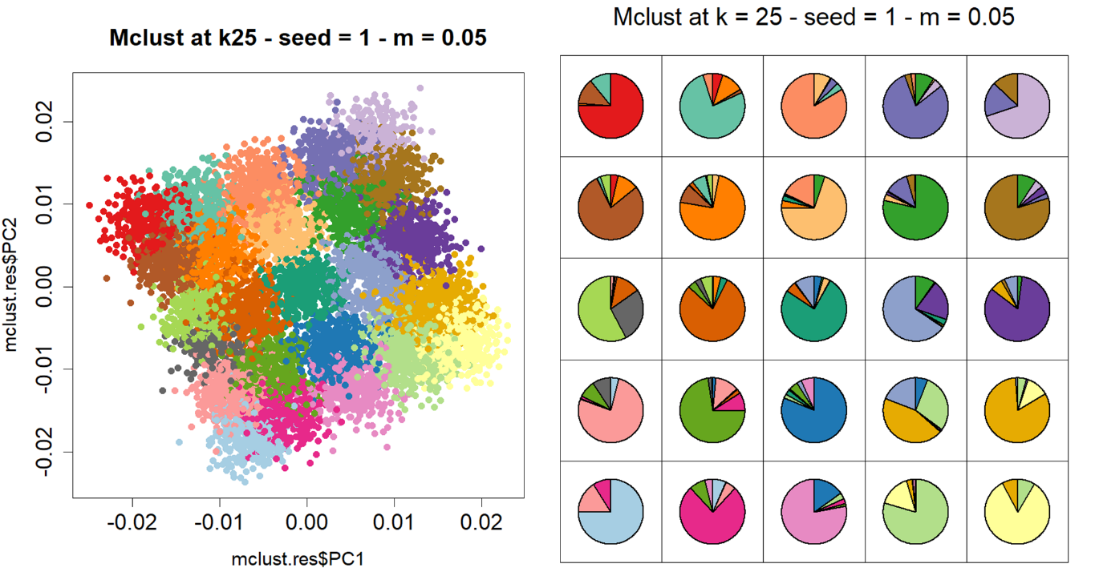
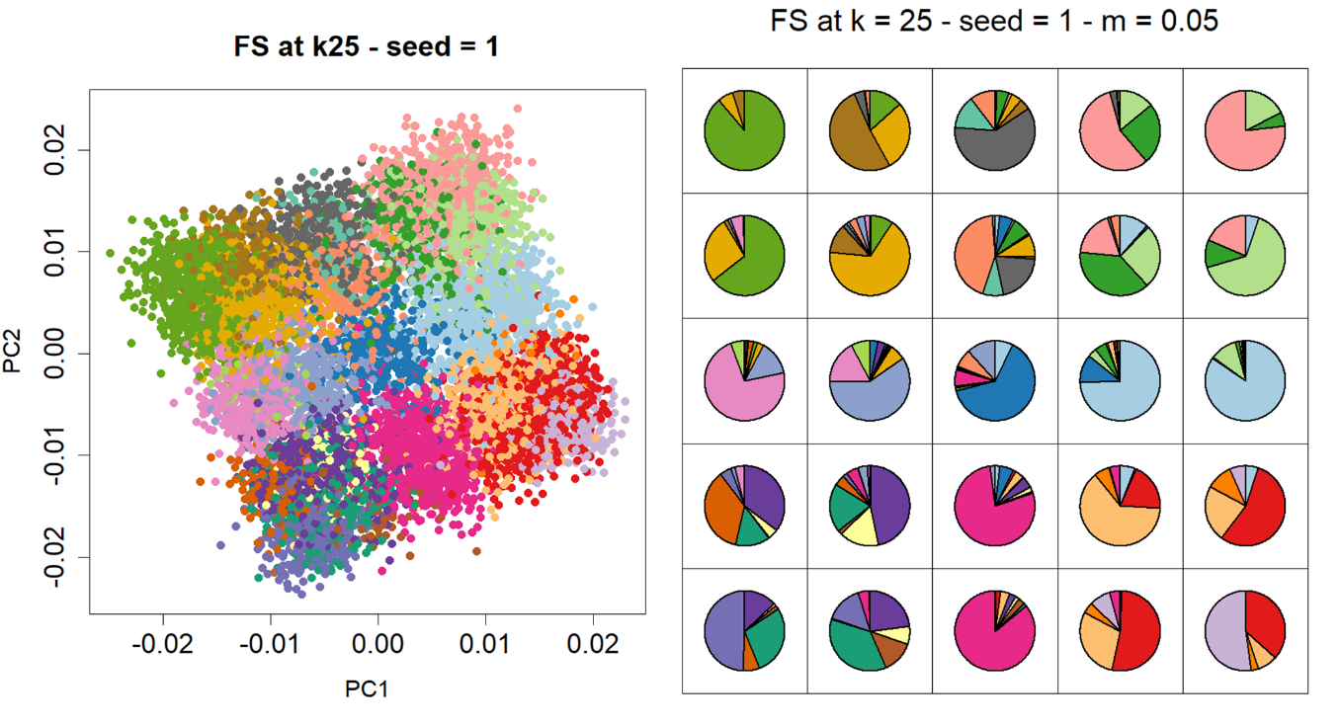
Fig. S11: –Clustering results are shown for Mclust (top panels) and FineSTRUCTURE, i.e. FS (bottom panels) based on PCA obtained from a kernel PCA performed on the PBWT-Paint similarity matrix. Results are reported for the random sampling scheme under a migration rate of m=0.05. The first random seed is shown for each clustering algorithm. Colours indicate cluster membership when the number of clusters is fixed at k=25. Left: Projection of individuals on the first two principal components (PCs). Right: Pie chart of the proportion of individual by deme belonging to each cluster.

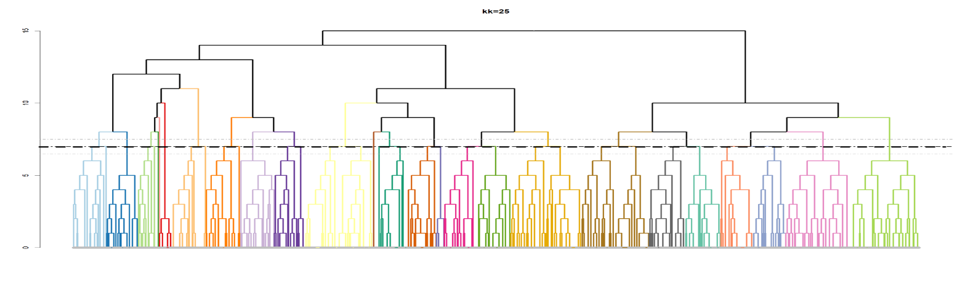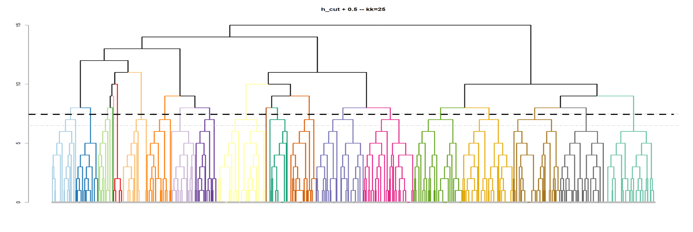
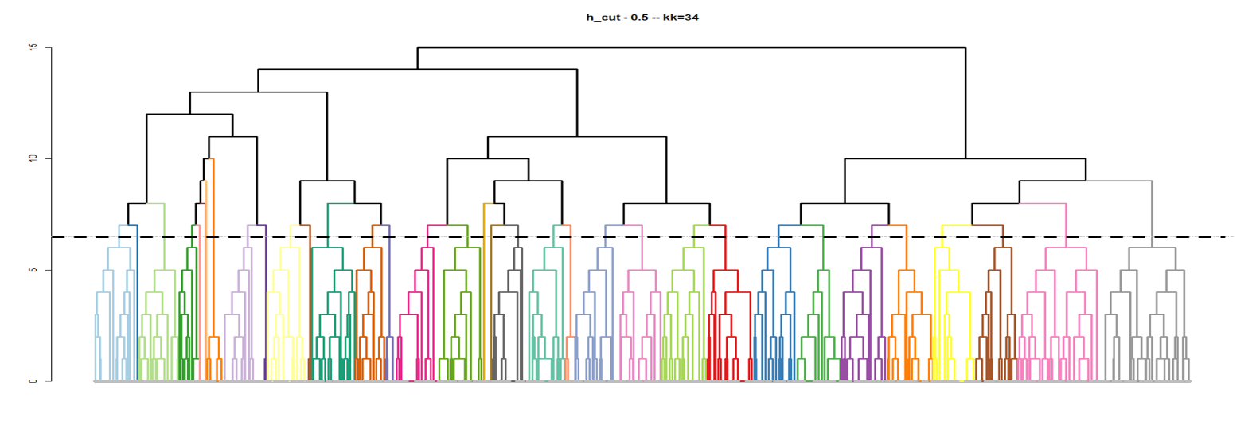Fig. S12: FineSTRUCTURE dendrogram obtained from the first random seed. A: The height (h_cut) is obtained using the cutree function in R for a fixed number of groups of 25. As expected, at h_cut, 25 groups are obtained; B: h_cut + 0.5 yields 21 clusters, while h_cut - 0.5 yields 34 clusters (C). Results are reported for the random sampling scheme under a migration rate of m=0.001. Similar trends were obtained under a migration rate of m=0.05.

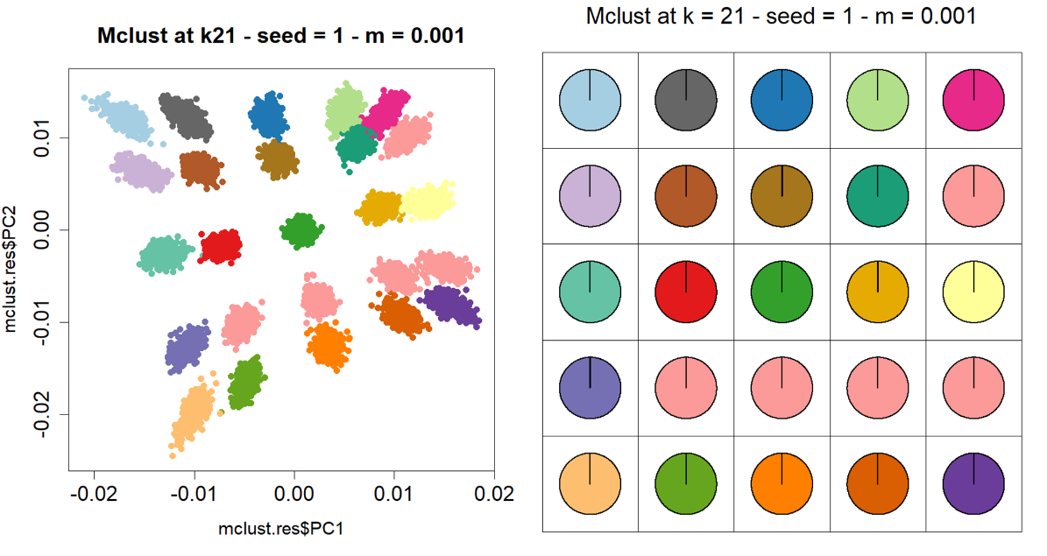
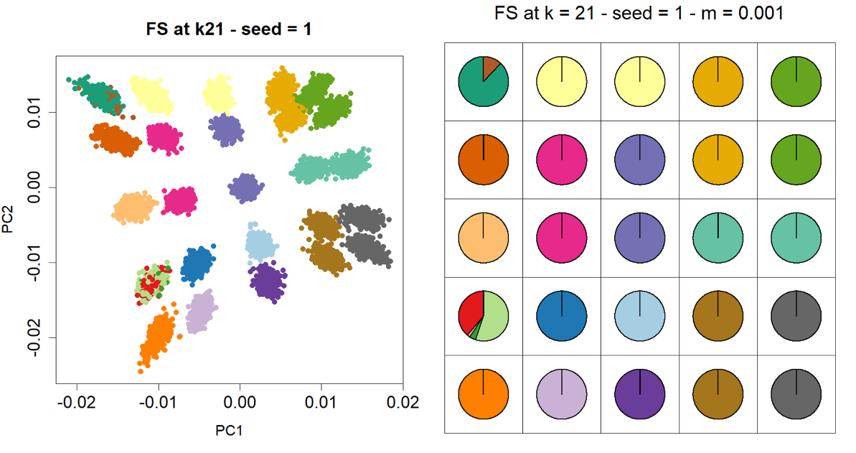
Fig. S13: Clustering results are shown for Mclust (top panels) and FineSTRUCTURE, i.e. FS (bottom panels) based on PCA obtained from a kernel PCA performed on the PBWT-Paint similarity matrix. Results are reported for the random sampling scheme under a migration rate of m=0.001. The first random seed is shown for each clustering algorithm. Colours indicate cluster membership when the number of clusters is fixed at k=21. Left: Projection of individuals on the first two principal components (PCs). Right: Pie chart of the proportion of individual by deme belonging to each cluster.
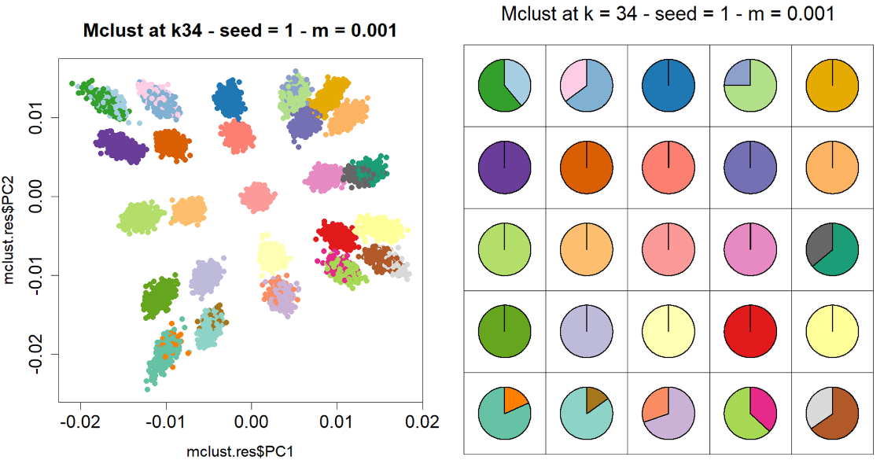
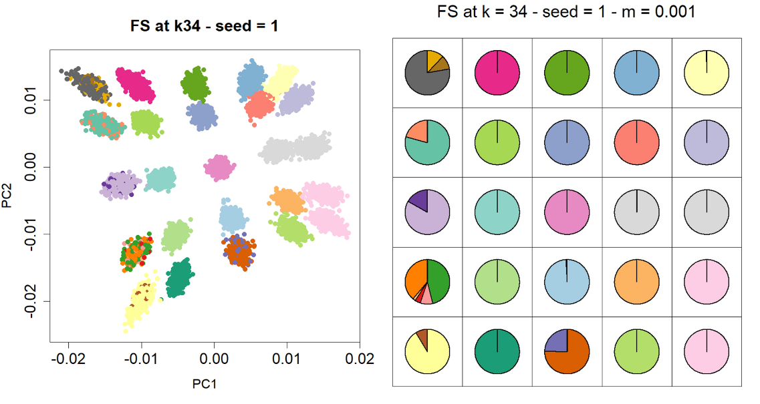
Fig. S14: –Clustering results are shown for Mclust (top panels) and FineSTRUCTURE, i.e. FS (bottom panels) based on PCA obtained from a kernel PCA performed on the PBWT-Paint similarity matrix. Results are reported for the random sampling scheme under a migration rate of m=0.001. The first random seed is shown for each clustering algorithm. Colours indicate cluster membership when the number of clusters is fixed at k=34. Left: Projection of individuals on the first two principal components (PCs). Right: Pie chart of the proportion of individual by deme belonging to each cluster.

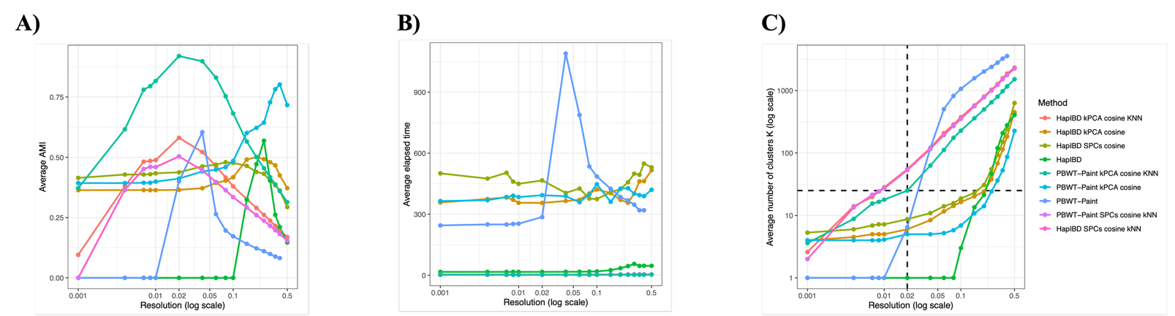 Fig. S15: Clustering performance, runtime, and number of inferred clusters as a function of the Leiden resolution parameter. Each point represents the average over 10 independent iterations. Results are reported for PBWT-Paint and HapIBD similarity matrices on random sampling scheme, a migration rate of 0.0255 and various preprocessing strategies. (A) Mean AMI score; (B) Mean elapsed time; (C) Mean number of inferred clusters.

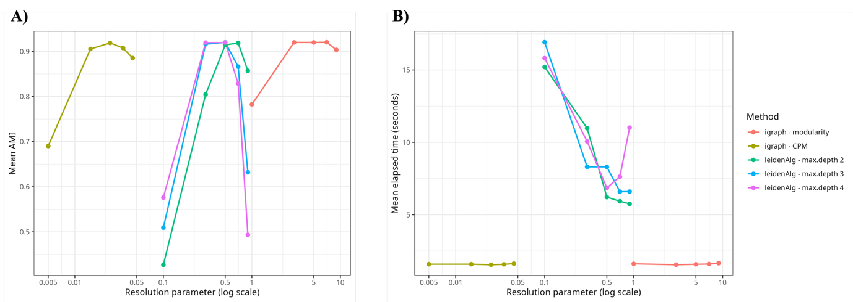
Fig. S16: Comparison of igraph (used in this study) and leidenAlg packages as a function of the Leiden resolution parameter. Results are based either on modularity or Constant Potts Model (CPM) as the objective function, with three values of the max.depth for LeidenAlg. Leiden were applied on the principal components obtained from PBWT-Paint with cosine similarity combined with 100 nearest-neighbour graph truncation (kNN) at a migration rate of m = 0.0255. (A) Mean AMI score; (B) mean elapsed time.

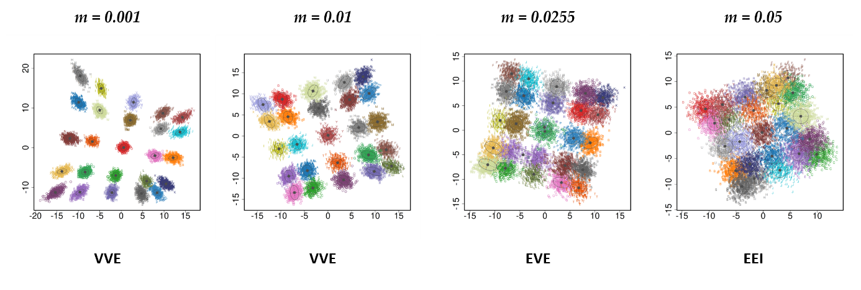
Fig. S17: First two principal components (PCs) obtained from a kernel PCA performed on the PBWT-Paint similarity matrix. Each point represents an individual, and colours indicate cluster membership inferred by Mclust. Ellipses correspond to the Gaussian mixture components defined by the covariance model selected using the BIC score.

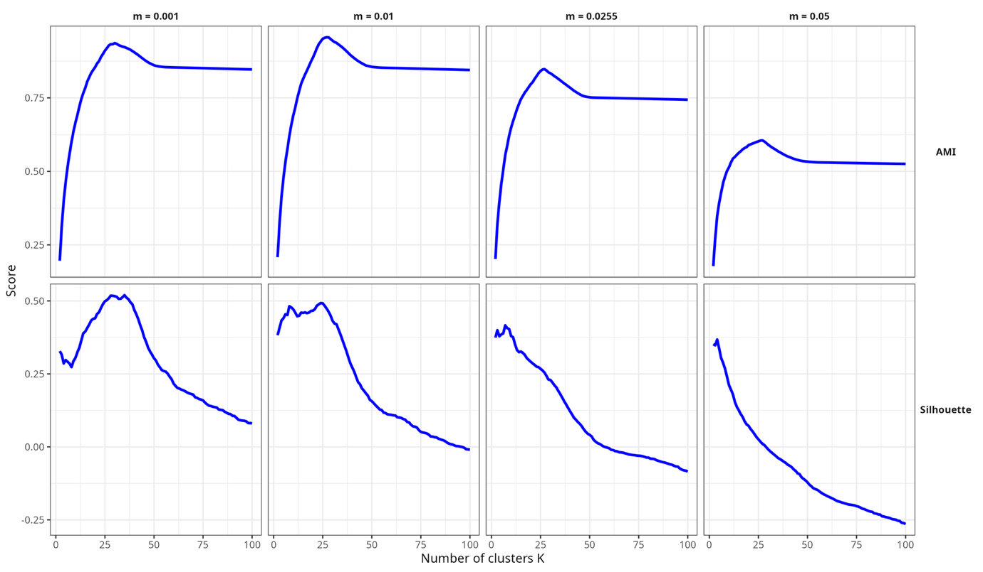
Fig. S18: AMI and silhouette scores of FineSTRUCTURE with default parameters as a function of the number of clusters K. Results are computed for each migration rate. Clusters are set by cutting the tree from 2 to 100 groups.

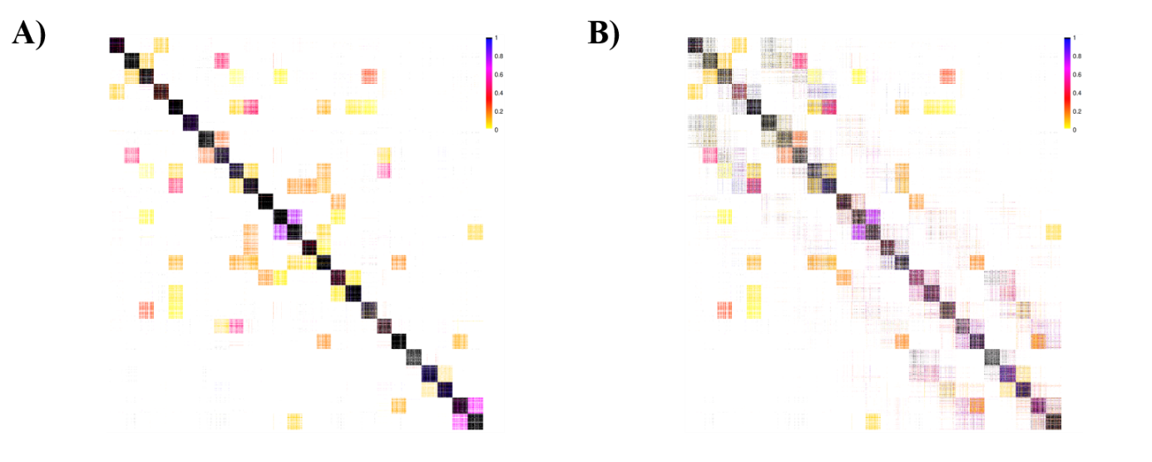
Fig. S19: Coincidence matrices between two chains of FineSTRUCTURE with default parameters for A) m=0.001 and B) m=0.05. Individuals are represented in the same order for rows and columns. For each pair of individuals, colours represent the proportion of MCMC samples in which they are clustered together. The lower triangle of the plot represents one MCMC chain and the upper triangle the other chain. Darker colours on the diagonal shows that individuals in the same deme tend to be clustered together.

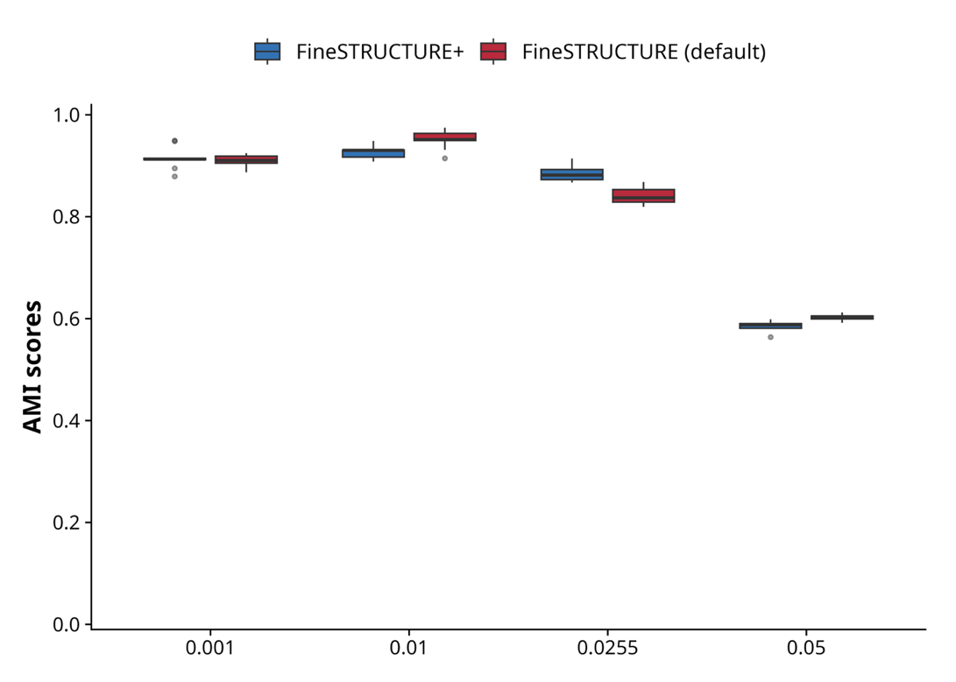
Fig. S20: Boxplot of average AMI scores of FineSTRUCTURE using default parameters (1,000 MCMC burn-in, 1,000 iterations, and every iteration sampled), and FineSTRUCTURE+ (10,000 MCMC burn-in, 90,000 iterations, and one iteration every thousand sampled). Results are shown for random sampling.
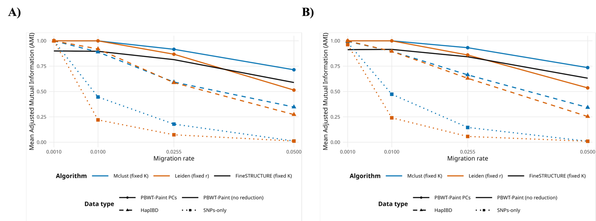
Fig. S21: Mean AMI score averaged over several iterations of each clustering algorithm and data type in function of the corresponding migration rate parameter. All partitions were set with an a priori of K=25 clusters. Results were computed on (A) poles sampling and (B) gradient sampling.

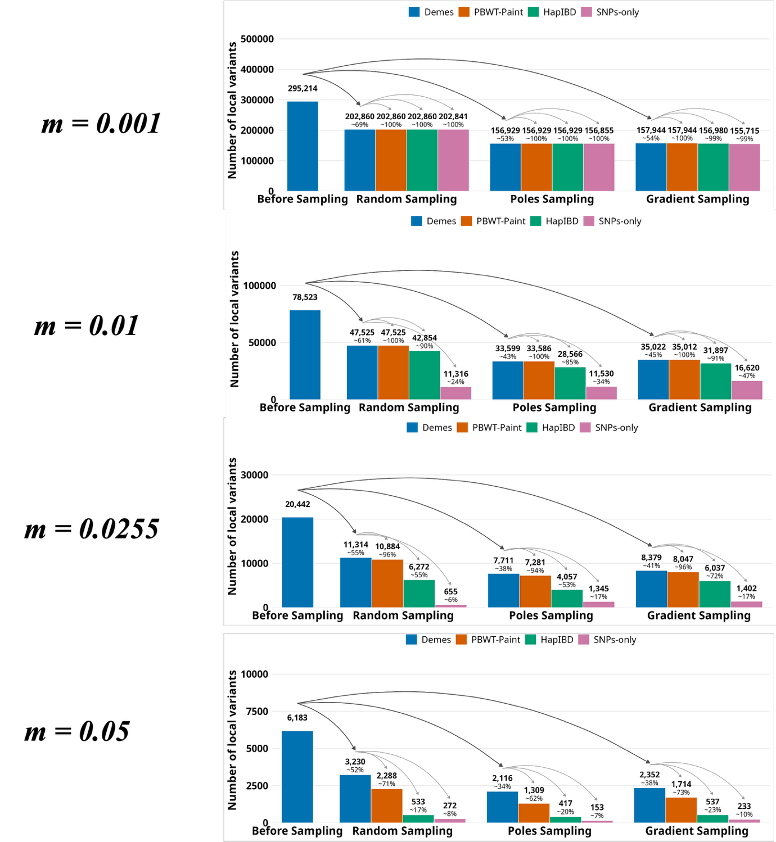
Fig. S22: Number of rare local variants remaining after each sampling step for each migration rate. The leftmost blue bar represents the total number of local variants that were identified before sampling, on 25,000 individuals. The three other blue bars represent the number of these variants that remain local after random, poles, and gradient sampling respectively. For each sampling scheme, the orange, green, and pink bars correspond to variants identified as local after sampling and that remain when using clusters instead of demes for PBWT-Paint, HapIBD, and SNPs-only, respectively, followed by clustering based on kPCA and Mclust on 20 PCs.

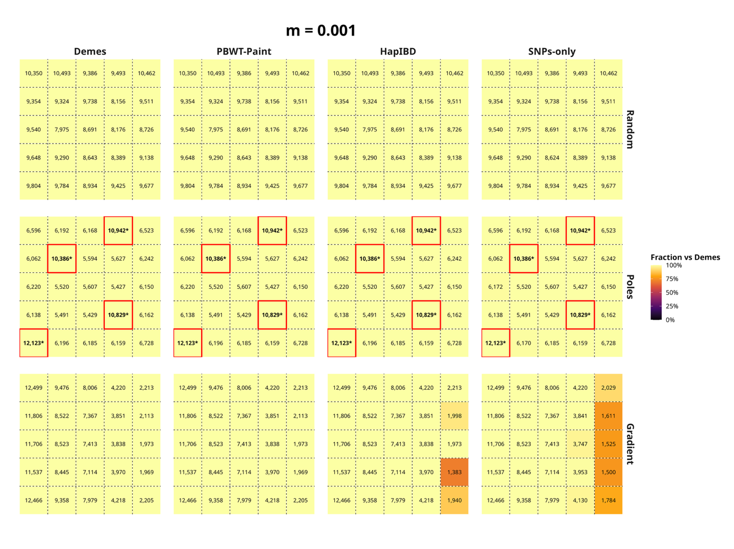
Fig. S23: Proportions of local variants correctly detected from the demes using PBWT-Paint, HapIBD, and SNPs-only pre-processing for random (A), poles (B) and gradient (C) sampling under a migration rate of 0.001. Each cell corresponds to a deme. Colours represent the proportion of local variants detected after sampling for that deme that are also detected by each pre-processing method, and numbers correspond to the raw counts per deme. A variant can be counted multiple times if it is local in more than one deme.

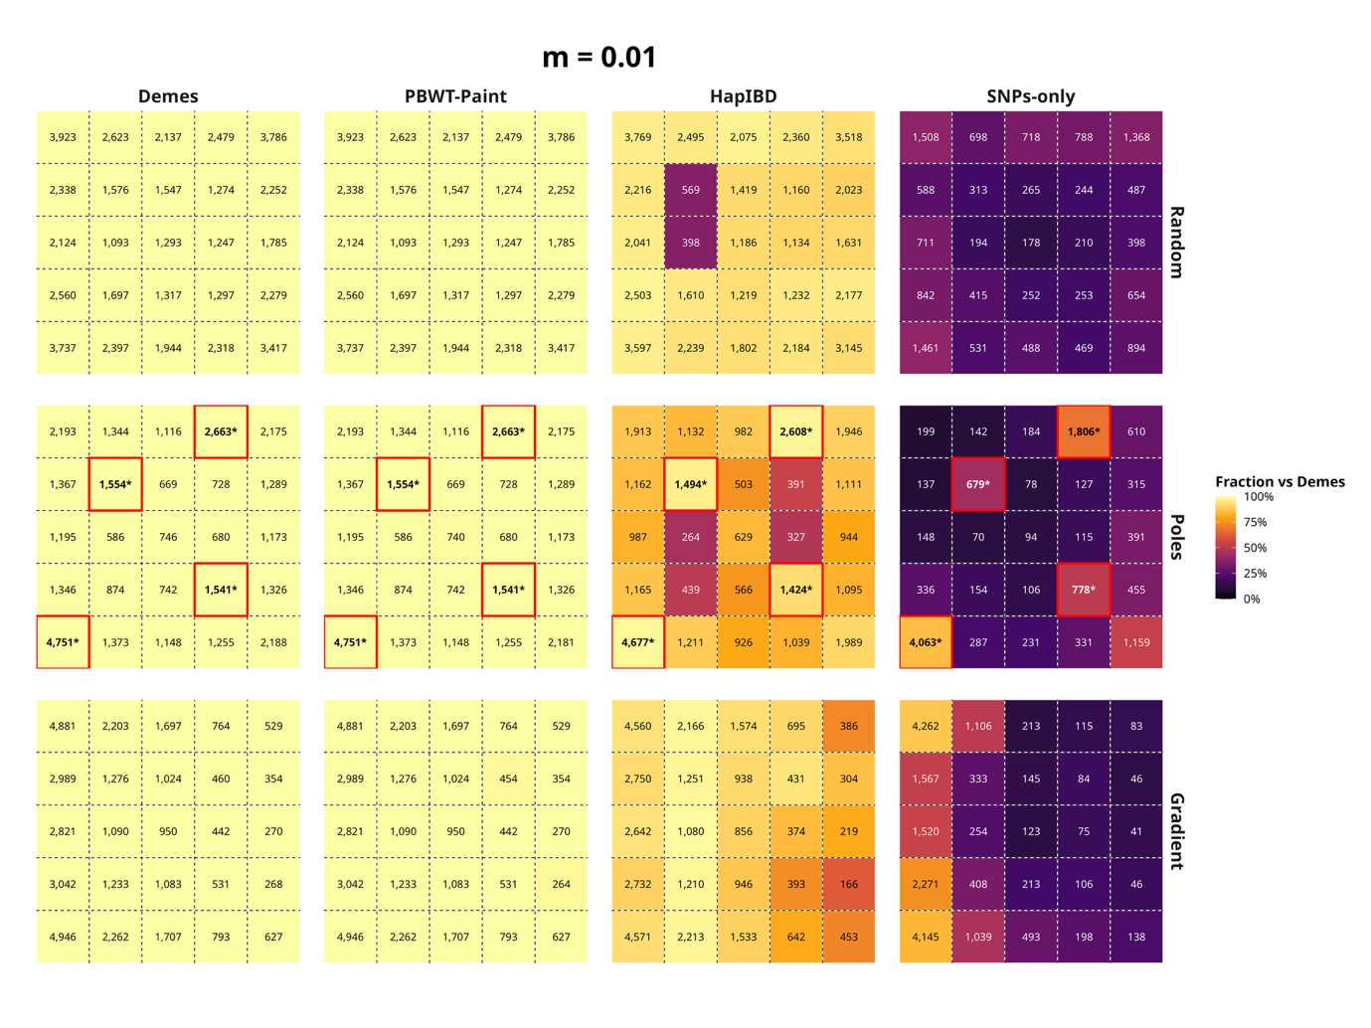
Fig. S24: Proportions of local variants correctly detected from the demes using PBWT-Paint, HapIBD, and SNPs-only pre-processing for random (A), poles (B) and gradient (C) sampling under a migration rate of 0.01. Each cell corresponds to a spatially ordered deme. Colours represent the proportion of local variants detected after sampling for that deme. Number corresponds to raw counts per deme. A variant can be counted multiple times if it is local in more than one deme.

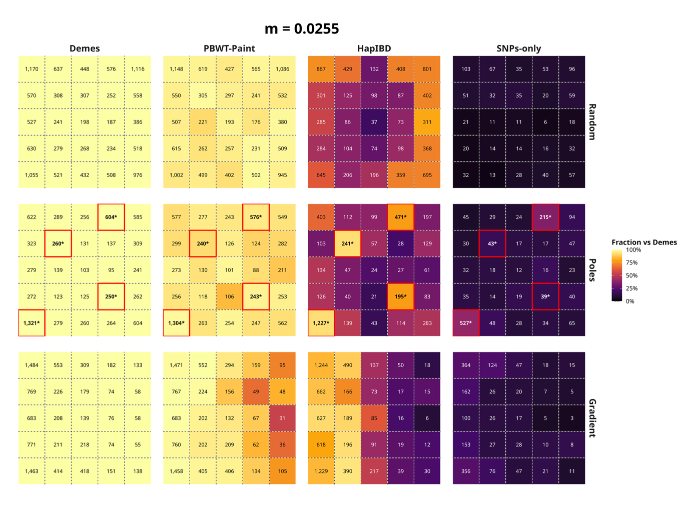
Fig. S25: Proportions of local variants correctly detected from the demes using PBWT-Paint, HapIBD, and SNPs-only pre-processing for random (A), poles (B) and gradient (C) sampling under a migration rate of 0.0255. Each cell corresponds to a spatially ordered deme. Colours represent the proportion of local variants detected after sampling for that deme. Number corresponds to raw counts per deme. A variant can be counted multiple times if it is local in more than one deme.

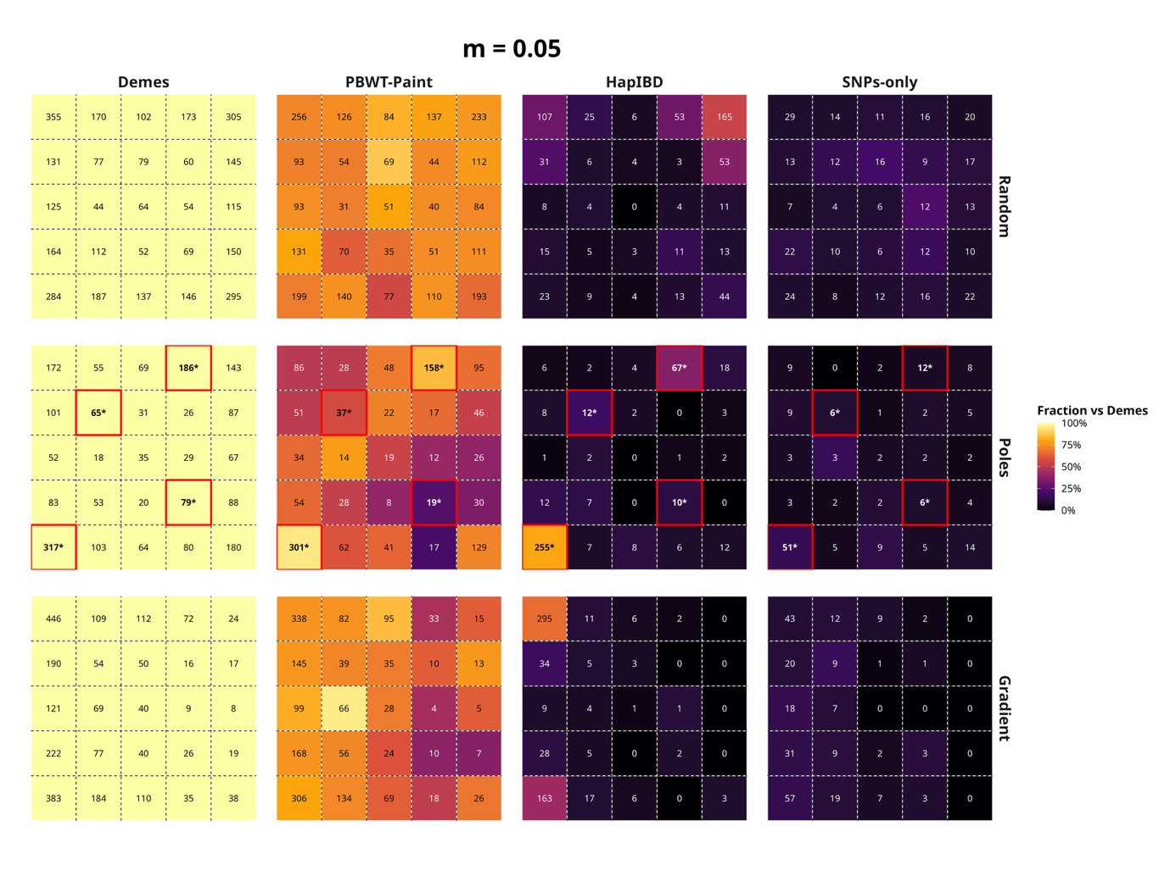
Fig. S26: Proportions of local variants correctly detected from the demes using PBWT-Paint, HapIBD, and SNPs-only pre-processing for random (A), poles (B) and gradient (C) sampling under a migration rate of 0.05. Each cell corresponds to a spatially ordered deme. Colours represent the proportion of local variants detected after sampling for that deme. Number corresponds to raw counts per deme. A variant can be counted multiple times if it is local in more than one deme.

References:

1. Choi, H. & Choi, S. Robust kernel Isomap. Pattern Recognition 40, 853–862 (2007).
2. Blackwell, D. & MacQueen, J. B. Ferguson Distributions Via Polya Urn Schemes. The Annals of Statistics 1, 353–355 (1973).
3. Yakowitz, S. J. & Spragins, J. D. On the Identifiability of Finite Mixtures. The Annals of Mathematical Statistics 39, 209–214 (1968).
4. Li, J. & Barron, A. Mixture Density Estimation. in Advances in Neural Information Processing Systems vol. 12 (MIT Press, 1999).
5. Chang, C. C. et al. Second-generation PLINK: rising to the challenge of larger and richer datasets. Gigascience 4, s13742-015-0047–8 (2015).

