Supplementary Table: Catalogue of Analysed Book Covers

No. | Book Title | Publisher | Permission Status | Cover Image
1 | Together with Purpose: Selected Malaysian Chinese LGBT Fiction（《有志一同：马华同志小说选》） | Got One Publisher Sdn Bhd | Obtained | 
2 | Raising the Horn: Selected Malaysian Chinese LGBT Fiction II 《号角举起：马华同志小说选 2》 | Got One Publisher Sdn Bhd | Obtained | 
3 | Malaysian Chinese Literature Series: Basic Concepts (《马华文学系列：基本概念》 | The Writers' Association of Chinese Medium of Malaysia | Obtained | 
4 | Chao Foon :512th issue, Special Edition: Transgender Fiction (《蕉风》512，跨性别小说特辑) | Southern University Press | Obtained | 
5A | Towards Light (《仰光》) | Reading Heart Publication | Obtained | 
5B | Back Light (《背光》） | Reading Heart Publication | Obtained
6 | Chao Foon (《蕉风》) :493th issue, Special Issue: Gender/Sexuality Transgression: TongZhi Lovers (《蕉风》493，“性/别越界：爱人同志”专辑) | Southern University Press | Obtained | 
7 | There (《那里》） | Got One Publisher Sdn Bhd | Obtained | 
8 | Poison and Concealment（《毒药与藏身》） | Empress Culture Sdn Bhd | Obtained | 
9 | Notes from Late Night Scavenging  （《深夜拾荒手记》） | Got One Publisher Sdn Bhd | Obtained | 
10 | Deleting Love Poems: Softly Erect in My Hands（《删情诗：在我手中微软勃起》） | Empress Culture Sdn Bhd | Obtained | 
11 | The Third Party《小三》 | Got One Publisher Sdn Bhd | Obtained | 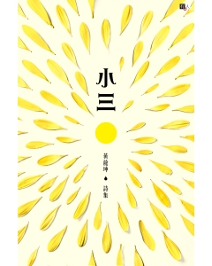
12 | Dreaming of Bears（《梦熊》） | Monsoon Books Malaysia | Obtained | 

