SUPPLEMENTARY MATERIAL
Table S1. Pearson correlation coefficients for the linear fits between pairs of daily values of TANOM, TPOT and GT over the eight sub-domains in the Iberian Peninsula (IP) and the Balearic Islands (BI) in the period 1948-2015 from the three reanalysis (ERA5 vs NCEP/NCAR Reanalysis 1, ERA5 vs NOAA-CIRES-DOE 20th Century Reanalysis V3 and NCEP/NCAR Reanalysis 1 vs NOAA-CIRES-DOE 20th Century Reanalysis V3).
 | ERA5 vs NCEP/NCAR | ERA5 vs NOAA 20th C. | NCEP/NCAR vs NOAA 20th C.
 | TANOM
NW-IP | 0.965 | 0.966 | 0.937
NE-IP | 0.962 | 0.953 | 0.954
N-IP | 0.968 | 0.969 | 0.934
BI | 0.966 | 0.957 | 0.932
E-IP | 0.959 | 0.959 | 0.931
SW-IP | 0.974 | 0.961 | 0.945
CEN-IP | 0.969 | 0.964 | 0.946
SE-IP | 0.944 | 0.950 | 0.919
 | TPOT
NW-IP | 0.986 | 0.988 | 0.979
NE-IP | 0.987 | 0.990 | 0.985
N-IP | 0.988 | 0.991 | 0.982
BI | 0.989 | 0.991 | 0.982
E-IP | 0.987 | 0.990 | 0.983
SW-IP | 0.991 | 0.990 | 0.983
CEN-IP | 0.990 | 0.991 | 0.985
SE-IP | 0.987 | 0.990 | 0.983
 | GT
NW-IP | 0.994 | 0.988 | 0.985
NE-IP | 0.995 | 0.991 | 0.991
N-IP | 0.996 | 0.991 | 0.989
BI | 0.996 | 0.992 | 0.988
E-IP | 0.996 | 0.991 | 0.989
SW-IP | 0.997 | 0.989 | 0.988
CEN-IP | 0.997 | 0.991 | 0.989
SE-IP | 0.994 | 0.989 | 0.988

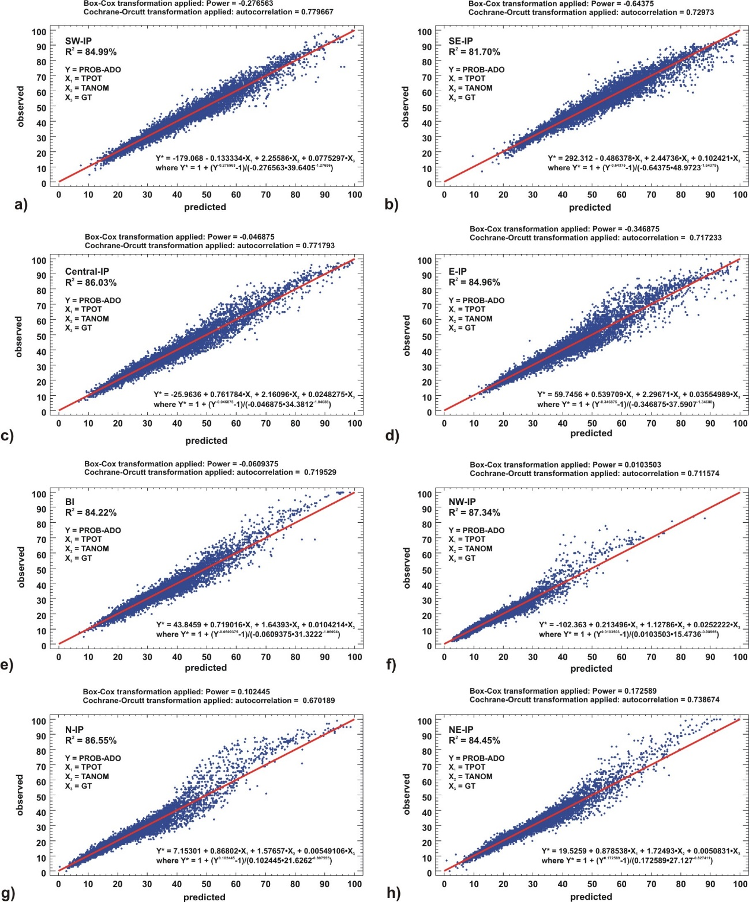
Figure S1. Multilinear regression models for computing probability of occurrence of ADO (PROB-ADO) over the eight sub-domains in the Iberian Peninsula (IP) and the Balearic Islands (BI). Comparison of observed and predicted values in 2001-2024.

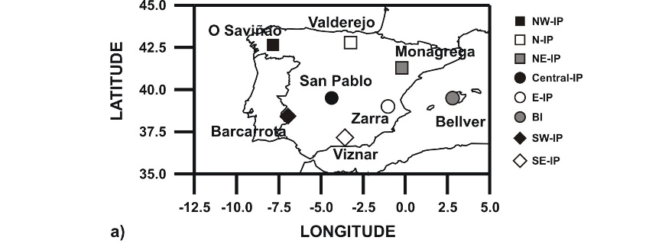
Figure S2. Geographical location of the regional background air quality monitoring stations used for estimating the daily PM_{10_net-dust} contribution registered during African dust outbreaks.

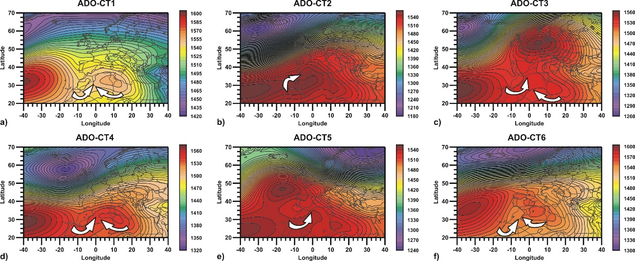
Figure S3. Composite synoptic maps of ERA5 reanalysis 850 hPa geopotential height at 12 UTC for ADO-CTs, for the period 1940–2024. Arrows indicate the prevailing advection of the air masses towards the Iberian Peninsula-Balearic Island domain.

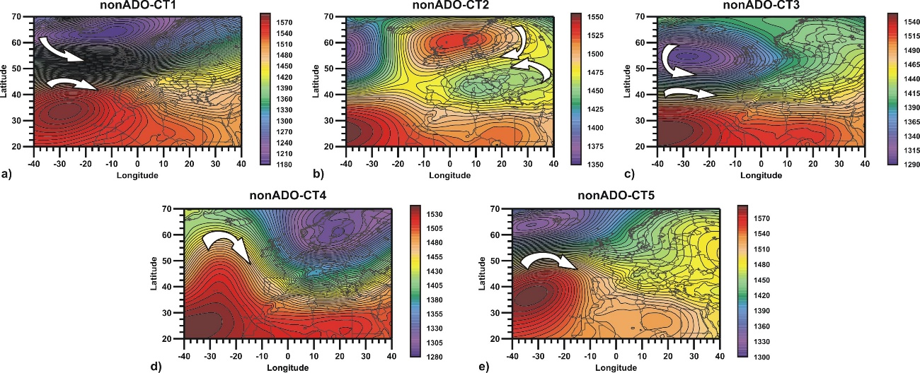
Figure S4. Composite synoptic maps of ERA5 reanalysis 850 hPa geopotential height at 12 UTC for nonADO-CTs, for the period 1940–2024. Arrows indicate the prevailing advection of the air masses towards the Iberian Peninsula-Balearic Island domain.

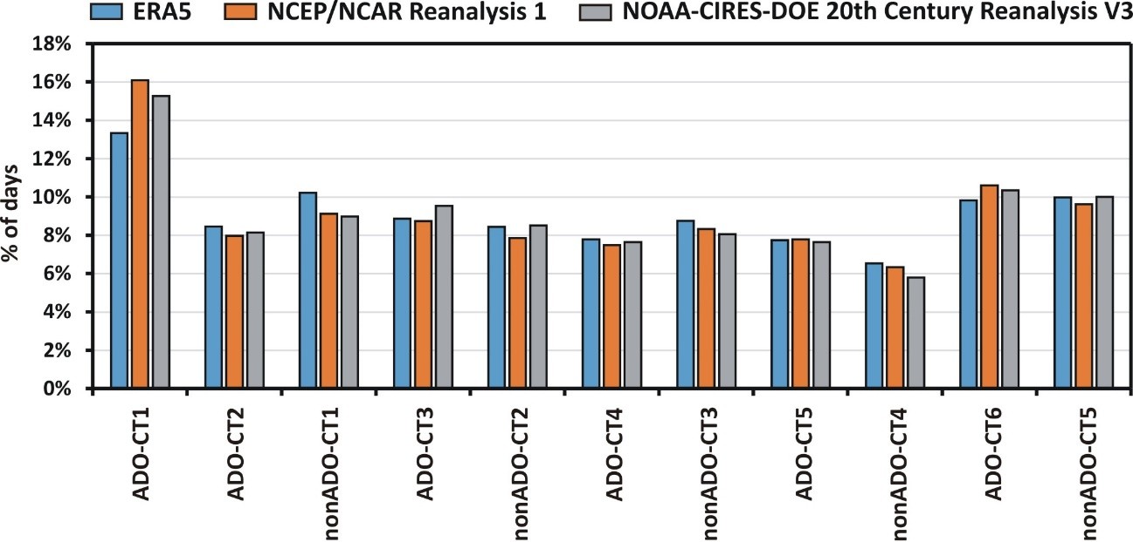
Figure S5. Results of the classification procedure of 3 different reanalysis databases of 850 hPa geopotential height daily fields (ERA5, NCEP/NCAR and NOAA 20th Century) into ADO and nonADO atmospheric circulation types (ADO-CT and nonADO-CT) for the period 1948–2015.

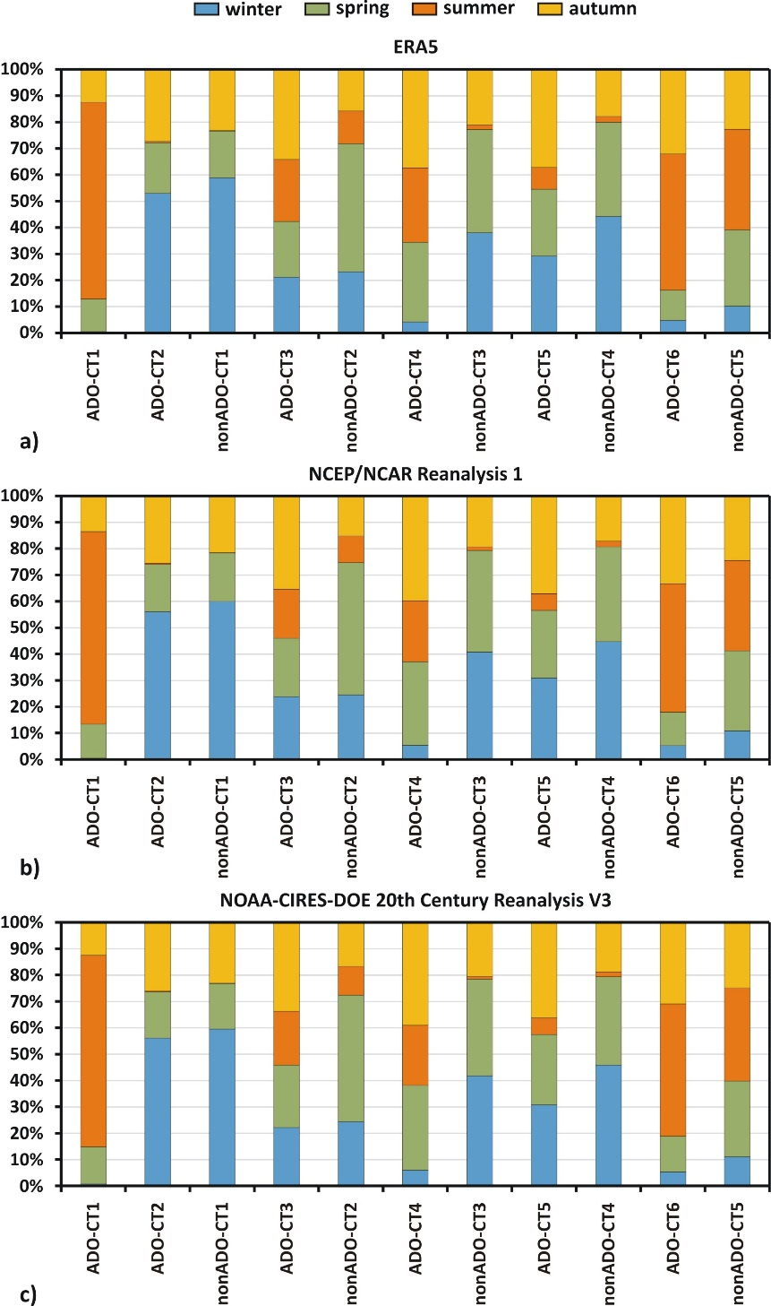
Figure S6. Seasonal distribution of daily ADO and nonADO atmospheric circulation types (ADO-CT and nonADO-CT) for the 1948–2015 period classified from ERA5 (a), NCEP/NCAR (b) and NOAA 20th Century (c) reanalysis databases of 850 hPa geopotential height daily fields.

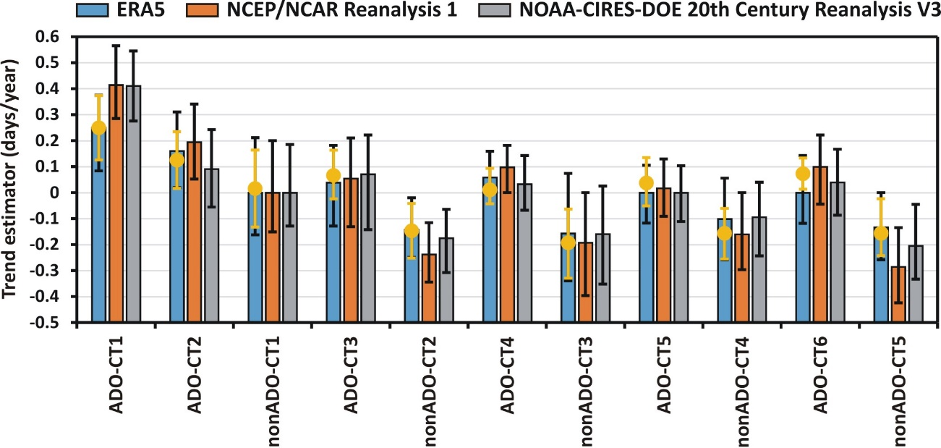
Figure S7. Results of the Theil-Sen trend analysis. Values of the trend estimator and the 95% confidence interval (days/year), for the number of days under ADO and nonADO atmospheric circulation types (ADO-CT and nonADO-CT) for the period 1948–2015. Classification procedure was applied to three different reanalysis databases of 850 hPa geopotential height daily fields (ERA5, NCEP/NCAR and NOAA 20th Century). Orange dots depict the trend estimators obtained for the period 1940-2024 from the ERA5 reanalysis data fields, used for the quantitative partitioning calculations.
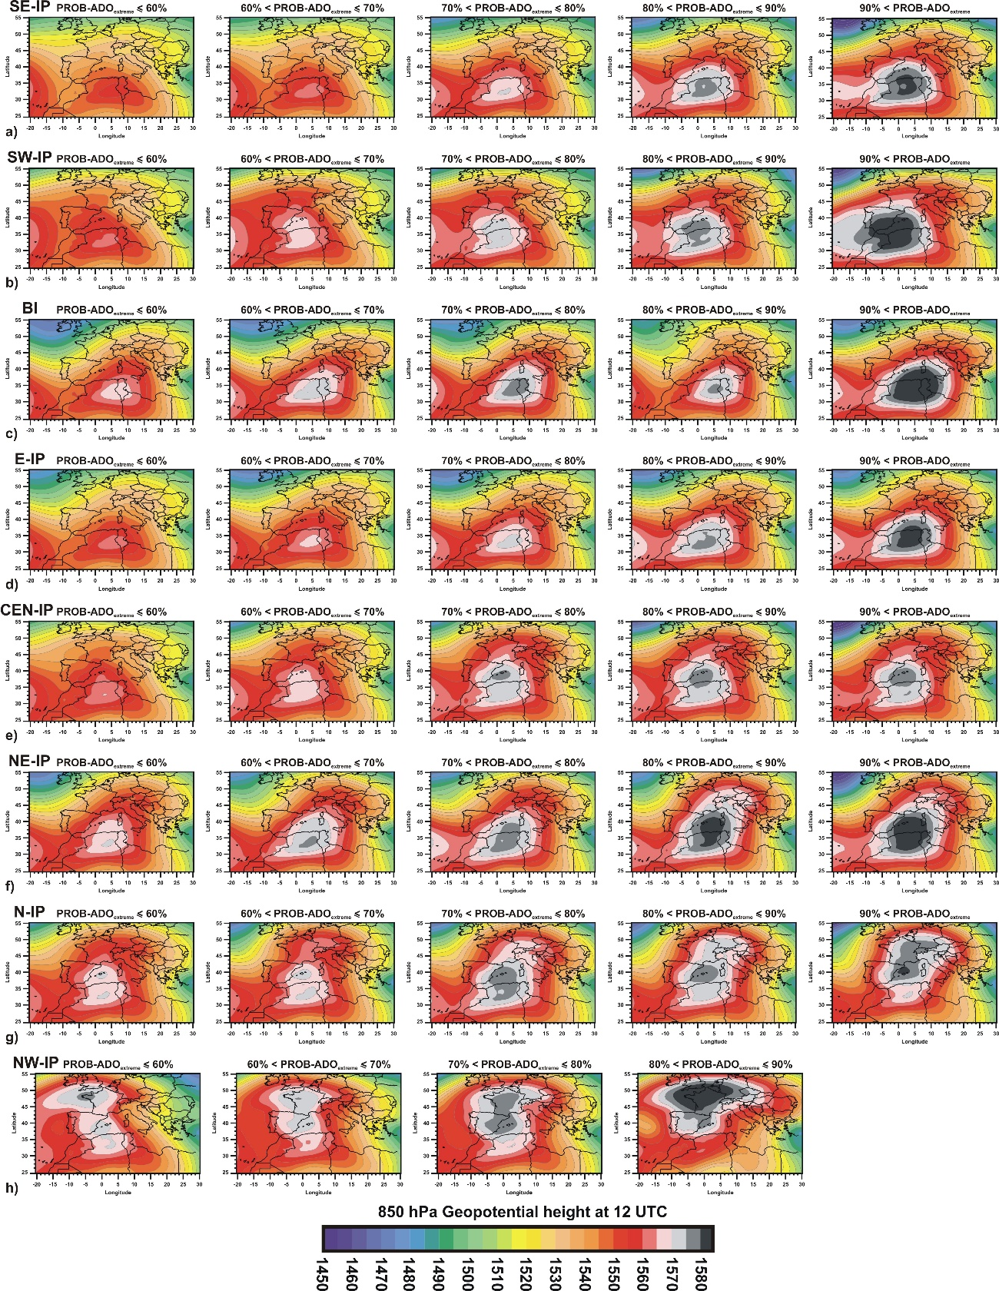
Figure S8. Composites of 850 hPa geopotential height at 12 UTC for increasing PROB-ADO extremes under ADO-CT1, in the eight sub-domains of the Iberian Peninsula (IP) and the Balearic Islands (BI) over 1940–2024.

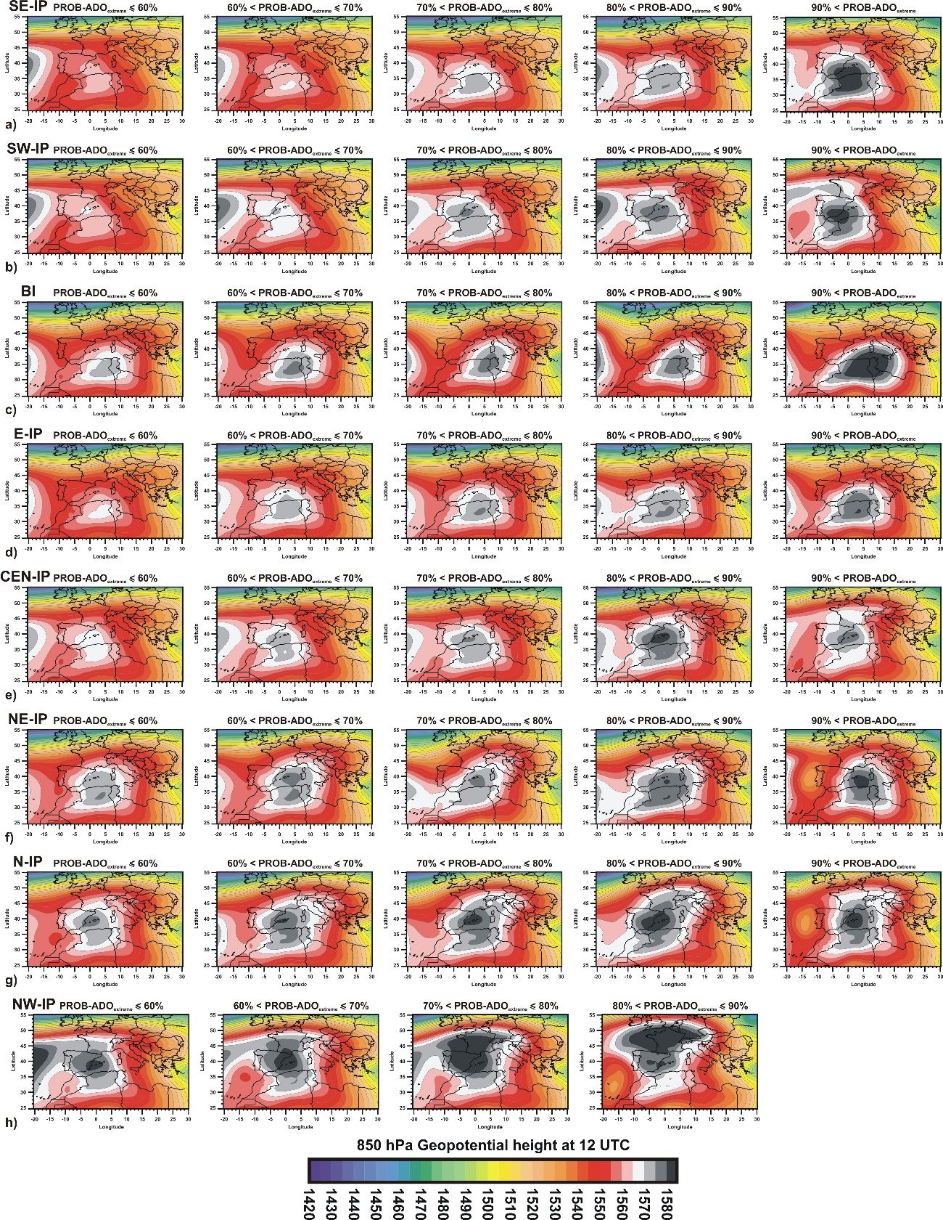
Figure S9. Composites of 850 hPa geopotential height at 12 UTC for increasing PROB-ADO extremes under ADO-CT6, in the eight sub-domains of the Iberian Peninsula (IP) and the Balearic Islands (BI) over 1940–2024.

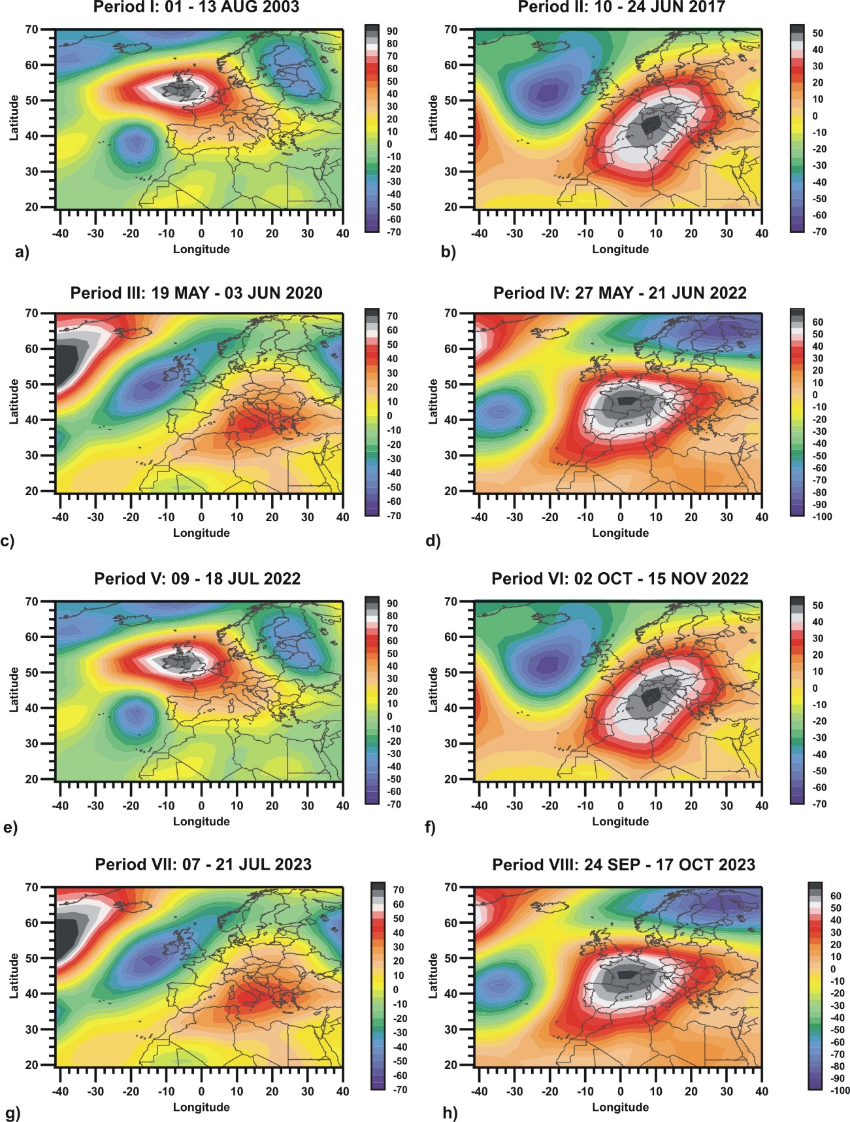
Figure S10. Composites of 850 hPa geopotential height anomalies (in m) for the climatological period 1991-2020 for selected persistent PROB-ADO extremes periods over NW-IP (Period I), NE-IP (Period II), CEN-IP (Period III), E-IP (Period IV), N-IP (Period V), SE-IP (Period VI), SW-IP (Period VII) and BI (Period VIII).

