Fitness functions for automated population pharmacokinetic modelling
(Supplemental Material)

Zhonghui Huang¹, Matthew Fidler², Joseph F Standing^{1,3}, Frank Kloprogge⁴
¹Great Ormond Street Institute of Child Health, University College London, London, UK
²Novartis Pharmaceuticals Corporation, Fort Worth, Texas, USA
³Great Ormond Street Hospital for Children, London, UK
⁴Institute for Global Health, University College London, London, UK.

Corresponding author: Zhonghui Huang
Affiliation: Great Ormond Street Institute of Child Health, University College London, London, UK
E-mail: zhonghui.huang.20@ucl.ac.uk

Supplementary Figure 1. Retrieval performance under different binary penalty configurations with Akaike Information Criterion (AIC).
Rows show penalty settings, columns show model components (structural model, IIV, residual error, IIV correlations). Lines represent intravenous, oral, and combined data. Configurations include single-term penalties (THETA, OMEGA, SIGMA, correlations, shrinkage, RSE, covariance step), the Full penalty, and No penalty. The Full penalty configuration considered all penalty terms jointly, while the No penalty configuration applied none. IIV, inter-individual variability; RSE, relative standard error; THETA, fixed-effect parameters; OMEGA, inter-individual variability expressed as coefficient of variation (CV%); SIGMA, residual error, including additive (σ_{add}) and proportional (σ_{prop}) components.

Supplementary Figure 2. Retrieval performance under different binary penalty configurations with objective function value (OFV).
Supplementary Figure 3. Sensitivity analysis of cutoff settings for penalty function.
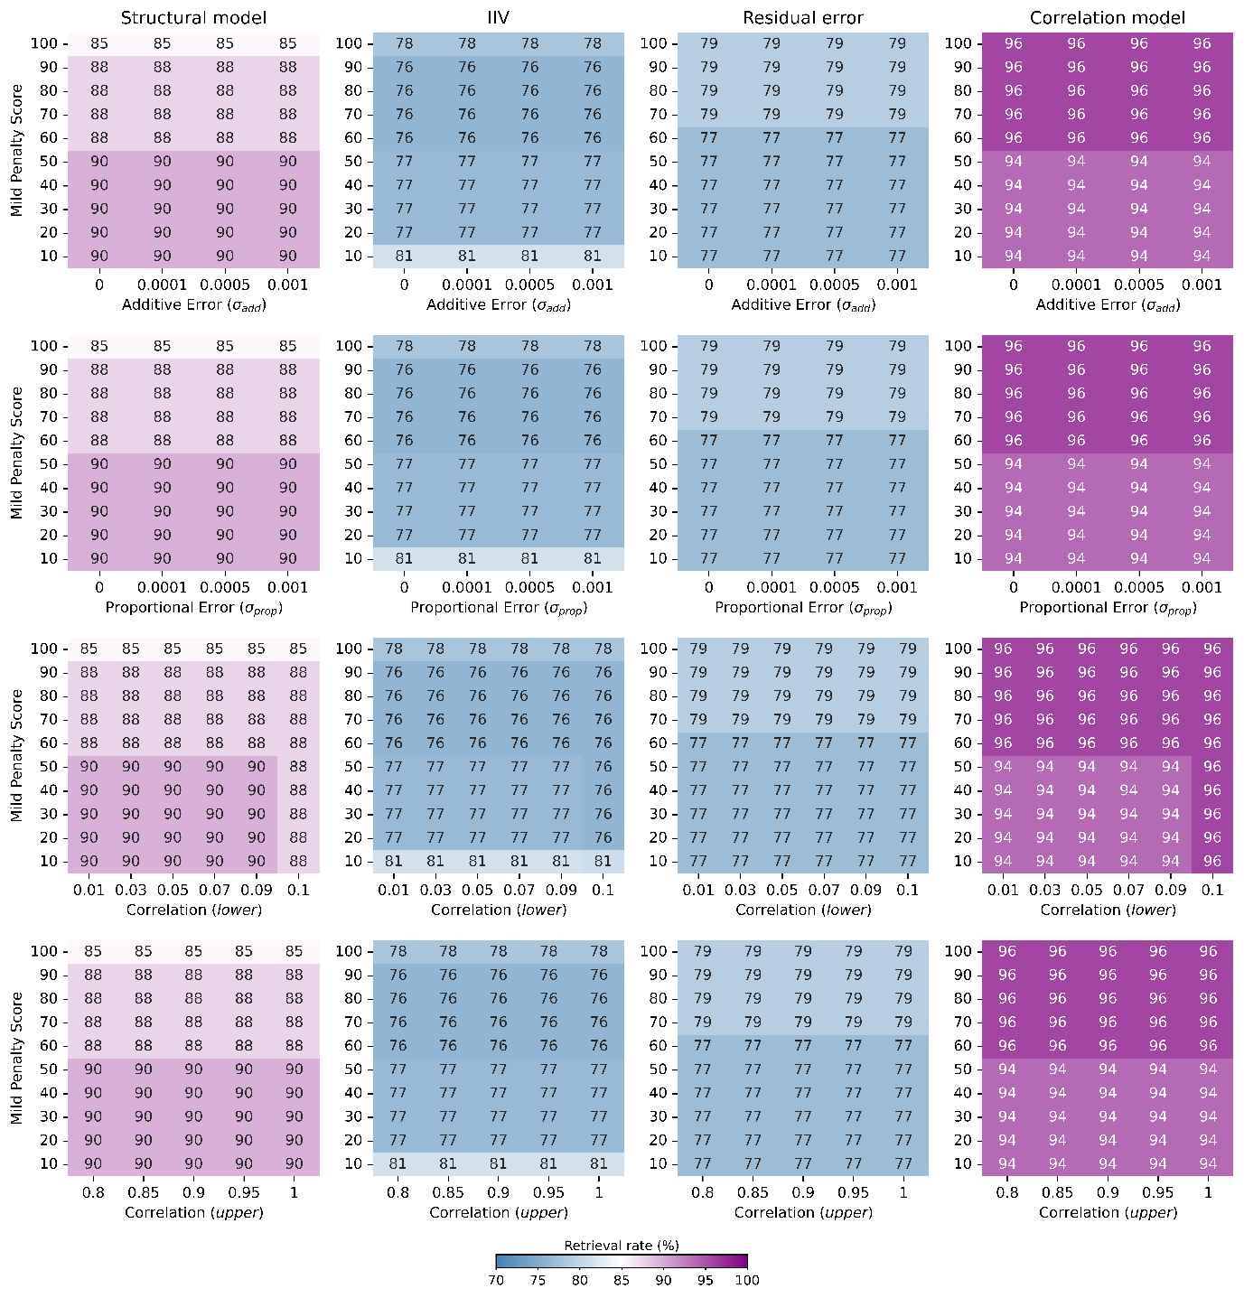
Heatmaps show retrieval rates (in %) of correct model identification across varying cutoff thresholds and mild penalty scores. Rows correspond to cutoff criteria applied to additive error (σ_{add}), proportional error (σ_{prop}) and correlation bounds (lower and upper). Columns represent evaluation dimensions: structural model, IIV model, residual error model and correlation model.

