Table S1: List of test compounds employed for pharmacophore model validation.
Compounds | IC₅₀ with AChE(µM) | IC₅₀ with BuChE(µM) | References
Niloticane | 4.0±1.7 | NA | https://doi.org/10.1016/j.jep.2010.01.057
12- O-demethylcryptojaponol | 50.8±6.6 | 70.1±2.9 | https://doi.org/10.1007/s11418-015-0908-6
Cunlanceloic acid | 6.14±0.66 | NA | https://doi.org/10.1039/D1QO00999K
17- hydroxycativic acid | 21.1 | 171.1 | https://doi.org/10.1016/j.bmc.2014.06.030  https://doi.org/10.3390/ecsoc-26-13581
Euphorfinoid E | 42.03±2.24 | >200 | https://doi.org/10.1016/j.phytochem.2021.112867
Hypargenin E | NA | 6.93 | http://dx.doi.org/10.2174/1567205017666200424133534
13-methyl-17-oxo-labda-7,13-diene-15-oic acid | 11.04±1.16 | NA | https://doi.org/10.3390/ecsoc-26-13581
Limbatolide B | 47.2±0.30 | 17.5±0.60 | https://doi.org/10.1248/cpb.53.378
Tanshinone Ⅱa | 45.16± 5.49* | 2.79±0.25 | http://dx.doi.org/10.1016/j.phytochem.2016.10.012
7-epicandicandiol | 230±0.09 | 22±0.01 | http://dx.doi.org/10.1016/j.phytol.2011.05.001

*Reported as % inhibition.

Table S2. Model score of the pharmacophore hypotheses generated using LigandScout from the selected training set ligands.
Model | Score
Model-1 | 0.8003
Model-2 | 0.8001
Model-3 | 0.7996
Model-4 | 0.7975
Model-5 | 0.7965
Model-6 | 0.7939
Model-7 | 0.7937
Model-8 | 0.7936
Model-9 | 0.7816
Model-10 | 0.7815

Fig 3. Pharmacophore feature mapping of individual training set ligands used for model generation.

Fig. 7. Structural representation of the active site of AChE (PDB ID: 4EY7) and BuChE (PDB ID: 5DYW) in complex with their respective co-crystallized ligands. (A). 3D representation of a protein-ligand complex of AChE with E20604 [Donepezil] (B). 3D representation of a protein-ligand complex of BuChE with 5HF [N-((1-benzylpiperidin-3-yl)methyl)-N-(2-methoxyethyl)naphthalene-2-sulfonamide].
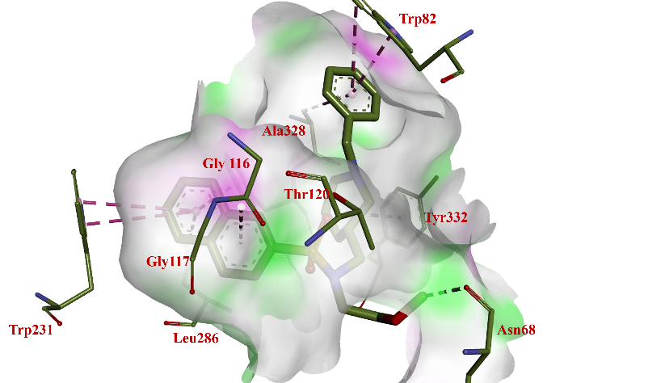
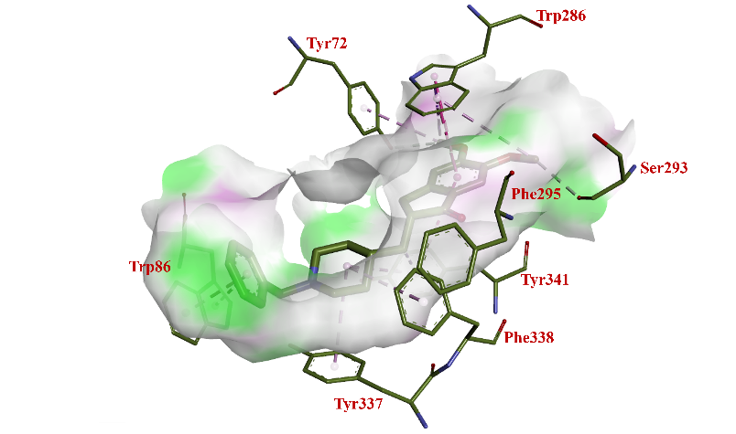
.

- (B)

Fig. S1. Structural representation of the active site of AChE (PDB ID: 4EY7) and BuChE (PDB ID: 5DYW) in complex with their respective co-crystallized ligands. (A). 2D representation of a protein-ligand complex of AChE with E20604 [Donepezil] (B). 2D representation of a protein-ligand complex of BuChE with 5HF [N-((1-benzylpiperidin-3-yl)methyl)-N-(2-methoxyethyl)naphthalene-2-sulfonamide].
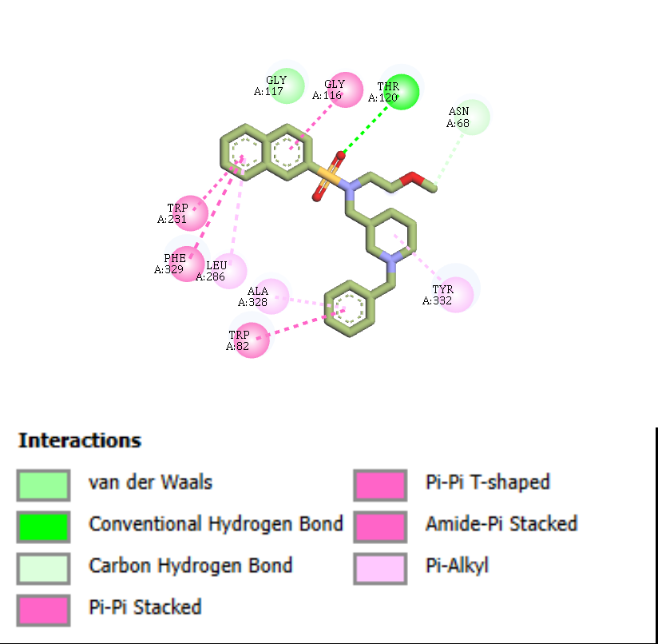
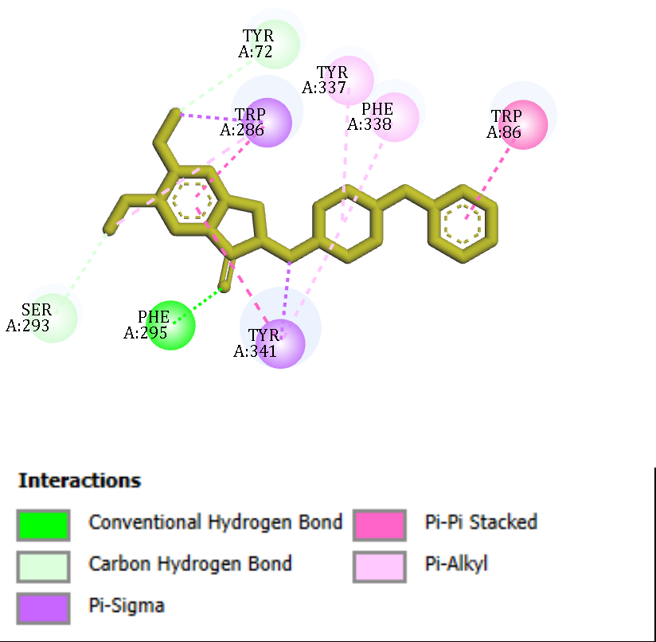
- (B)
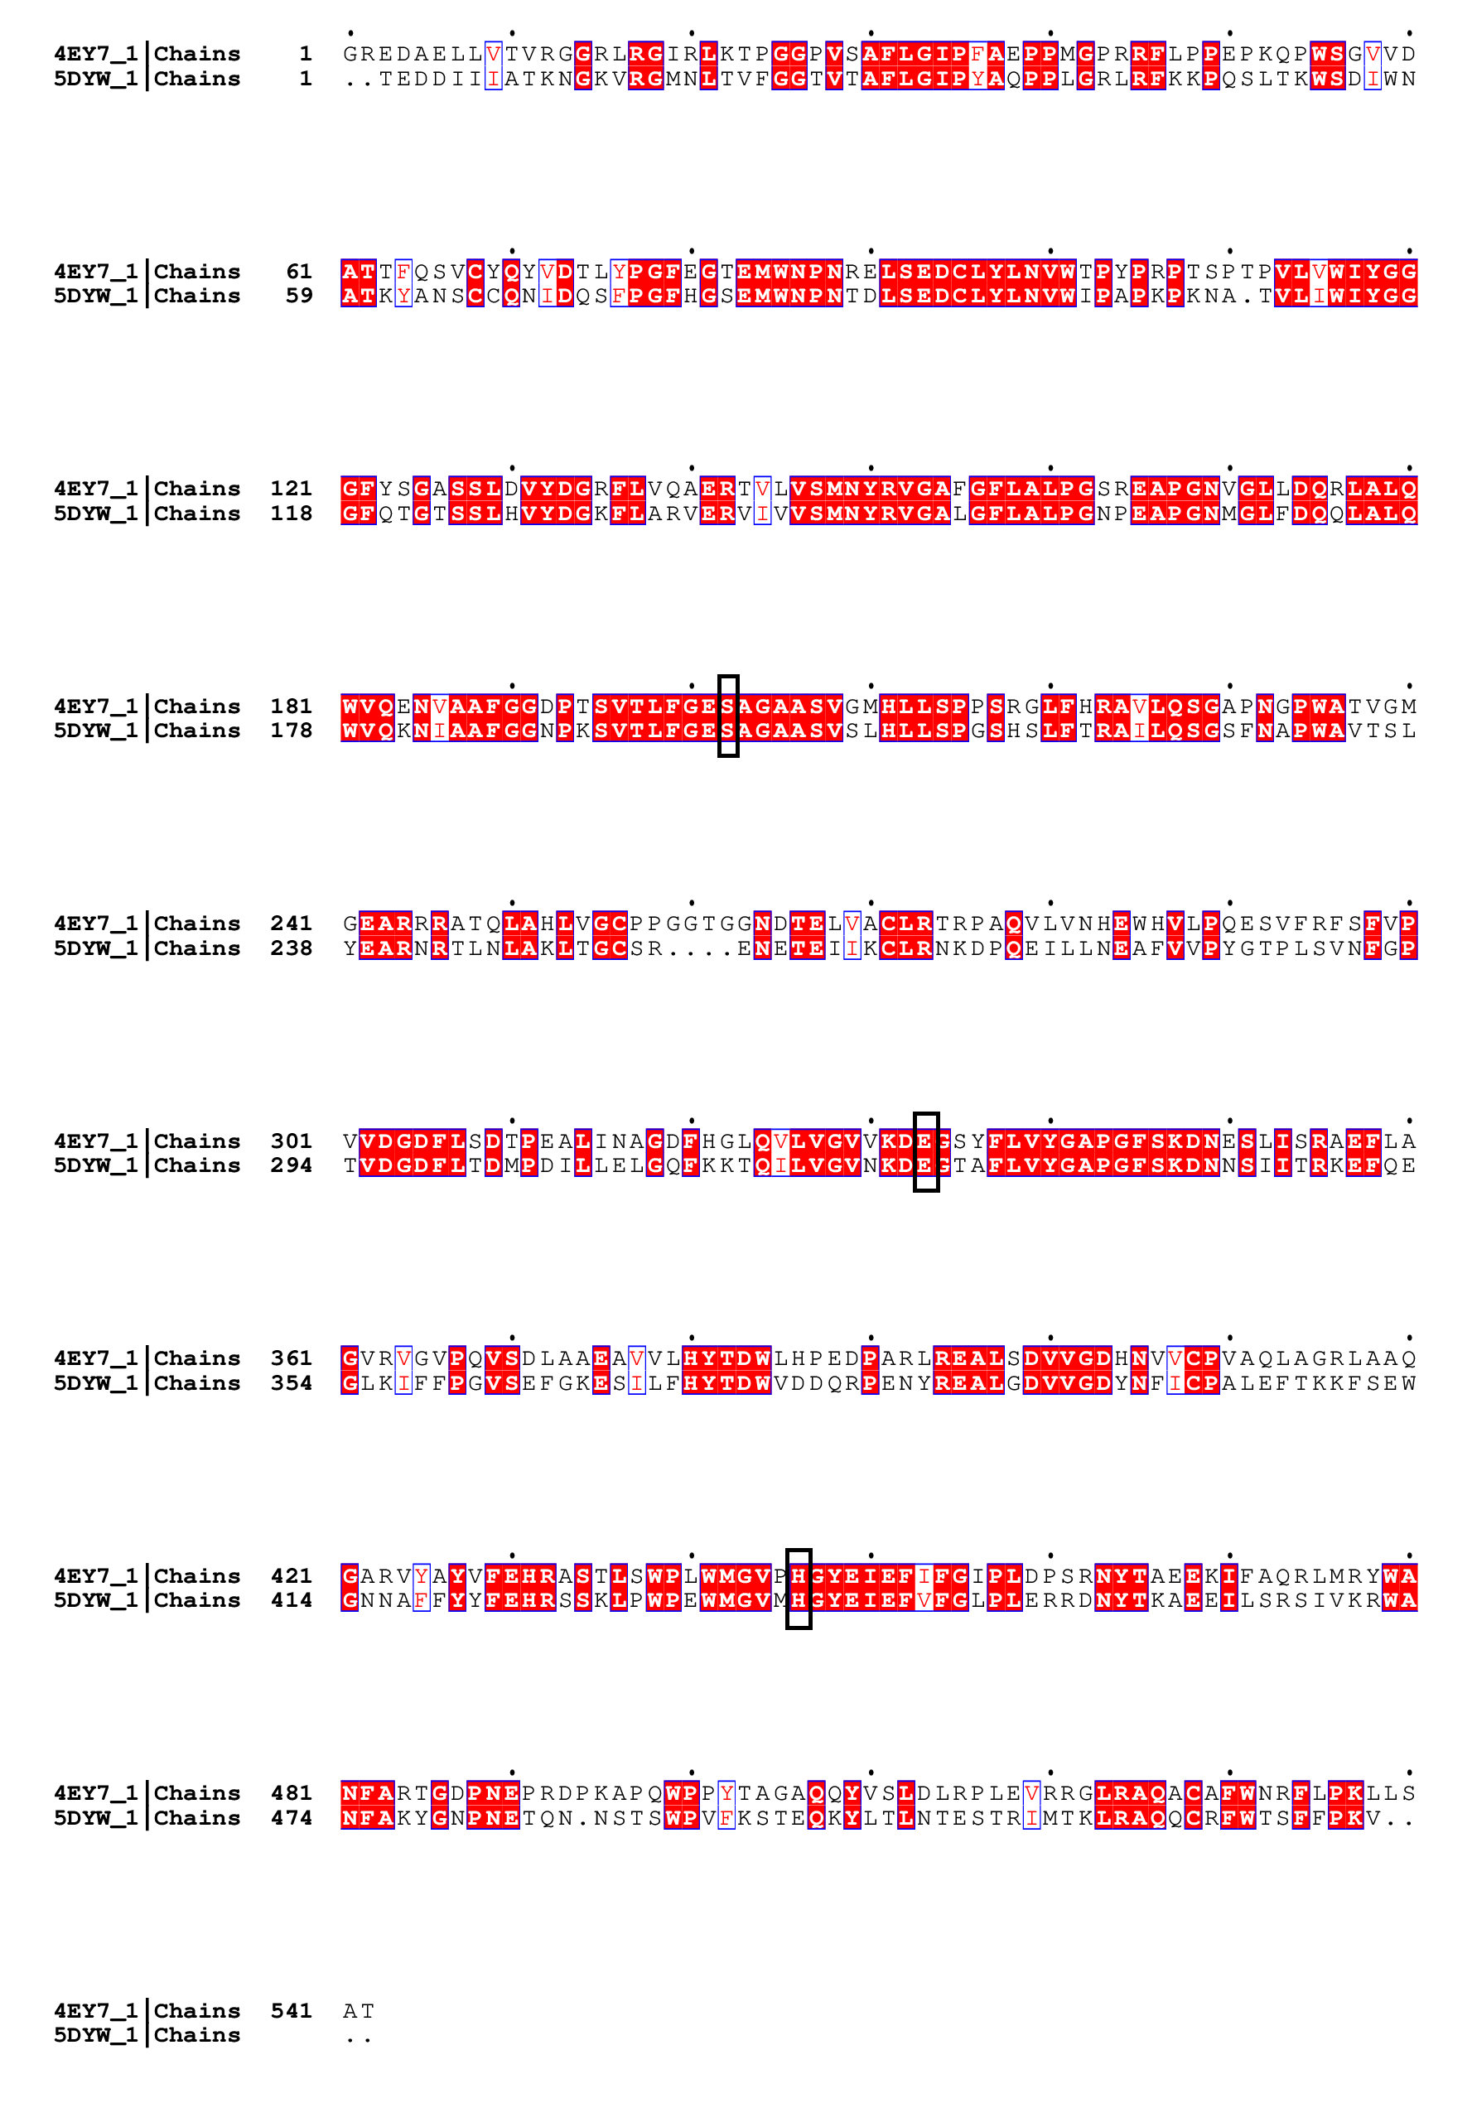
Fig S2. Pairwise sequence alignment of hAChE (4EY7) and hBuChE (5DYW) highlighting conserved amino acid residues. The catalytic triad residues, Ser203/Ser198, Glu334/Glu325, and His447/His438 are highlighted by black box.

Fig S2. RMSD values (in Å ) and superimposition of the redocked poses of ligands with the conformations in co-crystal structures.
Protein ID | RMSD (Å) | superimposes
4EY7 | 0.282 | 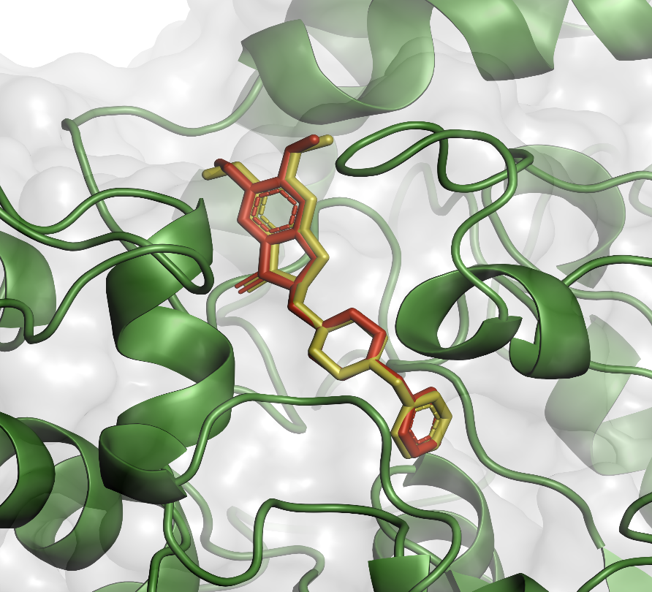  docked pose (red) vs. E20604
5DYW | 2.008 | 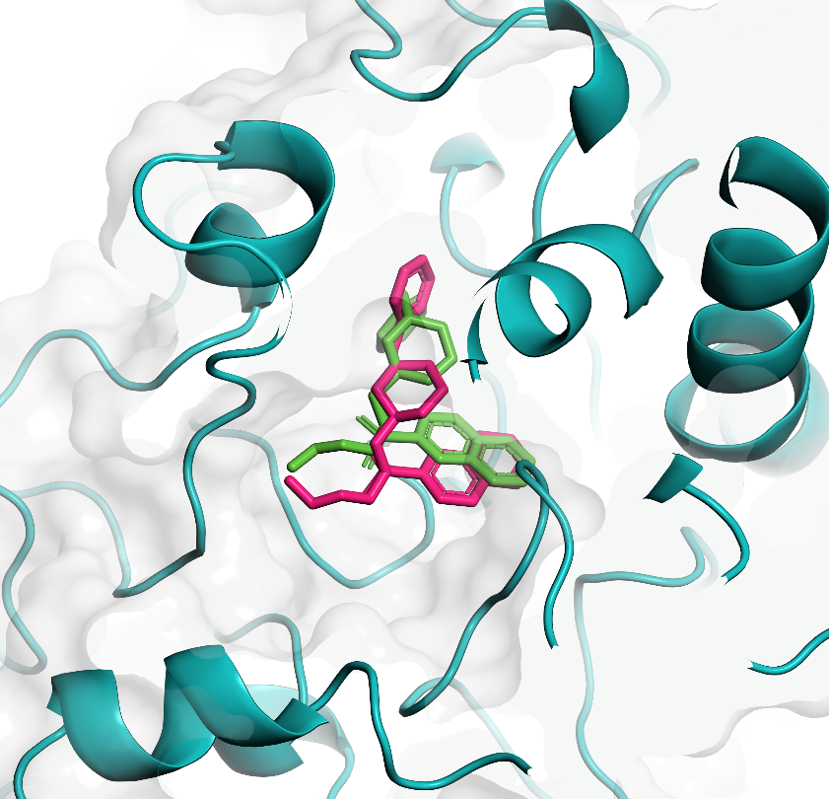  Docked pose (green) vs. 5HF
Fig S3. 2D protein-ligand interaction map of selected ligands within the active site of AChE and BuChE. Key intramolecular interactions are represented with colour coding. H-bonds are shown with a bold green line, Carbon hydrogen bond is shown in light green colour, purple colour shows π- σ interaction, π- π stacked with dark pink and light pink represent π- alkyl interaction.

Hits | 2D interaction
 | AChE | BuChE
Glabridin | 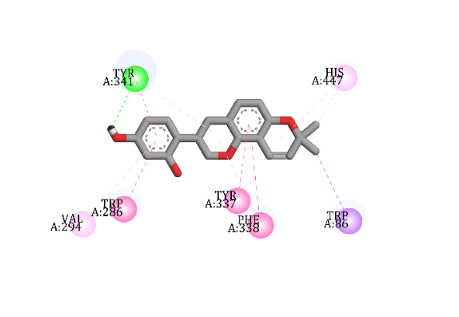 | 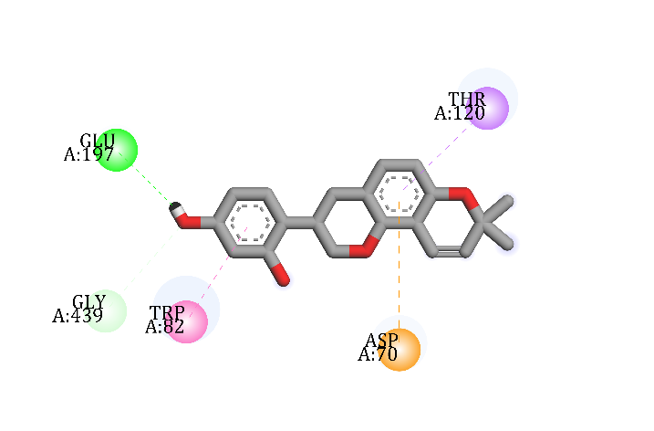
Corylin | 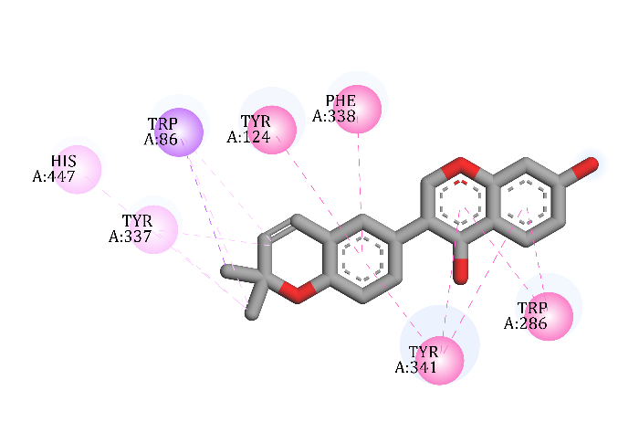 | 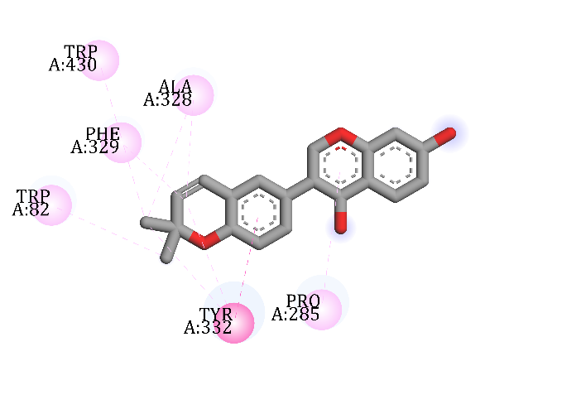
Galgravin | 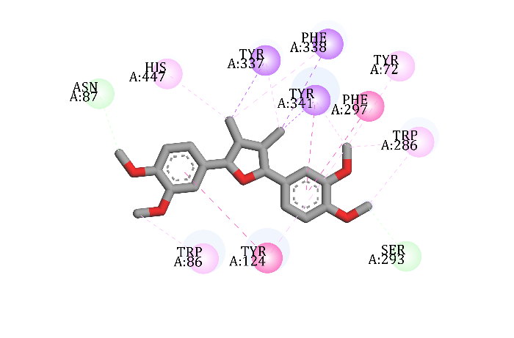 | 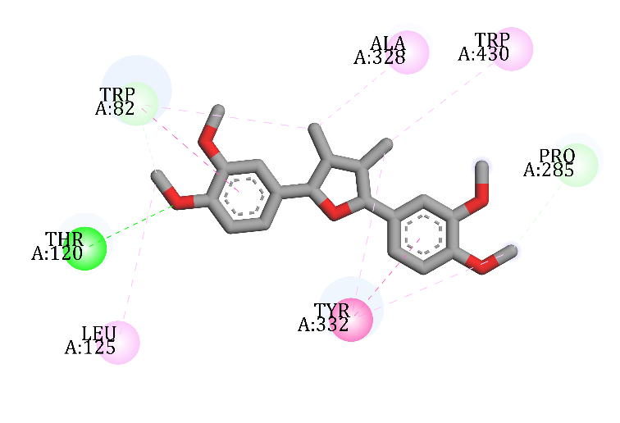
6-Hydroxy-2,2-dimethyl chroman-4-one | 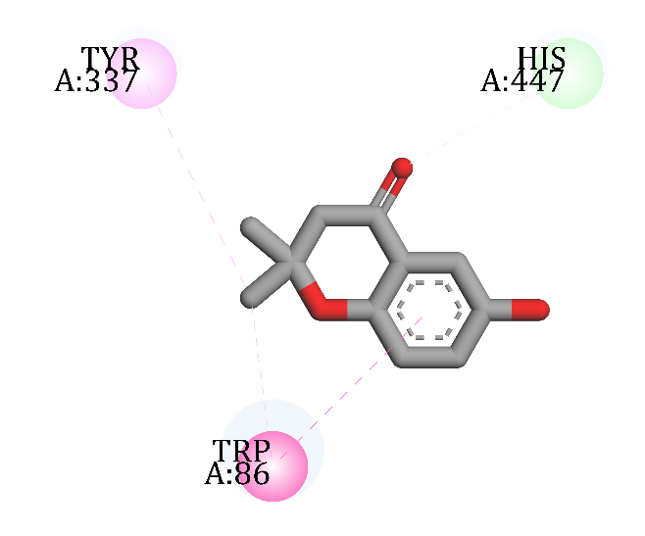 | 