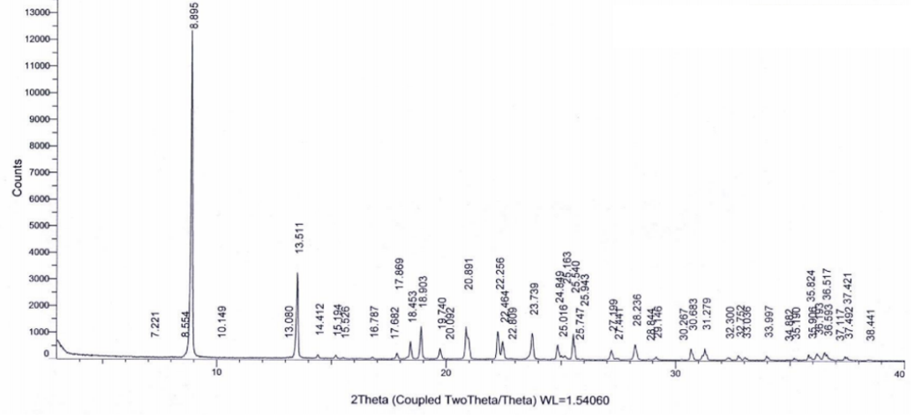Fig. S1 Powder X-ray diffraction of Taulipro.

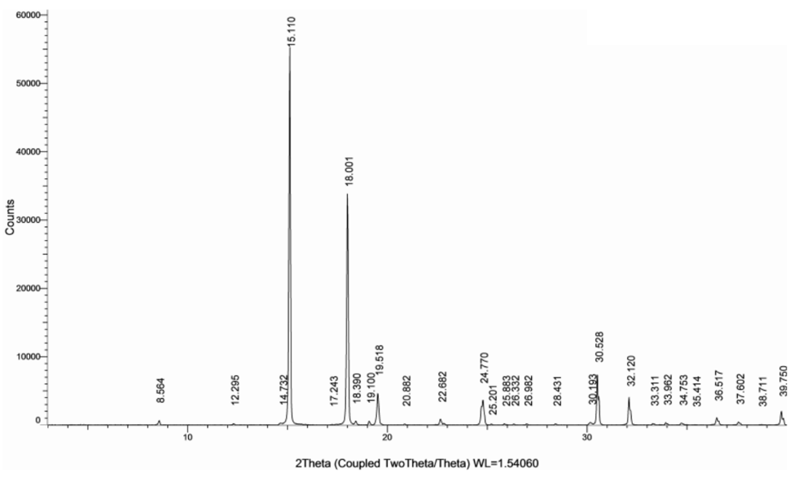Fig. S2 Powder X-ray diffraction of L-Proline.
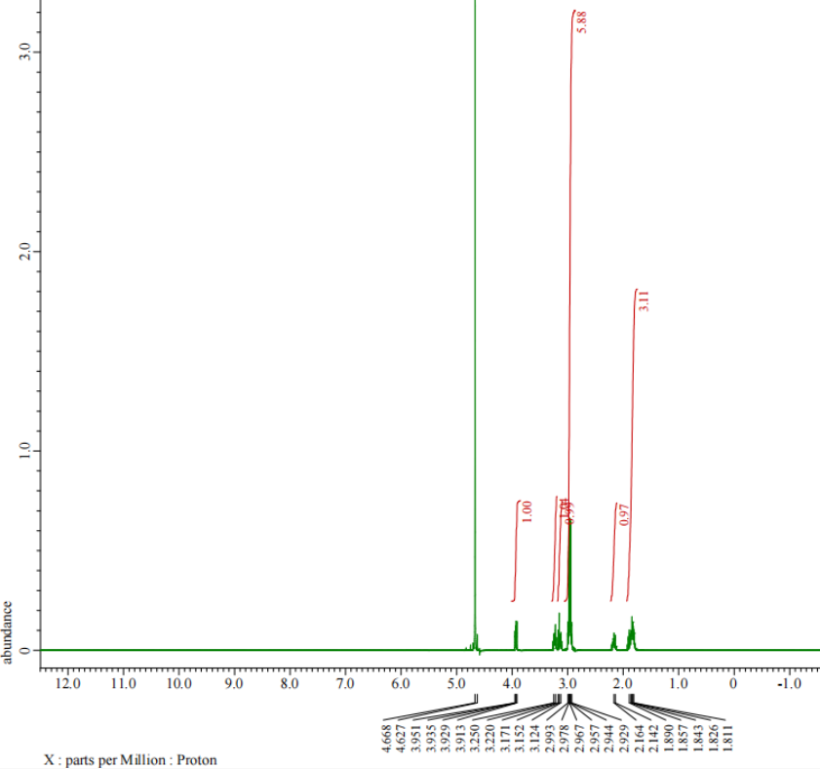
Fig.S3 The ¹H-NMR spectrum of Taulipro. 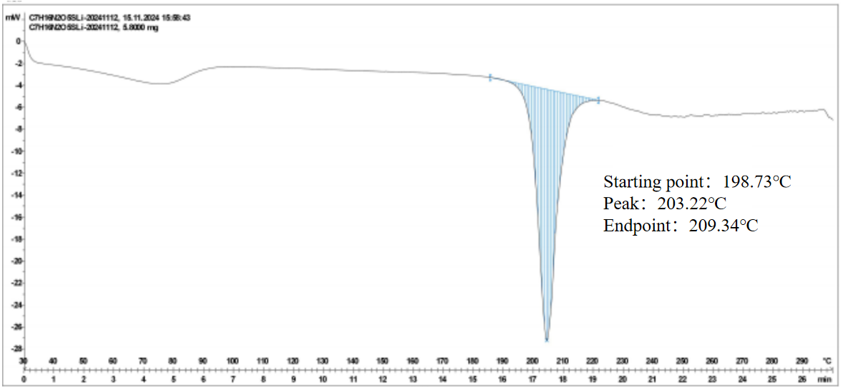

Fig. S4 Differential scanning calorimetry of Taulipro.

