Supporting Information

Asymmetric Fe@CNTS/Ag@CNTA Integrated Carbon Nanotube Frameworks for High-Efficiency and Low-Reflection Electromagnetic Interference Shielding
Chenkun Tuª, Jiapeng Zhang^{b,c}*, Wenjing Xi ª*

a. Kangda College, Nanjing Medical University, Lianyungang, 222000, P. R. China
b. Jiangsu Yueda Group Co., Ltd, YanCheng, 224000, P. R. China
c. Zhongke Yueda Shanghai Material Technology Co. Ltd Shanghai 201800, P. R. China

Jiapeng Zhang: xiaofeizi0824@163.com
Wenjing Xi: dadaxwj@163.com;

Calculation
The calculation formula of R, T, A, SE_{T}, SE_{R}, and SE_{A} is shown as below.
Above 15 dB, the SE_{T} can be simplified as:
$SE = {SE}_{R} + {SE}_{A} + {SE}_{M} ≈ {SE}_{R} + {SE}_{A}$ (S1)
Where
${SE }_{R}= - 10 \log{(1-{S11}^{2}})$ (S2)
${SE}_{A}=-10\log{{[S21}^{2}/(1-{S11}^{2})]}$ (S3)
$R={S11}^{2}$ (S4)
${T=S21}^{2}$ (S5)
$R+T+A=1$ (S6)
The S11 and S21 (linear value) are the input reflection and positive transmission coefficients, respectively.
All simulations were calculated using COMSOL 6.1 software. The xy planes are defined as the incident planes, respectively, and the TM polarization plane electromagnetic waves are incident along the z-axis direction to the Ni@CNTS and Ti3C2Tx planes, respectively. Calculate the electromagnetic field distribution in a material from Maxwell's wave equation:
$∇×μ_{r}^{-1}\left(∇×E\right)-k_{0}^{2}\left(ε_{r}-\frac{jσ}{ωε_{0}}\right)E$=0.

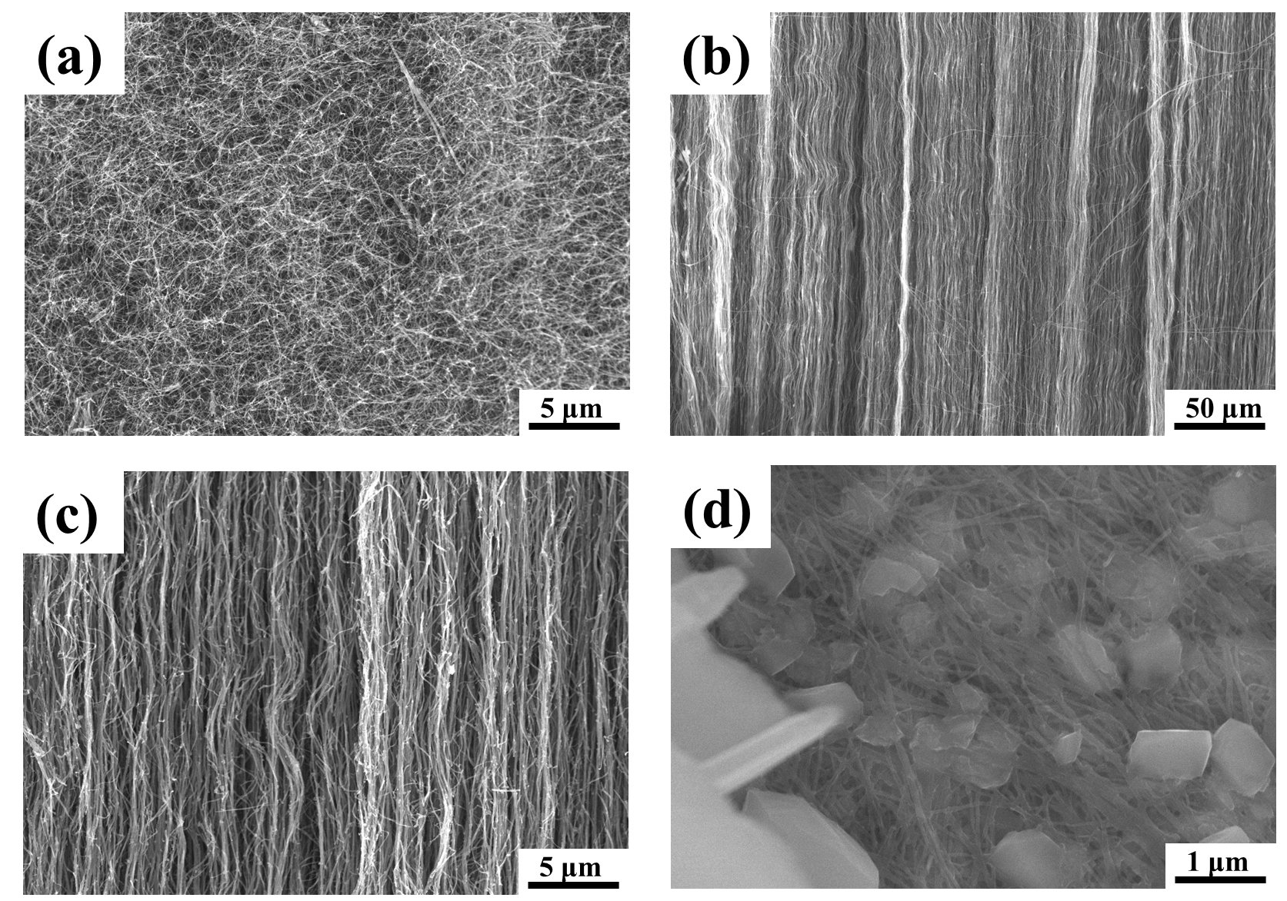
Figure S1. (a): SEM image of CNTS; (b), (c): SEM images of CNTA; (d): SEM image of the interior of Fe/CNTS.
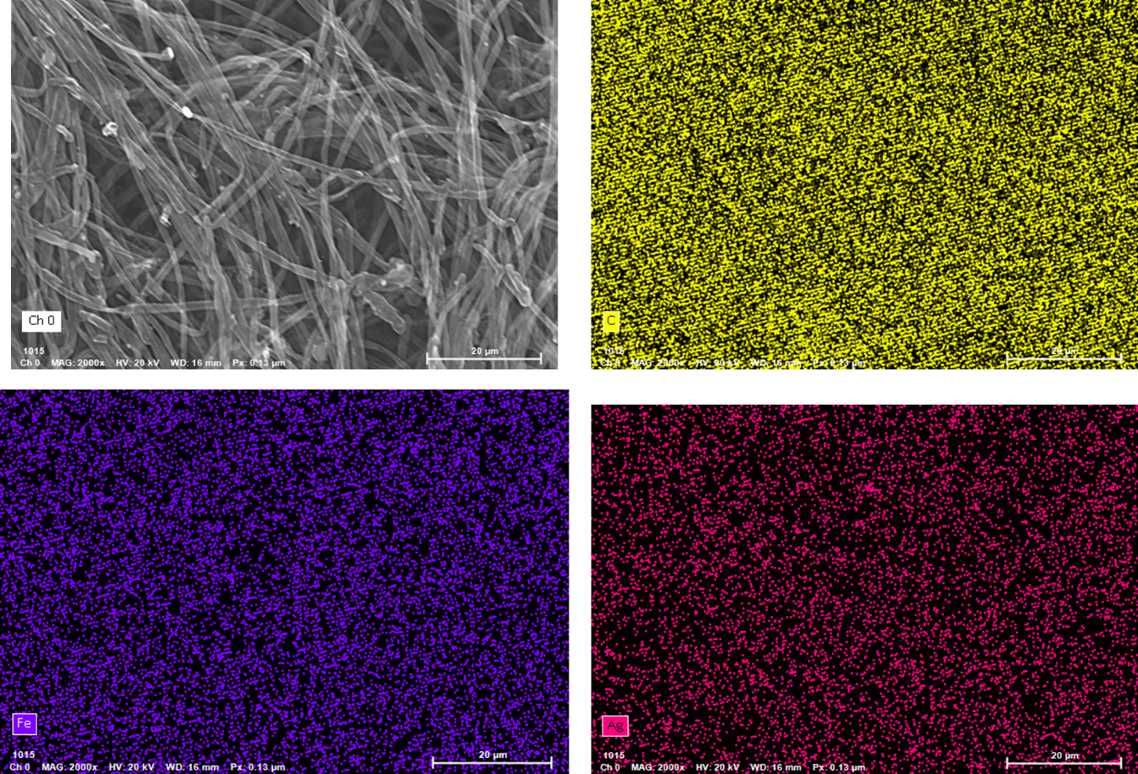
Figure S2. The EDS images of Fe@CNTS/Ag@CNTA

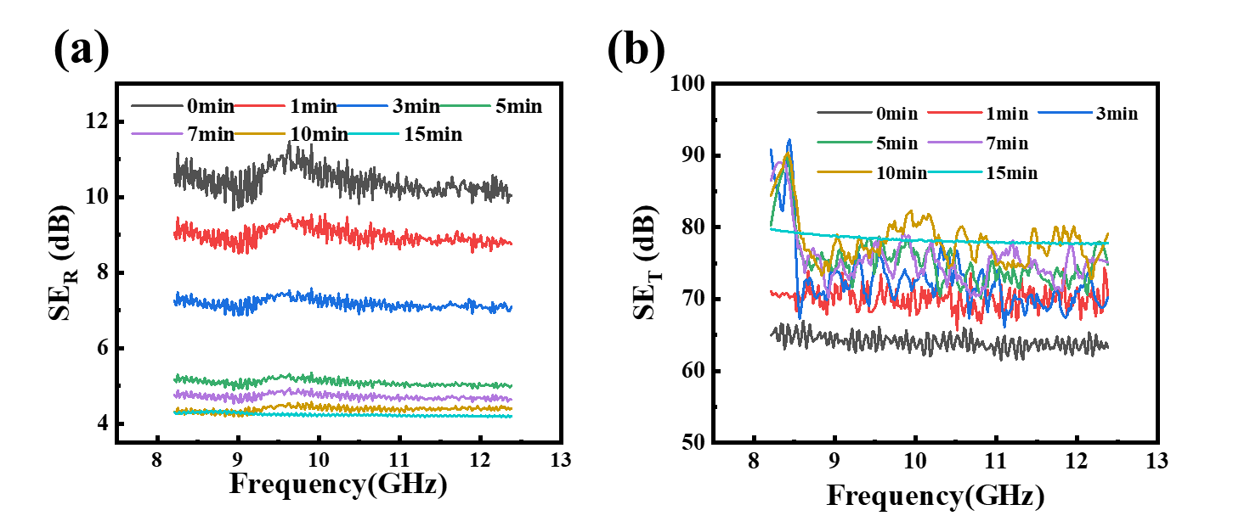
Figure S3. (a) The SE_{R} images of Fe@CNTS/CNTA ; (b) The SE_{T} images of Fe@CNTS/CNTA.
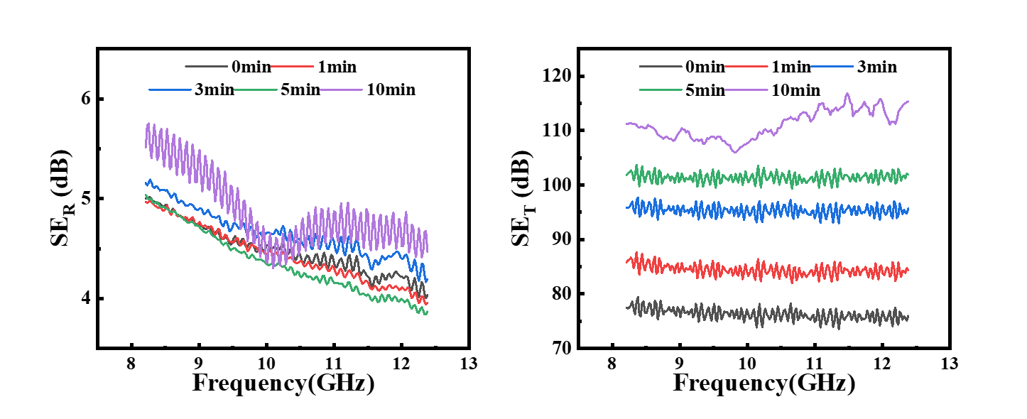
Figure S4. (a) The SE_{R} images of Fe@CNTS/Ag@CNTA; (b) The SE_{T} images of Fe@CNTS/Ag@CNTA.

