Global socioeconomic and urban-rural inequalities in dietary cholesterol intake from 1990 to 2020: a population-level observational analysis of Global Dietary Database estimates
Supplementary Material
Table of Contents
Table S1. Countries by world region (super region) in GDD 2020.
Table S2. Mean dietary cholesterol intakes (95% UI) by sex, education, and area of residence in the 25 most populous countries in 2020.
Table S3. Absolute difference in dietary cholesterol intakes (95% UI) by sex, education level, and area of residence globally and regionally across 185 countries in 2020.
Table S4. Absolute difference in dietary cholesterol intakes (95% UI) by age, education level, and area of residence globally and regionally across 185 countries in 1990.
Table S5. Mean dietary cholesterol intakes (95% UI) by age, education level, and area of residence across 185 countries in 2005.
Table S6. Mean dietary cholesterol intakes (95% UI) by sex, education, and area of residence in the 25 most populous countries in 1990.
Table S7. Mean dietary cholesterol intakes (95% UI) by sex, education, and area of residence in the 25 most populous countries in 2005.
Table S8. Absolute change in dietary cholesterol intakes (95% UI) from 1990–2005, 2005–2020, and 1990–2020 by world region across 185 countries.
Table S9. Absolute change in mean dietary cholesterol intakes (95% UI) from 1990–2005, 2005–2020, and 1990–2020 in the 25 most populous countries.
Figure S1. (A–F) National mean dietary cholesterol intakes and absolute changes for males across 185 countries (1990, 2005, 2020).
Figure S2. (A–F) National mean dietary cholesterol intakes and absolute changes for females across 185 countries (1990, 2005, 2020).
Figure S3. Changes in dietary cholesterol intakes of males by world region across 185 countries from 1990 to 2020.
Figure S4. Changes in dietary cholesterol intakes of females by world region across 185 countries from 1990 to 2020.
Figure S5. (A–C) Annual changes in dietary cholesterol intake by world region and sex across 185 countries from 1990 to 2020.

Table S1. Countries by world region (super region) in GDD 2020.
Central or Eastern Europe  and Central Asia†  n=29 | High-Income Countries  n=24 | Latin America & Caribbean  n=32 | Middle East &  North Africa  n=20 | South Asia§  n=8 | East & Southeast Asia  n=24 | Sub-Saharan Africa  n=48
Albania | Australia | Argentina | Algeria | Afghanistan | Brunei | Angola
Armenia | Austria | Antigua and Barbuda | Bahrain | Bangladesh | Cambodia | Benin
Azerbaijan | Belgium | Barbados | Egypt | Bhutan | China | Botswana
Belarus | Canada | Belize | Iran | India | Federated States of Micronesia | Burkina Faso
Bosnia and Herzegovina | Cyprus | Bolivia | Iraq | Maldives | Fiji | Burundi
Bulgaria | Denmark | Brazil | Israel | Nepal | Indonesia | Cameroon
Croatia | Finland | Chile | Jordan | Pakistan | Japan | Cape Verde
Czech Republic | France | Colombia | Kuwait | Sri Lanka | Kiribati | Central African Republic
Estonia | Germany | Costa Rica | Lebanon |  | Laos | Chad
Georgia | Greece | Cuba | Libya |  | Malaysia | Comoros
Hungary | Iceland | Dominica | Morocco |  | Marshall Islands | Congo
Kazakhstan | Ireland | Dominican Republic | Oman |  | Myanmar | Cote d'Ivoire
Kyrgyzstan | Italy | Ecuador | Palestine |  | Papua New Guinea | Democratic Republic of the Congo
Latvia | Luxembourg | El Salvador | Qatar |  | Philippines | Djibouti
Lithuania | Malta | Grenada | Saudi Arabia |  | Samoa | Equatorial Guinea
Macedonia | Netherlands | Guatemala | Syria |  | Singapore | Eritrea
Moldova | New Zealand | Guyana | Tunisia |  | Solomon Islands | Ethiopia
Mongolia | Norway | Haiti | Turkey |  | South Korea | The Gambia
Montenegro | Portugal | Honduras | United Arab Emirates |  | Taiwan | Gabon
Poland | Spain | Jamaica | Yemen |  | Thailand | Ghana
Romania | Sweden | Mexico |  |  | Timor-Leste | Guinea
Russia | Switzerland | Nicaragua |  |  | Tonga | Guinea-Bissau
Serbia | United Kingdom | Panama |  |  | Vanuatu | Kenya
Slovakia | United States | Paraguay |  |  | Vietnam | Lesotho
Slovenia |  | Peru |  |  |  | Liberia
Tajikistan |  | Saint Lucia |  |  |  | Madagascar
Turkmenistan |  | Saint Vincent and the Grenadines |  |  |  | Malawi
Ukraine |  | Suriname |  |  |  | Mali
Uzbekistan |  | Trinidad and Tobago |  |  |  | Mauritania
 |  | Uruguay |  |  |  | Mauritius
 |  | Venezuela |  |  |  | Mozambique
 |  |  |  |  |  | Namibia
 |  |  |  |  |  | Niger
 |  |  |  |  |  | Nigeria
 |  |  |  |  |  | Rwanda
 |  |  |  |  |  | Sao Tome and Principe
 |  |  |  |  |  | Senegal
 |  |  |  |  |  | Seychelles
 |  |  |  |  |  | Sierra Leone
 |  |  |  |  |  | South Africa
 |  |  |  |  |  | South Sudan
 |  |  |  |  |  | Sudan
 |  |  |  |  |  | Swaziland
 |  |  |  |  |  | Tanzania
 |  |  |  |  |  | Togo
 |  |  |  |  |  | Uganda
 |  |  |  |  |  | Zambia
 |  |  |  |  |  | Zimbabwe
†Referred to as Former Soviet Union in previous Global Dietary Database reports. §Referred to as Asia in previous Global Dietary Database reports.
Table S2. Mean dietary cholesterol intakes (95% UI) by sex, education, and area of residence in the 25 most populous countries in 2020.
Country | Female  mean (95% UI) | Male  mean (95% UI) | High Education  mean (95% UI) | Medium Education  mean (95% UI) | Low Education  mean (95% UI) | Rural  mean (95% UI) | Urban  mean (95% UI)
China | 264.95 (237.83, 295.65) | 273.86 (246.22, 304.05) | 291.66 (265.49, 320.36) | 271.10 (247.50, 296.94) | 254.77 (230.91, 281.28) | 260.99 (239.25, 284.90) | 274.92 (251.71, 300.82)
India | 73.65 (54.56, 99.18) | 75.38 (57.67, 98.35) | 100.38 (76.53, 131.44) | 89.64 (68.94, 116.24) | 62.51 (48.18, 81.48) | 73.02 (56.03, 95.10) | 78.13 (60.76, 100.89)
United States | 249.68 (242.31, 257.35) | 252.33 (244.87, 260.03) | 249.47 (242.28, 256.55) | 255.35 (247.27, 263.78) | 262.82 (253.63, 272.11) | 244.34 (239.87, 248.96) | 252.35 (244.43, 260.17)
Indonesia | 214.80 (195.25, 236.03) | 222.00 (200.46, 245.73) | 240.90 (220.31, 262.61) | 223.98 (206.26, 242.15) | 210.70 (193.90, 229.64) | 212.06 (196.36, 228.52) | 223.34 (205.79, 242.81)
Brazil | 266.68 (244.74, 290.33) | 277.41 (255.27, 300.92) | 264.08 (242.57, 287.51) | 267.85 (248.38, 288.50) | 276.65 (254.17, 300.81) | 255.51 (236.68, 275.87) | 274.20 (256.33, 292.95)
Pakistan | 158.87 (135.27, 187.31) | 156.90 (136.26, 180.37) | 218.47 (187.38, 256.08) | 195.02 (167.40, 226.20) | 135.91 (118.56, 156.18) | 153.69 (134.14, 175.61) | 164.81 (144.63, 188.32)
Russia | 337.22 (273.30, 415.74) | 360.28 (297.07, 438.82) | 335.37 (274.31, 409.80) | 370.29 (301.05, 455.02) | 371.52 (298.95, 459.38) | 337.12 (276.96, 410.02) | 352.57 (289.33, 428.58)
Japan | 355.75 (334.49, 379.77) | 332.76 (311.79, 355.55) | 358.69 (338.35, 379.24) | 333.38 (312.20, 355.53) | 313.40 (291.19, 337.41) | 328.53 (309.63, 348.32) | 346.11 (328.69, 364.16)
Bangladesh | 54.36 (49.13, 60.28) | 61.12 (55.40, 67.62) | 77.02 (67.19, 89.21) | 68.77 (60.96, 77.34) | 47.90 (43.36, 53.16) | 56.30 (51.80, 60.97) | 60.02 (53.87, 69.13)
Nigeria | 110.28 (75.16, 162.31) | 114.84 (79.02, 168.03) | 138.66 (95.12, 202.96) | 134.26 (93.67, 192.10) | 104.54 (68.71, 157.44) | 109.61 (74.74, 159.20) | 115.71 (79.31, 171.08)
Mexico | 261.57 (248.86, 274.77) | 266.49 (253.63, 280.14) | 257.52 (238.40, 277.66) | 261.47 (246.06, 276.97) | 270.00 (253.94, 287.84) | 249.31 (237.30, 261.33) | 267.45 (256.25, 279.76)
Germany | 272.53 (258.41, 287.00) | 277.96 (264.45, 292.42) | 269.97 (257.94, 281.79) | 276.15 (264.37, 289.18) | 284.14 (271.41, 297.97) | 268.41 (256.49, 280.62) | 277.30 (265.78, 289.73)
Vietnam | 301.99 (245.13, 367.86) | 307.91 (255.73, 367.74) | 336.02 (274.82, 406.79) | 312.20 (256.91, 376.74) | 293.81 (241.10, 355.71) | 299.00 (245.56, 358.84) | 314.71 (260.36, 379.02)
Philippines | 254.01 (228.13, 283.49) | 225.81 (202.29, 251.07) | 255.05 (232.87, 278.73) | 237.04 (216.16, 259.47) | 222.83 (202.80, 245.37) | 233.94 (214.74, 254.49) | 246.50 (225.49, 269.24)
Egypt | 248.61 (202.29, 302.62) | 267.91 (223.92, 321.96) | 261.90 (214.62, 316.97) | 259.01 (214.48, 312.15) | 257.00 (212.40, 314.01) | 251.64 (206.77, 303.47) | 268.15 (223.09, 321.15)
Iran | 159.82 (147.25, 173.90) | 172.86 (159.73, 187.14) | 168.42 (155.73, 182.47) | 166.76 (154.36, 179.67) | 165.22 (152.73, 179.48) | 158.66 (144.05, 173.23) | 169.03 (157.83, 181.13)
Turkey | 247.87 (210.36, 293.87) | 271.21 (225.81, 326.63) | 263.08 (226.15, 307.03) | 259.86 (224.86, 301.66) | 257.94 (220.96, 300.04) | 247.12 (211.85, 288.44) | 263.78 (228.37, 305.92)
Thailand | 296.38 (277.21, 317.34) | 299.16 (280.60, 320.67) | 329.75 (309.24, 352.94) | 306.61 (287.45, 326.81) | 288.26 (271.18, 307.73) | 289.71 (273.85, 306.85) | 305.33 (288.04, 324.24)
Ethiopia | 91.73 (61.21, 137.23) | 95.36 (63.73, 141.47) | 113.64 (75.79, 170.11) | 110.19 (74.84, 164.37) | 85.85 (55.00, 132.28) | 92.25 (62.17, 136.45) | 98.12 (65.44, 146.48)
United Kingdom | 276.35 (258.30, 295.44) | 272.89 (254.70, 292.09) | 268.71 (255.02, 283.24) | 275.10 (261.06, 289.56) | 283.15 (267.87, 298.90) | 267.38 (253.05, 282.17) | 276.19 (262.04, 290.39)
Italy | 255.18 (240.41, 271.23) | 287.58 (270.47, 305.83) | 265.37 (252.33, 279.14) | 271.72 (258.39, 285.68) | 279.56 (265.59, 294.34) | 264.89 (251.73, 278.24) | 273.42 (260.16, 287.69)
France | 255.87 (241.27, 272.35) | 405.21 (381.99, 429.84) | 320.82 (306.04, 335.79) | 328.44 (313.55, 343.45) | 337.97 (321.95, 354.74) | 319.76 (304.74, 335.00) | 330.24 (315.69, 344.92)
DR Congo | 152.38 (100.61, 227.90) | 158.28 (105.81, 238.28) | 190.97 (125.65, 287.80) | 184.34 (125.91, 275.81) | 144.05 (91.49, 222.41) | 151.19 (101.02, 225.60) | 160.62 (106.69, 241.15)
United Republic of Tanzania | 135.01 (92.18, 198.14) | 140.86 (96.71, 203.21) | 163.07 (110.33, 241.52) | 158.61 (109.38, 229.54) | 123.55 (80.21, 188.14) | 134.99 (92.05, 195.51) | 143.76 (98.07, 210.55)
South Africa | 267.85 (231.63, 308.05) | 269.31 (230.68, 313.35) | 300.04 (253.43, 360.24) | 291.59 (247.98, 340.60) | 227.54 (178.30, 286.78) | 258.12 (223.45, 293.02) | 273.75 (240.26, 313.27)
Countries are ordered from most to least populous (2020 population data).
Table S3. Absolute difference in dietary cholesterol intakes (95% UI) by sex, education level, and area of residence globally and regionally across 185 countries in 2020.
 | Global | South Asia | Sub-Saharan Africa | Former Soviet Union | Middle East &  North Africa | Latin America &  Caribbean | High-Income  Countries | East & Southeast Asia
Overall | 206.11 (197.16, 216.26) | 83.52 (70.42, 100.16) | 131.39 (95.82, 181.10) | 327.06 (282.85, 380.49) | 255.22 (231.47, 280.37) | 266.15 (251.30, 283.18) | 263.84 (258.67, 269.40) | 268.29 (252.81, 285.17)
High vs. Low Educated Overall
Sex
Female | 91.23(72.6-108.7) | 53.84(26.04-79.9) | 51.79(-15.98-122.52) | -34.4(-115.58-43.99) | 3.84(-36.64-44.46) | -2.71(-35.39-31.83) | -22.26(-34.45--9.45) | 45.44(13.65-77.02)
Male | 94.39(77.46-111.26) | 54.81(28.78-80.55) | 53.92(-17.84-123.48) | -33.63(-115.51-47.63) | 4.74(-37.07-45.09) | -1.9(-38.42-34.42) | -42.57(-56.21--29.77) | 38.37(6.82-71.14)
Age (years)
0-11m | 29.64 (8.87, 49.73) | 37.57 (-2.91, 77.51) | 19.57 (-31.76, 76.60) | -9.59 (-50.53, 32.19) | 2.42 (-128.17, 135.13) | -2.88 (-61.53, 56.57) | -7.87 (-13.57, -1.79) | 17.29 (-7.57, 41.65)
1-14 | 71.27 (60.29, 82.22) | 46.05 (32.03, 60.61) | 39.08 (3.59, 76.73) | -24.76 (-69.32, 18.51) | 3.59 (-41.45, 47.89) | -1.67 (-24.16, 20.93) | -20.39 (-25.15, -15.83) | 37.07 (20.11, 53.21)
15-39 | 100.89 (90.65, 111.00) | 60.30 (46.04, 74.24) | 58.35 (19.60, 99.02) | -37.79 (-94.37, 18.28) | 3.31 (-21.24, 26.62) | -2.20 (-20.47, 16.36) | -32.69 (-39.04, -26.12) | 46.08 (29.50, 62.67)
40-59 | 86.76 (76.39, 97.33) | 58.82 (41.99, 75.73) | 66.33 (19.52, 114.44) | -37.38 (-93.43, 16.22) | 2.24 (-20.18, 24.46) | -1.13 (-22.56, 19.81) | -33.12 (-40.74, -25.33) | 40.68 (24.19, 56.67)
60+ | 69.70 (63.38, 76.35) | 41.22 (31.15, 51.37) | 72.82 (30.09, 115.62) | -31.47 (-68.04, 5.44) | 5.08 (-9.99, 19.64) | 0.77 (-15.72, 17.27) | -29.53 (-34.92, -23.88) | 49.55 (38.19, 60.85)
Area of residence
Rural | 99.56(80.11-118.57) | 51.89(27.98-76.91) | 45.14(-23.61-114.75) | -31.4(-105.82-41.68) | 1.19(-47.05-48.22) | 0.64(-37.38-38.01) | -30.11(-41.49--18.44) | 32.46(5.05-60.66)
Urban | 74.16(57.55-90.03) | 58.06(31.73-83.8) | 59.68(-12.67-129.33) | -33.46(-117.16-47.06) | 3(-34.6-39.13) | -3.15(-37.28-30.03) | -32.49(-44.53--19.9) | 45.87(15.91-74.46)
Urban vs. Rural Areas
Sex
Female | 60.54(44.87-76.62) | 6.15(-19.8-30.9) | 15.55(-45.62-79.88) | 15.33(-55.99-85.19) | 15.64(-25.87-56.38) | 20.41(-6.96-48.67) | 5.27(-3.88-14.33) | 17.51(-11.31-46.22)
Male | 63.61(47.12-79.47) | 6.58(-18-29.27) | 16.44(-46.56-80.91) | 13.55(-61.9-85.67) | 18.16(-25.42-62.05) | 21.62(-9.19-51.85) | 4.19(-5.81-13.63) | 16.09(-13.52-46.42)
Age (years)
0-11m | 33.87(12.63-54.21) | 4.95(-28.51-36.49) | 6.79(-43.65-56.49) | 3.27(-33.23-40.18) | 8.96(-119.06-137.71) | 23.9(-30.5-78.33) | 1.22(-4.09-6.61) | 7.13(-16.35-30.19)
1-14 | 51.16(40.4-61.54) | 5.59(-5.17-17.41) | 10.42(-21.97-42.69) | 9.11(-31.43-48.68) | 15.1(-29.22-62.12) | 21.64(2.55-41.24) | 3.3(-0.45-7.02) | 14.74(-1.17-29.93)
15-39 | 63.97(54.85-72.96) | 7.42(-5.49-19.87) | 19.28(-16.05-53.8) | 16.6(-30.1-63.76) | 15.75(-8.62-40.91) | 22.05(7-37.32) | 5.33(0.43-10.31) | 19.15(3.7-34.24)
40-59 | 57.98(49-67.18) | 7.06(-8.62-22.45) | 22.7(-19.63-65.18) | 17.28(-30.89-66.08) | 13.82(-8.67-37) | 20.6(3.87-37.4) | 5.72(-0.29-11.9) | 17.35(2.03-32.75)
60+ | 54.14(48.47-59.7) | 4.68(-3.84-13.66) | 28.76(-9.12-65.21) | 17.5(-13.09-48.26) | 15.58(-0.05-30.39) | 17.98(4.58-31.47) | 5.53(0.88-9.79) | 26.83(16.25-37.5)
Education
Low | 57.15 (38.54, 75.83) | 5.54 (-13.80, 25.08) | 12.06 (-56.94, 77.84) | 18.12 (-64.75, 93.78) | 15.78 (-27.59, 60.60) | 23.20 (-8.47, 55.83) | 7.90 (-6.98, 22.61) | 10.59 (-17.30, 37.93)
Median | 58.78 (41.99, 74.60) | 6.76 (-22.69, 36.77) | 23.15 (-43.34, 88.51) | 14.40 (-54.52, 86.98) | 17.59 (-21.51, 57.84) | 18.99 (-9.97, 48.44) | 5.02 (-5.74, 16.04) | 15.24 (-12.04, 42.89)
High | 32.15 (15.24, 48.35) | 11.59 (-17.59, 41.06) | 28.04 (-48.97, 99.20) | 13.50 (-60.72, 89.13) | 18.51 (-22.49, 60.30) | 18.92 (-19.41, 57.07) | 5.23 (-3.96, 14.12) | 23.33 (-6.18, 53.08)

Table S4. Absolute difference in dietary cholesterol intakes (95% UI) by age, education level, and area of residence globally and regionally across 185 countries in 1990.
 | Global | South Asia | Sub-Saharan Africa | Former Soviet Union | Middle East &  North Africa | Latin America &  Caribbean | High-Income  Countries | East & Southeast Asia
Overall | 184.83 (175.85, 194.81) | 97.7 (80.17, 121.08) | 125.89 (93.2, 171.15) | 362.09 (316.71, 417.18) | 244.5 (219.9, 272.69) | 221.3 (208.27, 236.68) | 281.12 (276.25, 286.03) | 159.39 (147.57, 172.52)
0–11 months | 86 (52–88) | 62 (52–88) | 53 (52–88) | 104 (88–124) | 131 (124–160) | 235 (232–267) | 69 (52–88) | 65 (52–88)
12–23 months | 107 (88–124) | 69 (52–88) | 71 (52–88) | 161 (160–196) | 168 (160–196) | 229 (196–232) | 108 (88–124) | 93 (88–124)
2–5 years | 129 (124–160) | 75 (52–88) | 90 (88–124) | 224 (196–232) | 203 (196–232) | 225 (196–232) | 152 (124–160) | 123 (88–124)
6–10 years | 159 (124–160) | 80 (52–88) | 112 (88–124) | 306 (303–339) | 240 (232–267) | 221 (196–232) | 206 (196–232) | 163 (160–196)
11–14 years | 180 (160–196) | 87 (52–88) | 127 (124–160) | 365 (339–375) | 264 (232–267) | 220 (196–232) | 247 (232–267) | 184 (160–196)
15–19 years | 190 (160–196) | 95 (88–124) | 135 (124–160) | 394 (375–411) | 273 (267–303) | 222 (196–232) | 275 (267–303) | 184 (160–196)
20–24 years | 194 (160–196) | 104 (88–124) | 140 (124–160) | 404 (375–411) | 274 (267–303) | 223 (196–232) | 293 (267–303) | 176 (160–196)
25–29 years | 201 (196–232) | 113 (88–124) | 144 (124–160) | 407 (375–411) | 269 (267–303) | 224 (196–232) | 304 (303–339) | 170 (160–196)
30–34 years | 206 (196–232) | 119 (88–124) | 146 (124–160) | 410 (375–411) | 261 (232–267) | 224 (196–232) | 310 (303–339) | 164 (160–196)
35–39 years | 206 (196–232) | 122 (88–124) | 147 (124–160) | 408 (375–411) | 258 (232–267) | 223 (196–232) | 314 (303–339) | 157 (124–160)
40–44 years | 209 (196–232) | 122 (88–124) | 147 (124–160) | 403 (375–411) | 248 (232–267) | 222 (196–232) | 315 (303–339) | 159 (124–160)
45–49 years | 204 (196–232) | 119 (88–124) | 148 (124–160) | 390 (375–411) | 245 (232–267) | 220 (196–232) | 314 (303–339) | 156 (124–160)
50–54 years | 208 (196–232) | 114 (88–124) | 150 (124–160) | 378 (375–411) | 237 (232–267) | 217 (196–232) | 313 (303–339) | 152 (124–160)
55–59 years | 204 (196–232) | 108 (88–124) | 150 (124–160) | 367 (339–375) | 229 (196–232) | 215 (196–232) | 309 (303–339) | 149 (124–160)
60–64 years | 210 (196–232) | 102 (88–124) | 152 (124–160) | 358 (339–375) | 223 (196–232) | 212 (196–232) | 304 (303–339) | 148 (124–160)
65–69 years | 208 (196–232) | 97 (88–124) | 153 (124–160) | 350 (339–375) | 218 (196–232) | 210 (196–232) | 300 (267–303) | 145 (124–160)
70–74 years | 200 (196–232) | 93 (88–124) | 155 (124–160) | 339 (339–375) | 219 (196–232) | 208 (196–232) | 292 (267–303) | 142 (124–160)
75–79 years | 218 (196–232) | 89 (88–124) | 156 (124–160) | 333 (303–339) | 217 (196–232) | 207 (196–232) | 292 (267–303) | 146 (124–160)
80–84 years | 227 (196–232) | 86 (52–88) | 159 (124–160) | 325 (303–339) | 213 (196–232) | 206 (196–232) | 290 (267–303) | 151 (124–160)
85–89 years | 235 (232–267) | 83 (52–88) | 159 (124–160) | 314 (303–339) | 207 (196–232) | 205 (196–232) | 286 (267–303) | 156 (124–160)
90–94 years | 240 (232–267) | 81 (52–88) | 156 (124–160) | 306 (303–339) | 202 (196–232) | 204 (196–232) | 280 (267–303) | 164 (160–196)
≥95 years | 243 (232–267) | 79 (52–88) | 149 (124–160) | 298 (267–303) | 195 (160–196) | 204 (196–232) | 274 (267–303) | 164 (160–196)
Rural | 153.26 (142.69, 165.2) | 95.23 (77.18, 118.64) | 119.98 (86.58, 166.32) | 340.7 (290.48, 399.42) | 229.16 (201.73, 259.91) | 208.37 (191.05, 227.73) | 273.44 (267.67, 279.65) | 148.11 (135.71, 162.09)
Urban | 227.15 (218.42, 236.87) | 105.02 (87.03, 129.6) | 141.03 (108.18, 187.28) | 374.3 (325.53, 432.48) | 256.82 (232.16, 285.25) | 227.05 (213.64, 242.1) | 283.73 (277.7, 289.84) | 182.68 (171.34, 195.32)
Low education | 147.32 (136.89, 159.99) | 82.83 (67.82, 103.08) | 110.1 (74.46, 160.3) | 382.69 (330.94, 445.3) | 242.11 (215.09, 274.19) | 219.93 (202.69, 239.31) | 309.44 (299.88, 319.26) | 147.74 (134.56, 162.55)
Medium education | 191.98 (182.26, 203.04) | 115.26 (91.37, 145.92) | 156.23 (119.95, 206.29) | 381.6 (331.85, 436.31) | 246.85 (221.69, 275.54) | 222.78 (207.55, 239.24) | 287.48 (280.24, 294.64) | 157.07 (144.46, 171.7)
High education | 238.91 (227.82, 251.31) | 132.06 (110.72, 159.14) | 163.67 (124.48, 217.89) | 345.33 (296.18, 405.75) | 247.37 (222.18, 276.3) | 222.92 (201.93, 246.25) | 270.15 (265.15, 275.57) | 182.55 (168.7, 196.43)

Table S5. Mean dietary cholesterol intakes (95% UI) by age, education level, and area of residence across 185 countries in 2005.
 | Global | South Asia | Sub-Saharan Africa | Former Soviet Union | Middle East &  North Africa | Latin America &  Caribbean | High-Income  Countries | East & Southeast Asia
Overall | 200.04(191.54-209.74) | 100.52(83.78-122.21) | 137.09(102.34-185.96) | 280.25(244.08-324.85) | 242.82(220.16-267.49) | 240.41(227.55-254.8) | 274.5(269.77-279.36) | 231.97(219.62-244.55)
0–11 months | 94( 88-124) | 64( 52- 88) | 57( 52- 88) | 81( 52- 88) | 127(124-160) | 256(232-267) | 67( 52- 88) | 97( 88-124)
12–23 months | 116( 88-124) | 71( 52- 88) | 77( 52- 88) | 125(124-160) | 163(160-196) | 250(232-267) | 105( 88-124) | 139(124-160)
2–5 years | 139(124-160) | 77( 52- 88) | 97( 88-124) | 175(160-196) | 197(196-232) | 245(232-267) | 147(124-160) | 184(160-196)
6–10 years | 169(160-196) | 82( 52- 88) | 120( 88-124) | 234(232-267) | 234(232-267) | 242(232-267) | 199(196-232) | 235(232-267)
11–14 years | 193(160-196) | 89( 88-124) | 137(124-160) | 278(267-303) | 257(232-267) | 241(232-267) | 240(232-267) | 263(232-267)
15–19 years | 209(196-232) | 97( 88-124) | 147(124-160) | 301(267-303) | 264(232-267) | 241(232-267) | 266(232-267) | 268(267-303)
20–24 years | 212(196-232) | 106( 88-124) | 153(124-160) | 312(303-339) | 266(232-267) | 242(232-267) | 284(267-303) | 262(232-267)
25–29 years | 216(196-232) | 114( 88-124) | 157(124-160) | 314(303-339) | 264(232-267) | 244(232-267) | 295(267-303) | 252(232-267)
30–34 years | 219(196-232) | 119( 88-124) | 159(124-160) | 312(303-339) | 260(232-267) | 244(232-267) | 302(267-303) | 240(232-267)
35–39 years | 218(196-232) | 122( 88-124) | 161(160-196) | 306(303-339) | 254(232-267) | 243(232-267) | 305(303-339) | 230(196-232)
40–44 years | 218(196-232) | 122( 88-124) | 162(160-196) | 298(267-303) | 248(232-267) | 241(232-267) | 305(303-339) | 223(196-232)
45–49 years | 217(196-232) | 120( 88-124) | 163(160-196) | 292(267-303) | 241(232-267) | 239(232-267) | 303(303-339) | 218(196-232)
50–54 years | 215(196-232) | 115( 88-124) | 164(160-196) | 286(267-303) | 234(232-267) | 236(232-267) | 301(267-303) | 214(196-232)
55–59 years | 215(196-232) | 109( 88-124) | 164(160-196) | 279(267-303) | 228(196-232) | 232(196-232) | 297(267-303) | 215(196-232)
60–64 years | 210(196-232) | 103( 88-124) | 166(160-196) | 270(267-303) | 222(196-232) | 228(196-232) | 293(267-303) | 213(196-232)
65–69 years | 212(196-232) | 98( 88-124) | 167(160-196) | 261(232-267) | 218(196-232) | 224(196-232) | 290(267-303) | 211(196-232)
70–74 years | 212(196-232) | 93( 88-124) | 169(160-196) | 256(232-267) | 213(196-232) | 222(196-232) | 287(267-303) | 210(196-232)
75–79 years | 217(196-232) | 89( 88-124) | 171(160-196) | 248(232-267) | 209(196-232) | 219(196-232) | 284(267-303) | 212(196-232)
80–84 years | 222(196-232) | 85( 52- 88) | 171(160-196) | 243(232-267) | 206(196-232) | 216(196-232) | 281(267-303) | 214(196-232)
85–89 years | 225(196-232) | 82( 52- 88) | 172(160-196) | 237(232-267) | 206(196-232) | 214(196-232) | 275(267-303) | 217(196-232)
90–94 years | 236(232-267) | 79( 52- 88) | 168(160-196) | 232(196-232) | 205(196-232) | 212(196-232) | 274(267-303) | 227(196-232)
≥95 years | 238(232-267) | 75( 52- 88) | 164(160-196) | 225(196-232) | 202(196-232) | 211(196-232) | 270(267-303) | 235(232-267)
Rural | 173.4(185.55-162.89) | 98(119.99-80.75) | 130.45(181.27-94.81) | 270.54(311.02-236.59) | 230.45(260.36-202.8) | 227.02(247.12-208.72) | 269.91(276.13-263.9) | 221.82(235.21-208.28)
Urban | 227.78(236.04-219.87) | 107.13(130.25-89.25) | 149.99(199.93-114.53) | 286.11(333.96-247.82) | 250.44(273.78-228.56) | 244.5(258.62-231.62) | 275.83(281.7-270.06) | 243.98(257.85-231.18)
Low education | 150.84(166.04-139.04) | 78.13(95.43-65.06) | 117.48(172-78.93) | 314.92(362.25-273.27) | 241.85(272.18-214.6) | 244.95(266.41-226.15) | 292.24(302.25-282.66) | 210.71(226.37-196.24)
Medium education | 206.94(217.74-197.14) | 109.68(134.32-89.74) | 156.75(211.81-117.23) | 302.04(346.61-265.72) | 242.9(267.5-219.99) | 240.77(256.53-225.67) | 283.68(290.71-276.48) | 226.09(241.69-211.75)
High education | 231.02(241.08-221.59) | 123.6(154.04-100.02) | 178.18(234.98-137.27) | 272.3(318.86-235) | 243.62(270.79-219.88) | 236.64(258.13-216.53) | 269.58(274.89-264.5) | 252.69(268.83-237.15)

Table S6. Mean dietary cholesterol intakes (95% UI) by sex, education, and area of residence in the 25 most populous countries in 1990.
Country | Female  mean (95% UI) | Male  mean (95% UI) | High Education  mean (95% UI) | Medium Education  mean (95% UI) | Low Education  mean (95% UI) | Rural  mean (95% UI) | Urban  mean (95% UI)
China | 130.46 (114.40, 147.55) | 134.13 (118.09, 151.54) | 143.28 (127.00, 159.86) | 133.10 (118.88, 148.86) | 125.04 (110.97, 140.39) | 130.53 (116.83, 145.42) | 137.42 (122.78, 153.80)
India | 97.35 (72.39, 131.21) | 99.40 (75.83, 129.70) | 132.17 (101.47, 173.22) | 118.40 (91.16, 154.47) | 82.13 (63.36, 107.90) | 96.84 (74.63, 126.75) | 103.71 (81.10, 133.84)
United States | 261.61 (255.17, 268.31) | 263.63 (257.17, 270.36) | 261.02 (255.12, 267.06) | 267.04 (259.88, 274.97) | 275.04 (266.24, 283.82) | 256.30 (251.82, 261.00) | 264.71 (257.72, 271.75)
Indonesia | 198.92 (179.36, 220.55) | 205.65 (184.01, 229.68) | 223.12 (202.01, 246.67) | 207.45 (188.63, 227.61) | 194.91 (177.02, 214.67) | 199.08 (182.02, 217.45) | 209.71 (190.87, 230.12)
Brazil | 196.17 (179.62, 214.50) | 203.63 (186.43, 222.43) | 194.38 (177.47, 213.05) | 196.99 (182.12, 213.68) | 203.51 (186.35, 221.80) | 189.68 (174.78, 205.71) | 203.53 (189.57, 219.20)
Pakistan | 142.11 (120.40, 168.13) | 140.92 (121.97, 162.26) | 196.27 (166.77, 230.72) | 174.93 (149.89, 203.85) | 122.11 (105.80, 140.02) | 138.77 (120.31, 158.72) | 148.52 (129.81, 170.21)
Russia | 357.30 (290.49, 440.44) | 381.89 (312.60, 463.48) | 354.34 (289.36, 433.59) | 391.66 (319.72, 479.21) | 393.86 (320.05, 484.04) | 357.09 (291.92, 433.98) | 373.18 (307.64, 452.79)
Japan | 314.71 (295.40, 335.92) | 294.10 (275.13, 314.18) | 317.06 (298.87, 335.73) | 294.65 (276.27, 314.61) | 277.35 (256.49, 298.48) | 292.59 (275.28, 310.69) | 308.15 (292.36, 324.98)
Bangladesh | 41.68 (37.59, 46.04) | 47.17 (42.39, 52.30) | 59.34 (51.21, 68.92) | 52.93 (46.87, 59.68) | 36.94 (33.37, 40.82) | 43.89 (40.08, 48.00) | 46.83 (41.80, 54.25)
Nigeria | 106.69 (72.68, 158.11) | 110.88 (76.46, 160.62) | 133.32 (91.66, 194.90) | 129.74 (90.10, 185.26) | 101.02 (66.23, 151.69) | 106.84 (73.20, 155.09) | 113.69 (77.71, 166.46)
Mexico | 227.21 (212.88, 242.12) | 231.31 (216.89, 246.49) | 223.68 (205.09, 244.09) | 226.92 (211.72, 243.29) | 234.21 (217.75, 251.72) | 217.92 (204.25, 232.07) | 233.89 (220.16, 248.31)
Germany | 318.88 (301.91, 336.20) | 324.80 (308.47, 343.01) | 315.51 (301.18, 330.66) | 322.86 (308.44, 338.63) | 332.27 (316.73, 349.09) | 314.22 (299.93, 330.47) | 324.59 (310.22, 339.61)
Vietnam | 120.77 (92.92, 155.44) | 123.03 (95.95, 156.40) | 134.37 (104.77, 172.24) | 125.12 (96.90, 160.27) | 117.51 (90.73, 150.88) | 120.47 (94.06, 153.29) | 126.58 (99.53, 160.93)
Philippines | 184.07 (163.93, 205.91) | 163.13 (145.47, 182.62) | 184.47 (166.95, 202.83) | 171.29 (154.77, 189.37) | 161.13 (145.56, 178.44) | 169.13 (153.76, 185.97) | 178.30 (161.88, 195.86)
Egypt | 194.88 (155.01, 243.98) | 210.19 (171.44, 260.28) | 205.41 (165.78, 256.75) | 203.68 (165.26, 251.47) | 201.68 (162.72, 251.08) | 197.06 (158.89, 243.49) | 210.25 (171.66, 259.63)
Iran | 180.83 (161.48, 203.38) | 195.75 (175.25, 219.02) | 190.67 (170.65, 214.17) | 188.63 (169.40, 210.52) | 187.01 (167.53, 209.90) | 181.76 (160.99, 204.51) | 193.58 (174.93, 215.10)
Turkey | 224.25 (190.19, 266.05) | 244.01 (203.07, 293.91) | 237.32 (204.12, 277.74) | 234.57 (202.78, 272.83) | 232.72 (199.56, 270.68) | 225.41 (193.00, 263.21) | 240.41 (208.07, 278.51)
Thailand | 298.42 (279.81, 318.32) | 299.91 (281.70, 320.78) | 331.28 (311.62, 353.70) | 307.97 (290.18, 327.75) | 289.68 (272.98, 307.82) | 294.57 (279.31, 311.02) | 310.52 (293.98, 328.24)
Ethiopia | 103.27 (69.14, 156.39) | 107.89 (72.42, 159.06) | 129.29 (85.25, 192.03) | 124.51 (84.92, 183.78) | 96.97 (62.21, 150.59) | 104.94 (70.62, 155.55) | 111.73 (75.57, 166.94)
United Kingdom | 287.58 (269.09, 306.85) | 283.40 (264.76, 302.69) | 279.27 (265.23, 294.01) | 286.04 (271.60, 300.66) | 294.15 (278.73, 310.61) | 278.37 (263.51, 293.82) | 287.59 (273.53, 302.24)
Italy | 245.61 (231.33, 261.01) | 275.91 (259.83, 293.42) | 255.01 (242.60, 268.13) | 261.15 (248.42, 274.29) | 268.70 (255.33, 282.62) | 254.91 (241.83, 267.73) | 263.14 (250.43, 276.69)
France | 308.02 (290.07, 327.59) | 487.54 (458.48, 517.81) | 386.58 (368.63, 405.54) | 395.89 (377.41, 414.77) | 407.44 (386.68, 428.08) | 386.19 (367.43, 405.90) | 398.83 (380.18, 417.74)
DR Congo | 95.83 (63.61, 144.88) | 99.34 (66.15, 148.35) | 119.95 (79.66, 178.61) | 115.86 (79.33, 171.78) | 90.43 (57.88, 138.83) | 95.75 (63.60, 143.16) | 101.72 (67.65, 153.07)
United Republic of Tanzania | 143.94 (99.48, 208.75) | 168.83 (117.91, 241.46) | 174.80 (118.83, 255.62) | 149.81 (104.96, 215.99) | 132.11 (86.39, 199.61) | 145.04 (101.57, 208.42) | 154.15 (107.40, 222.48)
South Africa | 246.41 (213.90, 282.46) | 268.71 (230.43, 311.72) | 276.83 (233.62, 330.64) | 248.14 (214.54, 287.89) | 209.62 (164.19, 262.64) | 240.24 (207.76, 272.10) | 254.77 (224.90, 289.58)
Countries are ordered from most to least populous (2020 data).
Table S7. Mean dietary cholesterol intakes (95% UI) by sex, education, and area of residence in the 25 most populous countries in 2005.
Country | Female  mean (95% UI) | Male  mean (95% UI) | High Education  mean (95% UI) | Medium Education  mean (95% UI) | Low Education  mean (95% UI) | Rural  mean (95% UI) | Urban  mean (95% UI)
China | 220.34 (198.57, 244.38) | 226.99 (205.46, 250.15) | 237.75 (217.12, 259.12) | 220.88 (202.66, 240.22) | 207.73 (189.24, 227.91) | 218.92 (201.33, 236.77) | 230.59 (211.85, 250.71)
India | 98.32 (73.33, 130.75) | 100.24 (76.98, 130.11) | 121.79 (93.69, 158.46) | 108.92 (84.33, 141.33) | 75.76 (58.69, 98.51) | 97.49 (75.77, 126.23) | 104.58 (82.12, 133.64)
United States | 262.53 (255.71, 269.76) | 265.00 (258.03, 272.14) | 262.68 (256.54, 269.31) | 268.84 (261.29, 276.97) | 276.82 (267.90, 286.06) | 256.97 (252.55, 261.67) | 265.40 (258.18, 272.95)
Indonesia | 205.65 (188.28, 224.52) | 212.46 (192.43, 234.28) | 225.66 (207.04, 245.15) | 209.87 (194.08, 226.67) | 197.28 (181.83, 213.58) | 204.08 (190.00, 219.18) | 214.94 (198.77, 232.69)
Brazil | 238.57 (219.97, 258.75) | 247.96 (228.87, 268.78) | 238.95 (219.65, 260.36) | 242.36 (224.75, 260.87) | 250.24 (229.76, 271.76) | 229.33 (213.06, 247.25) | 246.31 (231.38, 262.35)
Pakistan | 150.30 (127.63, 178.04) | 148.68 (129.52, 170.42) | 189.88 (162.50, 222.81) | 169.32 (145.13, 196.53) | 118.09 (102.77, 135.06) | 146.24 (127.45, 167.01) | 156.41 (137.44, 179.00)
Russia | 273.38 (219.69, 340.28) | 292.69 (238.07, 355.58) | 276.13 (226.02, 338.84) | 306.69 (248.94, 375.24) | 306.84 (248.82, 377.72) | 272.86 (223.40, 332.30) | 285.68 (234.31, 350.48)
Japan | 351.54 (329.86, 374.67) | 328.63 (307.64, 350.85) | 348.70 (329.06, 368.62) | 324.05 (303.94, 345.55) | 304.80 (282.97, 328.02) | 325.38 (306.35, 345.05) | 342.72 (325.57, 360.42)
Bangladesh | 53.94 (49.38, 58.87) | 60.89 (55.91, 66.36) | 70.67 (62.22, 81.03) | 63.13 (57.01, 69.81) | 44.02 (40.72, 47.74) | 56.41 (52.77, 60.45) | 60.16 (54.78, 68.73)
Nigeria | 128.66 (89.00, 186.59) | 134.71 (93.64, 191.43) | 156.73 (108.01, 229.36) | 152.24 (107.70, 216.30) | 118.54 (78.33, 177.73) | 128.76 (89.78, 183.75) | 136.89 (94.22, 196.97)
Mexico | 248.94 (236.45, 261.70) | 253.44 (240.93, 266.38) | 246.82 (228.45, 265.97) | 250.47 (236.02, 264.90) | 258.60 (243.52, 274.98) | 237.82 (225.79, 250.04) | 255.34 (244.60, 266.59)
Germany | 281.32 (266.83, 295.73) | 286.98 (272.97, 301.78) | 281.58 (269.61, 293.70) | 288.09 (275.88, 301.29) | 296.48 (283.66, 310.63) | 277.20 (264.54, 290.51) | 286.36 (274.56, 298.58)
Vietnam | 232.34 (184.34, 289.18) | 236.53 (190.75, 292.07) | 251.93 (201.16, 312.11) | 235.12 (188.74, 291.39) | 220.75 (176.00, 274.80) | 231.17 (185.95, 285.13) | 243.65 (196.05, 299.58)
Philippines | 238.26 (214.04, 265.16) | 211.17 (189.73, 234.66) | 235.68 (215.36, 256.67) | 218.83 (200.20, 239.27) | 205.91 (187.82, 226.95) | 219.33 (201.41, 238.07) | 231.05 (211.59, 251.27)
Egypt | 235.74 (189.25, 290.78) | 253.86 (209.84, 310.07) | 247.59 (200.19, 304.82) | 245.24 (199.81, 300.86) | 242.57 (197.60, 298.62) | 238.20 (194.68, 291.36) | 253.64 (208.77, 309.94)
Iran | 192.04 (176.51, 209.64) | 207.95 (191.76, 226.32) | 201.90 (185.97, 219.45) | 199.43 (184.26, 216.22) | 197.93 (182.21, 215.65) | 191.93 (174.18, 209.77) | 204.29 (190.16, 219.80)
Turkey | 208.32 (178.70, 244.25) | 227.43 (191.13, 271.99) | 220.44 (191.40, 255.29) | 217.63 (190.14, 250.58) | 215.79 (186.78, 250.16) | 208.59 (180.86, 241.69) | 222.26 (194.14, 255.87)
Thailand | 306.06 (286.84, 326.30) | 307.94 (289.82, 327.73) | 331.80 (311.73, 353.60) | 308.52 (290.32, 328.20) | 290.16 (274.04, 308.28) | 300.91 (285.87, 317.43) | 317.14 (300.82, 334.37)
Ethiopia | 113.42 (76.42, 167.92) | 118.55 (80.45, 172.91) | 136.33 (91.14, 204.41) | 131.55 (89.22, 193.99) | 102.78 (65.62, 158.81) | 114.84 (77.49, 168.03) | 122.27 (82.77, 179.43)
United Kingdom | 283.35 (265.16, 302.15) | 279.42 (261.03, 298.76) | 277.90 (263.82, 292.36) | 284.62 (270.37, 299.19) | 292.72 (277.46, 309.21) | 274.25 (259.71, 289.79) | 283.31 (269.49, 297.60)
Italy | 268.22 (252.89, 284.68) | 301.76 (284.30, 320.71) | 279.97 (266.35, 294.19) | 286.73 (272.81, 301.24) | 295.00 (280.45, 310.33) | 278.53 (264.19, 292.71) | 287.50 (273.80, 301.84)
France | 272.22 (257.01, 289.46) | 431.09 (405.89, 457.02) | 344.93 (329.80, 361.11) | 353.31 (337.37, 368.93) | 363.45 (346.03, 380.75) | 340.55 (325.04, 357.24) | 351.91 (336.54, 367.23)
DR Congo | 122.31 (83.13, 178.55) | 126.51 (86.41, 183.91) | 150.67 (102.30, 221.56) | 146.08 (101.34, 211.96) | 114.37 (74.88, 172.34) | 121.74 (82.74, 177.57) | 129.09 (88.02, 188.49)
United Republic of Tanzania | 123.05 (84.31, 178.72) | 128.48 (88.61, 184.34) | 143.79 (96.32, 210.95) | 139.29 (96.35, 198.81) | 108.41 (70.59, 164.39) | 123.86 (85.41, 178.56) | 131.59 (90.62, 189.23)
South Africa | 256.59 (223.24, 294.30) | 258.76 (223.83, 298.58) | 276.09 (233.43, 330.84) | 267.93 (229.46, 311.00) | 208.99 (163.81, 262.56) | 249.02 (216.42, 281.06) | 263.87 (233.26, 300.24)
Countries are ordered from most to least populous (2020 data).

Table S8. Absolute change in dietary cholesterol intakes (95% UI) from 1990–2005, 2005–2020, and 1990–2020 by world region across 185 countries.
Year | Global | South Asia | Sub-Saharan Africa | Former Soviet Union | Middle East &  North Africa | Latin America &  Caribbean | High-Income  Countries | East & Southeast Asia
1990–2005 | 15.25 (2.54, 28.27) | 2.96 (–24.69, 31.44) | 12.12 (–46.94, 67.63) | –82.13 (–147.92, –17.92) | –2.28 (–36.77, 32.34) | 19.01 (–0.27, 38.87) | –6.68 (–13.68, –0.12) | 72.53 (55.05, 89.91)
2005–2020 | 6.17 (–7.34, 19.24) | –16.83 (–41.16, 6.94) | –5.95 (–64.69, 54.01) | 46.91 (–18.0, 109.78) | 12.78 (–21.73, 46.82) | 25.58 (4.06, 46.58) | –10.62 (–17.6, –3.41) | 36.41 (16.35, 56.66)
1990–2020 | 21.37 (7.78, 34.34) | –14.07 (–38.88, 11.33) | 5.68 (–51.04, 62.93) | –35.32 (–105.38, 34.97) | 10.73 (–25.18, 46.65) | 44.41 (23.32, 66.48) | –17.35 (–24.43, –9.83) | 108.81 (89.39, 129.59)

Table S9. Absolute change in mean dietary cholesterol intakes (95% UI) from 1990–2005, 2005–2020, and 1990–2020 in the 25 most populous countries.
Country | 1990–2005  mean (95% UI) | 2005–2020  mean (95% UI) | 1990–2020  mean (95% UI)
China | 91.93 (68.6, 114.56) | 45.95 (16.99, 75.62) | 137.76 (110.83, 164.08)
India | 0.74 (–34.57, 34.71) | –12.68 (–22.28, –3.58) | –11.59 (–20.73, –2.79)
United States | 1.09 (–7.25, 9.37) | –24.45 (–56.85, 6.88) | –23.9 (–56.22, 8.43)
Indonesia | 7.1 (–15.77, 30.76) | 9.47 (–12.3, 31.95) | 16.51 (–7.31, 41.53)
Brazil | 43.28 (21.75, 64.61) | 28.7 (5.32, 51.93) | 71.89 (49.23, 95.41)
Pakistan | 7.37 (–19.19, 33.93) | 7.94 (–19.58, 35.8) | 15.65 (–12.69, 42.73)
Russia | –87.23 (–176.13, 1.66) | 65.81 (–20.98, 151.64) | –19.75 (–118.75, 74.03)
Japan | 35.26 (11.53, 58.62) | 4.1 (–19.67, 28.7) | 39.77 (16.14, 63.54)
Bangladesh | 12.9 (7.06, 18.81) | 0.33 (–6.31, 7.04) | 13.25 (6.46, 19.73)
Nigeria | 22.44 (–39.56, 83.25) | –19.4 (–83.95, 43.6) | 3.15 (–56.5, 61.87)
Mexico | 21.5 (5.32, 38.04) | 13.02 (–1.36, 27.15) | 34.4 (18.69, 50.7)
Germany | –37.54 (–56.37, –19.13) | –8.67 (–25.49, 7.46) | –46.44 (–64.99, –27.77)
Vietnam | 112.07 (54.78, 169.68) | 70.29 (–4.5, 147.23) | 182.98 (118.59, 247.51)
Philippines | 51.44 (27.11, 74.59) | 15.37 (–12.01, 42.74) | 66.84 (40.21, 92.3)
Egypt | 40.95 (–20.91, 104.61) | 13.94 (–53.92, 80.71) | 55.13 (–8.13, 115.78)
Iran | 11.51 (–12.89, 36.43) | –34.18 (–52.43, –15.35) | –22.43 (–44.6, 0.76)
Turkey | –16.73 (–62.86, 29.19) | 42.18 (–5.6, 90.4) | 25.84 (–26.01, 78.27)
Thailand | 7.65 (–12.97, 29.51) | –9.25 (–31.52, 13.31) | –1.49 (–23.83, 20.96)
Ethiopia | 10.61 (–52.71, 72.44) | –23.08 (–80.08, 35.22) | –12.79 (–69.05, 43.8)
United Kingdom | –4.24 (–24.34, 16.18) | –6.58 (–27.96, 13.16) | –10.71 (–31.07, 8.63)
Italy | 24.12 (5.95, 42.66) | –13.41 (–32.31, 5.22) | 10.85 (–7.46, 28.85)
France | –46.51 (–69.6, –23.11) | –21.15 (–42.35, –0.84) | –67.47 (–90.62, –43.81)
DR Congo | 27.81 (–36.91, 89.91) | 29.8 (–48.45, 112.26) | 57.41 (–16.29, 134.01)
United Republic of Tanzania | –21.2 (–90.63, 49.19) | 11.87 (–55.92, 82.7) | –8.3 (–82.56, 63.62)
South Africa | 9.66 (–32.96, 52.26) | 10.89 (–32.53, 56.91) | 21.04 (–23.1, 65.0)
Countries are ordered from most to least populous (2020 data).
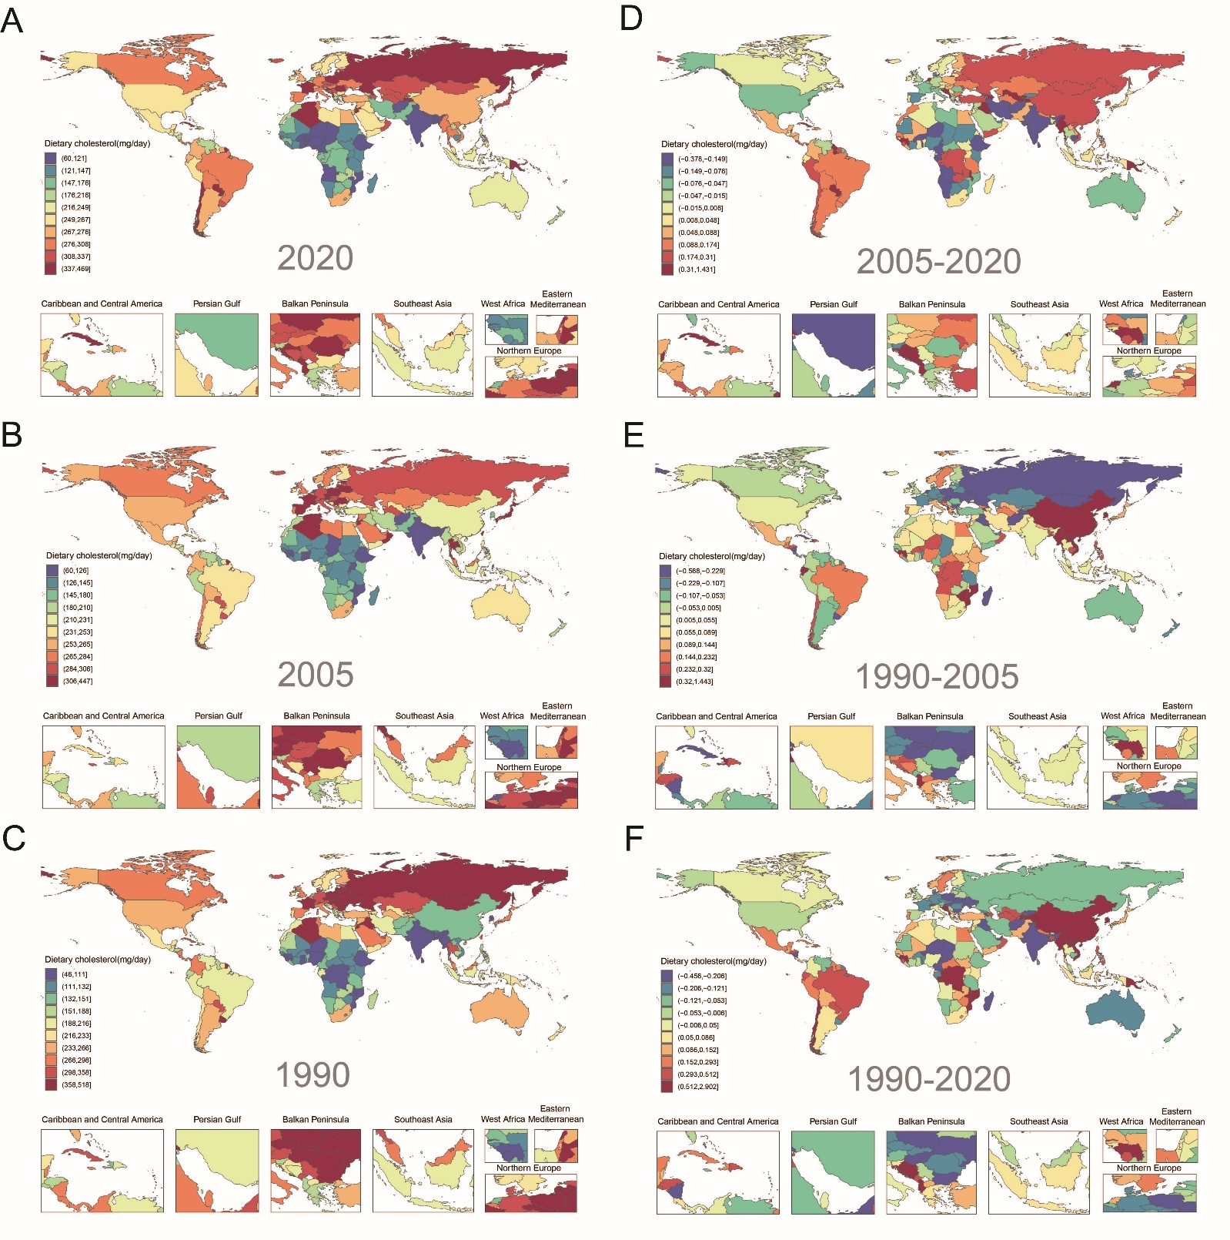
Figure S1. (A) National mean dietary cholesterol intakes of males across 185 countries in 2020; (B) males in 2005; (C) males in 1990; (D) Absolute change from 2005–2020 by world region; (E) Absolute change from 1990–2005 by world region; (F) Absolute change from 1990–2020 by world region.

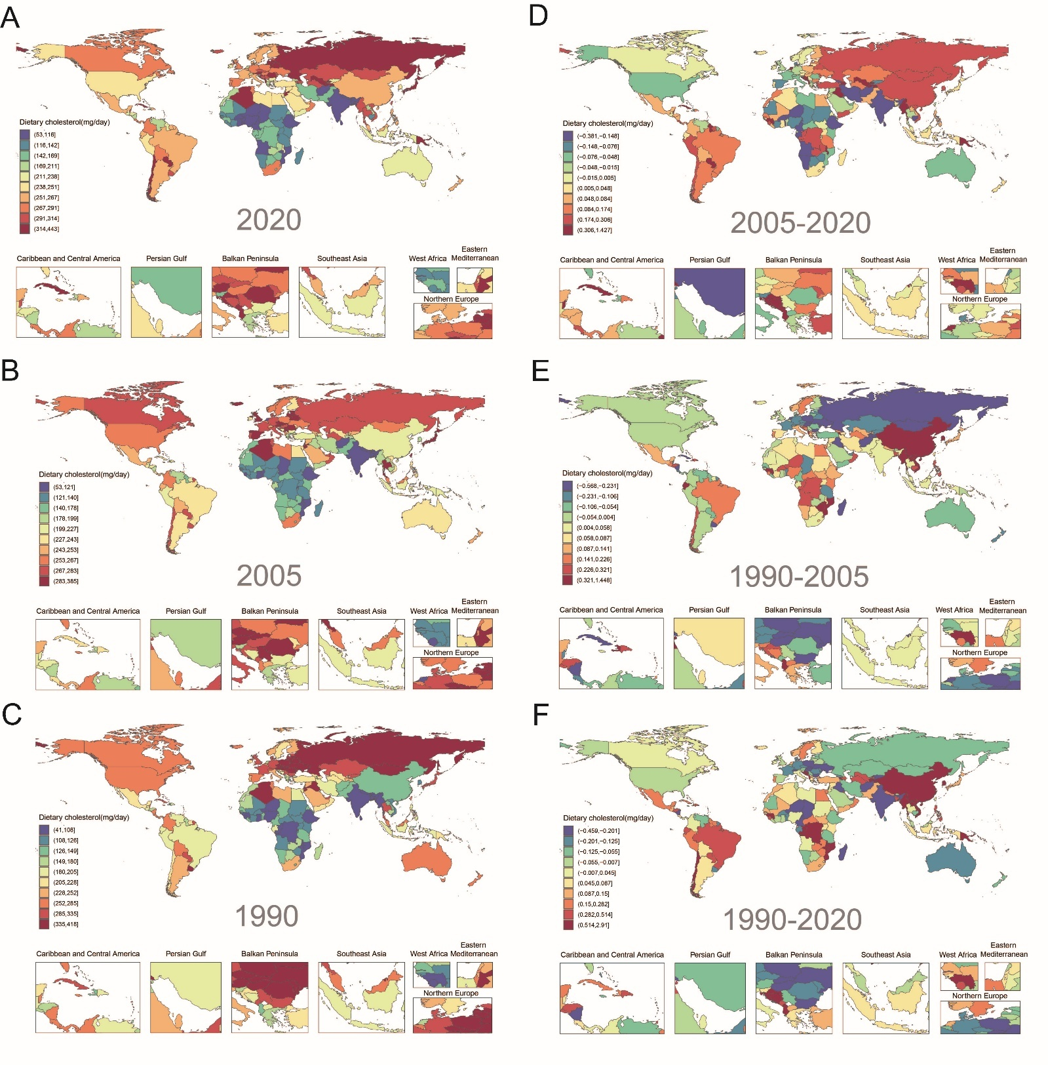
Figure S2. (A) National mean dietary cholesterol intakes of females across 185 countries in 2020; (B) females in 2005; (C) females in 1990; (D) Absolute change from 2005–2020 by world region; (E) Absolute change from 1990–2005 by world region; (F) Absolute change from 1990–2020 by world region.

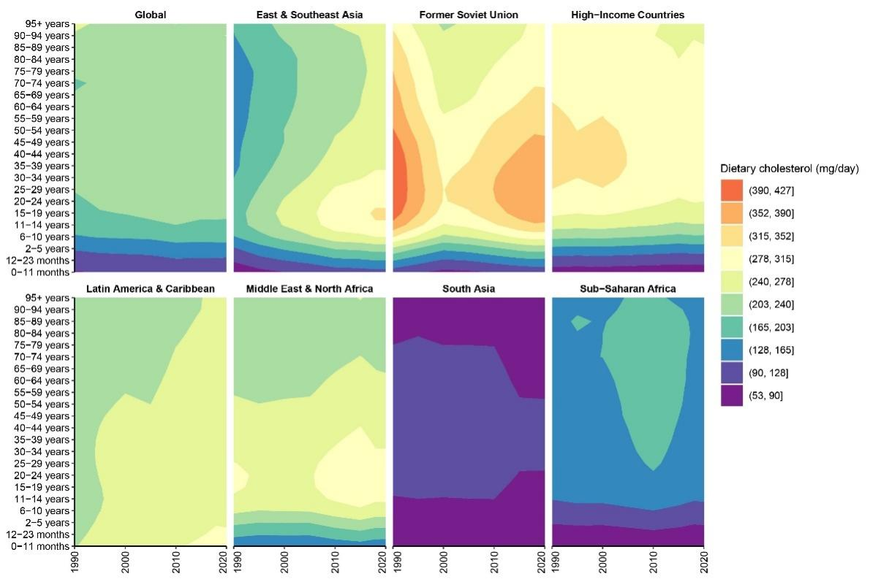
Figure S3. Changes in dietary cholesterol intakes of males by world region across 185 countries from 1990 to 2020.

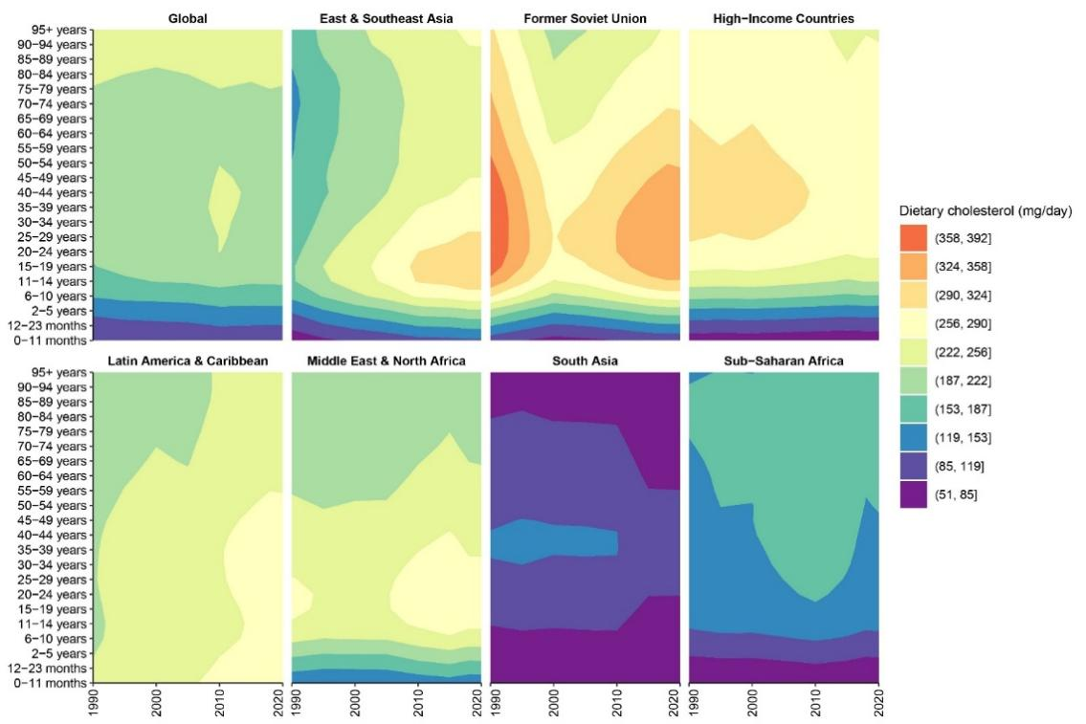
Figure S4. Changes in dietary cholesterol intakes of females by world region across 185 countries from 1990 to 2020.

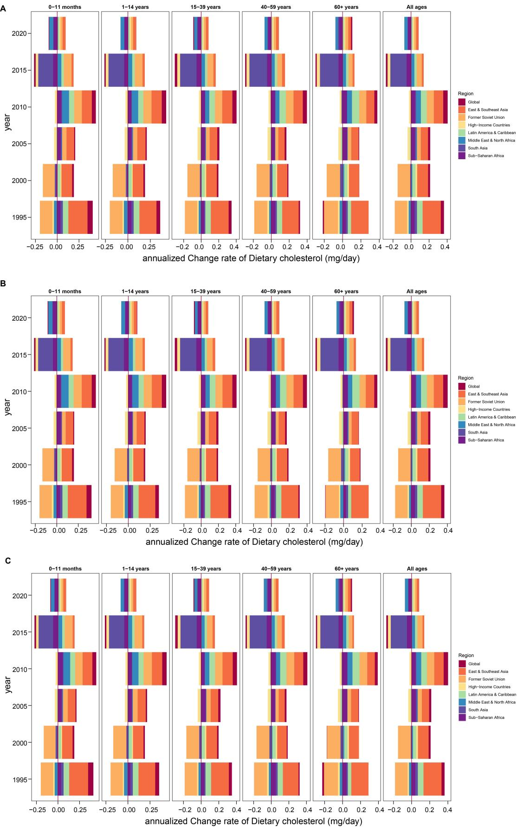

Figure S5. (A) Annual changes in dietary cholesterol intake by world region across 185 countries from 1990 to 2020; (B) Annual changes for males by world region; (C) Annual changes for females by world region.

