Supplement
Formulae for SMD calculation
Continuous variables:
$$SMD=\frac{{\overset{ˉ}{x}}_{1}-{\overset{ˉ}{x}}_{0}}{s_{pooled}},s_{pooled}=\sqrt{\frac{s_{1}^{2}+s_{0}^{2}}{2}}$$
Binary variables:

$$SMD=\frac{p_{1}-p_{0}}{\sqrt{\frac{p_{1}(1-p_{1})+p_{0}(1-p_{0})}{2}}}$$Supplementary Figure of Learning Curve Sensitivity Analysis
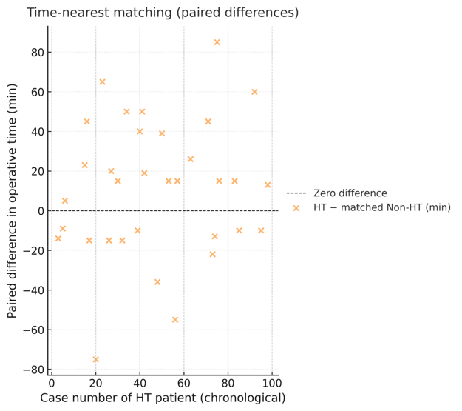
Figure S1. Paired operative-time differences after time-nearest matching. Each point represents the difference in operative time between one HT case and its chronologically nearest matched non-HT case (HT − matched non-HT). Matching was performed in a 1:1 greedy manner according to case number. The horizontal dashed line indicates zero difference. Positive values indicate longer operative time in HT cases relative to matched non-HT controls.
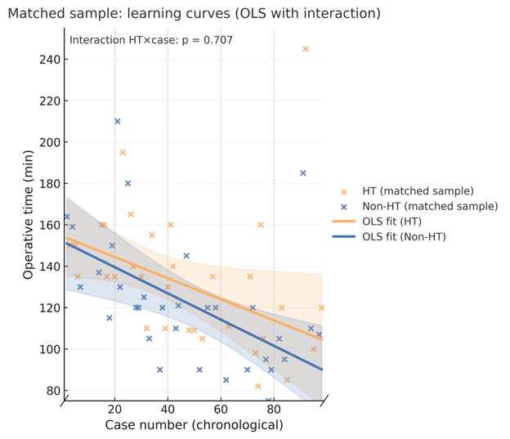
Figure S2. Matched-sample learning curves. Learning curves were re-estimated in the 1:1 time-nearest matched sample to minimize temporal clustering bias. Points represent individual matched cases, and solid lines represent fitted values from a multivariable ordinary least squares model with HC3 robust standard errors. Shaded areas indicate 95% confidence intervals. The HT × case number interaction term was included to test whether HT altered the slope of the learning curve after temporal matching.
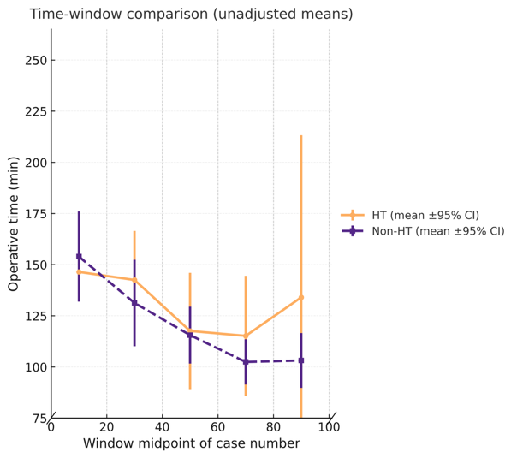
Figure S3. Operative time across chronological windows. The full case sequence was divided into five equal-width chronological windows. Points and error bars represent group-specific mean operative time and 95% confidence intervals within each time window for patients with and without Hashimoto’s thyroiditis (HT). This figure provides an unadjusted descriptive comparison of temporal patterns between groups.
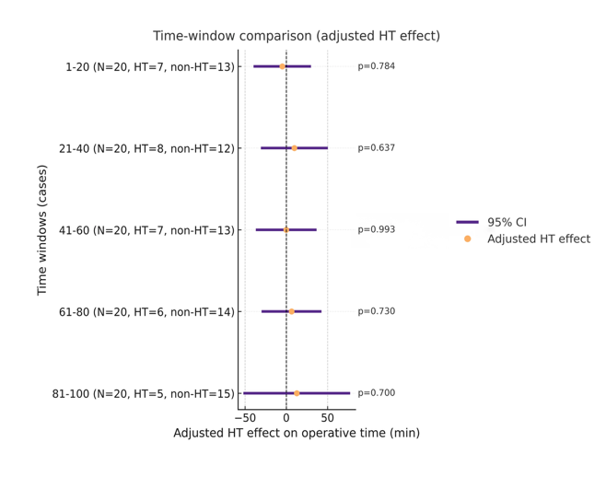
Figure S4. Window-specific adjusted effect of HT on operative time. The full case sequence was divided into five equal-width chronological windows. Within each window, the adjusted effect of Hashimoto’s thyroiditis (HT) on operative time was estimated using a multivariable linear regression model controlling for tumor size, tumor location, capsular invasion, any vascular/lymphatic/neural invasion, and total number of dissected lymph nodes. Points represent the estimated regression coefficients for HT, and horizontal lines represent 95% confidence intervals. The vertical dashed line indicates the null effect.

