APPENDICES
Appendix A. Data inventory and cleaning
Table A.1 Data inventory, detail and cleaning steps
Data | Purpose | Time span (update cycle) | Detailed items | Spatial scale / coverage | Cleaning steps and rationale | Source
Land cover (Sub-divided Level-3) | Derive PLC configuration metrics (Step 1) | 2019–2024, annual | Level-3 detailed classes reclassified to grey / green / blue | 10 m, EPSG:5186; 7 metros, each buffered 1 km | Reclassify Level-3 to the three-class GGB scheme (Level-3-to-GGB reclassification available from the corresponding author); extract land cover to the district boundary buffered outward 1 km so edge windows are computed from complete surroundings (buffer exceeds the 850 m window radius) | ME / EGIS
Community health survey (KCHS) | District-level health outcomes (Step 2) | 2019–2024, annual (~900 respondents / district / year) | Measured height and weight; physician-diagnosed hypertension and diabetes; walking and moderate-activity days; PHQ-9 depression; life satisfaction (1–10); age; sex | District-representative; 7 metros (~59,000 respondents / year; Seoul ~22,900) | BMI computed from measured height and weight after excluding physiologically implausible values; height/weight variables matched wave by wave (2019 measured items; 2020 precomputed BMI; 2021 onward standard items); life satisfaction absent in 2020 and 2023 (available for four years); KCHS income item not used (high non-response) | KDCA
Population grid (100 m) | Population weights for district aggregation; robustness (Step 2, Step 4) | Annual counts; age-sex-structured grid for 2022 | Resident counts per 100 m cell; age and sex structure (2022) | 100 m cells, national | Only populated cells (≥1 resident) used as weights; unpopulated cells (open water, forest, uninhabited ground) excluded from district values | KOSTAT / SGIS
District income | Socioeconomic covariate (Step 3) | 2019–2023; 2024 carried forward | Average per-filer wage and salary income (total taxable wage income ÷ number of filers) | District of residence | 2024 value not released at analysis time, so the 2023 value was carried forward | NTS year-end tax settlement / KOSIS (table DT_133001N)
Administrative boundaries | Define units; district area and per-district cover-type area (Steps 2–3) | 2019–2024 | District polygons; per-district area of each cover type (ha) | District | Exclude island-dominated districts, where open sea saturates blue aggregation and contiguity (Busan Yeongdo, Gangseo, Saha; Incheon Jung, Dong, Seo, Ganghwa, Ongjin; Ulsan Ulju), and Gunwi-gun (rural, annexed to Daegu in 2023); result is 65 districts | Statistics Korea

Table A.2 Descriptive statistics of PLC configuration metrics (district-year)
Perceivable Landscape Connectivity |  |  |  | Seoul (N=150) |  | 7 metros (N=390) |  | Pooled range
Metric | Cover | Window | Unit | Mean | SD | Mean | SD | Min | Max
AI | Grey | 450 | % | 95.791 | 1.622 | 95.175 | 2.938 | 82.791 | 99.862
AI | Grey | 850 | % | 94.225 | 1.745 | 93.475 | 3.372 | 79.882 | 99.762
AI | Green | 450 | % | 59.082 | 7.471 | 62.218 | 8.704 | 37.363 | 92.255
AI | Green | 850 | % | 66.398 | 8.761 | 70.666 | 9.689 | 43.716 | 93.958
AI | Blue | 450 | % | 61.934 | 19.827 | 63.265 | 18.198 | 19.908 | 99.971
AI | Blue | 850 | % | 60.176 | 18.214 | 62.492 | 16.948 | 20.505 | 99.698
Contiguity | Grey | 450 | 0-1 | 0.757 | 0.053 | 0.729 | 0.074 | 0.482 | 0.898
Contiguity | Grey | 850 | 0-1 | 0.503 | 0.081 | 0.480 | 0.116 | 0.260 | 0.845
Contiguity | Green | 450 | 0-1 | 0.217 | 0.039 | 0.224 | 0.046 | 0.121 | 0.568
Contiguity | Green | 850 | 0-1 | 0.176 | 0.022 | 0.186 | 0.053 | 0.122 | 0.828
Contiguity | Blue | 450 | 0-1 | 0.386 | 0.179 | 0.392 | 0.190 | 0.043 | 0.981
Contiguity | Blue | 850 | 0-1 | 0.350 | 0.161 | 0.359 | 0.169 | 0.061 | 0.981
Contact | Grey–Green | 450 | m | 14,481 | 3,490 | 13,635 | 4,217 | 0.001 | 21,857
Contact | Grey–Green | 850 | m | 49,944 | 11,295 | 45,348 | 13,470 | 23.211 | 72,822
Contact | Grey–Blue | 450 | m | 312 | 171 | 336 | 198 | 0.000 | 1,013
Contact | Grey–Blue | 850 | m | 1,279 | 599 | 1,342 | 699 | 0.000 | 3,853

Table A.3 Descriptive statistics of health outcomes (district-year)
Health Status |  | Seoul (N=150) |  | 7 metros (N=390) |  | Pooled range
Variable | Unit | Mean | SD | Mean | SD | Min | Max
Obesity | proportion | 0.291 | 0.030 | 0.297 | 0.032 | 0.206 | 0.401
Hypertension | proportion | 0.250 | 0.038 | 0.248 | 0.041 | 0.152 | 0.367
Diabetes | proportion | 0.107 | 0.022 | 0.111 | 0.023 | 0.054 | 0.178
Walking (light) | days/wk | 5.036 | 0.369 | 4.650 | 0.569 | 2.435 | 6.021
Moderate activity | days/wk | 1.167 | 0.285 | 1.179 | 0.303 | 0.299 | 2.911
Depression (PHQ-9) | PHQ-9 sum | 2.382 | 0.498 | 2.356 | 0.513 | 0.645 | 3.607
Life satisfaction | 1-10 | 7.024 | 0.212 | 6.979 | 0.210 | 6.297 | 7.461

Table A.4 Health outcome definitions and Korea Community Health Survey (KCHS) items

Outcome | KCHS variable | Survey item / measurement | Coding and unit
Obesity | oba_02z1, oba_03z1 (height, weight); 2019 mea_14z1, mea_10z1; 2020 oba_bmi | Measured height and weight | BMI = weight / height²; obese if BMI ≥ 25 kg/m²; district prevalence (proportion)
Hypertension | hya_04z1 | “Have you ever been diagnosed with high blood pressure (hypertension) by a doctor?” (Yes / No) | Diagnosed = Yes; district prevalence (proportion)
Diabetes | dia_04z1 | “Have you ever been diagnosed with diabetes by a doctor?” (Yes / No) | Diagnosed = Yes; district prevalence (proportion)
Walking (light) | phb_01z1 | “In the past week, on how many days did you walk for at least 10 minutes at a time?” | Number of days per week (0–7)
Moderate activity | pha_07z1 | “In the past week, on how many days did you do moderate-intensity physical activity for at least 10 minutes that made you feel slightly tired or short of breath, excluding walking (e.g., slow swimming, doubles tennis, volleyball, badminton, table tennis, carrying light loads)?” | Number of days per week (0–7)
Depression (PHQ-9) | mtb_07a1 – mtb_07i1 (9 items) | PHQ-9: “Over the last 2 weeks, how often have you been bothered by the following problems?” (9 items; see note) | Sum of 9 items, each scored 0–3; total 0–27
Life satisfaction | qoc_07z1 | “All things considered, how satisfied are you with your life these days?” | 1 (very dissatisfied) – 10 (very satisfied)
Notes. Variable names are Korea Community Health Survey (KCHS) raw-data codes used in this study; some codes vary by wave (obesity uses measured height and weight, provided precomputed for 2020). Prevalences are district means of the individual indicator. PHQ-9 items, each asked “over the last 2 weeks”: (1) little interest or pleasure in doing things; (2) feeling down, depressed, or hopeless; (3) trouble falling or staying asleep, or sleeping too much; (4) feeling tired or having little energy; (5) poor appetite or overeating; (6) feeling bad about yourself, or that you are a failure or have let yourself or your family down; (7) trouble concentrating on things such as reading the newspaper or watching television; (8) moving or speaking so slowly that others could have noticed, or being so fidgety or restless that you move around much more than usual; (9) thoughts that you would be better off dead or of hurting yourself. Life satisfaction is available for four years (2019, 2021, 2022, 2024).

Appendix B. Supplementary figures
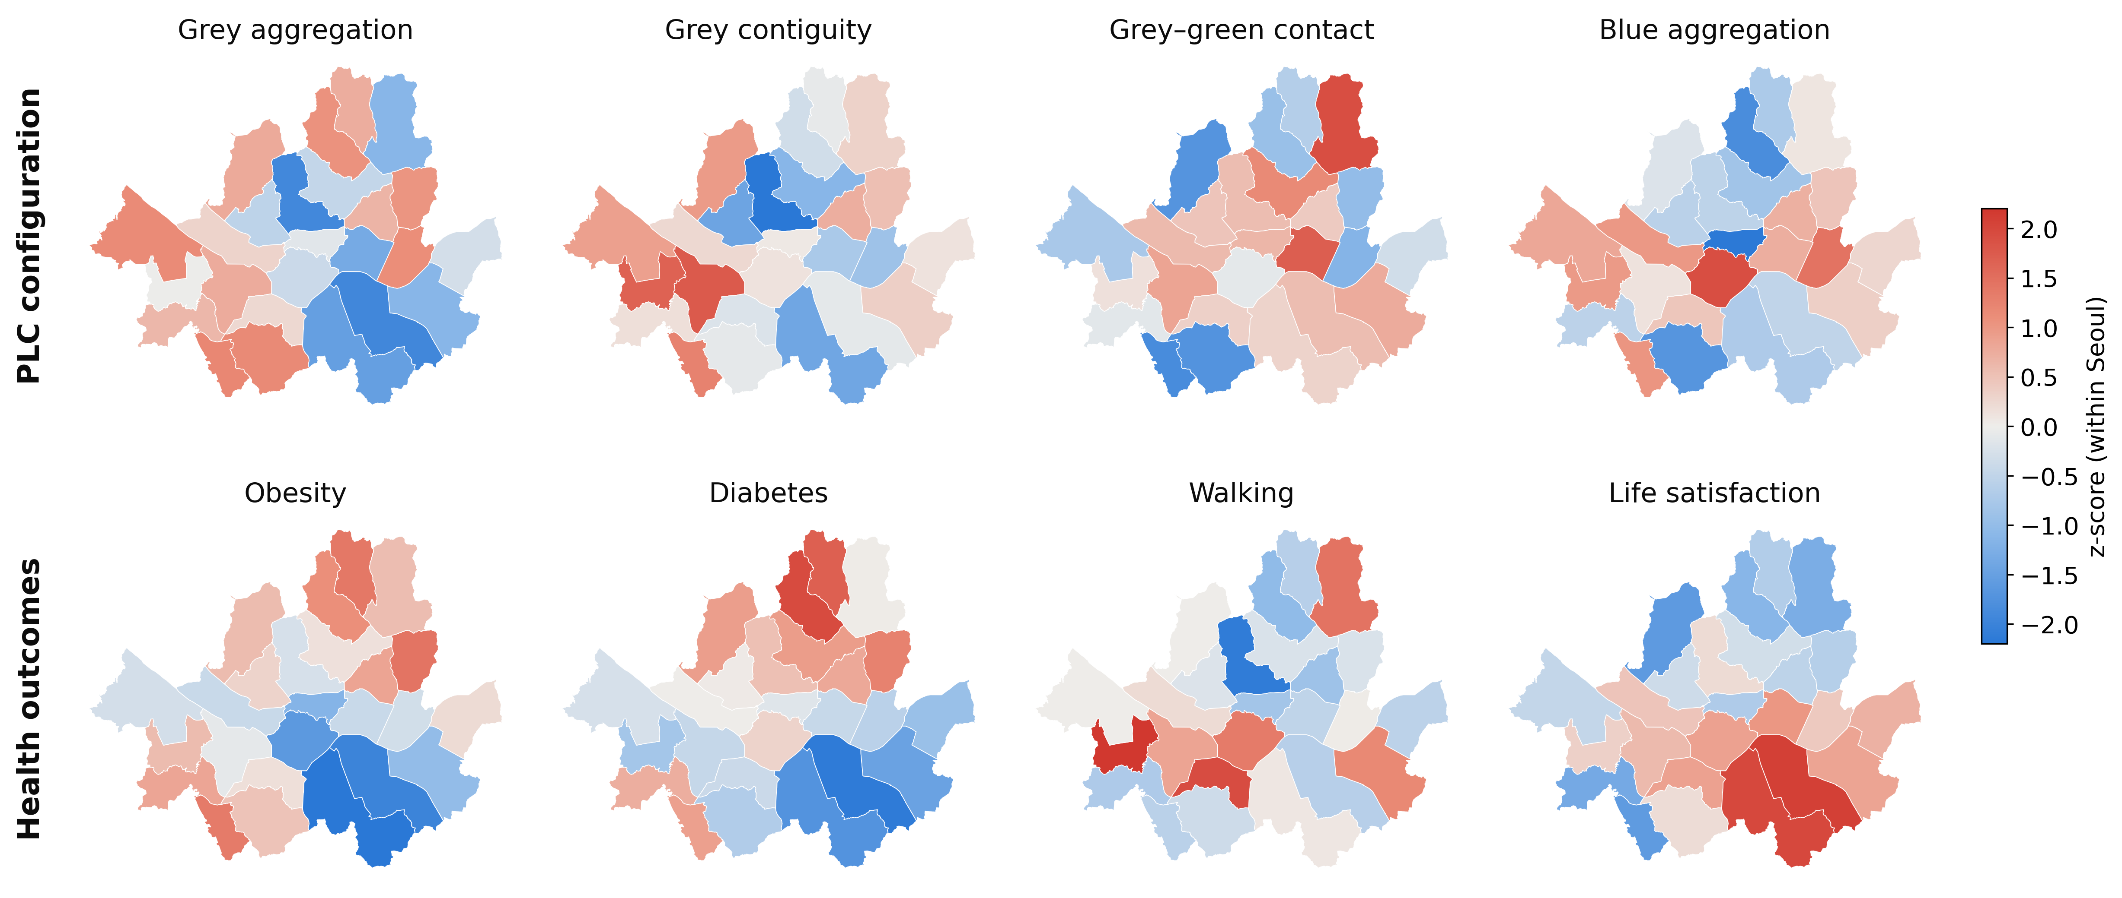
Figure 1 Spatial distribution of selected PLC metrics and health outcomes across Seoul's districts (2019-2024 mean)

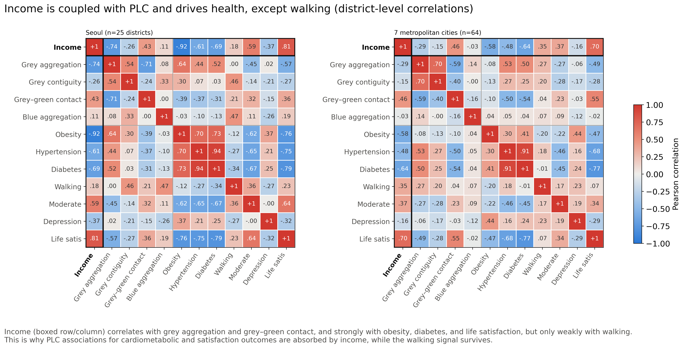
Fig. A2 Environment-income coupling. Correlations among grey-green contact, district income, and the health outcomes, showing that contact and income move together (r near +0.45) and income carries the stronger link to health

