Figure S1 Curculigo orchioides Gaert

Figure S2 Curculigo glabrescens (Ridl.) Merr.
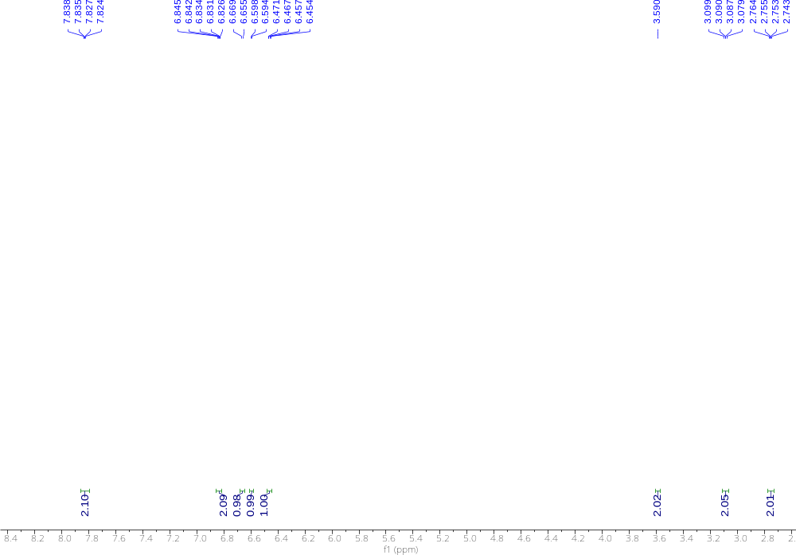
Figure S3 ¹H NMR of glabrescenin

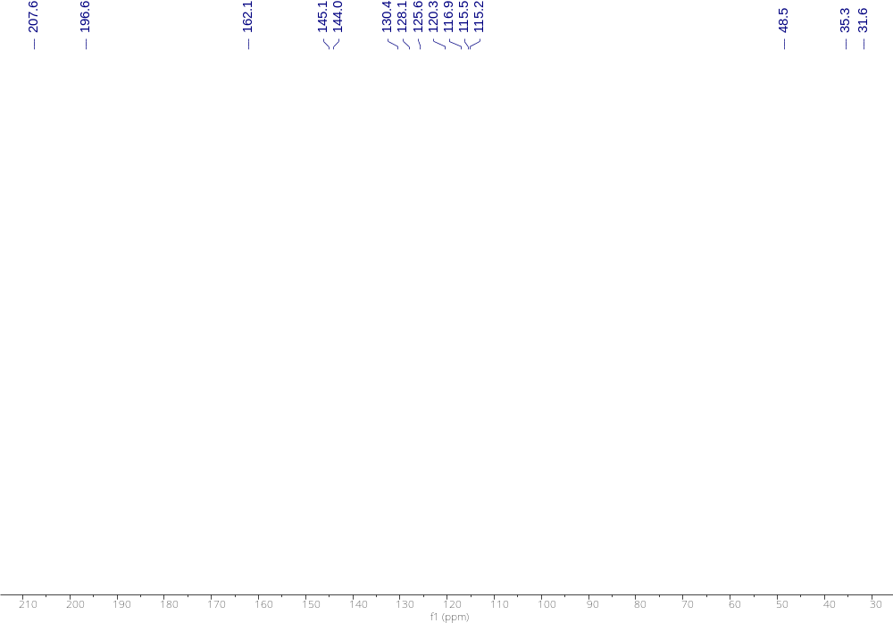
Figure S4 ¹³C NMR of glabrescenin

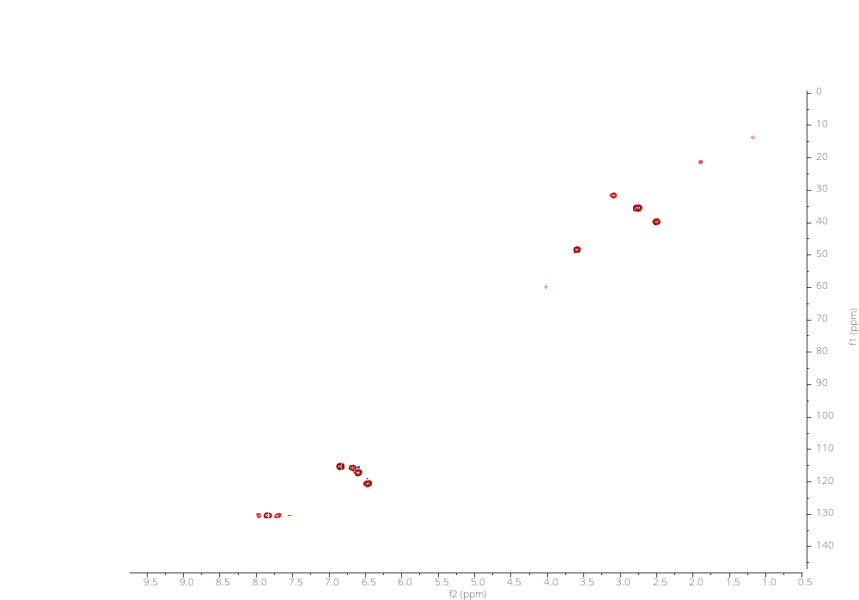
Figure S5 HSQC of glabrescenin
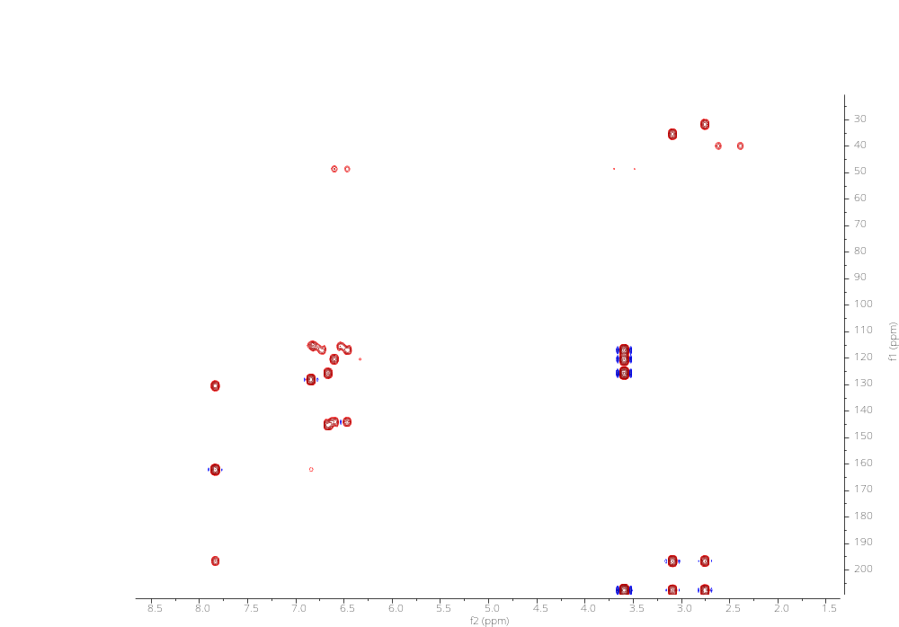
Figure S6 HMBC of glabrescenin

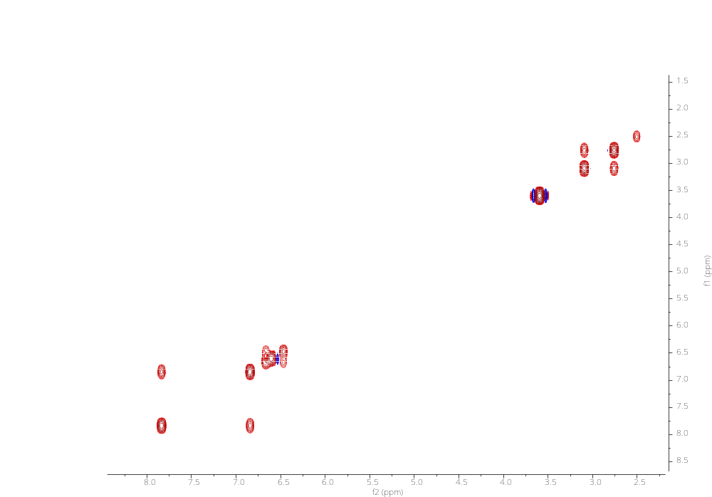
Figure S7 ¹H-¹H COSY of glabrescenin

