Supporting information
Promotive selectivity to C2-C3 polyols from alkaline cellulose hydrogenated by Ionic liquid-stablized Ru nanoparticles
Mingrui Liu*, Hua Wang
Dalian Research Institute of Petroleum and Petrochemicals, SINOPEC, Dalian, 116045, China
*Corresponding author, E-mail: mail:liumingrui.fshy@sinopec.com

Figure S1 TEM photographs (left) and the corresponding particle size histograms (right) of Ru nanoparticles.
a) Ru/[Bmim]BF₄; b) Ru/[Bmim]PF₆; c) Ru/[Bmim]Cl; d) Ru/[HO-emim]Cl..

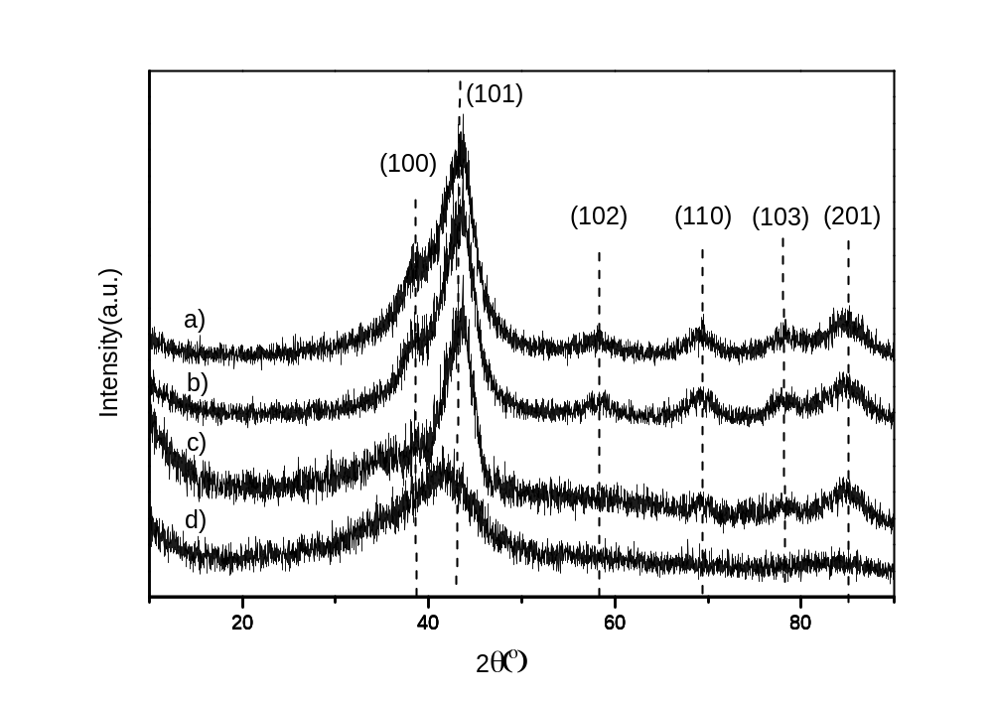
Figure S2 XRD pattern of Ru/IL nanoparticles.
a) Ru/[Bmim]BF₄; b) Ru/[Bmim]Cl; c) Ru/[HO-emim]Cl; d) Ru/[Bmim]PF₆.

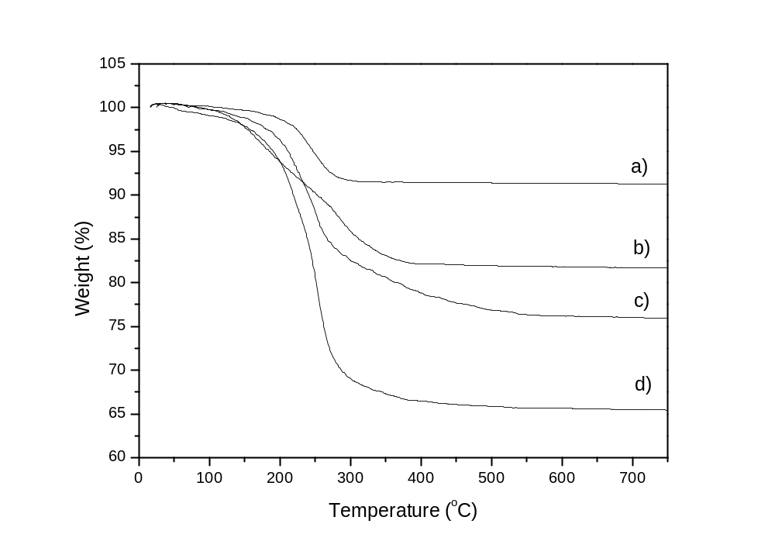
Figure S3 Thermogravimetric analysis of Ru nanoparticles.
a) Ru/[Bmim]BF₄; b) Ru/[Bmim]PF₆; c) Ru/[Bmim]Cl; d) Ru/[HO-emim]Cl.

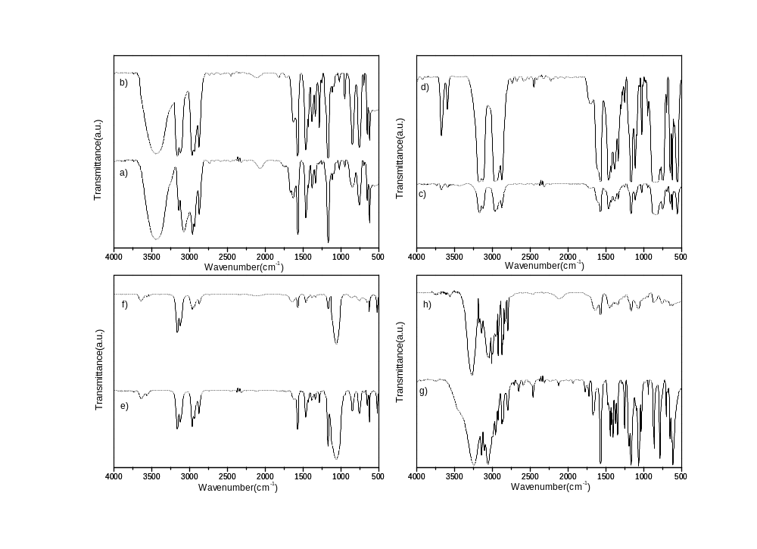
Figure S4 FTIR spectra of ionic liquids and Ru/IL nanoparticles.
a) [Bmim]BF₄; b) Ru/[Bmim]BF₄; c) [Bmim]PF₆; d) Ru/[Bmim]PF₆;
e) [Bmim]Cl; f) Ru/[Bmim]Cl; g) [HO-emim]Cl; h) Ru/[HO-emim]Cl.

