Additional file 1
Supplementary table and figures
Circulating CD4+ T-Cell Differentiation Subsets Are Redistributed in HTLV-1–Associated Adult T-Cell Leukemia/Lymphoma
Contents: Table S1 and Supplementary Figures S1–S3.

Supplementary Table S1
Table S1. Demographic, clinical, laboratory, and immunophenotypic characteristics of the study population
Characteristic | Healthy controls (n = 16) | Presumed sexual transmission (n = 29) | Presumed vertical/breastfeeding transmission (n = 51) | ATLL (n = 21) | Global p value
Demographic characteristics
Age, years | 42.5 (36.5–59.5); n=16 | 50.0 (46.0–56.0); n=29 | 57.0 (44.0–66.5); n=51 | 57.0 (43.0–68.0); n=21 | 0.063
Sex, n (%) |  |  |  |  | 0.232
Female | 11 (68.8) | 26 (89.7) | 42 (82.4) | 15 (71.4)
Male | 5 (31.2) | 3 (10.3) | 9 (17.6) | 6 (28.6)
Hematologic characteristics
White blood cell count, ×10³/µL | 78.41 (24.39–145.06); n=15 | 6.20 (5.61–7.53); n=29 | 7.15 (6.02–7.98); n=51 | 8.83 (7.91–16.43); n=21 | <0.001
Red blood cell count, ×10⁶/µL | 6.93 (5.61–7.94); n=15 | 5.35 (4.77–5.87); n=29 | 5.43 (4.83–5.88); n=51 | 4.64 (3.66–5.47); n=21 | <0.001
Hemoglobin, g/dL | 20.7 (16.9–22.5); n=15 | 15.4 (14.3–16.9); n=29 | 15.8 (14.3–17.2); n=51 | 13.4 (11.3–15.2); n=21 | <0.001
Hematocrit, % | 58.2 (49.9–66.3); n=15 | 43.2 (40.8–48.4); n=29 | 45.3 (42.0–48.5); n=51 | 39.6 (32.6–44.8); n=21 | <0.001
Mean corpuscular volume, fL | 85.5 (84.3–87.8); n=15 | 85.2 (82.6–87.0); n=29 | 84.8 (81.6–87.6); n=51 | 86.6 (82.1–89.0); n=21 | 0.587
Mean corpuscular hemoglobin, pg | 30.0 (29.0–30.4); n=15 | 29.5 (28.5–30.3); n=29 | 29.6 (28.6–30.4); n=51 | 28.9 (27.4–30.1); n=21 | 0.492
Mean corpuscular hemoglobin concentration, g/dL | 34.3 (34.2–35.0); n=15 | 34.6 (34.3–35.0); n=29 | 34.9 (34.3–35.5); n=51 | 33.8 (33.1–34.8); n=21 | 0.045
Platelet count, ×10³/µL | 402.0 (273.0–860.0); n=15 | 245.0 (201.0–283.0); n=29 | 252.0 (203.5–298.5); n=51 | 220.0 (171.0–272.0); n=21 | 0.002
Red cell distribution width–SD, fL | 43.7 (42.3–45.6); n=15 | 40.2 (39.3–42.3); n=29 | 40.5 (38.2–42.1); n=51 | 40.8 (38.6–48.8); n=20 | 0.011
Red cell distribution width–CV, % | 14.6 (13.2–16.9); n=15 | 12.8 (12.4–13.2); n=29 | 13.0 (12.6–13.5); n=50 | 13.4 (12.2–16.4); n=21 | 0.009
Mean platelet volume, fL | 11.0 (10.4–11.3); n=15 | 11.0 (10.5–11.4); n=29 | 10.8 (10.2–11.4); n=51 | 10.3 (9.7–10.9); n=21 | 0.046
Absolute neutrophil count, ×10³/µL | 4.63 (3.18–4.87); n=15 | 3.71 (3.04–4.53); n=28 | 3.78 (2.94–4.96); n=51 | 4.78 (2.77–6.80); n=21 | 0.734
Absolute lymphocyte count, ×10³/µL | 55.96 (17.35–109.27); n=15 | 2.12 (1.59–2.69); n=29 | 2.16 (1.75–2.87); n=51 | 3.07 (1.23–6.86); n=21 | <0.001
Absolute monocyte count, ×10³/µL | 13.28 (3.92–28.05); n=15 | 0.46 (0.38–0.59); n=27 | 0.47 (0.37–0.60); n=51 | 0.72 (0.47–1.20); n=21 | <0.001
Absolute eosinophil count, ×10³/µL | 0.14 (0.11–0.23); n=15 | 0.12 (0.07–0.20); n=29 | 0.11 (0.08–0.22); n=51 | 0.10 (0.03–0.23); n=21 | 0.517
Absolute basophil count, ×10³/µL | 0.49 (0.07–0.80); n=15 | 0.03 (0.02–0.05); n=29 | 0.03 (0.02–0.05); n=51 | 0.04 (0.01–0.07); n=21 | 0.002
Immature granulocyte count, ×10³/µL | 0.07 (0.01–0.13); n=15 | 0.01 (0.01–0.02); n=29 | 0.01 (0.01–0.02); n=50 | 0.02 (0.01–0.03); n=8 | 0.003
Biochemical characteristics
Lactate dehydrogenase, U/L | — | 196.5 (182.8–229.0); n=28 | 207.0 (183.2–222.2); n=48 | 350.0 (208.0–613.0); n=21 | 0.006
Total calcium, mg/dL | — | 9.4 (9.2–9.6); n=28 | 9.3 (9.2–9.7); n=49 | 9.5 (9.1–10.0); n=20 | 0.538
Albumin, g/dL | — | 4.5 (4.3–4.6); n=27 | 4.5 (4.3–4.7); n=48 | 4.2 (3.2–4.5); n=20 | 0.010
Uric acid, mg/dL | — | 4.8 (3.9–5.2); n=28 | 4.9 (4.2–5.8); n=48 | 5.5 (4.3–6.1); n=21 | 0.293
β2-microglobulin, mg/L | — | 1.82 (1.62–2.10); n=28 | 1.85 (1.63–2.18); n=49 | 2.24 (1.73–3.42); n=19 | 0.049
Alkaline phosphatase, U/L | — | 86.0 (68.2–107.2); n=28 | 80.0 (62.0–98.0); n=45 | 87.0 (76.0–146.0); n=21 | 0.247
Urea, mg/dL | — | 27.0 (22.9–33.7); n=28 | 28.0 (24.0–33.5); n=49 | 31.0 (26.0–37.3); n=21 | 0.233
Immunophenotypic characteristics
Total CD4+ T cells, % of viable CD3+ T cells | 38.0 (31.7–44.1); n=16 | 39.9 (32.7–45.7); n=29 | 36.5 (29.0–42.8); n=51 | 45.5 (36.5–74.2); n=21 | 0.098
TSCM, % of viable CD3+CD4+ T cells | 0.9 (0.7–1.2); n=16 | 1.1 (0.5–2.6); n=29 | 1.6 (0.4–3.5); n=51 | 0.6 (0.3–1.1); n=21 | 0.164
Naïve cells, % of viable CD3+CD4+ T cells | 24.4 (16.8–33.4); n=16 | 26.3 (13.6–34.8); n=29 | 31.6 (17.1–39.7); n=51 | 2.9 (0.4–24.7); n=21 | <0.001
TCM, % of viable CD3+CD4+ T cells | 31.9 (22.5–41.7); n=16 | 22.4 (17.2–34.2); n=29 | 25.6 (15.4–34.1); n=51 | 12.3 (8.8–27.6); n=21 | 0.010
TEM, % of viable CD3+CD4+ T cells | 17.8 (11.4–27.8); n=16 | 17.1 (14.0–23.5); n=29 | 14.8 (12.1–23.2); n=51 | 49.8 (37.7–61.5); n=21 | <0.001
TTE, % of viable CD3+CD4+ T cells | 0.4 (0.2–1.2); n=16 | 0.9 (0.2–1.3); n=29 | 0.4 (0.2–1.1); n=51 | 0.7 (0.2–2.5); n=21 | 0.768
ATLL-specific clinical characteristics
Acute subtype | — | — | — | 7 (33.3) | —
Lymphoma subtype | — | — | — | 4 (19.0) | —
Chronic subtype | — | — | — | 2 (9.5) | —
Smoldering subtype | — | — | — | 8 (38.1) | —
Aggressive ATLL | — | — | — | 11 (52.4) | —
Indolent ATLL | — | — | — | 10 (47.6) | —
Sample collected before treatment | — | — | — | 17 (81.0) | —
Sample collected after treatment initiation or at relapse | — | — | — | 4 (19.0) | —
Deaths recorded | — | — | — | 11 (52.4) | —
Note. Continuous variables are presented as median (interquartile range), with the available sample size indicated when applicable; categorical variables are presented as n (%). Global p values were obtained using the Kruskal–Wallis test for continuous variables and Fisher’s exact test for categorical variables. Missing values were not imputed. The em dash indicates that the variable was not applicable or unavailable for that group. Abbreviations: ATLL, adult T-cell leukemia/lymphoma; TCM, central memory T cells; TEM, effector memory T cells; TSCM, T memory stem cells; TTE, terminally differentiated effector T cells.

Supplementary Figure S1. Nonlinear dimension-reduction analyses
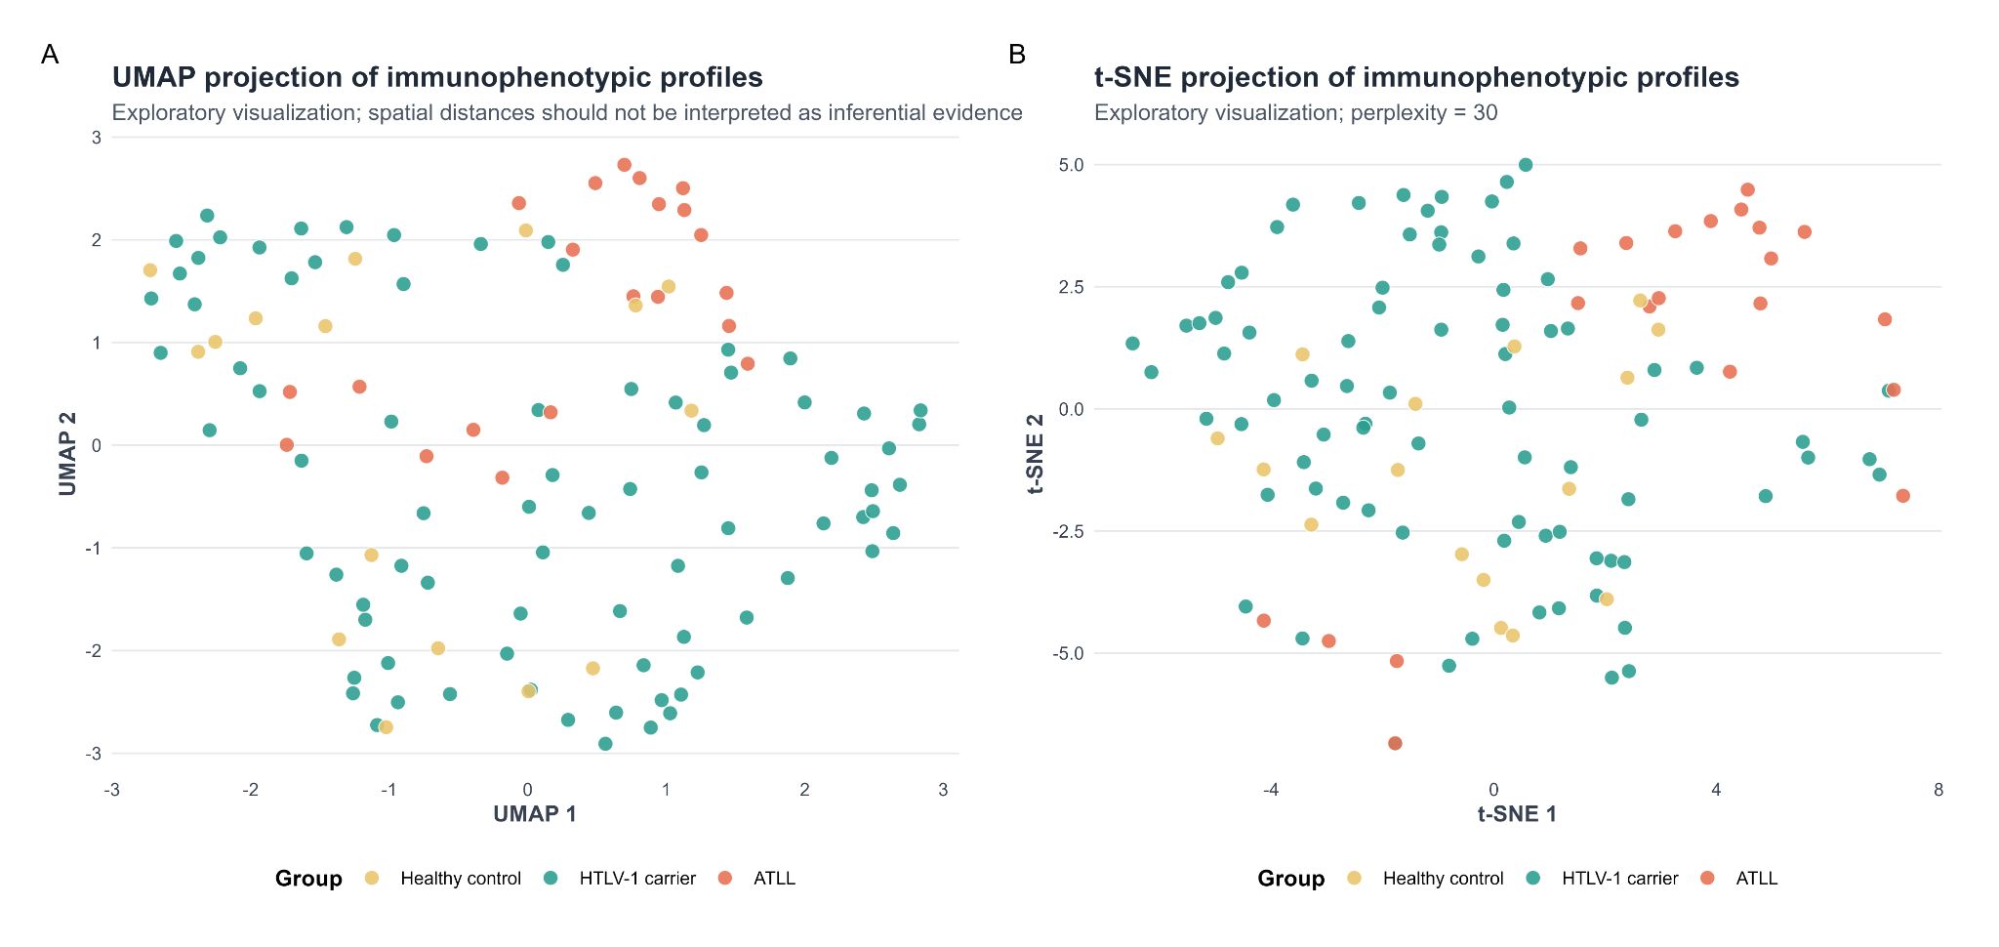
Supplementary Figure S1. Exploratory nonlinear projections of immunophenotypic profiles. (A) Uniform manifold approximation and projection (UMAP) and (B) t-distributed stochastic neighbor embedding (t-SNE) based on the six standardized immunophenotypic outcomes. Points represent individual participants and are colored by clinical group. These projections were used for exploratory visualization only; spatial distances and apparent group separation should not be interpreted as inferential evidence or validated diagnostic discrimination. ATLL, adult T-cell leukemia/lymphoma; HTLV-1, human T-cell lymphotropic virus type 1.

Supplementary Figure S2A. Hierarchical clustering
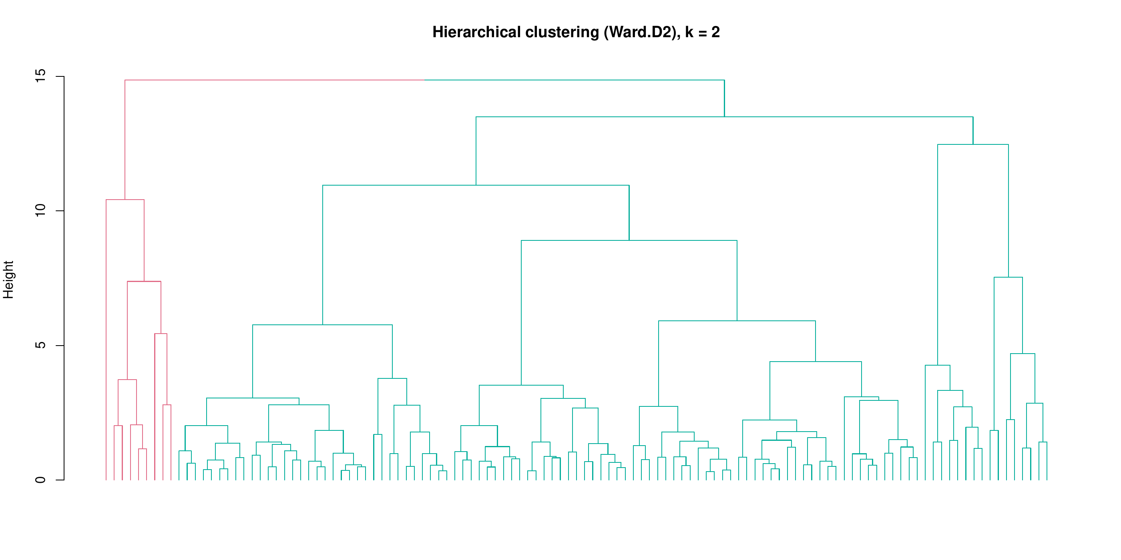
Supplementary Figure S2A. Hierarchical clustering dendrogram of standardized immunophenotypic profiles. Hierarchical clustering was performed using the Ward.D2 linkage method, and the displayed solution was cut at k = 2 clusters. Branch colors indicate cluster membership. The analysis was exploratory and was used to assess whether participants formed stable, naturally separated immunophenotypic groups.

Supplementary Figure S2B. Cluster-ordered heatmap
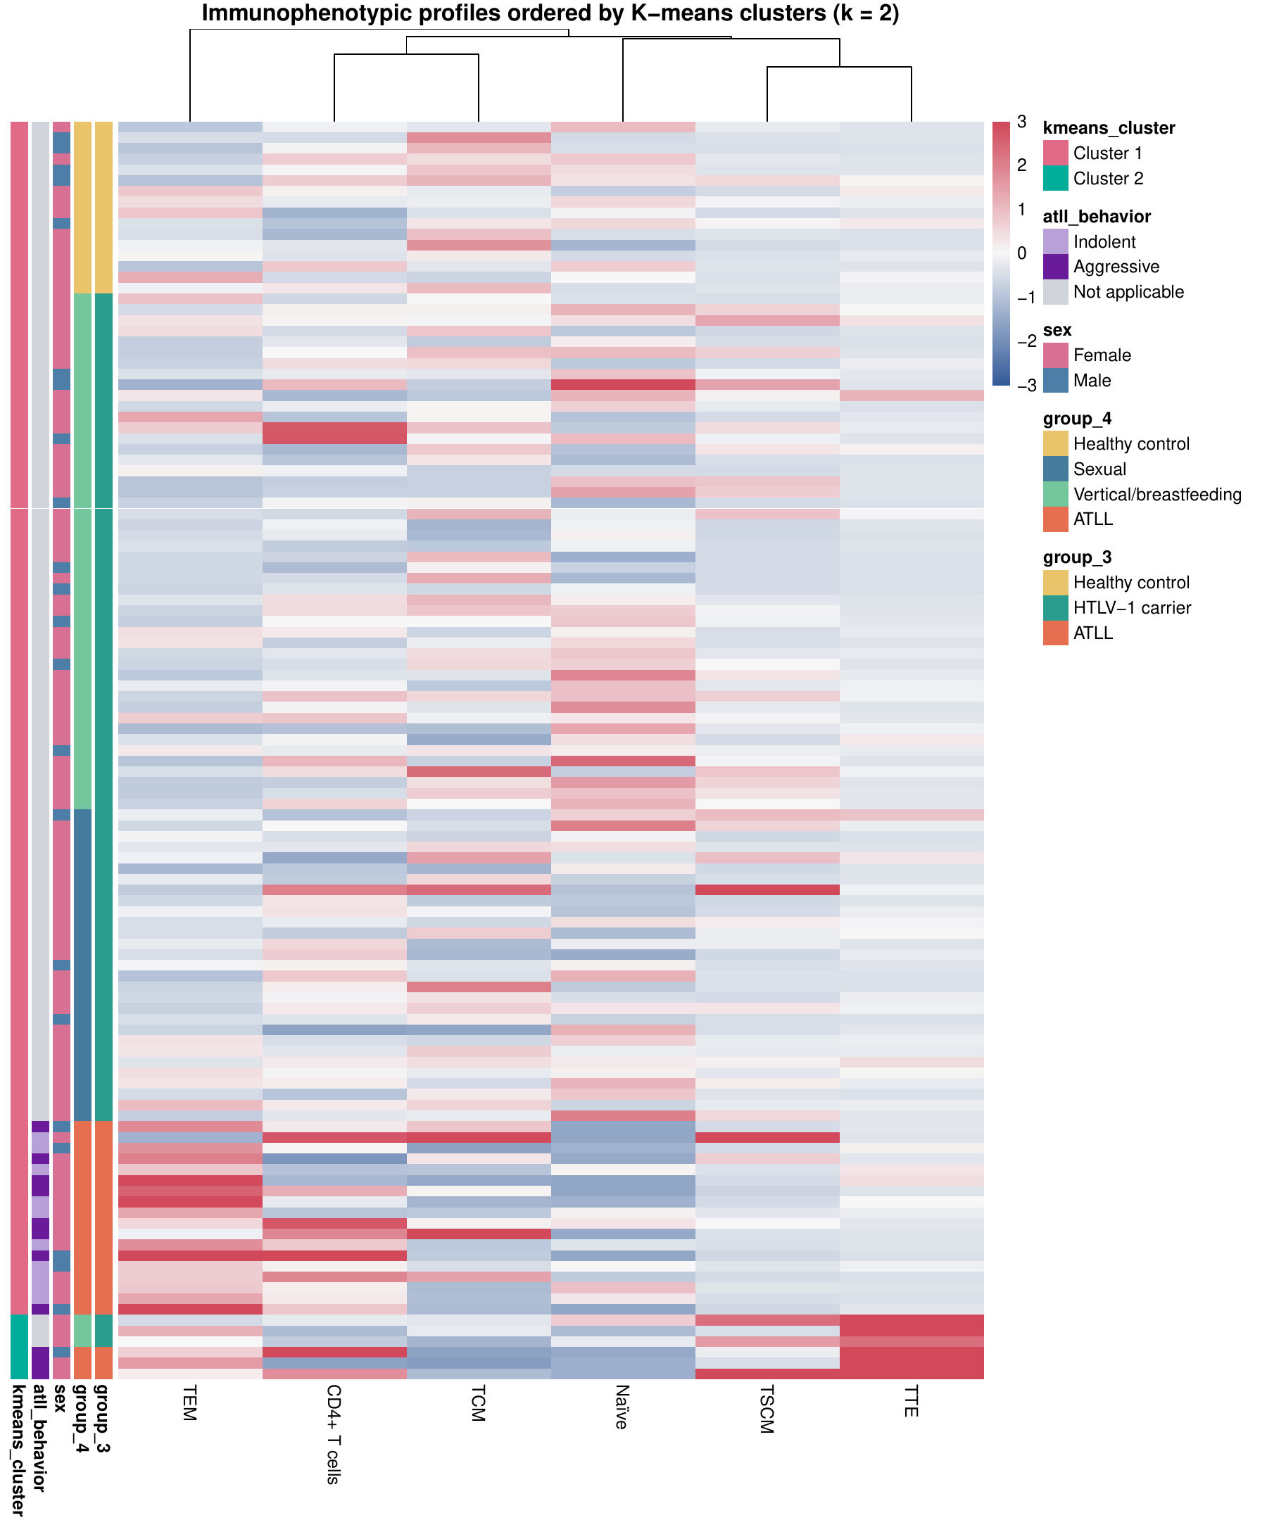
Supplementary Figure S2B. Heatmap of standardized immunophenotypic profiles ordered by K-means cluster membership (k = 2). Rows represent individual participants and columns represent the six immunophenotypic outcomes. Cell colors represent standardized values, ranging from lower (blue) to higher (red) relative values. Annotation bars indicate K-means cluster, ATLL behavior, sex, the four-group clinical classification, and the three-group clinical classification. ATLL, adult T-cell leukemia/lymphoma; TCM, central memory T cells; TEM, effector memory T cells; TSCM, T memory stem cells; TTE, terminally differentiated effector T cells.

Supplementary Figure S3A. Repeated cross-validation performance
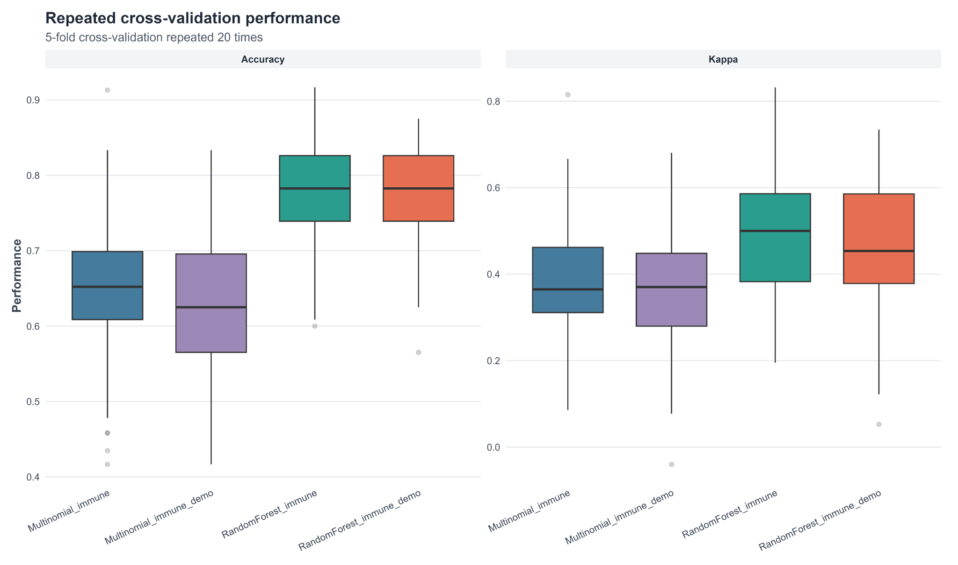
Supplementary Figure S3A. Repeated cross-validation performance of exploratory supervised classification models. Boxplots show accuracy and Cohen’s kappa across five-fold cross-validation repeated 20 times for multinomial regression and random-forest models based on immunophenotypic variables alone or immunophenotypic variables plus age and sex. The analyses were exploratory and were not externally validated.

Supplementary Figure S3B. Out-of-fold confusion matrix
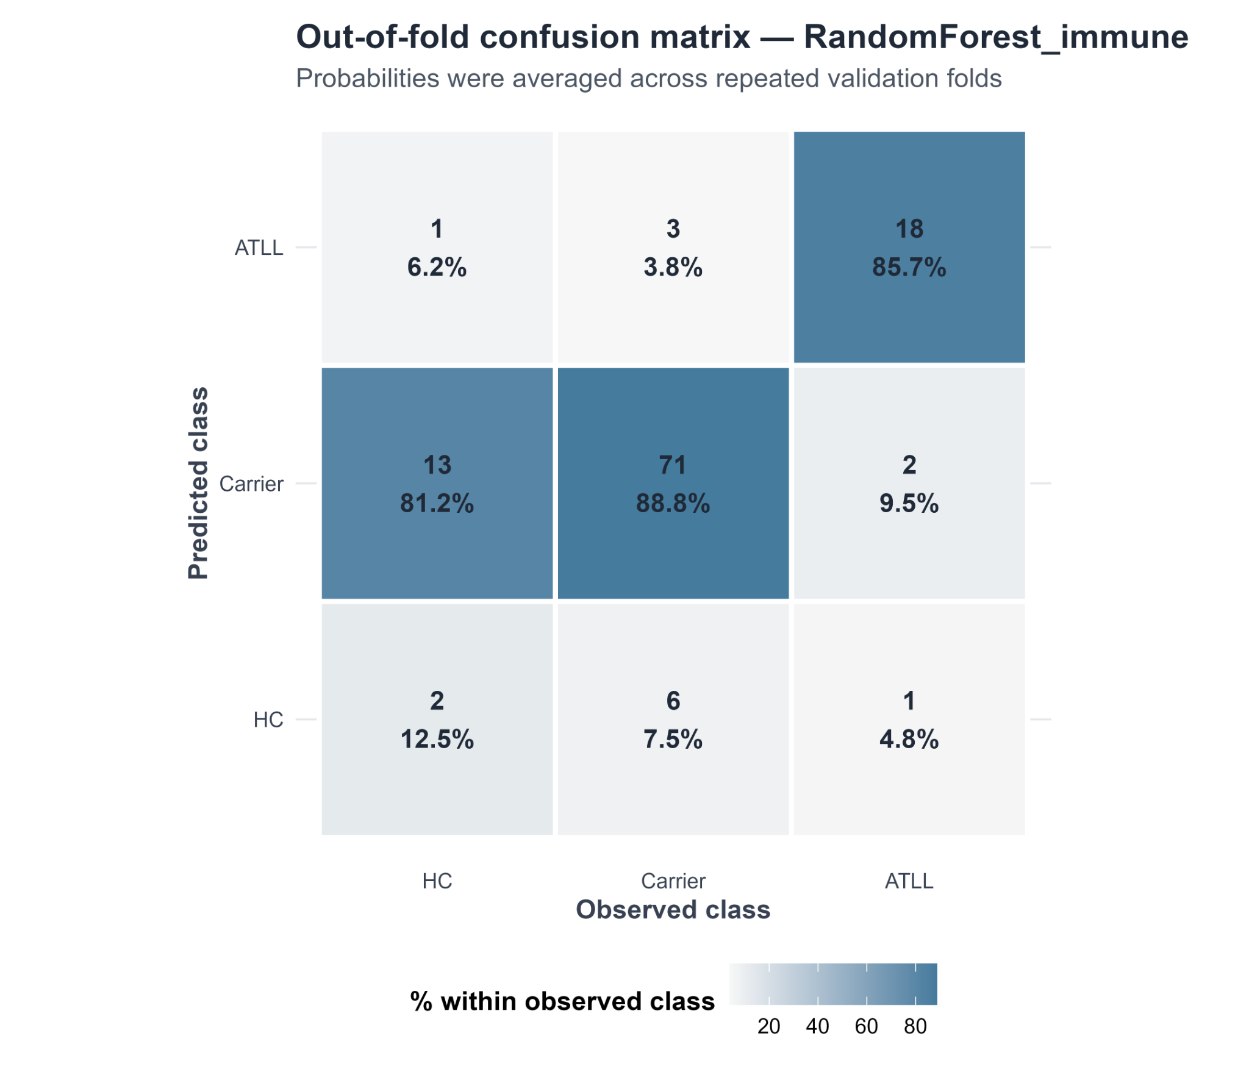
Supplementary Figure S3B. Aggregated out-of-fold confusion matrix for the immunophenotype-only random-forest model. Columns indicate observed classes and rows indicate predicted classes. Counts and percentages within each observed class are displayed. Out-of-fold probabilities were averaged across repeated validation folds. The model correctly classified 18 of 21 patients with ATLL and 71 of 80 asymptomatic carriers, but only 2 of 16 healthy controls. ATLL, adult T-cell leukemia/lymphoma; HC, healthy control.

Supplementary Figure S3C. One-versus-rest ROC curves
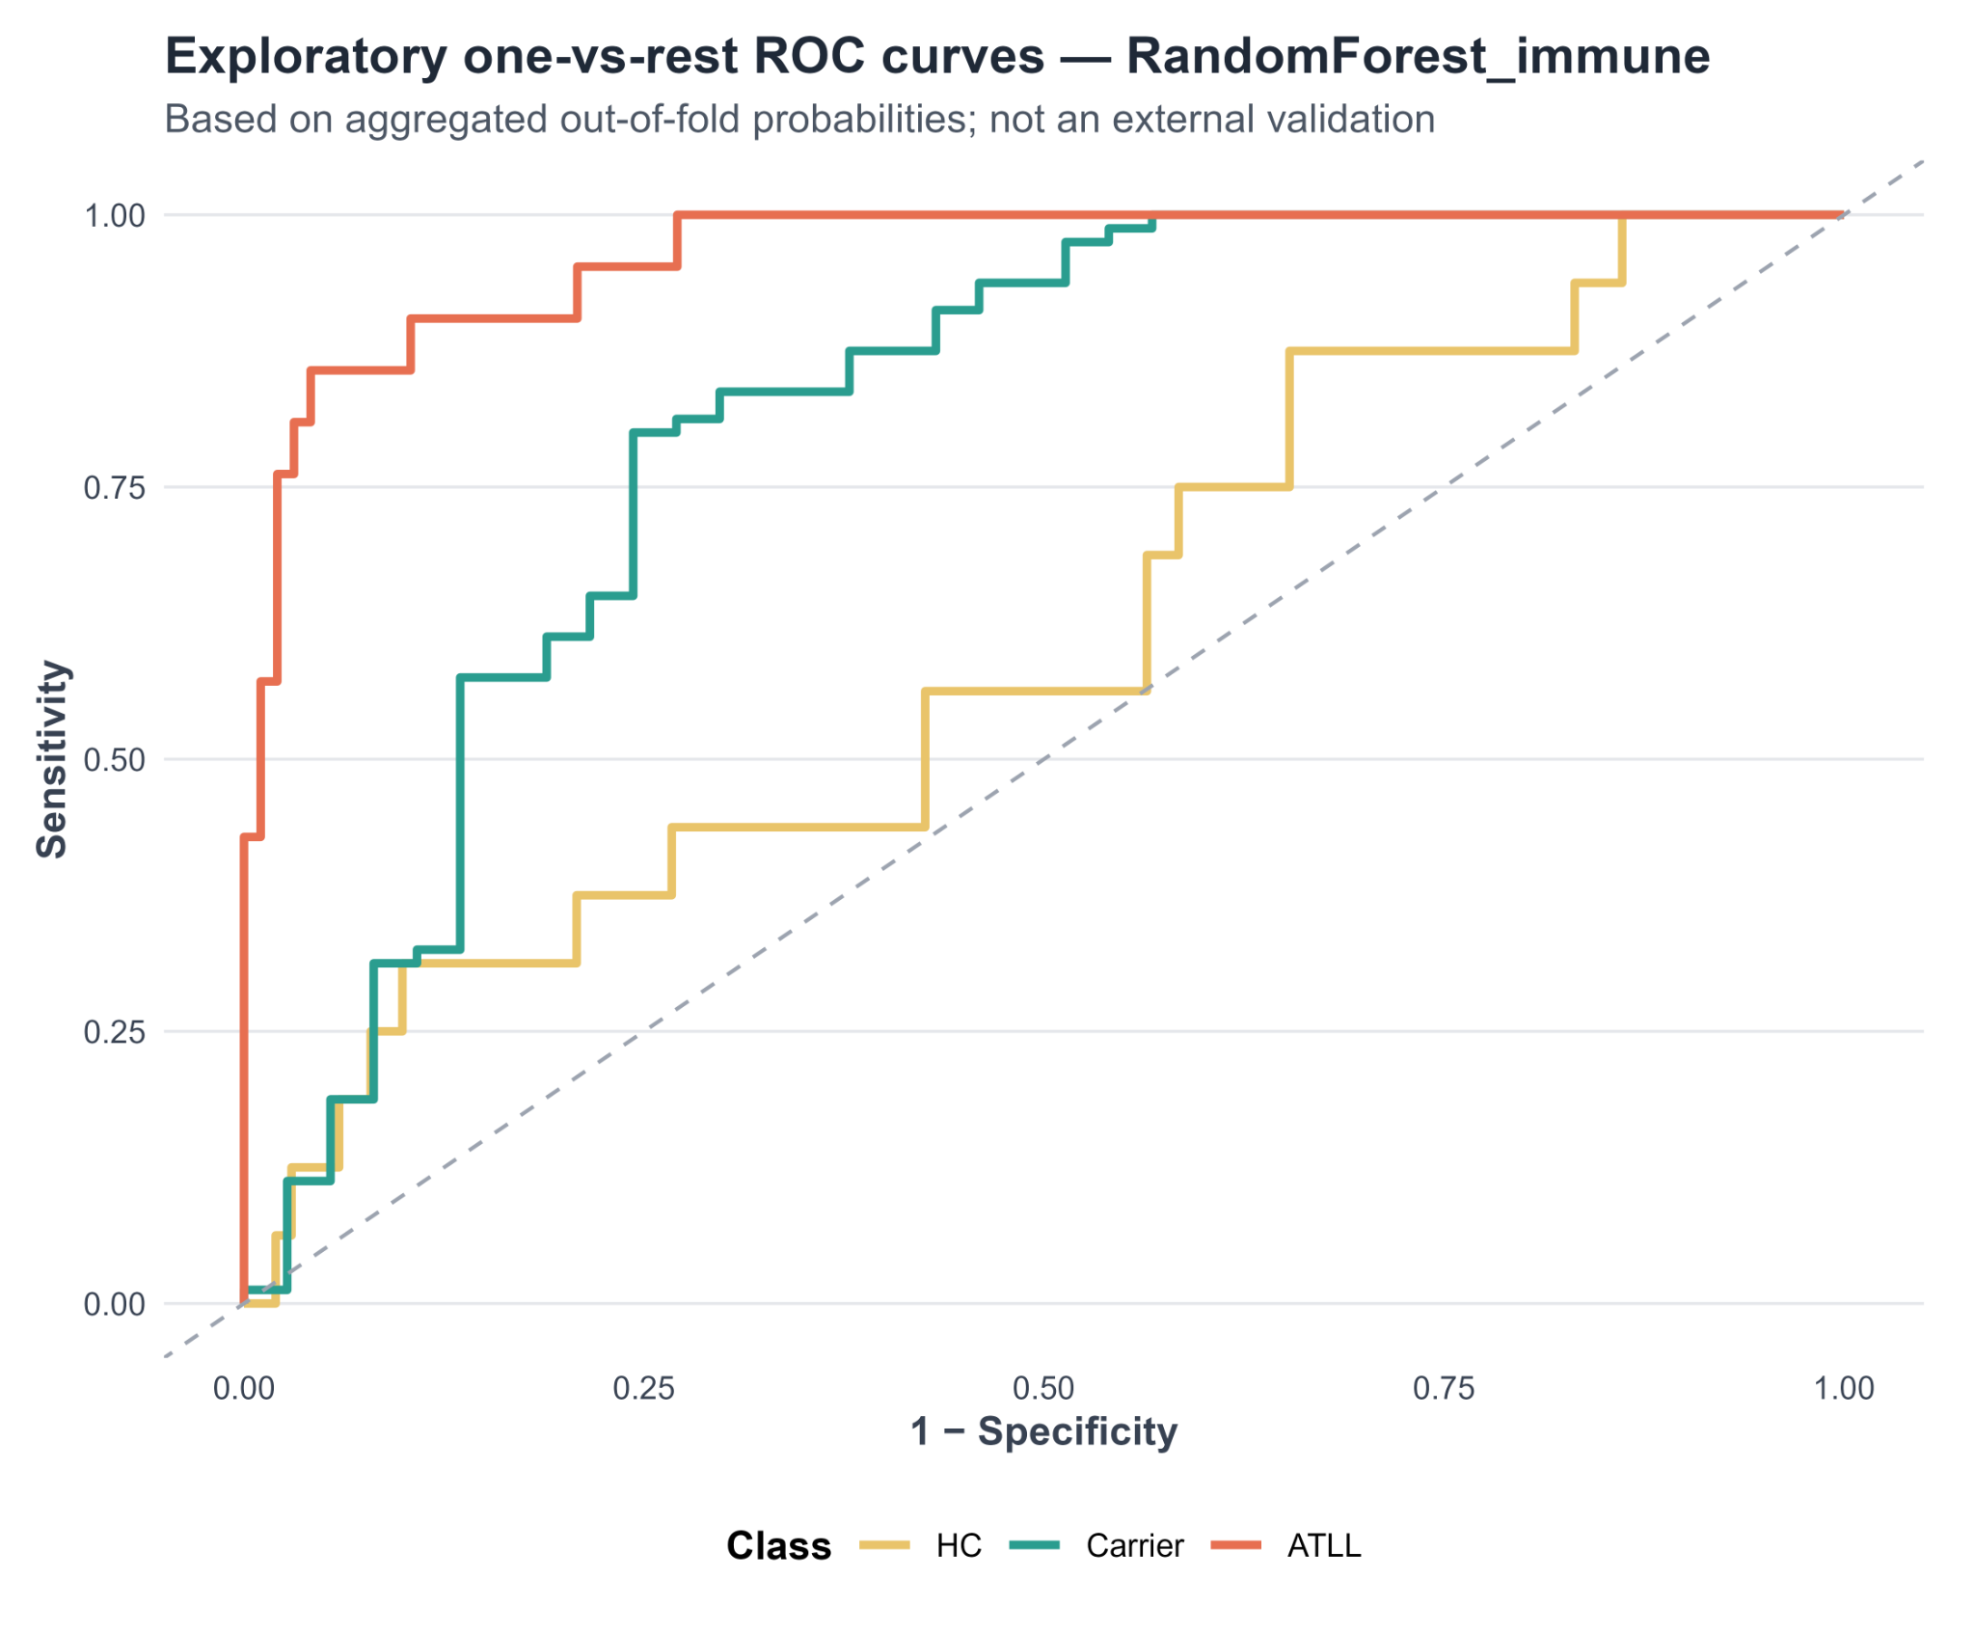
Supplementary Figure S3C. Exploratory one-versus-rest receiver operating characteristic curves for the immunophenotype-only random-forest model. Curves were constructed from aggregated out-of-fold probabilities. The analysis does not represent external validation. One-versus-rest areas under the curve were 0.963 for ATLL, 0.810 for asymptomatic HTLV-1 carriers, and 0.605 for healthy controls. ATLL, adult T-cell leukemia/lymphoma; HC, healthy control.

Supplementary Figure S3D. Random-forest variable importance
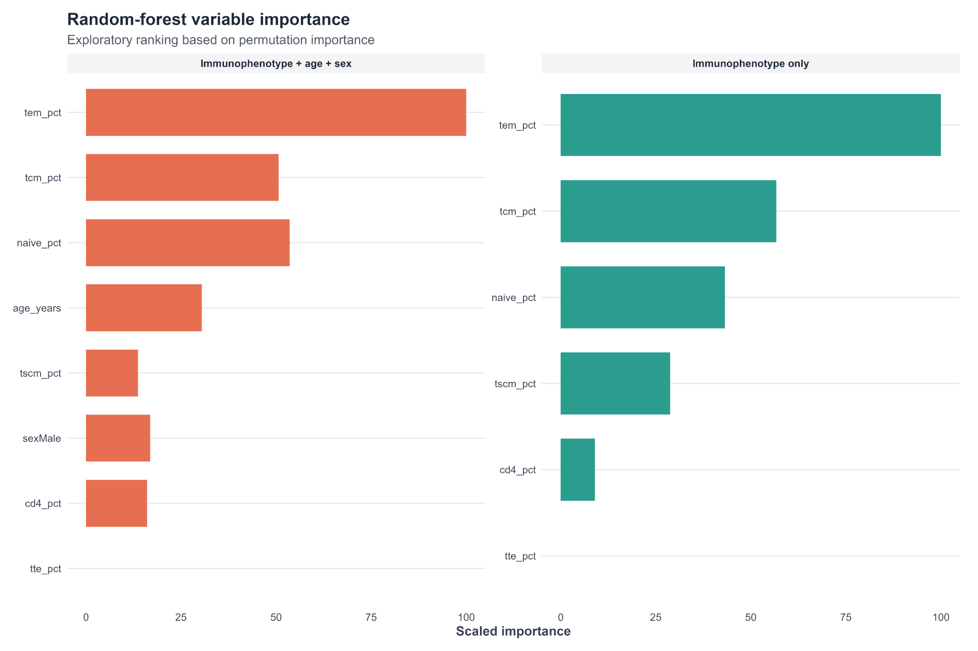
Supplementary Figure S3D. Permutation-based variable importance for the exploratory random-forest models. The left panel shows the model including immunophenotypic variables, age, and sex; the right panel shows the immunophenotype-only model. Importance values were scaled within each model. TEM frequency was the most influential variable, followed by TCM and naïve-cell frequencies. Total CD4+ T-cell frequency contributed comparatively little, and TTE frequency showed no measurable importance. TCM, central memory T cells; TEM, effector memory T cells; TSCM, T memory stem cells; TTE, terminally differentiated effector T cells.
Interpretive note. Supplementary Figures S1–S3 report prespecified exploratory analyses. They should not be interpreted as externally validated diagnostic or prognostic models.

