Supplementary File 1

Unravelling the mechanisms of cyanobacterial resilience in photosynthetic living materials

Henna Mustila, Elia Marelli, Sergey Kosourov, Yagut Allahverdiyeva
Molecular Plant Biology, Department of Life Technologies, University of Turku, Turku, Finland

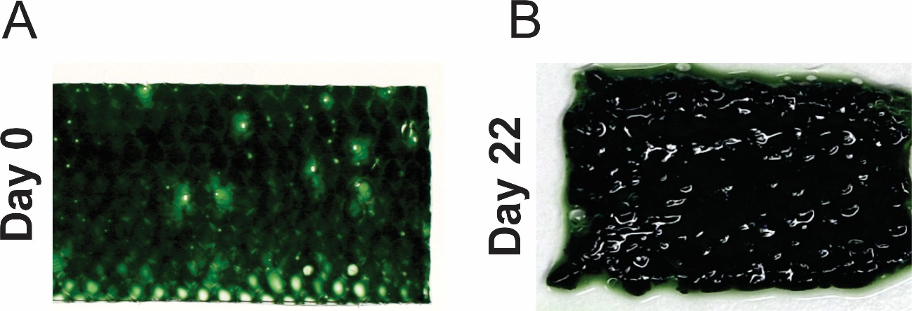
Figure S1. Photographs of the Synechocystis hydrogels on Day 0 and Day 22.

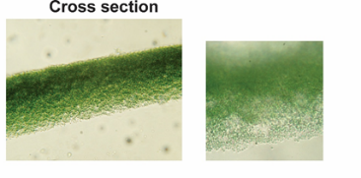
Figure S2. Brightfield microscope images of the cross section of freshly prepared hydrogel.
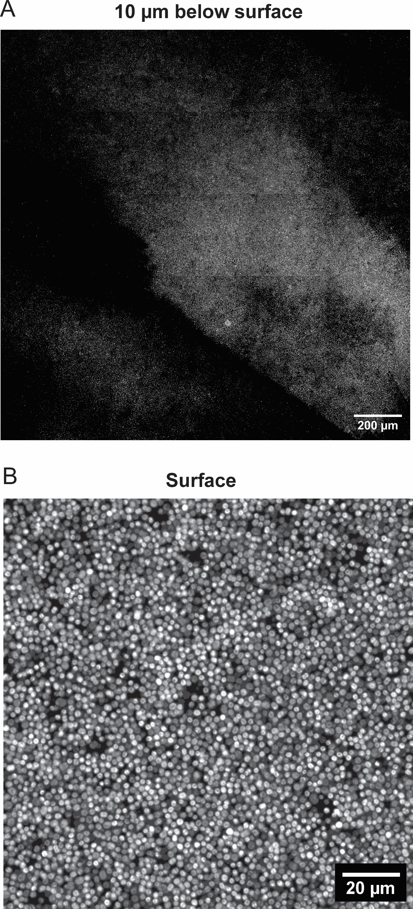
Figure S3. Laser scanning confocal microscopic images showing chlorophyll autofluorescence of embedded cells. A. Image from approximately 100 μm below the surface of the hydrogel after 22 days with 25 x magnification. B. Image from the surface of the hydrogel after 22 days with 40 x magnification.

