Supplementary
Table S1. Weighted adjacency matrix of the estimated network
Node | AGE | MAR | EDU | OCC | RES | BMI | SMK | PA | FFC | OIL | CB | AB | DM | HTN | PSY | PCOS
AGE | — | 0 | 0.14 | 0.371 | 0.06 | 0.16 | 0 | 0 | 0.04 | 0 | 0.6 | 0 | 0.36 | 0.51 | 0.07 | −0.323
MAR | 0 | — | 0 | 0.455 | 0.08 | 0.24 | 0 | 0 | 0.15 | 0.08 | 1.03 | 0.57 | 0 | 0 | 0 | 0.166
EDU | 0.14 | 0 | — | 0.372 | 0.27 | 0 | 0 | 0 | 0 | 0.06 | 0.26 | 0 | 0 | 0 | 0 | 0.219
OCC | 0.371 | 0.455 | 0.37 | — | 0.27 | 0.05 | 0 | 0.041 | 0.02 | 0 | 0.27 | 0.04 | 0 | 0 | 0 | 0.293
RES | 0.057 | 0.08 | 0.27 | 0.266 | — | 0.05 | 0 | 0.079 | 0 | 0.13 | 0.16 | 0 | 0 | 0 | 0 | 0.695
BMI | 0.163 | 0.243 | 0 | 0.052 | 0.05 | — | 0.043 | 0 | 0 | 0 | 0.04 | 0 | 0.18 | 0.07 | 0 | 0
SMK | 0 | 0 | 0 | 0 | 0 | 0.04 | — | 0 | 0 | 0 | 0 | 0 | 0 | 0 | 0.15 | 0
PA | 0 | 0 | 0 | 0.041 | 0.08 | 0 | 0 | — | 0 | 0 | 0.05 | 0 | 0 | 0 | 0 | −0.315
FFC | 0.039 | 0.15 | 0 | 0.02 | 0 | 0 | 0 | 0 | — | 0.26 | 0 | 0 | 0 | 0 | 0 | 0
OIL | 0 | 0.078 | 0.06 | 0 | 0.13 | 0 | 0 | 0 | 0.26 | — | 0.03 | 0 | 0 | 0 | 0 | 0
CB | 0.602 | 1.029 | 0.26 | 0.272 | 0.16 | 0.04 | 0 | 0.054 | 0 | 0.03 | — | 0.14 | 0.05 | 0.13 | 0 | 0.099
AB | 0 | 0.573 | 0 | 0.037 | 0 | 0 | 0 | 0 | 0 | 0 | 0.14 | — | 0 | 0 | 0 | 0
DM | 0.364 | 0 | 0 | 0 | 0 | 0.18 | 0 | 0 | 0 | 0 | 0.05 | 0 | — | 0.68 | 0 | 0
HTN | 0.514 | 0 | 0 | 0 | 0 | 0.07 | 0 | 0 | 0 | 0 | 0.13 | 0 | 0.68 | — | 0 | 0
PSY | 0.073 | 0 | 0 | 0 | 0 | 0 | 0.153 | 0 | 0 | 0 | 0 | 0 | 0 | 0 | — | 0
PCOS | −0.323 | 0.166 | 0.22 | 0.293 | 0.7 | 0 | 0 | −0.315 | 0 | 0 | 0.1 | 0 | 0 | 0 | 0 | —

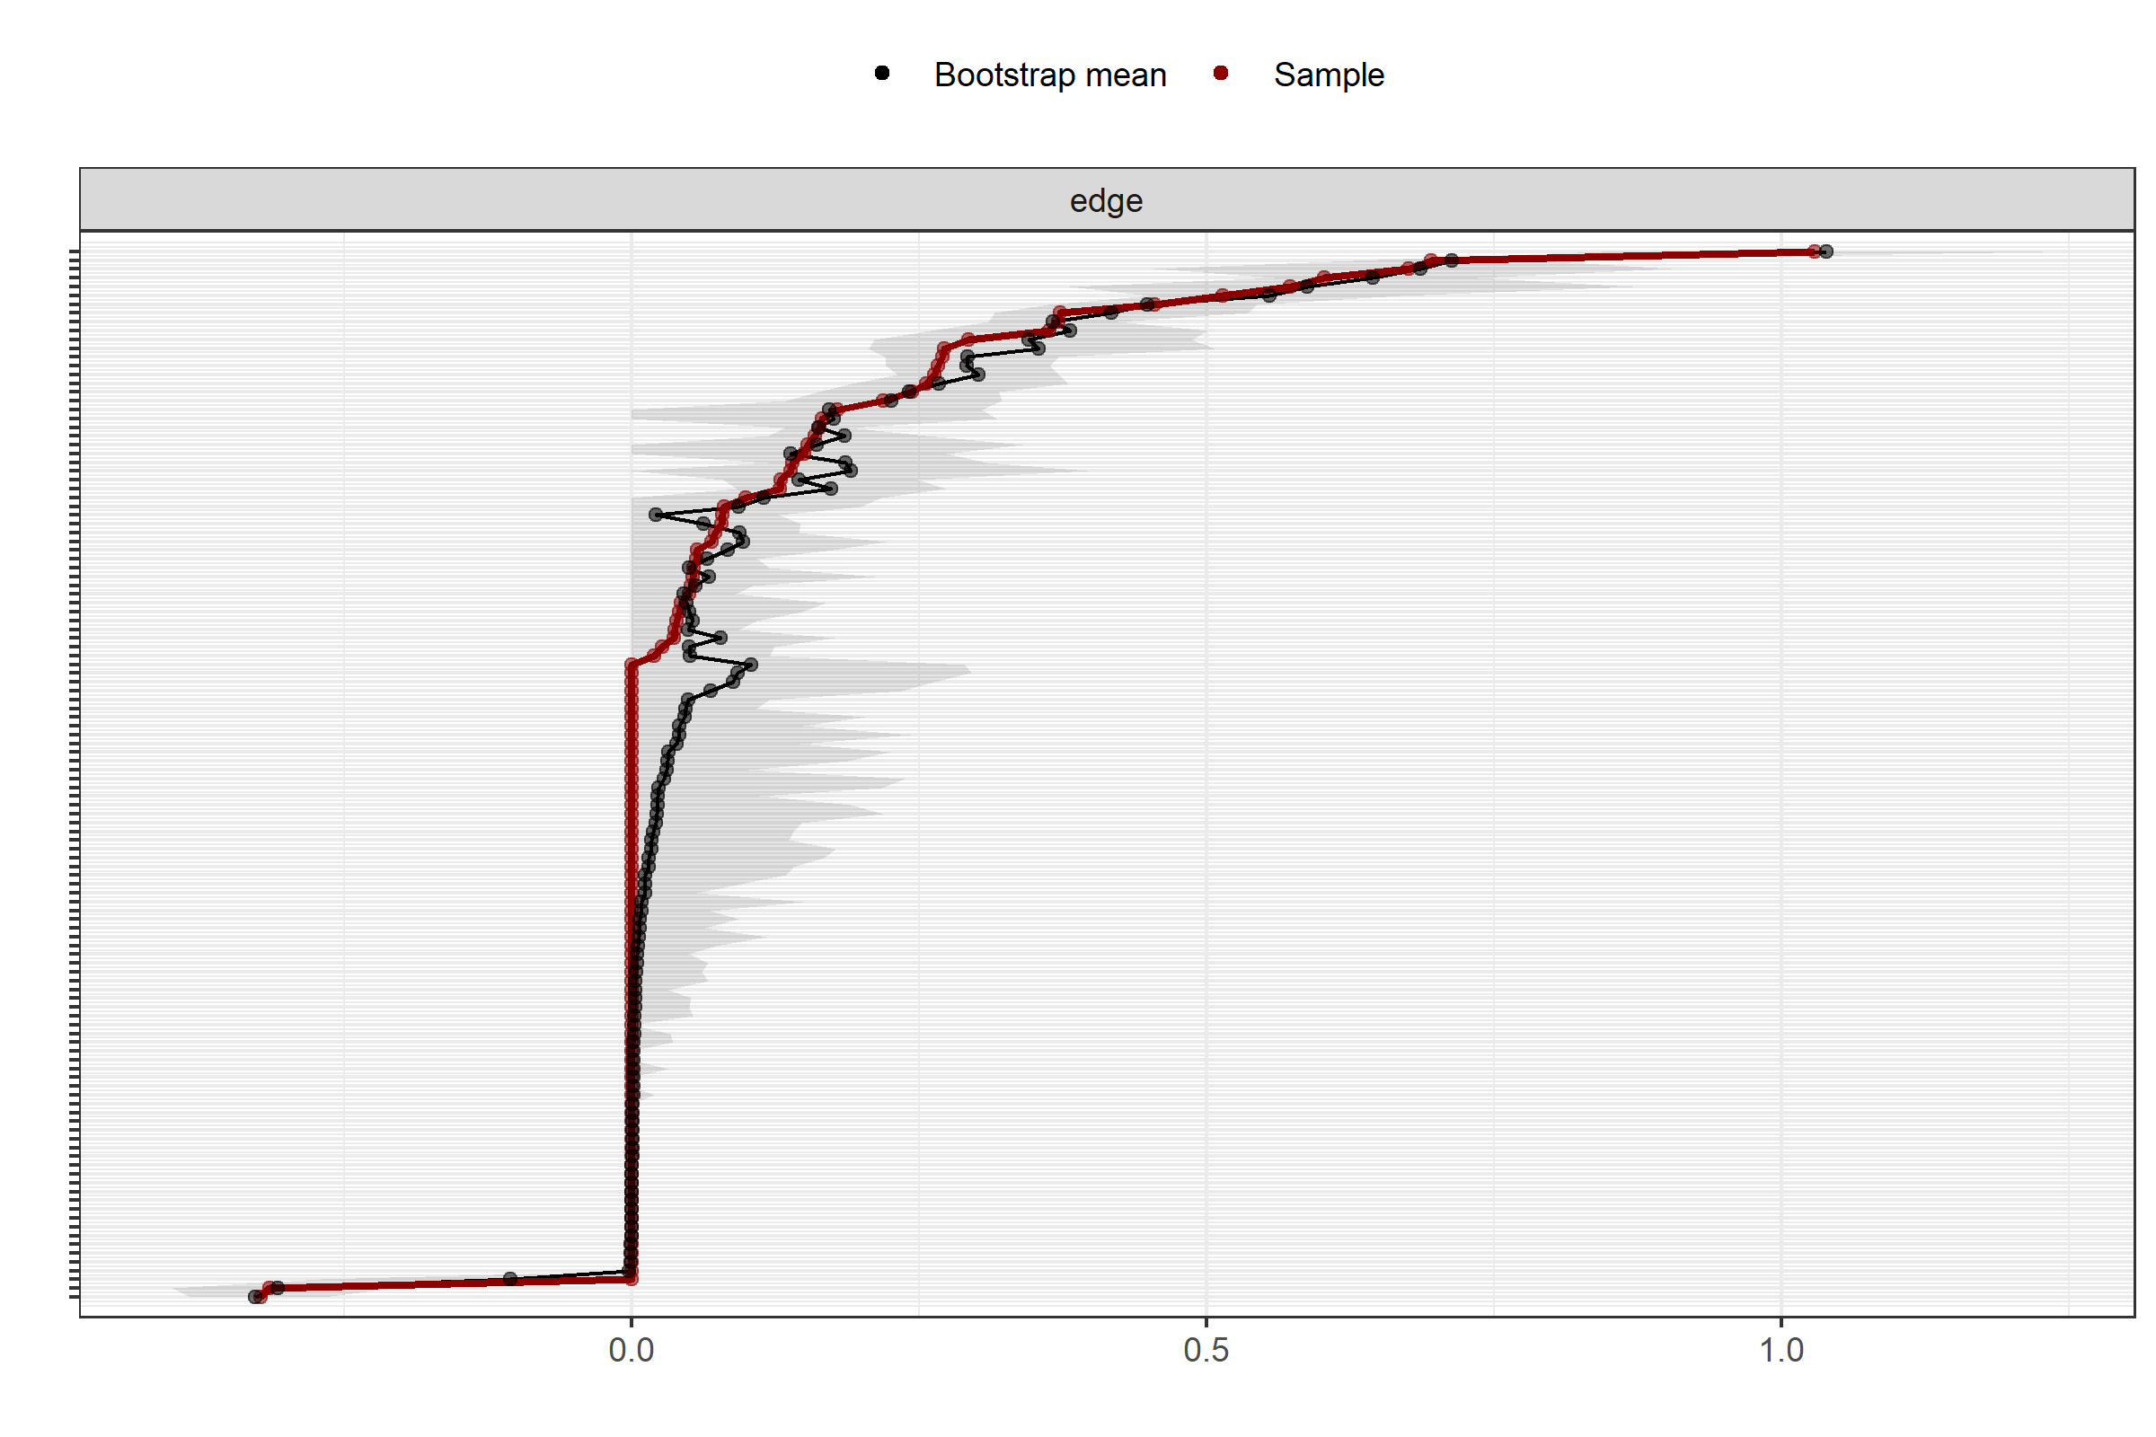

Figure S1. Accuracy of edge-weight estimates based on nonparametric bootstrapping

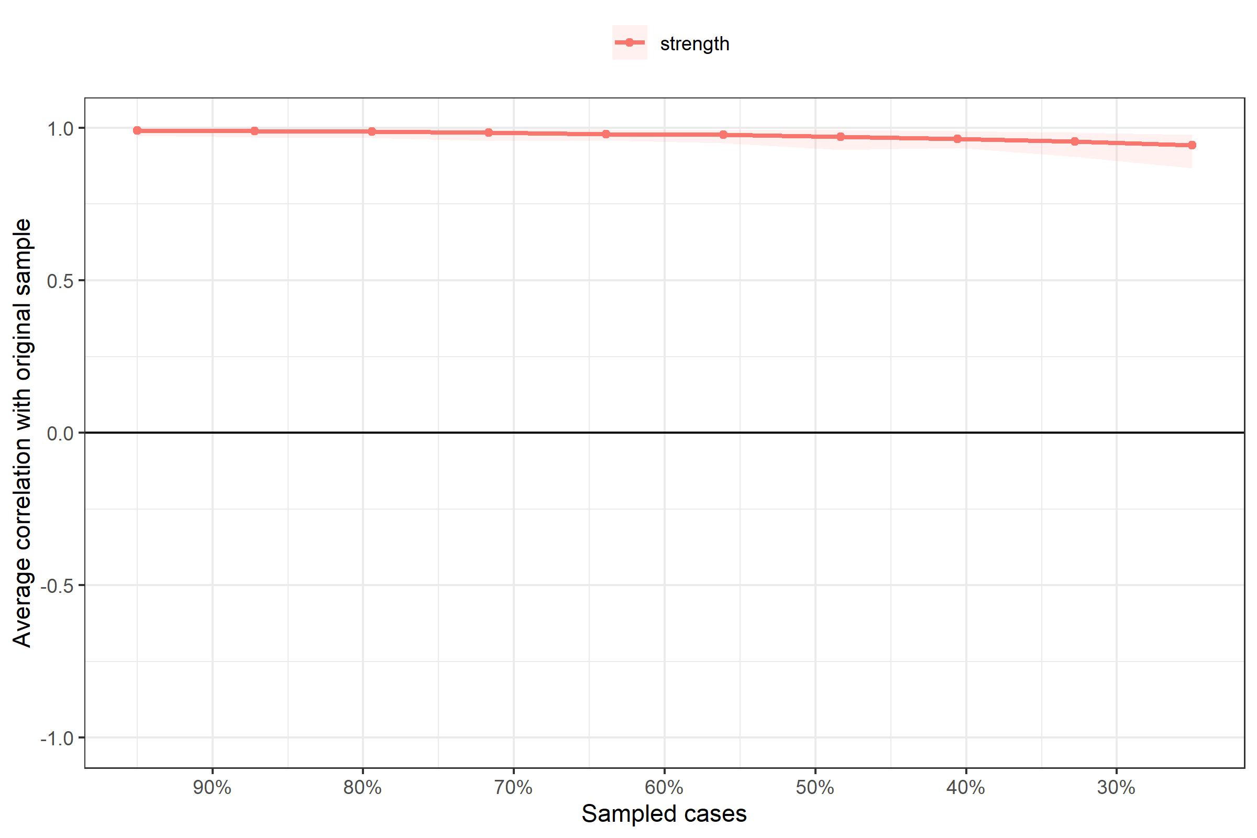
Figure S2. Stability of centrality indices based on case-dropping bootstrapping

