Supplementary Table 1 Primers used for quantitative PCR.
Primer | Sequence (5'→3')
PD-L1 | F: GGCATTTGCTGAACGCAT
 | R: CAATTAGTGCAGCCAGGT
CD47 | F: AGTGATGGACTCCGATTTGG
 | R: GGGTCTCATAGGTGACAACCA
GAPDH | F: ACAACTTTGGTATCGTGGAAGG
 | R: TATTTGGCAGGTTTTTCTAGACG
F, forward; R, reverse.

PPFIBP2
FER1L4
TRAK1
PPARG
DHRS2
TBX3
BCAS1
RAB15
HMGCS2
FBP1
FOXA1
SSH3
TMC4
CAPN5
SPINK1
ACP6
ATP8B1
FAM3B
SCNN1G
PSCA
DEGS1
SORL1
GOLT1A
TMC7
SPHK1
GNB4
KATNAL1
NPAS2
CD109
SRC
TEAD4
PIK3C2B
MAOA
BTBD16
MT1X
MFAP3L
DENND2D
CYP4F12
ZNF552
SLC29A3
SUOX
TNFRSF21
CDC25B
TNC
GPX2
OSMR
NADSYN1
CROT
IFT140
PLEKHA6
GPRC5C
CTSH
ACSL5
CLIC4
SH3YL1
GFPT2
TBX2
ATF7IP2
ST3GAL5
ANXA5
MPP1
SLC16A1
PHF19
PLA2G2F
ALOX5
ASCC2
ZNF440
PTRF
USP3
MMEL1
ORMDL3
PLEKHH1
ACOXL
TLE2
HSD17B2
HES1
AP1G2
PLXNB1
TNFAIP6
ABAT
MSI2
C2orf15
SLC22A5
ZSCAN16
OR13A1
SIDT1
SPAG4
SLC23A2
EFEMP1
SLC39A14
HAPLN3
PGPEP1
ZNF439
C17orf82
AGR2
DAPK1
ELF5
GFOD1
SEMA6A
MAPK10
PRRX1
BHMT
PRKCD
DGAT2
OXCT1
RHBG
ST3GAL4
ADCY7
FAP
DECR1
RBP1
SMAD6
APCDD1L
ATP1A4
PNMA1
TNFAIP8L3
DUSP14
ID1
COMT
LARGE
ANXA2
CPA4
TST
KCNQ1
NRP2
FOXD1
SYTL1
TBC1D9
S100A10
FAM3D
MTHFD1L
TSEN2
MMP9
ACY1
DSC2
CALD1
KRTAP5-9
DPP4
CAPN2
TEKT5
C19orf45
TMEM158
FN1
AKR1C3
TIMP2
PLK2
SPHK2
GNG4
CDC42EP1
MFGE8
EMP1
CAPN13
HES2
UGT2B7
GSN
DPYSL3
PKMYT1
S100A16
CPXM2
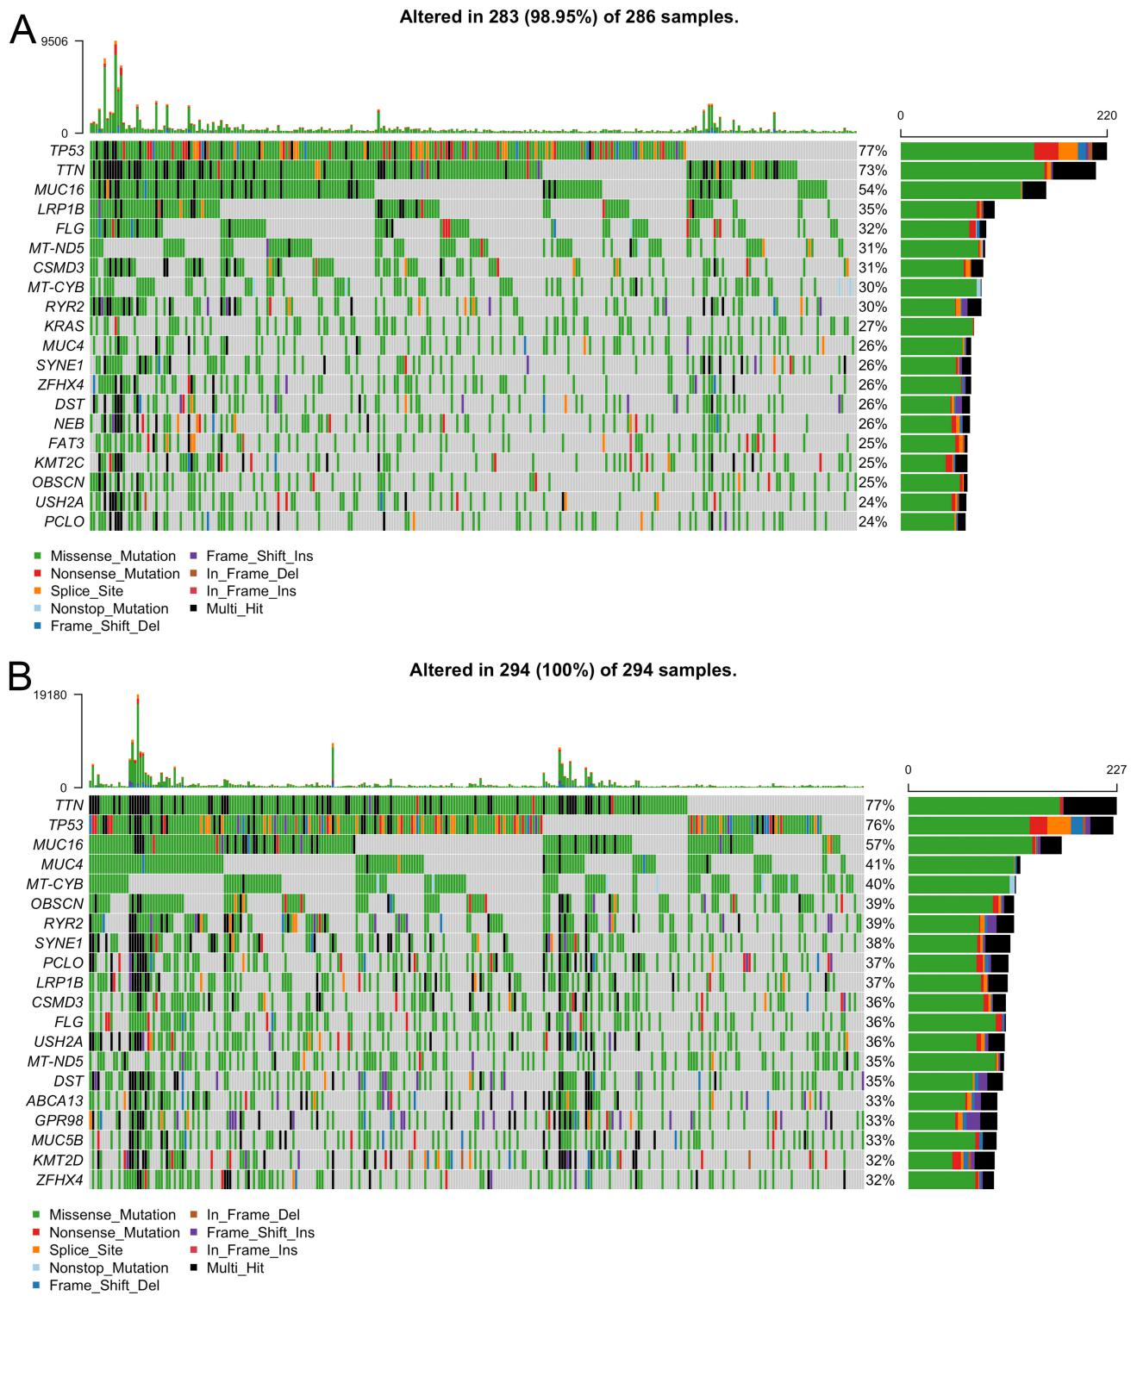
Supplementary Figure 1 The top 20 mutation genes in high- (A) and low-risk groups (B) in Cancer Cell Line Encyclopedia.
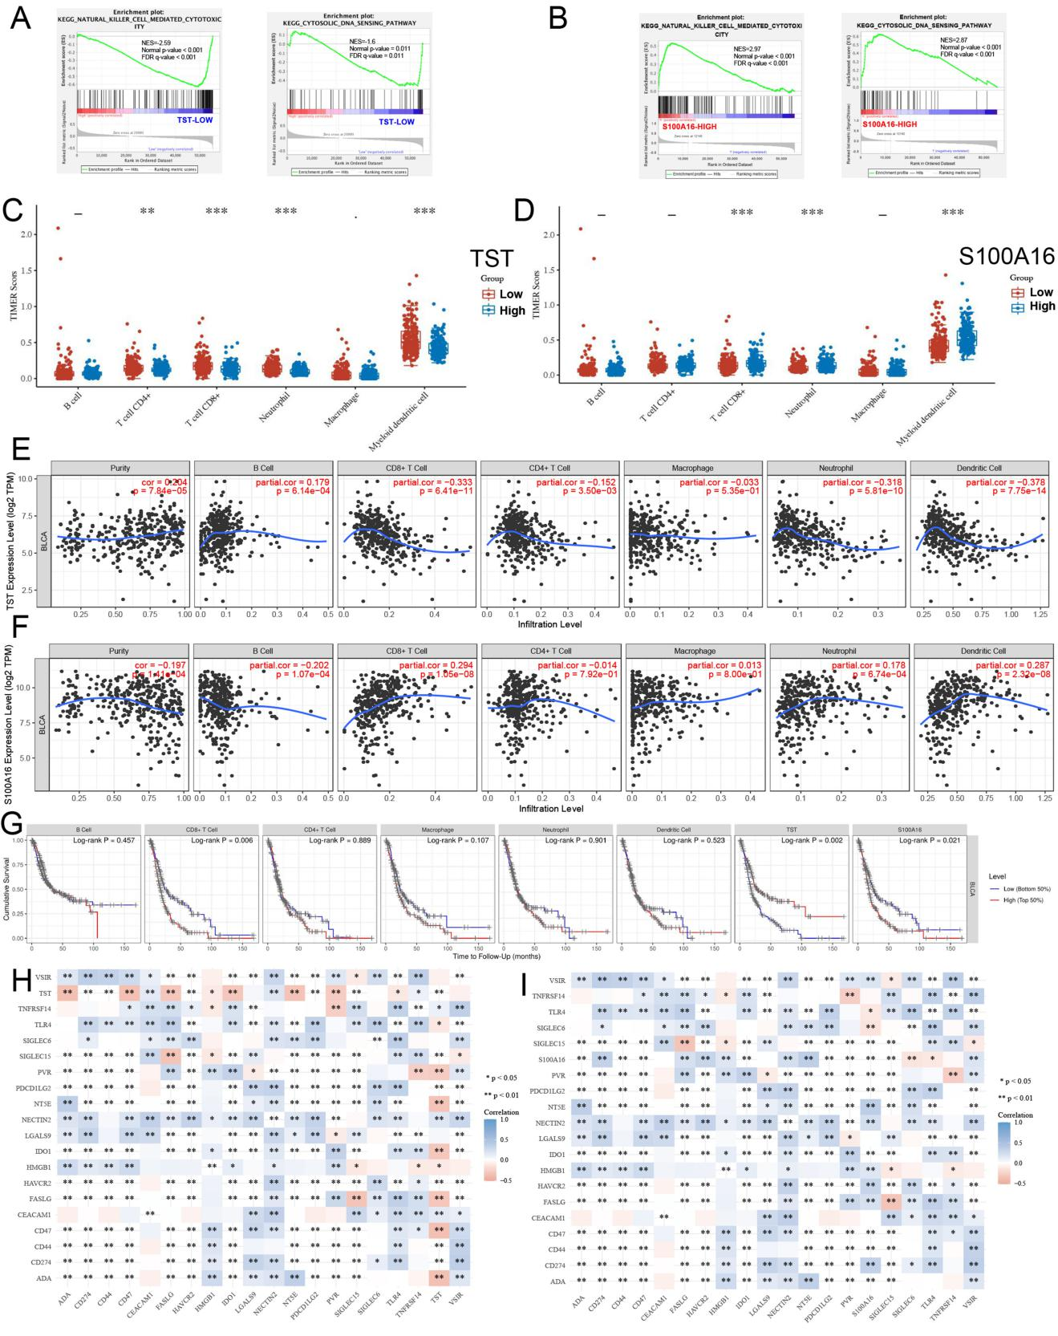
Supplementary Figure 2 Correlation between TST and S100A16 and tumor immune microenvironment of BCa. (A,B) GSEA analysis showed that the gene sets of NATURAL KILLER CELL MEDIATED CYTOTOXICITY and CYTOSOLIC DNA SENSING PATHWAY were enriched in the TST low expression group (A) and S100A16 high expression group (B). (C,D) The expression distribution of immune cells in high and low expression groups of TST (C) and S100A16 (D) genes from TCGA data for BCa. (E,F) The correlation analysis of the expression of TST (E) and S100A16 (F) and the infiltration level of immune cells by TIMER platform. (G) The expression of immune cells, TST and S100A16 plays a role in the prognosis of BCa in the ‘survival’ module of TIMER platform. (H,I) The correlation analysis of the expression of TST, S100A16 and different immune checkpoints.

