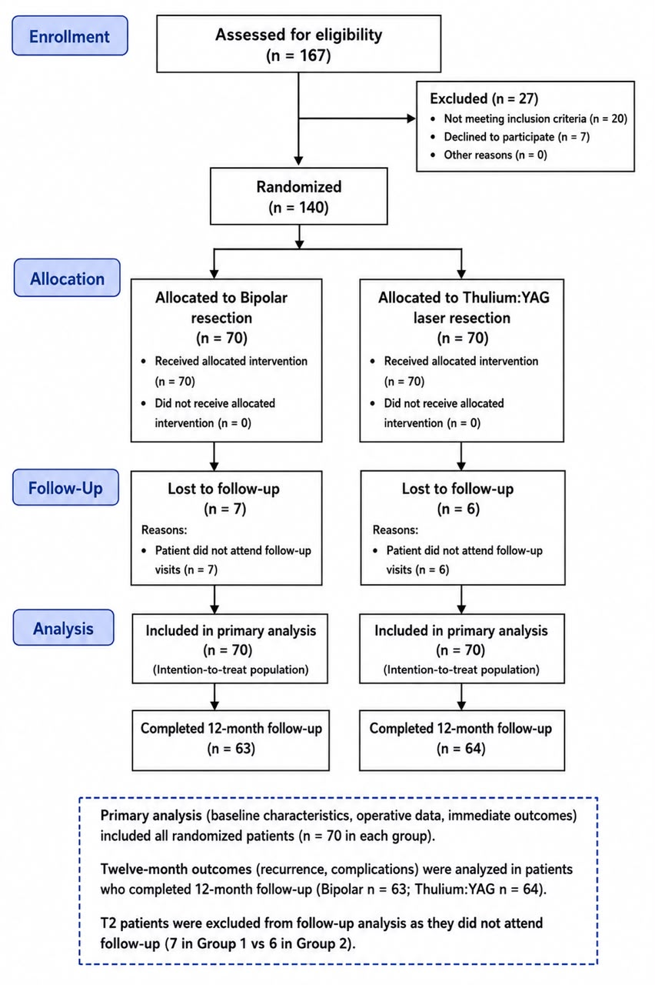
Figure (1): consort follow diagram
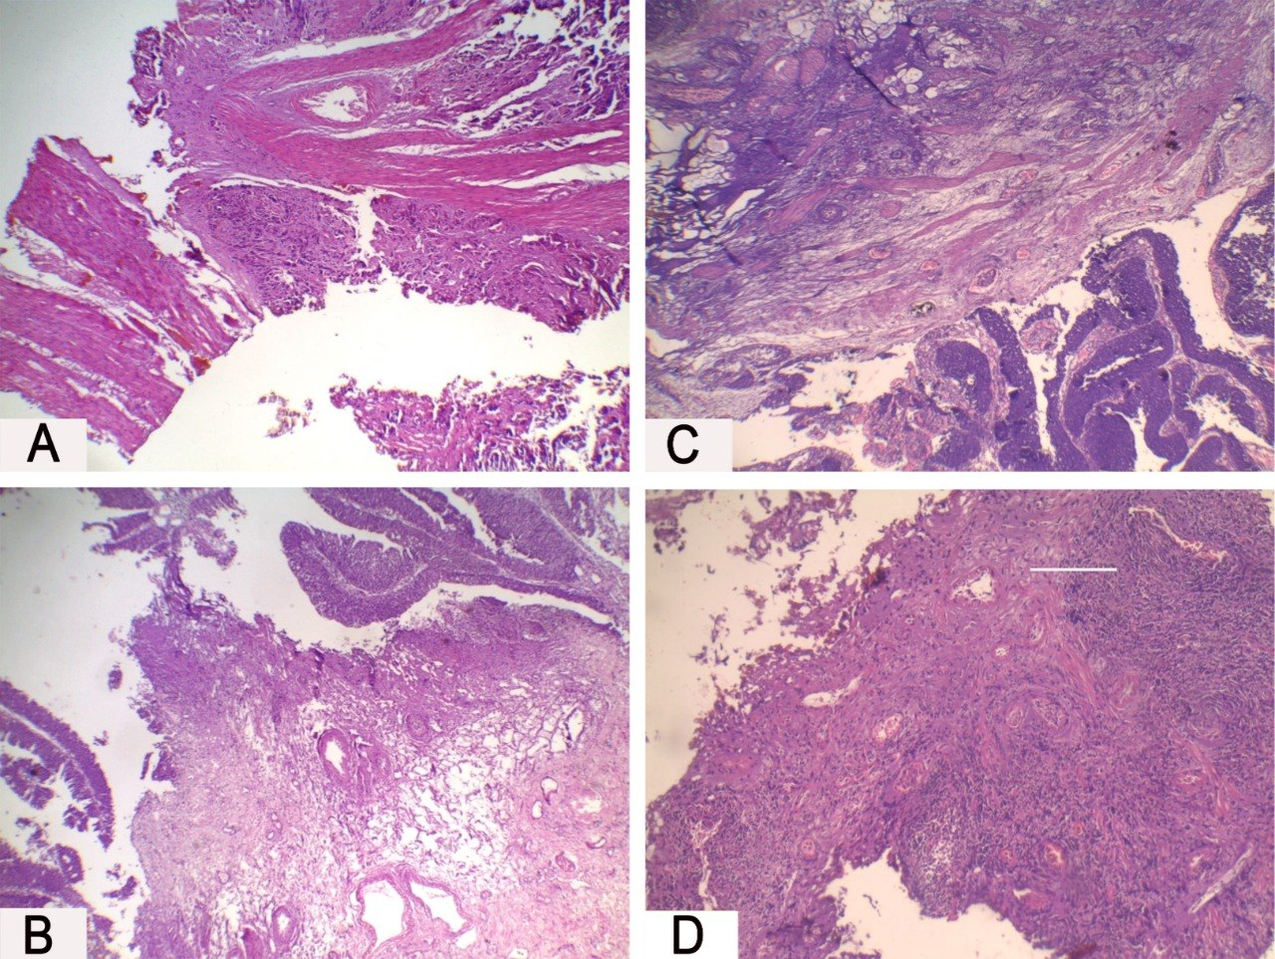

Figure (2): Thulium-Yag laser enbloc resection
(A- a case of high-grade muscle invasive TCC showing no tissue artifact H&E X40, B- a case of non-muscle invasive TCC Ta showing no tissue artifact H&E X40, C- a case of non-muscle invasive TCC Ta showing no tissue artifact H&E X100, D- a case of urothelial carcinoma showing no tissue artifact H&E X100)
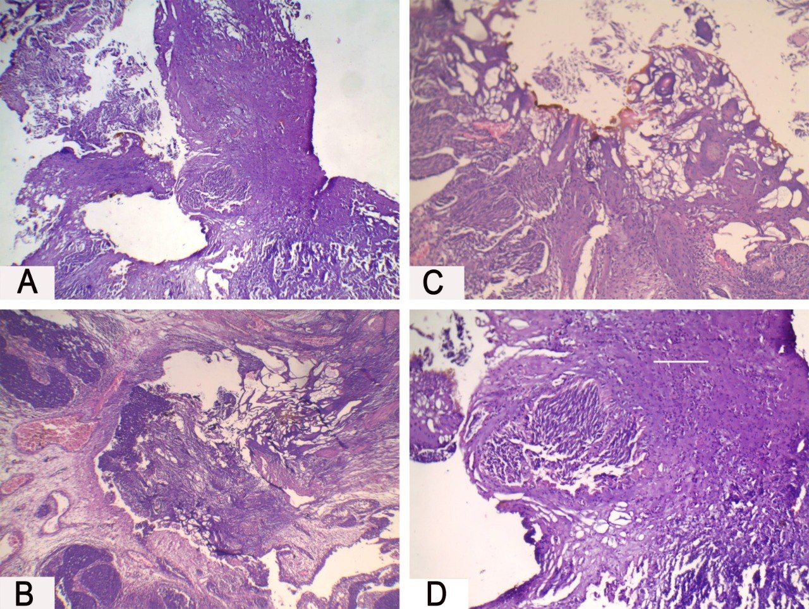
Figure (3): Bipolar enbloc resection
(A-a case of high grade non muscle invasive TCC showing mild cauterization artifact H&E X40, B- a case of low grade non muscle invasive TCC showing marked cauterization artifact H&E X100, C-a case on low grade non muscle invasive papillary TCC showing mild cauterization artifact H&E X40, D-a case of high-grade muscle invasive TCC showing moderate cauterization artifact H&E X100).

Tables
Table (1): Comparison between the two studied groups according to clinical and demographic data, radiological, preoperative findings and diagnostic cystoscopy findings:
 | Bipolar  (n = 70) | Thulium YAG  (n = 70) | P
Sex
Male | 42 (60.0%) | 50(71.4) % | 0.154
Female | 28(40.0) | 20(28.6%) | 0.154
Age (years)
Mean ± SD. | 61.01 ± 11.26 | 58.30 ± 10.84 | 0.149
Smoking | 28(40.0%) | 37(52.9%) | 0.127
ASA score
I | 39 (55.7%) | 28 (40.0%) | 0.063
II | 31(44.3%) | 42 (60.0%) | 0.063
DM | 19(27.1%) | 20(28.6%) | 0.850
HTN | 14(20.0%) | 22(31.4%) | 0.122
Cardiac | 10(14.3%) | 11(15.7%) | 0.813
Presentation
Accidentally | 7(10.0) | 5(7.1%) | 0.063
Hematuria | 22(31.4) | 21(30.0) | 0.063
LUTS | 28(40.0) | 34(48.6%) | 0.063
Hematuria+ clots | 6(8.6) | 10(14.3%) | 0.063
Hematuria+ LUTS | 7(10.0) | 0(0.0%) | 0.063
Status
1ry | 61(87.1%) | 62(88.6%) | 0.796
2ry | 9(12.9%) | 8(11.4%) | 0.796
Tumor number
I | 57(81.4%) | 63(90.0%) | 0.203
II | 11(15.7%) | 7(10.0%) | 0.203
III | 2(2.9%) | 0(0.0%) | 0.203
LN
No | 67(95.7%) | 68(97.1%) | 1.000
Yes | 3(4.3%) | 2(2.9%) | 1.000
Tumor size (mm)
Mean ± SD. | 24.71 ± 6.40 | 22.61 ± 9.37 | 0.124
Tumor site
Anterior | 2(2.9%) | 0(0.0%) | 0.313
Basal | 24(34.3%) | 26(37.1%) | 0.313
Dome | 1(1.4%) | 0(0.0%) | 0.313
Lateral | 29(41.4%) | 30(42.9%) | 0.313
lateral wall-basal | 0(0.0%) | 3(4.3%) | 0.313
Posterior | 14(20.0%) | 11(15.7%) | 0.313
Tumor morphology
Papillary | 31(44.3%) | 38(54.3%) | 0.237
Fungating broad base | 39(55.7%) | 32(45.7%) | 0.237

Table (2): Comparison between the two studied groups according to intraoperative and postoperative data:
 | Bipolar  (n = 70) | Thulium YAG  (n = 70) | P
Operative time (min)
Median (IQR) | 32.0 (22.0 – 40.0) | 32.50 (22.0 – 38.0) | 0.967
Complications
No | 56(80.0%) | 69(98.6%) | >0.001*
Jerk | 10(14.3%) | 0(0.0%) | >0.001*
Perforation | 2(2.9%) | 0(0.0%) | >0.001*
Bleeding controlled | 2(2.9%) | 1(1.4%) | >0.001*
Hemostasis quality
Poor | 6(8.6%) | 0(0.0%) | =0.001*
Fair | 14(20.0%) | 3(4.3%) | =0.001*
Good | 9(12.9%) | 8(11.4%) | =0.001*
Excellent | 41(58.6%) | 59(84.3%) | =0.001*
Hb (gm/dl) Preoperative
 |  |  | 0.194
Mean ± SD. | 12.87 ± 1.73 | 13.22 ± 1.40 | 0.194
Hb (gm/dl) Postoperative
 |  |  | 0.102
Mean ± SD. | 12.41 ± 1.83 | 13.05 ± 1.35 | 0.102
Difference
Median (IQR) | 0.40 (0.20 – 0.50) | 0.30 (0.20 – 0.40) | 0.415
Irrigation color
Clear | 61(87.1%) | 66(94.3%) | 0.375
Mild hematuria | 5(7.1%) | 2(2.9%) | 0.375
Moderate hematuria | 4(5.7%) | 2(2.9%) | 0.375
Irrigation time, h
Median (IQR) | 4.0 (4.0 – 6.0) | 4.0 (3.0 – 4.0) | 0.043*
Hospital stay (days)
Median (IQR) | 1.0 | 1.0 | 1.000
Pain score (vas score)
0 | 57(81.4%) | 65(92.9%) | 0.145
1 | 8(11.4%) | 3(4.3%) | 0.145
2 | 5(7.1%) | 2(2.9%) | 0.145
Catheterization time (days)
Median (IQR) | 3.0 (3.0 – 5.0) | 3.0(3.0 – 4.0) | 0.149
Postoperative-intravesical chemo. | 58  (82.9%) | 63  (90.0%) | 0.217
Pathology muscle | 47(67.1%) | 66(94.3%) | 0.001*
Pathology tumor type
TCC | 68(97.1%) | 67(95.7%) | 0.623
SCC | 1(1.4%) | 3(4.3%) | 0.623
Spindle cell | 1(1.4%) | 0(0.0%) | 0.623
Pathology grade
Low grade | 23(32.9%) | 29(41.4%) | 0.294
High grade | 47(67.1%) | 41(58.6%) | 0.294
Pathology stage
Ta | 19(27.1%) | 29(41.4%) | 0.203
T1 | 44(62.9%) | 35(50.0%) | 0.203
T2 | 7(10.0%) | 6(8.6%) | 0.203
Histopathological Thermal Artifact
Mild | 45(64.3%) | 68(97.1%) | >0.001*
Moderate | 20(28.6%) | 2(2.9%) | >0.001*
Severe | 5(7.1%) | 0(0.0%) | >0.001*

Table (3): Comparison between the two studied groups according to Recurrence During 12-Month Follow-up:
 | Bipolar  (n = 70) | Thulium YAG  (n = 70) | P
Follow up over 1 year
No FU | 7(10.0%) | 6(8.6%) | 0.487
Free | 54(77.1%) | 59(84.3%) | 0.487
Recurrent | 9(12.9%) | 5(7.1%) | 0.487
Site of Recurrence | (n = 63) | (n = 64)
No | 54(85.7%) | 59(92.2%) | 0.244
The same site | 9(14.3%) | 5(7.8%) | 0.244
Follow-up Cystoscopy | (n = 63) | (n = 64)
Normal mucosa | 36(57.1%) | 34(53.1%) | 0.155
Erythema | 5(7.9%) | 1(1.6%) | 0.155
Inflammatory reaction | 8(12.7%) | 10(15.6%) | 0.155
Small recurrent lesion | 7(11.1%) | 4(6.3%) | 0.155
Scar | 7(11.1%) | 15(23.4%) | 0.155
N.B: Patients lost to follow-up were excluded from recurrence-site and cystoscopic analyses

