Supporting information (SI) on
boosting photocatalytic efficiency of MoS₂/CdS by modulating morphology
Yubing Sun*, Jingting Xiao, Xinshui Huang, Peng Mei, Huihui Wang,
College of Environmental Science and Engineering, North China Electric Power University, Beijing, China, 102206

The calculation of bandgap (Eg)
The bandgap can be obtained by Tauc plots:
(αhv)^{(1/n)} = A(hν − E_{g}) (S1)
where α and h are absorption index and Planck constant, respectively; ν and A refer to photon frequency and proportional constant, respectively.
Characterizations
(b)
(a)
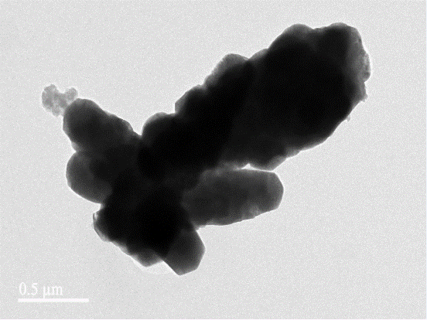
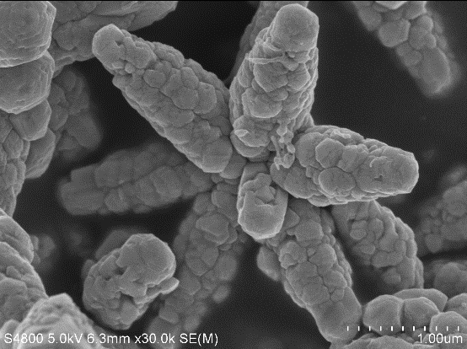

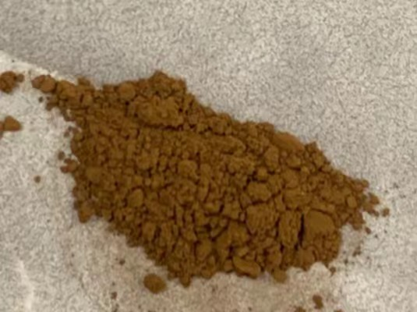
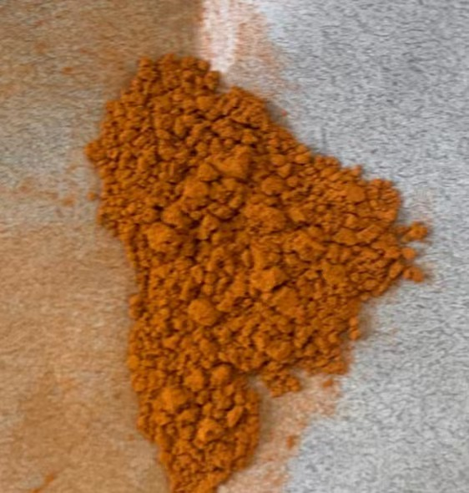
(d)
(c)

Figure S1 the additional characterization of MoS₂/CdS composite (a): SEM of CdS; (b): TEM of 2.5 wt% MoS₂/CdS; (c) and (d): photos of 5 wt% and 10 wt% MoS₂/CdS composite, respectively.

Table S1. BET surface area, pore volume and average pore size of CdS and 2.5 wt% MoS₂/CdS
Sample | BET surface area (m²/g) | Pore volume (cm³/g) | Average pore size (nm)
CdS | 3.854 | 0.0023 | 34.32
2.5 wt% MoS₂/CdS | 8.793 | 0.0152 | 35.14
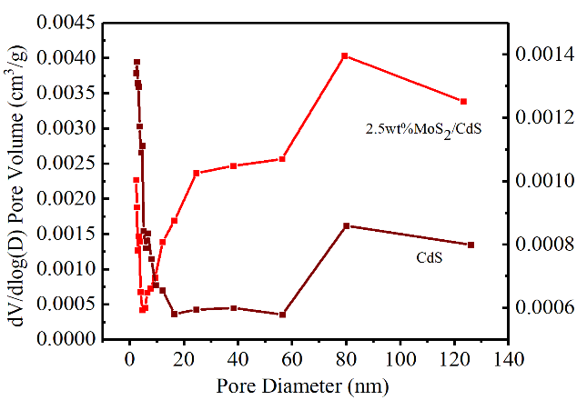
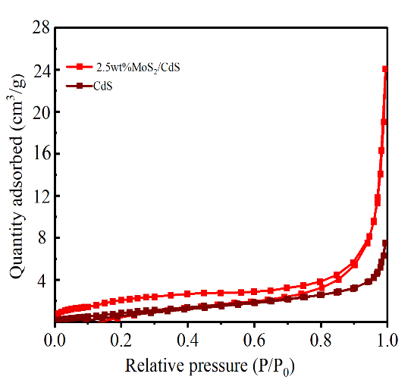

Fig. S2 Nitrogen adsorption-desorption isotherms and the corresponding pore size distribution curves of CdS and 2.5 wt% MoS₂/CdS.
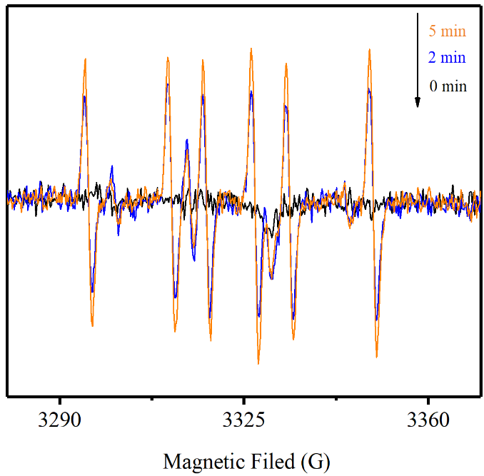
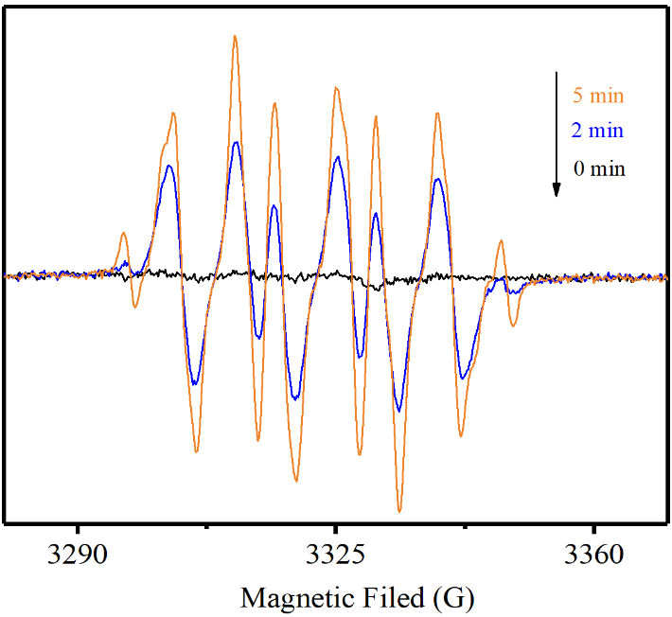
Analysis of EPR spectra
(b)
(a)

Fig. S3 The EPR spectra of (a) DMPO-·OH and (b) DMPO-·O₂⁻ over 2.5 wt% MoS2/CdS under different time
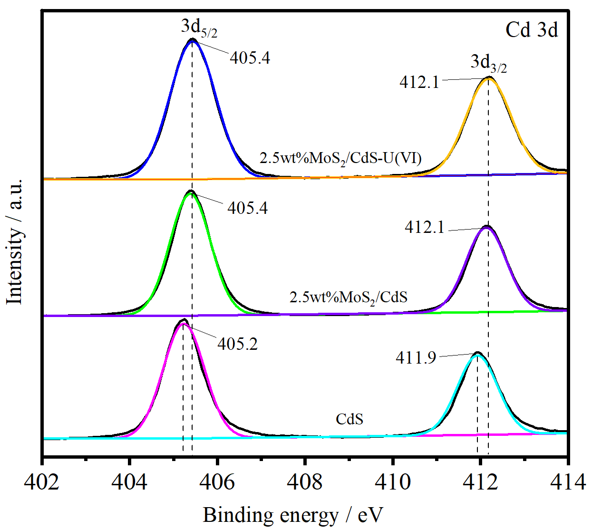
XPS analysis

Fig. S4 High resolution XPS spectra of Cd 3d

