Supplementary Information

Single-cell foundation models predict durable CAR T response despite imperfect cell annotation

K. Leo Shen¹, Zhiliang Bai^{1,2,3}, Mingyu Yang¹, Na Li⁴, Rong Fan^{1,5,6} *

¹ Department of Biomedical Engineering, Yale University; New Haven, CT, USA.
² Koch Institute for Integrative Cancer Research, Massachusetts Institute of Technology; Cambridge, MA, USA.
³ Department of Biological Engineering, Massachusetts Institute of Technology; Cambridge, MA, USA.
⁴ School of Engineering and Applied Science, Harvard University; Cambridge, MA, USA.
⁵ Department of Pathology, Yale School of Medicine; New Haven, CT, USA.
⁶ Yale Cancer Center, Yale Stem Cell Center, Yale Center for Research on Aging; New Haven, CT, USA.

* Correspondence: rong.fan@yale.edu (R.F.)

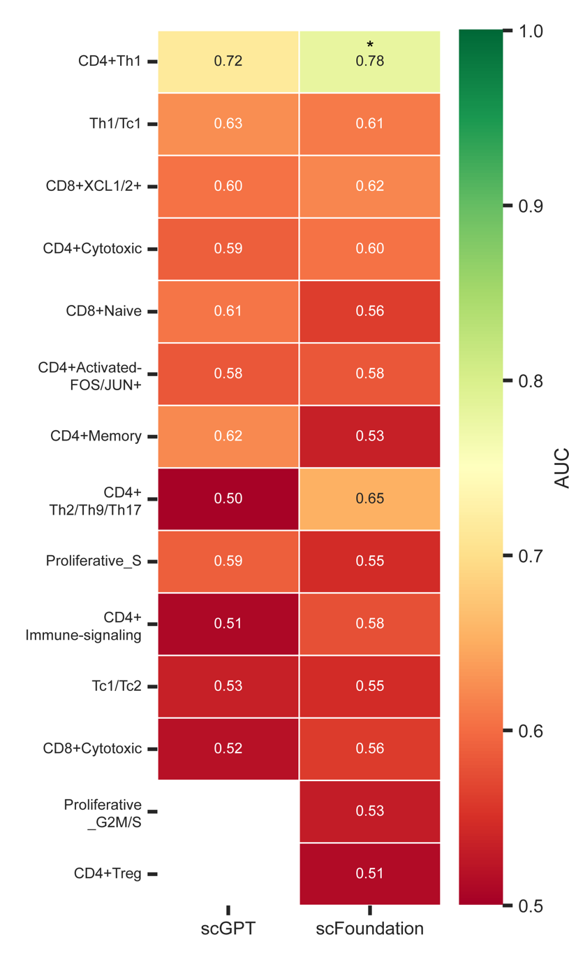

Supplementary Fig. 1: AUC heatmap for discrimination between BCA1 and BCA2 using cell type proportions derived from scGPT and scFoundation fine-tuned annotations under CD19 stimulation condition. Asterisks denote permutation-test significance (p<0.05).
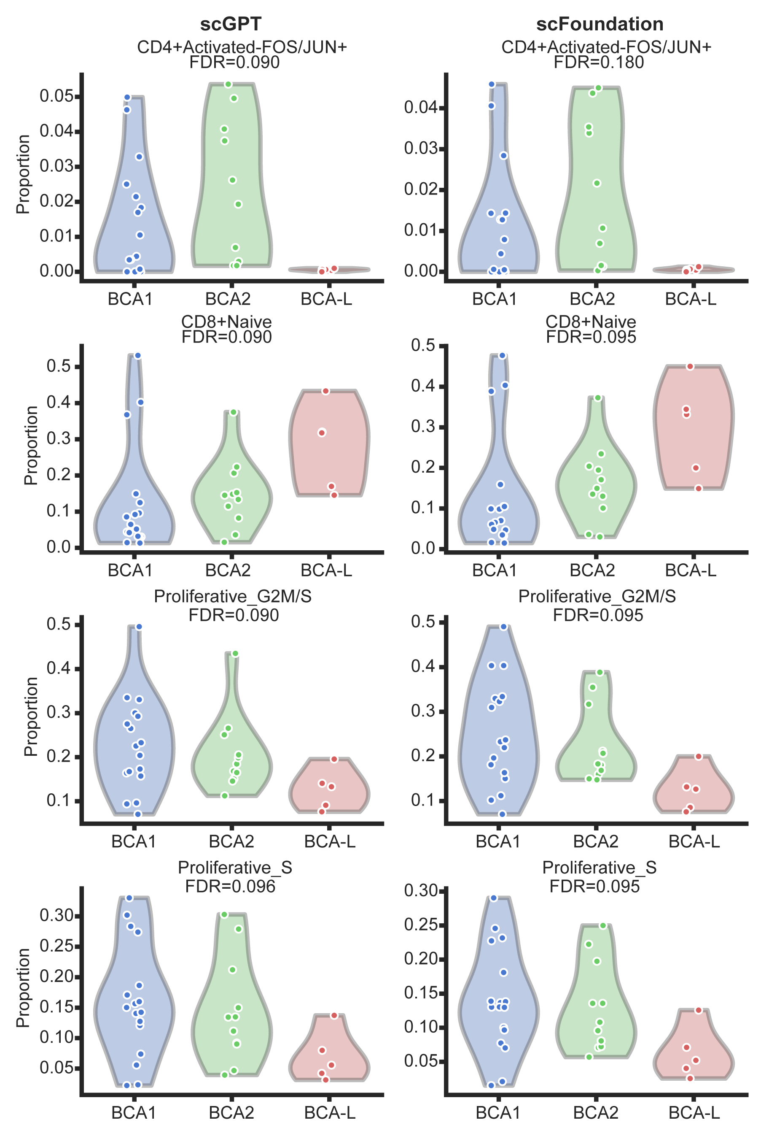

Supplementary Fig. 2: Violin plots showing distributions of the four most discriminative cell type proportions across BCA groups (BCA1, BCA2, BCA-L) for scGPT and scFoundation fine-tuned annotations under basal (unstimulated) condition; FDR values from Mann-Whitney tests are shown.

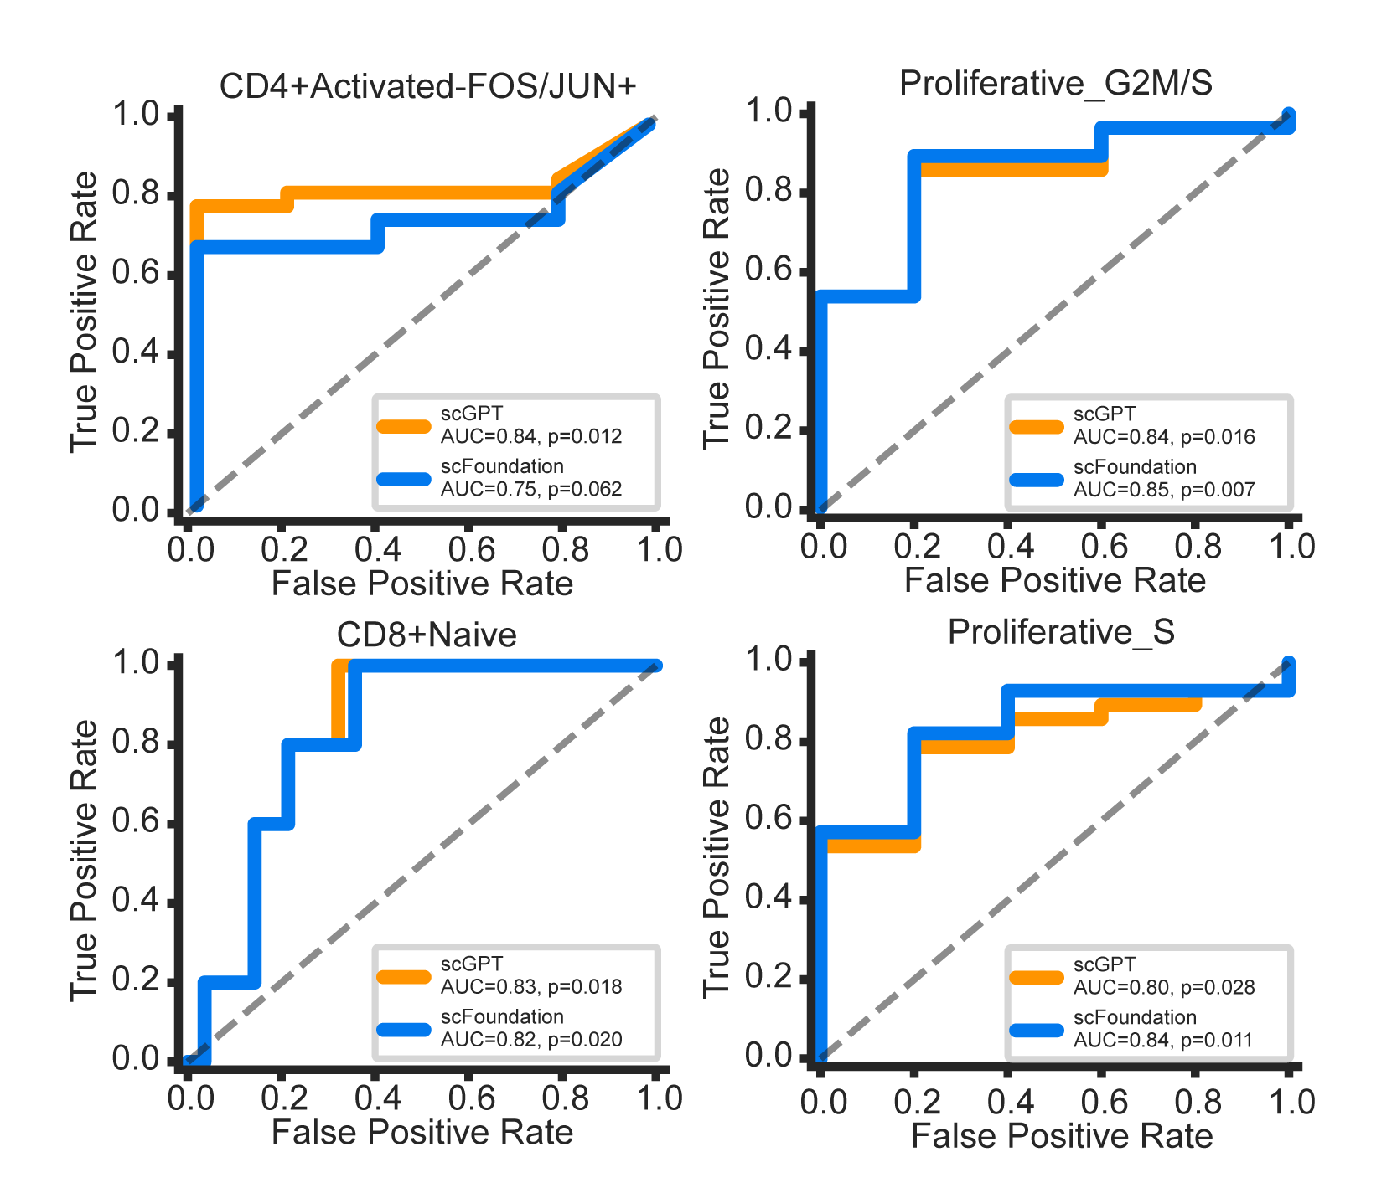

Supplementary Fig. 3: Receiver Operating Curve (ROC) analysis of association between CAR T cell basal states and clinical response. ROC curves for BCA-L vs. BCA1+BCA2 classification using proportions of the four top-performing cell types under basal (unstimulated) condition, for scGPT and scFoundation fine-tuned models.

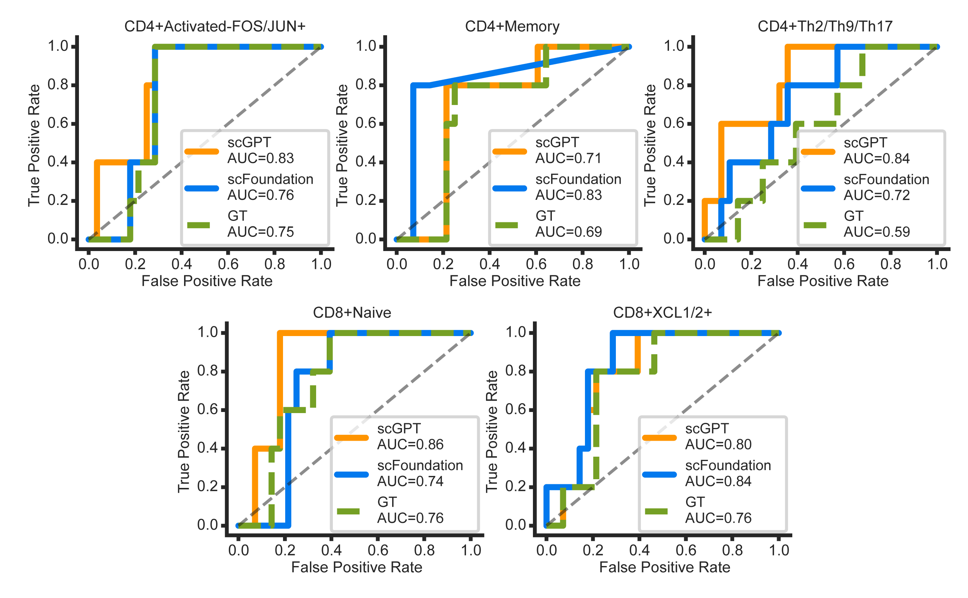

Supplementary Fig. 4: Receiver Operating Curve (ROC) analysis of association between CAR T cell activation states and clinical response. ROC curves for BCA-L vs. BCA1+BCA2 classification under CD19 stimulation condition comparing cell type proportions derived from scGPT fine-tuned, scFoundation fine-tuned, and ground-truth annotations, for the five cell types with highest discriminative performance. AUC values and permutation p-values are shown in each panel.

