Appendix A: Figure 2 in Dagan et al. (2021):
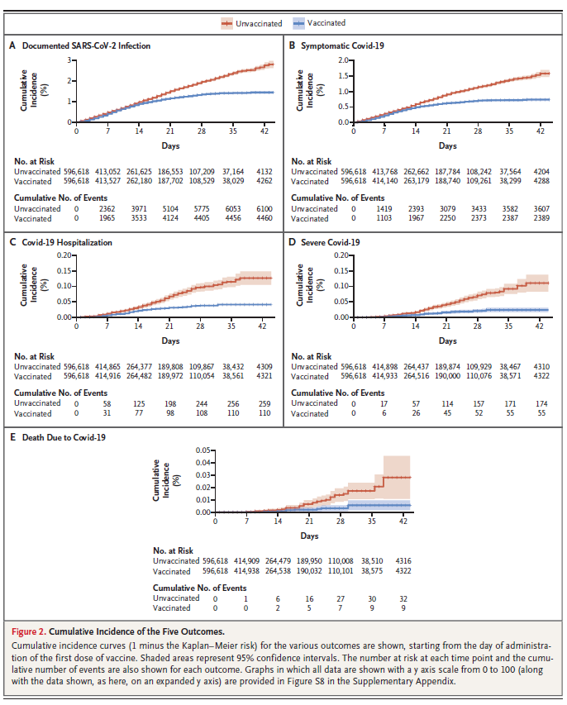
Appendix B: Table 2 in Dagan et al. (2021)
