Sex dimorphism in superficial muscle and adipose tissue composition assessed by broadband time domain diffuse optical spectroscopy in healthy adults

Agnese Segala¹, Vamshi Damagatla², Pranav Lanka^{2#}, Andrea Farina³, Enzo Nisoli⁴, Rinaldo Cubeddu², Antonio Pifferi^{2,3}, Alessandra Valerio¹, Paola Taroni^{2,3}*

Supplementary information

Supplementary Table S1. Demographics and anthropometrics of the subjects involved in the study.
Subject ID | Sex | Age (y) | BMI (kg/m²) | VL skin thickness (mm) | VL SAT thickness (mm) | ABD_4L Skin thickness (mm) | ABD_4L SAT thickness (mm) | ABD_4R Skin thickness (mm) | ABD_4R SAT thickness (mm)
0 | M | 54 | 22.20 | 1.60 | 2.74 | 1.94 | 17.64 | 2.09 | 17.94
1 | M | 24 | 22.15 | 1.79 | 2.01 | 1.79 | 6.02 | 1.29 | 6.71
2 | F | 26 | 20.90 | 1.23 | 8.98 | 1.69 | 10.54 | 1.59 | 9.30
3 | M | 27 | 23.46 | 1.23 | 3.67 | 1.88 | 6.09 | 1.69 | 4.98
4 | M | 26 | 23.85 | 1.27 | 3.96 | 1.80 | 19.09 | 1.80 | 21.30
5 | M | 29 | 20.76 | 1.30 | 2.55 | 2.30 | 6.51 | 2.02 | 6.38
6 | M | 28 | 19.73 | 1.36 | 3.98 | 1.01 | 7.73 | 1.87 | 6.14
7 | F | 29 | 23.42 | 1.37 | 7.33 | 1.74 | 15.55 | 1.85 | 19.93
8 | F | 29 | 22.96 | 1.29 | 10.98 | 1.35 | 10.58 | 1.35 | 10.97
9 | M | 34 | 23.67 | 1.33 | 4.73 | 2.04 | 12.25 | 1.87 | 11.89
11 | F | 36 | 21.97 | 1.37 | 10.83 | 1.27 | 11.48 | 1.30 | 10.83
12 | M | 27 | 21.87 | 1.29 | 6.81 | 1.74 | 22.72 | 1.94 | 22.00
13 | F | 44 | 19.56 | 1.24 | 6.61 | 1.22 | 12.53 | 1.24 | 11.83
15 | F | 29 | 20.83 | 0.95 | 6.54 | 1.36 | 7.77 | 1.38 | 6.58
16 | F | 57 | 19.10 | 1.15 | 11.95 | 1.43 | 7.99 | 1.30 | 9.04
17 | M | 59 | 18.94 | 0.90 | 2.83 | 1.30 | 7.01 | 1.44 | 7.85
18 | F | 28 | 21.23 | 1.20 | 9.45 | 1.32 | 10.99 | 1.25 | 10.97
19 | F | 35 | 20.42 | 0.98 | 7.85 | 1.25 | 9.69 | 1.34 | 9.84
20 | M | 39 | 22.89 | n.a. | n.a. | 1.21 | 14.71 | 1.35 | 18.14
21 | F | 51 | 21.36 | 1.09 | 11.76 | 1.26 | 7.98 | 1.37 | 6.00
22 | F | 26 | 19.83 | 0.90 | 7.58 | 1.22 | 5.71 | 1.12 | 8.51
23 | F | 28 | 19.72 | 1.13 | 6.23 | 1.72 | 5.15 | 1.49 | 6.56
25 | F | 28 | 24.09 | 1.20 | 8.60 | 1.17 | 16.58 | 1.27 | 19.63
BMI = body mass index | SAT = subcutaneous adipose tissue | VL = vastus lateralis | ABD = abdomen; 4L = 4 cm left of the umbilicus position | 4R = 4 cm right of the umbilicus position | n.a. = not available

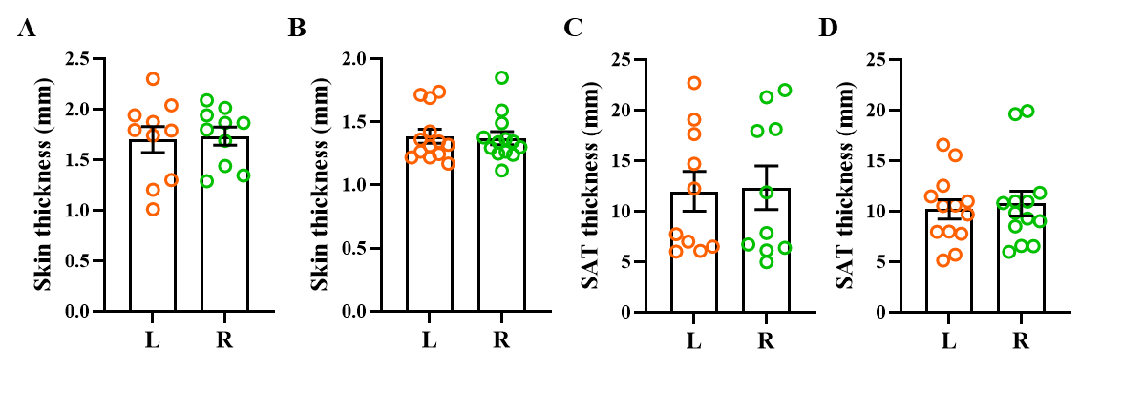Supplementary Fig. S1. Skin (A, B) and SAT (C, D) thickness at positions 4L (orange) and 4R (green) on the abdomen of males (A, C) and females (B, D). Statistical analysis was performed with multiple Wilcoxon matched-pairs signed rank test using GraphPad Prism 9.0.0 (San Diego. CA. USA). Data are presented in scatter plots with error bars representing SEM.

Supplementary Table S2. Blood parameters, tissue composition and scattering parameters of all subjects at the three S-D distances on the vastus lateralis region.
Subject ID | Sex | ρ  (cm) | tHb (µM) | SO₂ (%) | Lipid  (mg/cm³) | Water (mg/cm³) | Collagen (mg/cm³) | A  (cm⁻¹) | b  (-)
0 | M | 1 | 18.14 | 63 | 1 | 857 | 1367 | 12.03 | 1.74
0 | M | 2 | 21.87 | 79 | 162 | 501 | 1738 | 10.73 | 1.33
0 | M | 3 | 21.45 | 79 | 258 | 556 | 1268 | 9.73 | 1.02
1 | M | 1 | 35.13 | 82 | 165 | 511 | 1671 | 13.65 | 1.34
1 | M | 2 | 52.25 | 83 | 163 | 520 | 1654 | 9.97 | 1.06
1 | M | 3 | 53.61 | 59 | 4 | 287 | 1386 | 8.25 | 2.56
2 | F | 1 | 19.94 | 82 | 786 | 184 | 188 | 10.84 | 1.25
2 | F | 2 | 18.54 | 82 | 799 | 166 | 158 | 10.57 | 0.87
2 | F | 3 | 18.62 | 85 | 789 | 181 | 108 | 9.91 | 0.69
3 | M | 1 | 25.34 | 79 | 615 | 267 | 487 | 14.43 | 0.96
3 | M | 2 | 29.19 | 80 | 545 | 334 | 566 | 12.10 | 0.63
3 | M | 3 | 33.81 | 78 | 445 | 381 | 698 | 10.48 | 0.72
4 | M | 1 | 28.89 | 86 | 607 | 279 | 645 | 13.05 | 0.96
4 | M | 2 | 27.59 | 85 | 664 | 307 | 674 | 11.28 | 0.72
4 | M | 3 | 32.07 | 85 | 512 | 381 | 647 | 10.32 | 0.74
5 | M | 1 | 25.69 | 83 | 192 | 459 | 1754 | 11.70 | 1.32
5 | M | 2 | 28.07 | 87 | 258 | 491 | 1779 | 8.85 | 0.88
5 | M | 3 | 40.59 | 80 | 196 | 509 | 1422 | 8.43 | 1.03
6 | M | 1 | 27.89 | 77 | 674 | 298 | 508 | 16.21 | 1.27
6 | M | 2 | 28.35 | 80 | 658 | 339 | 530 | 12.28 | 0.89
6 | M | 3 | 28.42 | 83 | 515 | 438 | 756 | 10.62 | 0.83
7 | F | 1 | 13.56 | 80 | 789 | 169 | 258 | 11.97 | 0.91
7 | F | 2 | 15.72 | 79 | 769 | 181 | 247 | 10.25 | 0.79
7 | F | 3 | 15.56 | 84 | 764 | 216 | 386 | 9.61 | 0.69
8 | F | 1 | 17.53 | 80 | 863 | 127 | 61 | 12.45 | 0.66
8 | F | 2 | 18.06 | 82 | 862 | 129 | 128 | 10.62 | 0.58
8 | F | 3 | 17.35 | 84 | 793 | 151 | 231 | 10.01 | 0.57
9 | M | 1 | 18.34 | 80 | 651 | 267 | 576 | 16.64 | 1.19
9 | M | 2 | 19.66 | 90 | 578 | 283 | 796 | 12.86 | 0.81
9 | M | 3 | 20.84 | 89 | 543 | 325 | 682 | 10.36 | 0.73
11 | F | 1 | 15.11 | 80 | 813 | 145 | 223 | 10.90 | 0.64
11 | F | 2 | 15.16 | 76 | 809 | 148 | 180 | 9.96 | 0.59
11 | F | 3 | 15.84 | 79 | 792 | 138 | 211 | 9.80 | 0.56
12 | M | 1 | 12.63 | 79 | 649 | 222 | 437 | 15.48 | 0.90
12 | M | 2 | 13.51 | 80 | 733 | 252 | 433 | 10.90 | 0.55
12 | M | 3 | 16.92 | 81 | 691 | 261 | 331 | 9.35 | 0.50
13 | F | 1 | 15.59 | 82 | 750 | 196 | 484 | 12.42 | 0.94
13 | F | 2 | 15.05 | 81 | 717 | 197 | 488 | 10.90 | 0.78
13 | F | 3 | 16.90 | 82 | 722 | 216 | 357 | 9.91 | 0.65
15 | F | 1 | 17.61 | 89 | 639 | 245 | 577 | 13.12 | 0.93
15 | F | 2 | 18.10 | 89 | 713 | 233 | 541 | 11.29 | 0.68
15 | F | 3 | 20.87 | 91 | 663 | 243 | 402 | 10.01 | 0.68
16 | F | 1 | 15.78 | 87 | 790 | 133 | 125 | 11.13 | 0.80
16 | F | 2 | 15.47 | 84 | 852 | 121 | 80 | 10.32 | 0.70
16 | F | 3 | 14.04 | 84 | 817 | 132 | 129 | 9.88 | 0.61
17 | M | 1 | 23.63 | 84 | 209 | 543 | 1499 | 13.70 | 1.00
17 | M | 2 | 25.31 | 88 | 342 | 457 | 1607 | 10.26 | 0.74
17 | M | 3 | 29.90 | 83 | 322 | 493 | 1427 | 8.88 | 0.83
18 | F | 1 | 16.02 | 76 | 664 | 175 | 278 | 13.73 | 1.16
18 | F | 2 | 16.82 | 80 | 782 | 143 | 178 | 11.48 | 0.78
18 | F | 3 | 16.38 | 82 | 800 | 145 | 231 | 11.34 | 0.72
19 | F | 1 | 18.35 | 82 | 644 | 283 | 463 | 10.13 | 0.93
19 | F | 2 | 20.48 | 83 | 680 | 250 | 534 | 8.98 | 0.74
19 | F | 3 | 21.91 | 85 | 676 | 252 | 517 | 8.51 | 0.67
21 | F | 1 | 13.71 | 69 | 830 | 107 | 0 | 10.12 | 0.74
21 | F | 2 | 14.37 | 72 | 909 | 118 | 1 | 9.71 | 0.46
21 | F | 3 | 13.41 | 74 | 868 | 121 | 69 | 9.59 | 0.42
22 | F | 1 | 20.62 | 82 | 829 | 157 | 4 | 10.20 | 0.69
22 | F | 2 | 22.57 | 82 | 863 | 176 | 24 | 9.62 | 0.56
22 | F | 3 | 22.80 | 86 | 815 | 176 | 168 | 9.23 | 0.48
23 | F | 1 | 22.08 | 86 | 784 | 180 | 233 | 12.05 | 0.97
23 | F | 2 | 26.55 | 87 | 762 | 229 | 532 | 10.03 | 0.70
23 | F | 3 | 26.86 | 83 | 733 | 267 | 361 | 9.54 | 0.61
25 | F | 1 | 13.33 | 77 | 851 | 149 | 1 | 8.75 | 0.76
25 | F | 2 | 16.43 | 80 | 877 | 157 | 115 | 8.22 | 0.59
tHb = total hemoglobin content, StO₂ = oxygen saturation.

Supplementary Table S3. Blood parameters, tissue composition and scattering parameters for all subjects at the three S-D distances on the abdomen at 4 cm to the left of the umbilicus (4L).
Subject ID | Sex | ρ  (cm) | tHb  (µM) | StO₂ (%) | Lipid (mg/cm³) | Water (mg/cm³) | Collagen (mg/cm³) | A  (cm⁻¹) | b  (-)
0 | M | 1 | 9.41 | 71 | 521 | 284 | 383 | 14.29 | 1.62
0 | M | 2 | 14.76 | 93 | 662 | 141 | 469 | 11.88 | 1.06
0 | M | 3 | 15.81 | 91 | 718 | 139 | 309 | 10.45 | 0.85
1 | M | 1 | 28.24 | 86 | 318 | 124 | 412 | 13.82 | 2.09
1 | M | 2 | 35.34 | 80 | 375 | 91 | 86 | 13.80 | 2.10
1 | M | 3 | 32.35 | 81 | 374 | 124 | 16 | 12.66 | 1.69
2 | F | 1 | 10.30 | 70 | 675 | 199 | 0 | 13.92 | 1.57
2 | F | 2 | 19.40 | 76 | 520 | 121 | 87 | 15.60 | 1.97
2 | F | 3 | 18.69 | 70 | 347 | 76 | 33 | 12.67 | 2.40
3 | M | 1 | 28.30 | 87 | 605 | 255 | 242 | 22.76 | 1.21
3 | M | 2 | 34.33 | 87 | 554 | 308 | 197 | 19.95 | 0.96
3 | M | 3 | 43.66 | 88 | 339 | 564 | 268 | 17.14 | 0.62
4 | M | 1 | 9.25 | 73 | 799 | 185 | 1 | 12.51 | 0.97
4 | M | 2 | 12.77 | 79 | 847 | 131 | 0 | 11.56 | 0.98
4 | M | 3 | 15.74 | 88 | 837 | 72 | 17 | 10.96 | 0.98
5 | M | 1 | 22.27 | 89 | 567 | 179 | 398 | 15.75 | 1.49
5 | M | 2 | 25.75 | 88 | 694 | 178 | 271 | 13.95 | 1.18
5 | M | 3 | 26.44 | 87 | 649 | 243 | 330 | 14.26 | 0.99
6 | M | 1 | 29.62 | 93 | 684 | 195 | 347 | 16.80 | 1.41
6 | M | 2 | 33.28 | 91 | 750 | 218 | 256 | 13.57 | 1.09
6 | M | 3 | 33.65 | 90 | 614 | 334 | 377 | 14.49 | 0.98
7 | F | 1 | 6.53 | 65 | 676 | 198 | 0 | 13.65 | 0.68
7 | F | 2 | 18.36 | 93 | 777 | 118 | 174 | 13.97 | 0.84
7 | F | 3 | 18.02 | 89 | 803 | 124 | 73 | 12.68 | 0.79
8 | F | 1 | 28.15 | 90 | 646 | 189 | 343 | 16.41 | 1.34
8 | F | 2 | 28.69 | 89 | 781 | 163 | 141 | 14.05 | 1.00
8 | F | 3 | 28.67 | 89 | 754 | 237 | 147 | 14.47 | 0.79
9 | M | 1 | 18.45 | 92 | 573 | 158 | 450 | 16.77 | 1.56
9 | M | 2 | 19.80 | 92 | 718 | 144 | 221 | 13.54 | 0.98
9 | M | 3 | 19.01 | 89 | 798 | 133 | 110 | 13.64 | 0.88
11 | F | 1 | 17.59 | 89 | 762 | 128 | 267 | 14.18 | 1.00
11 | F | 2 | 17.79 | 89 | 807 | 117 | 241 | 11.16 | 0.78
11 | F | 3 | 18.00 | 86 | 836 | 125 | 118 | 11.78 | 0.68
12 | M | 1 | 8.43 | 74 | 778 | 173 | 0 | 13.46 | 0.74
12 | M | 2 | 14.81 | 91 | 788 | 77 | 80 | 11.71 | 0.82
12 | M | 3 | 11.70 | 89 | 788 | 126 | 0 | 10.26 | 0.48
13 | F | 1 | 10.00 | 71 | 779 | 135 | 111 | 14.57 | 1.11
13 | F | 2 | 10.44 | 81 | 823 | 97 | 145 | 10.95 | 0.79
13 | F | 3 | 11.44 | 79 | 843 | 95 | 85 | 10.65 | 0.69
15 | F | 1 | 19.30 | 92 | 707 | 116 | 288 | 12.91 | 1.37
15 | F | 2 | 21.54 | 92 | 680 | 153 | 278 | 10.40 | 1.06
15 | F | 3 | 23.60 | 89 | 835 | 164 | 103 | 11.95 | 0.83
16 | F | 1 | 14.16 | 83 | 663 | 136 | 301 | 13.38 | 1.35
16 | F | 2 | 16.98 | 86 | 781 | 132 | 287 | 11.95 | 0.86
16 | F | 3 | 17.27 | 84 | 739 | 172 | 297 | 12.30 | 0.76
17 | M | 1 | 25.16 | 88 | 567 | 219 | 661 | 14.35 | 1.20
17 | M | 2 | 26.01 | 89 | 731 | 187 | 363 | 12.01 | 0.82
17 | M | 3 | 24.86 | 83 | 664 | 229 | 343 | 12.05 | 0.74
18 | F | 1 | 21.35 | 87 | 579 | 224 | 422 | 16.67 | 1.47
18 | F | 2 | 20.38 | 88 | 712 | 184 | 328 | 15.22 | 1.06
18 | F | 3 | 20.16 | 84 | 698 | 281 | 165 | 14.53 | 0.84
19 | F | 1 | 18.60 | 87 | 753 | 144 | 112 | 10.60 | 1.32
19 | F | 2 | 19.43 | 85 | 863 | 143 | 2 | 9.93 | 0.93
19 | F | 3 | 19.49 | 88 | 791 | 159 | 133 | 10.98 | 0.88
20 | M | 1 | 17.17 | 90 | 735 | 147 | 191 | 14.84 | 1.00
20 | M | 2 | 17.55 | 91 | 850 | 118 | 74 | 11.02 | 0.69
20 | M | 3 | 16.60 | 89 | 859 | 112 | 13 | 11.37 | 0.65
21 | F | 1 | 28.42 | 85 | 757 | 195 | 4 | 13.96 | 1.09
21 | F | 2 | 28.54 | 83 | 826 | 208 | 138 | 14.07 | 0.89
21 | F | 3 | 31.25 | 86 | 683 | 292 | 255 | 14.07 | 0.68
22 | F | 1 | 21.03 | 85 | 851 | 175 | 3 | 13.02 | 0.88
22 | F | 2 | 26.29 | 88 | 865 | 162 | 10 | 13.79 | 0.80
22 | F | 3 | 28.40 | 88 | 737 | 238 | 106 | 14.28 | 0.71
23 | F | 1 | 26.34 | 85 | 589 | 216 | 323 | 16.12 | 1.47
23 | F | 2 | 27.71 | 85 | 729 | 205 | 215 | 14.58 | 1.09
23 | F | 3 | 30.27 | 86 | 619 | 299 | 311 | 15.36 | 0.84
25 | F | 1 | 10.41 | 74 | 822 | 192 | 0 | 12.77 | 0.93
25 | F | 2 | 15.09 | 83 | 851 | 110 | 0 | 11.77 | 0.92
25 | F | 3 | 17.13 | 90 | 864 | 94 | 44 | 11.14 | 0.65
tHb = total hemoglobin content, StO₂ = oxygen saturation.

Supplementary Table S4. Blood parameters, tissue composition and scattering parameters for all subjects at the three S-D distances on the abdomen at 4 cm to the right of the umbilicus (4R).
Subject ID | Sex | ρ  (cm) | tHb (µM) | StO₂ (%) | Lipid (mg/cm³) | Water (mg/cm³) | Collagen (mg/cm³) | A  (cm⁻¹) | b  (-)
0 | M | 1 | 8.81 | 58 | 545 | 364 | 135 | 14.40 | 1.65
0 | M | 2 | 13.74 | 85 | 721 | 139 | 238 | 12.60 | 1.19
0 | M | 3 | 13.12 | 87 | 783 | 129 | 184 | 12.14 | 0.88
1 | M | 1 | 21.57 | 76 | 418 | 190 | 125 | 15.92 | 2.11
1 | M | 2 | 26.36 | 77 | 413 | 123 | 78 | 15.81 | 1.97
1 | M | 3 | 26.34 | 80 | 402 | 148 | 57 | 14.01 | 1.71
2 | F | 1 | 9.11 | 67 | 625 | 170 | 0 | 12.52 | 1.89
2 | F | 2 | 17.63 | 76 | 567 | 91 | 18 | 13.03 | 2.05
2 | F | 3 | 15.85 | 61 | 329 | 28 | 48 | 15.02 | 3.23
3 | M | 1 | 31.98 | 87 | 563 | 269 | 335 | 20.29 | 1.28
3 | M | 2 | 34.67 | 85 | 650 | 248 | 131 | 17.07 | 0.95
3 | M | 3 | 37.71 | 90 | 510 | 447 | 484 | 16.15 | 0.50
4 | M | 1 | 7.90 | 69 | 756 | 184 | 0 | 12.81 | 0.88
4 | M | 2 | 12.20 | 79 | 843 | 115 | 0 | 11.91 | 0.91
4 | M | 3 | 15.27 | 87 | 827 | 77 | 1 | 11.43 | 0.92
5 | M | 1 | 17.10 | 84 | 490 | 212 | 424 | 16.68 | 1.67
5 | M | 2 | 19.12 | 85 | 690 | 170 | 218 | 14.72 | 1.18
5 | M | 3 | 20.39 | 86 | 730 | 220 | 118 | 15.12 | 0.87
6 | M | 1 | 25.29 | 88 | 671 | 189 | 336 | 17.81 | 1.46
6 | M | 2 | 28.69 | 90 | 743 | 207 | 280 | 14.17 | 1.01
6 | M | 3 | 31.46 | 90 | 616 | 324 | 371 | 13.95 | 0.92
7 | F | 1 | 5.50 | 57 | 572 | 175 | 0 | 13.55 | 0.62
7 | F | 2 | 10.43 | 78 | 781 | 158 | 1 | 13.52 | 0.68
7 | F | 3 | 17.69 | 91 | 841 | 119 | 72 | 13.72 | 0.67
8 | F | 1 | 22.95 | 91 | 711 | 146 | 228 | 18.12 | 1.16
8 | F | 2 | 26.00 | 89 | 808 | 136 | 105 | 15.05 | 0.93
8 | F | 3 | 26.78 | 91 | 746 | 192 | 258 | 15.58 | 0.81
9 | M | 1 | 13.80 | 81 | 700 | 135 | 152 | 14.55 | 1.49
9 | M | 2 | 15.25 | 89 | 796 | 107 | 149 | 12.65 | 0.89
9 | M | 3 | 16.40 | 88 | 819 | 116 | 73 | 13.14 | 0.81
11 | F | 1 | 12.14 | 83 | 754 | 117 | 188 | 15.61 | 1.06
11 | F | 2 | 14.40 | 86 | 806 | 109 | 171 | 13.22 | 0.84
11 | F | 3 | 14.84 | 84 | 863 | 113 | 40 | 13.57 | 0.75
12 | M | 1 | 7.38 | 71 | 732 | 164 | 1 | 13.37 | 0.73
12 | M | 2 | 13.71 | 90 | 786 | 71 | 90 | 11.52 | 0.84
12 | M | 3 | 13.47 | 87 | 794 | 67 | 1 | 10.85 | 0.82
13 | F | 1 | 9.08 | 77 | 780 | 105 | 174 | 13.16 | 0.93
13 | F | 2 | 10.26 | 81 | 848 | 100 | 128 | 11.29 | 0.63
13 | F | 3 | 12.70 | 78 | 850 | 102 | 63 | 12.89 | 0.67
15 | F | 1 | 20.69 | 92 | 595 | 163 | 449 | 14.09 | 1.34
15 | F | 2 | 22.49 | 92 | 719 | 146 | 343 | 12.13 | 1.16
15 | F | 3 | 21.68 | 88 | 734 | 188 | 161 | 13.49 | 0.92
16 | F | 1 | 12.75 | 80 | 709 | 146 | 208 | 13.40 | 1.21
16 | F | 2 | 15.54 | 83 | 788 | 122 | 161 | 12.44 | 0.88
16 | F | 3 | 16.50 | 85 | 763 | 133 | 212 | 13.32 | 0.83
17 | M | 1 | 20.53 | 83 | 647 | 209 | 415 | 16.17 | 1.03
17 | M | 2 | 22.38 | 85 | 771 | 158 | 340 | 13.69 | 0.72
17 | M | 3 | 22.54 | 82 | 725 | 210 | 275 | 13.88 | 0.64
18 | F | 1 | 18.01 | 87 | 597 | 186 | 298 | 16.51 | 1.56
18 | F | 2 | 19.61 | 85 | 782 | 152 | 123 | 13.08 | 1.08
18 | F | 3 | 18.52 | 86 | 748 | 173 | 144 | 13.90 | 0.95
19 | F | 1 | 20.48 | 89 | 715 | 159 | 119 | 11.69 | 1.21
19 | F | 2 | 21.09 | 91 | 823 | 134 | 150 | 10.51 | 0.87
19 | F | 3 | 21.89 | 89 | 833 | 151 | 77 | 10.31 | 0.79
20 | M | 1 | 9.88 | 76 | 803 | 189 | 1 | 13.31 | 0.79
20 | M | 2 | 14.14 | 81 | 833 | 130 | 0 | 11.87 | 0.87
20 | M | 3 | 15.27 | 86 | 845 | 86 | 1 | 11.77 | 0.84
21 | F | 1 | 20.61 | 83 | 847 | 148 | 0 | 12.92 | 0.84
21 | F | 2 | 25.05 | 86 | 875 | 133 | 2 | 13.02 | 0.76
21 | F | 3 | 26.35 | 88 | 795 | 187 | 65 | 14.00 | 0.62
22 | F | 1 | 22.96 | 84 | 866 | 189 | 1 | 12.84 | 0.89
22 | F | 2 | 30.01 | 89 | 847 | 153 | 8 | 13.74 | 0.81
22 | F | 3 | 29.62 | 91 | 705 | 225 | 221 | 14.69 | 0.68
23 | F | 1 | 25.44 | 84 | 593 | 225 | 247 | 17.34 | 1.49
23 | F | 2 | 27.29 | 85 | 760 | 186 | 173 | 16.35 | 1.16
23 | F | 3 | 30.07 | 88 | 632 | 251 | 277 | 17.20 | 0.97
25 | F | 1 | 9.16 | 73 | 778 | 207 | 1 | 13.63 | 0.76
25 | F | 2 | 15.30 | 81 | 829 | 139 | 0 | 12.42 | 0.85
25 | F | 3 | 17.14 | 86 | 823 | 104 | 0 | 12.31 | 0.77
tHb = total hemoglobin content, StO₂ = oxygen saturation.

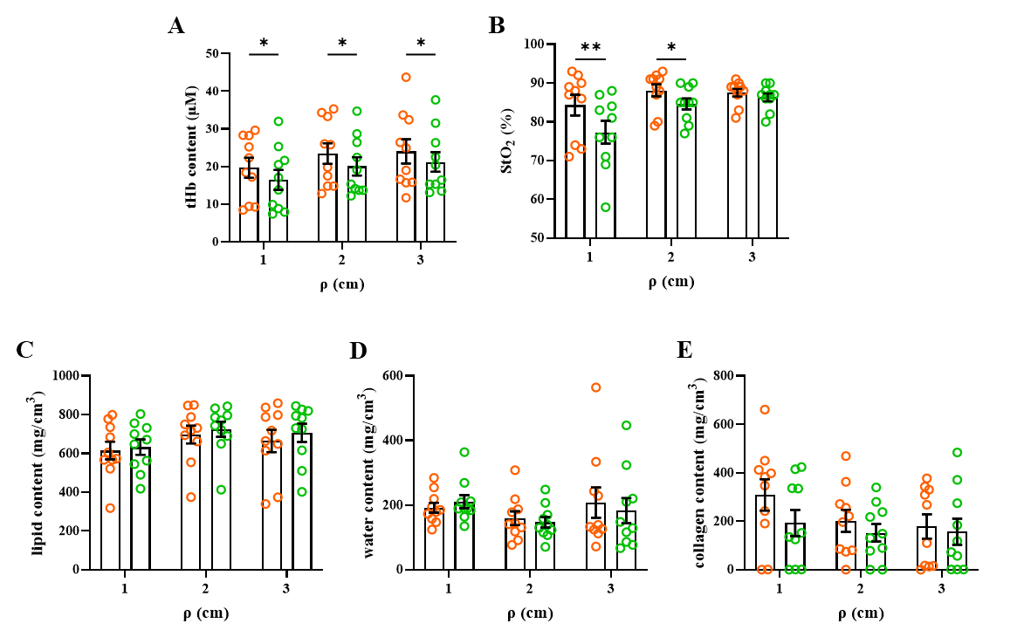
Supplementary Fig. S2. Total hemoglobin content (A), oxygen saturation (B), lipid content (C), water content (D) and collagen content (E) at different S-D distances in males. Left (4L, orange) and right (4R, green) on the abdomen are compared. Statistical analysis was performed with RM Two-way ANOVA with Šídák's multiple comparisons test using GraphPad Prism 9.0.0 (San Diego. CA. USA). Data are presented in scatter plots with error bars representing SEM. * corresponds to p value < 0.05; ** p < 0.01.

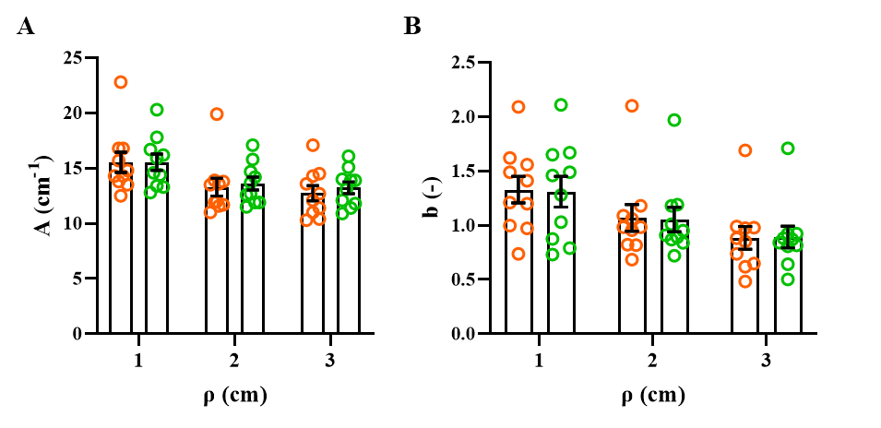
Supplementary Fig. S3. Scattering amplitude (A) and scattering slope (B) at different S-D distances in males. Left (4L, orange) and right (4R, green) on the abdomen are compared. Statistical analysis was performed with RM Two-way ANOVA with Šídák's multiple comparisons test using GraphPad Prism 9.0.0 (San Diego. CA. USA). Data are presented in scatter plots with bars. Error bars represent SEM.

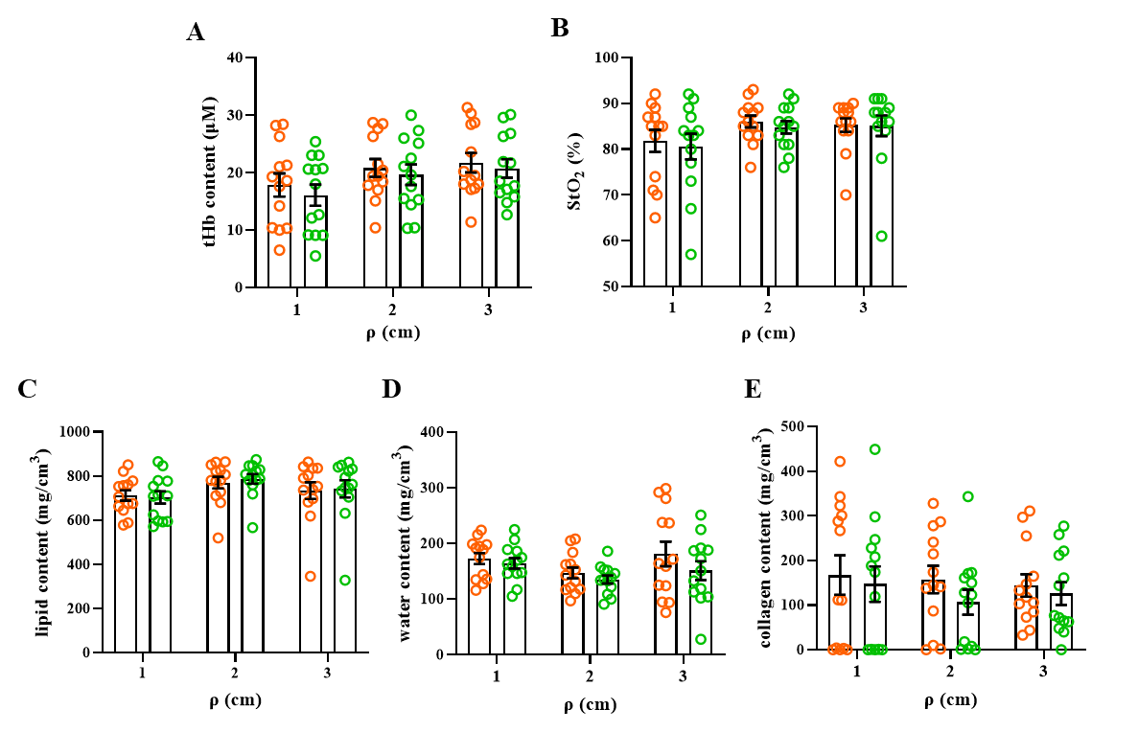 Supplementary Fig. S4. Total hemoglobin content (A), oxygen saturation (B), lipid content (C), water content (D) and collagen content (D) at different S-D distances in females. Left (4L, orange) and right (4R, green) on the abdomen are compared. Statistical analysis was performed with RM Two-way ANOVA with Šídák's multiple comparisons test using GraphPad Prism 9.0.0 (San Diego. CA. USA). Data are presented in scatter plots with error bars representing SEM.

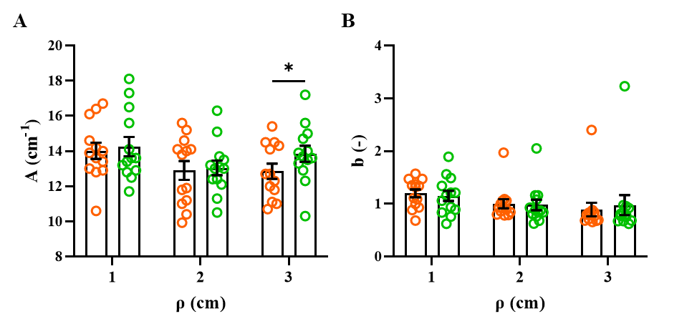
Supplementary Fig. S5. Scattering amplitude (A), scattering slope (B) and background (C) at different S-D distances in female. Left (4L, orange) and right (4R, green) on the abdomen are compared. Statistical analysis was performed with RM Two-way ANOVA with Šídák's multiple comparisons test using GraphPad Prism 9.0.0 (San Diego. CA. USA). Data are presented in scatter plots with error bars representing SEM. * corresponds to p value p < 0.05.

Supplementary Fig. S6. Correlation plot for ultrasound measurements, blood parameters, tissue composition and scattering parameters in males. It visualizes all the Spearman correlations (𝜌_{௦}) between couples of quantitative variables (average values at the 3 S-D distances) collected in vastus lateralis (VL) and abdomen region (ABD) for the 4L and 4R positions, considering the mean value of the three S-D distances measurements. Blue and red cells correspond to positive (0 ≤ 𝜌_{௦} ≤ 1) and negative correlations (−1 ≤ 𝜌_{௦} < 0), respectively. The color intensity of the cell is proportional to the magnitude of the Spearman index. Analyses were carried out using GraphPad Prism 9.0.0 (San Diego. CA. USA). VL, vastus lateralis; ABD, abdomen; 4L, 4 cm left of the umbilicus; 4R, 4 cm right of the umbilicus; Skin, skin thickness; SAT, subcutaneous adipose tissue thickness; tHb, total hemoglobin content (µM); StO₂, oxygen saturation level (%); lipid, lipid content (mg/cm³); water, water content (mg/cm³); collagen, collagen content (mg/cm³); A scattering amplitude (cm⁻¹); b, scattering slope (-).

Supplementary Fig. S7. Correlation plot for ultrasound measurements, blood parameters, tissue composition and scattering parameters in females. It visualizes all the Spearman correlations (𝜌_{௦}) between couples of quantitative variables (average values at the 3 S-D distances) collected in vastus lateralis (VL) and abdomen region (ABD) for the 4L and 4R positions, considering the mean value of the three S-D distances measurements. Blue and red cells correspond to positive (0 ≤ 𝜌_{௦} ≤ 1) and negative correlations (−1 ≤ 𝜌_{௦} < 0), respectively. The color intensity of the cell is proportional to the magnitude of the Spearman index. Analyses were carried out using GraphPad Prism 9.0.0 (San Diego. CA. USA). VL, vastus lateralis; ABD, abdomen; 4L, 4 cm left of the umbilicus; 4R, 4 cm right of the umbilicus; Skin, skin thickness; SAT, subcutaneous adipose tissue thickness; tHb, total hemoglobin content (µM); StO₂, oxygen saturation (%); lipid, lipid content (mg/cm³); water, water content (mg/cm³); collagen, collagen content (mg/cm³); A, scattering amplitude (cm⁻¹); b, scattering slope (-).

