Supplemental materials

What about Adaptive Introgression? The Genomic Revolution Is Shaping Scientific and Public Perception

Identification of studies via other methods
Identification of studies via databases and registers

Records identified from:
Citation searching (n = 47)
Records removed before screening:
Duplicate records removed (n = 279)
Records identified from:
Databases (n = 820)

Identification

Records screened
(n = 541)
Records excluded
(n = 55)

Reports not retrieved
(n = 20)
Reports sought for retrieval
(n = 47)
Reports sought for retrieval
(n = 486)
Reports not retrieved
(n = 77)
Screening

Reports assessed for eligibility
(n = 27)
Reports excluded:
Reason 1 (n = 2)
Reason 2 (n = 9)

Reports assessed for eligibility
(n = 409)
Reports excluded:
Reason 1 (n = 20)
Reason 2 (n = 47)
.

Studies included in review
(n = 358)
Included

WebFigure 1. PRISMA 2020 flow diagram. Adapted from: Page MJ, McKenzie JE, Bossuyt PM, Boutron I, Hoffmann TC, Mulrow CD, et al. The PRISMA 2020 statement: an updated guideline for reporting systematic reviews. BMJ 2021;372:n71. doi: 10.1136/bmj.n71. For more information, visit: http://www.prisma-statement.org/

Search details
We used the following search string for on-line databases:
“Topic=(hybrid* AND adapt* AND introgress* AND genom* NOT invas* NOT domest* NOT exotic) OR Topic=(adapt* AND introgress* AND genom* NOT invas* NOT domest* NOT exotic)”
We defined some keywords as strict retention criteria: Adapt* (all terms related to adaptation, adaptive, etc.), Introgress* (all terms related to introgression, introgressive, etc) and Genom* (all terms related to genome, genomics, etc.). We also used as non-strict retention criterion for the term hybrid* (all terms related to hybrids, hybridization, etc.) that could be present together with the previous ones or not. We excluded all breeding contacts between taxa under direct human interference (breeding manipulations between species that do not naturally interbreed, genetic manipulation, invasive species scenarios, etc.). We used the following keywords as strict exclusion criteria: Invas* (all terms related to invasion, invasive species, etc.), Exotic and Domest* (all terms related to domestic species, domestication, etc.).
We defined the expression “Adaptive Introgression” as a keyword used as strict retention criteria searching for relevance grey literature through Google and Google scholar.

Table S1. Full list of information and the total number of papers that includes each category extracted from each reviewed paper.
Categories of information | Variables extracted | Classes used | Number of papers
Bibliographic information | - Authors  - Year  - Title  - Journal  - Research area  - Type of publication  - Location of author’s institution |  | 358  358  358  358  358  358  358
Authors’ initial perception about introgression | - Polarity  - Why positive?  - Why negative?  - Why neutral?  - Prevalence  - Semantics | Positive  Negative  Both  Neutral  Very rare [-3]  Rare [-2]  Infrequent [-1]  Unknown [0]  Few cases [1]  Some cases [2]  Common [3]  Many cases [4]  Ubiquitous [5]  Hybrid* terms used  Hybrid* terms not used | 351  250  78  129  135  358
Taxa under study | - Main taxonomic group  - Families  - Species pairs | Animal  Plant  Fungi  Protists  Bacteria | 355  355  355
Time and space of introgressions’ case studies | - Epoch  - Continent  - Approximated location | Ancient  Recent  Both | 355  355  355
Methods used | - Type of experiment  - Type of introgression markers  - Whole-genome sequencing  - Reference genome | In-situ  Ex-situ  Both  Quantitative Trait Locus  Microsatellites  Mitochondrial DNA  Ribosomal DNA  Single-Nucleotide Polymorphisms  AFLP  PCR amplification  Electrophoresis (DGGE)  Karyotypes  Performed  Not performed  Available  Not available | 351  347  347  165

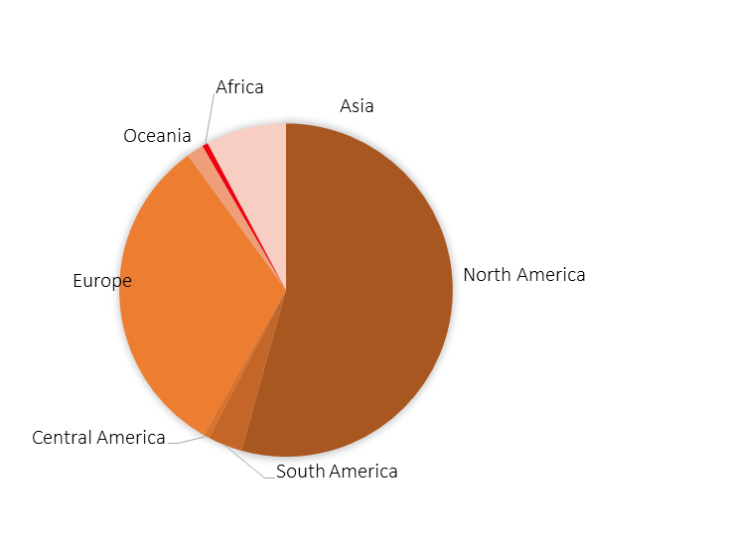
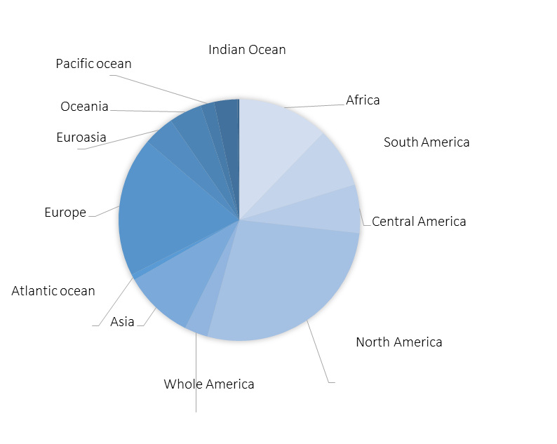

Research teams’ origin
Case studies’ distribution

Figure S1. Distribution of reported adaptive introgression case studies by research team origin (top plot) and geographic location (plot from below).

Table S2. Total number of papers produced by teams from specific geographic regions on case studies located in other geographical locations. 26 papers analysed more than one case study and three papers did not include a case study, resulting in a total of 388 case studies.

Research Team | North America | South America | Central America | Europe | Oceania | Africa | Asia | N_{br} of case study
Case Study
North America | 93% | 0% | 0% | 6% | 0% | 0% | 1% | 104
South America | 27% | 46% | 4% | 23% | 0% | 0% | 0% | 26
Central America | 62% | 10% | 5% | 24% | 0% | 0% | 0% | 21
Europe | 19% | 0% | 0% | 81% | 0% | 0% | 0% | 73
Oceania | 41% | 0% | 0% | 29% | 29% | 0% | 0% | 17
Africa | 55% | 0% | 0% | 40% | 0% | 4% | 0% | 47
Asia | 10% | 0% | 0% | 14% | 0% | 0% | 76% | 58
Indian Ocean | 0% | 0% | 0% | 67% | 0% | 0% | 33% | 3
Atlantic ocean | 50% | 0% | 0% | 50% | 0% | 0% | 0% | 2
Pacific ocean | 57% | 0% | 0% | 29% | 0% | 0% | 14% | 7
Whole world | 91% | 0% | 0% | 9% | 0% | 0% | 0% | 11
Whole America | 50% | 0% | 0% | 50% | 0% | 0% | 0% | 4
Eurasia | 53% | 0% | 0% | 27% | 0% | 0% | 20% | 15
N_{br} of papers per research team | 195 | 14 | 2 | 120 | 5 | 2 | 50 | 388

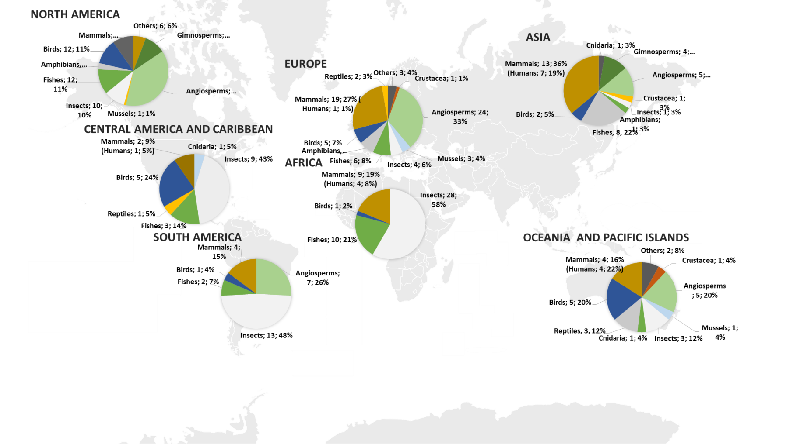

Figure S2. Spatial distribution of reported adaptive introgression case studies by taxa.

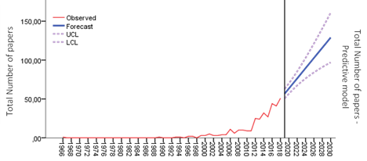

Figure S3. Predictive model of temporal series projections (until 2030), performed by the Expert Modeler Method.

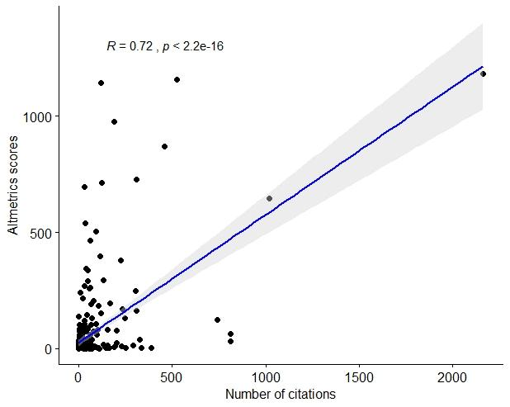
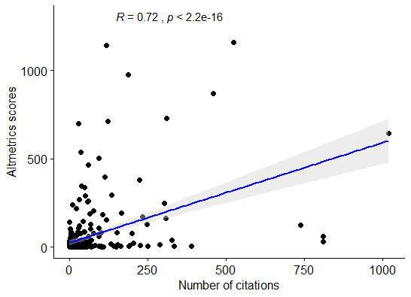

Figure S4. Altmetric.com Attention Score (ASS) correlation with citation count (traditional bibliometric for research ranking) in the literature through Spearman correlation analysis. The solid blue line depicts the relationship between ASS and the number of citations with the main outlier (Green et al. 2010) (a) and without it (b).

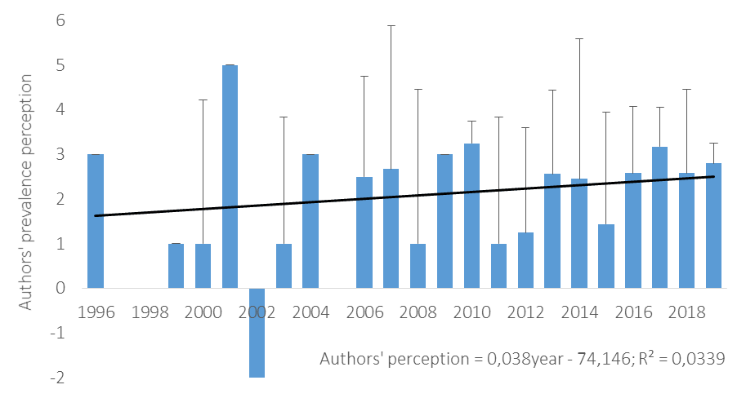

Figure S5. Annual changes in authors' average perception of the prevalence of adaptive introgression, categorized into nine classes: very rare [-3], rare [-2], infrequent [-1], unknown [0], few cases [1], some cases [2], common [3], many cases [4] and ubiquitous [5]. The solid line depicts the relationship between the perception ranking over time.

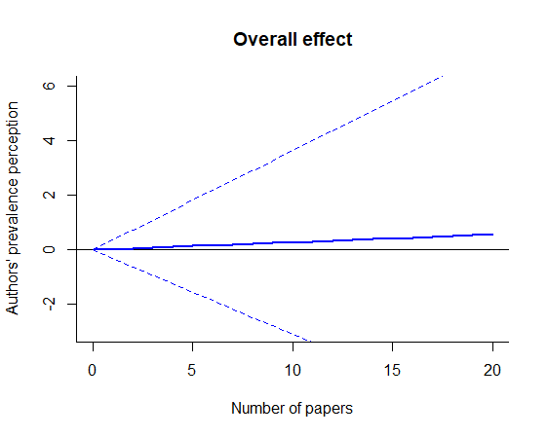
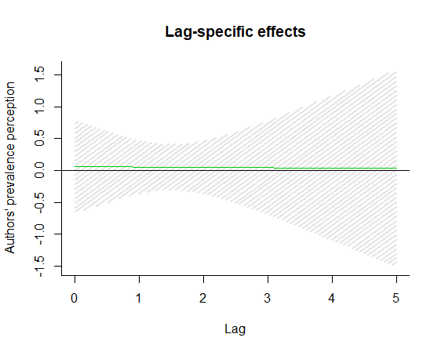

Figure S6. Overall cumulative exposure–response relationships between the temporal change in the number of papers providing evidence for adaptive introgression and authors’ prevalence perception predicted from the model with no interaction (interpreted as the average), with 95% CI (a). Lag–response relationships between the number of adaptive introgression evidence (number of papers) and authors’ perception about its prevalence, with 95% CI (b).

Anger | Disgust
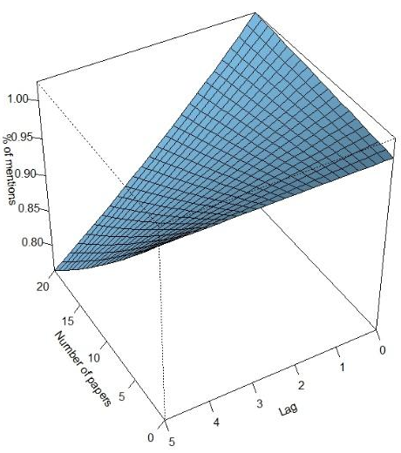 | 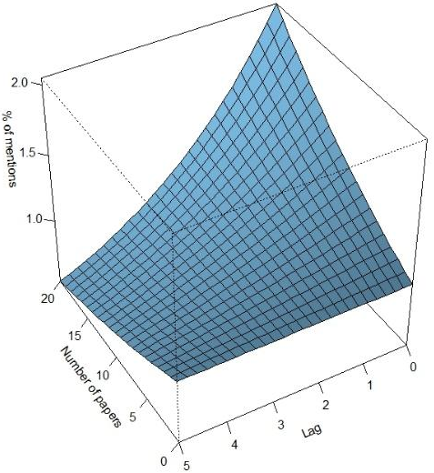
Fear | Sadness
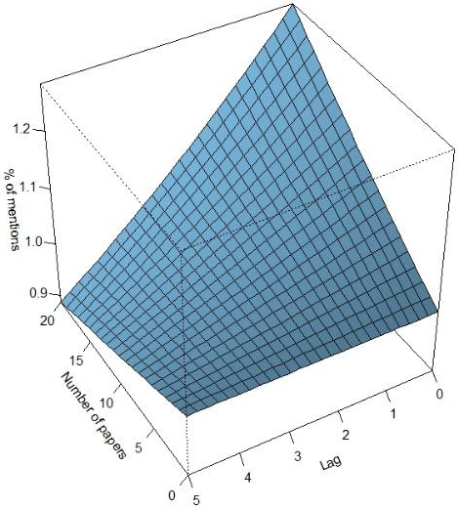 | 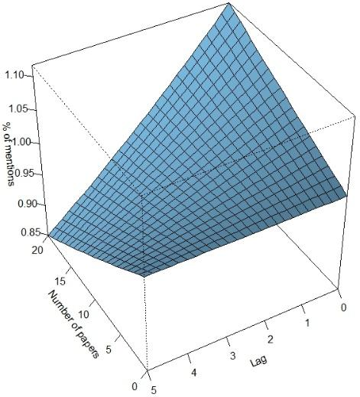

Figure S7. Three-dimensional plots showing temporal changes (from 2000 to 2019) in the estimated exposure–lag–response association between the number of published papers providing evidence for adaptive introgression and the percentage of mentions expressing negative emotions (anger, disgust, fear and sadness) of the total annual mentions expressed by the public about them, with the average as reference, and each Lag period corresponding to 4 years.

Anticipation | Joy
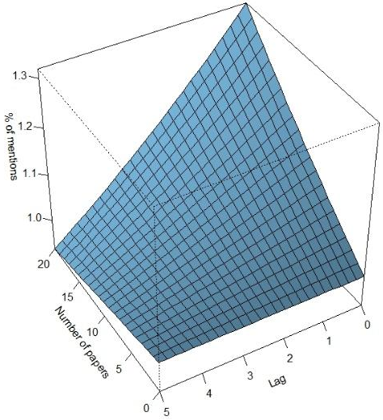 | 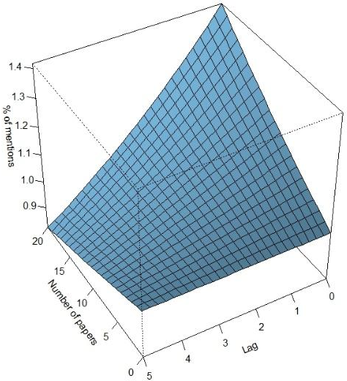
Surprise | Trust
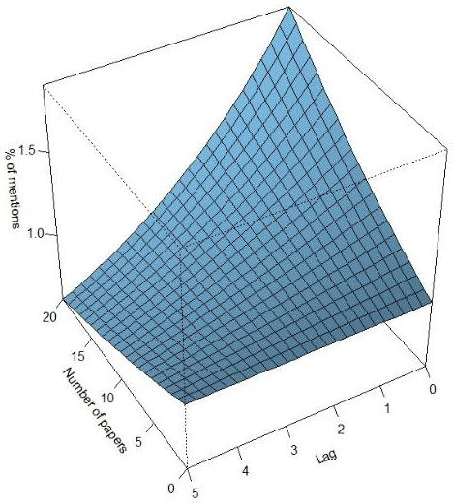 | 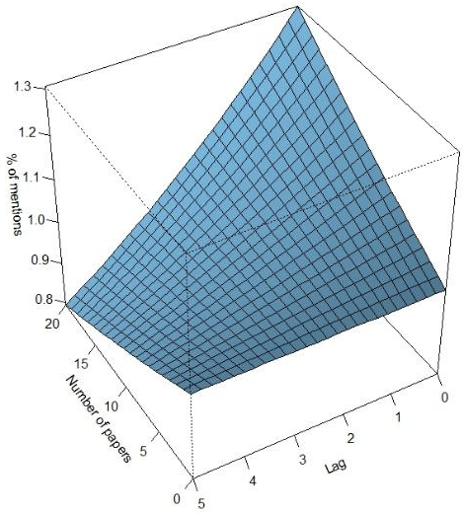

Figure S8. Three-dimensional plots showing temporal changes (from 2000 to 2019) of the estimated exposure–lag–response association between the number of published papers providing evidence for adaptive introgression and the percentage of mentions expressing positive emotions (anticipation, joy, surprise and trust) of the total annual mentions expressed by the public about them, with the average as reference, and each Lag period corresponding to 4 years.

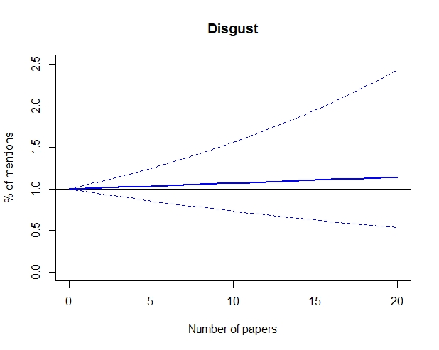
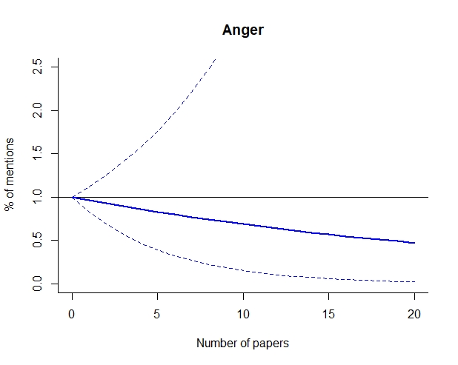
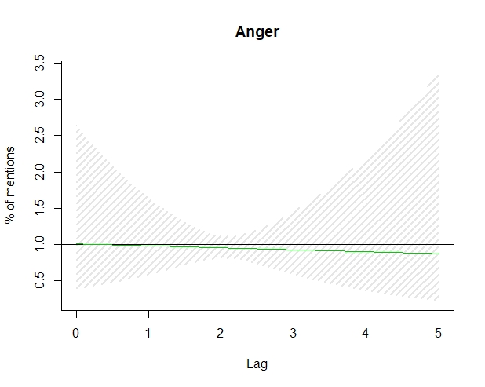
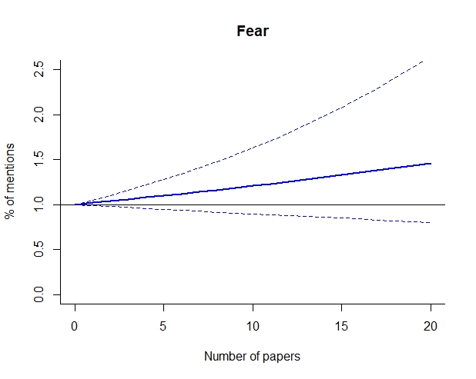
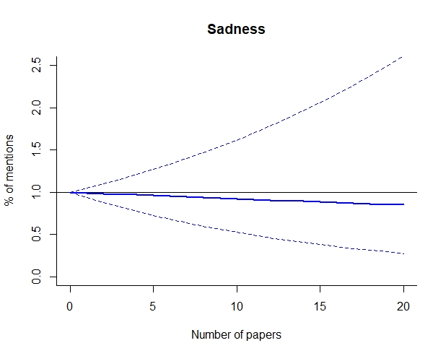
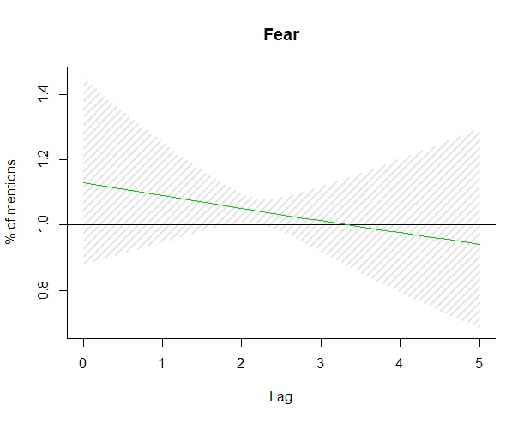
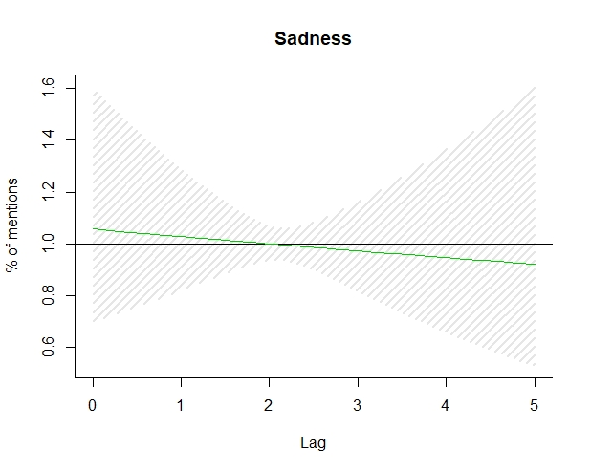
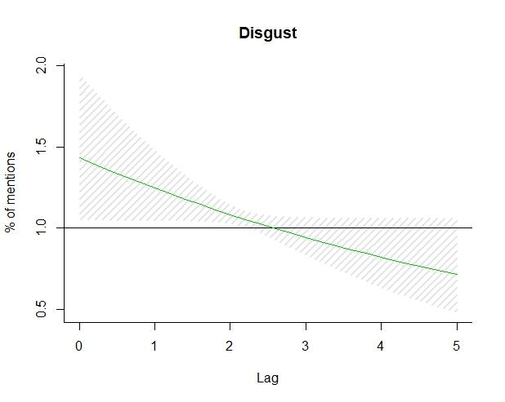
Figure S9. Overall cumulative exposure–response (left plots) and Lag–response (right plots) relationships between temporal changes (from 2000 to 2019) in the number of papers providing evidence for adaptive introgression evidences and the percentage of mentions revealing negative emotions (Anger, Disgust, Fear and Sadness) predicted from the model with no interaction (interpreted as the average), with 95% CI.

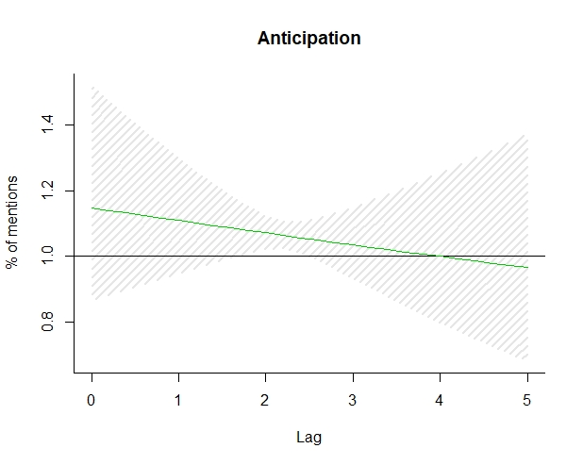
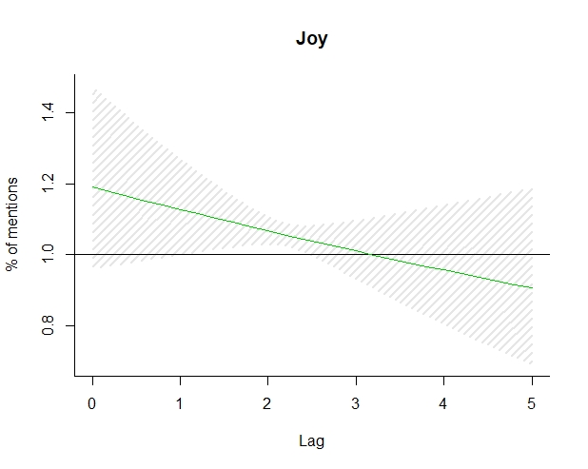
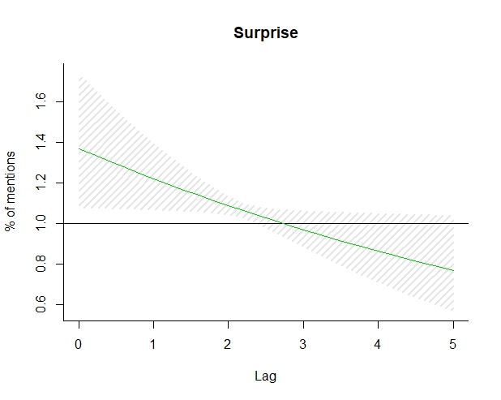
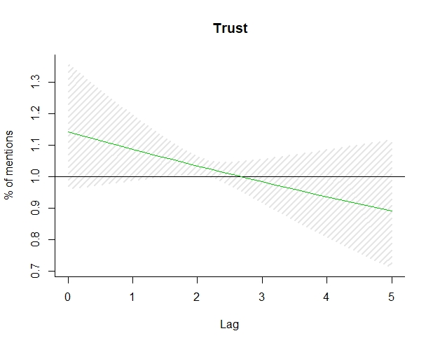
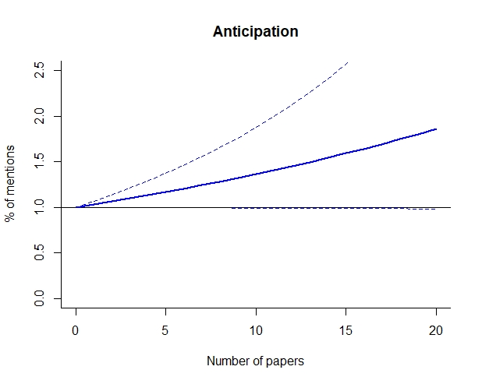
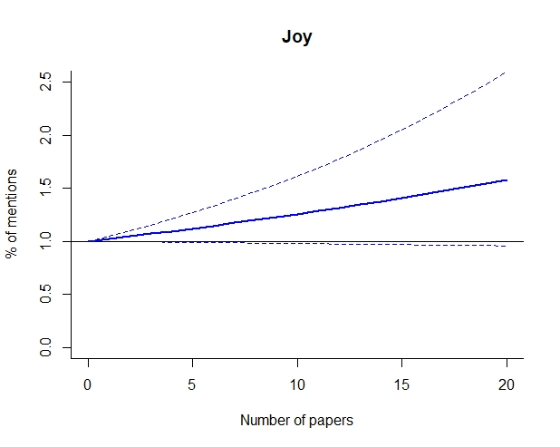
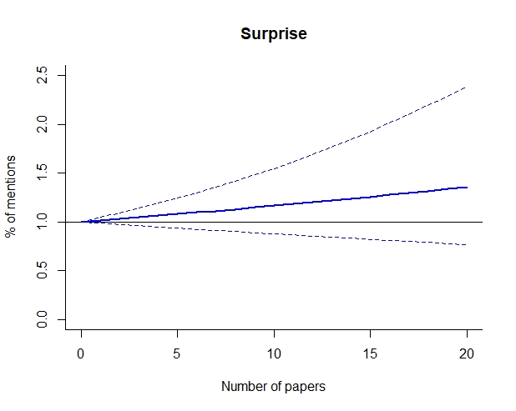
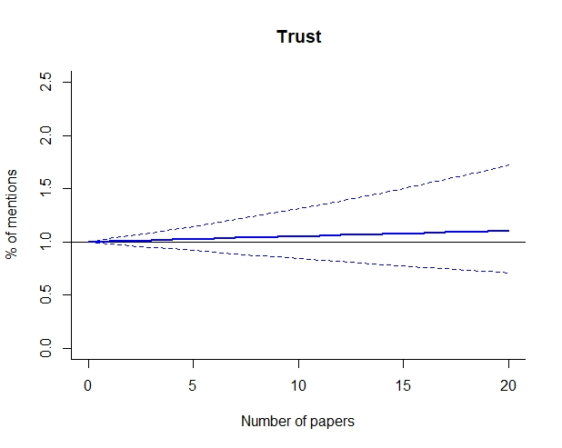
Figure S10. Overall cumulative exposure–response (left plots) and Lag–response (right plots) relationships between the temporal changes (from 2000 to 2019) in the number of adaptive introgression evidences (number of papers) and the percentage of mentions revealing positive emotions (Anticipation, Joy, Surprise and Trust) predicted from the model with no interaction (interpreted as the average), with 95% CI.

