Supplementary Material 2
Trust in HPV Vaccine Effectiveness and Safety and Vaccination Willingness Among Unvaccinated Female College Students Recruited Through University-Based Online Networks in China

Supplementary Table S1. Coding and completeness of variables used in the primary analysis
Variable | Analytic coding | Missing,  n (%)
High vaccination willingness | Somewhat willing or very willing=1; uncertain, somewhat unwilling, or very unwilling=0 | 0 (0.0)
Age | Continuous, years | 0 (0.0)
Educational level | Vocational college=1; undergraduate=2; postgraduate or above=3 | 0 (0.0)
Residence | Rural=1; urban=0 | 0 (0.0)
Medical or health-related major | Yes=1; no=0 | 0 (0.0)
Trust in HPV vaccine effectiveness | Very distrustful=1 to very trustful=5; primary models categorical | 0 (0.0)
Trust in the safety of domestically produced bivalent HPV vaccines | Very distrustful=1 to very trustful=5; primary models categorical | 0 (0.0)
Trust in the safety of imported HPV vaccines | Very distrustful=1 to very trustful=5; primary models categorical | 0 (0.0)
Medical recommendation trust | Very distrustful=1 to very trustful=5 | 0 (0.0)
Adverse-event report exposure | Yes=1; no=0 | 0 (0.0)
Perceived necessity | HPV vaccination necessary=1; not necessary=0 | 0 (0.0)
HPV vaccine attention | Very low=1 to very high=5 | 0 (0.0)
Acceptable price | <=1000, 1000-1999, 2000-2999, 3000-3999, >=4000 yuan, or uncertain | 0 (0.0)

Note: The 86 participants selecting uncertain for acceptable vaccine price represented a substantive response category and were not classified as missing.

Supplementary Table S2. Correlations with effectiveness trust and collinearity diagnostics for variables in the fully adjusted model
Variable | Spearman rho with effectiveness trust | VIF | Tolerance
Trust in HPV vaccine effectiveness | - | 2.150 | 0.465
Trust in the safety of domestically produced bivalent HPV vaccines | 0.619 | 2.152 | 0.465
Trust in the safety of imported HPV vaccines | 0.625 | 2.111 | 0.474
Medical recommendation trust | 0.589 | 1.965 | 0.509
Attention to HPV vaccine information | 0.604 | 1.977 | 0.506
Perceived necessity of HPV vaccination | 0.233 | 1.251 | 0.800
Age | - | 1.293 | 0.773
Educational level | - | 1.096 | 0.912
Rural residence | - | 1.009 | 0.991
Medical or health-related major | - | 1.051 | 0.952
Adverse-event report exposure | - | 1.096 | 0.913
Acceptable vaccine price | - | 1.112 | 0.899

Note: Spearman correlations among all trust and perception-related variables are presented in Supplementary Figure S1. This table reports correlations with trust in HPV vaccine effectiveness. VIFs were calculated from the same 32-predictor dummy-variable design matrix used for Model 3, rather than from ordinal-coded variables. The maximum VIF was 2.855 (very trustful domestic safety); the corresponding tolerance was 0.350. The correlation column reports Spearman correlations with effectiveness trust. Correlations are descriptive and do not establish construct independence. The moderate correlations support interpreting Model 3 as a conditional association model.

Supplementary Table S3. Complete Model 3 adjusted odds ratios for high HPV vaccination willingness
Trust category | aOR | 95% CI | p value
Trust in HPV vaccine effectiveness: very distrustful | Reference
Trust in HPV vaccine effectiveness: somewhat distrustful | 1.343 | 0.838-2.153 | 0.220
Trust in HPV vaccine effectiveness: neutral | 1.831 | 1.130-2.965 | 0.014
Trust in HPV vaccine effectiveness: somewhat trustful | 3.665 | 2.228-6.028 | <0.001
Trust in HPV vaccine effectiveness: very trustful | 5.397 | 3.246-8.973 | <0.001
Trust in the safety of domestically produced bivalent HPV vaccines:  very distrustful | Reference
Trust in the safety of domestically produced bivalent HPV vaccines: somewhat distrustful | 1.075 | 0.645-1.793 | 0.781
Trust in the safety of domestically produced bivalent HPV vaccines: neutral | 1.977 | 1.203-3.248 | 0.007
Trust in the safety of domestically produced bivalent HPV vaccines: somewhat trustful | 2.802 | 1.658-4.735 | <0.001
Trust in the safety of domestically produced bivalent HPV vaccines: very trustful | 3.307 | 1.930-5.665 | <0.001
Trust in the safety of imported HPV vaccines: very distrustful | Reference
Trust in the safety of imported HPV vaccines: somewhat distrustful | 1.890 | 1.099-3.251 | 0.021
Trust in the safety of imported HPV vaccines: neutral | 2.569 | 1.502-4.395 | <0.001
Trust in the safety of imported HPV vaccines: somewhat trustful | 3.143 | 1.772-5.575 | <0.001
ITrust in the safety of imported HPV vaccines: very trustful | 5.022 | 2.741-9.201 | <0.001
Note: The full Model 3 includes all three trust measures simultaneously, along with age, educational level, residence, medical or health-related major, trust in medical recommendations, exposure to media reports of adverse vaccine events, acceptable HPV vaccine price, perceived necessity of HPV vaccination, and attention to HPV vaccine information. The estimates shown above are conditional cross-sectional associations.

Supplementary Table S4. Acceptable HPV vaccine price and high vaccination willingness among unvaccinated participants
Acceptable price | Total N | High willingness, n (%) | Fully adjusted aOR (95% CI) | p value
1000 yuan or less | 553 | 297 (53.7) | Reference
1000-1999 yuan | 511 | 180 (35.2) | 0.808 (0.574-1.138) | 0.223
2000-2999 yuan | 426 | 140 (32.9) | 0.684 (0.472-0.990) | 0.044
3000-3999 yuan | 379 | 95 (25.1) | 0.563 (0.376-0.842) | 0.005
4000 yuan or more | 260 | 65 (25.0) | 0.567 (0.363-0.885) | 0.012
Uncertain | 86 | 41 (47.7) | 0.763 (0.408-1.427) | 0.397
Note: Percentages represent the proportion with high willingness within each price category. The fully adjusted model included age, educational level, residence, medical or health-related major, trust in medical recommendations, exposure to media reports of adverse vaccine events, perceived necessity of HPV vaccination, attention to HPV vaccine information, and all three trust measures simultaneously. These associations are cross-sectional and should not be interpreted as causal effects of affordability or willingness to pay.

Supplementary Table S5. Sensitivity analysis excluding participants reporting uncertain vaccination willingness
Measure | Result
Analytical sample | 1,783
Trust in HPV vaccine effectiveness: very trustful vs very distrustful | 5.694 (3.077-10.538), p<0.001
Trust in the safety of domestically produced bivalent HPV vaccines: very trustful vs very distrustful | 3.940 (2.079-7.466), p<0.001
Trust in the safety of imported HPV vaccines: very trustful vs very distrustful | 6.924 (3.344-14.336), p<0.001
Model likelihood-ratio χ² (df = 32) | 1302.127, p<0.001
Nagelkerke R-squared | 0.693
Note:The analysis compared participants reporting somewhat willing or very willing with those reporting somewhat unwilling or very unwilling, after excluding 432 participants reporting uncertain willingness. The model included the same covariates and categorical specifications as Model 3.

Supplementary Table S6. Three-category multinomial logistic regression: selected very trustful versus very distrustful contrasts
Trust measure | Uncertain vs unwilling RRR (95% CI) | Willing vs unwilling RRR (95% CI)
Trust in HPV vaccine effectiveness | 1.211 (0.676-2.170) | 5.637 (3.122-10.177)
Trust in the safety of domestically produced bivalent HPV vaccines | 2.302 (1.291-4.103) | 4.485 (2.432-8.268)
Trust in the safety of imported HPV vaccines | 2.638 (1.364-5.102) | 7.148 (3.559-14.359)
Note:The multinomial model used unwillingness as the reference category and included the same covariates and categorical specifications as Model 3. RRR, relative risk ratio.

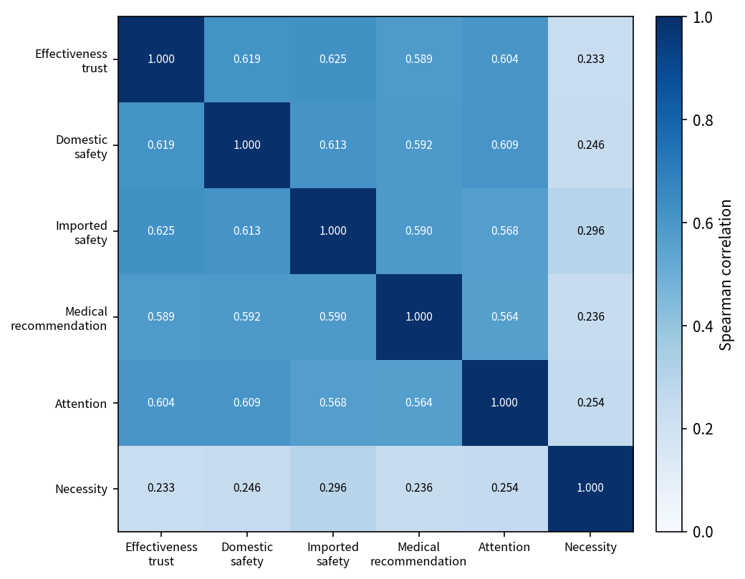
Supplementary Figure S1. Spearman correlation matrix of trust and perception-related variables among unvaccinated participants (N=2,215). All displayed off-diagonal correlations were p<0.01.

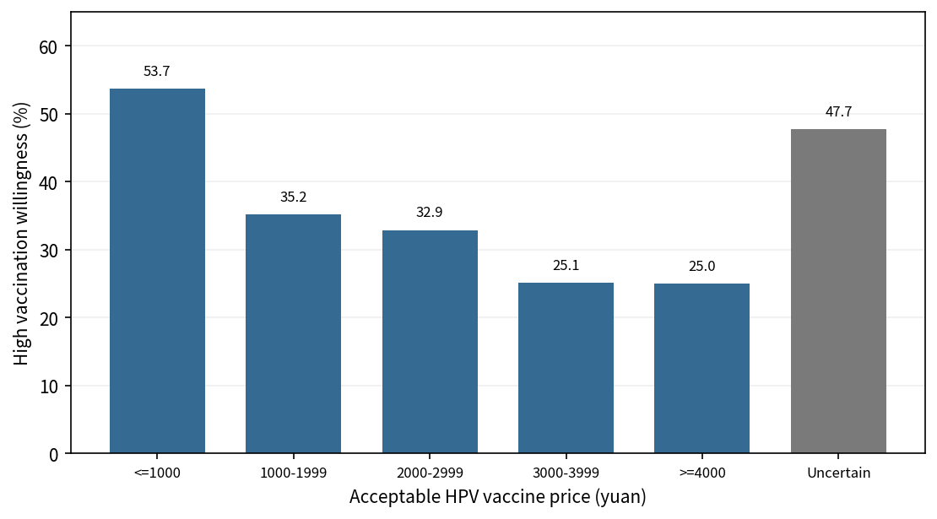
Supplementary Figure S2. High HPV vaccination willingness by acceptable HPV vaccine price category among unvaccinated participants.

