Supplementary material
Analgesia-Motor Recovery Trade-off After Liposomal Bupivacaine Interscalene Block for Shoulder Arthroscopy: An Exploratory Randomized Dose-Ranging Trial
Supplementary Figure S1 .Representative ultrasound images of ultrasound-guided interscalene brachial plexus block.
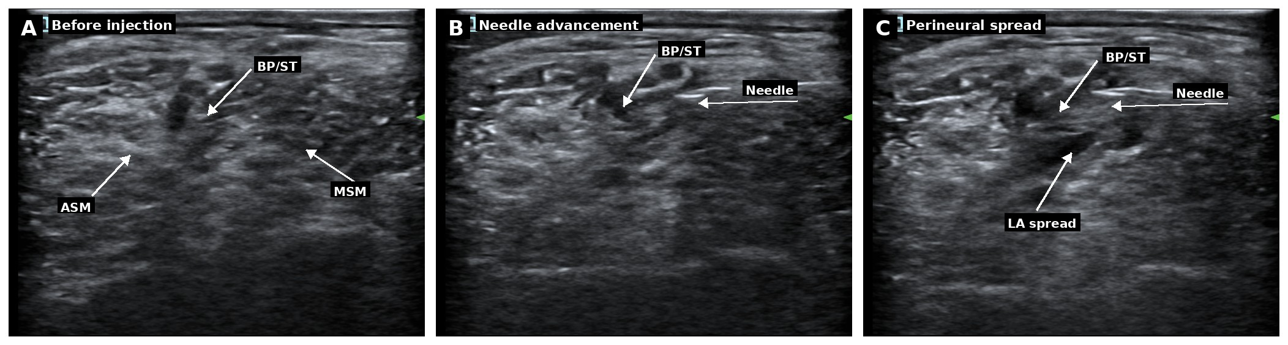
A, Target anatomy before injection. The brachial plexus was identified between the anterior and middle scalene muscles. B, In-plane advancement of the block needle toward the perineural region. C, Perineural spread of the allocated liposomal bupivacaine mixture around the brachial plexus after injection. ASM, anterior scalene muscle; MSM, middle scalene muscle; BP, brachial plexus; LA, local anesthetic.

Supplementary Table S2. Resting VAS scores among the three groups
Time | LB 6.7 mg/mL group | LB 8.3 mg/mL group | LB 10.0 mg/mL group | H value | P1 | P2 | P3
0 h | 4.0 (4.0, 4.0) | 4.0 (4.0, 4.0) | 4.0 (4.0, 4.0) | 0.2 | >0.99 | >0.99 | >0.99
6 h | 0.0 (0.0, 0.0) | 0.0 (0.0, 0.0) | 0.0 (0.0, 0.0) | 0.0 | >0.99 | >0.99 | >0.99
12 h | 0.0 (0.0, 0.0) | 0.0 (0.0, 0.0) | 0.0 (0.0, 0.0) | 0.0 | >0.99 | >0.99 | >0.99
24 h | 0.0 (0.0, 0.0) | 0.0 (0.0, 0.0) | 0.0 (0.0, 0.0) | 0.0 | >0.99 | >0.99 | >0.99
36 h | 0.0 (0.0, 0.5) | 0.0 (0.0, 0.0) | 0.0 (0.0, 0.0) | 26.0 | <0.01 | <0.01 | >0.99
48 h | 2.0 (2.0, 3.0) | 1.0 (0.0, 1.0) | 0.0 (0.0, 1.0) | 107.3 | <0.01 | <0.01 | >0.99
60 h | 2.0 (1.0, 2.0) | 0.0 (0.0, 0.5) | 0.0 (0.0, 0.0) | 103.3 | <0.01 | <0.01 | >0.99
72 h | 1.0 (1.0, 2.0) | 0.0 (0.0, 0.0) | 0.0 (0.0, 0.0) | 122.4 | <0.01 | <0.01 | 0.82
Data are presented as median (Q1, Q3). Overall comparisons among the three groups were performed using the Kruskal-Wallis test. Pairwise post hoc comparisons were performed using Dunn's test with Bonferroni adjustment. P1: LB 6.7 mg/mL vs LB 8.3 mg/mL; P2: LB 6.7 mg/mL vs LB 10.0 mg/mL; P3: LB 8.3 mg/mL vs LB 10.0 mg/mL. VAS, visual analog scale; LB, liposomal bupivacaine.
Supplementary Table S3. Activity-related VAS scores among the three groups
Time | LB 6.7 mg/mL group | LB 8.3 mg/mL group | LB 10.0 mg/mL group | H value | P1 | P2 | P3
6 h | 0.0 (0.0, 0.0) | 0.0 (0.0, 0.0) | 0.0 (0.0, 0.0) | 0.0 | >0.99 | >0.99 | >0.99
12 h | 0.0 (0.0, 0.0) | 0.0 (0.0, 0.0) | 0.0 (0.0, 0.0) | 0.0 | >0.99 | >0.99 | >0.99
24 h | 0.0 (0.0, 0.0) | 0.0 (0.0, 0.0) | 0.0 (0.0, 0.0) | 0.0 | >0.99 | >0.99 | >0.99
36 h | 1.0 (0.0, 1.0) | 0.0 (0.0, 0.0) | 0.0 (0.0, 0.0) | 21.8 | <0.01 | <0.01 | 0.34
48 h | 3.0 (3.0, 4.0) | 1.0 (1.0, 2.0) | 1.0 (1.0, 2.0) | 105.8 | <0.01 | <0.01 | >0.99
60 h | 3.0 (3.0, 5.0) | 2.0 (1.0, 2.0) | 2.0 (1.0, 2.0) | 107.3 | <0.01 | <0.01 | >0.99
72 h | 3.0 (2.0, 3.0) | 1.0 (1.0, 2.0) | 1.0 (1.0, 2.0) | 85.5 | <0.01 | <0.01 | >0.99
Data are presented as median (Q1, Q3). Overall comparisons among the three groups were performed using the Kruskal-Wallis test. Pairwise post hoc comparisons were performed using Dunn's test with Bonferroni adjustment. P1: LB 6.7 mg/mL vs LB 8.3 mg/mL; P2: LB 6.7 mg/mL vs LB 10.0 mg/mL; P3: LB 8.3 mg/mL vs LB 10.0 mg/mL. VAS, visual analog scale; LB, liposomal bupivacaine.
Supplementary Table S4. PCIA bolus deliveries by postoperative interval
Time | LB 6.7 mg/mL group | LB 8.3 mg/mL group | LB 10.0 mg/mL group | H value | P1 | P2 | P3
6 h | 0.0 (0.0, 0.0) | 0.0 (0.0, 0.0) | 0.0 (0.0, 0.0) | 0.0 | >0.99 | >0.99 | >0.99
12 h | 0.0 (0.0, 0.0) | 0.0 (0.0, 0.0) | 0.0 (0.0, 0.0) | 0.0 | >0.99 | >0.99 | >0.99
24 h | 0.0 (0.0, 0.0) | 0.0 (0.0, 0.0) | 0.0 (0.0, 0.0) | 0.0 | >0.99 | >0.99 | >0.99
36 h | 0.0 (0.0, 0.0) | 0.0 (0.0, 0.0) | 0.0 (0.0, 0.0) | 0.0 | >0.99 | >0.99 | >0.99
48 h | 4.0 (3.0, 5.0) | 0.0 (0.0, 0.0) | 0.0 (0.0, 0.0) | 139.2 | <0.01 | <0.01 | >0.99
60 h | 2.0 (2.0, 2.0) | 0.0 (0.0, 0.0) | 0.0 (0.0, 0.0) | 116.8 | <0.01 | <0.01 | >0.99
72 h | 1.0 (0.0, 1.0) | 0.0 (0.0, 0.0) | 0.0 (0.0, 0.0) | 69.5 | <0.01 | <0.01 | >0.99
Data are presented as median (Q1, Q3). Overall comparisons among the three groups were performed using the Kruskal-Wallis test. Pairwise post hoc comparisons were performed using Dunn's test with Bonferroni adjustment. P1: LB 6.7 mg/mL vs LB 8.3 mg/mL; P2: LB 6.7 mg/mL vs LB 10.0 mg/mL; P3: LB 8.3 mg/mL vs LB 10.0 mg/mL. PCIA, patient-controlled intravenous analgesia; LB, liposomal bupivacaine.
Supplementary Table S5. Adverse events within 72 h after surgery among the three groups
Adverse event | LB 6.7 mg/mL group | LB 8.3 mg/mL group | LB 10.0 mg/mL group
Respiratory distress | 0 | 0 | 0
Local anesthetic systemic toxicity (LAST) | 0 | 0 | 0
Postoperative nausea and vomiting (PONV) | 0 | 0 | 0
Emergence delirium | 0 | 0 | 0
Hypotension | 0 | 0 | 0
Excessive sedation | 0 | 0 | 0
Data are presented as number of patients. LAST, local anesthetic systemic toxicity; PONV, postoperative nausea and vomiting; LB, liposomal bupivacaine.

