Graphical Abstract
DFT-Elucidated of α-ZrP/Phosphorus-Nitrogen Co-Doped Hollow Carbon Spheres Composite for Highly Sensitive Electrochemical Detection of Moxifloxacin
Yuan Jin ª, Yanhong Zhang ª, Jinxia Yao ª, Nanke Ma ª, Guangli Li ^{a,*}
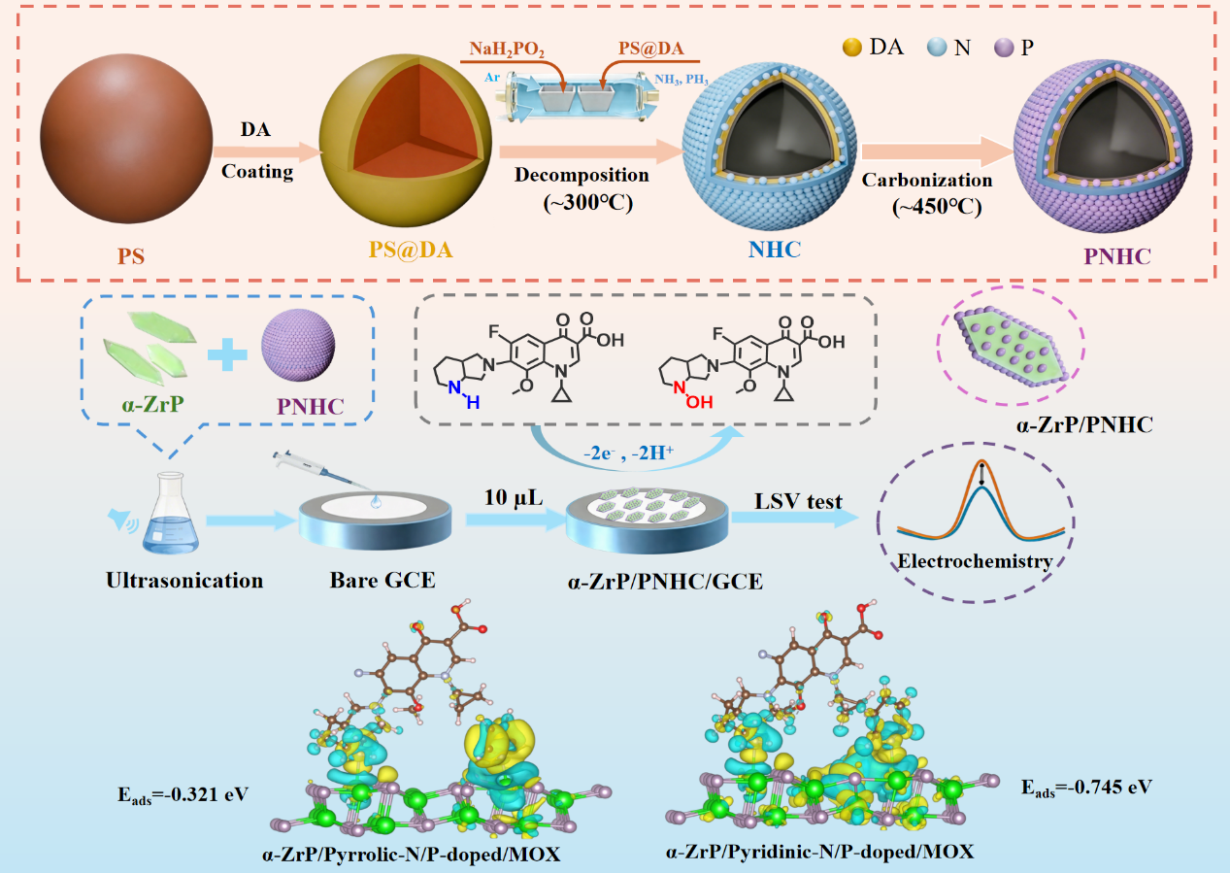
Scheme 1. Schematic representation of the fabrication of α-ZrP/PNHC/GCE for the sensitive determination of MOX.
A novel α‑ZrP/PNHC composite is fabricated for ultrasensitive electrochemical detection of moxifloxacin (MOX). DFT calculations reveal that P atoms preferentially occupy shoulder carbon sites adjacent to pyridinic-N, injecting electrons into the carbon framework and moderately reducing its Lewis basicity. This electronic modulation shifts MOX interaction from excessively strong coordination (–0.963 eV) to moderate hydrogen bonding/π–π stacking (–0.745 eV). The optimized adsorption enables a wide linear range (0.03–10 μM), a low detection limit (0.015 μM), and excellent recoveries (97.29%–103.70%) in real samples.

