Additional File 2. Sensitivity-analysis figures
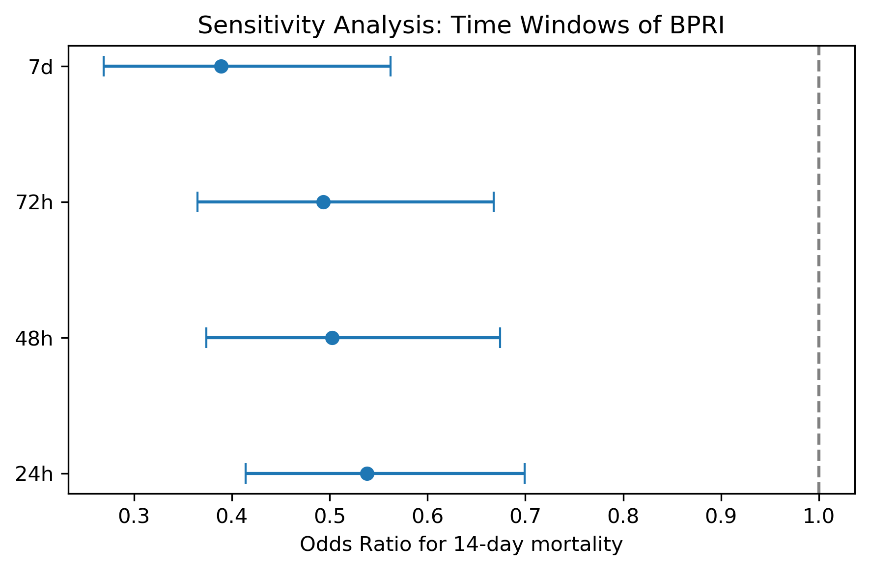
Supplementary Figure S1. Sensitivity analysis across BPRI time windows.
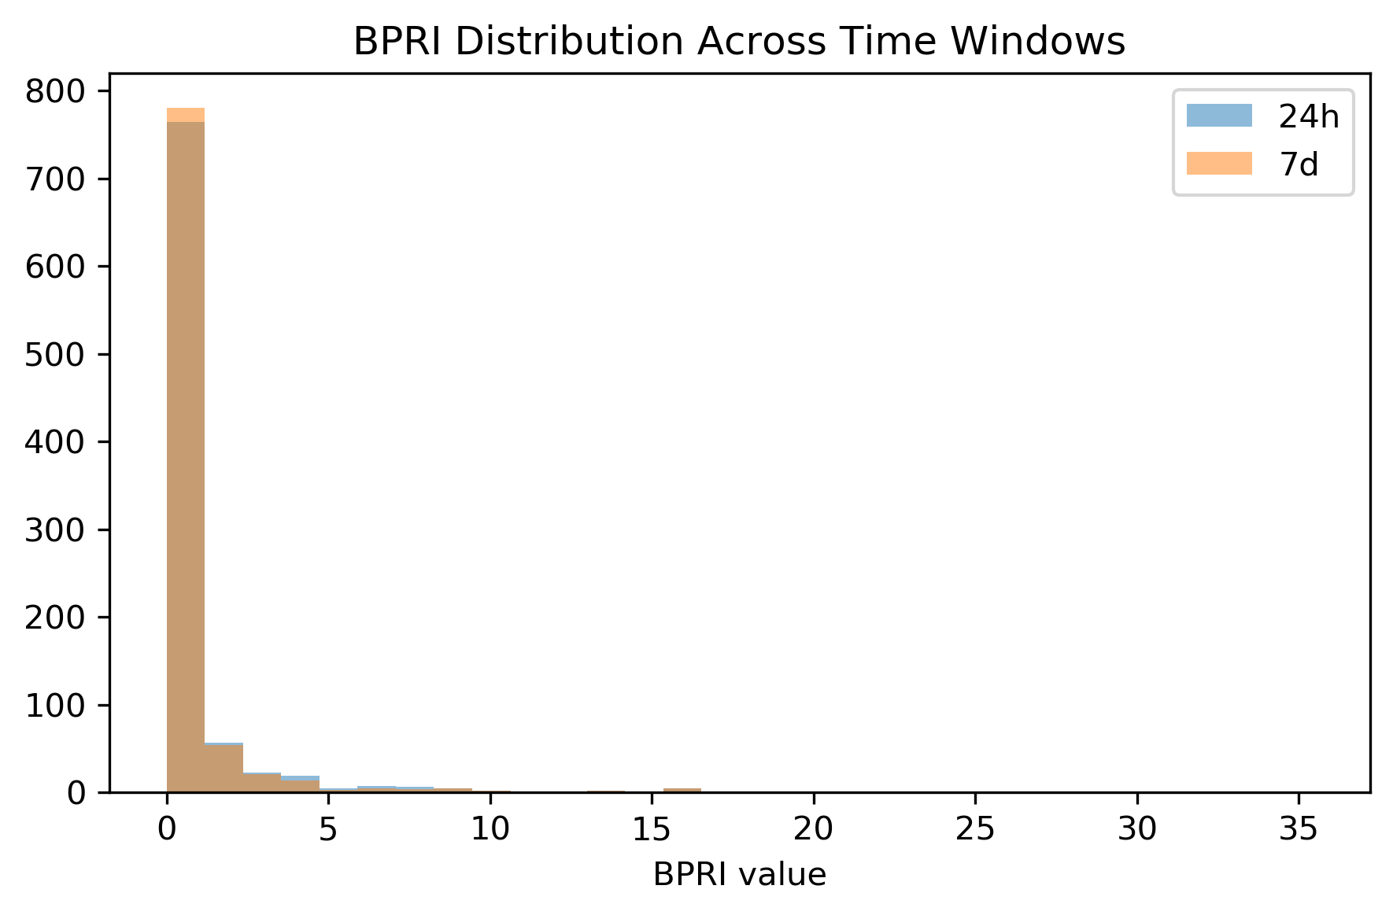
Supplementary Figure S2. BPRI distribution across time windows.
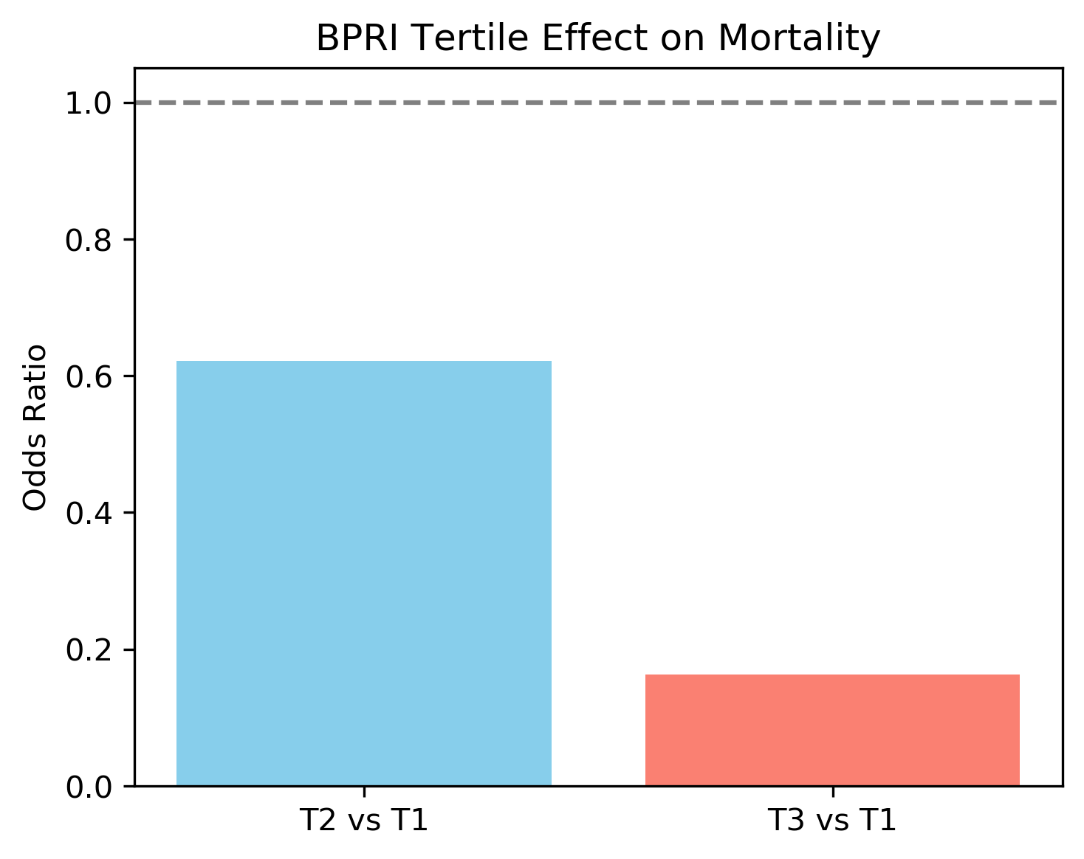
Supplementary Figure S3. BPRI tertile effect on mortality.

