Supporting Information
Enhanced Corrosion Protection of Carbon Steel in CO₂-Saturated Saline Media Using Multi-Directional Alkoxy Resorcin[4]arenes
Abeer Alfarhan*^{a,b}, Mohammad BinSabtª, and Ali Husain*ª
ªDepartment of Chemistry, Kuwait University, Safat 13060, Kuwait
^{b}Kuwait Institute for Scientific Research, Kuwait.
*E-mail: abfarhan@kisr.edu.kw, ali.husain@ku.edu.kw

Table of Contents
1. NMR Spectra of Compounds 1-8 & R1-R7 S2-S17
2. ESI-MS Spectra of Compounds 1-8 & R1-R8 S18-25
3. DSC Spectra of Compounds R1-R8 S26-29
4. FT-IR Spectra of Compounds R1-R8 S30-33

1. NMR Spectra of Compounds 1-8 & R1-R8
Figure S1. ¹H-NMR spectrum (600 MHz, CDCl₃, 25 ⁰C) of compound 1.
Figure S2. ¹³C-NMR spectrum (150 MHz, CDCl₃, 25 ⁰C) of compound 1.
Figure S3. ¹H-NMR spectrum (600 MHz, CDCl₃, 25 ⁰C) of compound 2.
Figure S4. ¹³C-NMR spectrum (150 MHz, CDCl₃, 25 ⁰C) of compound 2.

Figure S5. ¹H-NMR spectrum (600 MHz, CDCl₃, 25 ⁰C) of compound 3.
Figure S6. ¹³C-NMR spectrum (150 MHz, CDCl₃, 25 ⁰C) of compound 3.
Figure S7. ¹H-NMR spectrum (600 MHz, CDCl₃, 25 ⁰C) of compound 4.
Figure S8. ¹³C-NMR spectrum (150 MHz, CDCl₃, 25 ⁰C) of compound 4.
Figure S9. ¹H-NMR spectrum (600 MHz, CDCl₃, 25 ⁰C) of compound 5.
Figure S10. ¹³C-NMR spectrum (150 MHz, CDCl₃, 25 ⁰C) of compound 5.

Figure S11. ¹H-NMR spectrum (600 MHz, CDCl₃, 25 ⁰C) of compound 6.
Figure S12. ¹³C-NMR spectrum (150 MHz, CDCl₃, 25 ⁰C) of compound 6.

Figure S13. ¹H-NMR spectrum (600 MHz, CDCl₃, 25 ⁰C) of compound 7.
Figure S14. ¹³C-NMR spectrum (150 MHz, CDCl₃, 25 ⁰C) of compound 7.

Figure S15. ¹H-NMR spectrum (600 MHz, CDCl₃, 25 ⁰C) of compound 8.
Figure S16. ¹³C-NMR spectrum (150 MHz, CDCl₃, 25 ⁰C) of compound 8.
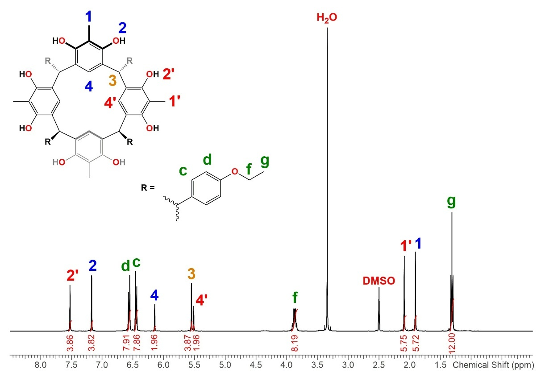
Figure S17. ¹H-NMR spectrum (400 MHz, DMSO-d₆, 25 ⁰C) of compound R1.
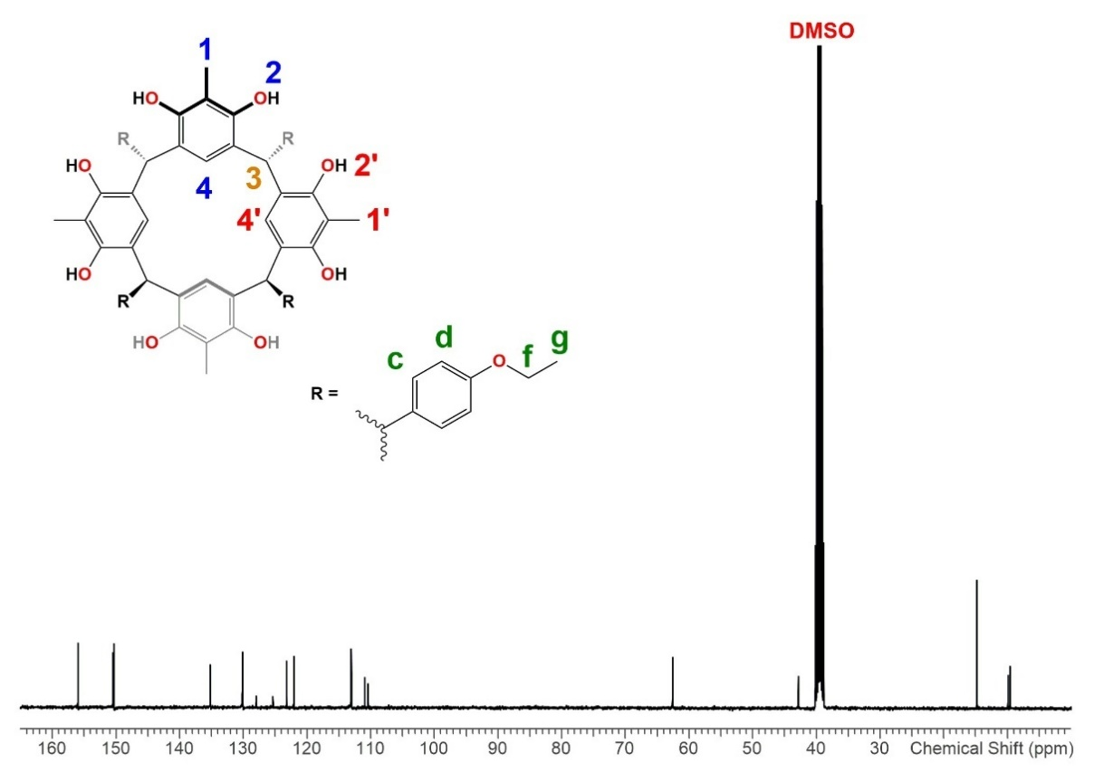
Figure S18. ¹³C-NMR spectrum (100 MHz, DMSO-d₆, 25 ⁰C) of compound R1.
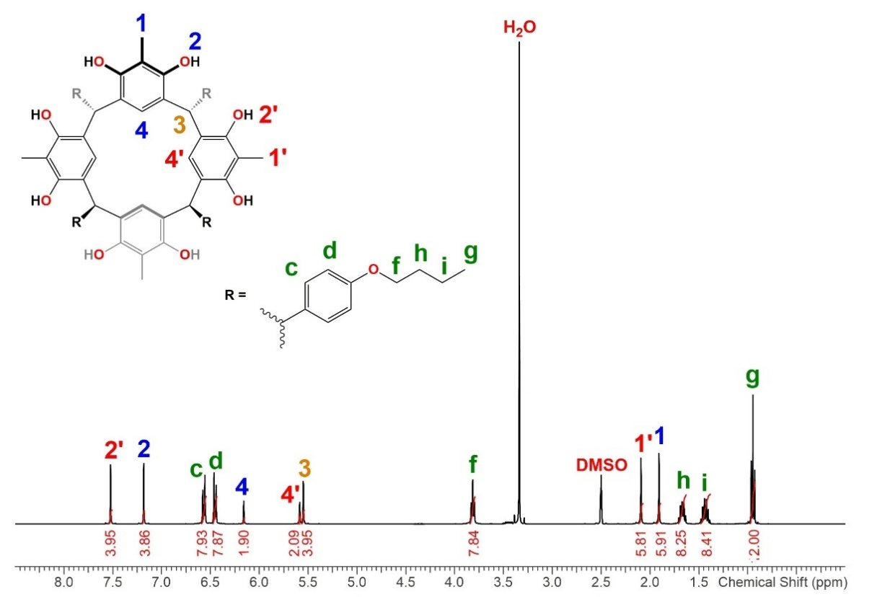
Figure S19. ¹H-NMR spectrum (400 MHz, DMSO-d₆, 25 ⁰C) of compound R2.
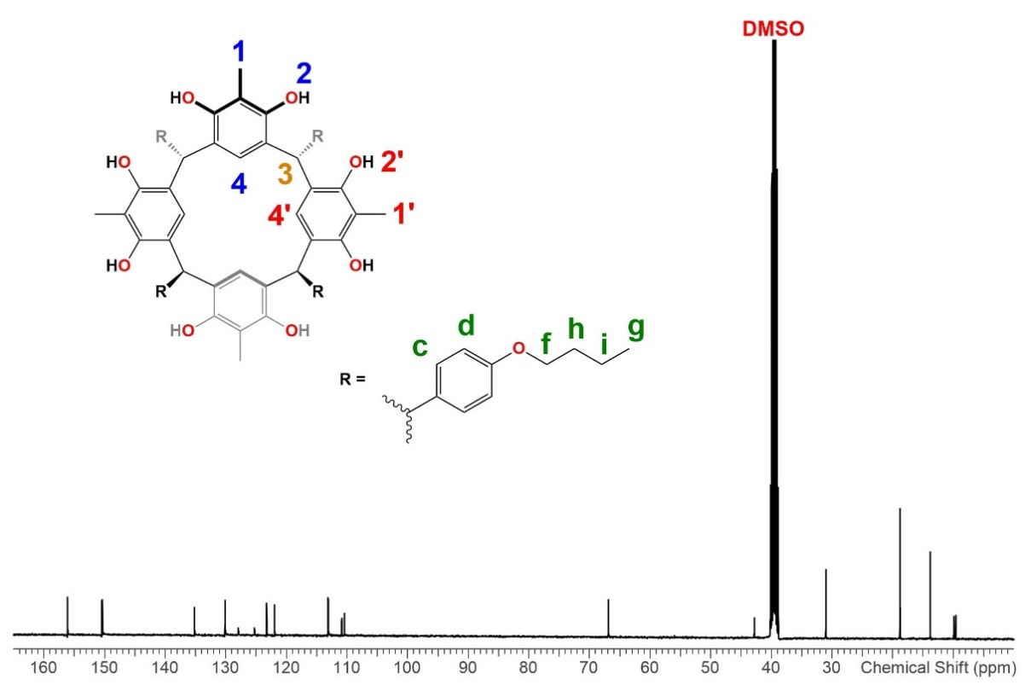
Figure S20. ¹³C-NMR spectrum (100 MHz, DMSO-d₆, 25 ⁰C) of compound R2.
Figure S21. ¹H-NMR spectrum (400 MHz, DMSO-d₆, 25 ⁰C) of compound R3.
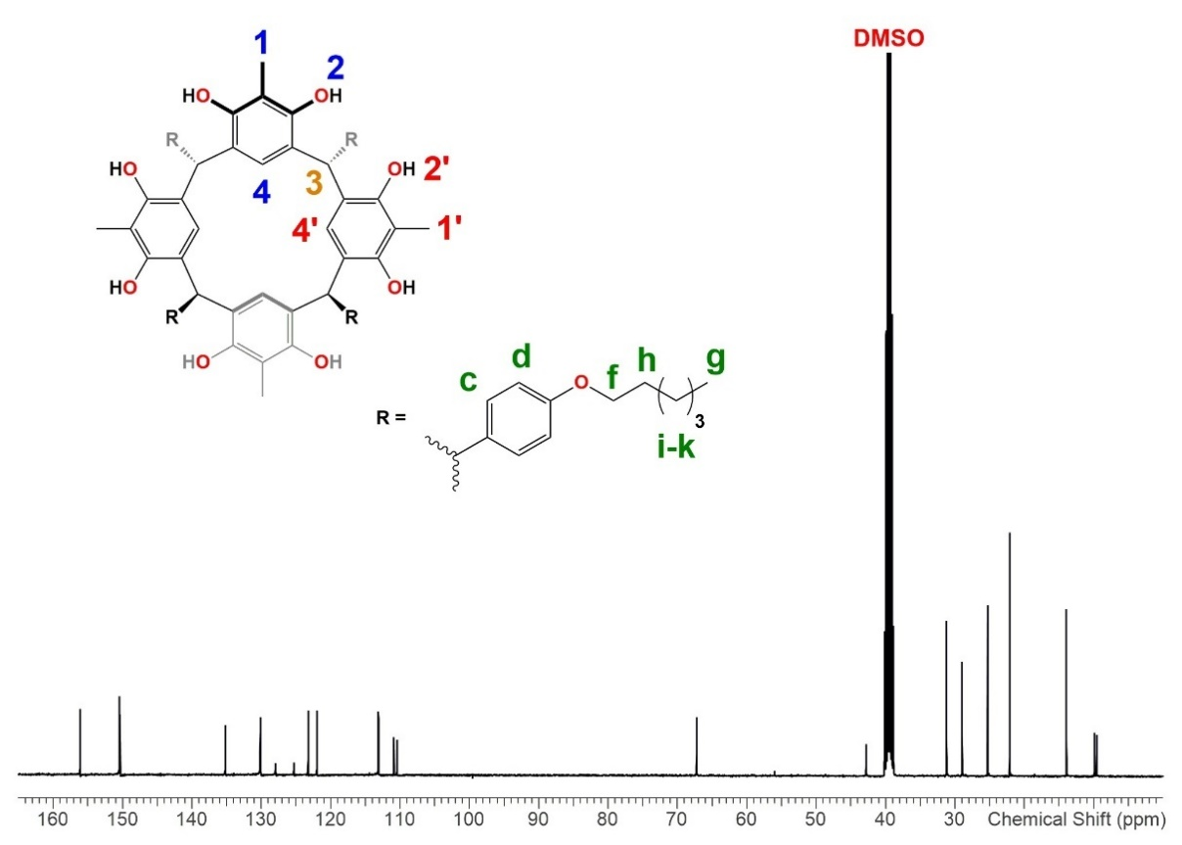
Figure S22. ¹³C-NMR spectrum (100 MHz, DMSO-d₆, 25 ⁰C) of compound R3.
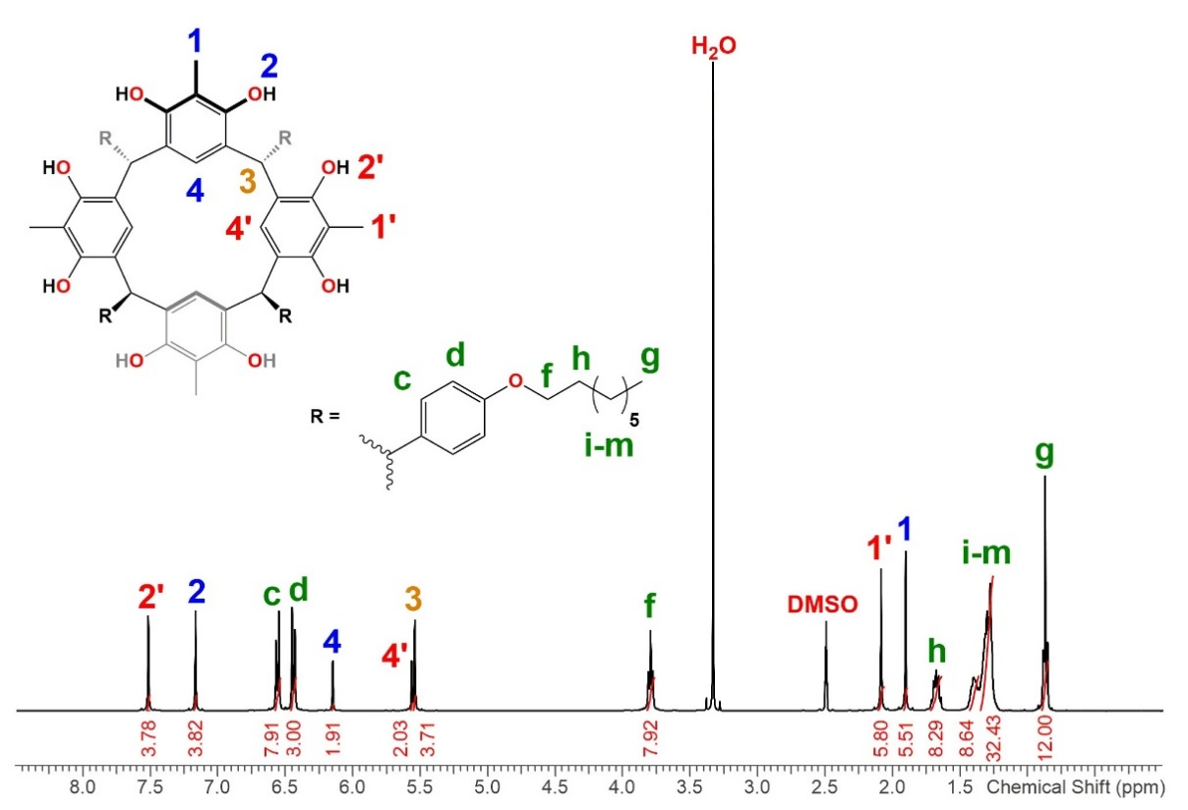
Figure S23. ¹H-NMR spectrum (400 MHz, DMSO-d₆, 25 ⁰C) of compound R4.
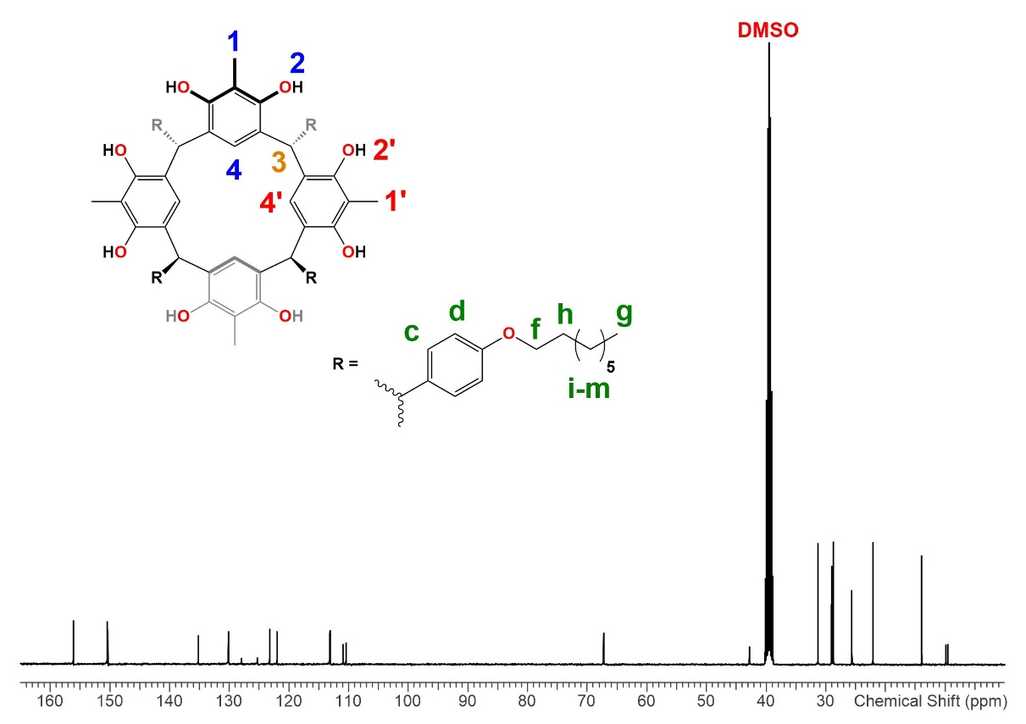
Figure S24. ¹³C-NMR spectrum (100 MHz, DMSO-d₆, 25 ⁰C) of compound R4.
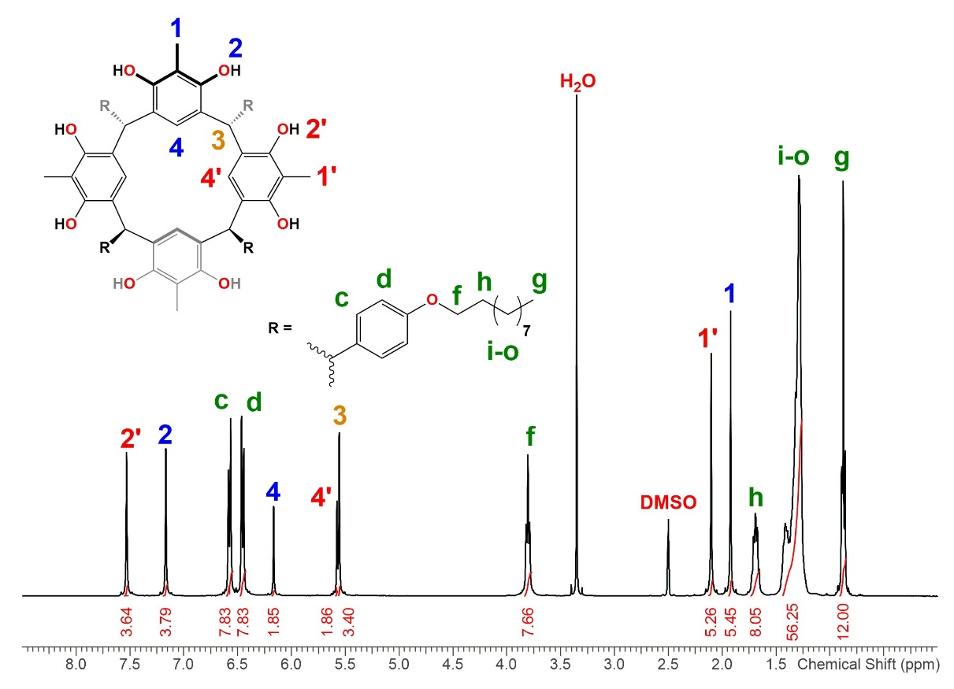
Figure S24. ¹H-NMR spectrum (400 MHz, DMSO-d₆, 25 ⁰C) of compound R5.
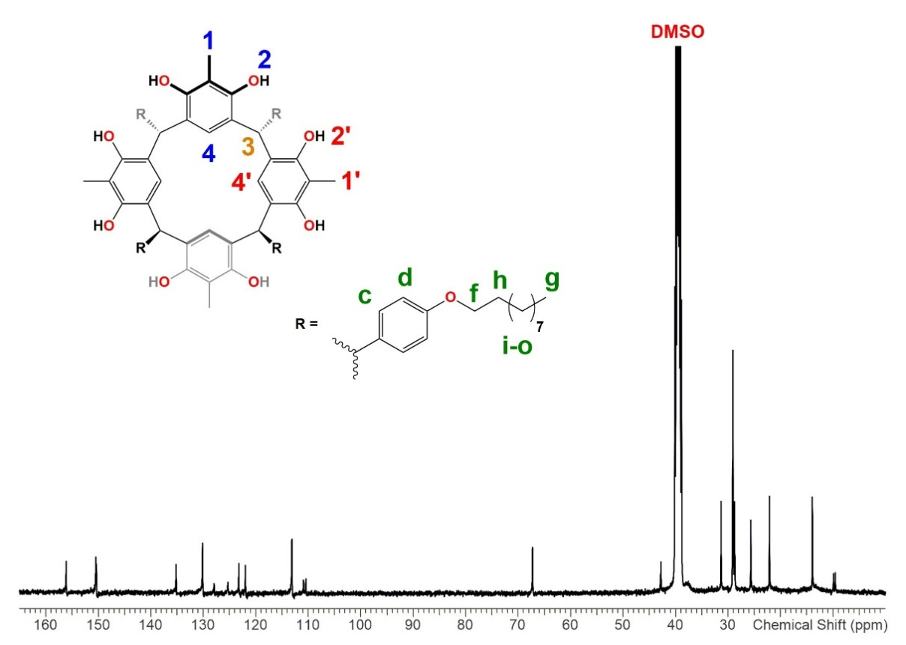
Figure S26. ¹³C-NMR spectrum (100 MHz, DMSO-d₆, 25 ⁰C) of compound R5.
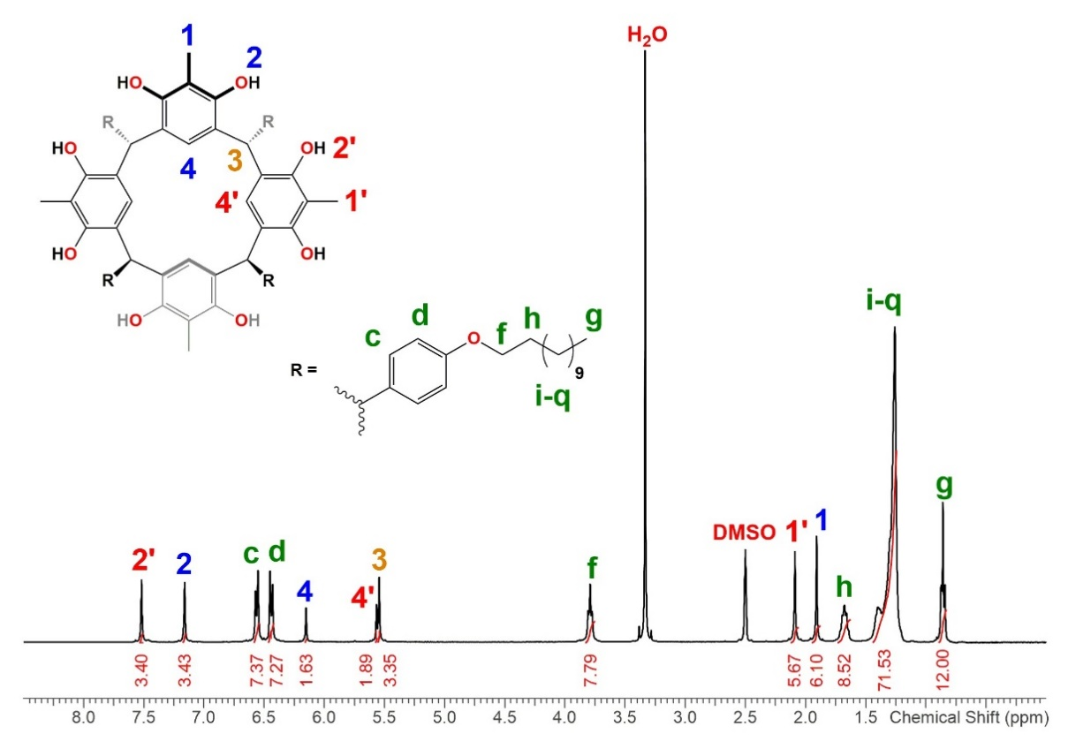
Figure S27. ¹H-NMR spectrum (400 MHz, DMSO-d₆, 25 ⁰C) of compound R6.
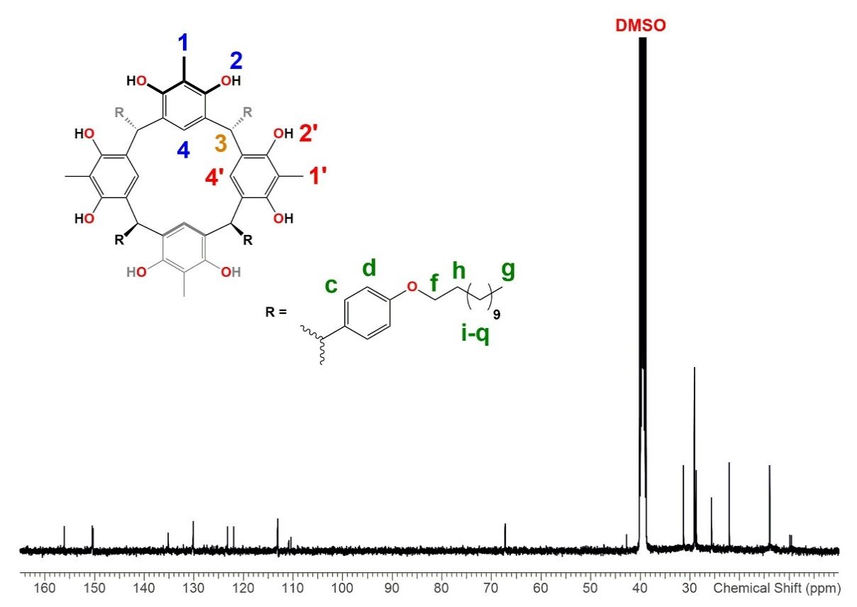
Figure S28. ¹³C-NMR spectrum (100 MHz, DMSO-d₆, 25 ⁰C) of compound R6.
Figure S29. ¹H-NMR spectrum (400 MHz, DMSO-d₆, 25 ⁰C) of compound R7.
Figure S30. ¹³C-NMR spectrum (100 MHz, DMSO-d₆, 25 ⁰C) of compound R7.
Figure S31. ¹H-NMR spectrum (400 MHz, DMSO-d₆, 40 ⁰C) of compound R8.
Figure S32. ¹³C-NMR spectrum (100 MHz, DMSO-d₆, 40 ⁰C) of compound R8.

2. ESI-MS Spectra of Compounds 1-8 & R1-R8
Figure S33. ESI-MS spectrum of compound 1.
Figure S34. ESI-MS spectrum of compound 2.

Figure S35. ESI-MS spectrum of compound 3.
Figure S36. ESI-MS spectrum of compound 4.
Figure S37. ESI-MS spectrum of compound 5.
Figure S38. ESI-MS spectrum of compound 6.
Figure S39. ESI-MS spectrum of compound 7.
Figure S40. ESI-MS spectrum of compound 8.
Figure S41. ESI-MS spectrum of compound R1.
Figure S42. ESI-MS spectrum of compound R2.
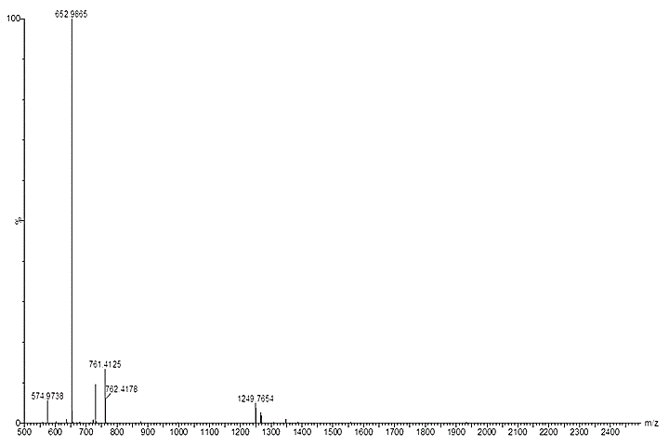
Figure S43. ESI-MS spectrum of compound R3.
Figure S44. ESI-MS spectrum of compound R4.
Figure S45. ESI-MS spectrum of compound R5.
Figure S46. ESI-MS spectrum of compound R6.
Figure S47. ESI-MS spectrum of compound R7.
Figure S48. ESI-MS spectrum of compound R8.
3. DSC Spectra of Compounds R1-R8
Figure S49. DSC spectrum of compound R1.
Figure S50. DSC spectrum of compound R2.

Figure S51. DSC spectrum of compound R3.
Figure S52. DSC spectrum of compound R4.

Figure S53. DSC spectrum of compound R5.
Figure S54. DSC spectrum of compound R6.

Figure S55. DSC spectrum of compound R7.
Figure S56. DSC spectrum of compound R8.

4. FT-IR Spectra of Compounds R1-R8
Figure S57. FT-IR spectrum of compound R1.
Figure S58. FT-IR spectrum of compound R2.

Figure S59. FT-IR spectrum of compound R3.
Figure S60. FT-IR spectrum of compound R4.

Figure S61. FT-IR spectrum of compound R5.
Figure S62. FT-IR spectrum of compound R6.

Figure S63. FT-IR spectrum of compound R7.
Figure S64. FT-IR spectrum of compound R8.

