Genetic regulation of circulating metabolome in cattle

The supplementary information contains:
Supplementary Figures 1-20
Supplementary Tables 1-30 (in a separate Excel file)

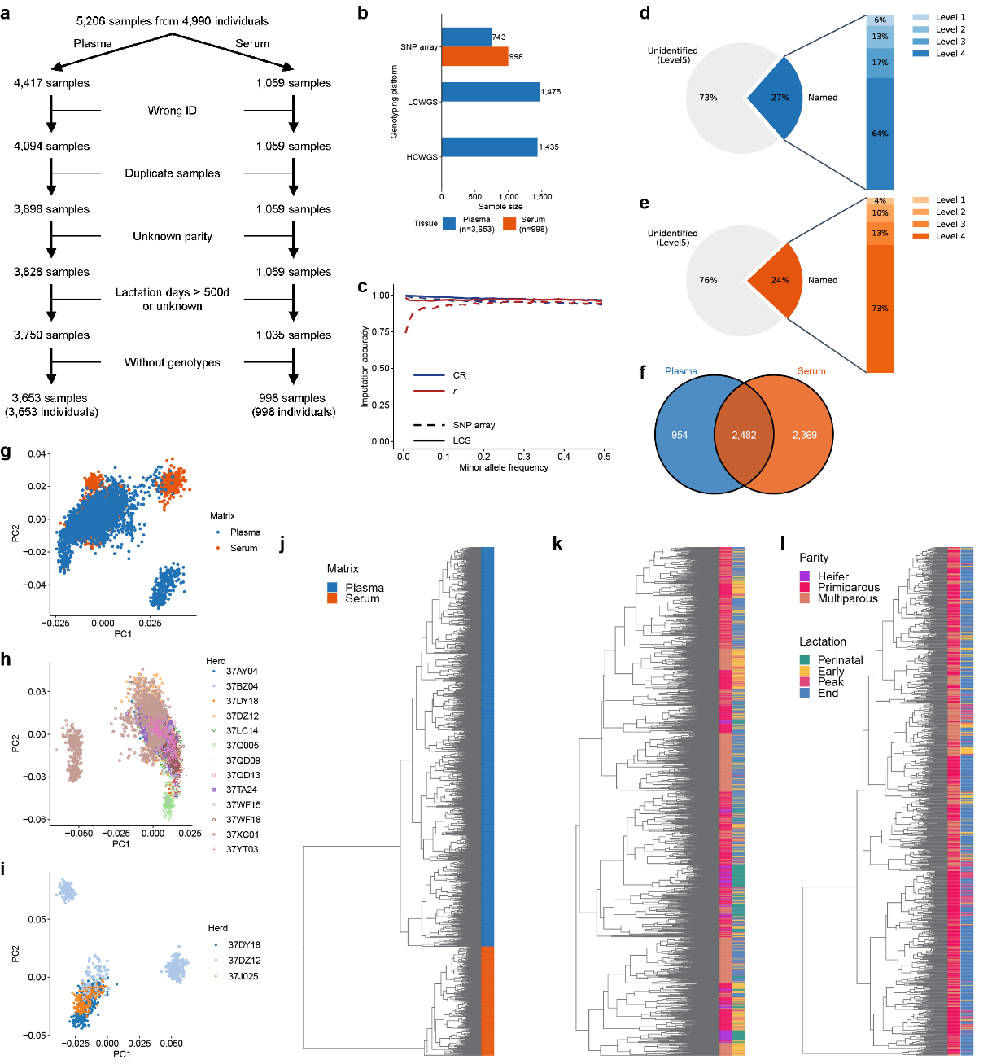
Supplementary Fig. 1 | Summary of metabolite samples. a, Workflow for sample quality control. b, Overview of sample sizes across genotyping platforms and tissues. LCWGS, low-coverage whole-genome sequencing; HCWGS, high-coverage whole-genome sequencing. d, Distribution of 12,667 metabolites measured in plasma and 19,959 metabolites measured in serum. The pie chart (left) illustrates the proportion of named metabolites versus unidentified features. The stacked bar chart (right) provides a granular breakdown of named metabolites according to established identification levels. e, Venn diagram illustrating the overlap of named metabolic features detected in plasma and serum. f, Hierarchical clustering analysis of overlapping metabolites between plasma and serum. f, Hierarchical clustering analysis of named metabolites in plasma. g, Hierarchical clustering analysis of named metabolites in serum. Dendrograms represent the clustering of metabolic features based on their abundance patterns. Sidebars indicate the physiological context of the samples, including parity stages (Heifer, Primiparous, and Multiparous) and lactation stages (Perinatal, Early, Peak, and End). For each hierarchical clustering analysis, the top 1,000 most variable metabolites (ranked by standard deviation) were used.
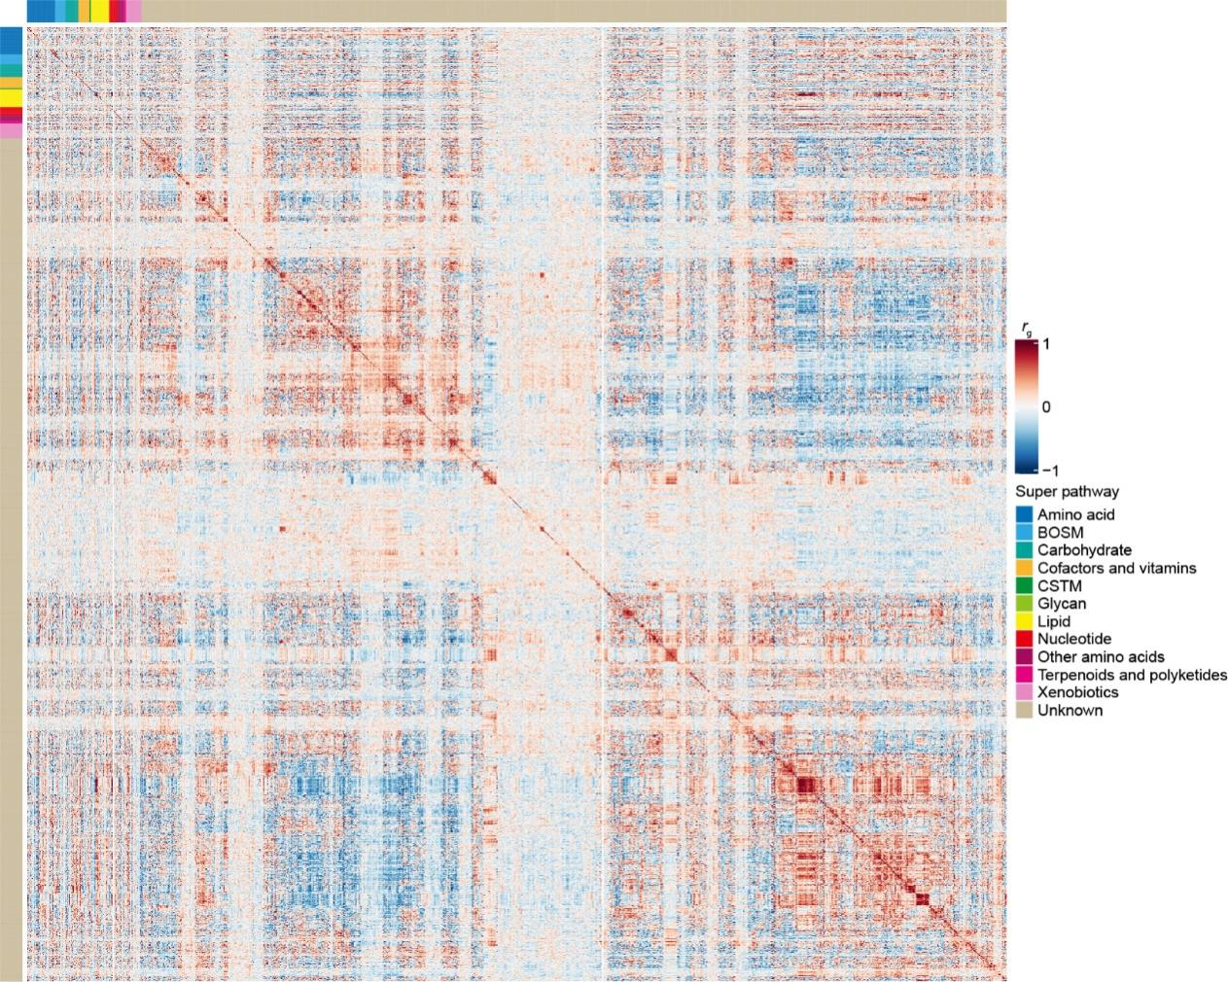
Supplementary Fig. 2 | Genetic correlation matrix of 3,436 plasma metabolites. BOSM: Biosynthesis of other secondary metabolites; CSTM: Chemical structure transformation maps; GOM: Global and overview maps.
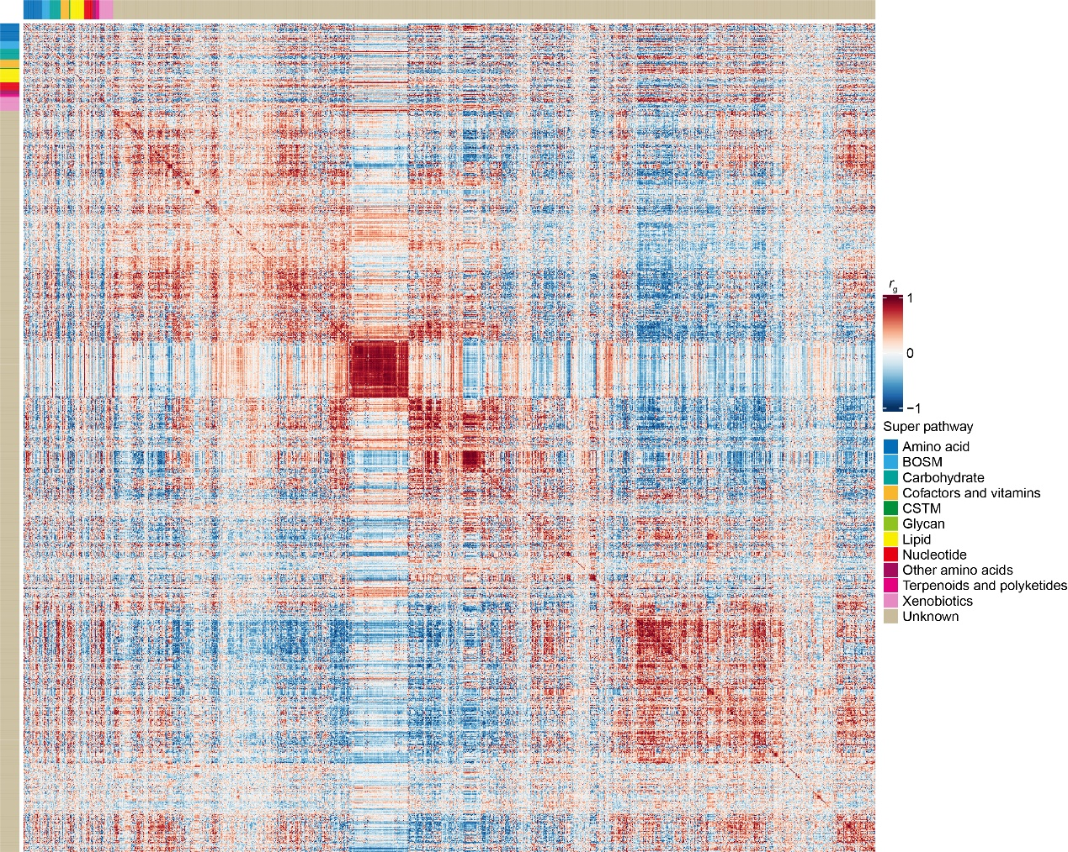
Supplementary Fig. 3 | Genetic correlation matrix of 4,851 serum metabolites. BOSM: Biosynthesis of other secondary metabolites; CSTM: Chemical structure transformation maps; GOM: Global and overview maps.

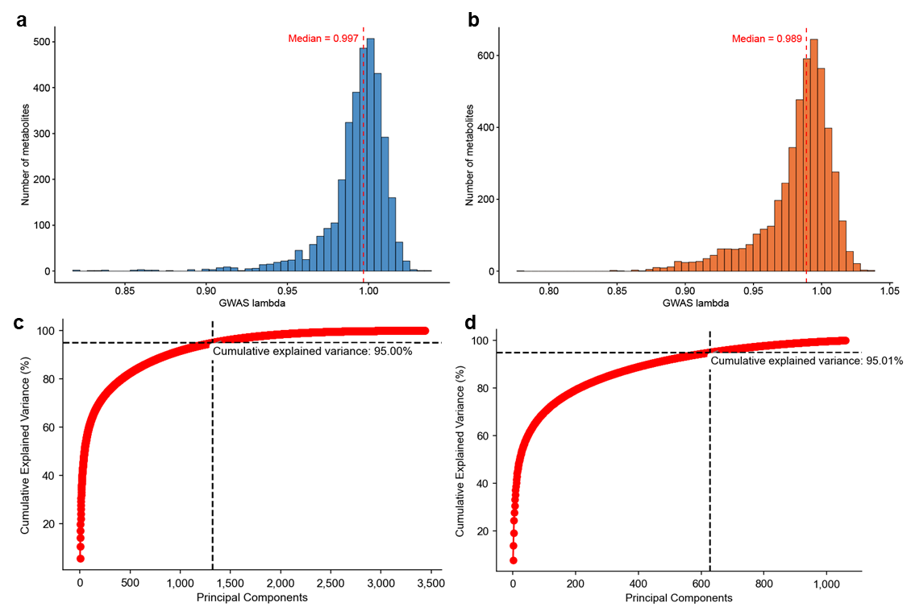
Supplementary Fig. 4 | a, Distribution of GWAS lambda of 3,436 measured metabolites in plasma. b, Distribution of GWAS lambda of 4,851 measured metabolites in serum. c, Cumulative explained variance of principal component analysis (PCA) components of 3,436 measured metabolites in plasma. d, Cumulative explained variance of PCA components of 4,851 measured metabolites in serum.
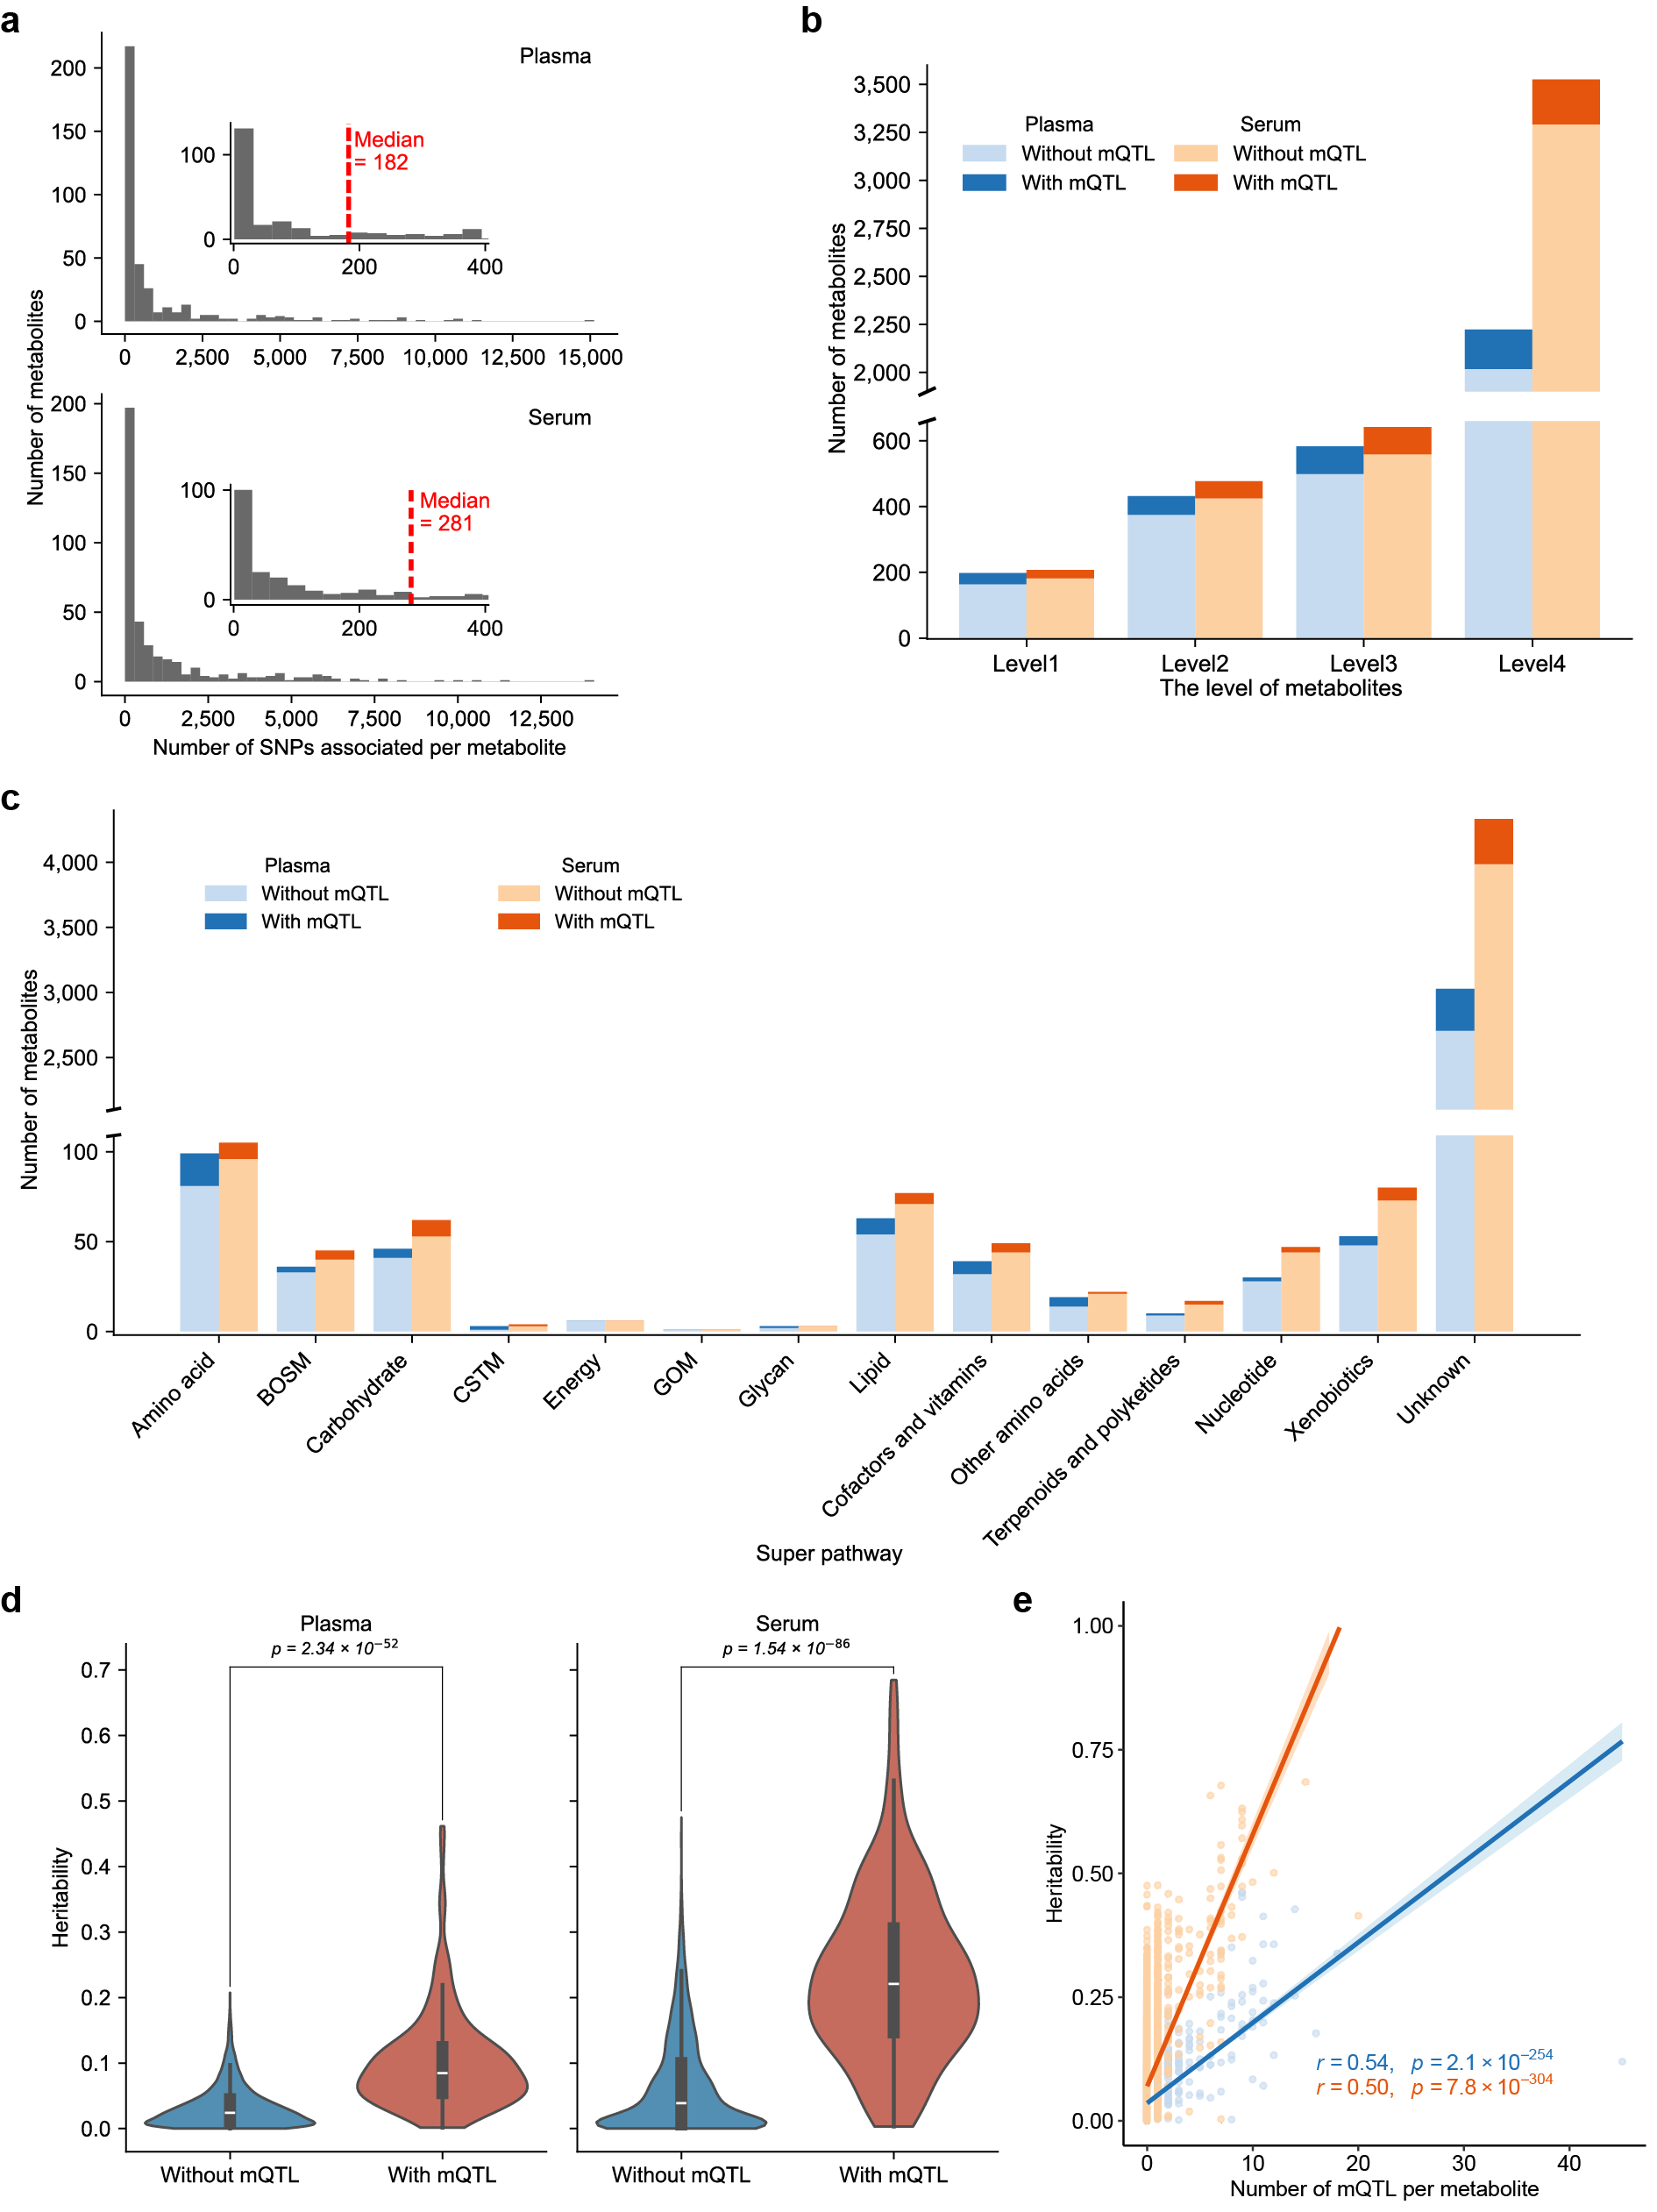
Supplementary Fig. 5 | Summary of metabolite genome-wide association studies (mGWAS). a, Distribution of the number of mQTL per metabolite in plasma and serum. The median number of mQTL per metabolite is indicated in red (Plasma: median = 182; Serum: median = 281). b, Distribution of metabolites with and without mQTL according to annotation levels (Level1-Level4) for plasma and serum. c, Number of metabolites with and without mQTL across metabolite super-pathways in plasma and serum. BOSM: Biosynthesis of other secondary metabolites; CSTM: Chemical structure transformation maps; GOM: Global and overview maps. d, Violin plots showing heritability estimates for metabolites with and without mQTL in plasma and serum. Statistical significance was determined using a two-sided Wilcoxon rank-sum test. e, Relationship between metabolite heritability and the number of independent mQTL detected per metabolite. Each point represents a metabolite. Linear regression lines are shown for plasma (blue) and serum (orange). Pearson’s correlation coefficient and corresponding P-value are shown.

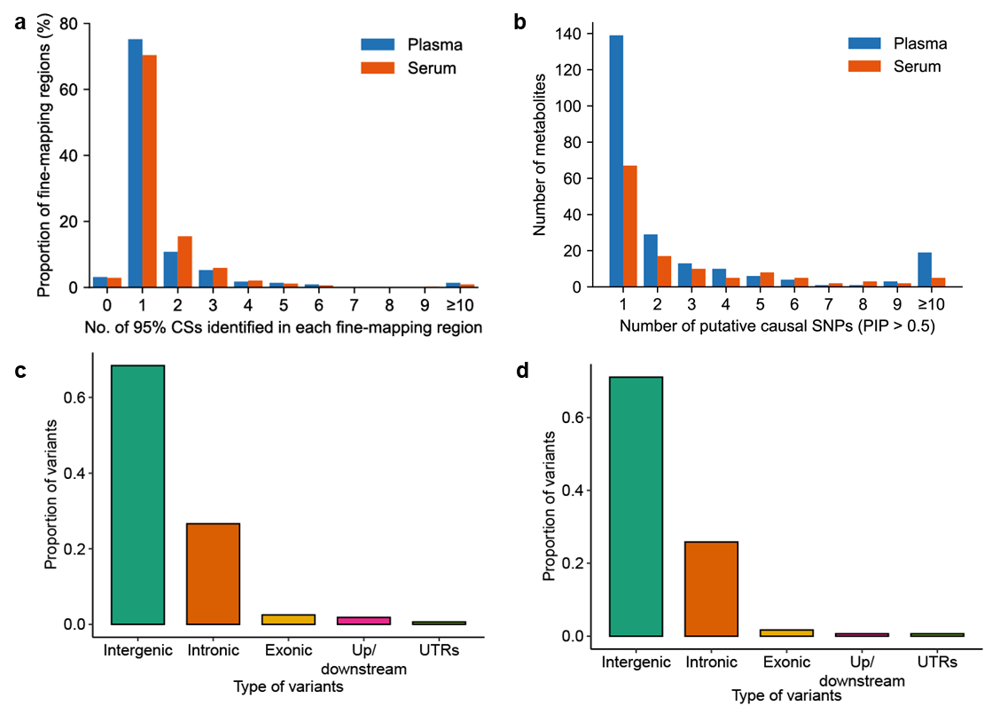
Supplementary Fig. 6 | Summary of fine-mapping results. a, Distribution of the number of 95% credible sets (CSs) across fine-mapped regions. Most regions contain a single or a few variants in the CSs, indicating high resolution of fine-mapping. b, Distribution of the number of putative causal SNPs (PIP > 0.5) per metabolite. c and d, Functional annotation of putative causal SNPs (PIP > 0.5) in plasma (c) and serum (d).

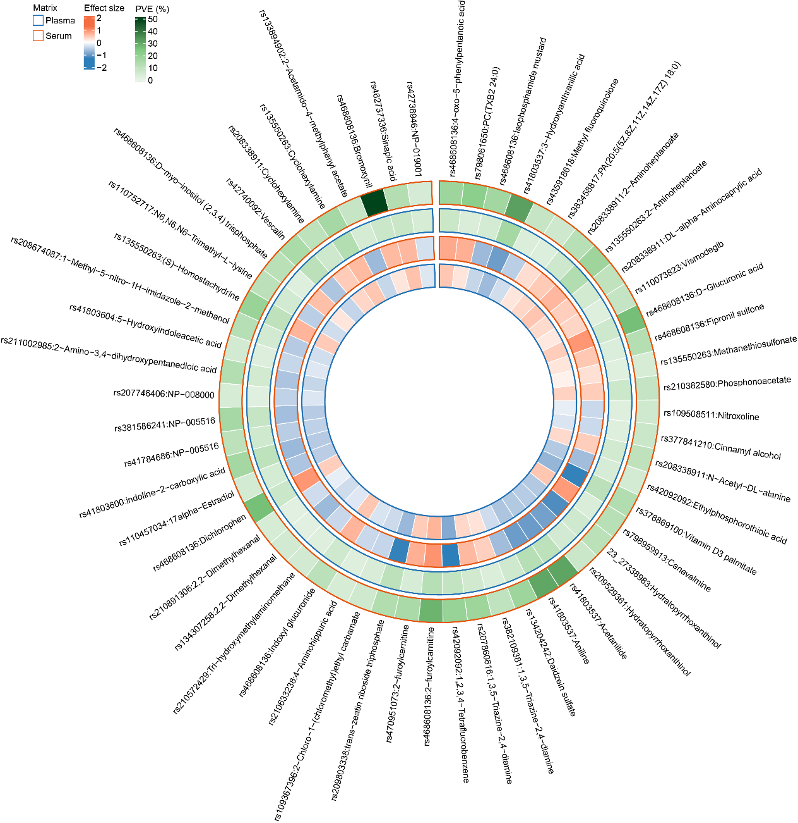Supplementary Fig. 7 | Shared genetic effects of colocalized mQTL on overlapping metabolites between plasma and serum. Each sector corresponds to an SNP-metabolite association. The inner ring represents the effect size of mQTL on metabolite. The outer ring shows the proportion of variation explained (PVE) by mQTL for each metabolite. Blue and orange outlines denote the plasma and serum layers, respectively.

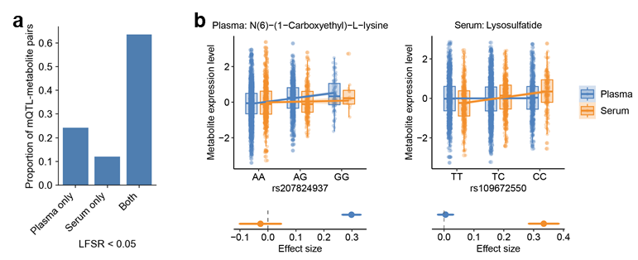
Supplementary Fig. 8 | Cross-matrix sharing and matrix-specific regulation of mQTL. a, Proportions of mQTL-metabolite pairs with significant effects detected only in plasma, only in serum, or in both matrices, as inferred by MashR at LFSR < 0.05. b, Representative examples of a plasma-specific mQTL for N(6)-(1-carboxyethyl)-L-lysine and a serum-specific mQTL for lysosulfatide. Boxplots show metabolite abundance across genotypes, whereas point plots show mQTL effect-size estimates with standard errors from the mGWAS.

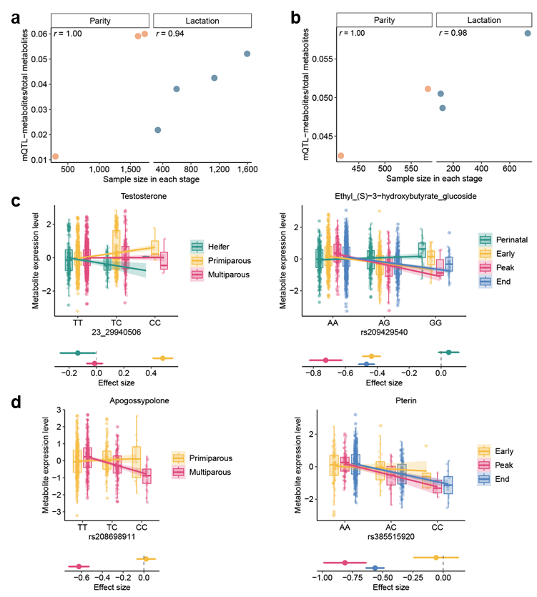
Supplementary Fig. 9 | Context sharing and specificity properties of mQTL across parity and lactation stages. a, Relationship between the proportion of metabolites with mQTL and sample size across different parity and lactation stages in plasma. b, Relationship between the proportion of metabolites with mQTL and sample size across different parity and lactation stages in serum. c, Examples of parity- or lactation-stage specific mQTL in plasma. d, Examples of parity- or lactation-stage specific mQTL in serum.

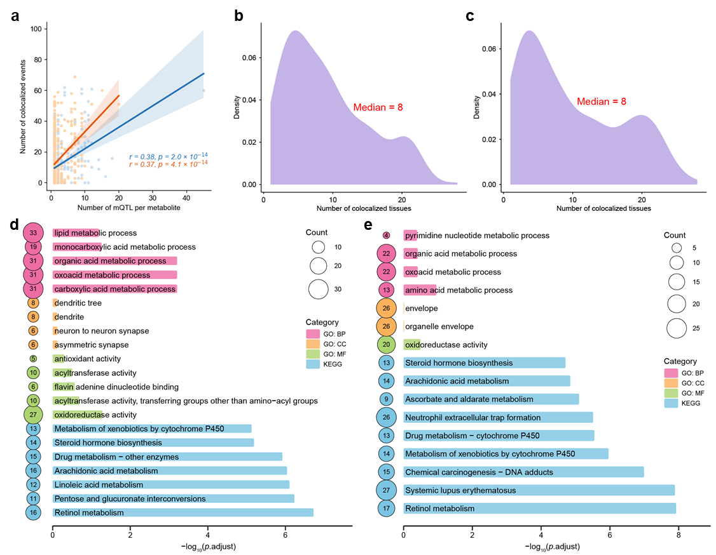
Supplementary Fig. 10 | Characteristics and functional annotation of colocalization signals. a, Relationship between the number of mQTL and the number of colocalization events per metabolite in plasma and serum. Each point represents one metabolite; solid lines indicate linear regression fits, and shaded areas denote 95% confidence intervals. Pearson correlation coefficients and corresponding two-sided P-values are shown. b and c, Distribution of the number of tissues showing colocalization for each metabolite in plasma (b) and serum (c). Median values are indicated. d, Functional enrichment analysis of genes implicated by colocalization in plasma. e, Functional enrichment analysis of genes implicated by colocalization in serum. Enriched terms from Gene Ontology of biological process (BP), cellular component (CC), and molecular function (MF) and KEGG pathways are shown.
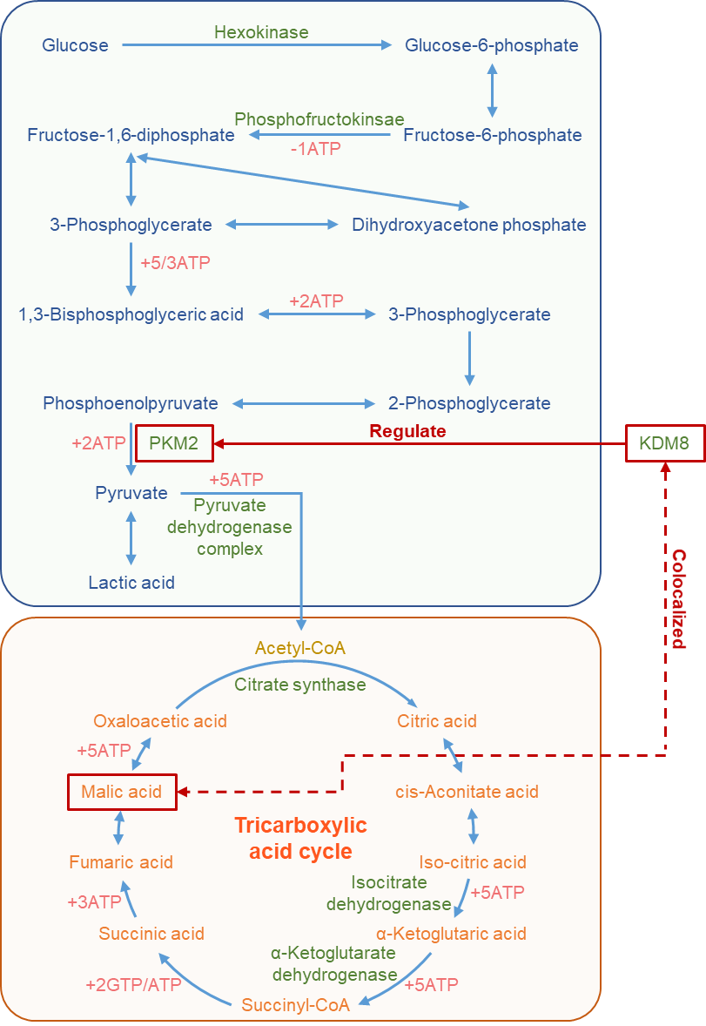
Supplementary Fig. 11 | Schematic overview of glycolysis and the tricarboxylic acid (TCA) cycle. In glycolysis, KDM8 has been reported to regulate PKM2, which catalyzes the conversion of phosphoenolpyruvate to pyruvate. The dashed red line indicates the colocalization between KDM8 expression and malic acid levels. Arrows denote metabolic flow, and key enzymatic steps are indicated.
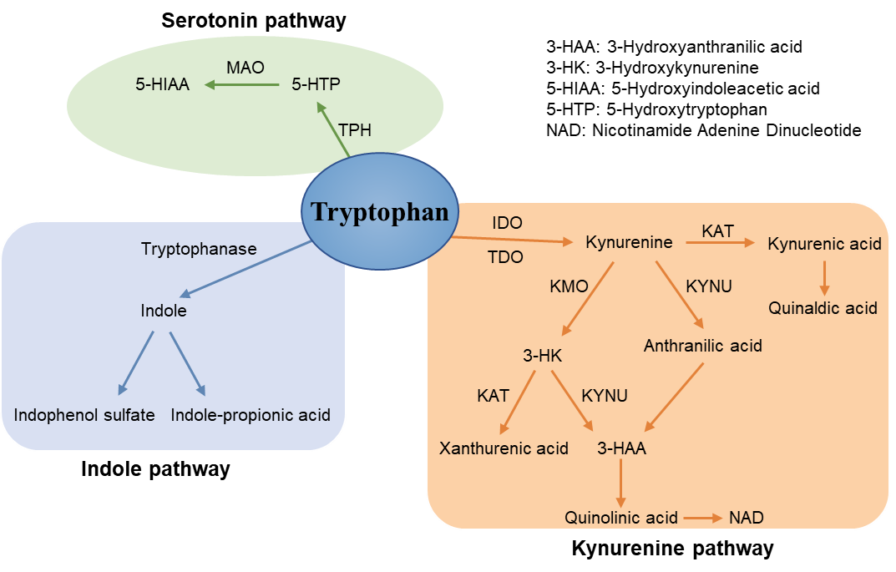
Supplementary Fig. 12 | Schematic overview of tryptophan metabolism. Tryptophan is metabolized through three major pathway branches: the serotonin pathway, the indole pathway, and the kynurenine pathway. Key intermediates and downstream metabolites are shown. Major enzymes involved in each step are indicated. Arrows denote the direction of metabolic conversions.

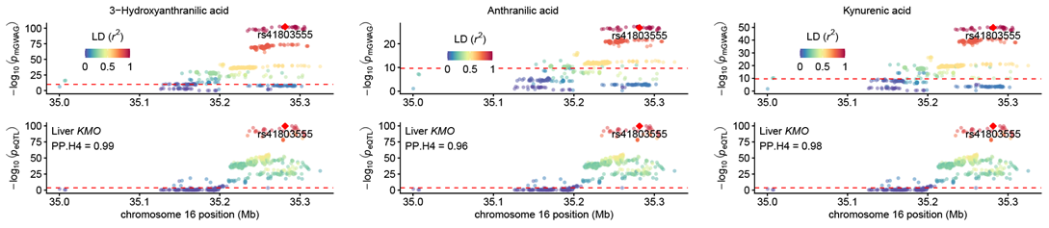
Supplementary Fig. 13 | Examples of colocalization between serum mQTL and cis-eQTL. Regional colocalization plots are shown for serum mQTL of 3-hydroxyanthranilic acid, anthranilic acid, and kynurenic acid, each colocalized with cis-eQTL for KMO in the liver. Variants are colored according to their linkage disequilibrium (r²) with the lead colocalized variant. Dashed horizontal lines indicate the significance threshold.

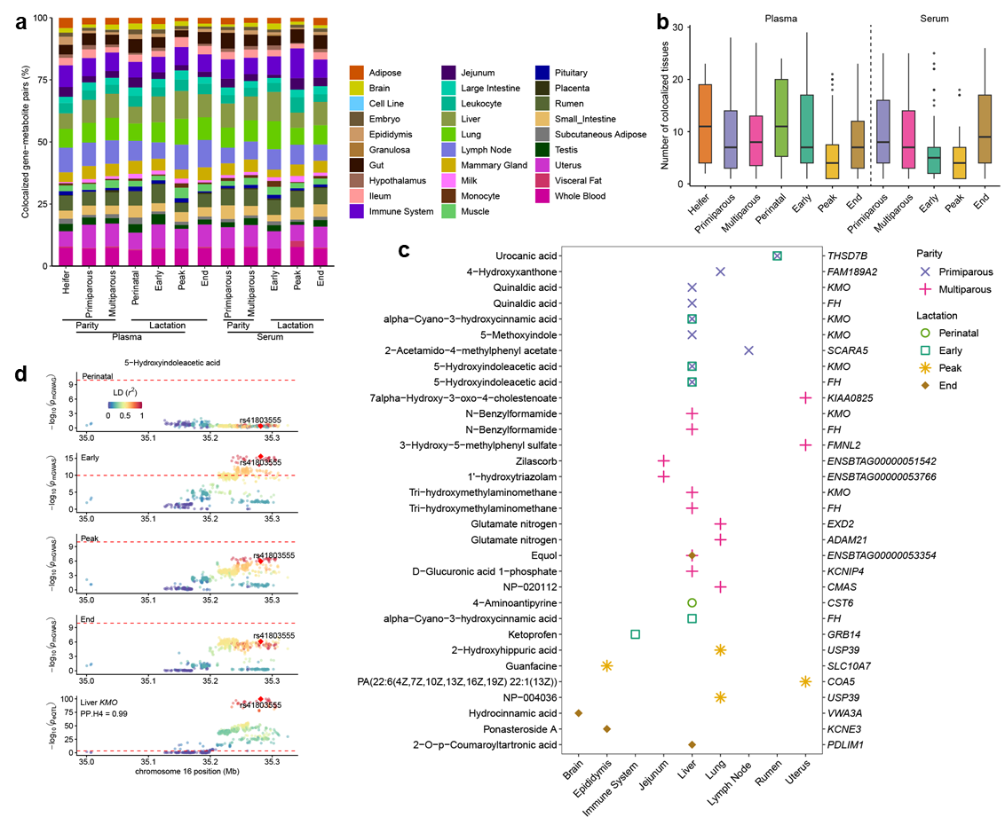
Supplementary Fig. 14 | Summary of stage-based colocalization signals across tissues. a, Proportion of colocalization events across tissues for plasma and serum metabolites, stratified by parity and lactation stages. Stacked bars represent the tissue composition of colocalized signals within each stage. b, Distribution of the number of tissues showing colocalization for each metabolite in plasma and serum across parity and lactation stages. c, Summary of stage-specific colocalization events in which a plasma metabolite was colocalized only in a single stage with the cis-eQTL of a single gene in a single tissue. d, Regional colocalization plots for a stage-specific signal at the KMO locus in the liver across lactation stages. The top four panels show metabolite association signals in the perinatal, early, peak, and end stages, and the bottom panel shows the corresponding liver KMO cis-eQTL signal. Variants are colored according to their linkage disequilibrium (r²) with the lead colocalized variant. Dashed horizontal lines indicate the significance threshold.
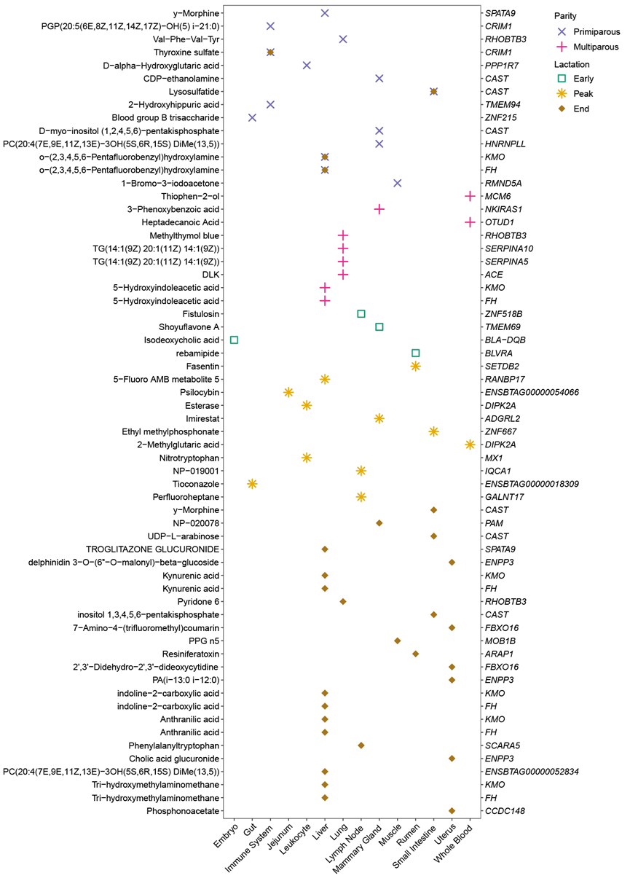
Supplementary Fig. 15 | Summary of stage-specific colocalization events in which a serum metabolite exclusively colocalize within a single stage with the cis-eQTL of a single gene in a single tissue.

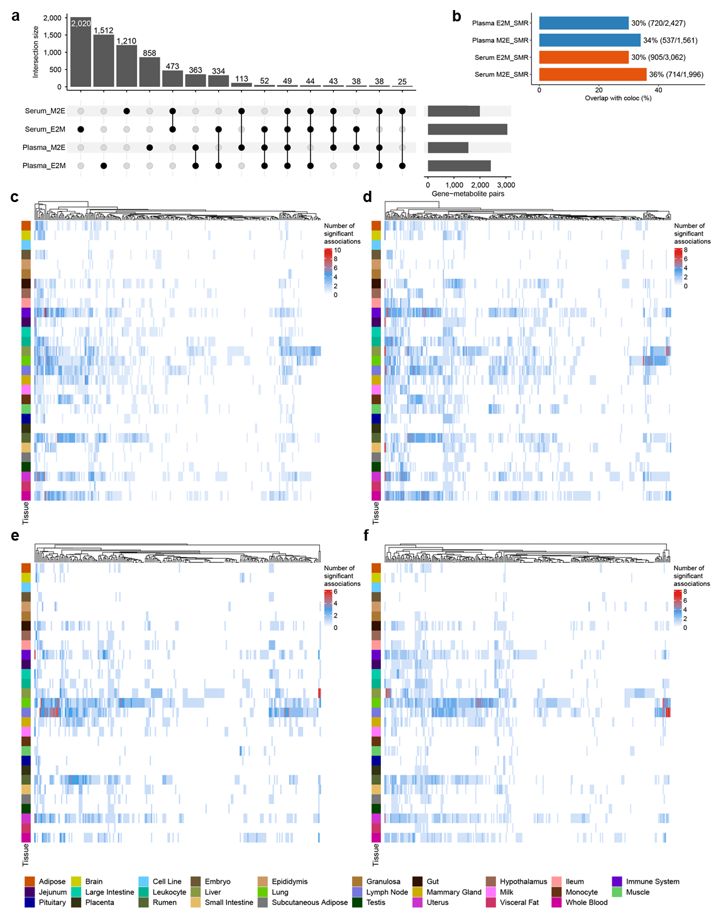
Supplementary Fig. 16 | Summary data-based Mendelian randomization (SMR) associations in plasma and serum. a, UpSetR plot showing the overlap between significant E2M_SMR (gene expression to metabolite level) and M2E_SMR (metabolite level to gene expression) associations (P-value_{SMR} < 5 × 10⁻⁶ and P-value_{HEIDI} > 0.05) in plasma and serum. b, Proportion of SMR associations overlapping with colocalization results in plasma and serum. c and d, Heatmaps showing the number of significant E2M_SMR (c) and M2E_SMR (d) associations for each plasma metabolite across tissues. e and f, Heatmaps showing the number of significant E2M_SMR (e) and M2E_SMR (f) associations for each serum metabolite across tissues. Rows represent tissues, and columns represent metabolites. Metabolites are ordered by hierarchical clustering based on the tissue distribution of colocalization events.

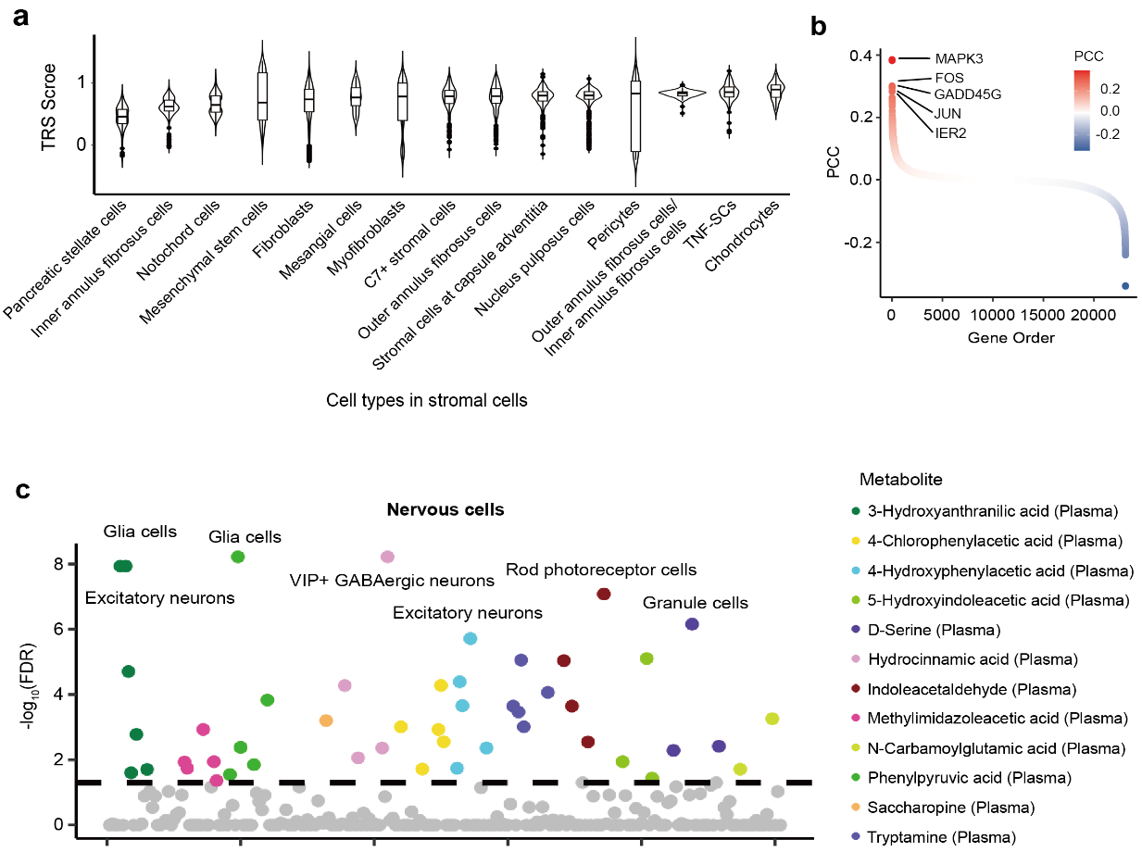
Supplementary Fig. 17 | a, Association between stromal cells and D-glucuronic acid 1-phosphate. The violin plot presents the TRS for each cell type with the D-glucuronic acid 1-phosphate. b, Active KEGG pathways in the top significant trait-relevant cell types. Dot size represents the significance level (-log₁₀(p)) of pathway activity; the dot color represents the significance level (FDR) after multiple comparisons of the enrichment between active pathway genes and top metabolism-relevant genes in the given cell type. c, Association between carbohydrate metabolism and nervous cells. Each circle represents a cell type–trait association. The x axis represents cell lineages sorted alphabetically.

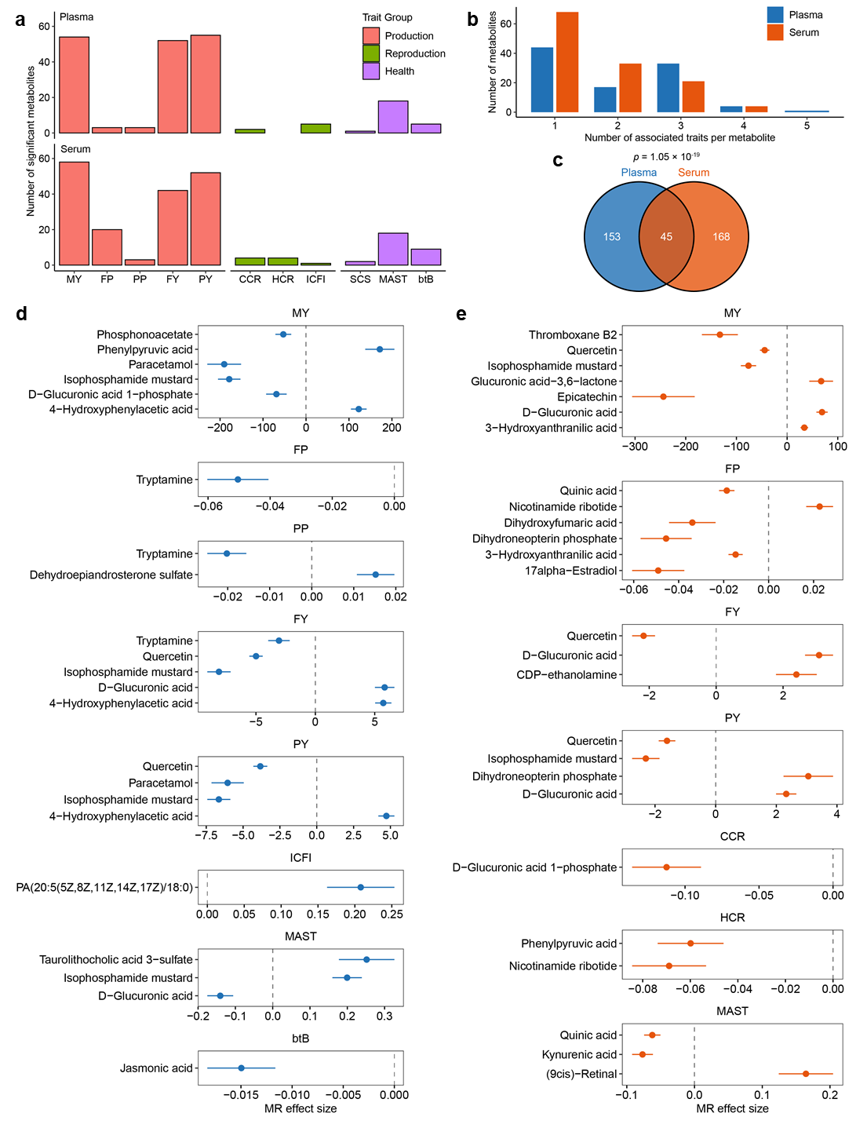
Supplementary Fig. 18 | Mendelian randomization (MR) reveals candidate causal metabolites across traits. a, Number of significant plasma and serum metabolites identified by Mendelian randomization for production, reproduction, and health traits. b, Distribution of the number of associated traits per metabolite in plasma and serum. c, Overlap of significant metabolites identified in plasma and serum. d and e, Estimated Mendelian randomization effect sizes for representative significant metabolites associated with traits in plasma (d) and serum (e). Points indicate effect estimates with standard errors derived from the inverse variance weighted (IVW) in MR analysis.
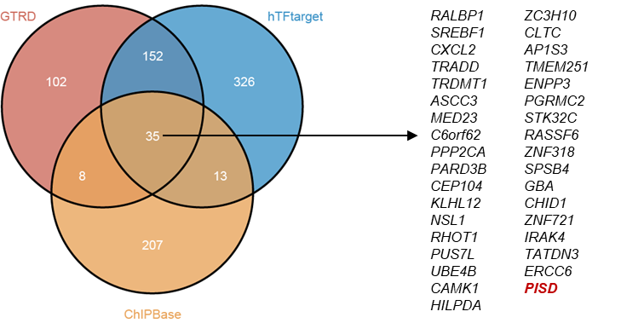
Supplementary Fig. 19 | Overlap of predicted target genes for ZNF331 across three databases. Shared genes are shown in the right panel.

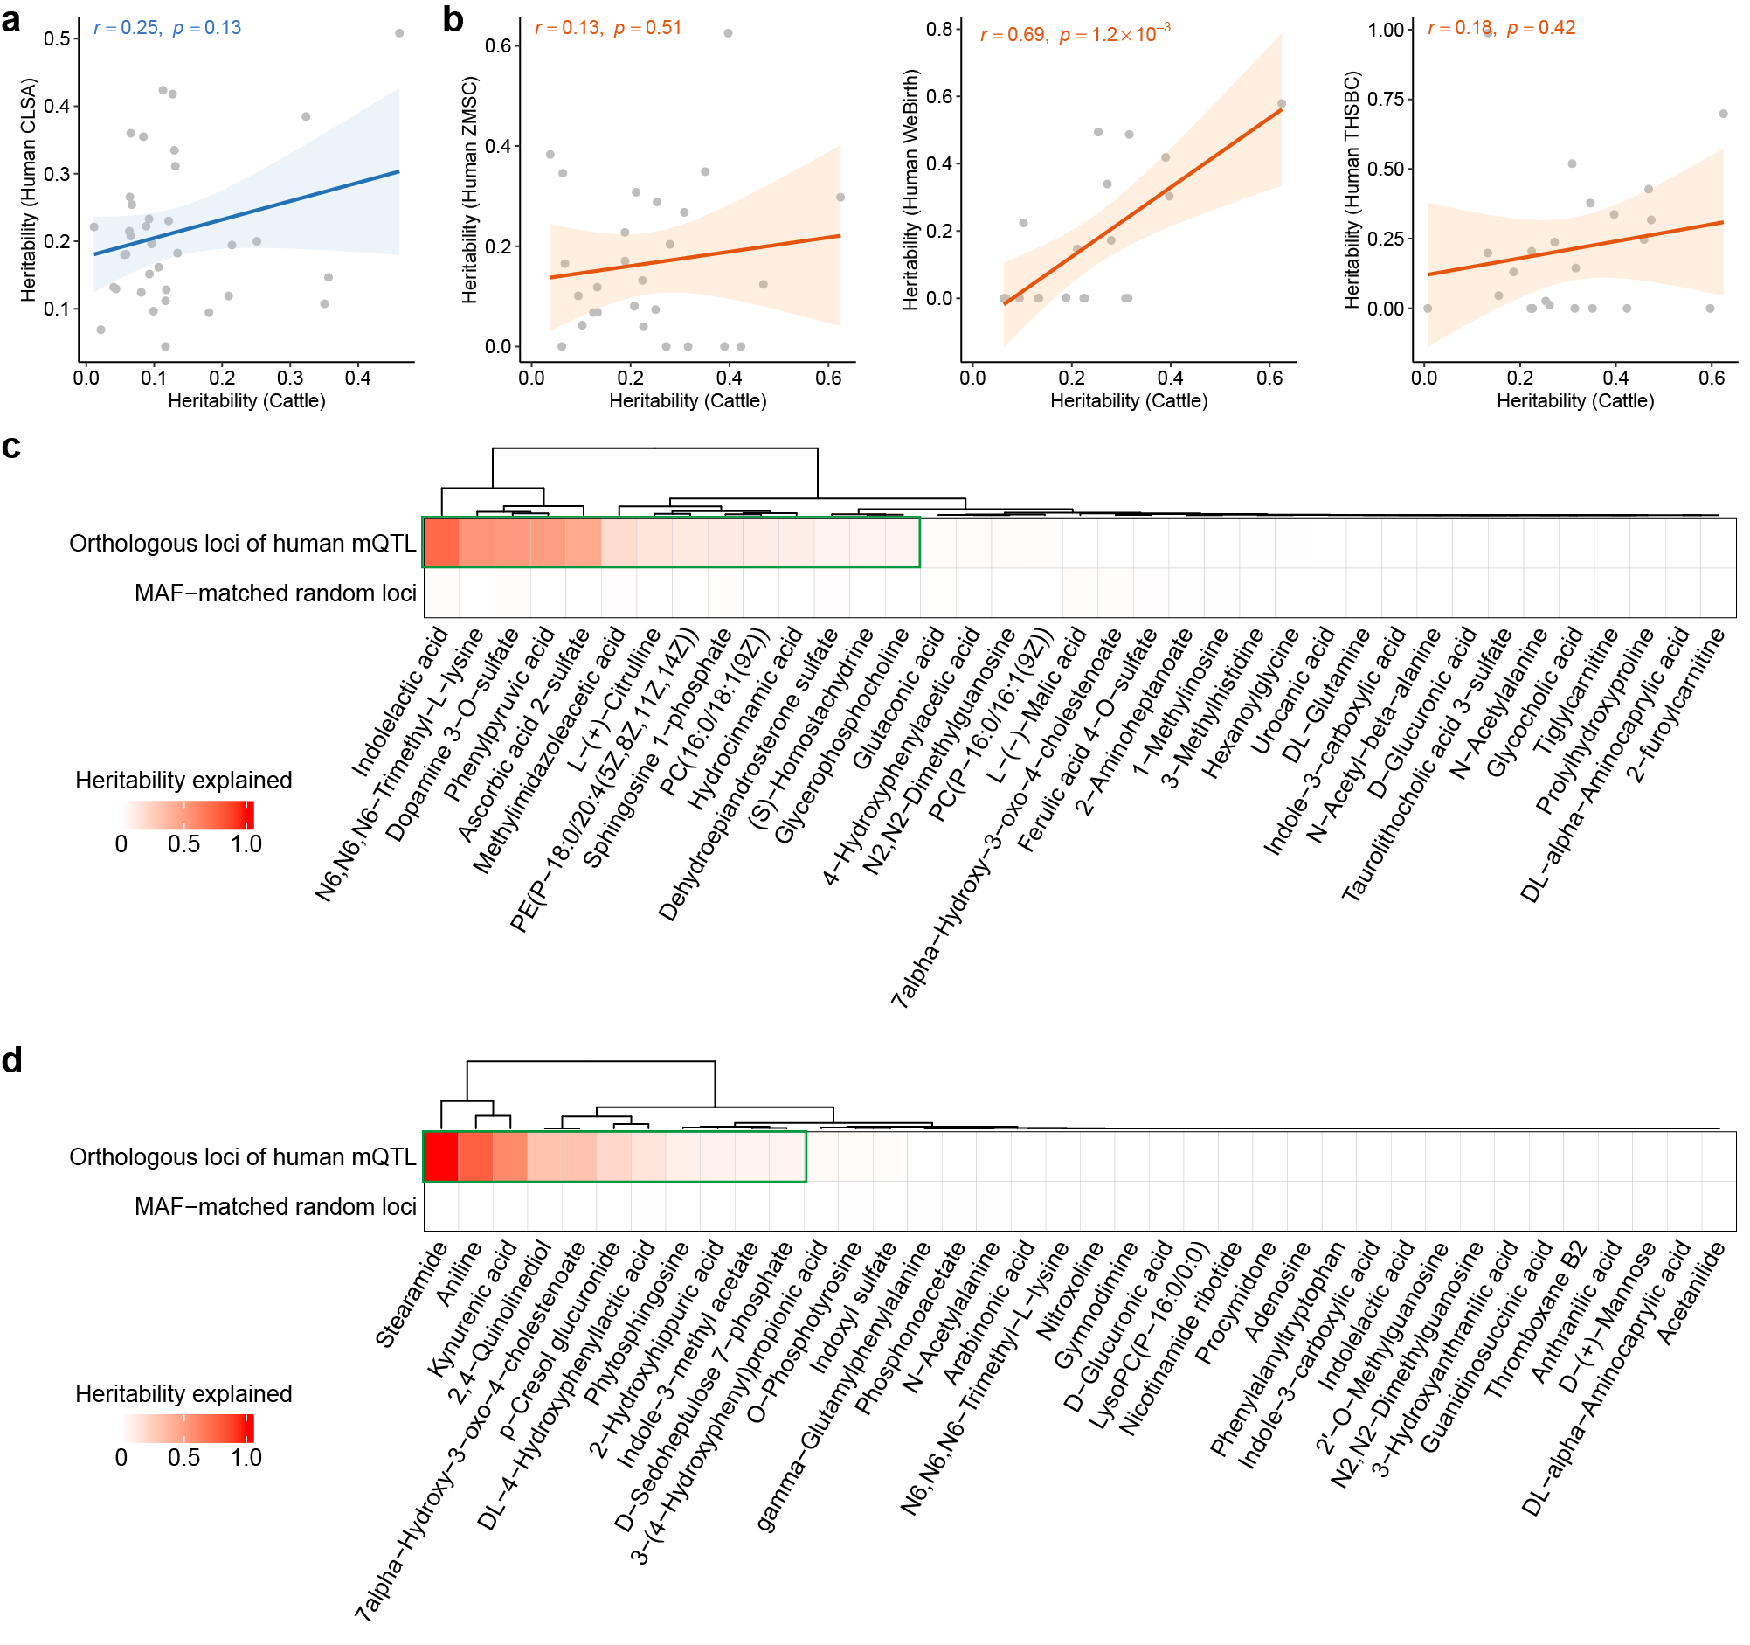
Supplementary Fig. 20 | Cross-species comparison of metabolite heritability and heritability enrichment at orthologous loci. a and b, Correlation of metabolite heritability estimates between cattle and humans for overlapping plasma metabolites using human CLSA cohort (a) and serum metabolites using human ZMSC, WeBirth and THSBC (b) cohorts. Each point represents one metabolite. Solid lines indicate linear regression fits, and shaded areas denote 95% confidence intervals. Pearson’s correlation coefficients and two-sided P-values are shown. c, d, Proportion of cattle metabolite heritability explained by orthologous loci of human mQTL and MAF-matched random loci for overlapping plasma (c) and serum (d) metabolites shared between cattle and humans. Colors indicate the proportion of heritability explained by each locus set. Green boxes indicate metabolites for which orthologous loci explained >5% of heritability.

