Supplementary Materials

Interpretable Latent Representations of Odor Perception by Integrating Molecular Structure and Olfactory Receptor Responses

Shigenori Tanaka
Center for Life Photonic Innovation, Kobe University, 1-1 Rokkodai, Nada-ku, Kobe 657-8501, Japan
Email: tanaka2@kobe-u.ac.jp

Table S1. Summary of the 24 OR-only SAE latent components.
For each OR-only SAE component, F1–F24, the table lists representative odorant molecules, top ATLAS odor descriptors, and top associated human olfactory receptors (ORs). The F components were obtained from sparse autoencoder (SAE) analysis of the 409-dimensional olfactory-receptor docking-score profiles. ATLAS odor descriptors were assigned post hoc to aid perceptual interpretation of each receptor-derived latent component. ATLAS descriptors are shown as descriptor names only, without numerical descriptor IDs, and olfactory receptors are denoted by OR gene symbols with UniProt accession numbers in parentheses.

Table S2. Summary of the 24 Joint SAE latent components.
For each Joint SAE component, J1–J24, the table shows representative odorant molecules, top ATLAS odor descriptors, and top associated human olfactory receptors (ORs). ATLAS descriptors are shown as descriptor names only, without numerical descriptor IDs. Olfactory receptors are listed as OR gene symbols followed by UniProt accession numbers in parentheses. The table provides a compact overview of the perceptual and receptor-level characteristics of all Joint SAE components.
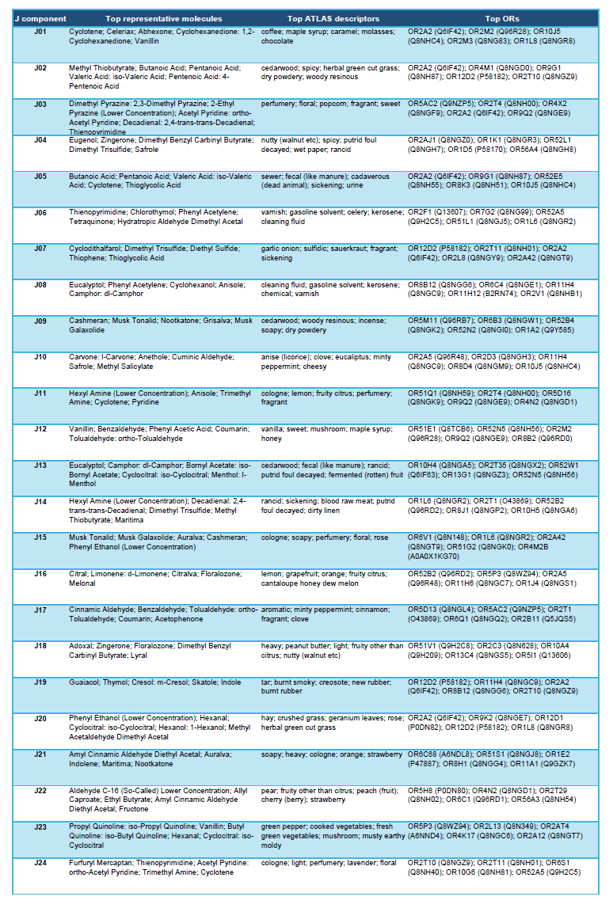

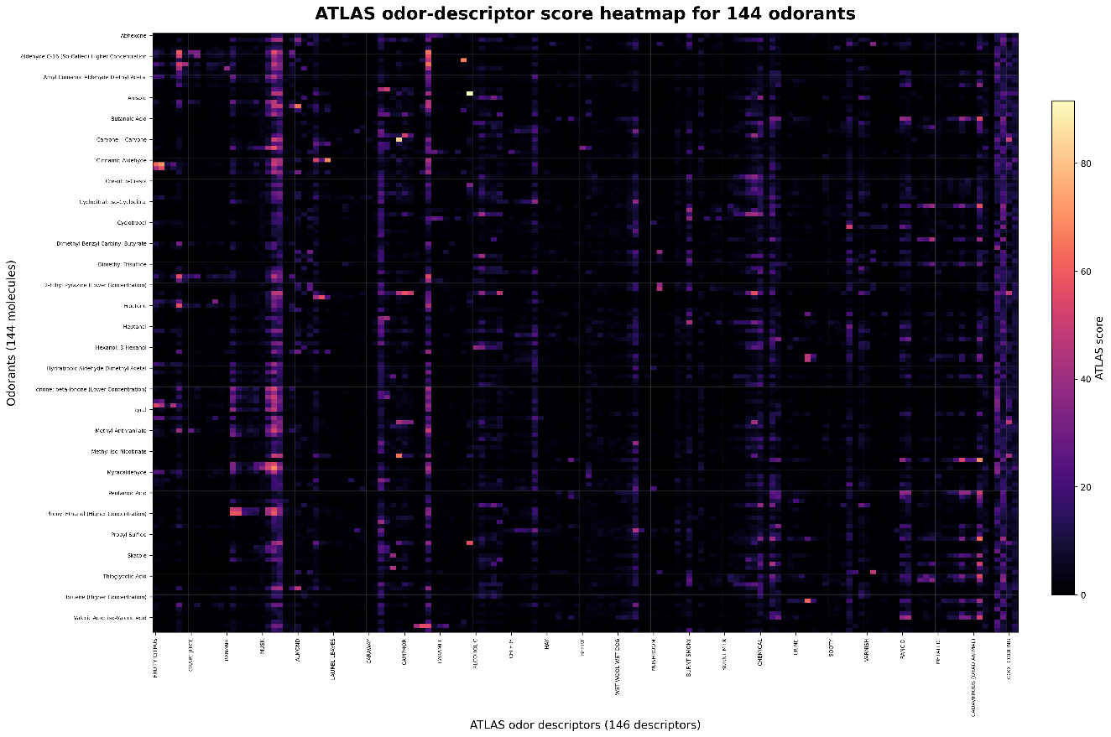
Figure S1. Raw ATLAS odor-descriptor score heatmap.
Heatmap showing the raw ATLAS odor-descriptor scores for 138 odorants (144 samples including the data with different concentrations) across 146 perceptual descriptors. Rows correspond to odorants and columns correspond to ATLAS descriptors. Color intensity indicates the original descriptor score. This figure provides the unnormalized perceptual-annotation landscape used in the Joint SAE analysis.

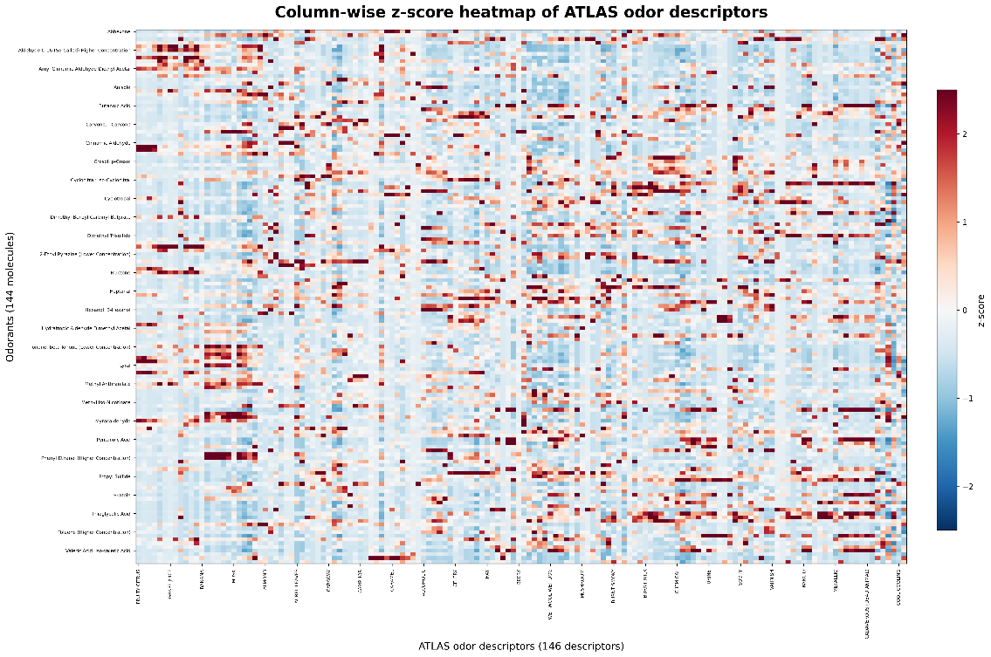
Figure S2. Column-wise z-score heatmap of ATLAS odor-descriptor profiles.
Heatmap showing column-wise z-score–normalized ATLAS odor-descriptor scores for 138 odorants across 146 descriptors. For each descriptor, scores were standardized across odorants so that the heatmap emphasizes odorants with relatively high or low scores for that descriptor. Positive values indicate odorants that are more strongly associated with a given descriptor than the dataset average, whereas negative values indicate weaker-than-average association. This representation highlights descriptor-centered perceptual structure across odorants.

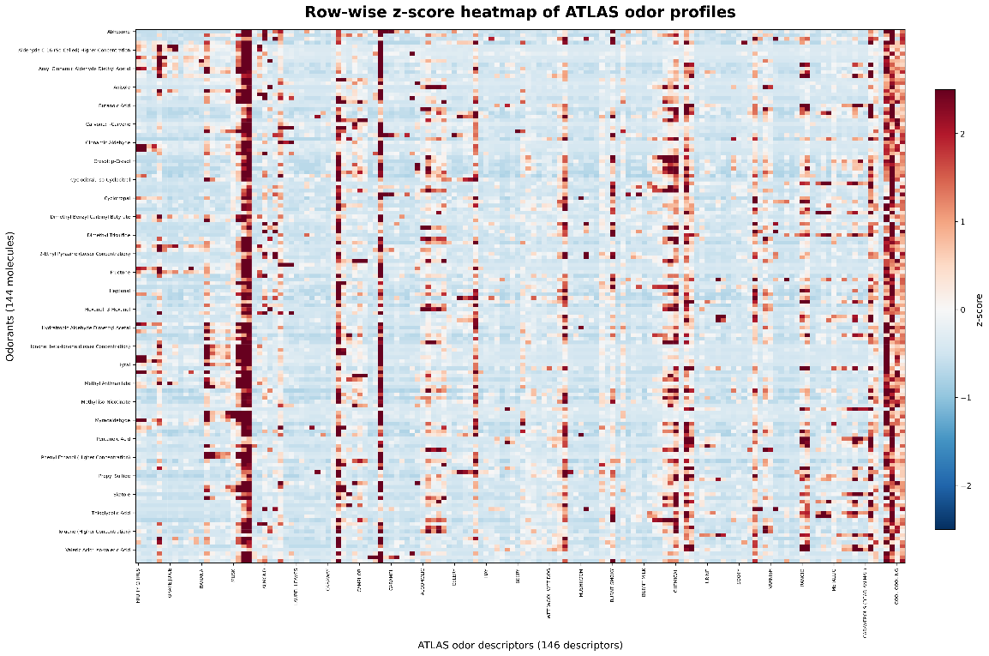
Figure S3. Row-wise z-score heatmap of ATLAS odor-descriptor profiles.
Heatmap showing row-wise z-score–normalized ATLAS odor-descriptor scores for 138 odorants across 146 descriptors. For each odorant, scores were standardized across descriptors so that the heatmap emphasizes descriptors that are relatively high or low within that odorant’s perceptual profile. Positive values indicate descriptors that are more prominent than the odorant’s average descriptor score, whereas negative values indicate less prominent descriptors. This representation highlights odorant-specific perceptual signatures.

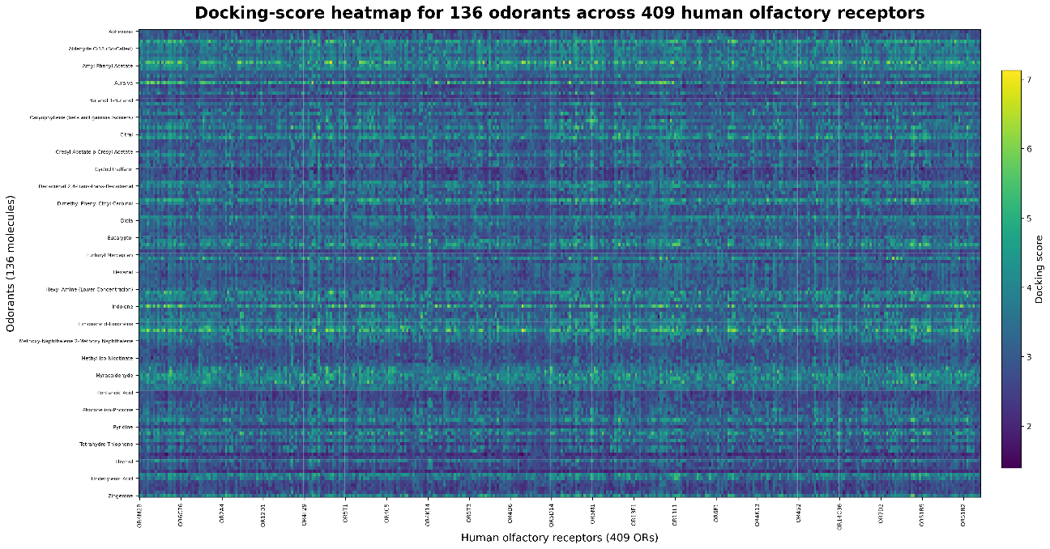
Figure S4. Raw docking-score heatmap for 136 odorants across 409 human olfactory receptors.
Heatmap showing the raw docking scores for 136 odorants against the 409 human olfactory receptors used in this study. Rows correspond to odorants and columns correspond to receptors. Color intensity indicates the magnitude of the docking score. This figure provides the unnormalized receptor–ligand docking landscape that served as the basis for receptor-informed representation learning.

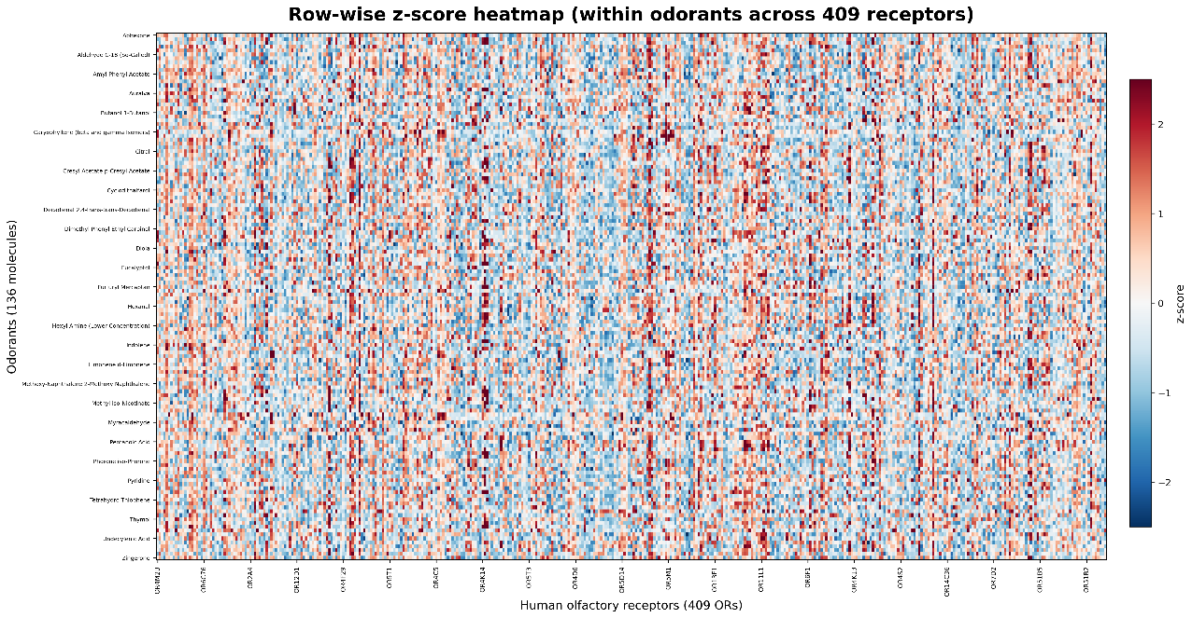
Figure S5. Row-wise z-score heatmap of docking profiles.
Heatmap showing row-wise z-score–normalized docking scores for the 136 odorants across the 409 human olfactory receptors. For each odorant, docking scores were standardized across receptors so that the heatmap emphasizes receptor-specific deviations from that odorant’s mean docking profile. Positive values indicate receptors with relatively stronger docking for a given odorant, whereas negative values indicate relatively weaker docking. This representation highlights odorant-specific receptor-preference patterns.

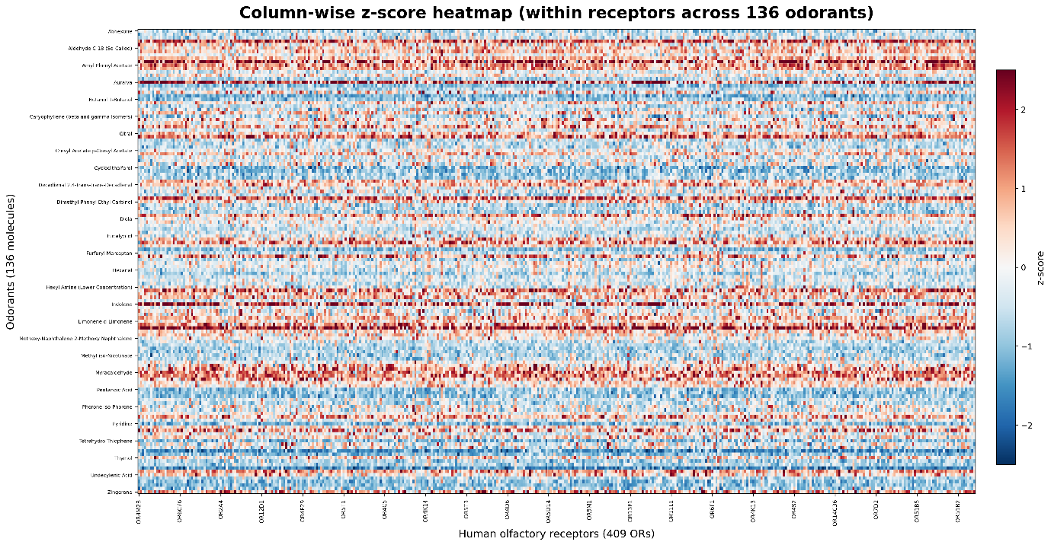
Figure S6. Column-wise z-score heatmap of docking profiles.
Heatmap showing column-wise z-score–normalized docking scores for the 136 odorants across the 409 human olfactory receptors. For each receptor, docking scores were standardized across odorants so that the heatmap emphasizes odorant-specific deviations from that receptor’s mean docking profile. Positive values indicate odorants with relatively stronger docking to a given receptor, whereas negative values indicate relatively weaker docking. This representation highlights receptor-centered ligand selectivity patterns.

