L NC R1 R2 R3 R4 R5 R6 R7 R8 R9 R10
nuc (225bp)

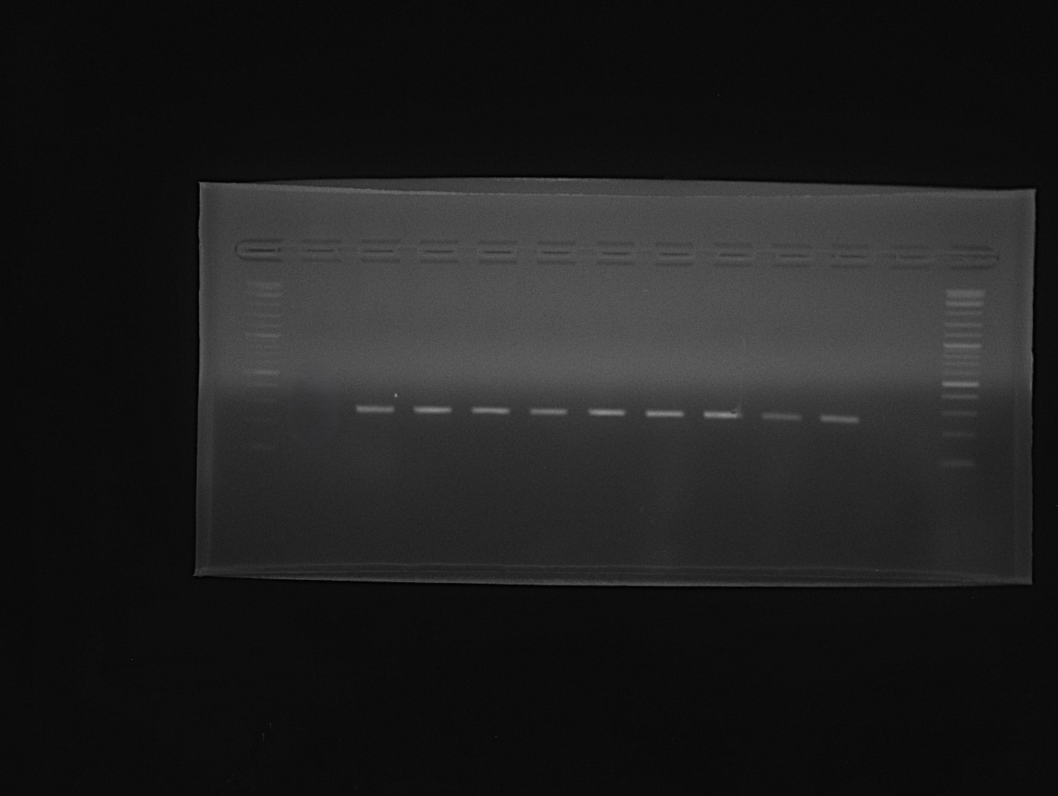
L NC R11 R12 R13 R14 R15 R16 R17 R18 R19
nuc (225bp)

L NC R1 R2 R3 R4 R5 R6 R7 R8 R9 R10
mecA (500bp)

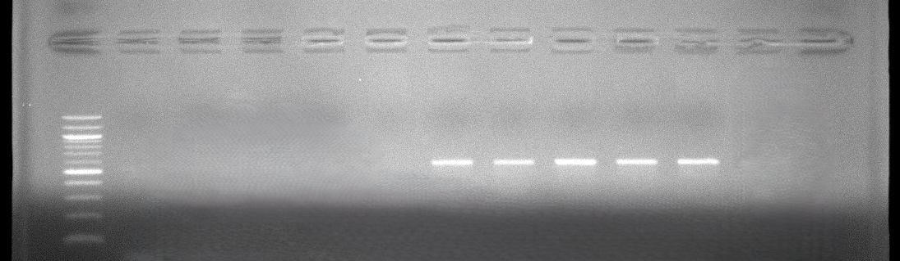
mecA (500bp)
L NC R11 R12 R13 R14 R15 R16 R17 R18 R19

