Supplementary Information

Swallow Nest-Inspired Asymmetric Transparent Bamboo for All-weather Water Manipulation and Thermal Management

S1 Supplementary Notes: S1-S2
Note S1: Experimental Section
Note S2: Preparation and Chemical Characterization of Transparent Bamboo Substrate
Note S3: Interfacial Component Regulation
S2 Supplementary Figures: S1-S21
S3 Supplementary Tables: S1-S2
S4 Supplementary References

S1 Supplementary Notes
Note S1: Preparation and Chemical Characterization of Transparent Bamboo Substrate
The microstructural evolution and chemical compositional changes during the fabrication of the TB substrate were characterized via SEM, XRD and FTIR. Cross-sectional morphologies observed by SEM are shown in Figure 1b. The cross-section of NB exhibits a typical porous structure with regularly shaped, closely arranged parenchyma cells. After delignification, lignin and extractives are removed and partial hemicelluloses are degraded. The parenchyma cells of DB undergo collapse and deformation, with reduced cell wall thickness and enlarged intercellular spaces, which provide permeation channels for subsequent resin impregnation¹. After epoxy resin impregnation, the cell lumens and intercellular spaces of TB are fully filled with epoxy resin, and the cell walls are tightly integrated with the resin matrix, providing a flat and stable mechanical and structural substrate for subsequent surface modification.
XRD analysis (Figure 1c) indicates that both NB and DB show characteristic diffraction peaks of cellulose Ⅰ at 16.2° (101), 22.1° (002) and 34.8° (040). The slightly increased peak intensity of DB confirms that the delignification process removes amorphous lignin without destroying the intrinsic crystalline structure of cellulose². Compared with NB and DB, the characteristic diffraction peaks of TB become broader with moderately decreased intensity, which is attributed to the filling of amorphous epoxy resin that forms a crystalline-amorphous composite system.
FTIR spectra (Figure 1d) verify the chemical compositional changes during TB fabrication. For NB, characteristic peaks of lignin are observed, including aromatic skeleton stretching vibrations at 1605 cm⁻¹ and 1510 cm⁻¹, asymmetric -CH₃ bending vibration at 1460 cm⁻¹, aromatic ring C-H in-plane bending vibration at 1425 cm⁻¹, and C-H vibration of guaiacyl derivatives at 830 cm⁻¹. These peaks almost completely disappear in DB, demonstrating that lignin components are efficiently removed via delignification³. Characteristic peaks of hemicelluloses and cellulose include the acetyl group stretching vibration at 1735 cm⁻¹, cellulose/hemicellulose C-H bending vibration at 1378 cm⁻¹, cellulose C-H bending vibration at 1324 cm⁻¹, cellulose ether bond stretching vibration at 1165 cm⁻¹, and cellulose C-H stretching vibration at 897 cm⁻¹ ⁴. The intensities of these peaks show slight elevation or minor reduction in the DB spectrum, indicating that most cellulose and hemicellulose components are retained. TB preserves all the above characteristic peaks of cellulose and hemicelluloses, and simultaneously presents new peaks assigned to epoxy resin: aromatic ring skeleton stretching vibrations at 1605 cm⁻¹, 1580 cm⁻¹ and 1510 cm⁻¹, aliphatic-aromatic ether C-O-C stretching vibrations at 1252 cm⁻¹ and 1035 cm⁻¹, isopropyl aromatic C-CH₃ vibration at 1183 cm⁻¹, and out-of-plane deformation peak of para-substituted benzene ring (=CH-) at 830 cm⁻¹ ^{5,6}. These results confirm that epoxy resin is successfully impregnated into the porous structure of delignified bamboo and forms a stable composite system with the cellulose skeleton, which is consistent with the SEM and XRD results.
Note S2: Interfacial Component Regulation
EP/PDMS Blending Ratio: Epoxy resin possesses favorable rigidity and adhesion strength but poor hydrophobicity, while PDMS is a flexible low-surface-energy material with strong hydrophobicity and excellent weather resistance but low strength and high deformability. Blending the two components at an appropriate ratio achieves balanced mechanical rigidity and low surface energy, and the migration of free PDMS segments to the surface enables the healing of damaged hydrophobicity⁷. In the blended matrix, increasing PDMS content leads to enhanced hydrophobicity but reduced mechanical strength. An excessively high PDMS ratio will induce macroscopic phase separation, resulting in deteriorated hydrophobicity as well as impaired optical transmittance and mechanical strength. The hydrophobicity of matrices with different blending ratios was tested, as shown in Figure S1. The matrix achieves favorable hydrophobicity when the epoxy resin content is 80 wt% and 70 wt%. Comprehensively considering mechanical strength, hydrophobicity and optical transmittance (Figure S2), the mass ratio of epoxy resin to PDMS was determined as 4:1.
Particle Size of ZnO Nanoparticles: As the basic building blocks of the interfacial micro/nanostructures, the particle size of ZnO nanoparticles exerts a decisive influence on transmittance and surface morphology. Smaller particles can effectively reduce interfacial Rayleigh scattering and maintain high transmittance, but are insufficient to construct adequate surface roughness. At an EP/PDMS mass ratio of 4:1 and a HDTMS@ZnO loading of 42 wt%, WCAs corresponding to different particle sizes are compared in Figure S4. When the particle size is 5 nm, the surface micro/nanomorphology is underdeveloped, with a WCA of only 125.5°. For particle sizes of 15 nm, 30 nm, 50 nm, 90 nm and 200 nm, the WCAs are 132.2°, 133.6°, 130.4°, 125.7° and 129.0°, respectively. Optical transmittance decreases with increasing particle size. Comprehensively considering the requirements for maximizing optical transmittance and initial hydrophobicity, 15 nm HDTMS@ZnO was selected as the optimal 0D filler for constructing the biomimetic surface.

S2 Supplementary Figures: S1-S20
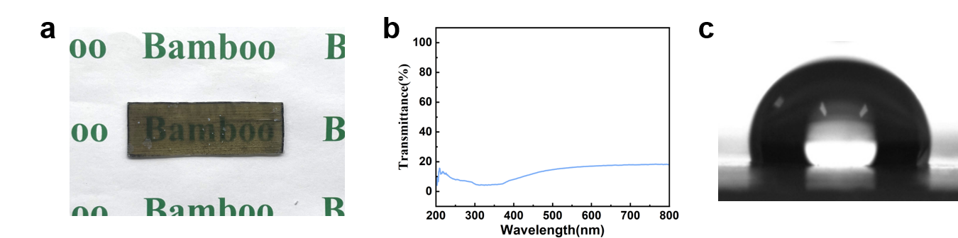
Figure S1. Optical and wetting properties of the homogeneous transparent bamboo. The sample was prepared by impregnating the delignified template with an EP/PDMS matrix doped with 1 wt% nanoparticles (0.99 wt% HDTMS@ZnO and 0.01 wt% MWCNTs). (a) Digital photograph of the homogeneous transparent bamboo. (b) UV–vis transmittance spectrum. (c) Water contact angle measurement of the surface (104.3°).
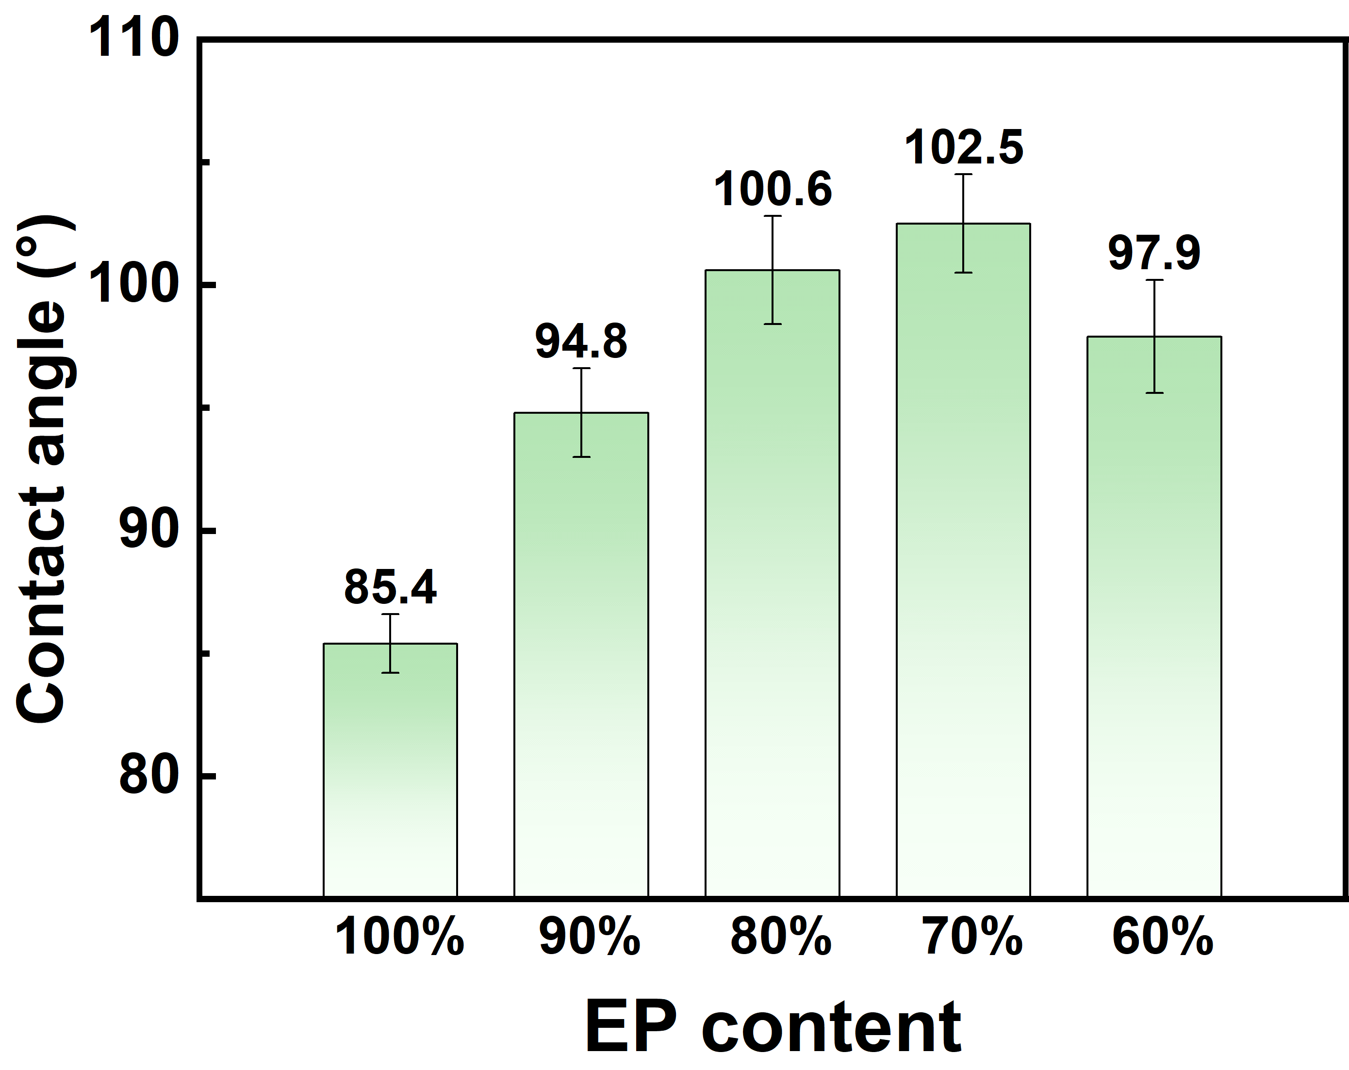
Figure S2. Water contact angles of blended matrices with different EP contents. 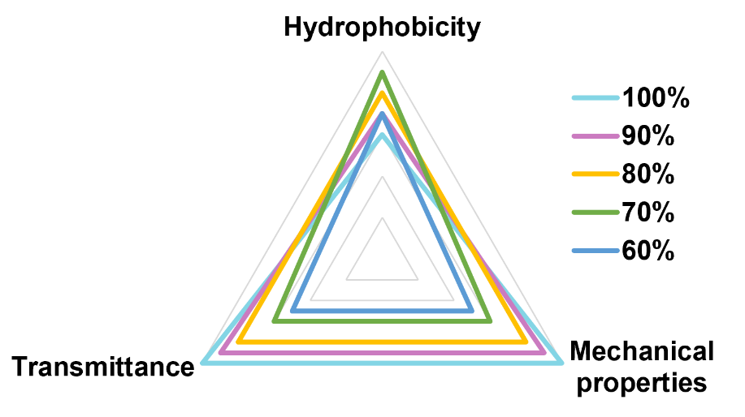
Figure S3. Comparison of hydrophobic surface properties at varying EP contents.
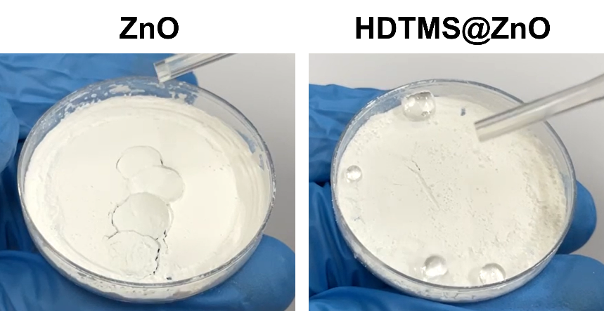
Figure S4. Wettability difference between pristine ZnO and HDTMS@ZnO. 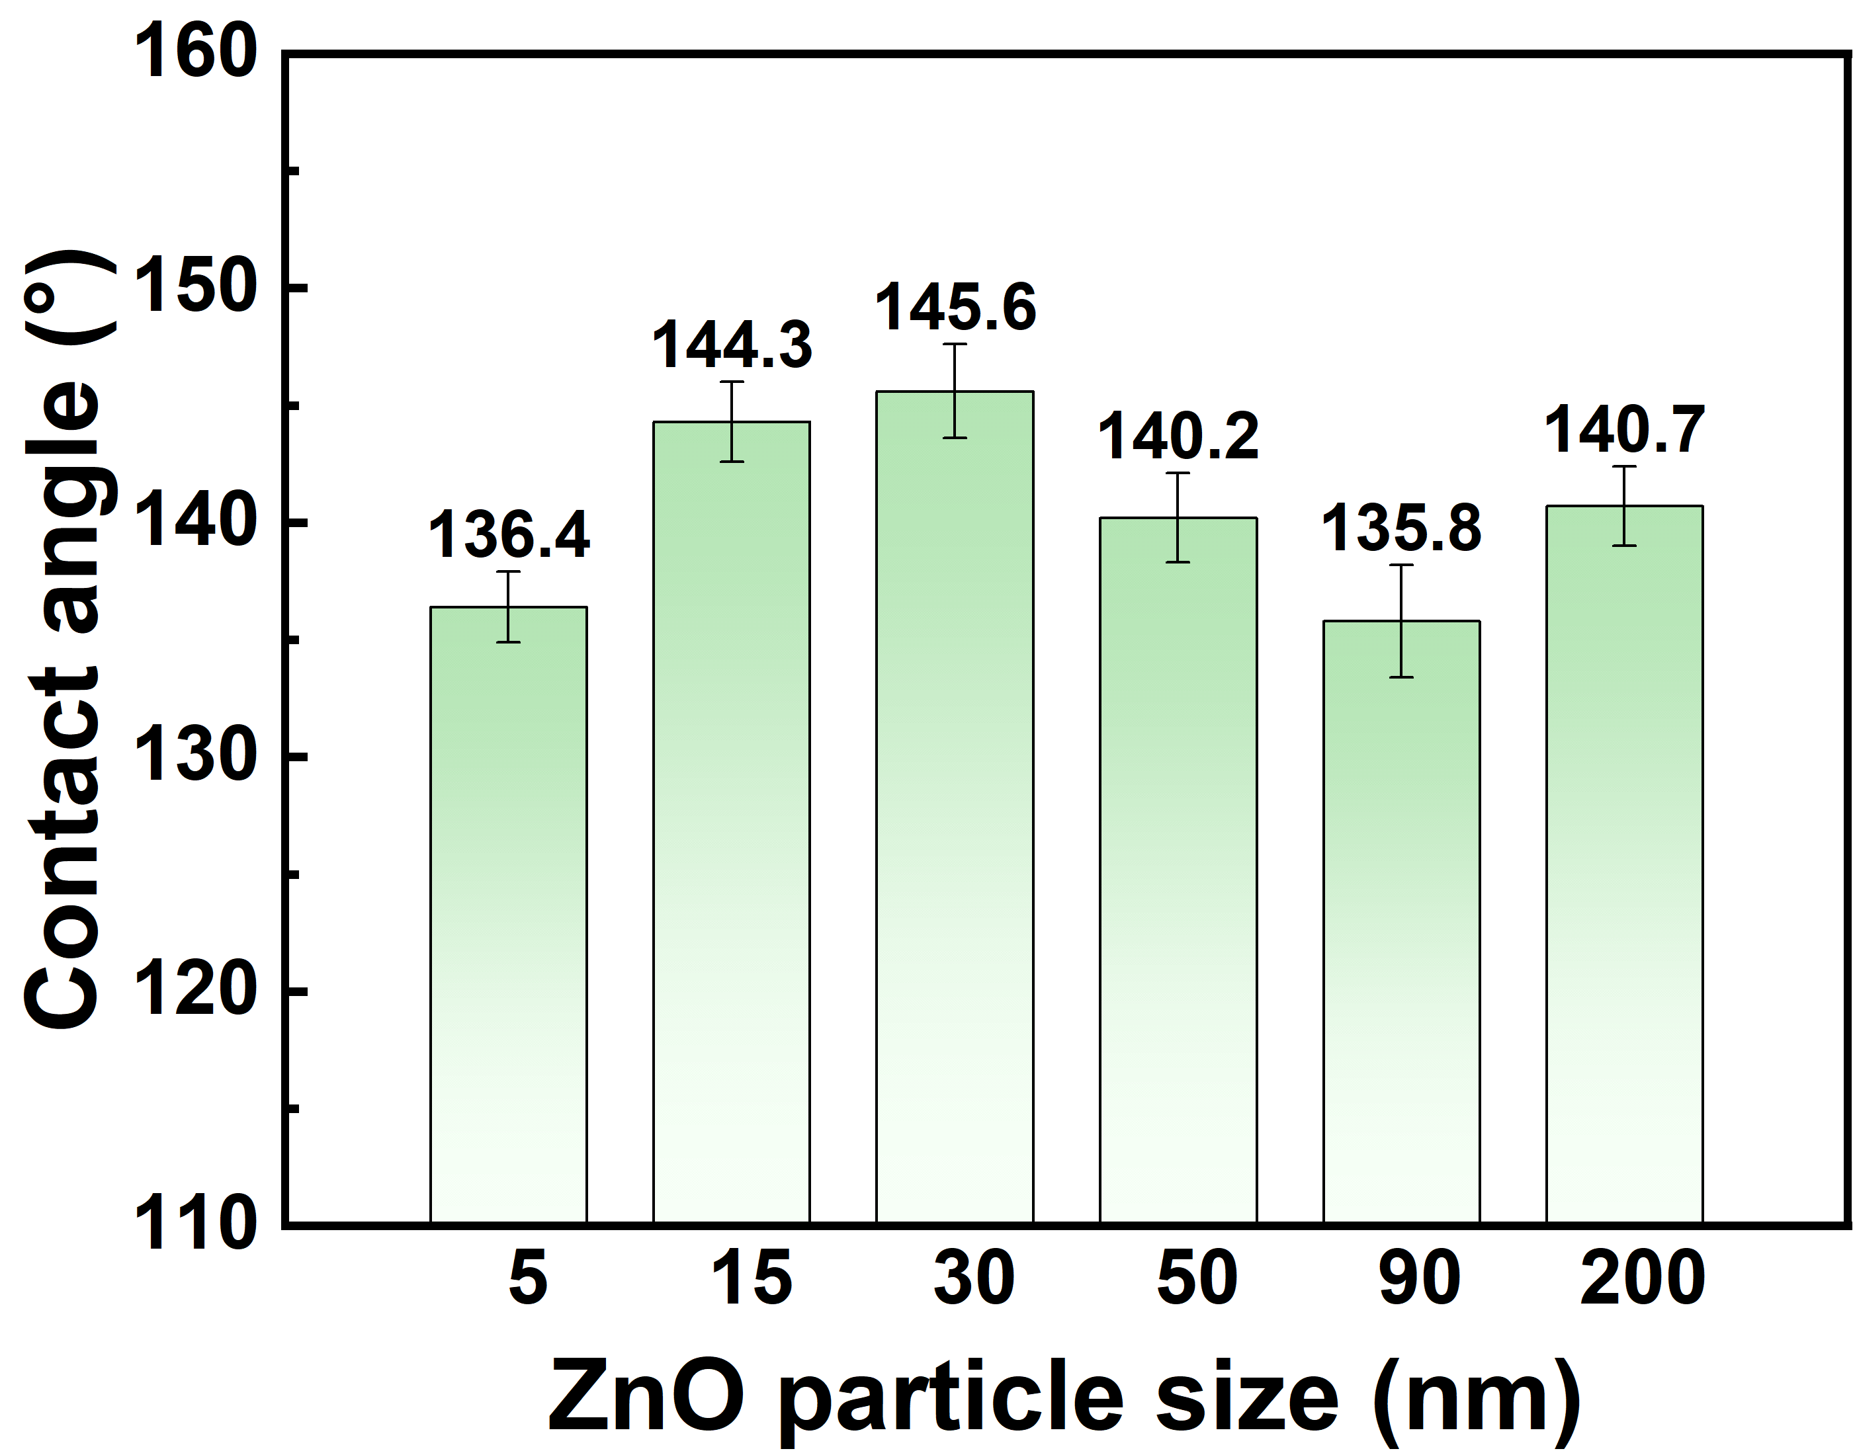
Figure S5. Water contact angles of coatings fabricated with HDTMS@ZnO of different particle sizes at a total loading of 42 wt%.
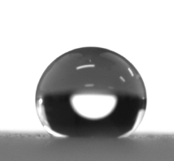
Figure S6. Water contact angle of STB-M0 (144.3°).
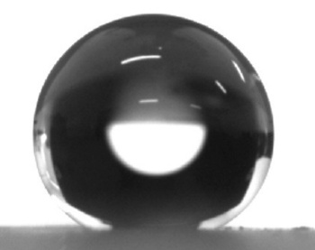
Figure S7. Water contact angle of STB-M0.4 (156.8°).
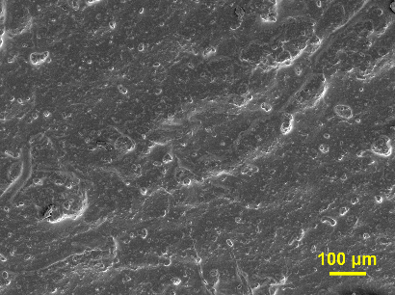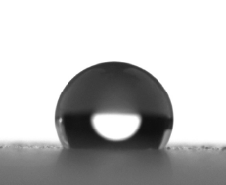
Figure S8. Surface morphology (left) and water contact angle (right, 119.5°) of the coating with pure MWCNTs and no HDTMS@ZnO.
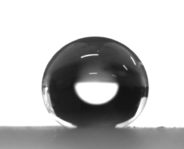
Figure S9. Superhydrophobic threshold of the coating with only 0D HDTMS@ZnO (no MWCNTs) at 46 wt% loading (WCA = 150.6°).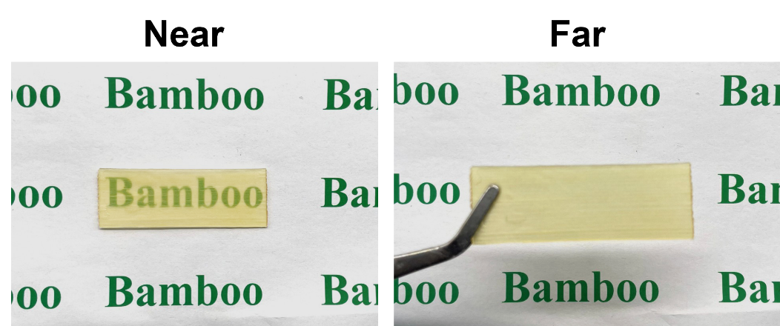
Figure S10. Privacy protection performance of STB-M0.4 derived from its high haze property.
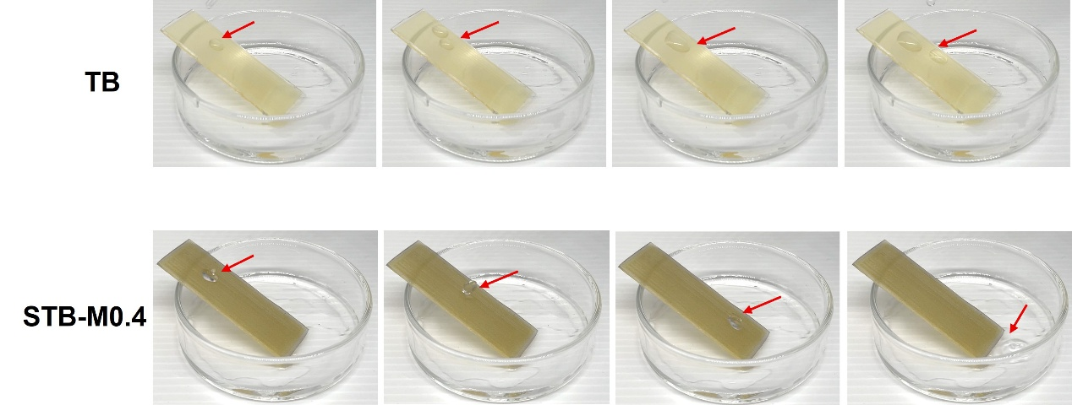
Figure S11. Comparison of surface adhesion between TB and STB-M0.4.

Figure S12. Schematic illustration of the sandpaper abrasion test.
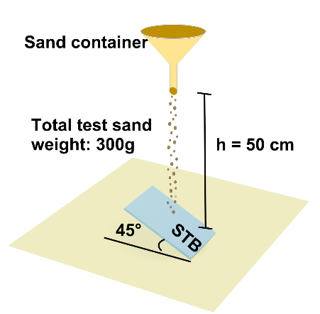
Figure S13. Schematic illustration of the sand particle impact test.
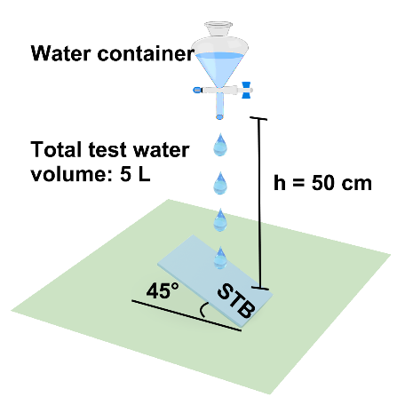
Figure S14. Schematic illustration of the water jet impact test.

Figure S15. Schematic illustration of the tape peeling test.
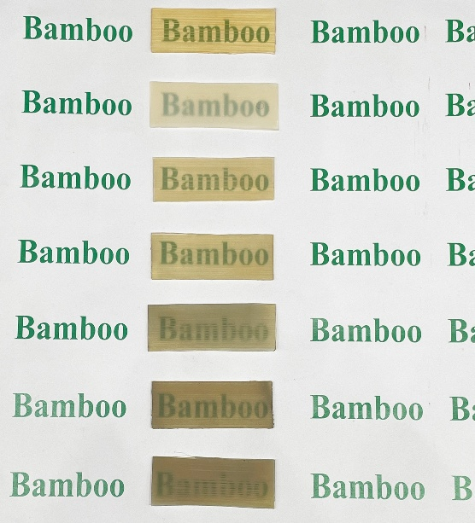
Figure S16. Digital photographs of samples after UV accelerated aging, from top to bottom: TB, STB-M0, STB-M0.2, STB-M0.4, STB-M0.6, STB-M0.8, STB-M1.0.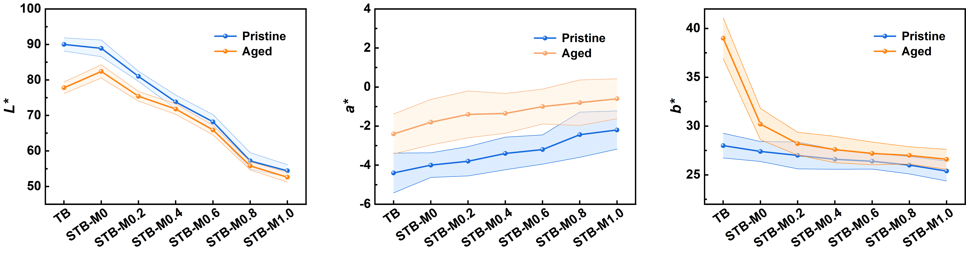
Figure S17. Variation of CIELAB color parameters after UV accelerated aging.
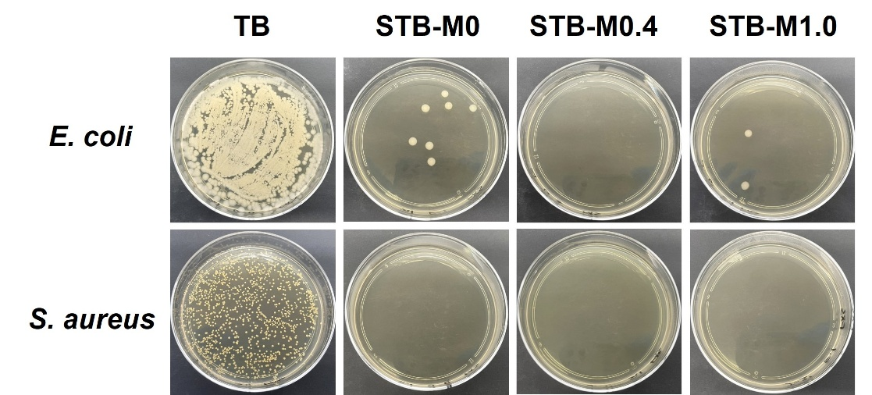
Figure S18. Antibacterial performance of TB, STB-M0, STB-M0.4 and STB-M1.0.
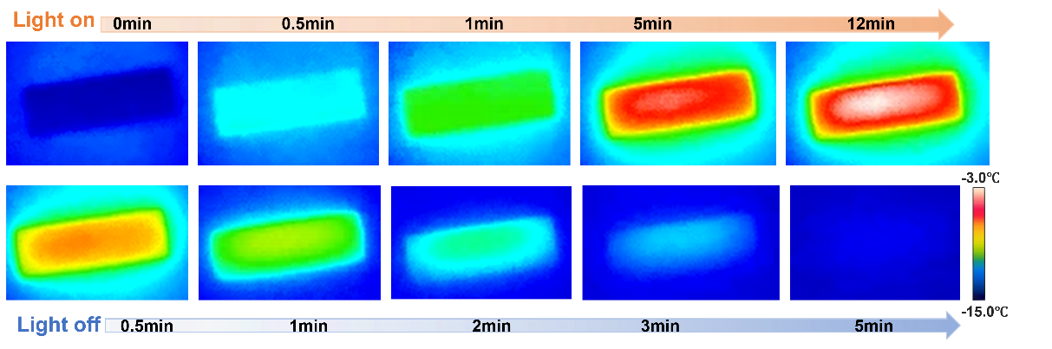
Figure S19. Photothermal heating curve of TB under 1 sun irradiation at −15 °C.
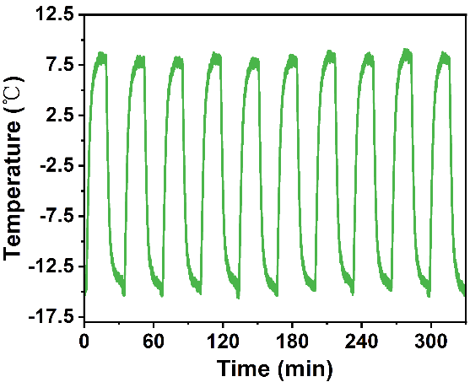
Figure S20. Temperature variation of STB-M0.4 during light-dark cycles at −15 °C.
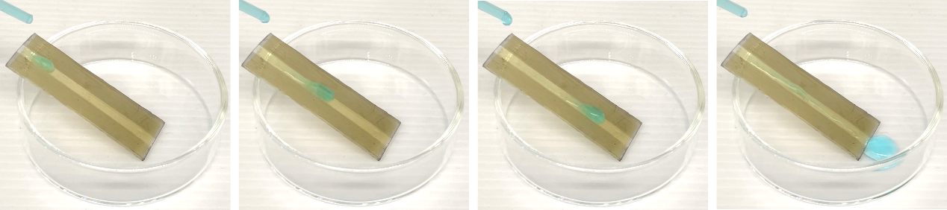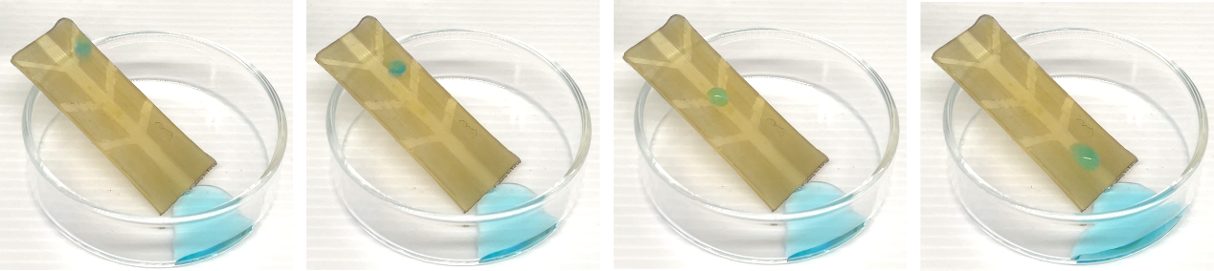
Figure S21. Directional droplet transport performance of linear and dendritic patterned surfaces.
S3 Supplementary Tables
Table S1. Effects of total nanoparticle content and MWCNT content on Water contact angles
MWCNT content | nanoparticle conten
 | 36% | 38% | 40% | 42% | 44% | 46%
0% | 127.6±1.9 | 133.3±1.5 | 138.9±1.4 | 144.2±1.3 | 147.4±1.2 | 150.6±1.6
0.2% | 136.4±1.6 | 142.7±1.4 | 146.7±1.3 | 149.6±0.8 | 152.5±0.8 | 155.4±1.0
0.4% | 144.5±2.0 | 148.8±2.3 | 153.6±1.1 | 156.8±1.4 | 160.0±0.7 | 160.9±0.9
0.6% | 148.8±2.2 | 151.2±0.7 | 155.3±0.8 | 159.3±1.7 | 160.5±1.5 | 161.7±1.1
0.8% | 150.7±0.8 | 152.4±2.1 | 156.5±1.3 | 160.1±0.9 | 161.0±1.3 | 162.5±1.4
1.0% | 151.2±1.2 | 153.0±1.1 | 157.2±0.9 | 160.8±0.8 | 162.3±0.9 | 163.1±1.3

Table S2. Comparison of Core Performances of Transparent Bamboo with Existing Studies
References | Thickness (mm) | Transmittance (%) | Haze (%) | Contact angle ( °) | Thermal Conductivity (W/(m·K))
This work（STB-M0.4） | 1.0 | 66.50 | 95.46 | 156.8 | 0.2062
8 | 6.63 | 43.00 | 89.30 | / | /
9 | 6.23 | 59.20 | / | / | /
1 | 3 | 70.70 | 96.70 | 154.7 | /
10 | 1.5 | ~75.00 | ~80.00% | / | 0.203
11 | 1.5 | ~87.00 | ~90.00 | / | 0.330
5 | 1.0 | 68.60 | 49.40 | / | 0.213
12 | 1.0 | 66.40 | 96.70 | / | /
13 | 1.0 | ~80.00 | ~72.00 | / | 0.350
4 | 1.0 | 77.30 | 56.40 | 95.30 | 0.186
2 | 1.0 | 79.27 | 87.20 | 91.29 | 0.225
14 | 1.0 | ~80.00 | 95.89 | 99.68 | 0.245
15 | 1.0 | ~80.00 | ~80.00 | / | 0.203
16 | 1.0 | ~90.00 | ~60.00 | / | /
17 | 0.75 | ~89.00 | / | / | 0.249
18 | 0.9 | 81.60 | ~79.00 | / | 0.360
19 | 0.5 | 81.47 | 72.43 | 94.27 | 0.201
6 | 0.4 | 92.15 | / | 94.80 | /
3 | 0.3 | 89.20 | / | 96.40 | /
20 | / | ~85.00 | ~75.00 | / | /

S4 Supplementary References
1 Su, J. H. et al. A Novel Flame-Retardant, Smoke-Suppressing, and Superhydrophobic Transparent Bamboo. Research-China 7 (2024).
2 Ji, Y. H. et al. Reversible thermochromic transparent bamboo for dynamically adaptive smart windows. Ind Crop Prod 197 (2023).
3 Wang, Z. H., Wang, X. & Zhang, Y. L. Properties of transparent bamboo based on different positions of bamboo. Ind Crop Prod 202 (2023).
4 Wang, Z. H. et al. Preparation and performance of fluorescent transparent bamboo. Ind Crop Prod 186 (2022).
5 Wang, Z. H., Gao, J. S., Wang, X., Zhang, Y. L. & Cai, L. P. Optically transparent bamboo with magnetic properties. Compos Sci Technol 230 (2022).
6 Kong, L. F. et al. Transparent bamboo as a replacement for glass: Effects of lignin decolorisation methods on weatherability. Int J Biol Macromol 277 (2024).
7 Wei, D. S., Wang, J. G., Li, S. Y., Wang, D. W. & Liu, Y. A non-fluorinated, in-situ self-healing electrothermal/superhydrophobic coating on Mg alloy for anti-icing and anti-corrosion. Chem Eng J 475 (2023).
8 Huang, L. S., Yao, X. Z., Zhang, Y. B., Jing, Y. D. & Wu, Y. Research on the preparation process and performance of translucent bamboo materials utilizing whole bamboo with low energy consumption. Wood Mater Sci Eng 21, 1199–1210 (2026).
9 Wang, J. et al. Green, Sustainable Architectural Bamboo with High Light Transmission and Excellent Electromagnetic Shielding as a Candidate for Energy-Saving Buildings. Nano-Micro Lett 15 (2023).
10 Wang, X. et al. Optically Transparent Bamboo with High Strength and Low Thermal Conductivity. Acs Appl Mater Inter 13, 1662–1669 (2021).
11 Wang, Y. Y. et al. High overall performance transparent bamboo composite via a lignin-modification strategy. Compos Part B-Eng 235 (2022).
12 Yang, B. et al. Large-scale fabrication of transparent bamboo structural materials with turnable mechanical strength. Compos Part B-Eng 303 (2025).
13 Wang, K. L. et al. Scalable, large-size, and flexible transparent bamboo. Chem Eng J 451 (2023).
14 Fang, X. S., Zhou, C. L. & Li, X. G. A transparent bamboo with superior ultraviolet-resistance and thermal-insulating capacity towards durable sustainable buildings. J Clean Prod 549 (2026).
15 Zhou, C. Z. et al. Transparent Bamboo with High Radiative Cooling Targeting Energy Savings. Acs Mater Lett 3, 883–888 (2021).
16 Xia, R. Q. et al. Transparent wood with phase change heat storage as novel green energy storage composites for building energy conservation. J Clean Prod 296 (2021).
17 Liu, Y. X. et al. Inspired by chromophores: A intelligent transparent bamboo with intrinsic photo- and pH-responsiveness. Ind Crop Prod 203 (2023).
18 Zhang, T. et al. Photochromic transparent bamboo composite with excellent optical and thermal management for smart window applications. Ind Crop Prod 205 (2023).
19 Wang, W. et al. Flexible and transparent bamboo composites Enabled by a Dual-Resin blending strategy. Chem Eng J 509 (2025).
20 Ren, W. T. et al. Sustainable, High-Performance, Aqu-Recyclable Transparent Panels via Phase Engineering and Water-Induced Plasticization of Bamboo. Adv Funct Mater 36 (2026).

