Supplement
Table of Contents
Aedes larval habitat types and broader categories 2
Table S1. Distribution of Aedes larval habitats by habitat type and habitat category in Sri Lanka, 2024–2025. 2
Supplementary Fig 1: Spatial heterogeneity and ecological transition of Aedes larval habitat categories along an urbanization gradient. 3
Supplementary Fig 2. Seasonal variation in Container Index 4
Supplementary Fig 3. Temporal flux in non-biodegradable waste load and post-festive accumulation. 5
Pilot field validation for material-specific waste partitioning 6
Table S2: Empirical substrate partitioning and Aedes larval infestation dynamics across pilot sentinel districts. 6
Assessing association between discarded non-biodegradable waste and dengue 7
Supplementary Fig. 4: Lag–specific relationship between BIwaste and dengue incidence. 7
Supplementary Fig. 5: Effect modification of the BIwaste–dengue association by climate and landscape. 8
Table S3: Univariable multivariate meta-regression of climate zones and urban-rural gradient 8
Validation of BI_{waste} as the primary risk indicator 8
Exposure–response associations between container-specific larval indices and dengue relative risk 9
Sensitivity analysis of DLNM cross-basis function specification and model selection 9
Sensitivity Analysis of DLNM alternative lag structure across different exposure variables for estimating attributable fraction 10
Table S4: Attributable fraction of dengue cases across lag periods 4 to 12 by habitat category. 11
Cost-of-Illness Analysis and Economic Attribution Framework 11
Table S5: Parameters and parameter specifications used in cost of illness analysis 11
Hierarchical surrogate-to-specific population attribution framework 13
Estimation of attributable cases and deaths 14
Probabilistic uncertainty analysis 17
Supplementary Fig. 6: One-way deterministic sensitivity analysis of the total attributable societal economic burden (discount rate =0.035). 18
Supplementary Fig. 7: One-way deterministic sensitivity analysis of the total attributable societal economic burden (discount rate = 0). 19
Table S5: The CHEERS 2022 checklist 19

Aedes larval habitat types and broader categories
To facilitate epidemiological modelling and improve interpretability for risk attribution, the 21 habitat types were aggregated into five broad habitat categories (Supplementary Table 1).

Table S1. Distribution of Aedes larval habitats by habitat type and habitat category in Sri Lanka, 2024–2025. National entomological surveillance data from 2,036,022 inspected containers were classified into 21 standardized habitat types and subsequently grouped into five broad habitat categories: discarded non-biodegradable waste, ornamental and domestic containers, water-storage containers, infrastructure and drainage systems, and natural habitats. For each habitat type, the table presents the total number of containers inspected, the number of water-holding containers (B), the number of Aedes-positive containers (A), and the Container Index (CI), calculated as the proportion of water-holding containers positive for Aedes larvae or pupae $\left(CI=A/B×100\right)$. The contribution to total infestation represents the percentage of all Aedes-positive containers attributable to each habitat type. Habitat category totals summarize the cumulative burden across all constituent habitat types, while the final row provides national aggregate estimates across all surveyed sites.

Habitat Categories | Total Containers inspected | Water-Holding Containers (B) | Aedes-Positive Containers (A) | Container Index (CI) (A/B) (%) | Contribution to Total Infestation* (%)
Discarded non-biodegradable waste | 568,902 | 189,116 | 33,213 | 17.6 | 28.9
Discarded non-biodegradable containers | 495,847 | 157,461 | 23,775 | 15.1 | 20.7
Tyres | 73,055 | 31,655 | 9,438 | 29.8 | 8.2
Ornamental & Domestic | 898,662 | 395,553 | 45,953 | 11.6 | 40.0
Temporary removable items | 205,710 | 89,909 | 14,489 | 16.1 | 12.6
Ornamental containers | 115,910 | 76,587 | 11,260 | 14.7 | 9.8
Covering items | 144,690 | 45,599 | 5,717 | 12.5 | 5.0
Pet feeding cups | 92,973 | 70,379 | 4,494 | 6.4 | 3.9
Discarded reuse | 109,553 | 35,075 | 4,368 | 12.5 | 3.8
Discarded degradable | 159,790 | 42,505 | 3,576 | 8.4 | 3.1
Refrigerator trays | 70,036 | 35,499 | 2,049 | 5.8 | 1.8
Water Storage | 321,350 | 224,691 | 22,284 | 9.9 | 19.4
Barrels | 109,760 | 84,513 | 8,949 | 10.6 | 7.8
Cement Tanks | 52,372 | 34,412 | 2,546 | 7.4 | 2.2
Other Water Storage | 159,218 | 105,766 | 10,789 | 10.2 | 9.4
Infrastructure & Drainage | 144,017 | 107,320 | 5,356 | 5.0 | 4.6
Ponds | 28,695 | 26,104 | 1,384 | 5.3 | 1.2
Concrete Slabs | 31,406 | 15,599 | 1,014 | 6.5 | 0.9
Non-used Cisterns/Commodes | 8,473 | 5,382 | 1,023 | 19.0 | 0.9
Roof Gutters | 22,917 | 9,824 | 849 | 8.6 | 0.7
Wells | 42,454 | 42,051 | 458 | 1.1 | 0.4
Tube Wells | 7,457 | 6,294 | 464 | 7.4 | 0.4
Blocked Drains | 2,615 | 2,066 | 164 | 7.9 | 0.1
Natural | 45,711 | 24,439 | 2,826 | 11.6 | 2.5
Naturals | 45,711 | 24,439 | 2,826 | 11.6 | 2.5
Other | 57,380 | 31,707 | 5,216 | 16.5 | 4.5
Other Miscellaneous | 57,380 | 31,707 | 5,216 | 16.5 | 4.5
Cumulative Total | 2,036,022 | 972,826 | 114,848 | 11.8 | 100.0

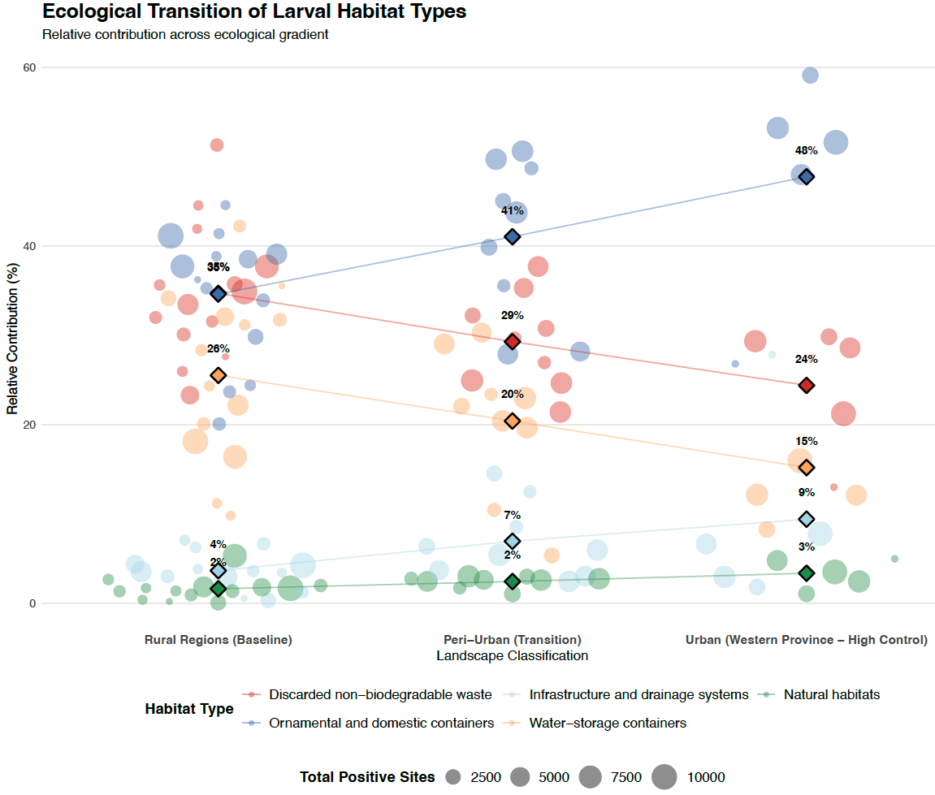
Supplementary Fig 1: Spatial heterogeneity and ecological transition of Aedes larval habitat categories along an urbanization gradient. Relative contribution (%) of five distinct larval habitat categories–discarded non-biodegradable waste, ornamental and domestic containers, water-storage containers, infrastructure and drainage systems, and natural habitats– across an urbanisation gradient comprising rural regions (baseline), peri-urban (transition), and urban areas (Western Province; high control). Diamond markers represent district-level means for each habitat category, with overlaid trendlines illustrating overall patterns across the gradient. Circular markers show individual district-level contributions within each landscape class. Marker size is proportional to the total number of Aedes-positive containers recorded per district, reflecting relative surveillance intensity and vector burden. Data are derived from the national entomological surveillance system and comply with standardised field inspection protocols.

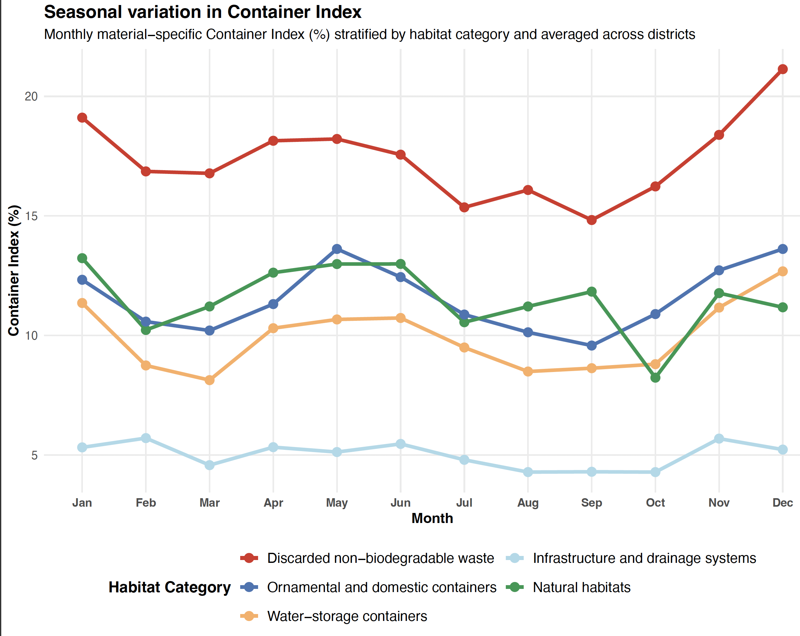
Supplementary Fig 2. Seasonal variation in Container Index. Monthly mean material specific Container Index (CI) by habitat categories, averaged across districts from January 2024 to December 2025. Discarded non-biodegradable waste shows consistently higher average CI throughout the year, with a marked increase during the late-year monsoon period. Other categories display lower and more stable patterns, indicating a comparatively smaller contribution to seasonal variation in Aedes breeding.

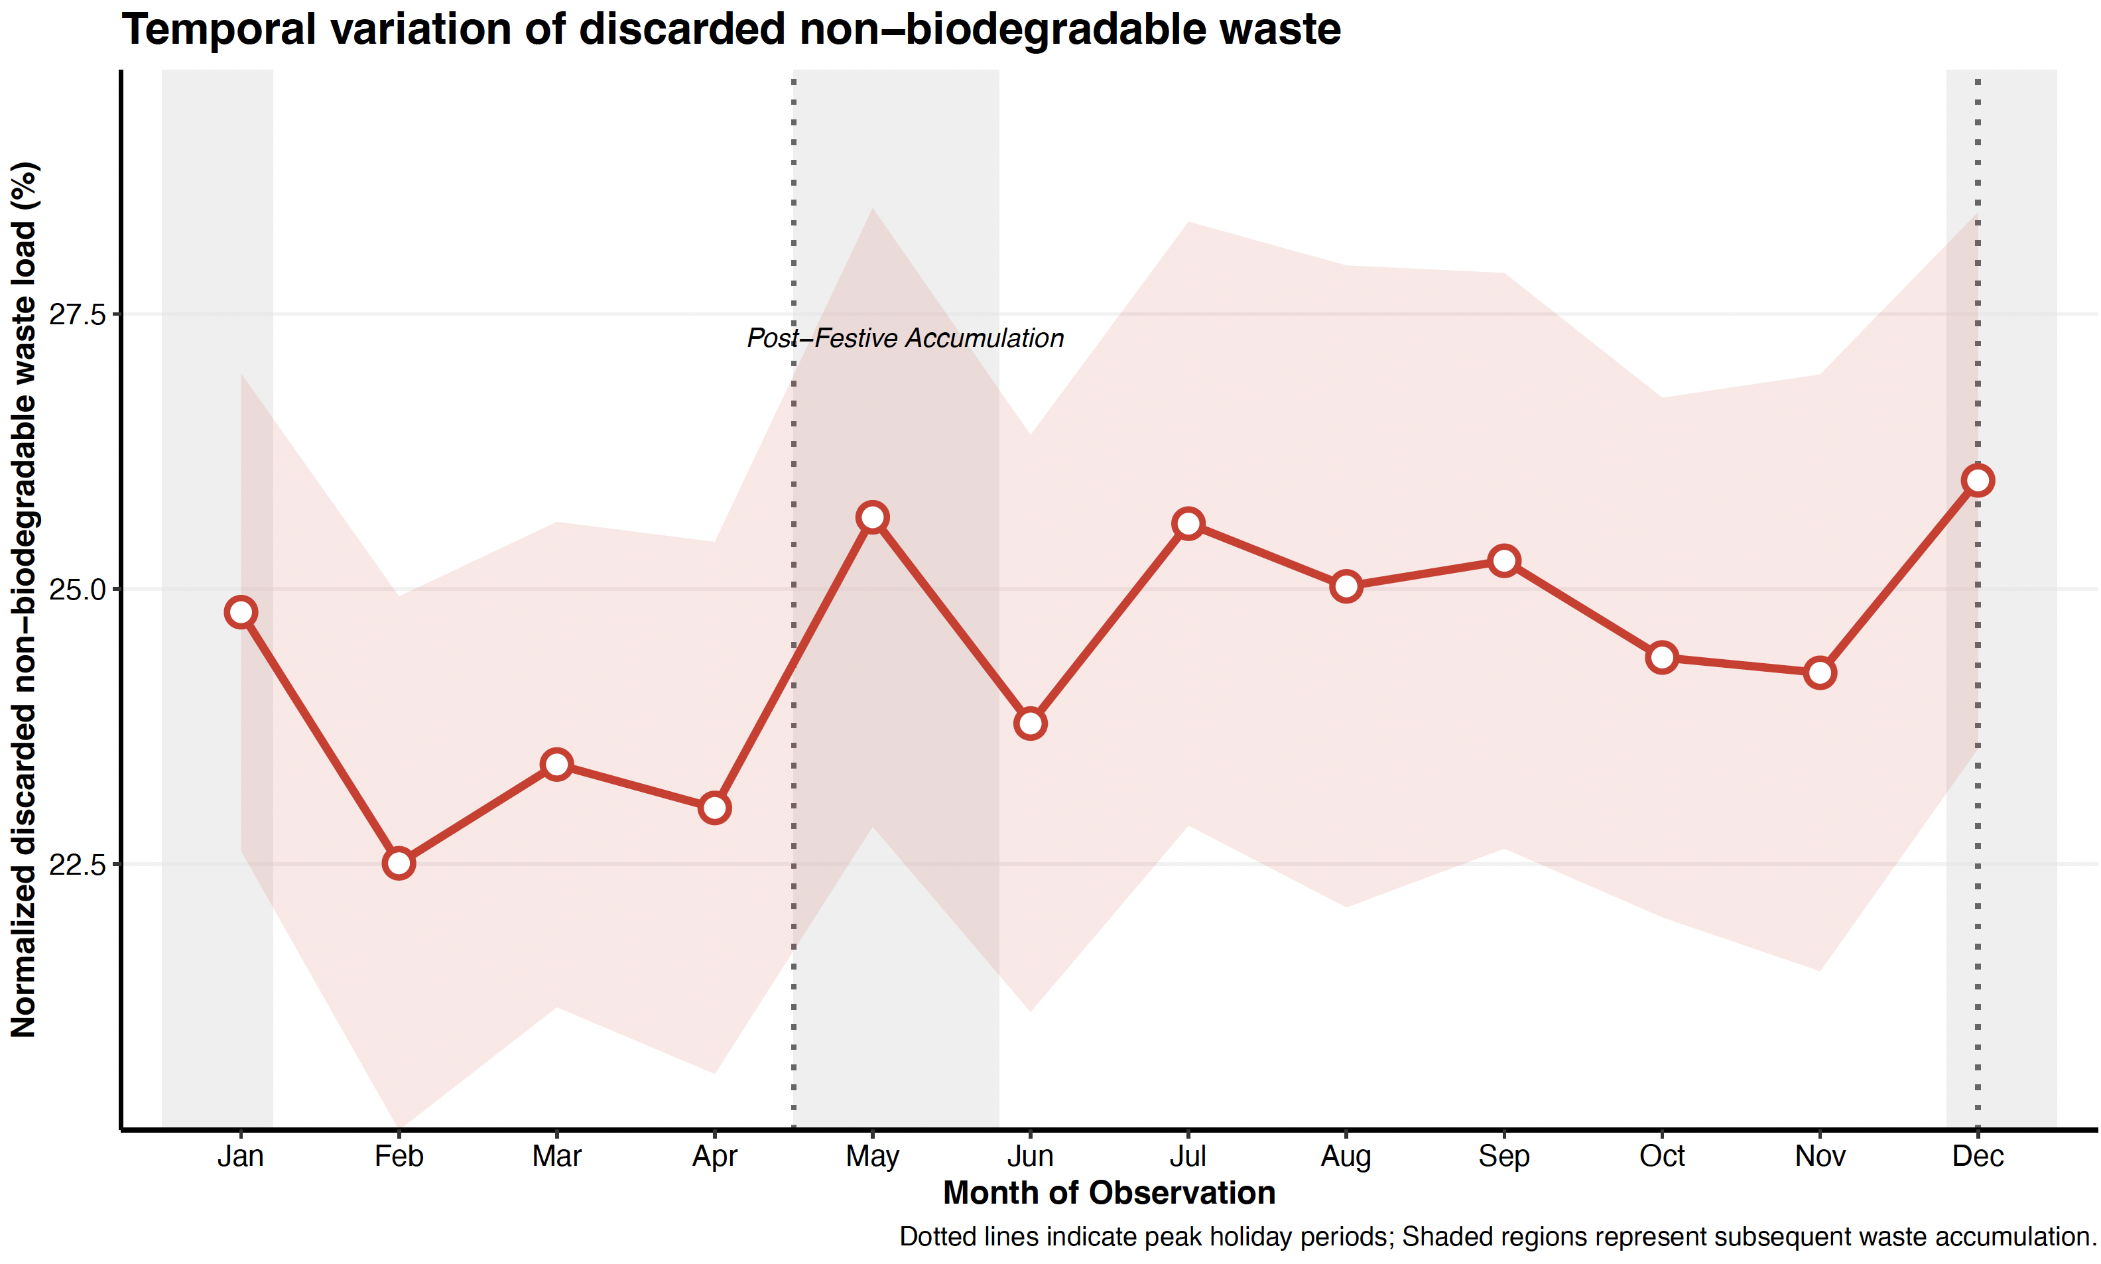
Supplementary Fig 3. Temporal distribution in non-biodegradable waste load in relation to the festival seasons. Monthly normalized non-biodegradable waste load (%), representing the proportion of discarded waste containers relative to total inspected sites. Dotted vertical lines denote peak holiday and festive periods (mid-April and late-December), while shaded regions indicate subsequent windows of waste accumulation. The red trend line and shaded ribbon represent the national mean and 95% confidence interval.

Our analysis reveals a distinct climate-waste interaction where consumer-driven waste surges are seasonally activated by monsoonal rainfall to amplify vector breeding. Immediately following festive peaks in mid-April and late-December, the normalized environmental load of discarded non-biodegradable waste rises sharply and accumulates into subsequent months (Supplementary Fig. 3). This accumulation creates ecological conditions conducive to Aedes mosquito breeding when intersected with regional monsoon dynamics; the mid-April waste surge is filled by the Southwest monsoon (May–September), while the late-December surge aligns with the Northeast monsoon (December–February). Because plastic containers resist environmental degradation and collect rainwater efficiently, this intersection triggers widespread larval productivity. This mechanism is confirmed by the dramatic divergence of the red trend line in Supplementary Fig. 2, where the Container Index of non-biodegradable waste (majority of which composed of plastics) maintains the highest breeding efficiency year-round, peaking at over 21% in December. Conversely, alternative domestic, ornamental, and natural habitats remain lower and temporally stable, proving that the interaction between plastic waste accumulation and monsoonal rainfall is the primary driver of seasonal vector amplification.

Pilot field validation for material-specific waste partitioning

This table summarizes the results of a representative pilot study conducted from March to May 2026 across eight districts covering nearly half of the national population. These data provide the essential empirical basis for the hierarchical transition from the baseline BI_{waste} to the high-resolution BI_{plastics}. The Survey Effort (Days) denotes the total number of days dedicated to field inspection within each district. Total Containers Inspected represents the environmental load of discarded non-biodegradable items identified, partitioned into synthetic plastic and non-synthetic (Other) components. Water-Holding Containers (B) indicates the count of "wet" containers serving as potential breeding sites, while the Plastic Share (%) reflects the percentage of the total load or water-holding containers attributed specifically to plastic materials. Aedes-Positive Containers (A) refers to the number of containers found to be positive for Aedes larvae or pupae during the pilot survey. The Container Index (CI) (A/B) (%) measures the breeding efficiency (larval productivity) of each material category, representing the percentage of water-holding containers that were positive for larvae. The "Plastic Share" of total containers inspected in each district serves as the primary weighting factor for the risk attribution.

Table S2: Empirical material partitioning and Aedes larval infestation dynamics across pilot sentinel districts. Field validation metrics classifying discarded non-biodegradable containers into plastic and non-plastic ("Other") material matrices across eight districts over a cumulative 425 survey days.

Pilot Districts | Survey Effort (Days) | Total Containers Inspected |  |  | Water-Holding Containers (B) |  |  | Aedes-Positive Containers (A) |  | Container Index (CI) (A/B) (%) |  | Plastic Share  ($ω_{plastic}$)
 |  | Plastic | Other | Share (%) | Plastic | Other | Share (%) | Plastic | Other | Plastic | Other | Plastic Share  ($ω_{plastic}$)
Galle | 47 | 1402 | 1243 | 53.0 | 534 | 462 | 53.6 | 68 | 44 | 12.7 | 9.5 | 60.7
Gampaha | 120 | 2062 | 685 | 75.1 | 822 | 252 | 76.5 | 115 | 20 | 13.9 | 7.9 | 85.2
Jaffna | 24 | 1235 | 802 | 60.6 | 143 | 67 | 68.1 | 36 | 10 | 25.2 | 14.9 | 78.3
Kalutara | 59 | 514 | 447 | 53.5 | 231 | 191 | 54.7 | 66 | 41 | 28.6 | 21.4 | 61.7
Kandy | 36 | 575 | 330 | 63.5 | 279 | 157 | 63.9 | 39 | 27 | 13.9 | 17.1 | 59.1
Kurunegala | 7 | 33 | 43 | 43.4 | 5 | 21 | 19.2 | 1 | 3 | 20.0 | 14.3 | 25.0
Monaragala | 38 | 2178 | 1632 | 57.2 | 682 | 429 | 61.4 | 87 | 46 | 12.8 | 10.7 | 65.4
Ratnapura | 94 | 3906 | 5761 | 40.4 | 1640 | 1478 | 52.6 | 262 | 160 | 15.9 | 10.8 | 62.1
TOTAL | 425 | 11905 | 10943 | 52.1 | 4336 | 3057 | 58.7 | 674 | 351 | 15.5 | 11.5 | 65.8

The Table 2 details the structural breakdown of total environmental container load, localized water availability (water-holding status), and material-specific Container Indexes (CI). The plastic share of the discarded non-biodegradable waste ($ω_{\text{plastic}}$) is calculated by dividing plastic positives with the sum of plastic and other positives. The $ω_{\text{plastic}}$ serves as the core scale-partitioning weight used to attribute downstream health and economic burdens to mismanaged plastic micro-habitats within the population attributable risk framework.

Assessing association between discarded non-biodegradable waste and dengue

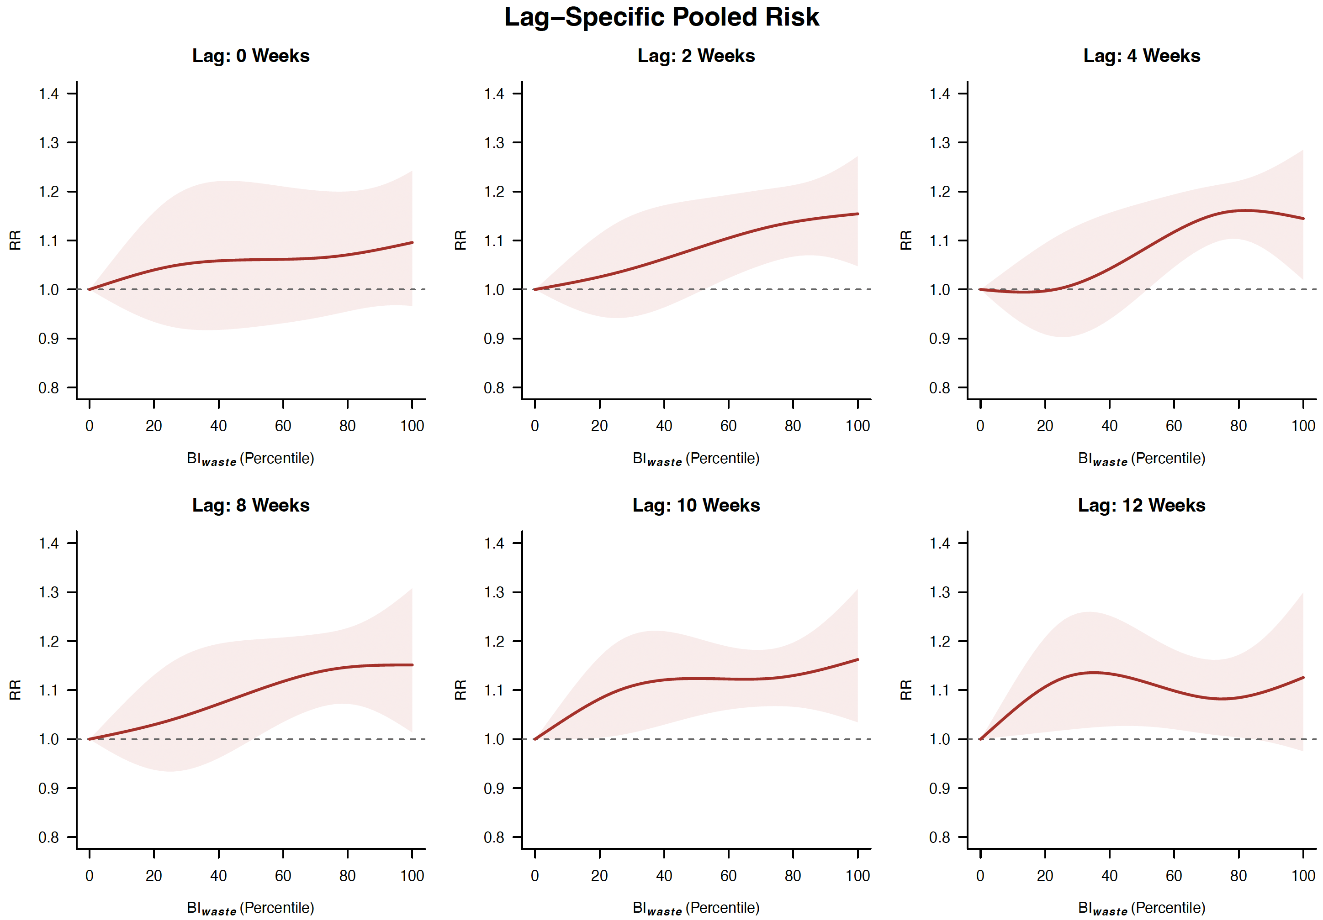

Supplementary Fig. 4: Lag–specific relationship between BIwaste and dengue incidence.
Lag-specific relative risks (RR) of dengue across selected lag periods (0–12 weeks) pooled across all the districts, showing the temporal distribution of exposure effects. The strongest associations are observed at 2–12 weeks following exposure, consistent with vector and pathogen dynamics. Shaded regions represent 95% confidence intervals.

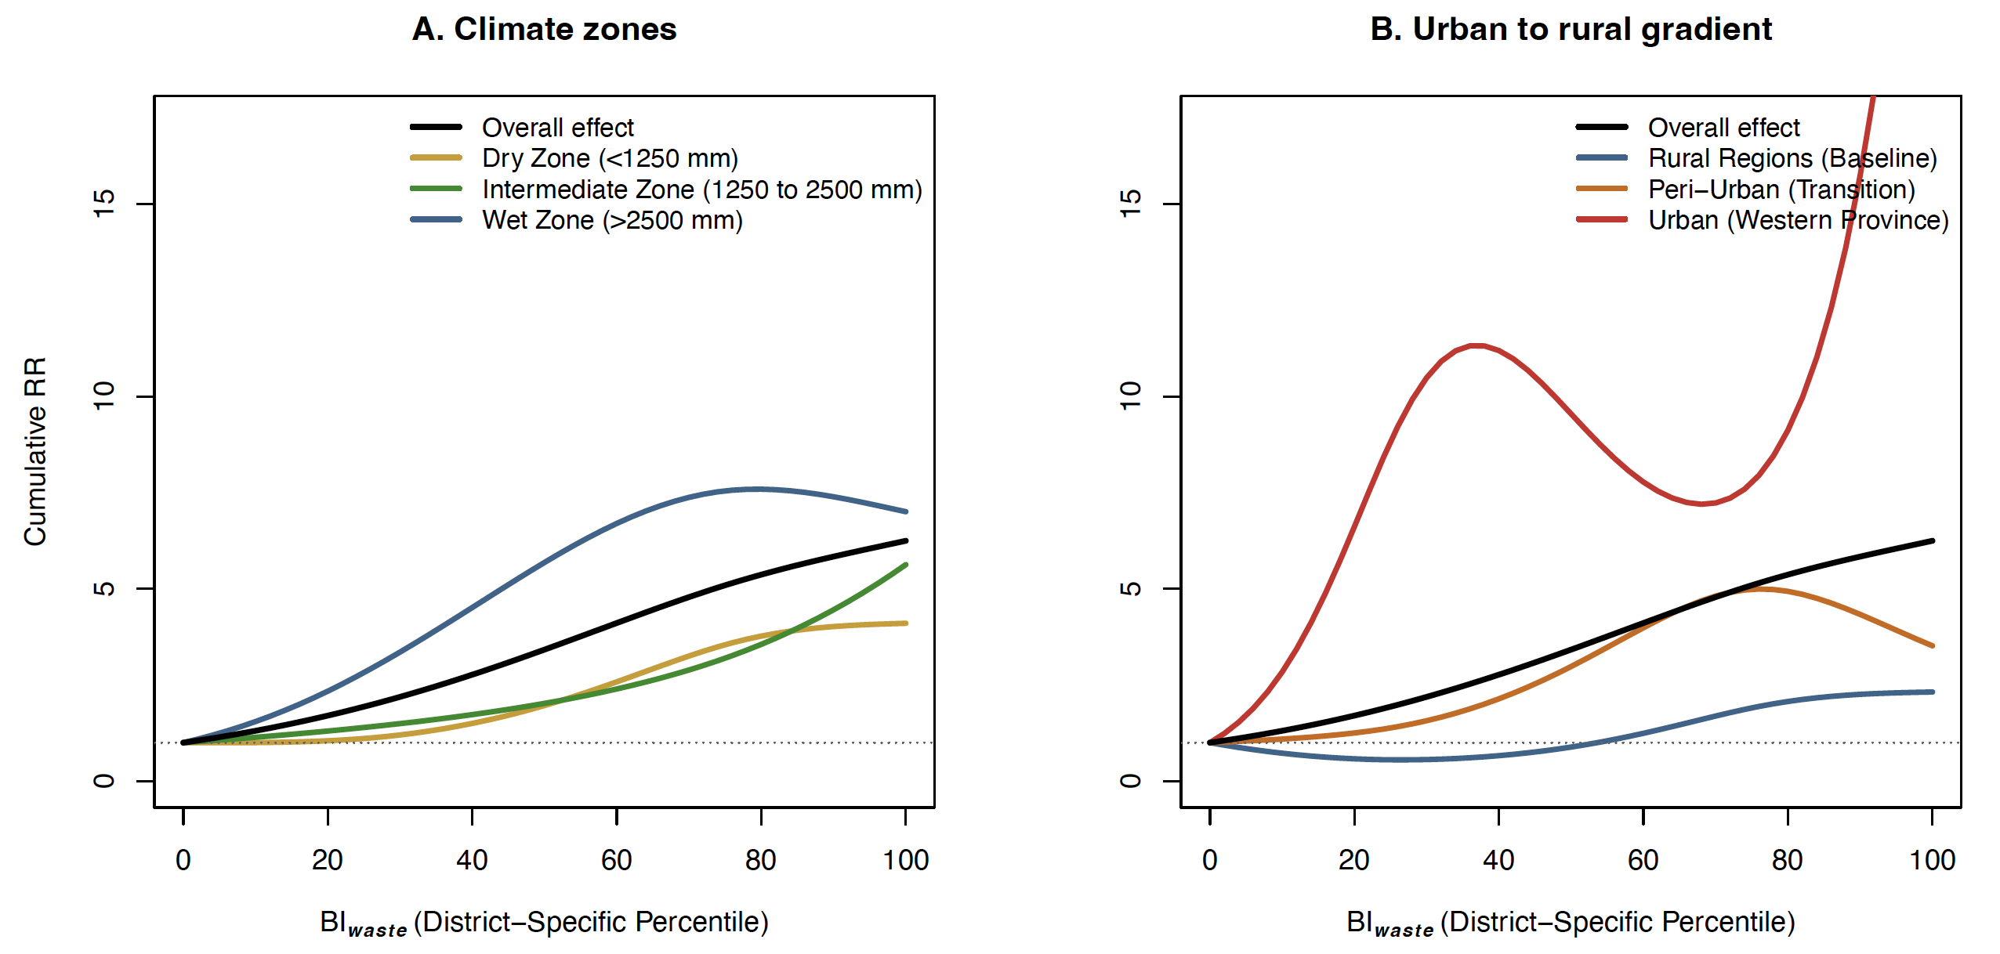
Supplementary Fig. 5: Effect modification of the BIwaste–dengue association by climate and landscape. Multivariate meta-regression of distributed lag non-linear model (DLNM) coefficients across 28 districts. (A) Stratified exposure–response curves by national climate zones: Dry (<1250 mm), Intermediate (1250–2500 mm), and Wet (>2500 mm). While a positive association persists across all zones, the magnitude of relative risk (RR) shows limited differentiation based on rainfall alone (LR test p = 0.012; Wald p = 0.80). (B) Stratified curves across the urban–rural gradient, comparing rural baseline regions, peri-urban transition zones, and the highly urbanized Western Province. The urban–rural context significantly modifies the association (LR test p < 0.001), with the highest risk escalation observed in urban settings. The solid black lines in both panels represent the national pooled overall association. All associations are anchored to the 0th percentile of the BIwaste ECDF.

Table S3: Univariable multivariate meta-regression of climate zones and urban-rural gradient

Model | Q | dfQ | pQ | I² (%) | AIC | BIC | LR stat | dfLR | pLR | Wald stat | dfWald | pWald
Intercept-only | 326.65 | 81 | <0.001 | 75.20 | 474.15 | 495.70 | — | — | — | — | — | —
Annual rainfall | 307.96 | 78 | <0.001 | 74.67 | 516.93 | 545.21 | -36.77 | 3 | 1.00 | 3.25 | 3 | 0.35
Climate zones | 305.62 | 75 | <0.001 | 75.46 | 469.87 | 504.63 | 16.29 | 6 | 0.012 | 0.99 | 3 | 0.80
Urban–rural gradient | 278.62 | 69 | <0.001 | 75.24 | 436.94 | 470.45 | 49.21 | 6 | <0.001 | 8.88 | 6 | 0.18

Validation of BI_{waste} as the primary risk indicator

To establish the epidemiological and policy relevance of our findings, we conducted a systematic comparative analysis of the exposure–response relationships across four distinct environmental domains. By utilizing a harmonized modeling framework–applying identical two-stage DLNM and multivariate meta-regression specifications to each container category–we ensured that all associations were directly comparable. This validation step was important to objectively determine which environmental reservoir serves as the most potent and reliable predictor of national dengue transmission, thereby justifying its selection for subsequent disease burden attribution.

Exposure–response associations between container-specific larval indices and dengue relative risk

Across all evaluated domains, the BI_{waste} demonstrated the strongest and most consistent association with dengue risk. While Ornamental and Domestic containers contribute significantly to the total larval count, their risk profile is markedly delayed, with statistically significant effects emerging only at the 84th percentile (RR = 2.26; 95% CI: 1.01–5.07). In contrast, BI_{waste} exhibited a clear threshold pattern where risk began to escalate significantly at the 36th percentile (RR = 2.53; 95% CI: 1.04–6.15), reaching a peak magnitude (RR = 6.25) nearly double that of ornamental sources (RR = 3.43). This index demonstrated the lowest heterogeneity among all high-risk models (I² = 75.2%), indicating significantly more consistent effects across the 28 districts compared to Total breeding sites (I² = 78.6%) or Water storage containers (I² = 87.4%).
The stability of the BI_{waste} model outperformed broader indicators like total breeding sites, which showed a lower peak risk (RR = 4.04 at the 76th percentile) and a subsequent attenuation at the extreme upper bound. Furthermore, Water storage containers showed no statistically robust threshold, characterized by wide confidence intervals (RR = 2.32; 95% CI: 0.38–14.10) that indicate substantial regional inconsistency and limited predictive value for national-level outbreaks.
These findings indicate a clear gradient of risk that identifies unmanaged discarded non-biodegradable waste as the most potent drivers of transmission among the evaluated sources. The superior "productivity-to-risk" translation of plastic waste–where relatively lower container counts yield higher epidemiological impacts–justifies the use of BI_{waste} as the primary metric for the attribution of disease burden and subsequent cost-of-illness calculations.

Sensitivity analysis of DLNM cross-basis function specification and model selection

To evaluate the robustness of the distributed lag non-linear model (DLNM) specification, we conducted a sensitivity analysis using multiple alternative spline knot configurations for both the exposure–response and lag–response dimensions. The primary objective was to assess whether the estimated associations between the BI_{waste} and dengue incidence were sensitive to assumptions regarding spline flexibility and knot placement.
For the exposure–response dimension, natural spline knot placements were evaluated at several percentile combinations of the district-specific exposure distribution, including 10th–90th, 20th–80th, 25th–75th, 33rd–66th, and 15th–50th–85th percentiles. For the lag structure, knot placements at weeks 3, 4, 5, and a two-knot specification at weeks 2 and 6 were assessed. All models retained the same maximum lag period (0–12 weeks), quasi-Poisson framework, and district-specific percentile transformation approach used in the primary analysis.
Model performance was evaluated using the summed quasi-Akaike Information Criterion (Q-AIC) across all district-specific first-stage models. Although models with increased spline flexibility and additional knots achieved marginally lower summed Q-AIC values, the differences in fit at the individual district level were relatively small and produced highly comparable overall exposure–response relationships, lag structures, attributable fractions, and pooled meta-analytic estimates. This indicates that the estimated association between BI_{waste} and dengue risk was robust across a wide range of plausible spline specifications.
The final model specification retained exposure knots at the 25th and 75th percentiles and a lag knot at week 4. This specification was selected a priori as the primary model and retained for the final analysis because it provided a more parsimonious and epidemiologically interpretable exposure–response function while maintaining strong statistical performance. Compared with more flexible spline structures, the selected model demonstrated smoother cumulative risk trajectories, clearer threshold behavior, greater stability at the upper percentiles of exposure, and reduced susceptibility to local overfitting. Importantly, the selected model yielded pooled effect estimates and attributable burden estimates that were highly consistent with those obtained from alternative knot specifications.

Sensitivity Analysis of DLNM alternative lag structure across different exposure variables for estimating attributable fraction

Sensitivity analyses across alternative lag structures (4, 6, 8, 10, and 12 weeks) demonstrated that the attributable fraction associated with plastic and waste-related breeding sites remained consistently high and stable, ranging from 21.3% (4 weeks) to 32.9% (12 weeks). Intermediate lag windows showed similar magnitudes, including 25.6% at 6 weeks, 25.7% at 8 weeks, and 27.8% at 10 weeks, indicating a robust and gradually increasing cumulative effect with longer exposure windows. This monotonic pattern supports a biologically plausible accumulation of risk consistent with sustained vector breeding dynamics in waste environments. In contrast, water storage containers exhibited substantial temporal variability, with attributable fractions ranging from 18.4% (4 weeks) to 29.6% (8 weeks) and fluctuating estimates at other lags (24.4% at 6 weeks, 27.6% at 10 weeks, and 22.6% at 12 weeks), alongside wide confidence intervals that frequently included near-zero effects. Ornamental and domestic containers showed a generally declining pattern with increasing lag duration, from 17.2% (4 weeks) to 10.8% (12 weeks), suggesting weaker and less temporally persistent contributions. Total breeding sites displayed intermediate stability, ranging from 18.8% to 24.7%, reflecting their aggregated ecological nature.

Table S4: Attributable fraction of dengue cases across lag periods 4 to 12 by habitat category.

Exposure | Lag 4 (%) | Lag 6 (%) | Lag 8 (%) | Lag 10 (%) | Lag 12 (%)
Waste-Specific Breteau Index | 21.3 (14.4–26.5) | 25.6 (17.1–30.8) | 25.7 (17.6–32.3) | 27.8 (15.7–38.0) | 32.9 (19.3–40.0)
Water storage containers | 18.4 (0.1–30.9) | 24.4 (0.1–37.3) | 29.6 (5.2–41.2) | 27.6 (0.3–41.6) | 22.6 (0–43.7)
Total breeding sites | 18.8 (5.2–28.2) | 20.3 (8.5–29.9) | 24.7 (12.6–34.0) | 24.1 (11.2–35.2) | 24.2 (9.6–36.4)
Ornamental & domestic containers | 17.2 (1.0–29.9) | 19.6 (3.8–32.1) | 23.3 (7.4–34.5) | 14.1 (2.6–29.0) | 10.8 (1.2–30.3)

Cost-of-Illness Analysis and Economic Attribution Framework
The economic evaluation quantified the district-level and aggregated national burden of dengue attributable to discarded non-degradable waste and plastic-associated larval habitats in Sri Lanka during 2024 and 2025. The analysis adopted a societal perspective in accordance with the Consolidated Health Economic Evaluation Reporting Standards (CHEERS 2022)¹ and incorporated direct healthcare expenditures, dengue prevention program costs, household out-of-pocket expenditures, productivity losses, and premature mortality costs. All costs were expressed in 2024 United States dollars (USD) following inflation adjustment and currency standardization. The data and the methods used for the parameter estimation is given in the Table S5 below.

Table S5: Parameters and parameter specifications used in cost of illness analysis

Domain | Input Variable | Distribution | Distribution Parameters / Specification | Data Source / Methodological Reference
Attributable Risk Framework | DLNM-derived macro waste-attributable fraction $\left(AF_{\text{waste}}\right)$ | Multivariate Normal propagation through DLNM coefficient simulation | 5,000 Monte Carlo draws from:  $$β∼\text{MVN}\left(μ=\text{coef}\left(\text{meta_overall}\right),Σ=\text{vcov}\left(\text{meta_overall}\right)\right)$$  Fraction estimated as:  $$AF=\frac{RR-1}{RR} \text{where }RR>1$$ | Empirical meta-regression of two-staged distributed lag non-linear model surfaces².
 | Relative risk exposure-response surface | Non-linear DLNM prediction surface | Cross-predicted from distributed lag non-linear meta-regression centered at zero exposure. | Standard two stage DLNM meta-analytical framework^{3–5}.
 | Plastic container share of positive breeding habitats | Beta | Parameterized via field-derived larval surveys:  $$α=\text{Plastic containers}+1$$  $$β=\text{Non-plastic containers}+1$$ | 8-district sentinel surveillance data on plastic-specific larval infestations. Laplace-Bayes uniform prior⁶.
 | Plastic-attributable fraction $\left(AF_{\text{plastic},i}\right)$ | Derived probabilistically | Computed explicitly at the localized grid-iteration level:  $$AF_{\text{plastic},i}=AF_{\text{waste},i}×ω_{\text{plastic},i}$$  Where the conditional breeding weight is defined as:  $$ω_{\text{plastic},i}=\frac{{\text{Plastic Containers Containing Larvae}}_{i}}{{\text{Total Waste Containers Containing Larvae}}_{i}}$$ | Data source: Dedicated sentinel surveillance in 8 pilot districts specifying Aedes larval breeding in plastic containers.
Epidemiological & Mortality Parameters | Hospitalization rate among notified cases | Deterministic fixed ratio | 0.25 (25% hospitalized inpatient cohort; 75% ambulatory outpatient cohort). | Data source: NADSyS-National Dengue Surveillance system: National Dengue Control Unit, Ministry of Health Sri Lanka.
 | Observed annual nationwide baseline dengue deaths for 28 districts | Poisson | Drawn dynamically per year iteration for macro baseline modeling:  $${\text{Deaths}}_{y,\text{National}}∼\text{Poisson}\left(λ=\text{Empirical National Deaths}\right)$$  (2024 baseline $λ$= 24; 2025 baseline $λ$= 29) | Data source: NADSyS-National Dengue Surveillance system: National Dengue Control Unit, Ministry of Health Sri Lanka.
 | Observed annual bassline dengue deaths for pilot districts | Poisson | Drawn dynamically per year iteration for regional pilot scaling:  $${\text{Deaths}}_{y,\text{Pilot}}∼\text{Poisson}\left(λ=\text{Empirical Pilot Deaths}\right)$$(2024 baseline $λ$= 14; 2025 baseline $λ$= 16) | Data source: NADSyS-National Dengue Surveillance system: National Dengue Control Unit, Ministry of Health Sri Lanka.
 | Attributable deaths | Deterministic | Computed explicitly at iteration runtime  National Macro-Waste Model  $${\text{Deaths}}_{\text{attrib},i}=AF_{\text{waste},i}×\text{Poisson}\left({\text{Deaths}}_{y,\text{National}}\right)$$  Sentinel Pilot Plastic Model:  $${\text{Deaths}}_{\text{attrib},i}=AF_{\text{plastic},i}×\text{Poisson}\left({\text{Deaths}}_{y,\text{Pilot}}\right)$$ | Boundary-stratified case-weighted downscaling framework mapping macro-epidemiological parameters to local pilot district boundaries. Present study.
 | Pediatric vs. Adult Case and Mortality Distribution | Deterministic fixed shares | Pediatric fraction ($≤$14 years): 0.203  Adult fraction (> 14 years): 0.797 | Data source: NADSyS-National Dengue Surveillance system: National Dengue Control Unit, Ministry of Health Sri Lanka.
Clinical Severity Fractions | Pediatric Clinical Cohort Splitting Fractions | Deterministic proportions | Dengue Fever (DF): 0.650  Dengue Hemorrhagic Fever (DHF): 0.257  Dengue Shock Syndrome (DSS): 0.093 | Dengue clinical surveillance database, Sri Lanka
 | Adult Clinical Cohort Splitting Fractions | Deterministic proportions | Dengue Fever (DF): 0.736  Dengue Hemorrhagic Fever (DHF): 0.175  Dengue Shock Syndrome (DSS): 0.089 | Dengue clinical surveillance database, Sri Lanka
Health System Provider Costs (USD) | Ambulatory Outpatient Management Cost | Gamma | Mean = 14.47; Coefficient of Variation (CV) = 20%; stochastic Gamma draw per simulation loop. | Thalagala et al. cost matrices; values local-currency adjusted and inflated to baseline⁷.
 | Pediatric General Ward Admission Cost | Gamma | Mean = 37.07; CV = 20%; stochastic Gamma draw per simulation loop. | Thalagala et al. macro-costing model; baseline localized LKR conversion^{7,8}.
 | Adult General Ward Admission Cost | Gamma | Mean = 33.29; CV = 20%; stochastic Gamma draw per simulation loop. | Thalagala et al. macro-costing model; baseline localized LKR conversion⁷.
 | Pediatric ICU Management Cost | Gamma | Mean = 105.00; CV = 20%; stochastic Gamma draw per simulation loop. | Thalagala et al. macro-costing model; baseline localized LKR conversion^{7,8}.
 | Adult ICU Management Cost | Gamma | Mean = 149.31; CV =20%; stochastic Gamma draw per simulation loop. | Thalagala et al. macro-costing model; baseline localized LKR conversion⁷.
 | National Preventive Vector Program Expenditure | Deterministic Structural Function | Computed dynamically per iteration runtime matching the financial tiering matrix:  $${\text{Program Cost}}_{\text{attrib},i,y}=\left[\frac{{\text{Operational}}_{y}+{\text{Labor}}_{y}}{{\text{USD Rate}}_{y}}\right]×{\overline{AF}}_{i,y}$$Where components are structurally defined as:  $${\text{Operational}}_{y}={\text{Preventive}}_{y}+{\text{Review}}_{y}+\left(0.75×{\text{Admin}}_{y}\right)$$  $${\text{Labor}}_{2024}=\text{Entomologists }\left(n=28\right)+\text{Officers }\left(n=158\right)+\text{Field Assistants }\left(n=667\right)$$ | Integrated Health-System Resource Costing Framework⁹. Base data extracted from the Ministry of Health National Dengue Control Unit Budget Registry
Societal & Macroeconomic Cost Parameters | Household Out-of-Pocket (OOP) medical expenditure | Lognormal | Mean = 23.63; Parameterized using log-scale transformations:  $$μ_{\text{log}}=2.87, σ_{\text{log}}=0.73$$ | Weerasinghe et al. household asset survey data; currency-adjusted¹⁰.
 | Adult direct productivity loss (absenteeism) | Lognormal | Mean = 441.02; Parameterized using log-scale transformations:  $$μ_{\text{log}}=5.29, σ_{\text{log}}=1.25$$ | Weerasinghe et al. household asset survey data; currency-adjusted¹⁰.
 | Pediatric caregiver indirect cost | Uniform | Minimum bound = 15.00; Maximum bound = 33.00 | Wickramasinghe et al. caregiver time-valuation profiles¹¹.
 | Annual macroeconomic product distribution | Gamma | Year-specific Gross Domestic Product (GDP) per capita:  2024 Baseline Mean = 4,516.00  2025 Baseline Mean = 4,753.00  (CV = 10% across both intervals) | Central Bank of Sri Lanka Economic Intelligence Reports¹².
Health Outcome Parameters | DALY Disability Weight (Ambulatory Outpatient) | Normal (left-truncated at 0) | Mean = 0.032; SD = 0.006 | Zeng et al. standard weights¹³.
 | DALY Disability Weight (Hospitalized Inpatient) | Normal (left-truncated at 0) | Mean = 0.036; SD = 0.007 | Zeng et al. standard weights¹³.
 | Acute Infection Clinical Duration | Deterministic fixed fraction | Calculated uniformly as:  $$t=\frac{14\text{ days}}{365.25\text{ days}}≈0.0383\text{ years}$$ | Clinical consensus duration vectors for acute multi-phase dengue^{14,15}.
 | Social Policy Parameters | Alternative Deterministic Scenarios | Retirement Age Horizonal Boundaries: 60 years vs. 65 years.  Social Discount Rates: 3.5% (Main Policy Model), 0.0% (Undiscounted), 5.0% (Sensitivity Boundary). | Regional and international health economics guideline frameworks¹⁶.

Hierarchical surrogate-to-specific population attribution framework to estimate the dengue burden attributable to plastic habitats
To estimate the dengue burden attributable to discarded plastic waste, we implemented a hierarchical surrogate-to-specific population attribution framework. In the first stage, dengue burden attributable to waste-associated mosquito breeding habitats was estimated using the Waste-Specific Breteau Index ($BI_{waste}$), which served as the epidemiologically validated exposure surrogate linking non-biodegradable waste accumulation to dengue transmission. Distributed lag non-linear models (DLNMs) were fitted to estimate the exposure–response relationship between $BI_{waste}$ and dengue incidence, and attributable fractions were derived from the relative risks as:
$$\left[AF_{waste}=\frac{RR-1}{RR}\right]$$
where RR denotes the cumulative relative risk associated with a given $BI_{waste}$ exposure level.
Parameter uncertainty from the DLNM was propagated through 5,000 Monte Carlo simulations by drawing coefficient vectors from a multivariate normal distribution:
$$\left[β∼MVN\left(\overset{ˆ}{β},Σ\right)\right]$$
where $\left(\overset{ˆ}{β}\right)$ represents the estimated meta-analytic coefficient vector and ($Σ$) its variance-covariance matrix.
In the second stage, waste-attributable burden was partitioned into plastic-specific burden using the plastic-associated Breteau Index ($BI_{plastics}$), derived from dedicated entomological surveillance conducted across eight sentinel districts. The proportional contribution of plastic breeding habitats was estimated as:
$$\left[ω_{plastic,i}\frac{{\text{Plastic habitats}\text{ infested with }\text{Aedes}\text{ larvae}}_{i}}{{\text{All }\text{non-degradable }\text{waste-}\text{related habitats }\text{infested with }\text{Aedes}\text{ larvae}}_{i}}\right]$$
and plastic-attributable fractions were calculated as:
$$\left[AF_{plastic,i} = AF_{waste,i}×ω_{plastic,i}\right]$$
where $\left(ω_{plastic,i}\right)$ was modeled probabilistically using Beta distributions parameterized from observed plastic and non-plastic larval habitat counts in i district.

Estimation of attributable cases and deaths
For each simulation iteration, attributable dengue cases were estimated as:
$$\left[AN_{i}=AF_{i}×Cases_{i}\right]$$
where ($AN_{i}$) represented either the waste-attributable fraction or plastic-attributable fraction depending on district i.
Observed annual dengue deaths were modeled using Poisson distributions to reflect stochastic uncertainty around reported mortality:
$$\left[Deaths_{y}∼Poisson\left(λ_{y}\right)\right]$$
where ($λ_{y}$) corresponded to nationally observed annual dengue deaths for each year. Attributable deaths were subsequently estimated as:
$$\left[Deaths_{attrib,i} = AF_{i}×Deaths_{y}\right]$$
reflecting the assumption that the attributable fraction for mortality is proportional to the attributable fraction estimated for incident disease in the absence of exposure-specific mortality data.
Age-specific distributions of reported dengue deaths obtained from national surveillance records were incorporated to allocate attributable mortality across age strata. This enabled estimation of age-specific years of life lost and productivity losses associated with premature mortality.

Clinical severity stratification
Hospitalized dengue cases were stratified by age and disease severity to capture differential healthcare resource utilization. Based on national surveillance data, 25% of attributable dengue cases were classified as hospitalized and 75% as ambulatory.
Hospitalized pediatric and adult cohorts were further divided into dengue fever (DF), dengue hemorrhagic fever (DHF), and dengue shock syndrome (DSS) using empirically observed severity distributions. Pediatric cases were allocated as 65.0% DF, 25.7% DHF, and 9.3% DSS, whereas adult cases were allocated as 73.6% DF, 17.5% DHF, and 8.9% DSS. These severity categories determined the corresponding ward-based and intensive care unit (ICU) treatment costs applied within each simulation iteration.

Direct healthcare costs
Provider costs included outpatient management, general ward admissions, and ICU admissions. Cost estimates were derived from Sri Lankan dengue costing studies and updated to 2024 values using inflation-adjusted currency conversions. All healthcare costs were modeled using Gamma distributions:
$$\left[Cost∼Gamma\left(shape,scale\right)\right]$$
with coefficients of variation fixed at 20% to reflect uncertainty around resource utilization and costing estimates.
Total provider costs were estimated by summing severity-specific expenditures across ambulatory, ward-based, and ICU-managed patients.

National Dengue Prevention Program Costs
In addition to treatment-related expenditures, the analysis incorporated annual national dengue prevention and vector-control expenditures. These included operational costs, administrative expenditures, outbreak review activities, entomological surveillance, and personnel salaries for entomologists, public health officers, and field assistants.
Annual attributable program costs were estimated as:
$$\left[ProgramCost_{attrib} = ProgramCost_{total}×\overline{AF}\right]$$
where $\left(\overline{AF}\right)$ denotes the mean annual attributable fraction estimated for each simulation. Program budgets were subjected to probabilistic uncertainty using Gamma-distributed draws with a coefficient of variation of 10%.

Household and productivity costs
Household out-of-pocket expenditures were estimated using nationally representative household survey data and modeled using lognormal distributions. Productivity losses among adult patients were similarly modeled using lognormal distributions derived from empirically observed absenteeism costs.
For pediatric dengue cases, indirect costs were estimated through caregiver productivity losses using a uniform distribution representing plausible lower and upper valuation bounds.
Total indirect costs were therefore calculated as the sum of adult productivity losses and caregiver time costs attributable to pediatric illness episodes.

Disability-Adjusted Life Years
Health burden was quantified using disability-adjusted life years (DALYs), calculated as the sum of years lived with disability (YLD) and years of life lost (YLL):
$$\left[DALY=YLD+YLL\right]$$
YLDs were estimated separately for ambulatory and hospitalized dengue episodes using disability weights obtained from Global Burden of Disease studies. Disability weights were sampled from truncated normal distributions and multiplied by episode duration:
$$\left[YLD=\left(Cases_{amb}×DW_{amb}+Cases_{hosp}×DW_{hosp}\right)×t\right]$$
where (t) represents the average acute dengue duration of 14 days:
$$\left[t=\frac{14}{365.25}=0.0383\text{ years}\right]$$
thus converting short-term morbidity into annualized disability burden.

Years of Life Lost
YLLs were estimated using age-specific mortality distributions and remaining life expectancy. For each age stratum:
$$\left[YLL_{a}Deaths_{a}×LE_{a}\right]$$
where ($Y{LL}_{a}$) denotes the remaining life expectancy at age of death.
Discounted YLL estimates were calculated using:
$$\left[YLL_{disc}Deaths_{a}×\frac{1-e^{-rLE_{a}}}{r}\right]$$
where (r) is the annual discount rate.

Valuation of Premature Mortality
Premature mortality costs were estimated using an age-specific human capital approach. Annual productivity was represented by Sri Lankan gross domestic product (GDP) per capita and modeled using Gamma distributions to incorporate macroeconomic uncertainty.
For each age group, future productivity losses were estimated as:
$$\left[Mortality Cost Deaths_{a}×GDP_{pc}×AF_{a}\right]$$
where ($AF_{a}$) represents the discounted annuity factor corresponding to remaining working years up to retirement age.
Two retirement-age assumptions (60 and 65 years) were evaluated. Importantly, mortality costs represented productivity losses only and did not replace direct medical expenditures. Individuals who died from dengue therefore contributed both treatment-related costs and mortality-related productivity losses to the societal burden estimates.

Probabilistic uncertainty analysis
All epidemiological, clinical, economic, and macroeconomic parameters were propagated simultaneously through 5,000 Monte Carlo simulations. The probabilistic framework incorporated uncertainty in DLNM coefficients, plastic-attribution fractions, healthcare costs, household expenditures, productivity losses, mortality counts, disability weights, GDP per capita, and vector-control program budgets. Results are presented as posterior means and 95% uncertainty intervals (UI) corresponding to the 2.5th and 97.5th percentiles of the simulated distributions.

Sensitivity analyses
Scenario analyses were performed to evaluate the influence of alternative social discount rates (0% and 3.5%) at retirement ages of 60 years on mortality valuation and total societal burden estimates. The undiscounted scenario (3.5 %) was included to facilitate comparison with conventional burden-of-disease studies, whereas 0% served as the primary policy analysis in accordance with international economic evaluation guidelines¹⁶. Parameter influence on total societal burden estimates was further evaluated using probabilistic tornado analyses generated from the Monte Carlo simulation outputs.
Table S5. National and subnational epidemiological and economic burden of dengue attributable to mismanaged waste and plastic pollution in Sri Lanka under a 3.5% social discount rate (2024–2025). Estimates represent the discounted policy model projections utilizing a baseline 3.5% social discount rate to evaluate future health and economic streams. Data are aggregated nationally (n=28 health districts) using the macro-waste indicator ($BI_{\text{waste}}$) and subnationally across sentinel pilot districts (n=8) using the high-resolution plastic indicator ($BI_{\text{plastics}}$). Main metrics report point estimates alongside 95% uncertainty intervals (95% UI) derived from 5,000 Monte Carlo simulation draws. Population figures marked with an asterisk (*) denote projected demographic denominators. Direct health system and broader societal costs are standardized in 2024 United States Dollars (USD M = Millions), with future productivity losses and premature mortality costs adjusted to net present value using the Human Capital Approach (HCA).
Burden Domain and Metric | National  Estimate (95% UI) | Pilot districts  Estimate (95% UI) | National  Estimate (95% UI) | Pilot districts  Estimate (95% UI)
Context
Year | 2024 | 2024 | 2025 | 2025
Indicator | BI_{waste} | BI_{plastics} | BI_{waste} | BI_{plastics}
Health districts (n) | 28 | 8 | 28 | 8
Population | 21,781,800 | 10,337,108 | 21,756,000* | 10,324,874*
Epidemiological
Total Reported Cases | 49,525 | 25,154 | 51,552 | 25,489
Attributable Fraction (AF) | 29.9 (18.0–38.4) | 23.3 (13.4–30.7) | 34.2 (22.4–42.3) | 22.5 (14.3–28.3)
Attributable Cases | 14,789 (8,939–19,037) | 5,870 (3,369–7,715) | 17,654 (11,561–21,810) | 5,748 (3,642–7,211)
DALYs | 209 (109–322) | 156 (70–266) | 287 (163–418) | 180 (87–291)
Deaths (n) | 7 (4–11) | 3 (1–6) | 10 (6–15) | 4 (2–6)
Per-Capita (per 100k)
Cases per 100,000 | 68.0 (41.0–87.4) | 56.78 (32.6–74.6) | 81.1 (53.1–100.1) | 55.6 (35.2–69.7)
DALYs per 100,000 | 0.96 (0.50–1.48) | 1.51 (0.68–2.58) | 1.32 (0.75–1.92) | 1.74 (0.85–2.82)
Deaths per 100,000 | 0.03 (0.02–0.05) | 0.03 (0.01–0.05) | 0.05 (0.03–0.07) | 0.04 (0.02–0.06)
Health System (USD M)
Provider Treatment Cost | 2.23 (1.31–3.13) | 0.89 (0.49–1.27) | 2.67 (1.67–3.67) | 0.87 (0.53–1.19)
Prevention Programme Cost | 0.46 (0.28–0.59) | 0.12 (0.06–0.19) | 0.58 (0.38–0.72) | 0.12 (0.07–0.19)
Total Health System Cost | 2.69 (1.58–3.71)) | 1.00 (0.55–1.46) | 3.25 (2.05–4.39) | 0.99 (0.60–1.38)
Societal Cost (USD M)
Household Out-of-Pocket | 0.27 (0.05–0.91) | 0.11 (0.02–0.37) | 0.33 (0.05–1.10) | 0.10 (0.02–0.32)
Indirect Morbidity Productivity Loss | 1.01 (0.06–5.03) | 0.41 (0.02–2.08) | 1.24 (0.07–6.47) | 0.40 (0.02–2.02)
Premature Mortality Productivity Loss (HCA) | 0.49 (0.24–0.79) | 0.38 (0.16–0.67) | 0.60 (0.32–0.94) | 0.37 (0.17–0.63)
Total Societal Burden | 4.46 (1.93–10.45) | 1.90 (0.92–3.85) | 5.42 (2.49–12.89) | 1.87 (1.01–3.59)

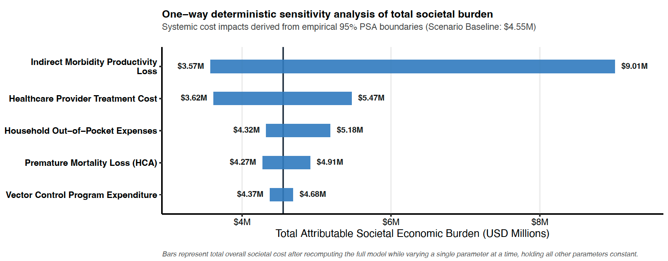

Supplementary Fig. 6: One-way deterministic sensitivity analysis of the total attributable societal economic burden (discount rate =0.035).
The Figure illustrated the ranks model input parameters horizontally based on their total systemic elasticity variance relative to the baseline projection framework. The vertical reference line designates the unvaried baseline macro-estimate ($\$4.55\text{M}$ for the 2024 evaluation cycle). Horizontal blue bars indicate the net directional movement of total combined societal expenditures as individual variables are toggled deterministically between their empirical 95% Probabilistic Sensitivity Analysis (PSA) boundary thresholds. Inline metrics specify extreme system outcomes, revealing Indirect Morbidity Productivity Loss as the primary driver of mathematical variance, shifting the cumulative burden to a maximum threshold of $\$9.01\text{M}.$ All secondary components are fixed statically to point-estimates during individual parameter test runs. HCA: Human Capital Approach.

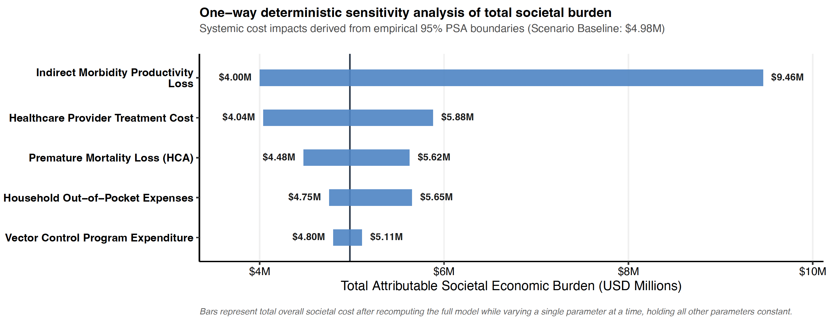

Supplementary Fig. 7: One-way deterministic sensitivity analysis of the total attributable societal economic burden (discount rate = 0) One-way deterministic sensitivity analysis of the total attributable societal economic burden (discount rate = 0). The Figure illustrated the ranks model input parameters horizontally based on their total systemic elasticity variance relative to the baseline projection framework. The vertical reference line designates the unvaried baseline macro-estimate ($\$4.98\text{M}$ for the 2024 evaluation cycle). Horizontal blue bars indicate the net directional movement of total combined societal expenditures as individual variables are toggled deterministically between their empirical 95% Probabilistic Sensitivity Analysis (PSA) boundary thresholds. Inline metrics specify extreme system outcomes, revealing Indirect Morbidity Productivity Loss as the primary driver of mathematical variance, shifting the cumulative burden to a maximum threshold of $\$9.46\text{M}.$ All secondary components are fixed statically to point-estimates during individual parameter test runs. HCA: Human Capital Approach.

Table S5: The CHEERS 2022 checklist
Section/topic | Item No | Guidance for reporting | Reported in section
Title | 1 | Identify the study as an economic evaluation and specify the interventions being compared. | Title (reflects the primary epidemiological finding of the study. The economic evaluation and cost-of-illness analyses are described in the Abstract, Online Methods, Results, and Discussion).
Abstract | 2 | Provide a structured summary that highlights context, key methods, results, and alternative analyses. | Abstract (reported in Nature Medicine's required unstructured format, summarizing the study background, analytical framework, principal findings, and policy implications).
Introduction | 3 | Give the context for the study, the study question, and its practical relevance for decision making in policy or practice. | Introduction.
Methods
Health economic analysis plan | 4 | Indicate whether a health economic analysis plan was developed and where available. | Online Methods (Cost of Illness Analysis and Supplementary Methods).
Study population | 5 | Describe characteristics of the study population (such as age range, demographics, socioeconomic, or clinical characteristics). | Online Methods (Study setting, surveillance data sources and epidemiological modelling); Supplementary Methods.
Setting and location | 6 | Provide relevant contextual information that may influence findings. | Methods (Study setting); Online Methods; Supplementary Methods.
Comparators | 7 | Describe the interventions or strategies being compared and why chosen. | Not applicable. This was a burden-of-disease and cost-of-illness study rather than a comparative economic evaluation.
Perspective | 8 | State the perspective(s) adopted by the study and why chosen. | Online Methods (Cost of Illness Analysis).
Time horizon | 9 | State the time horizon for the study and why appropriate. | Methods (Study period and Cost of Illness Analysis).
Discount rate | 10 | Report the discount rate(s) and reason chosen. | Online Methods (DALY estimation and mortality valuation).
Selection of outcomes | 11 | Describe what outcomes were used as the measure(s) of benefit(s) and harm(s). | Methods (Epidemiological modelling and Cost of Illness Analysis).
Measurement of outcomes | 12 | Describe how outcomes used to capture benefit(s) and harm(s) were measured. | Methods (DLNM modelling, attributable risk estimation and Cost of Illness Analysis).
Valuation of outcomes | 13 | Describe the population and methods used to measure and value outcomes. | Online Methods (DALY estimation and economic valuation); Supplementary Methods.
Measurement and valuation of resources and costs | 14 | Describe how costs were valued. | Online Methods (Cost of Illness Analysis); Supplementary Table S5
Currency, price date, and conversion | 15 | Report the dates of the estimated resource quantities and unit costs, plus the currency and year of conversion. | Online Methods (Cost of Illness Analysis).
Rationale and description of model | 16 | If modelling is used, describe in detail and why used. Report if the model is publicly available and where it can be accessed. | Methods (Two-stage DLNM framework, multivariate meta-analysis, hierarchical attribution framework and Monte Carlo simulation); code availability statement.
Analytics and assumptions | 17 | Describe any methods for analysing or statistically transforming data, any extrapolation methods, and approaches for validating any model used. | Methods (Statistical Analysis); Online Methods; Supplementary Methods.
Characterizing heterogeneity | 18 | Describe any methods used for estimating how the results of the study vary for subgroups. | Methods (District-level DLNM, multivariate meta-analysis and meta-regression using climate zone and urbanization moderators).
Characterizing distributional effects | 19 | Describe how impacts are distributed across different individuals or adjustments made to reflect priority populations. | Online and supplementary Methods (Age-specific epidemiological and economic parameterization).
Characterizing uncertainty | 20 | Describe methods to characterize any sources of uncertainty in the analysis. | Methods (Monte Carlo uncertainty propagation); Supplementary Methods.
Approach to engagement with patients and others affected by the study | 21 | Describe any approaches to engage patients or service recipients, the general public, communities, or stakeholders (such as clinicians or payers) in the design of the study. | National dengue and entomological surveillance data were generated through routine public health surveillance systems. No direct patient or community participant involvement was undertaken because the study used secondary, aggregated surveillance data without individual-level patient information. Public health stakeholders, including collaborators from the Ministry of Health, Sri Lanka, were actively engaged in study conceptualization, interpretation of findings, and refinement of the indicator framework. Ministry of Health collaborators contributed to the design and implementation of the pilot material-partitioning survey used to characterize plastic-associated larval habitats.
Results
Study parameters | 22 | Report all analytic inputs (such as values, ranges, references) including uncertainty or distributional assumptions. | Supplementary Table S5 and Supplementary Methods.
Summary of main results | 23 | Report the mean values for the main categories of costs and outcomes of interest and summarise them in the most appropriate overall measure. | Results (Attributable burden estimates and Cost of Illness Analysis).
Effect of uncertainty | 24 | Describe how uncertainty about analytic judgments, inputs, or projections affect findings. Report the effect of choice of discount rate and time horizon, if applicable. | Results (95% uncertainty intervals); Supplementary Methods (probabilistic sensitivity analysis).
Effect of engagement with patients and others affected by the study | 25 | Report on any difference patient/service recipient, general public, community, or stakeholder involvement made to the approach or findings of the study. | No patient or community participants were involved in the design, conduct, or reporting of this secondary-data modelling study. Public health stakeholders, including collaborators from the National Dengue Control Unit and Ministry of Health, Sri Lanka, contributed technical input regarding surveillance practices, habitat classification, and the design of the material-partitioning pilot survey. These contributions informed the contextualization of surveillance data and the feasibility of the indicator framework but did not influence the statistical modelling procedures, parameter estimation, or interpretation of quantitative effects.
Discussion
Study findings, limitations, generalizability, and current knowledge | 26 | Report key findings, limitations, ethical or equity considerations not captured, and how these could affect patients, policy, or practice. | Discussion (including Strengths, Limitations and Policy Implications).
Other relevant information
Source of funding | 27 | Describe how the study was funded and any role of the funder in the identification, design, conduct, and reporting of the analysis. | Funding Statement.
Conflicts of interest | 28 | Report authors conflicts of interest according to journal or International Committee of Medical Journal Editors requirements. | Competing Interests Statement.

Reference:
1. Husereau, D. et al. Consolidated Health Economic Evaluation Reporting Standards 2022 (CHEERS 2022) Statement: Updated Reporting Guidance for Health Economic Evaluations. Value in Health 25, 3–9 (2022).
2. Gasparrini, A. & Leone, M. Attributable risk from distributed lag models. BMC Med. Res. Methodol. 14, 1–8 (2014).
3. Gasparrinia, A., Armstrong, B. & Kenward, M. G. Distributed lag non-linear models. Stat. Med. 29, 2224–2234 (2010).
4. Gasparrini, A. Modeling exposure-lag-response associations with distributed lag non-linear models. Stat. Med. 33, 881–899 (2014).
5. Gasparrini, A. & Armstrong, B. Reducing and meta-analysing estimates from distributed lag non-linear models. BMC Med. Res. Methodol. 13, 1–10 (2013).
6. Tuyl, F., Gerlach, R. & Mengersen, K. A Comparison of Bayes–Laplace, Jeffreys, and Other Priors. Am. Stat. 62, 40–44 (2008).
7. Thalagala, N. et al. Costs of Dengue Control Activities and Hospitalizations in the Public Health Sector during an Epidemic Year in Urban Sri Lanka. PLoS Negl. Trop. Dis. 10, e0004466 (2016).
8. Fernando, E. S. et al. Household and hospitalization costs of pediatric dengue illness in Colombo, Sri Lanka. Am J Trop Med Hyg 105, 110–116 (2021).
9. Jo, C. Cost-of-illness studies: concepts, scopes, and methods. Clin. Mol. Hepatol. 20, 327 (2014).
10. Weerasinghe, N. P. et al. Direct and indirect costs for hospitalized patients with dengue in Southern Sri Lanka. BMC Health Serv Res 22, 657 (2022).
11. Wickramasinghe, Dr. H. T., Ranawaka, Prof. R., Kalra, Dr. P., Hanley, R. & Gallagher, E. Evaluating the Economic Burden of Dengue in Sri Lanka: A Systematic Review of Costs from 2010 to 2024. IJID Regions 18, 100837 (2026).
12. Gross Domestic Product | Central Bank of Sri Lanka. https://www.cbsl.gov.lk/en/statistics/economic-indicators/gross-domestic-product.
13. Zeng, W., Halasa-Rappel, Y. A., Durand, L., Coudeville, L. & Shepard, D. S. Impact of a nonfatal dengue episode on disability-adjusted life years: A systematic analysis. American Journal of Tropical Medicine and Hygiene 99, 1458–1465 (2018).
14. Stanaway, J. D. et al. The global burden of dengue: an analysis from the Global Burden of Disease Study 2013. Lancet Infect. Dis. 16, 712–723 (2016).
15. Paz-Bailey, G., Adams, L. E., Deen, J., Anderson, K. B. & Katzelnick, L. C. Dengue. The Lancet 403, 667–682 (2024).
16. HM Treasury. The Green Book: Central Government Guidance on Appraisal and Evaluation. https://www.gov.uk/government/publications/the-green-book-appraisal-and-evaluation-in-central-government.

