Additional file 1
Supplementary tables and figures for: Twenty-five years of maternal, neonatal, child and reproductive health measurement in Ethiopia: a harmonized trend and subnational inequality analysis of six Demographic and Health Surveys, 2000–2025

Contents
Supplementary Table S1. Complete regional data matrix for ten key indicators, Ethiopia EDHS 2024–25
Supplementary Figure S1. Trends in total fertility rate by residence
Supplementary Figure S2. Trends in modern contraceptive prevalence and unmet need for family planning
Supplementary Figure S3. Trends in the pregnancy-related mortality ratio
Supplementary Figure S4. Trends in full basic-antigen vaccination and zero-dose prevalence
Supplementary Figure S5. Trends in stunting, underweight and wasting among children under five
Supplementary Figure S6. Urban–rural gaps in selected maternal, child health and nutrition indicators
Supplementary Figure S7. Skilled birth attendance by region
Supplementary Figure S8. Regional performance matrix (heat map) across ten key indicators
Supplementary Figure S9. Regional association between antenatal care completion and skilled birth attendance
Supplementary Figure S10. Regional ranking of zero-dose prevalence among children aged 12–23 months
Supplementary Figure S11. Regional ranking of stunting prevalence among children under five

Supplementary Table S1
Complete regional data matrix for ten key indicators, Ethiopia EDHS 2024–25 (%).
Region | ANC  skilled | ANC 4+ | SBA | PNC ≤2d | mCPR | Demand sat. | Full imm. | Zero dose | Stunting | Teen preg.
Tigrai | 90.2 | 57.1 | 69.3 | 34.8 | 25.2 | 57.4 | 24.8 | 3.5 | 41.6 | 13.4
Afar | 70.8 | 46.2 | 35.0 | 17.1 | 8.8 | 41.1 | 16.2 | 42.8 | 46.0 | 23.3
Amhara | 90.3 | 62.0 | 74.3 | 41.7 | 43.3 | 74.8 | 24.1 | 7.6 | 43.1 | 6.3
Oromia | 70.9 | 48.4 | 58.4 | 32.9 | 31.0 | 69.0 | 18.1 | 24.9 | 41.3 | 13.7
Somali | 35.1 | 12.7 | 37.0 | 9.4 | 1.6 | 6.9 | 5.5 | 61.4 | 34.6 | 13.6
Benishangul-Gumuz | 70.9 | 57.2 | 62.2 | 27.5 | 31.2 | 67.0 | 12.9 | 26.9 | 51.6 | 13.5
Central Ethiopia | 82.8 | 58.5 | 78.9 | 47.4 | 19.0 | 48.5 | 11.2 | 22.5 | 35.0 | 7.5
Sidama | 85.0 | 41.5 | 66.3 | 42.4 | 55.7 | 80.7 | 14.0 | 17.8 | 30.8 | 5.2
South West Ethiopia | 73.6 | 48.1 | 54.7 | 19.8 | 54.2 | 82.7 | 11.4 | 21.2 | 41.8 | 4.9
South Ethiopia | 75.9 | 47.1 | 49.5 | 27.1 | 28.5 | 59.0 | 7.1 | 28.6 | 41.6 | 10.7
Gambella | 79.6 | 49.2 | 73.7 | 44.2 | 34.2 | 62.9 | 9.6 | 19.3 | 16.5 | 14.7
Harari | 79.8 | 46.5 | 80.0 | 39.9 | 28.0 | 62.0 | 27.6 | 9.6 | 34.8 | 14.4
Addis Ababa | 98.2 | 94.8 | 98.2 | 68.1 | 47.3 | 83.4 | 69.9 | 2.7 | 14.7 | 2.1
Dire Dawa | 88.0 | 69.1 | 83.0 | 37.0 | 24.7 | 60.7 | 38.9 | 18.6 | 33.3 | 9.5
NATIONAL | 78.1 | 53.0 | 64.0 | 35.6 | 34.5 | 69.6 | 30.1 | 19.8 | 39.9 | 10.2
ANC antenatal care, SBA skilled birth attendance (live births in the two years preceding the survey), PNC postnatal check within two days, mCPR modern contraceptive prevalence among currently married women, Demand sat. proportion of family-planning demand satisfied (any method), Full imm. fully vaccinated with basic antigens (children aged 12–23 months), Zero dose no vaccinations received, Stunting height-for-age below −2 SD (children under five), Teen preg. women aged 15–19 ever pregnant. Estimates for Harari, Gambella, Dire Dawa and Afar rest on small weighted denominators and should be interpreted with wide confidence intervals. Source: EDHS 2024–25 Key Indicators Report [6]. Referenced from Results, section 3.5.

Supplementary Figures

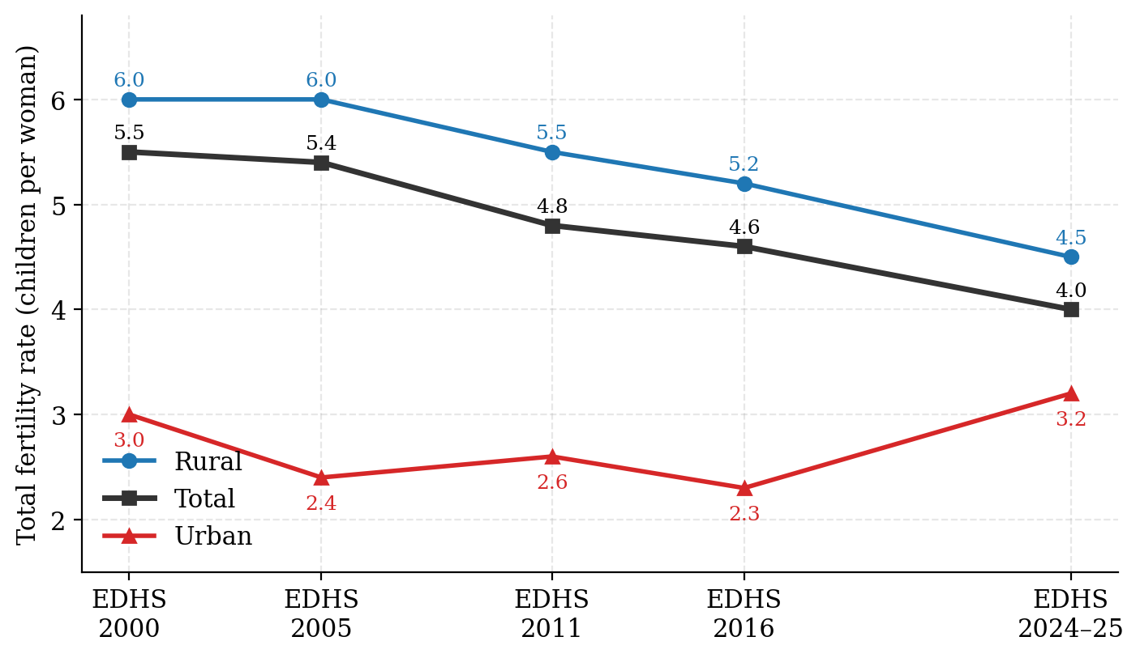
Supplementary Figure S1. Trends in total fertility rate by residence, Ethiopia DHS 2000–2024/25. The total fertility rate refers to the three years preceding each survey. Source: EDHS final and key-indicator reports [1–6].

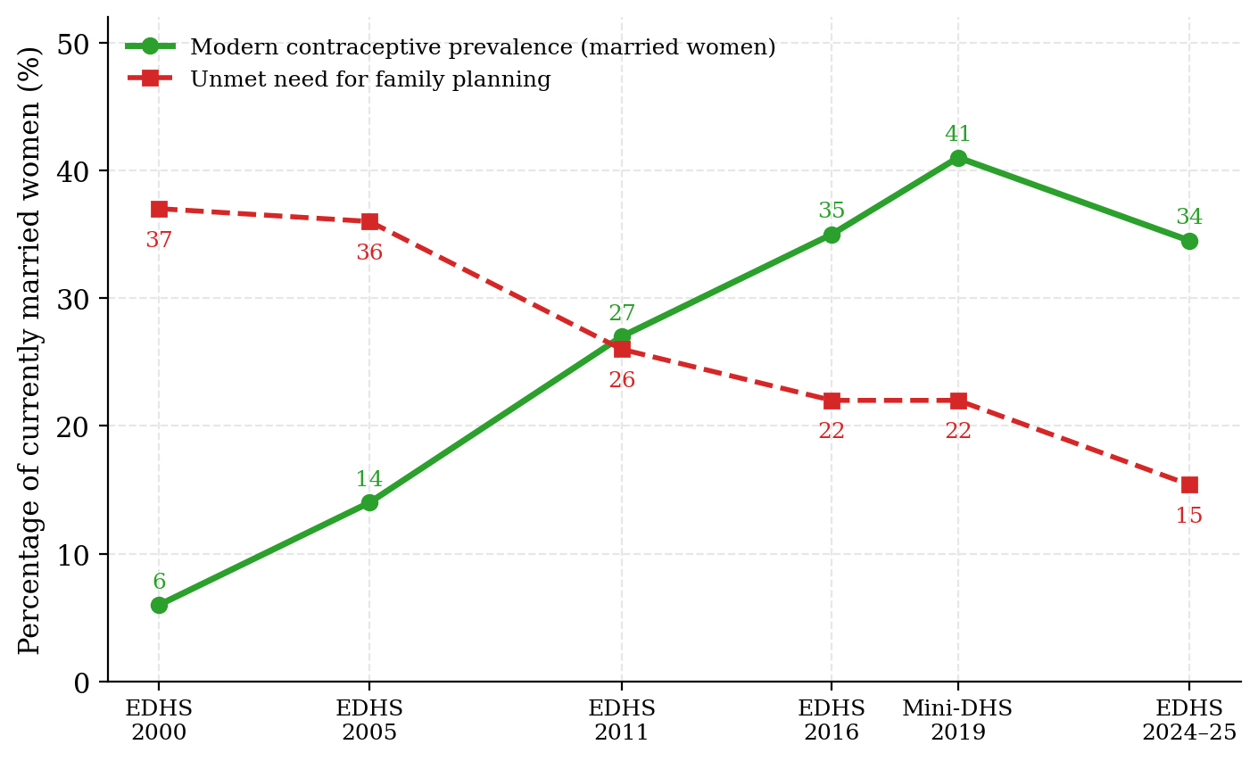
Supplementary Figure S2. Trends in modern contraceptive prevalence and unmet need for family planning, Ethiopia DHS 2000–2024/25. Currently married women aged 15–49. The 2019 point is from the Mini-DHS; the apparent post-2019 decline in contraceptive prevalence should be interpreted in light of the narrower scope of that round and conflict-related service disruption over 2020–2023.

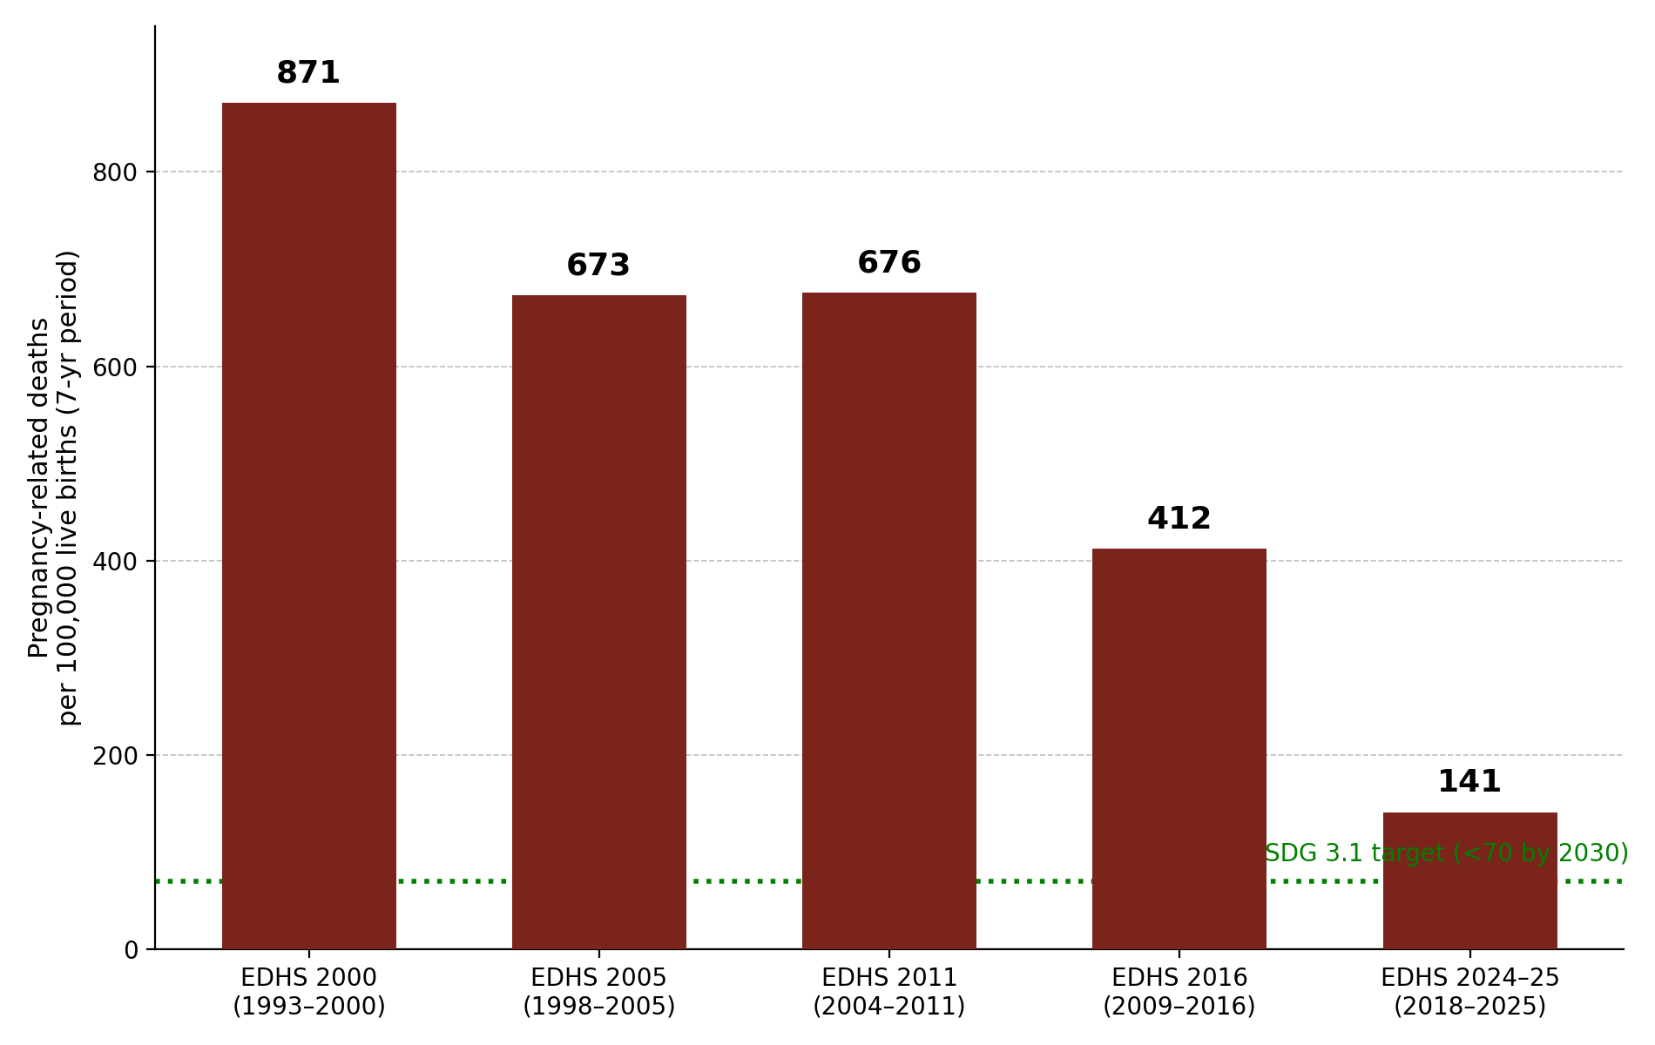
Supplementary Figure S3. Trends in the pregnancy-related mortality ratio, Ethiopia DHS 2000–2024/25. Estimates refer to the seven years preceding each survey and include all deaths during pregnancy, childbirth or within 42 days of termination of pregnancy, irrespective of cause. The 2019 Mini-DHS did not measure maternal mortality. The dashed line marks the SDG 3.1 target.

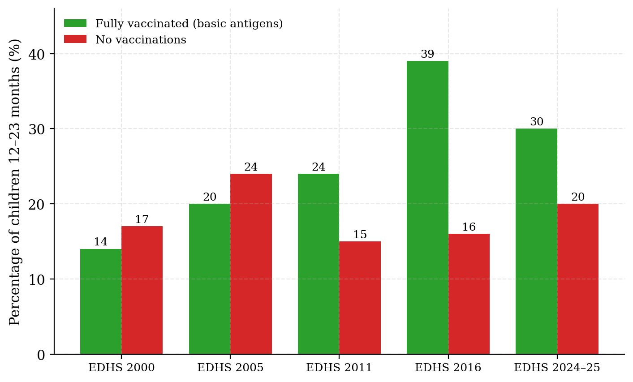
Supplementary Figure S4. Trends in full basic-antigen vaccination and zero-dose prevalence, Ethiopia DHS 2000–2024/25. Children aged 12–23 months. Basic antigens comprise BCG, three doses of a DPT-containing vaccine, three doses of polio vaccine and one measles-containing dose. The 2016 round included a health-facility record check, which may raise ascertainment relative to other rounds.

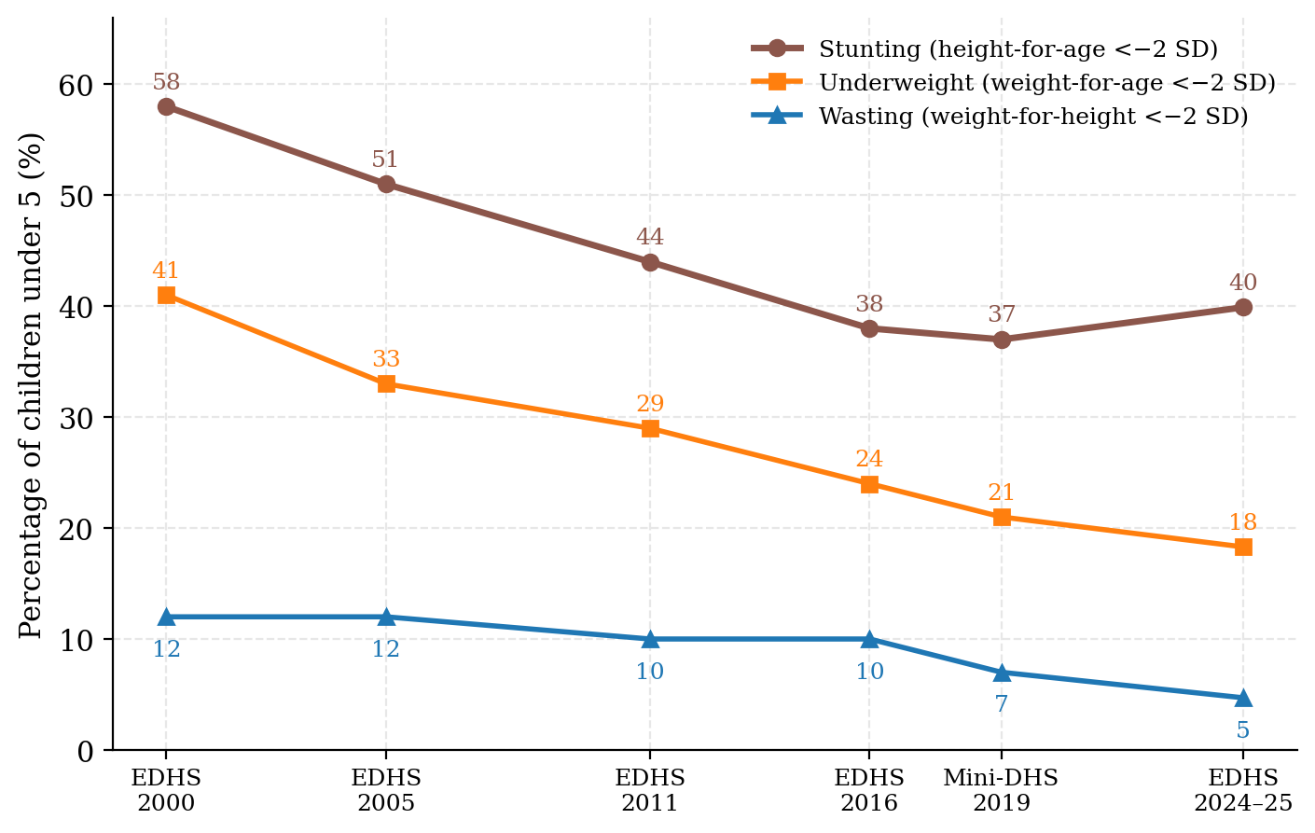
Supplementary Figure S5. Trends in stunting, underweight and wasting among children under five, Ethiopia DHS 2000–2024/25. Based on the WHO Child Growth Standards. All six rounds are shown; 2019 values are from the Mini-DHS.

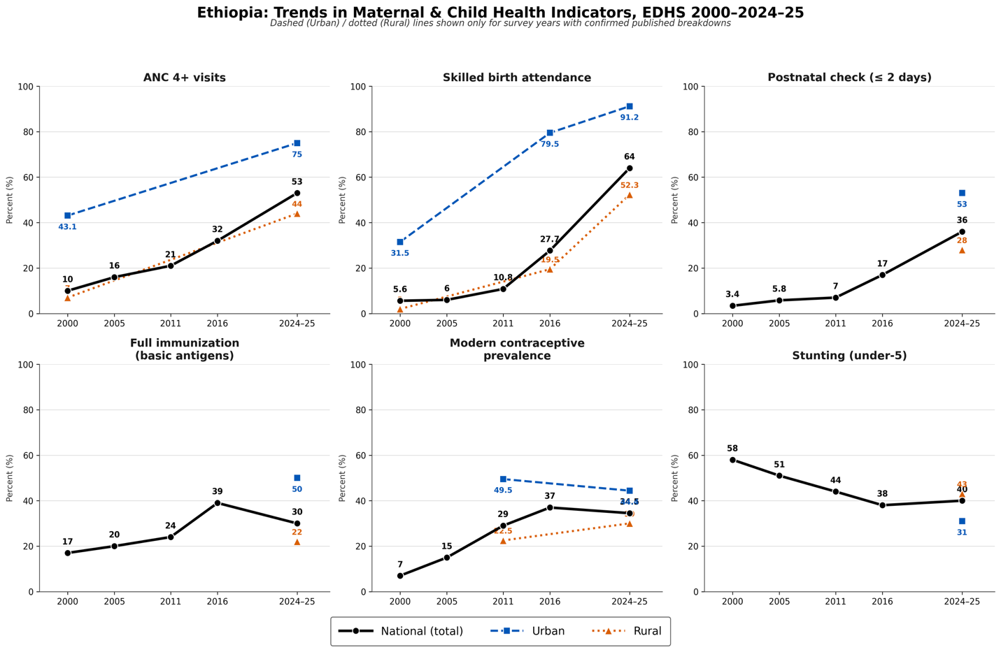
Supplementary Figure S6. Urban–rural gaps in selected maternal, child health and nutrition indicators, Ethiopia DHS 2000–2024/25. For stunting, lower values indicate better nutritional status.

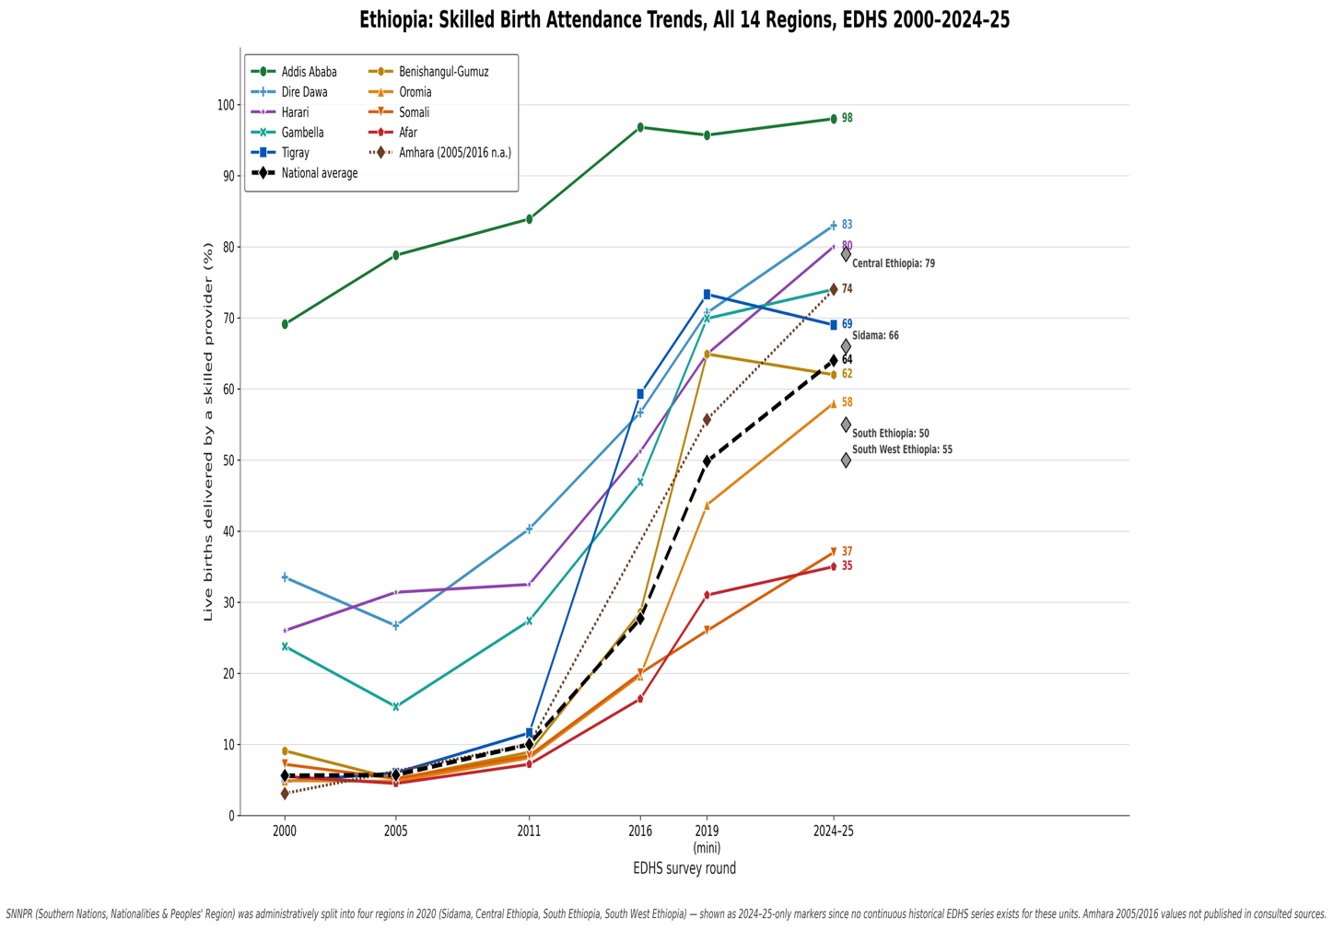
Supplementary Figure S7. Skilled birth attendance by region, Ethiopia EDHS 2024–25. Percentage of live births in the two years preceding the survey delivered by a skilled provider. The dashed line marks the national average (64.0 percent).

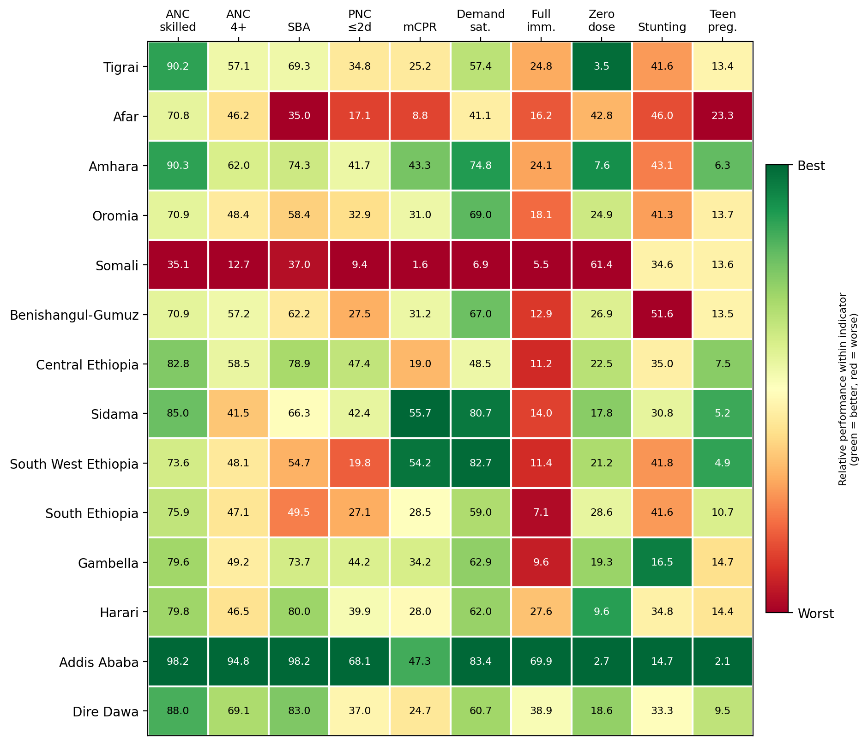
Supplementary Figure S8. Regional performance matrix (heat map) across ten key indicators, Ethiopia EDHS 2024–25. Cell shading is normalized within each indicator (column) so that green denotes relatively better and red relatively worse performance; for zero-dose prevalence, stunting and teenage pregnancy the shading is inverted so that lower prevalence displays as green. Cell values are the indicator percentages from Supplementary Table S1. This matrix is summarized in main-text Fig. 6.

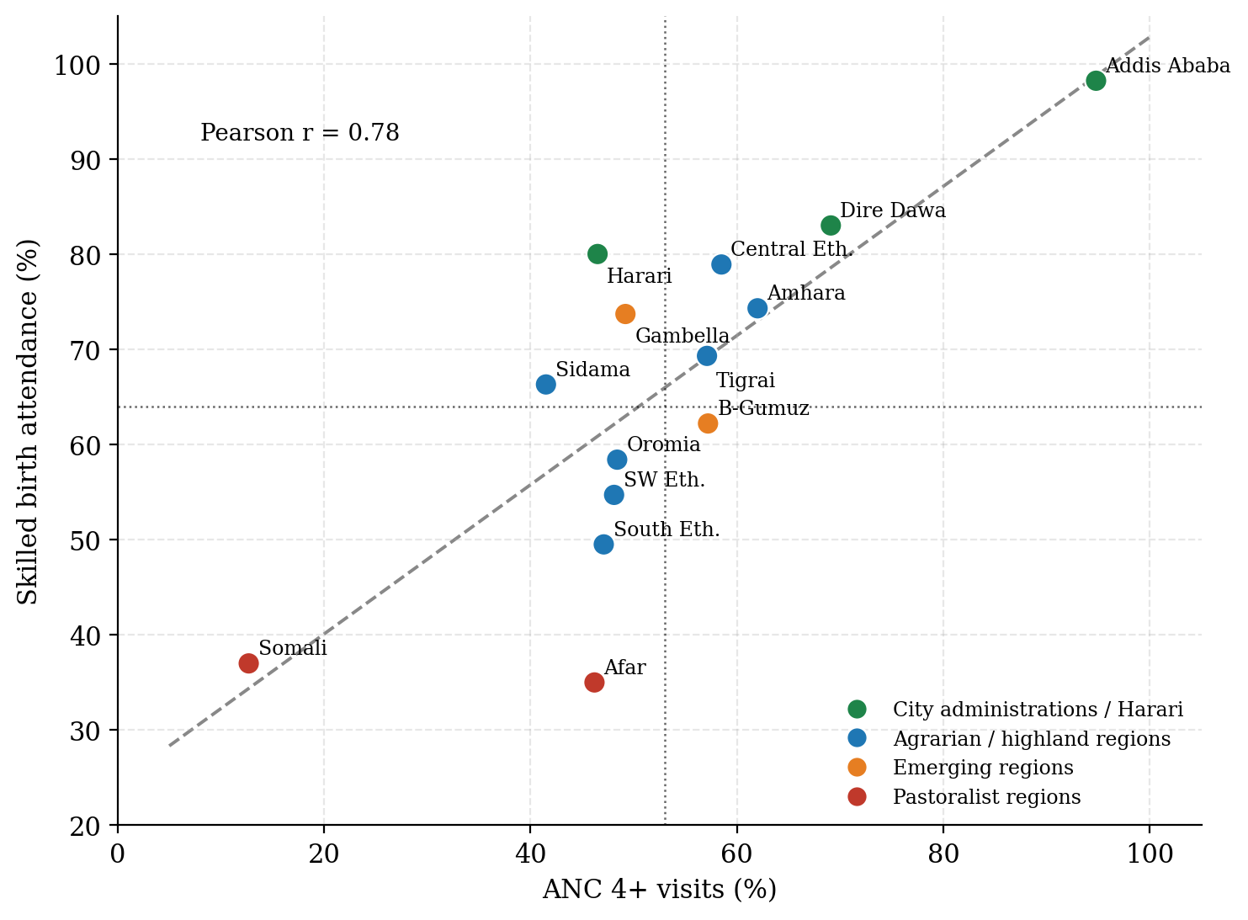
Supplementary Figure S9. Regional association between antenatal care completion (4+ visits) and skilled birth attendance, Ethiopia EDHS 2024–25. Dotted reference lines mark the national averages (53.0 and 64.0 percent) and the dashed line is the linear fit across the fourteen regions and city administrations. Colours distinguish city administrations, agrarian/highland regions, emerging regions and pastoralist regions.

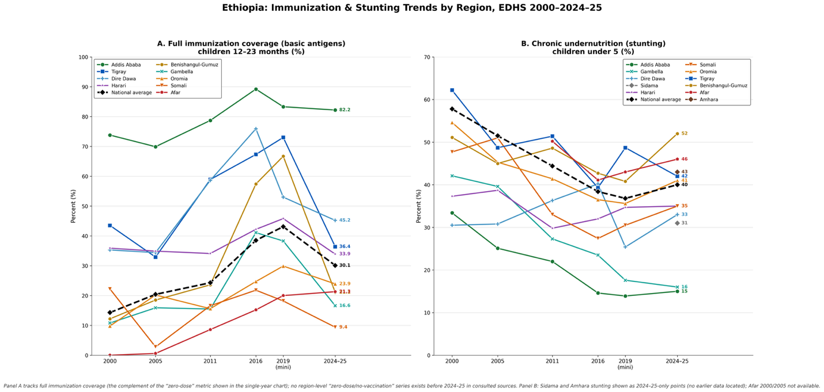
Supplementary Figure S10. Regional ranking of zero-dose prevalence among children aged 12–23 months, Ethiopia EDHS 2024–25. Percentage of children who received no vaccinations. The dashed line marks the national average (19.8 percent). Red denotes substantially worse than the national average, orange worse, and green better.

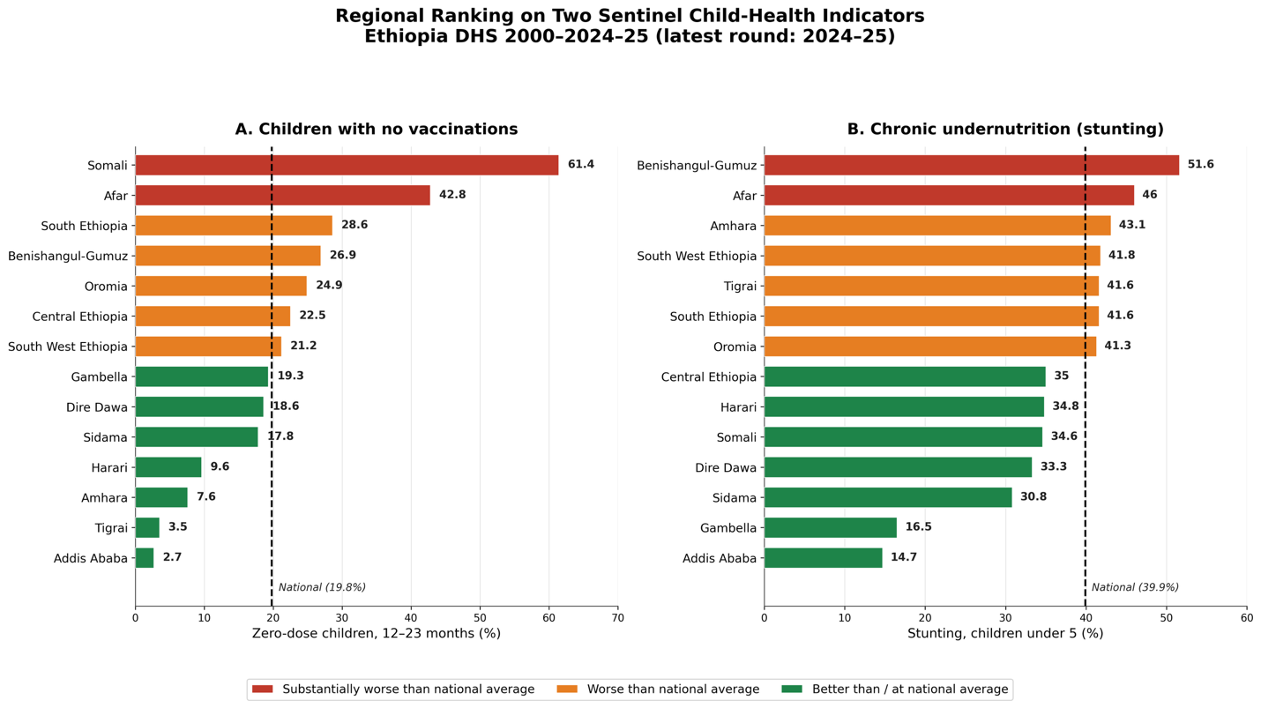
Supplementary Figure S11. Regional ranking of stunting prevalence among children under five, Ethiopia EDHS 2024–25. The dashed line marks the national average (39.9 percent). Red denotes substantially worse than the national average, orange worse, and green better.

