Online Resource 4
SELECT-NET: Multiple contextual representations of bacterial genomes through selection-based subnetwork reconstruction
Gerardo R. Amores.
Molecular Biology and Microbial Ecology Laboratory, Cinvestav-Irapuato, Km. 9.6 Libramiento Norte Carretera Irapuato-León 36821, Irapuato, Guanajuato, México.
gerardo.ruiz.a@cinvestav.mx ; amoresgr@gmail.com
ORCID: 0000-0001-7905-6741

Supplementary Figures

Supplementary Fig S1 – Genome network and genome subnetworks recovered through Q90 preservation (Mode B) in bacteria isolates (a) E. coli TOP10 (SRR22364163), (b) STEC-1 (SRR7739427), (c) C. difficile (SRR32099327), and (d) C. gilardii (SRR15654681).

Supplementary Fig S2 – Accessory-genome subnetworks recovered through heuristic core-genome subtraction (Mode C) in STEC and Clostridioides difficile isolates using Full workflow of SELECT-NET.

Supplementary Fig S3 – Accessory-genome subnetworks recovered through heuristic cgMLST combined with low-abundance subtraction (Mode CL) in Escherichia coli TOP10 and Shiga toxin–producing isolates.

Supplementary Fig S4 – Comparative epidemiological subnetworks generated from E. coli using Full workflows (Mode D).

Supplementary Fig. S5 Epidemiological subnetwork reconstructed from an Acinetobacter baumannii RNA-seq dataset using the Full workflow (Mode D).

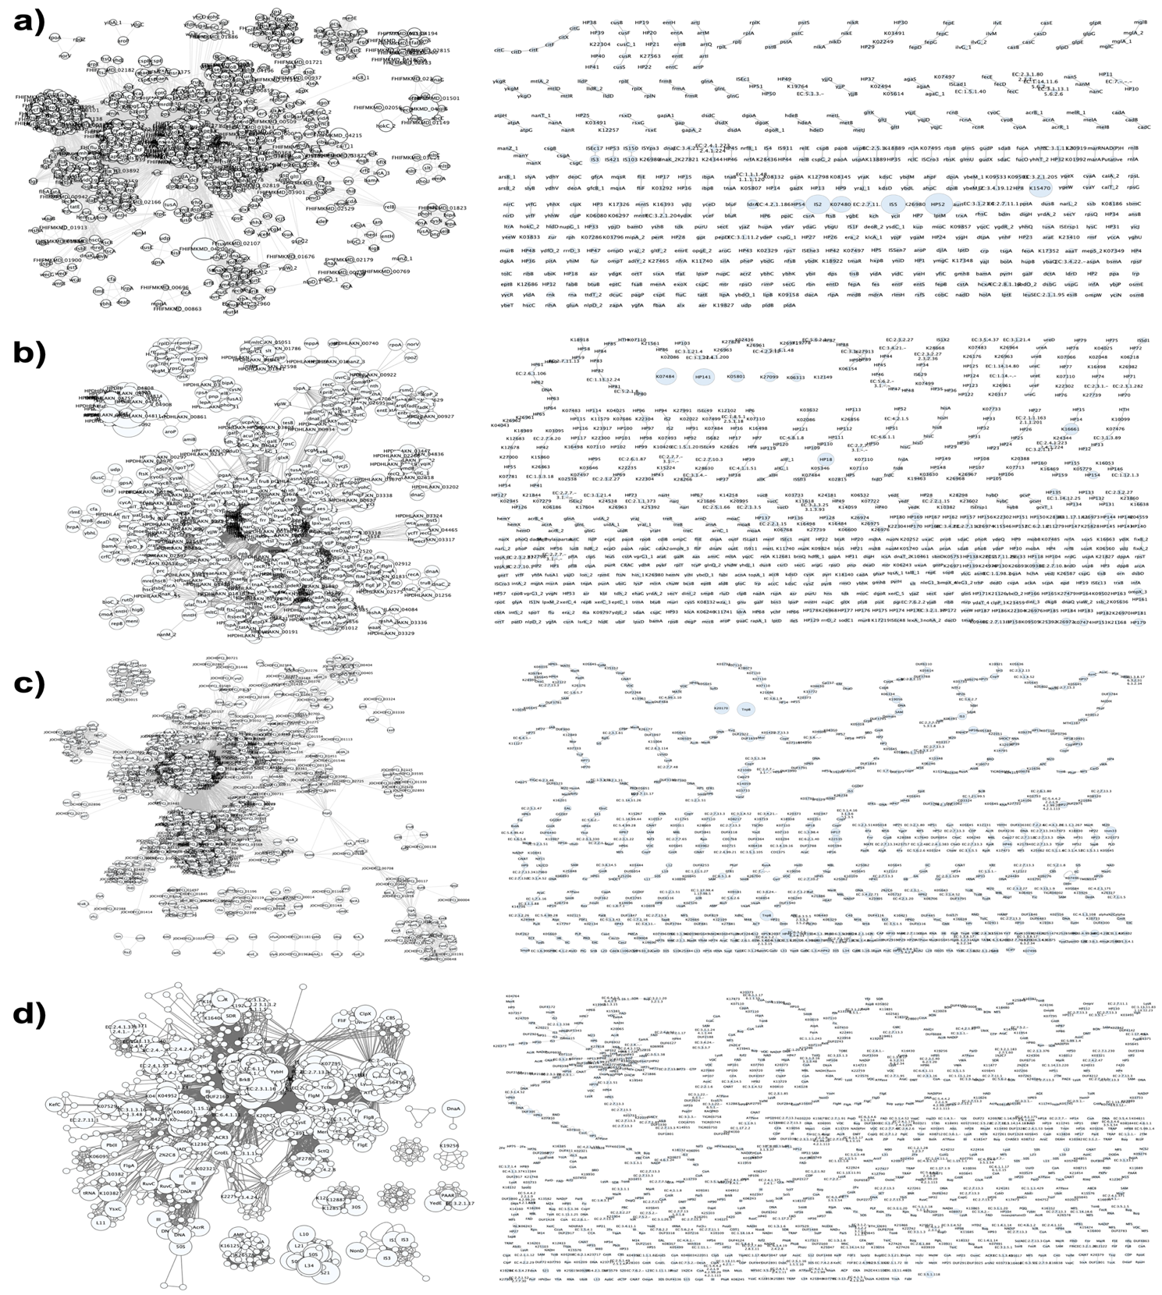
Fig. S1 Genome network and genome subnetworks recovered through Q90 preservation (Mode B) in bacteria isolates. Network representations of the full genome annotation are shown at the left and the generated subnetworks after application of the RPKM 90% quantile filter (Mode B) at all the bacteria genomes dataset evaluated in this work. (a) E. coli TOP10 (SRR22364163). (b) STEC-1 (SRR7739427). (c) C. difficile (SRR32099327). (d) C. gilardii (SRR15654681). Node size indicates RPKM-based normalized abundance metric.
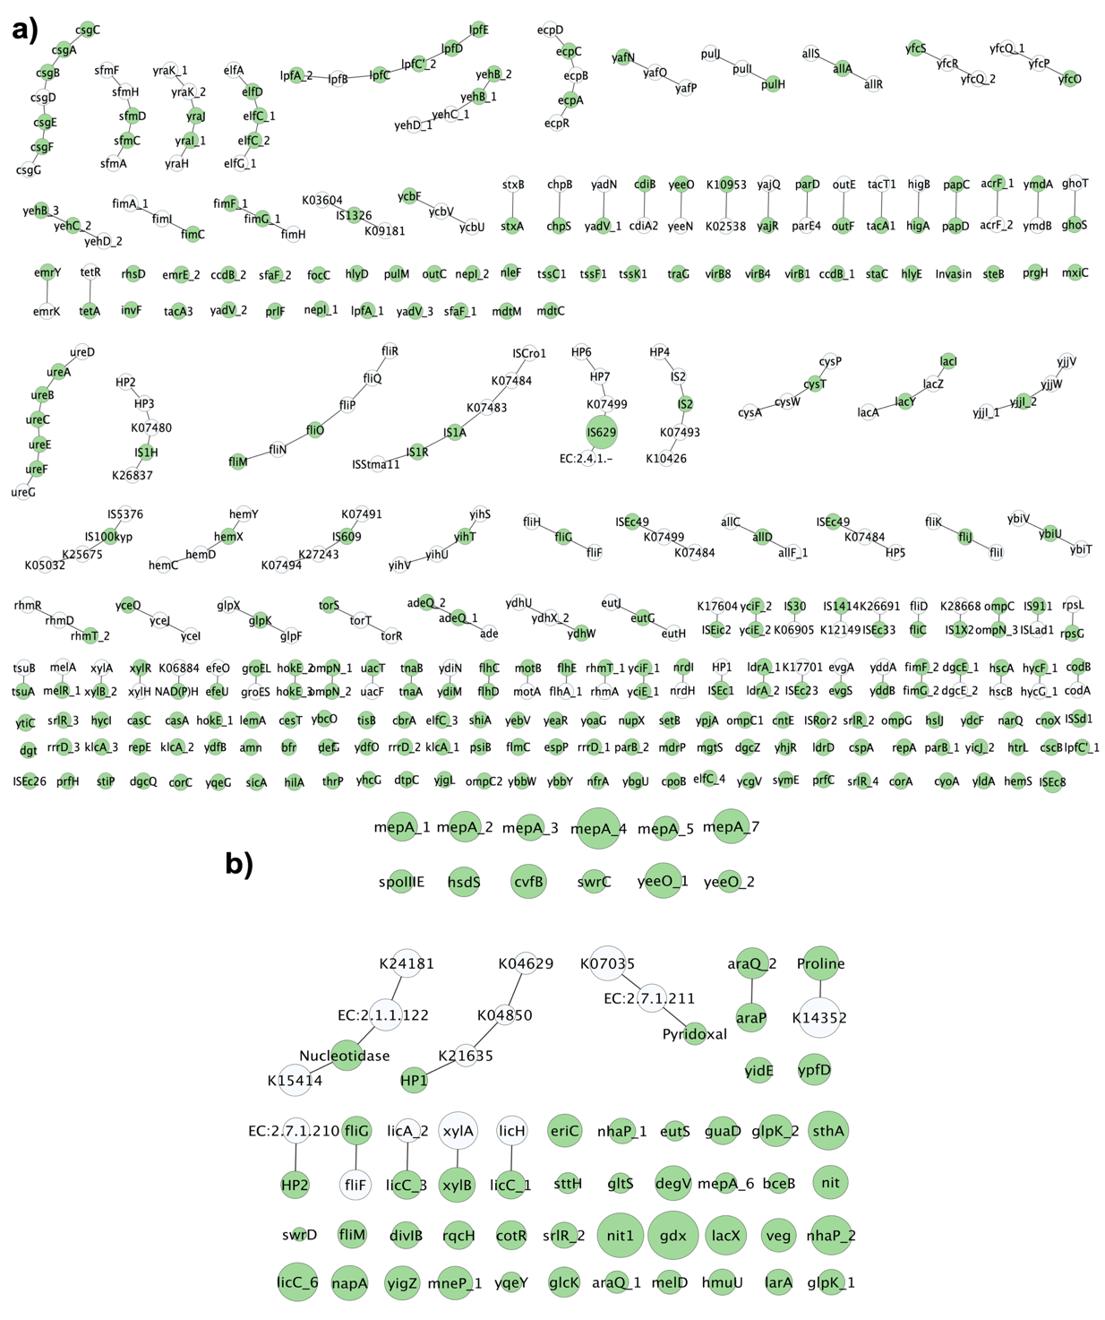
Fig. S2 Accessory-genome subnetworks recovered through heuristic core-genome subtraction (Mode C) in STEC and Clostridioides difficile isolates using Full workflow of SELECT-NET. Network representations generated after application of the core-subtraction filter (Mode C) to STEC-2 (SRR6128369) genome (a). Representation of Clostridioides difficile isolate (b). Green nodes correspond to genes retained after subtraction of the external E. Coli and Clostridioides cgMLST reference (respectively), representing genomic features absent from the conserved core background. White nodes indicate neighboring genes incorporated through contextual expansion during network reconstruction. Node size represents RPKM-based normalized abundance metric. The resulting subnetworks highlight accessory genomic content while preserving local genomic organization.
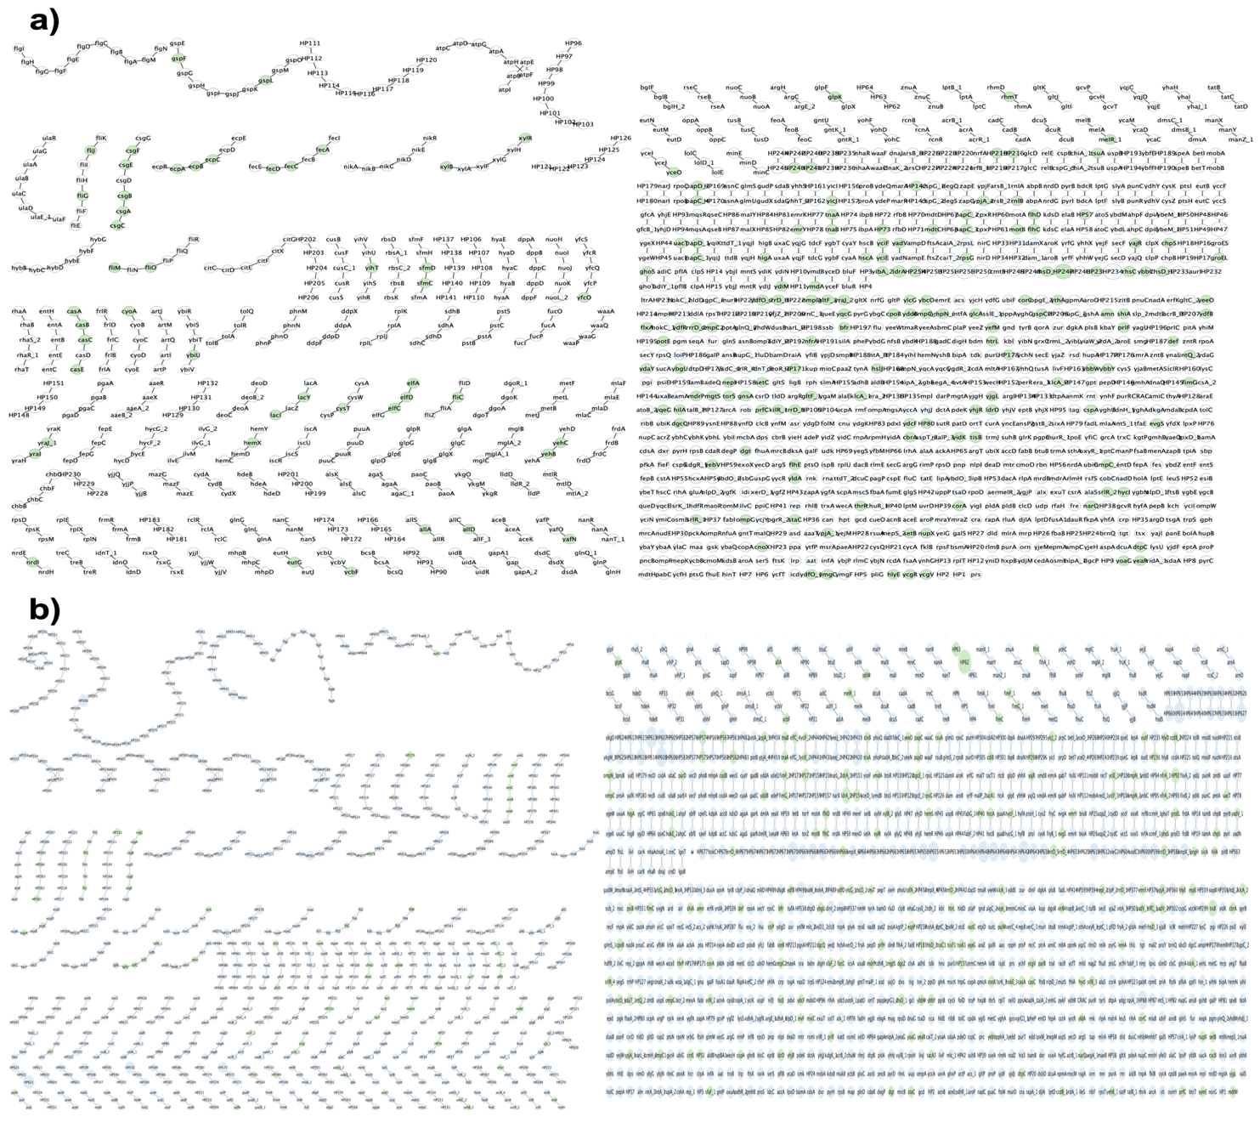
Fig. S3 Accessory-genome subnetworks recovered through heuristic cgMLST combined with low-abundance subtraction (Mode CL) in Escherichia coli TOP10 and Shiga toxin–producing isolates. Network representations to E. coli TOP10 (SRR22364163) (a), and STEC-1 (SRR7739427) (b). Green nodes correspond to genes retained after subtraction of the external Escherichia coli cgMLST reference, representing genomic features absent from the conserved core background. White nodes indicate neighboring genes incorporated through contextual expansion during network reconstruction and quantile retained nodes. Node size represents RPKM-based normalized abundance metric. The resulting subnetworks highlight accessory genomic content while preserving local genomic organization
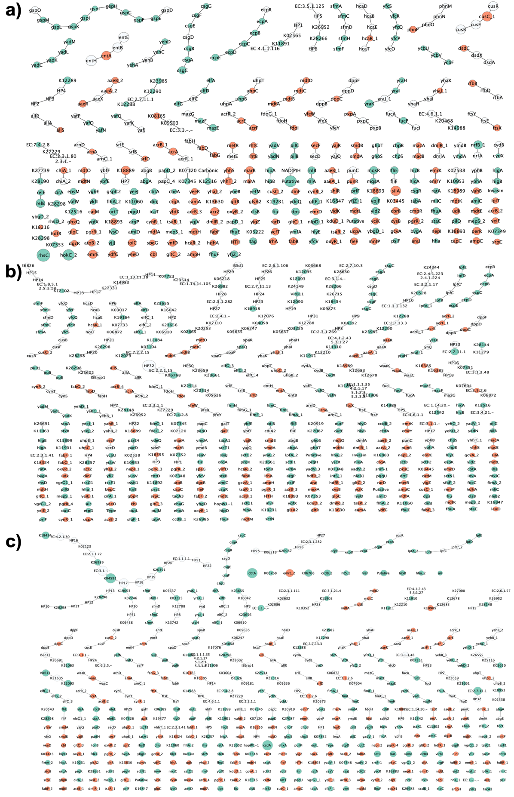
Fig S4 Comparative epidemiological subnetworks generated from E. coli using Full workflows (Mode D). Epidemiological subnetworks reconstructed after application of the Mode D filter on (a) E. coli TOP10 (SRR22364163). (b) STEC-1 (SRR7739427). (c) STEC-2 (SRR6128369). Nodes associated with virulence-related functions are shown in turquoise, whereas nodes associated with antimicrobial resistance are shown in orange. White nodes represent contextual neighboring genes retained during network reconstruction. Node size represents RPKM-based normalized abundance metric. A comparable core subnetwork was recovered across E. coli strains, whereas STEC-1 and STEC-2 retained additional virulence- and resistance-associated categories.

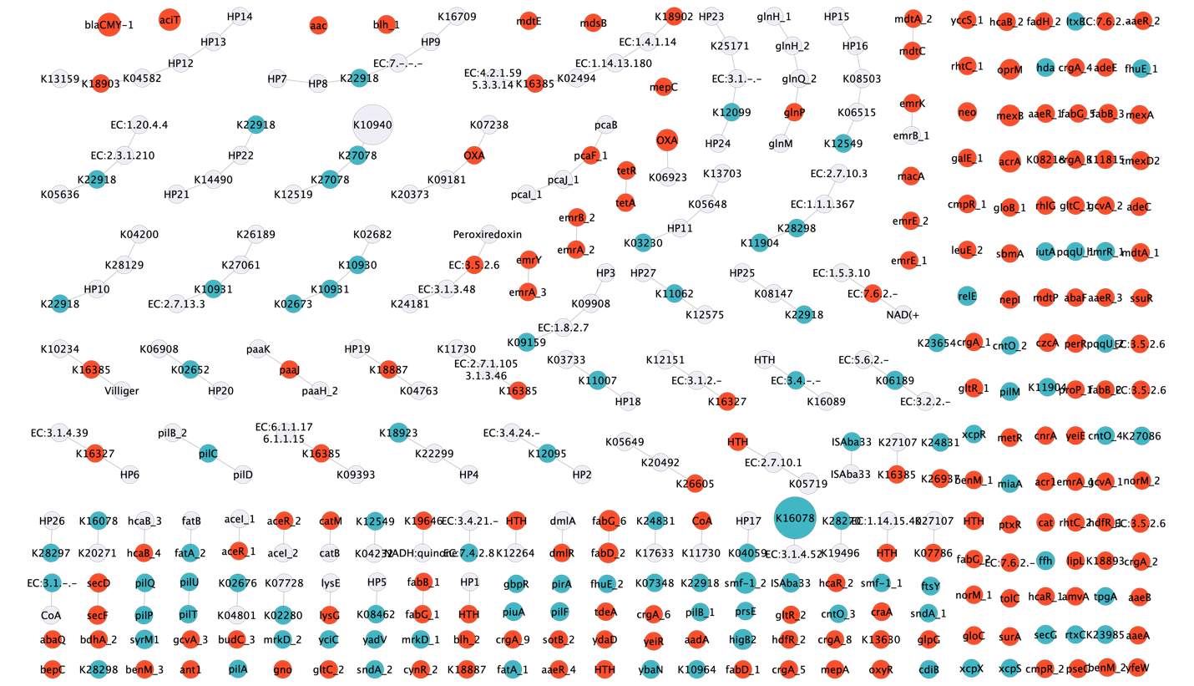
Fig. S5 Epidemiological subnetwork reconstructed from an Acinetobacter baumannii RNA-seq dataset using the Full workflow (Mode D). Epidemiological subnetworks were generated following application of the Mode D on an Acinetobacter baumannii transcriptomic dataset. Nodes associated with virulence-related functions are shown in turquoise, whereas nodes associated with antimicrobial resistance are shown in red. White nodes represent contextual neighboring genes retained during network reconstruction. Node size is proportional to RPKM-based normalized abundance metric. The recovered subnetwork includes multiple antimicrobial resistance determinants, multidrug efflux systems, pilus-associated proteins, secretion-related factors, adhesion-associated functions, and iron acquisition systems, consistent with the pathogenic profile of A. baumannii. These results illustrate that SELECT-NET can be applied to RNA-seq datasets while recovered multiple resistance-associated determinants reported for these strains.

