Online Resource 2
SELECT-NET: Multiple contextual representations of bacterial genomes through selection-based subnetwork reconstruction
Gerardo R. Amores.
Molecular Biology and Microbial Ecology Laboratory, Cinvestav-Irapuato, Km. 9.6 Libramiento Norte Carretera Irapuato-León 36821, Irapuato, Guanajuato, México.
gerardo.ruiz.a@cinvestav.mx ; amoresgr@gmail.com
ORCID: 0000-0001-7905-6741

SELECT-NET – Standard Operational Procedure

Table 1. Requirements for running SELECT-NET
Requirements | Full | Lite
Internet connection | YES | YES
Google account | YES | YES
Google Drive access | YES | YES
FASTQ files / SRA accession | YES | YES
protein.faa | NO | YES
genomic.gff | NO | YES
GCF_genomic.fna | NO | YES
Note: Detailed descriptions of SELECT-NET methods are provided in the main article. Briefly, the Full workflow performs de novo assembly, annotation, filtering, and network construction directly from sequencing reads. The Lite workflow requires pre-existing FAA, GFF, and FNA files, which can be obtained from public repositories such as NCBI and used directly for SELECT-NET filtering and network reconstruction.

Table 2. SELECT-NET filtering modes
Mode - Strategy | Description | Interpretation
A - Thematic | Retains genes assigned to Extremophile-like, Bioplastic-like, Biodegradation-like and Industrial-enzyme-like categories | Adaptive and biotechnology-oriented contextual exploration
B - Quantitative | Retains genes above the abundance threshold | Abundance-supported contextual exploration
C - Core subtraction | Removes genes matching external core references | Accessory-genome exploration
CH - Exploratory extension | Removes core-like combined with high-abundance genes | Exploratory accessory-genome reconstruction
CL - Exploratory extension | Removes core-like combined with low-abundance genes | Exploratory accessory-genome reconstruction
D - Epidemiological | Retains Resistance and Virulence categories | Epidemiologically relevant contextual exploration
Note: Categories were heuristically derived from gene product descriptions, gene names, and KO-associated annotations. These categories were intended to enrich the resulting subnetworks for stress-associated functions, biopolymer-related metabolism, biodegradation-associated activities, and putative industrial enzymes.

Step 1. – Initialize SELECT-NET Workflow
- Download the SELECT_NET.ipynb file from the source article to your local device.
- Navigate to https://colab.research.google.com/ using a web browser.
- Select the Upload tab (or go to File > Import notebook).
- Import the previously downloaded SELECT_NET.ipynb file from your local directory.
- Verify that the notebook loads completely with all code cells visible and ready for execution.

Step 2. – Running the Workflow
Click either the Play button or Run all to start the workflow.
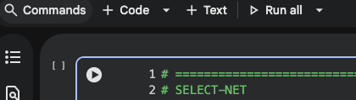
A new window will prompt you to connect your Google Drive account. Grant the required permissions to continue. Once authorization is completed, a folder named SELECT-NET will be automatically created in your Google Drive. The workflow outputs will be stored in the corresponding output directory generated during the analysis.

Step 3. – Input source
After initialization, the workflow will automatically scroll to the configuration section. Input data can be provided either as:
- Public sequencing runs retrieved from repository accessions (S), or
- Local FASTQ files supplied directly by the user (L).
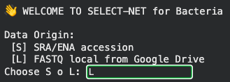
Step 3.1 – Local data
For local datasets, sequencing reads should be placed inside the input directory created within the SELECT-NET folder.
Specify the file paths as follows:
local_r1 = "/content/drive/MyDrive/SELECT-NET/input/NAME_OF_FILE_R1.fastq.gz"
local_r2 = "/content/drive/MyDrive/SELECT-NET /input/NAME_OF_FILE_R2.fastq.gz"
For paired-end sequencing data, both files should be specified.
Relevant metadata, including species name, sequencing type, accession or local identifier, and filtering mode, are automatically recorded in the run-level metadata generated by the workflow.
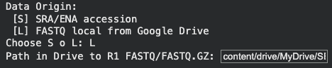
Step 3.2 – Repository data
For publicly available sequencing datasets, enter the corresponding SRA accession number in the designated field and press Enter.
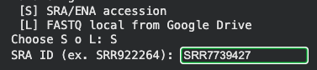

Step 4. – Library and assembly configuration
Select the sequencing library type and assembly strategy corresponding to the sample being analyzed.
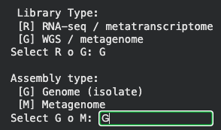

Step 5 – Filter mode
Select the filtering approach to be applied for network construction.
Modes A, B, and D initiate the workflow immediately. Depending on the provided input files, SELECT-NET will automatically determine whether to execute the Full or Lite workflow.
If only sequencing reads are supplied (repository accessions or local FASTQ files), SELECT-NET executes the Full workflow, including:
- de novo assembly,
- genome annotation,
- KO assignment using KOfam,
- node filtering, and
- network construction.
Alternatively, if GFF, FAA, and FNA files are also available (at the “input” folder), SELECT-NET executes the Lite workflow, which uses the supplied annotations to perform filtering and network reconstruction without repeating the assembly and annotation stages.
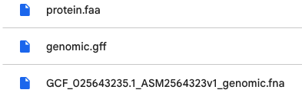

If modes C, CH, or CL are selected, additional options will be displayed to configure the desired core-subtraction settings.
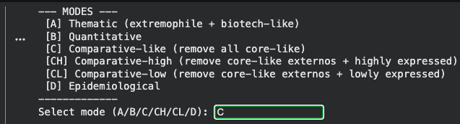
Step 5.1 –Core-like filtering
Core-like filtering uses curated reference collections derived from bacterial species with well-characterized core genomes. Rather than distinguishing between pathogenic and non-pathogenic organisms, this filtering strategy aims to reduce the contribution of highly conserved functions shared among related bacterial genomes.
By removing genes associated with these conserved core-like functions, the resulting network becomes enriched in accessory and potentially niche-specific genetic features. This approach facilitates the identification of biological differences among closely related strains while preserving genes not represented in the reference collections
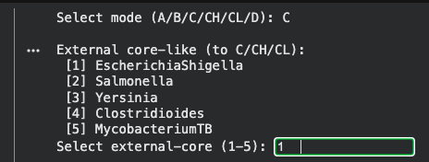

Step 6 – Results
Runtime depends on internet connectivity, data size, selected workflow mode, and filtering strategy.
Multiple filtering modes can be applied sequentially. Once an analysis has been completed, generated checkpoints allow subsequent filtering modes to execute considerably faster by reusing intermediate files. For example, after one filtering mode has been executed, SELECT-NET can reuse previously generated GFF, FAA, and FNA files, avoiding redundant processing steps.
The workflow generates multiple output files. The most relevant include:
- …node_X.graphml — network file compatible with Cytoscape.
- …global_edges.csv — complete edge table.
- …full_table.csv — comprehensive annotation table for all detected nodes.
- …mode_X_node.csv — filtered node table corresponding to the selected mode.
The x.graphml, global_edges.csv, and full_table.csv files can be imported directly into Cytoscape for network visualization and editing. Additionally, full_table.csv and mode_X_node.csv may be inspected independently to evaluate individual node characteristics. Within the SELECT-NET directory, the workflow automatically generates checkpoint folders identified by the corresponding analysis accession. These folders contain intermediate files, including protein.faa, which can be used for further manual sequence inspection and downstream analyses.
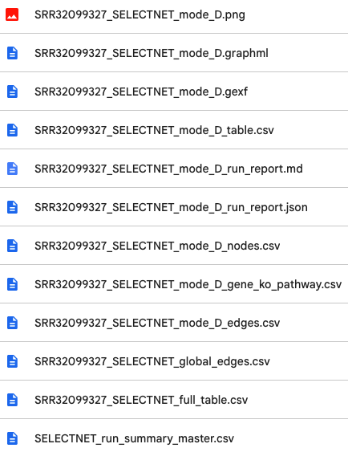

Step 7 – Cytoscape implementation
Download and install the Cytoscape software from the official website (https://cytoscape.org/), then import the .graphml file to visualize and explore the network results.

Notes on code terminology
Some internal variable names, output labels, and legacy code identifiers may retain the term "expression" from earlier stages of workflow development. Within SELECT-NET, these labels should be interpreted according to the biological context of the analyzed dataset. For RNA-seq datasets, RPKM values represent normalized transcript abundance, whereas for whole-genome sequencing datasets they represent normalized read representation and are used exclusively as a within-sample prioritization metric.

