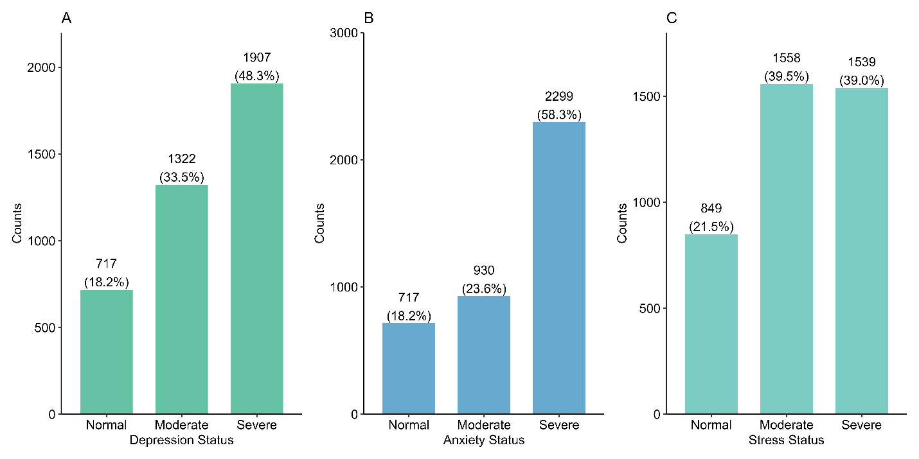
Supplementary Figure 1: Distribution of depression, anxiety, and stress status based on the DAS21 scale. (A) Depression status (B) Anxiety status (C) Stress status. Counts and percentages are labeled on the bars for each category.

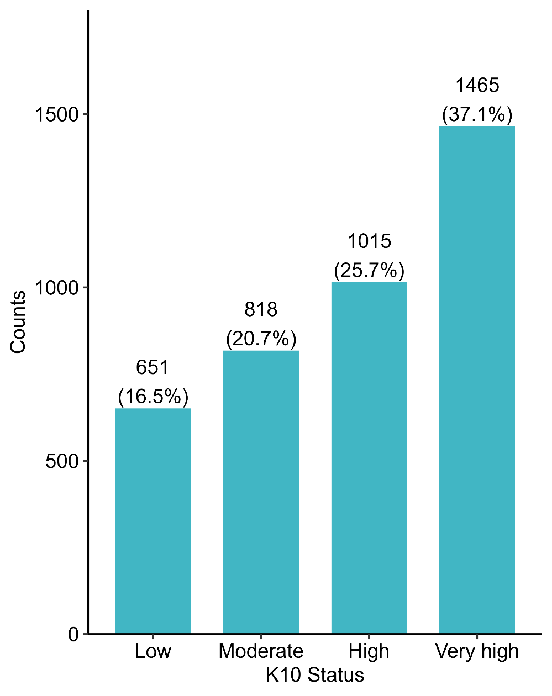
Supplementary Figure 2: Distribution of K10 status categorized into Low distress, Moderate distress, and High distress. Counts and percentages are labeled above each bar to illustrate the proportions of participants in each category.

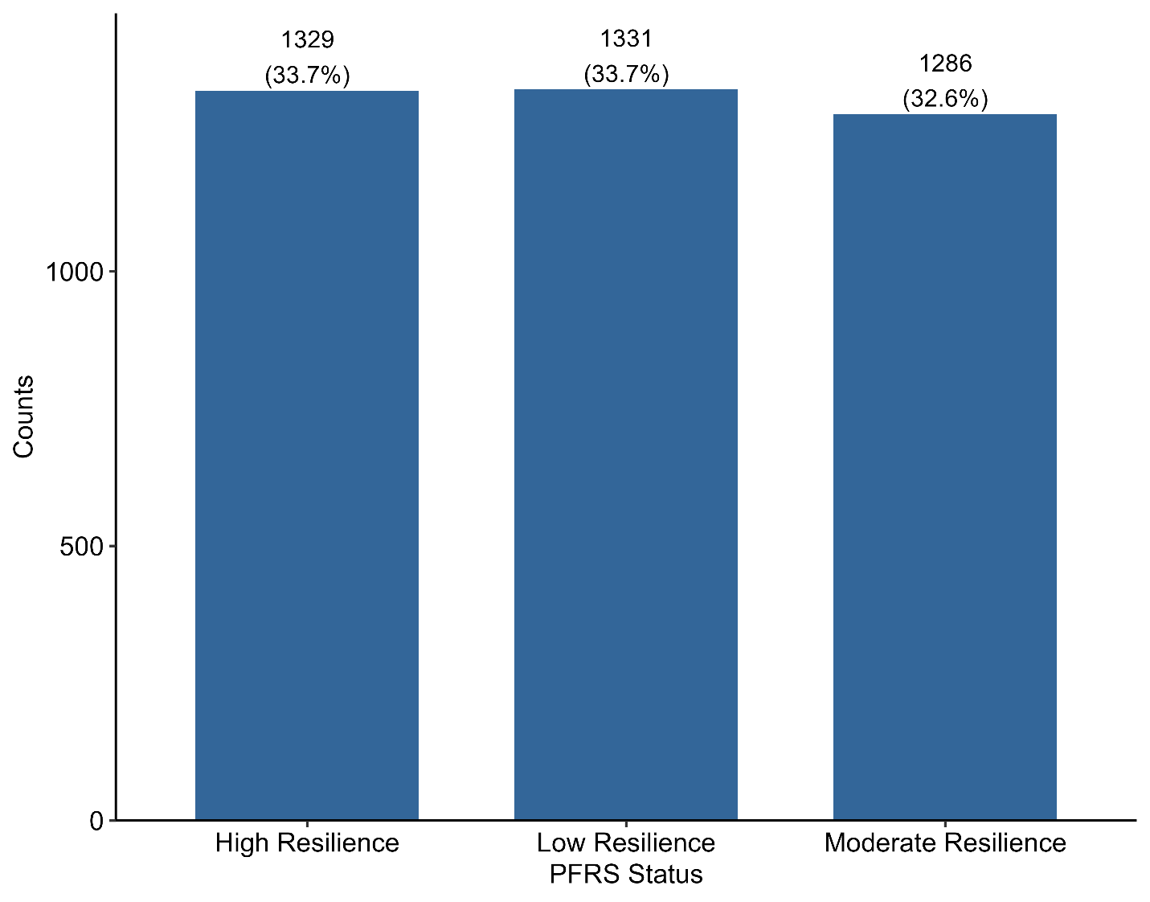
Supplementary Figure 3: Distribution of PFRS status categorized into High Resilience, Low Resilience, and Moderate Resilience. Counts and percentages are displayed above the bars, representing the proportion of individuals in each category.

