Supplementary Note
Method 1. PRS Partition according to tissues
Let ${\hat{b}}_{1},…,{\hat{b}}_{M}$ be the marginal genetic effects of $M$ variants from GWAS of a BP trait and ${\hat{β}}_{1},…,{\hat{β}}_{M}$be the estimated joint effect sizes of these variants using SBayesRC¹. Denote $\hat{β}={({\hat{β}}_{1},…,{\hat{β}}_{M})}^{T}$, representing the joint effect sizes of genetic variants, and ${\hat{β}}_{C_{k}}={\left({\hat{β}}_{1}a_{1}^{C_{k}},…,{\hat{β}}_{M}a_{M}^{C_{k}}\right)}^{T}$, representing the joint effect sizes of variants falling into CREs active to the kth tissue, where $k=1,…, q$, and $a_{j}^{C_{k}}$ being a binary indicator: being 1 if the $j$th variant belongs to the $k$th tissue specific CREs and 0 otherwise, where we denote $C_{k}$ as the kth tissue active CREs. Note that a genetic variant can fall into a CRE active to multiple tissues, which creates a challenge to estimate tissue specific contribution. We perform the linear regression accounting for linkage disequilibrium among variants:
$\hat{β}=θ_{1}{\hat{β}}_{C_{1}}+⋯+θ_{q}{\hat{β}}_{C_{q}}+ϵ$.
Specifically, ${\hat{β}}_{C_{k}}$ are estimated from SBayesRC containing estimation error. We thus estimate $θ=(θ_{1},…,θ_{q})$ by
$$\hat{θ}={\hat{H}}_{b}^{-1} {\hat{g}}_{b},$$
where ${\hat{g}}_{b}=({\hat{β}}_{C_{1}}^{⊤}R\hat{β}, …,{\hat{β}}_{C_{q}}^{⊤}R\hat{β})$ and the $(j,k)$-element in ${\hat{H}}_{b}$ is ${\hat{β}}_{C_{j}}^{⊤}R{\hat{β}}_{C_{k}}$. The idea is the same as the S-Predixcan as the weighted estimates should be adjusted by the LD matrix $R$.
Let ${\hat{θ}}_{1},…{\hat{θ}}_{q}$ be the estimated regression coefficients. The partitioned PRS corresponding to the kth tissue active CREs is defined as
$${PRS}_{C_{k}}=\sum_{j=1}^{M}{{\hat{θ}}_{k}{a_{j}^{C_{k}}\hat{β}}_{j}g_{j}, }$$
where $g_{j}$ denoted the genotype value for the jth variant.
To estimate the heritability explained by the tissue partitioned PRSs, we can use the Pratt index, ^{2,3} which measures a covariate’s contribution to outcome in a regression model while accounting for its correlations with other covariates. Consider the regression model$y=x_{1}β_{1}+⋯+x_{p}β_{p}+ϵ$ where $y$ and $x_{1},…,x_{p}$ are p standardized covariates with mean zero. The Pratt index of the covariate $x_{j}$ is defined as:
$$PI_{j}=β_{j}×cov\left(x_{j},y\right)=β_{j}^{2}+\sum_{s≠j}{cov\left(x_{j},x_{s}\right)β_{j}β_{s}.}$$
Pratt index can be considered as the explained variance attributed to a covariate and can be used to measure the importance of the covariate³. An appealing property of the Pratt index is its additivity:
$$R^{2}=PI_{1}+⋯+PI_{p},$$
where $R^{2}=var(\sum_{j}{x_{ij}β_{j}})$.

For our case, the SNP heritability can be estimated by:
$$h_{SNP}^{2}=\sum_{j=1}^{M}{{\hat{b}}_{j}{\hat{β}}_{j}. }$$
For a heritability attributed to ${PRS}_{C_{k}}$ or the variants falling in the CREs active to the kth tissue, using Pratt index, it was estimated by:
$$h_{C_{k}}^{2}=\sum_{j=1}^{M}{{\hat{b}}_{j}{\hat{θ}}_{k}{a_{j}^{C_{k}}\hat{β}}_{j}. }$$
Method 2. PRS Partition according to the 15 disjoint
Method 1 has a challenge in separating the tissue specific contributions when variants falling to CREs active to multiple tissues. To solve this problem, we partitioned the CREs into all possible 15 disjoint sets of CREs for the tissue types in which the CREs are active (Fig. 2B, main text). This approach is straightforward and we only need to worry about the linkage disequilibrium (LD) among the genetic variants. Since the partitioned PRS weights were obtained from the joint variant effects from SBayesRC, the LD were incorporated naturally.

BP PRS partition using Method 1 and 2
In our real data analysis, we first estimated the variant joint effects from BP GWAS summary statistics using SBayesRC¹. The estimated variant joint effects were then summed to construct PRSs. Next, we constructed tcPRSs by summing the variant joint effects located in all active CREs for each specific tissue studied. We constructed PRSs for each of SBP, DBP, PP, and an additional BP relevant trait that represents horizontal pleiotropy but not through mediation between SBP and DBP.⁴ We named the latter trait BP_plei. Using the largest sample BP GWAS summary statistics available⁵, we estimated that the BP heritability explained by the corresponding PRSs ranged from 0.059 to 0.147 in UKB, with BP_plei showing the lowest heritability explained (Fig. 2A, main text). For ease of discussion, we term this the SNP heritability. We next calculated the BP SNP heritability explained only by the variants residing within CREs of the four tissues, with a range between 67.9-83.1% of the BP SNP heritability, representing a 3.75 - 4.59 fold enrichment. Subsequently, we partitioned each BP PRS into four tcPRSs based on the CREs active within the adrenal gland, artery, heart, and kidney, respectively (Method 1). The explained SNP heritability of these four tcPRSs together ranged from 50.6-73.9% (Fig. 2A, main text), demonstrating a significant loss of information. The reason for this loss is that many CREs are tissue-agnostic and are active in all four tissues: repeated usage of these tissue-agnostic variants loses information and is consistent with our observations in computer simulations (Supplementary note Fig. 1). We partitioned the CREs into all possible 15 disjoint sets of CREs for the tissue types in which the CREs are active (Method 2). Accordingly, we recomputed the 15 partitioned tcPRSs for each BP trait in these disjoint sets and estimated the heritability explained by them together and observed no SNP heritability loss (Fig. 2A). Thus, we focused on these 15 tcPRS, as well as the residual PRS (resPRS) calculated using all other variants mapping outside the CREs relevant to the 4 tissues. As noted, a BP PRS can be accurately obtained by summing the 15 tcPRS and resPRS, that is, $PRS=\sum_{j=1}^{16}{tcPRS_{j}}$, where j=16 represents the resPRS.

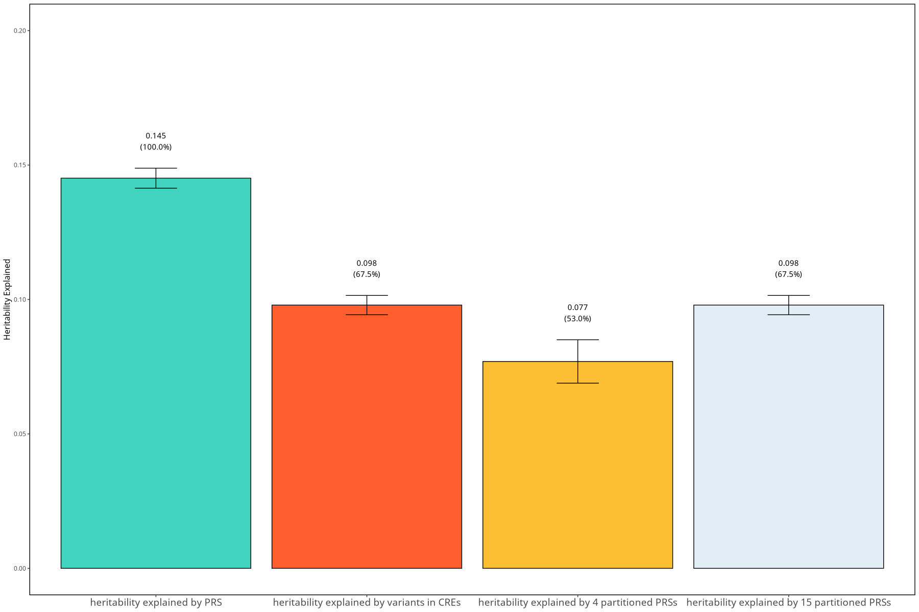
Supplementary note Figure 1. Using SBP as an example, we showed that partitioning PRS into four tissue-specific PRSs leads to a loss of heritability, whereas partitioning into 15 tcPRSs together with the residual PRS preserves heritability. We first applied SBayesRC to SBP summary statistics and obtained 81,727 potential causal variants among 7,356,518 variants, corresponding to 1.1% causal variants in the genome. We next randomly sampled 81,727 variants as causal variants with effect size generated from N(0, 0.147). We next uniformly scaled the effect sizes of causal variants falling in and outside CREs of the 4 tissues separately so that the heritability explained by these two sets of causal variants was 0.1 and 0.047, respectively, which mimicked the SBP heritability distribution we observed (main text Figure 2A). Since all genotypes were standardized, this scaling was conducted without difficulty. We next calculated the marginal effect sizes according to the European LD matrix provided by SBayesRC to reconstruct GWAS summary statistics in 7,356,518 variants. We then recalculated the SNP heritability using SBayesRC and the heritability explained by the four partitioned tissue-specific PRSs, as well as the heritability explained by the 15 tcPRSs and resPRS. We demonstrated a loss of heritability by the four tissue-specific PRSs whereas partitioning into 15 tcPRSs together with the residual PRS preserves heritability.

1. Zheng, Z. et al. Leveraging functional genomic annotations and genome coverage to improve polygenic prediction of complex traits within and between ancestries. Nat Genet 56, 767-777 (2024).
2. Pratt, J.W. Dividing the indivisible: Using simple symmetry to partition variance explained. Proceedings of the second international Tampere conference in statistics, 16 (1987).
3. Thomas, D.R., Hughes, E. & Zumbo, B.D. On variable importance in linear regression. Social Indicators Research 45, 23 (1998).
4. Zhu, X., Zhu, L., Wang, H., Cooper, R.S. & Chakravarti, A. Genome-wide pleiotropy analysis identifies novel blood pressure variants and improves its polygenic risk scores. Genet Epidemiol 46, 105-121 (2022).
5. Keaton, J.M. et al. Genome-wide analysis in over 1 million individuals of European ancestry yields improved polygenic risk scores for blood pressure traits. Nat Genet 56, 778-791 (2024).

