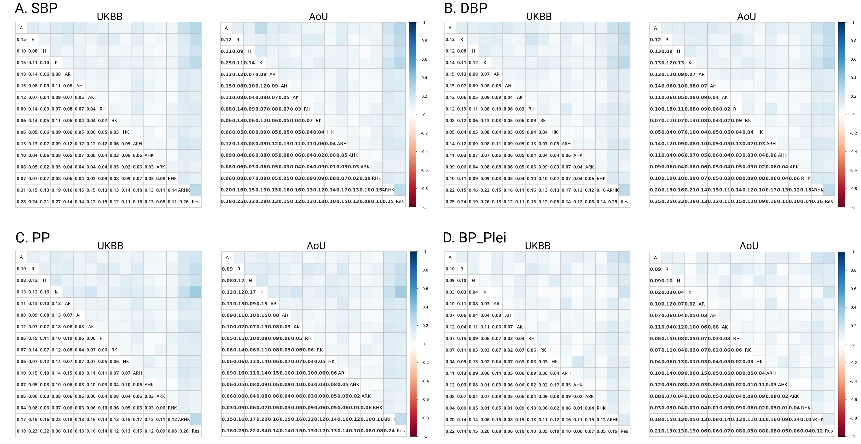

Supplementary Figure 1. Person correlations among the 15 tcPRSs and resPRS in UKB and AoU. The characters in diagonal cells represent the tissue specific active CREs for imputing tcPRSs and resPRS. All the correlations are low in both UKB and AoU.
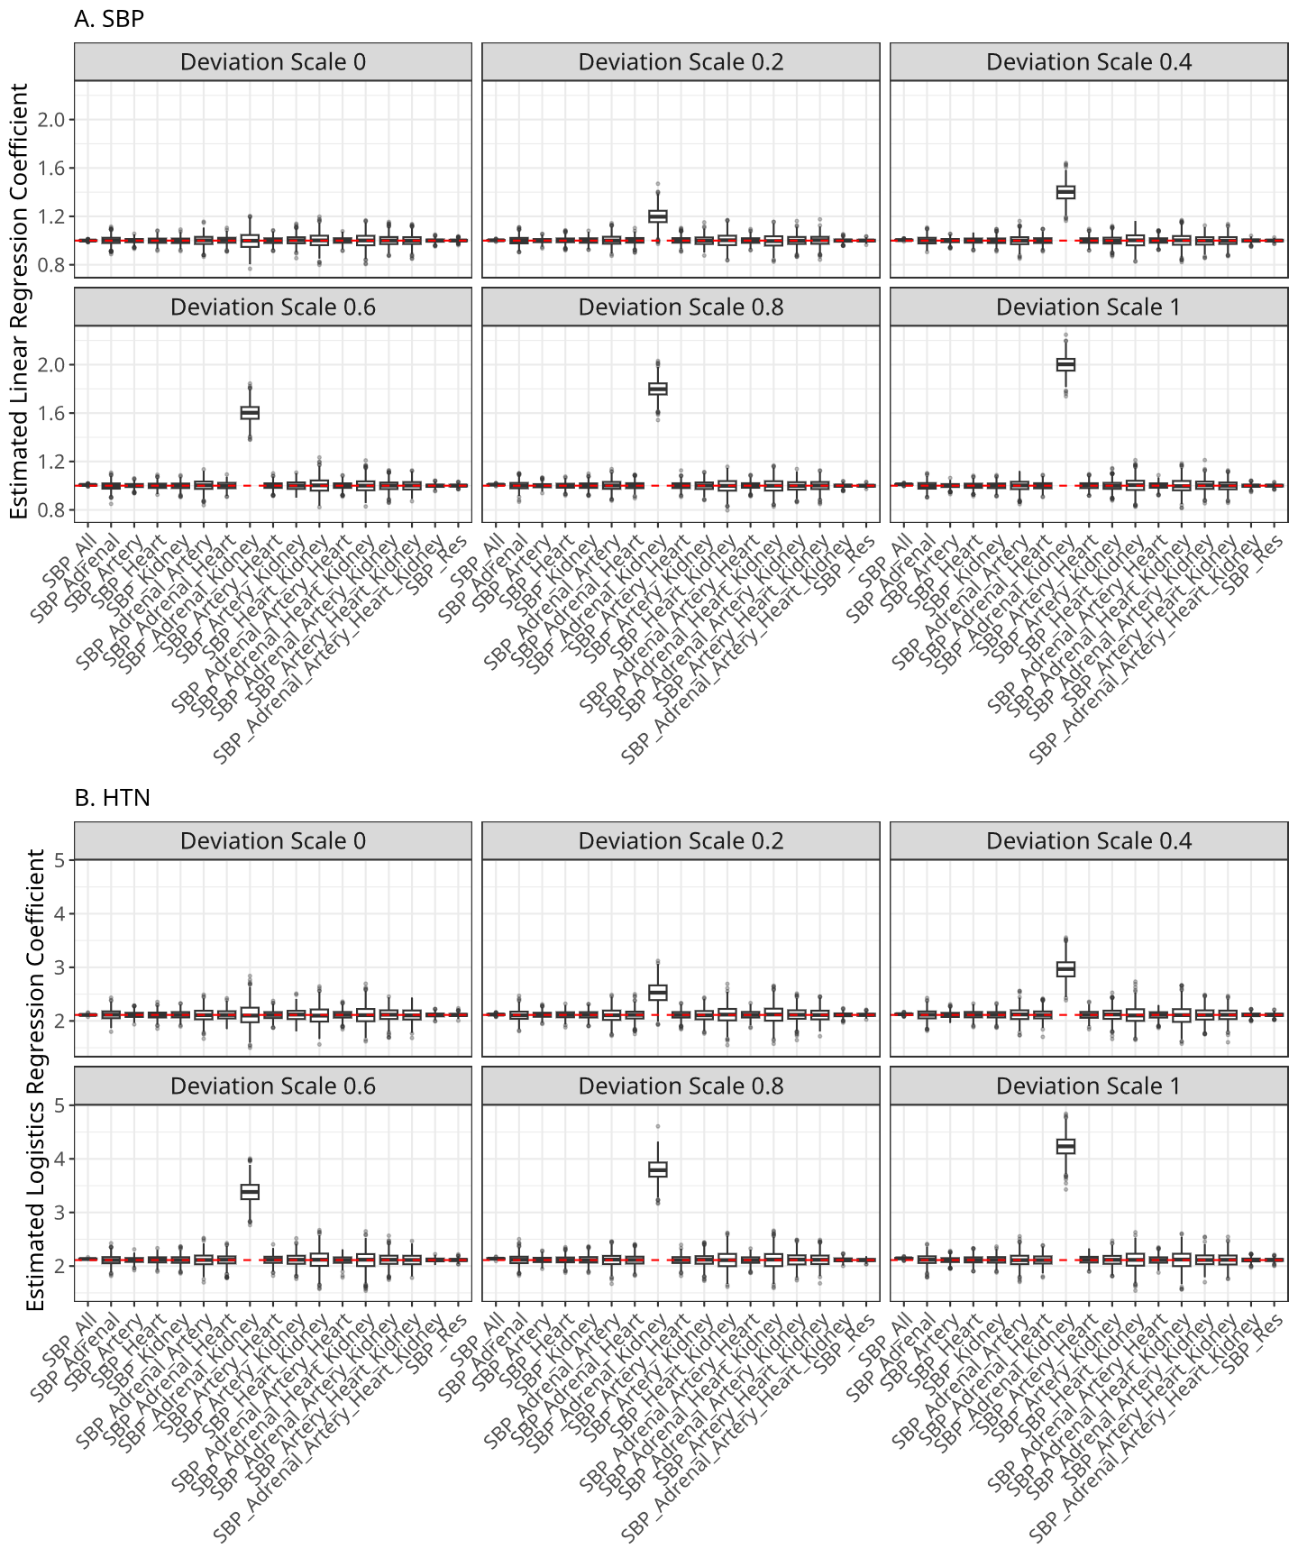
Supplementary Figure 2. Estimated regression coefficients. We simulated SBP and HTN using effect sizes estimated from the UKB. Specifically, we first regressed SBP on the overall SBP PRS and covariates and obtained their regression coefficients $\hat{θ}$ Similarly, we applied logistic regression for HTN on the SBP PRS and covariates. We then simulated individual SBP values in UKB by the model $SBP=PRS_{All}*\hat{θ}+tcPRS_{AK}*\hat{θ}*s+covariate+ϵ$ where $s$ denotes the deviation scale and $tcPRS_{AK}$ denotes the partitioned PRS for CREs common for adrenal gland and kidney. The residual variance was scaled so that the total variance of the simulated SBP was 1. We simulated HTN using the logistic regression using the estimated coefficients and the same predictor variables as simulating SBP. We then performed two linear regressions for simulated SBP: 1) $SBP=β_{0}+β_{All}PRS_{All}+covariate+ϵ$; 2) $SBP=β_{0}+\sum_{i=1}^{16}{β_{i}PRS_{i}}+covariate+ϵ$; and two logistic regressions for HTN: 1) $logit(HTN)=β_{0}+β_{All}PRS_{All}+covariate$; 2) $logit(HTN)=β_{0}+\sum_{i=1}^{16}{β_{i}PRS_{i}}+covariate$. The top and bottom panels present the estimated regression coefficients for SBP and HTN for different deviations of $tcPRS_{AK}$ effect, respectively. We performed 100 simulations. When no deviation of $tcPRS_{AK}$, there was no heterogeneity observed for both SBP and HTN. When there is deviation of $tcPRS_{AK}$ effect, we also observed the heterogeneity, which was consistent with partitioned PRS analysis in UKB and AoU. Here the deviation of $tcPRS_{AK}$ effect can be considered as the contribution of gene-environment or gene-gene interactions.

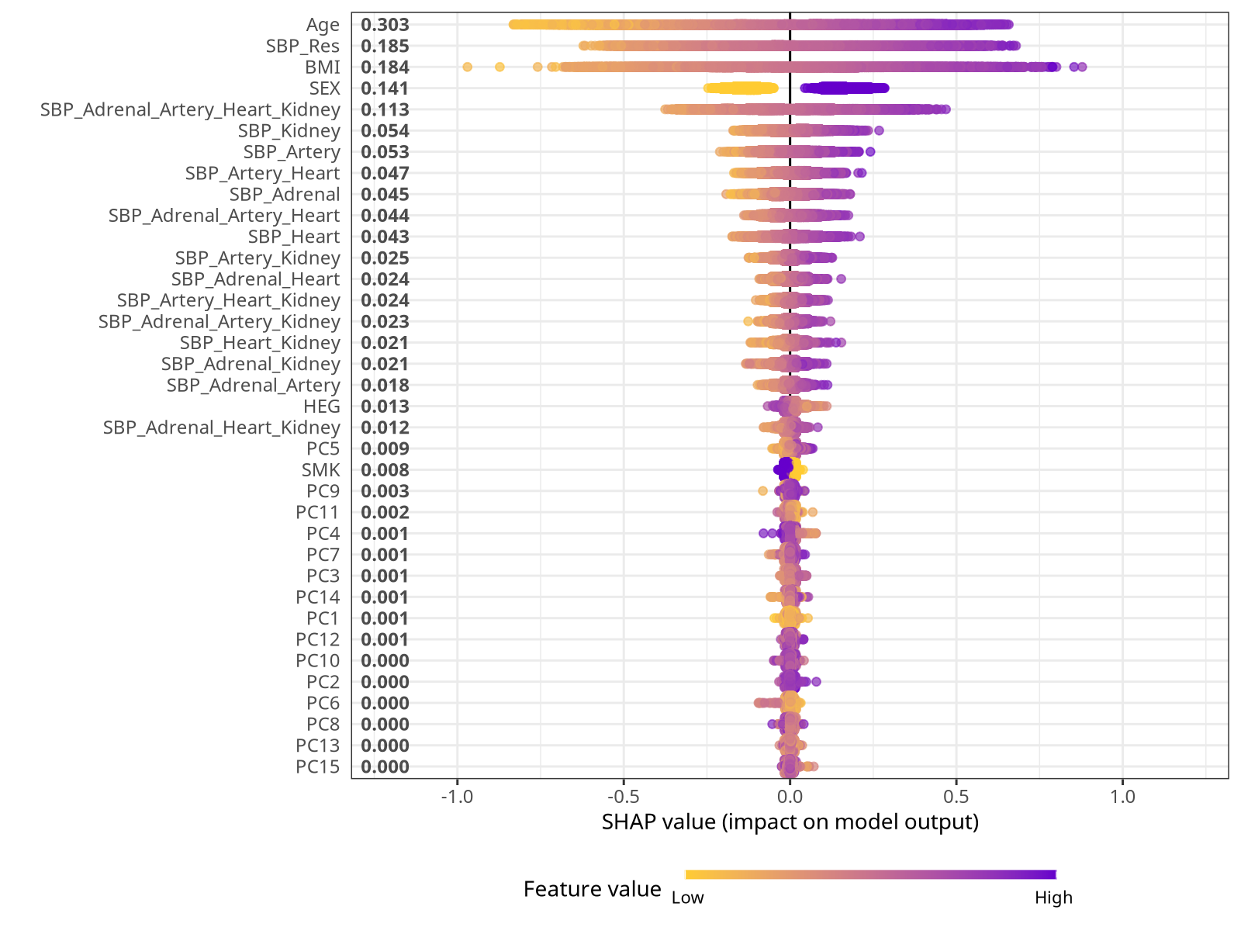
Supplementary Figure 3. SHAP summary plot for the SBP Xgboost model. We show here the SHAP distribution for the SBP Xgboost model trained on UKB European-ancestry individuals. Each point represents one individual’s SHAP value for a given feature, with features ordered by their mean absolute SHAP value. The horizontal axis indicates the SHAP value (impact on model output), and the color scale reflects the corresponding feature value (from low to high).

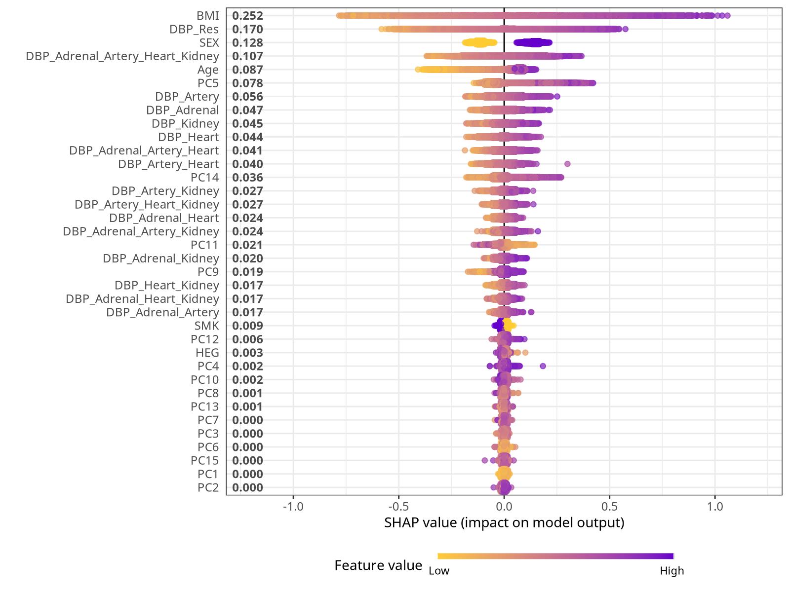
Supplementary Figure 4. SHAP summary plot for the DBP Xgboost model. We show here the SHAP distribution for the DBP Xgboost model trained on UKB European-ancestry individuals. Each point represents one individual’s SHAP value for a given feature, with features ordered by their mean absolute SHAP value. The horizontal axis indicates the SHAP value (impact on model output), and the color scale reflects the corresponding feature value (from low to high).

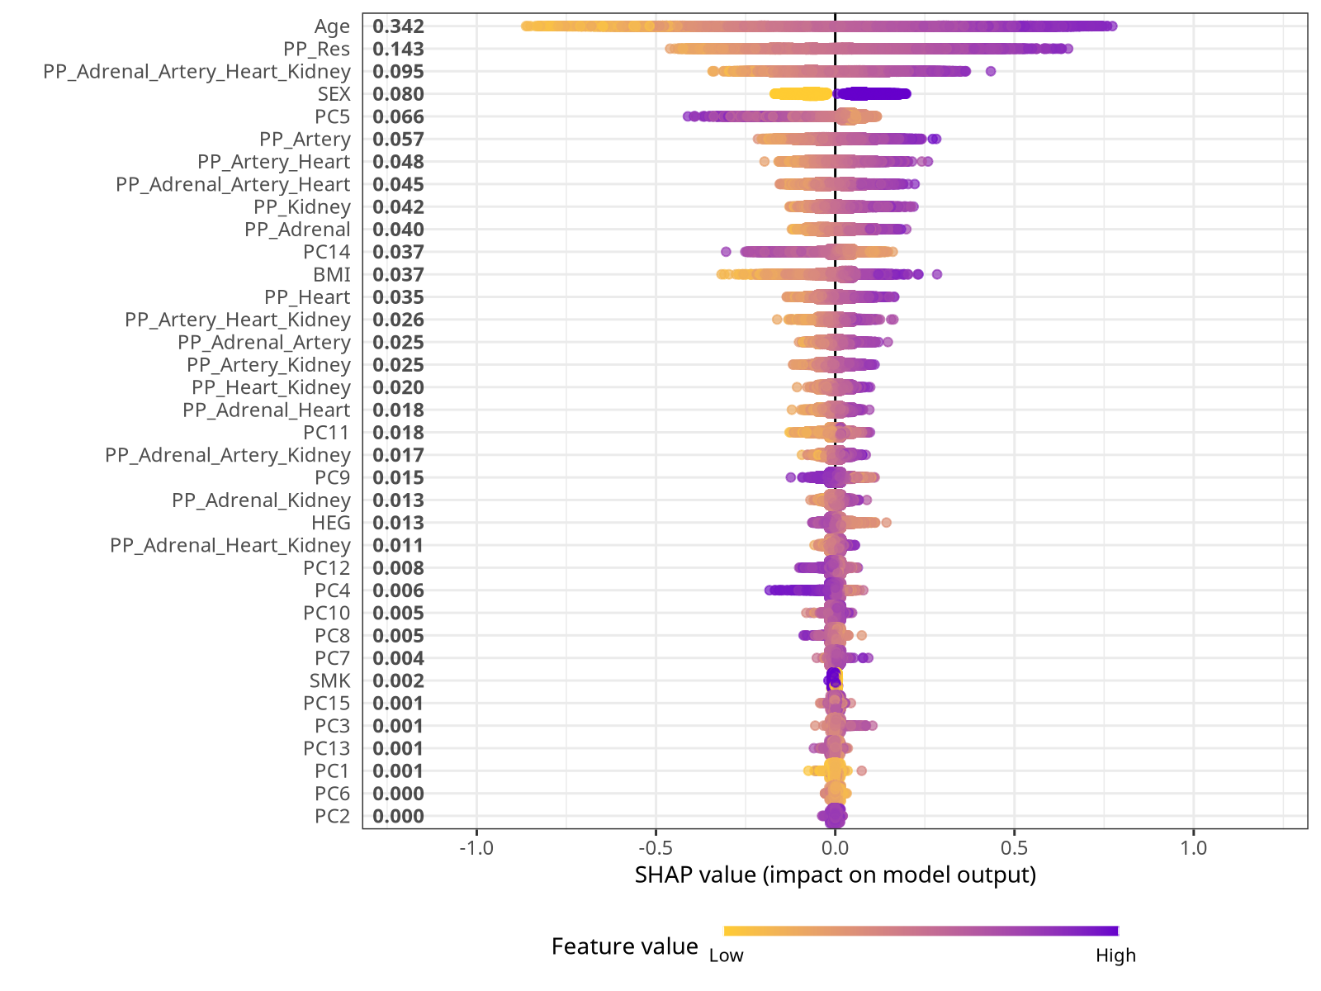
Supplementary Figure 5. SHAP summary plot for the PP Xgboost model. We show here the SHAP distribution for the P Xgboost model trained on UKB European-ancestry individuals. Each point represents one individual’s SHAP value for a given feature, with features ordered by their mean absolute SHAP value. The horizontal axis indicates the SHAP value (impact on model output), and the color scale reflects the corresponding feature value (from low to high).
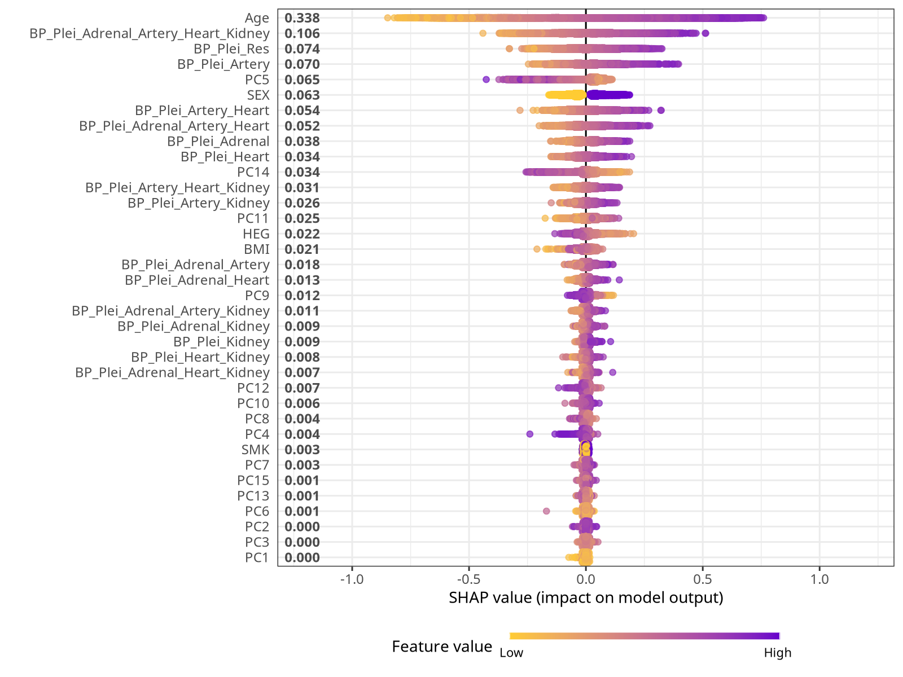 Supplementary Figure 6. SHAP summary plot for the BP_Plei Xgboost model. We show here the SHAP distribution for the BP_Plei Xgboost model trained on UKB European-ancestry individuals. Each point represents one individual’s SHAP value for a given feature, with features ordered by their mean absolute SHAP value. The horizontal axis indicates the SHAP value (impact on model output), and the color scale reflects the corresponding feature value (from low to high).

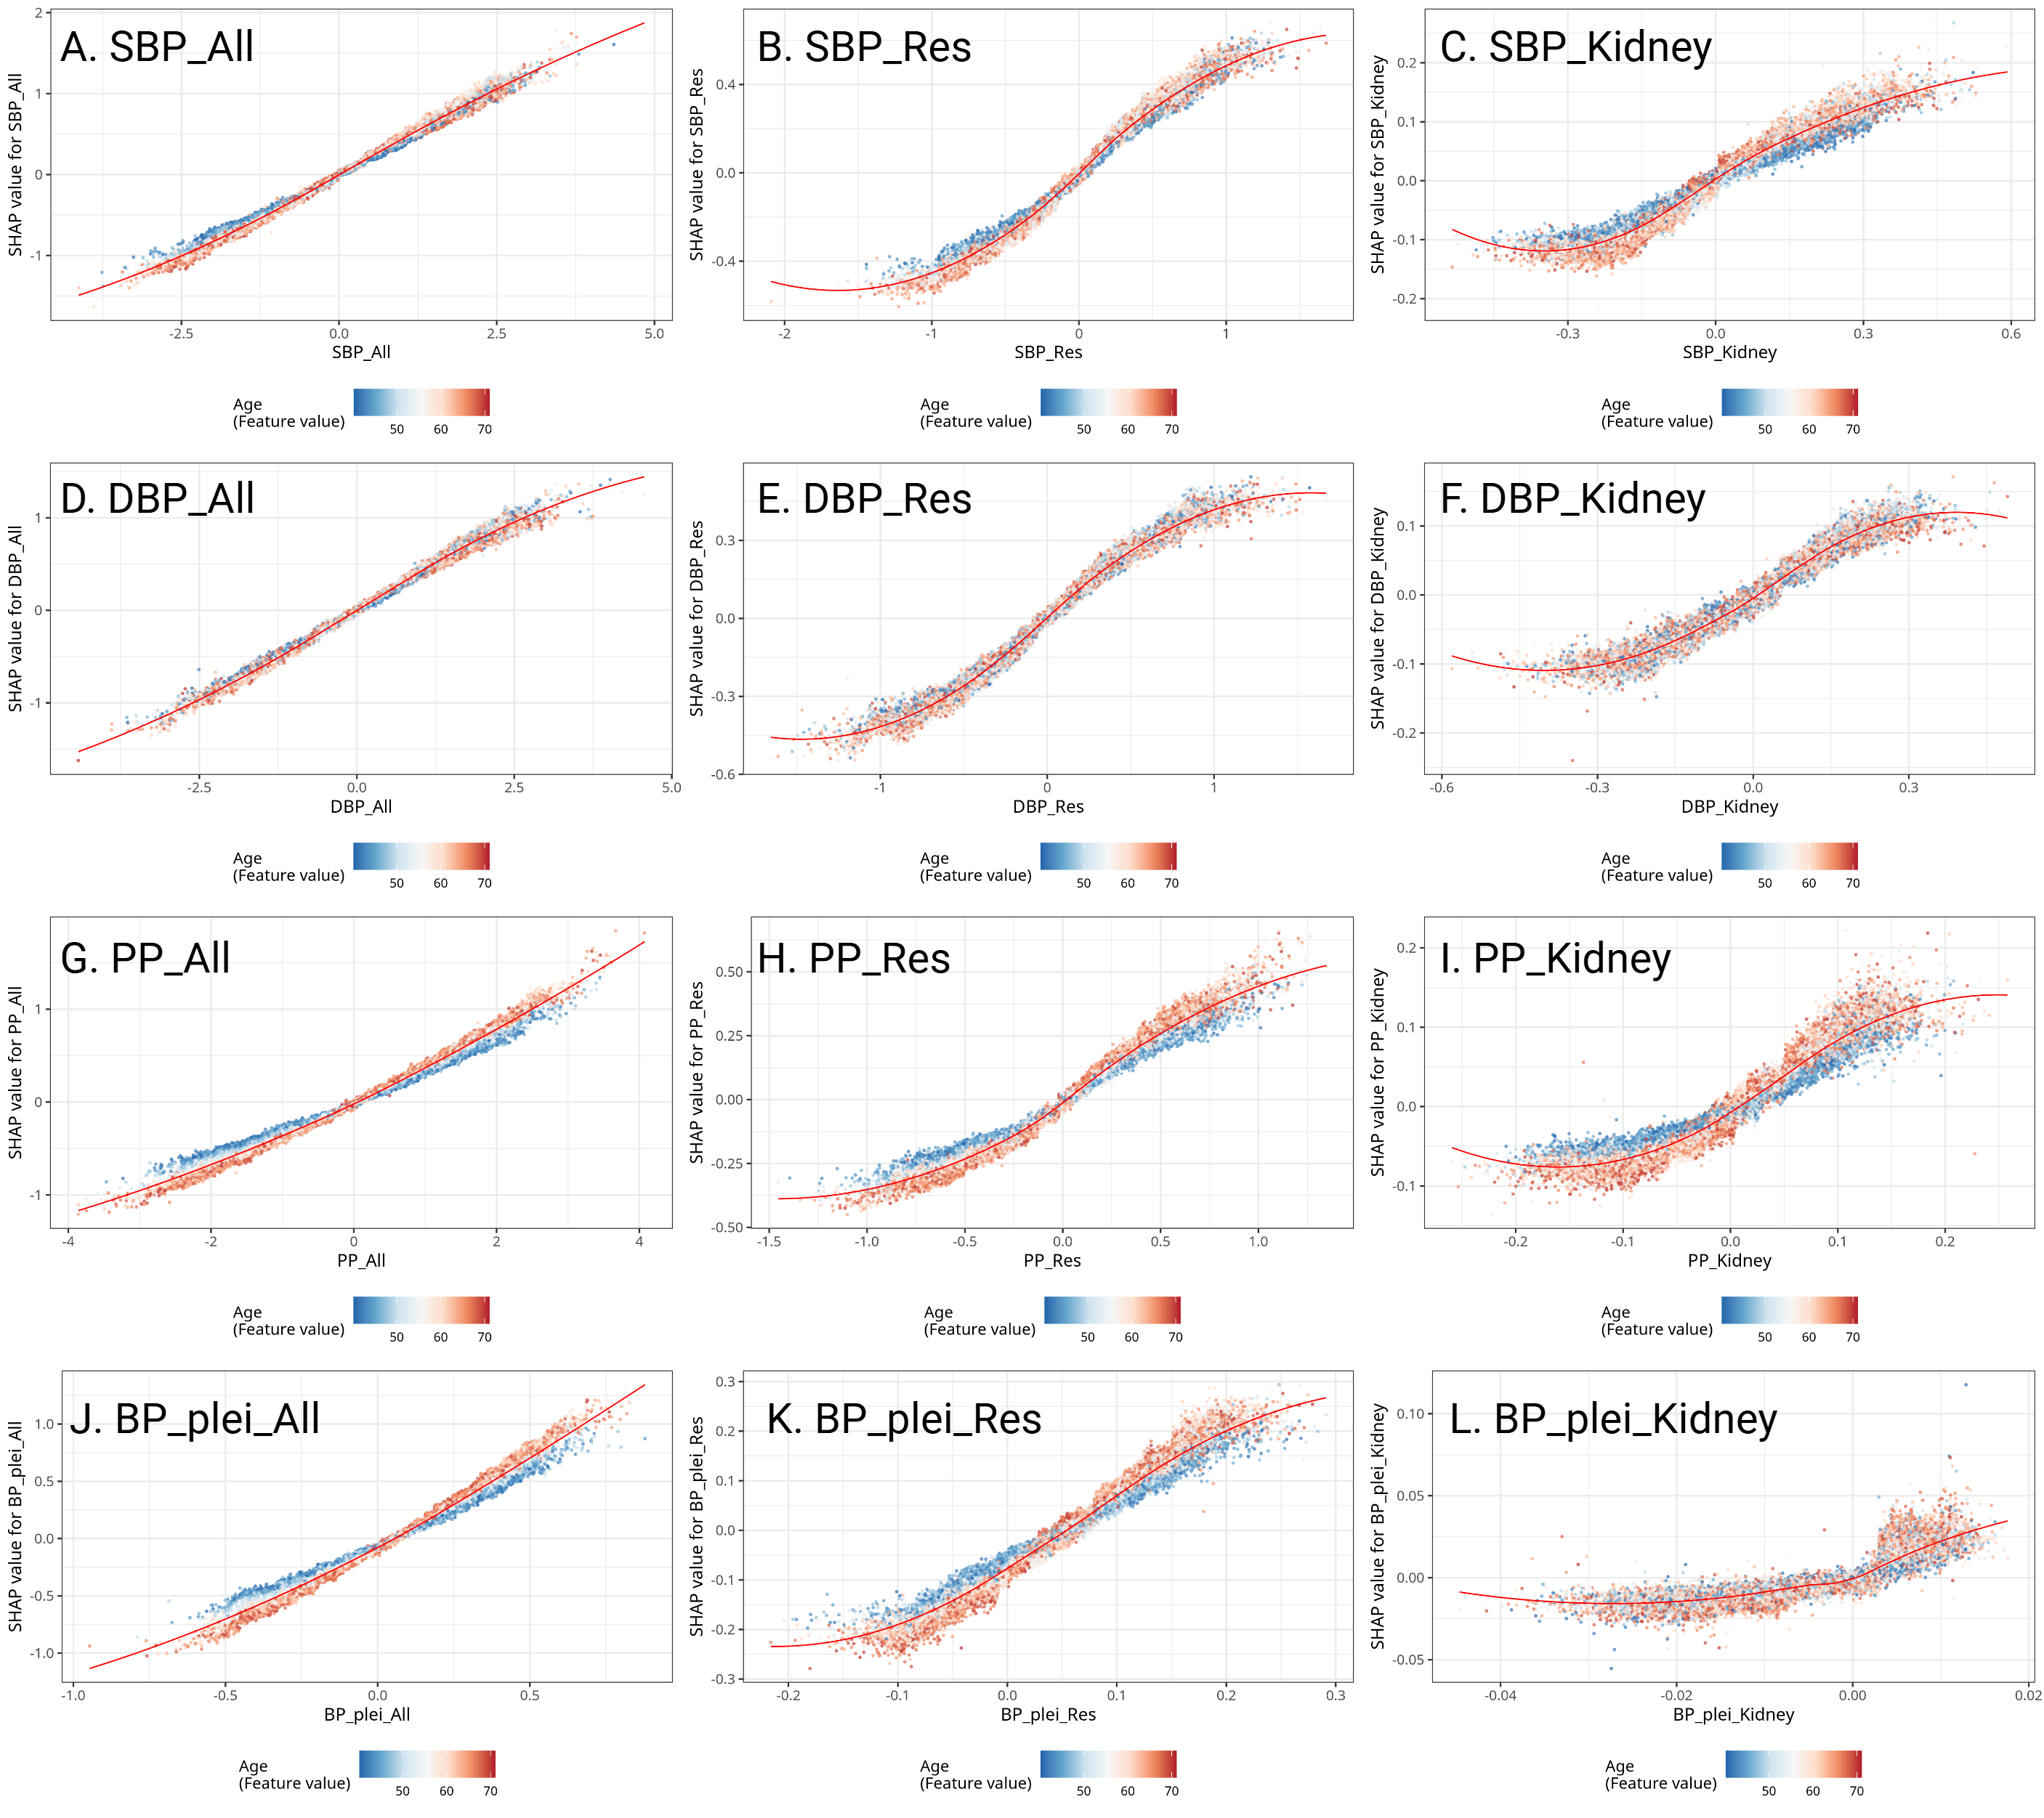

Supplementary Figure 7. Scatterplots of SHAP versus PRS values for three representative CRE-specific PRSs: PRS_All, PRS_Res, and PRS_Kidney, across the four blood pressure traits (SBP, DBP, PP, and BP_plei). Each panel shows the non-linear relationship between a given PRS (x-axis) and its corresponding SHAP value (y-axis), with points colored by the participant’s age. Warmer colors indicate older ages. These three PRS were selected as representative examples to illustrate the presence of PRS-age interactions, demonstrating how age modifies the marginal contribution of each PRS to model predictions. Smoothing curves are overlaid to highlight the non-linear patterns.

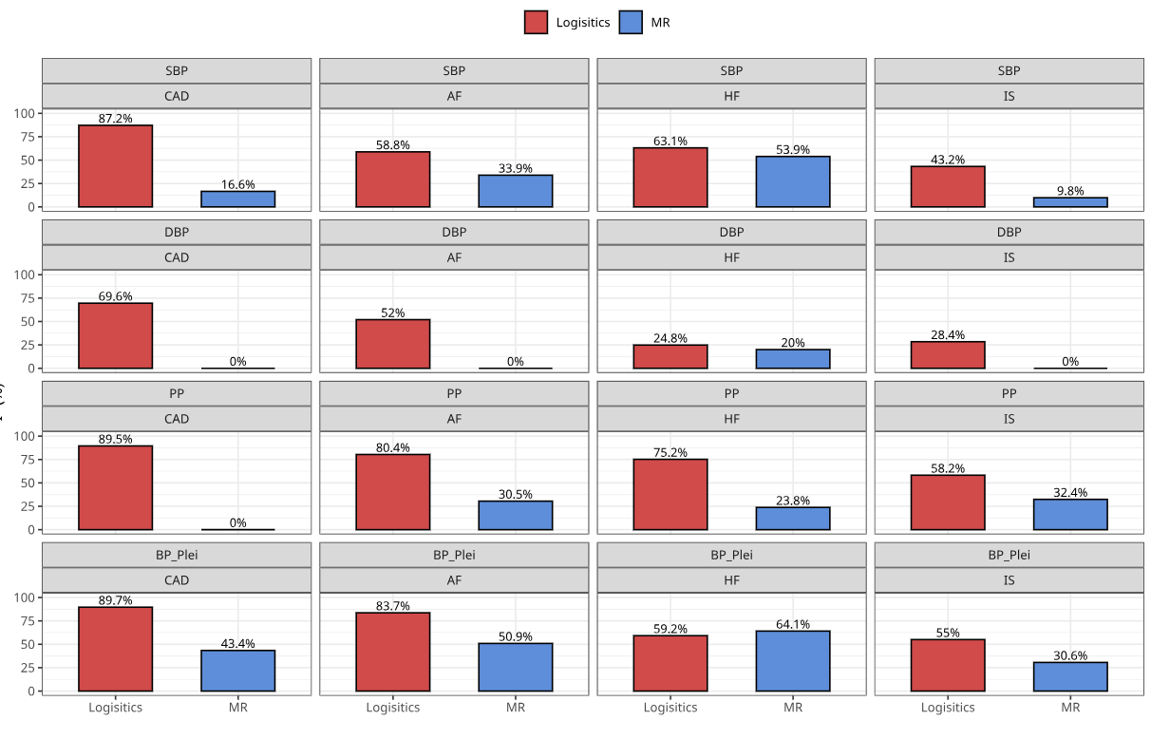
Supplementary Figure 8. Heterogeneity (I² statistics) of blood-pressure CRE effects estimated by logistic regression versus MR across four cardiovascular outcomes. Each panel shows the I² statistic (%) quantifying between-CRE effect heterogeneity for a set of 16 cis-regulatory elements (CREs), comparing two estimation approaches: logistic regression on the real phenotype (red) and Mendelian randomization on GWAS summary data (blue). Rows correspond to four blood-pressure exposures (SBP, DBP, PP, and BP_Plei), and columns to four outcomes (CAD, AF, HF, and IS). Higher I² indicates greater heterogeneity in the estimated coefficients across the 16 CREs.

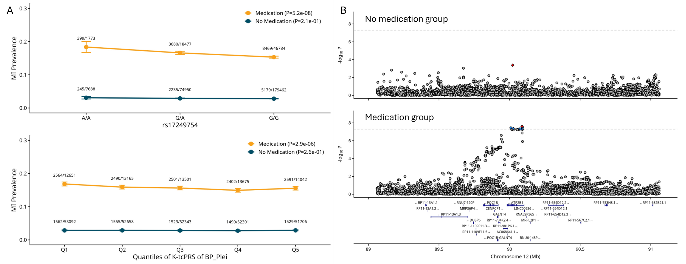
Supplementary Figure 9. A. Interaction analyses between K-tcPRS of BP_Plei and antihypertensive medication on myocardial infarction (MI), as well as between the intron variant rs17249754 in ATP2B1 and antihypertensive medication. Upper panel shows MI prevalence across genotypes of rs17249754 stratified by antihypertensive medication status. Lower panel displays MI prevalence across quintiles of K-tcPRS of BP_Plei by antihypertensive medication groups. Sample sizes are indicated above each data point as cases/controls. Significant interactions were observed in both analyses. B. Locus zoom plots of MI association at the ATP2B1 locus stratified by antihypertensive medication status. Upper panel shows the association in the no medication group, while lower panel displays associationts from the medication group. The x-axis represents the genomic position on chromosome 12 (Mb), and the y-axis shows -log10 P-values. Horizontal dashed lines indicate genome-wide significance thresholds. Significant association signals were predominantly observed in the medication group, with lead variants highlighted in blue and red. Gene annotations are shown at the bottom of each panel, with ATP2B1 as the key candidate gene at this locus.
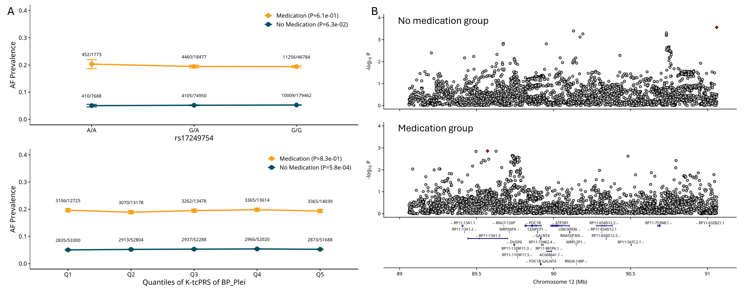
Supplementary Figure 10. A. Interaction analyses between K-tcPRS of BP_Plei and antihypertensive medication on atrial fibrillation (AF), as well as between the intron variant rs17249754 in ATP2B1 and antihypertensive medication. Upper panel shows AF prevalence across genotypes of rs17249754 stratified by antihypertensive medication status. Lower panel displays AF prevalence across quintiles of K-tcPRS of BP_Plei by antihypertensive medication groups. Sample sizes are indicated above each data point as cases/controls. Significant interactions were observed in both analyses. B. Locus zoom plots of AF association at the ATP2B1 locus stratified by antihypertensive medication status. Upper panel shows the association in the no medication group, while lower panel displays results from the medication group. The x-axis represents the genomic position on chromosome 12 (Mb), and the y-axis shows -log10 P-values. Horizontal dashed lines indicate genome-wide significance thresholds. Association evidence is similar between groups with and without medications.

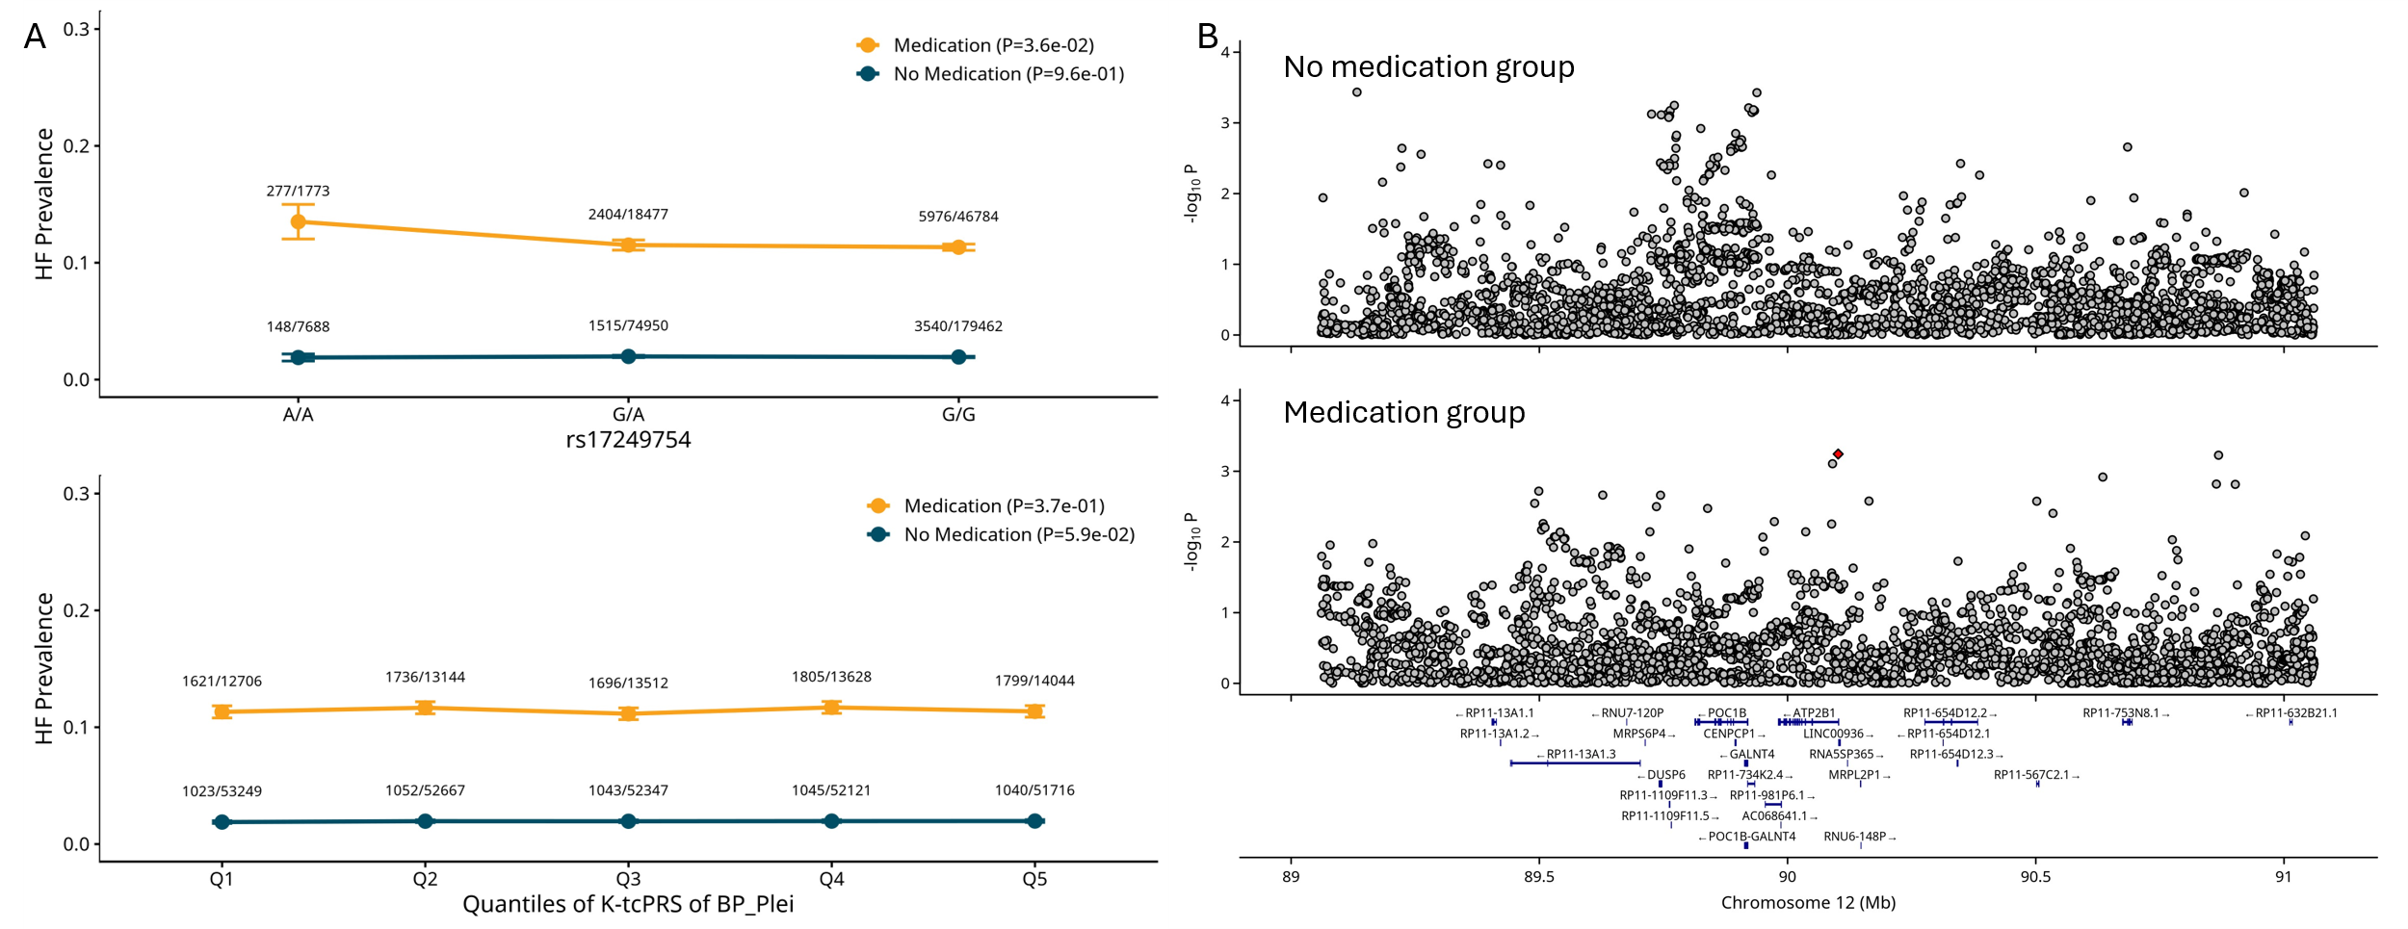
Supplementary Figure 11. A. Interaction analyses between K-tcPRS of BP_Plei and antihypertensive medication on heart failure (HF), as well as between the intron variant rs17249754 in ATP2B1 and antihypertensive medication. Upper panel shows HF prevalence across genotypes of rs17249754 stratified by medication status. Lower panel displays HF prevalence across quintiles of K-tcPRS of BP_Plei by medication groups. Sample sizes are indicated above each data point as cases/controls. Significant interactions were observed in both analyses. B. Locus zoom plots of HF association at the ATP2B1 locus stratified by antihypertensive medication status. Upper panel shows the association in the no medication group, while lower panel displays results from the medication group. The x-axis represents the genomic position on chromosome 12 (Mb), and the y-axis shows -log10 P-values. Horizontal dashed lines indicate genome-wide significance thresholds. Association evidence is similar between groups with and without medications.

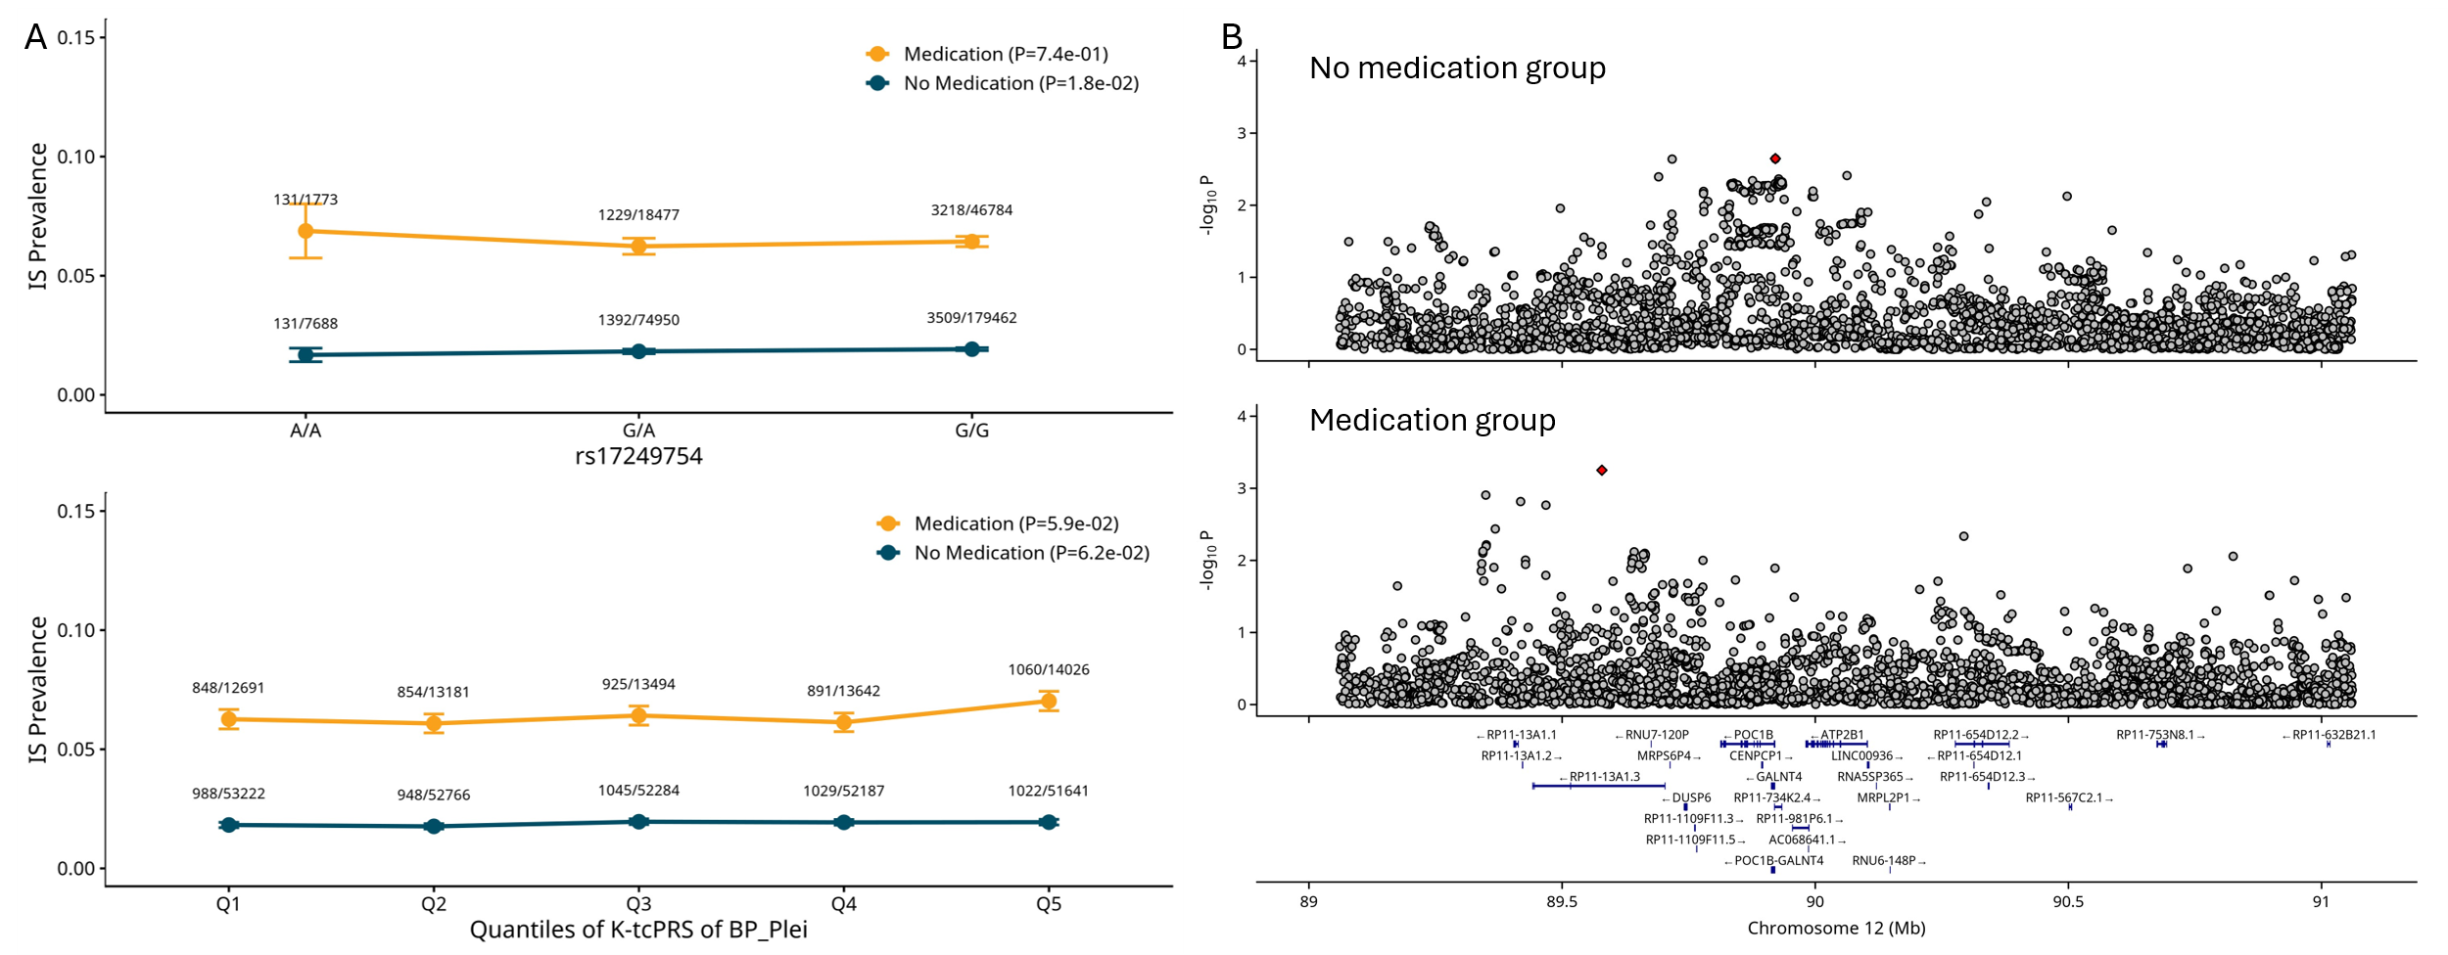
Supplementary Figure 12. A. Interaction analyses between K-tcPRS of BP_Plei and antihypertensive medication on ischemic stroke (IS), as well as between the intron variant rs17249754 in ATP2B1 and antihypertensive medication. Upper panel shows IS prevalence across genotypes of rs17249754 stratified by medication status. Lower panel displays IS prevalence across quintiles of K-tcPRS of BP_Plei by medication groups. Sample sizes are indicated above each data point as cases/controls. Significant interactions were observed in both analyses. B. Locus zoom plots of IS association at the ATP2B1 locus stratified by antihypertensive medication status. Upper panel shows the association in the no medication group, while lower panel displays results from the medication group. The x-axis represents the genomic position on chromosome 12 (Mb), and the y-axis shows -log10 P-values. Horizontal dashed lines indicate genome-wide significance thresholds. Association evidence is similar between groups with and without medications.

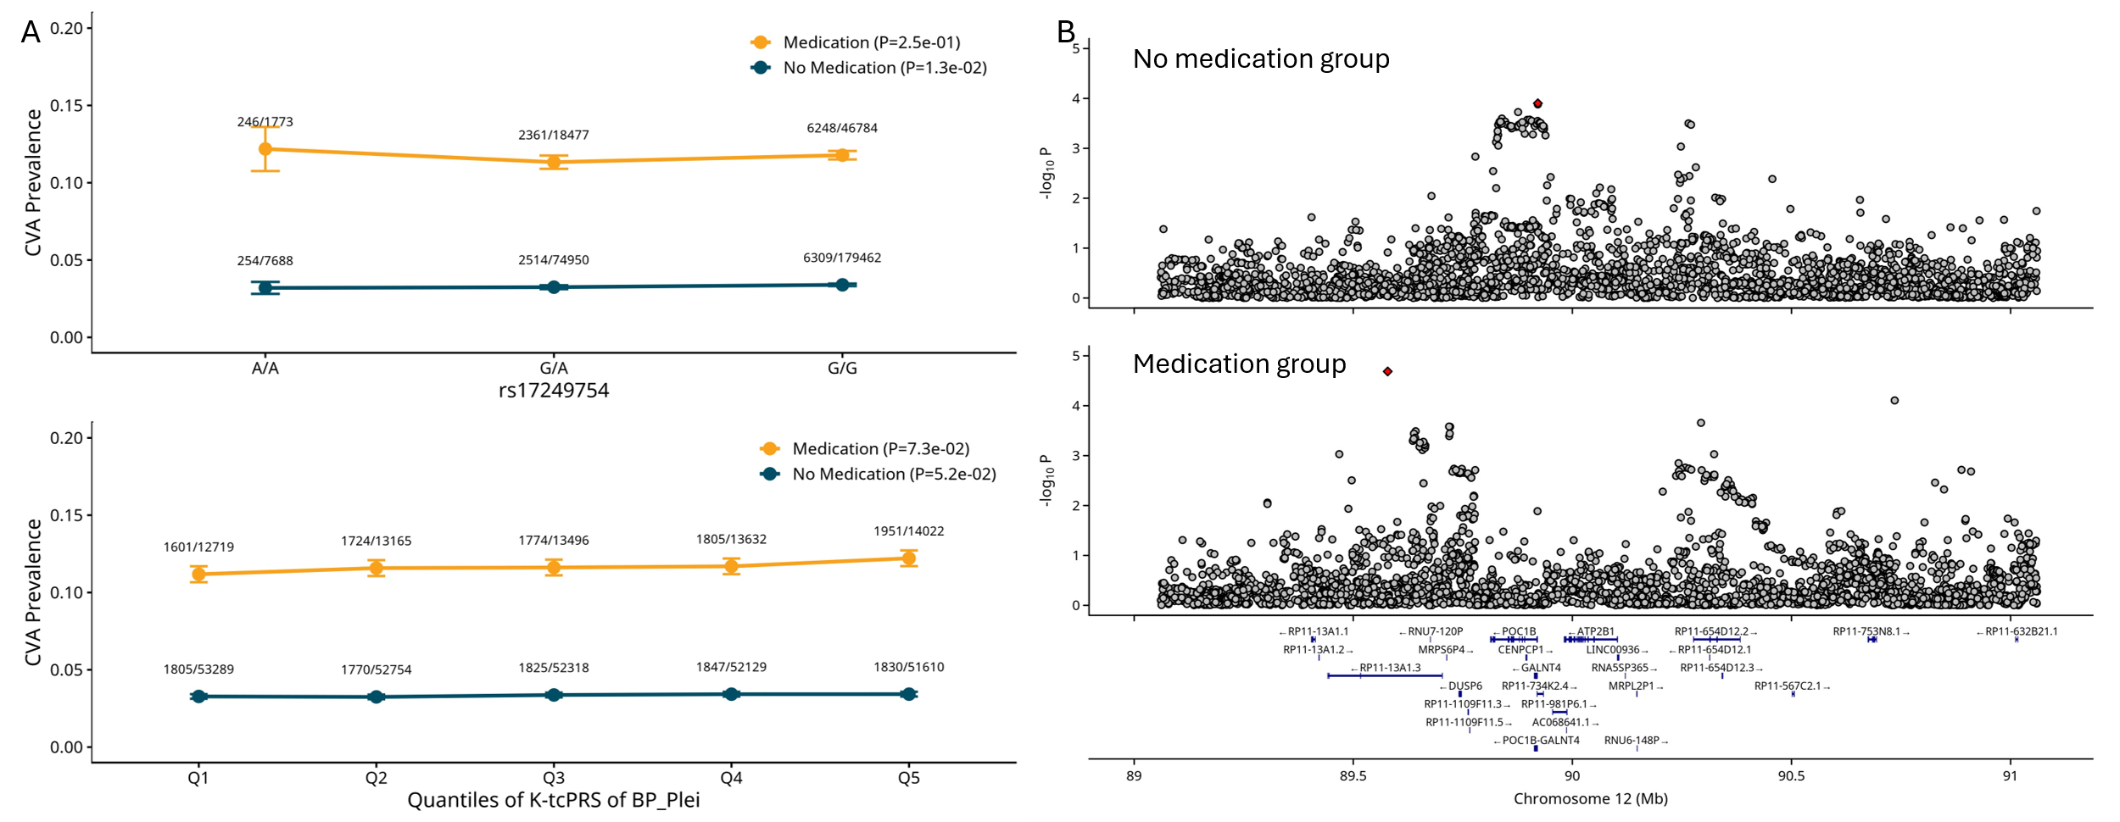
Supplementary Figure 13. A. Interaction analyses between K-tcPRS of BP_Plei and antihypertensive medication on cerebrovascular accident (CVA), as well as between the intron variant rs17249754 in ATP2B1 and antihypertensive medication. Upper panel shows CVA prevalence across genotypes of rs17249754 stratified by medication status. Lower panel displays CVA prevalence across quintiles of K-tcPRS of BP_Plei by medication groups. Sample sizes are indicated above each data point as cases/controls. Significant interactions were observed in both analyses. B. Locus zoom plots of CVA association at the ATP2B1 locus stratified by antihypertensive medication status. Upper panel shows the association in the no medication group, while lower panel displays results from the medication group. The x-axis represents the genomic position on chromosome 12 (Mb), and the y-axis shows -log10 P-values. Horizontal dashed lines indicate genome-wide significance thresholds. Association evidence is similar between groups with and without medications.

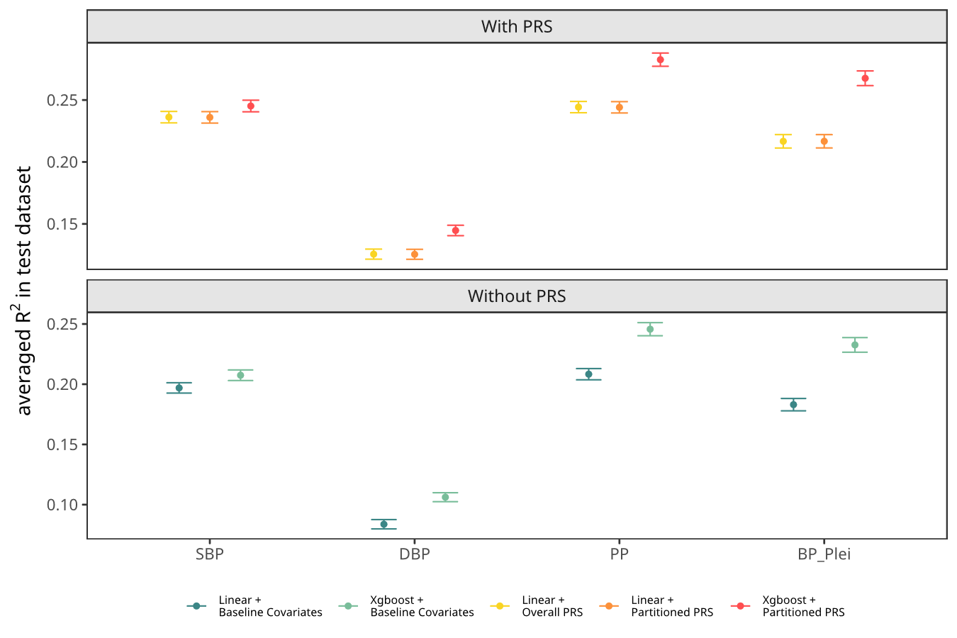
Supplementary Figure 14. Prediction of overall PRS vs 15 tcPRSs and resPRS for the four BP traits in AoU. Top panel: R² of prediction models when including the overall PRS vs including 15 tcPRS and resPRS. Bottom panel: no PRS was included. Points show the average R² across 100 bootstrap samples; error bars denote ±2 standard deviations from 100 simulations. R² was improved by including 15 tcPRSs and resPRS over a single overall PRS, and was further improved by adding nonlinear effects of the tcPRSs and resPRS using XGBoost.
Genetic ancestry was defined using the ancestry predictions distributed by the AoU Data and Research Center, which are based on a random forest classifier trained on the HGDP + 1000 Genomes reference panel using the top 16 principal components as features. AoU samples are projected into the reference principal component space, and each participant receives a predicted label and class probabilities across six categories: AFR, AMR, EAS, EUR, MID, and SAS. From the 414,830 short-read WGS participants, we retained those with a class probability exceeding 0.95, yielding EUR (188,517), AFR (68,955), and AMR (60,572), for a total of 318,044. We only evaluated the prediction in AFR, AMR and EUR because of sample sizes.
References: Genomic data in the All of Us Research Program. Nature 627, 340–346 (2024). https://doi.org/10.1038/s41586-023-06957-x; All of Us Genomic Quality Report, https://support.researchallofus.org/hc/en-us/articles/29390274413716-All-of-Us-Genomic-Quality-Report

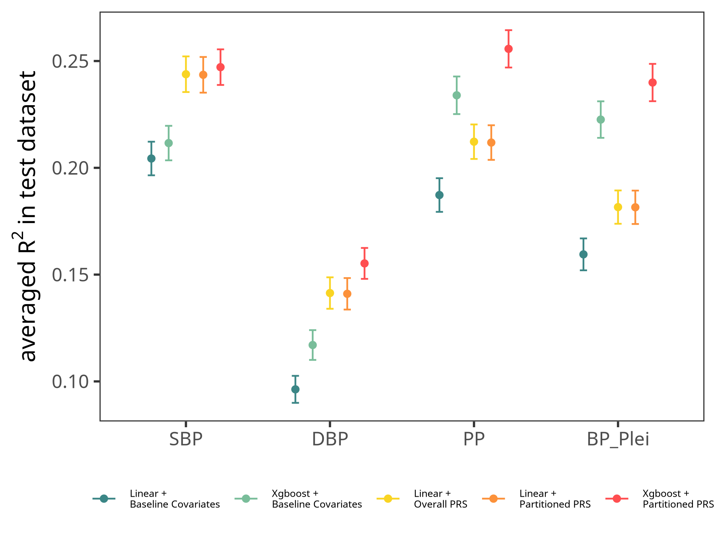
Supplementary Figure 15. We imputed the European-derived overall PRS, 15 tcPRSs and resPRS into AFR in AoU and evaluated their prediction. R² for different prediction models were presented for SBP, DBP, PP and BP_plei in AFR. Points show the average R² across 100 bootstrap samples; error bars denote ±2 standard deviations from 100 simulations. R² was significantly improved by including 15 tcPRSs, resPRS and interactions using XGBoost.

Supplementary Figure 16. We imputed the European-derived overall PRS, 15 tcPRSs and resPRS into AMR in AoU and evaluated their prediction. R² for different prediction models were presented for SBP, DBP, PP and BP_plei in African Americans. Points show the average R² across 100 bootstrap samples; error bars denote ±2 standard deviations from 100 simulations. R² was significantly improved by including 15 tcPRSs, resPRS and interactions using XGBoost.

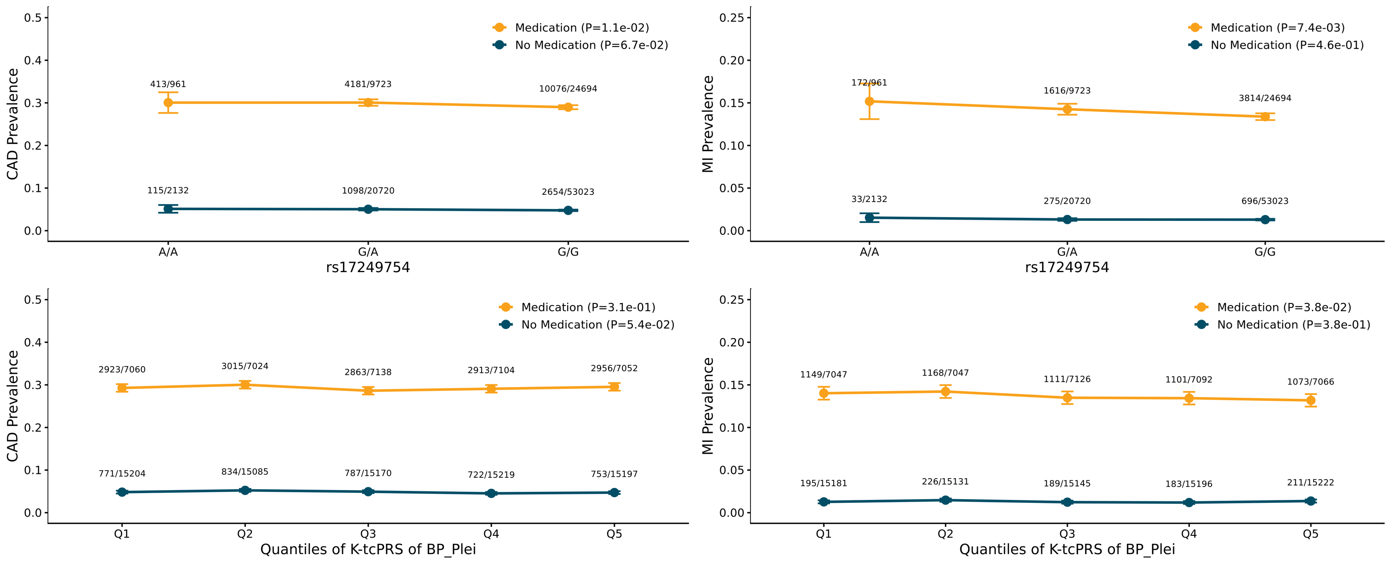

Supplementary Figure 17. Stratified analyses between K-tcPRS and antihypertensive medication on CAD and MI, as well as between the intron variant rs17249754 in ATP2B1 and antihypertensive medication in AoU. Analysis was conducted by stratified into medication and no medication group. The two numbers at each data point represent the cases/controls. All p-values were calculated in logistic regression adjusting for covariates.

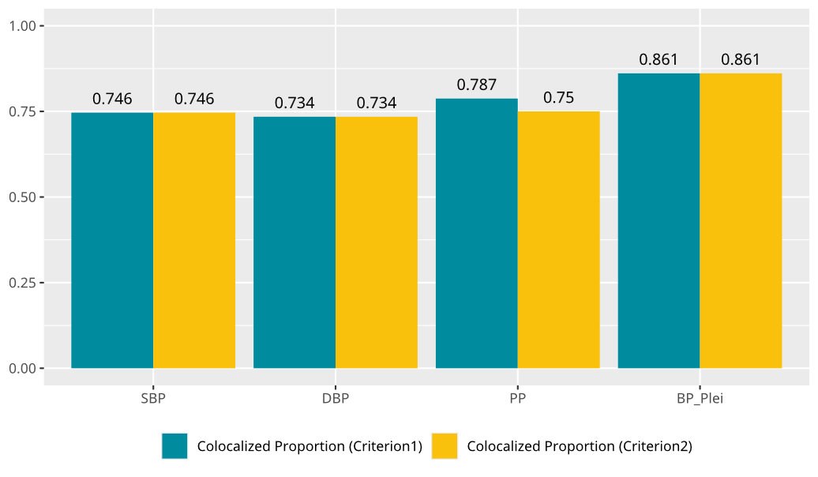
Supplementary Figure 18. Proportion of causal gene–tissue pairs identified by TGVIS and supported by coloc-susie. This figure shows, under two evaluation criteria, the proportion of SBP, DBP, PP, and BP_plei gene–tissue pairs identified by TGVIS that also exhibit colocalized evidence in the coloc-susie analysis. Since a credible set could include multiple tissue-gene pairs, we defined a colocalization of a credible set in two criteria: (1) the credible set contained at least one gene-tissue pair that is colocalized with the trait; (2) more than 50% of the gene-tissue pairs in the credible set were colocalized with the trait

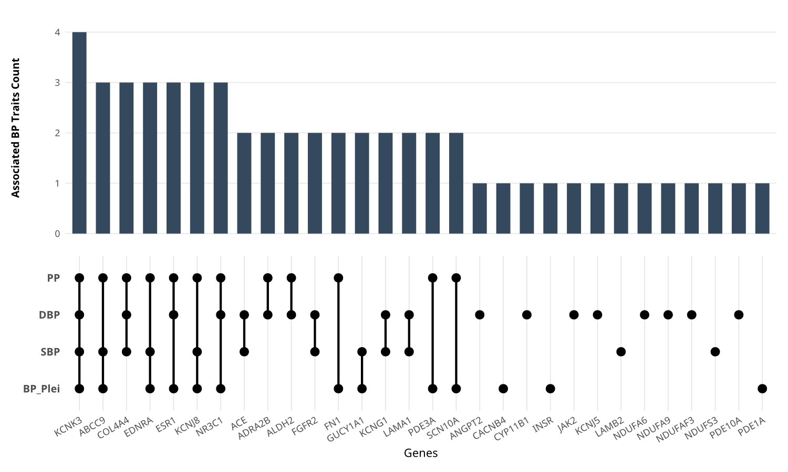
Supplementary Figure 19. Distribution of TGVIS-identified drug-target genes across blood pressure traits. This figure displays the genes identified by TGVIS across four blood pressure traits (SBP, DBP, PP, and BP_Plei) that overlap with the drug-target gene list from Trajanoska et al. (2023). The upper bar graph quantifies the total number of causally associated traits for each gene. The lower matrix panel details the specific trait combinations, with solid circles and connecting lines indicating the exact traits in which each causal association was identified

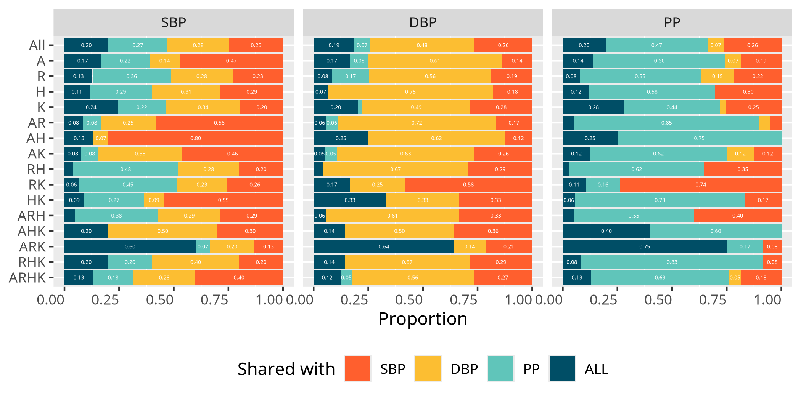
Supplementary Figure 20. Shared patterns of causal gene–tissue xQTLs across CRE groups for SBP, DBP, and PP. Here we summarize, for each trait, how TGVIS-identified causal gene–tissue pairs are distributed across the 15 tissue-specific CRE groups, and the extent to which their corresponding causal xQTLs are shared across traits. For each trait panel, the stacked bars represent the proportion of that trait’s causal xQTLs within each CRE group that are also identified for one or both of the other traits, with numeric values shown inside the bars. For example, in the SBP panel, each bar shows the proportions of SBP causal xQTLs in a given CRE group that are shared with DBP, with PP, with both DBP and PP, or unique to SBP.

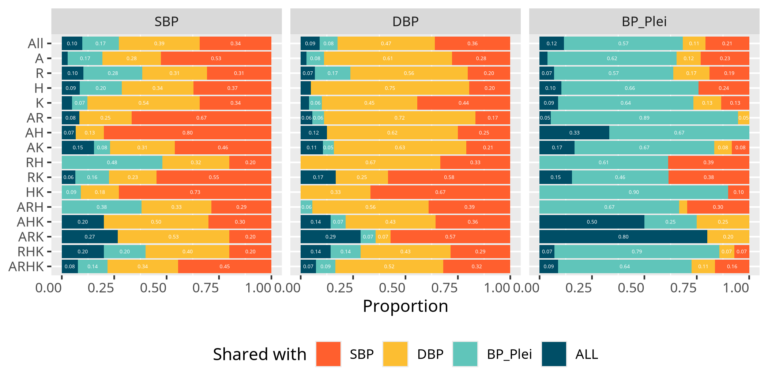
Supplementary Figure 21. Shared patterns of causal gene–tissue xQTLs across CRE groups for SBP, DBP, and BP_plei. Here we summarize, for each trait, how TGVIS-identified causal gene–tissue pairs distributed across the 15 tissue-specific CRE groups, and the extent to which their corresponding causal xQTLs are shared across traits. For each trait panel, the stacked bars represent the proportion of that trait’s causal xQTLs within each CRE group that are also identified for one or both of the other traits, with numeric values shown inside the bars for clarity.

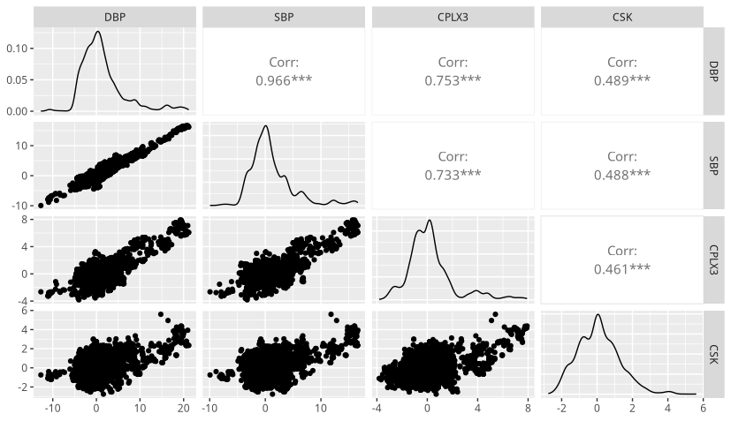
Supplementary Figure 22. Pairwise scatterplots of GWAS and eQTL Z-scores at the CPLX3 locus in lower-left panels. Here we show scatterplots of Z-scores for SBP, DBP, and the CPLX3 splicing event in atrial appendage tissue, and CSK expression in subcutaneous adipose tissue within the CPLX3 locus. Diagonal panels report the effect size distributions of DBP, SBP, CPLX3 splicing event in atrial appendage tissue, and CSK expression in subcutaneous adipose tissue from GTEx. Upper-right panels report Pearson correlations computed directly from the Z-scores without accounting for linkage disequilibrium, with significance obtained under the assumption of independent estimates. These correlations are intended only as a visual indication of Z-score similarity.
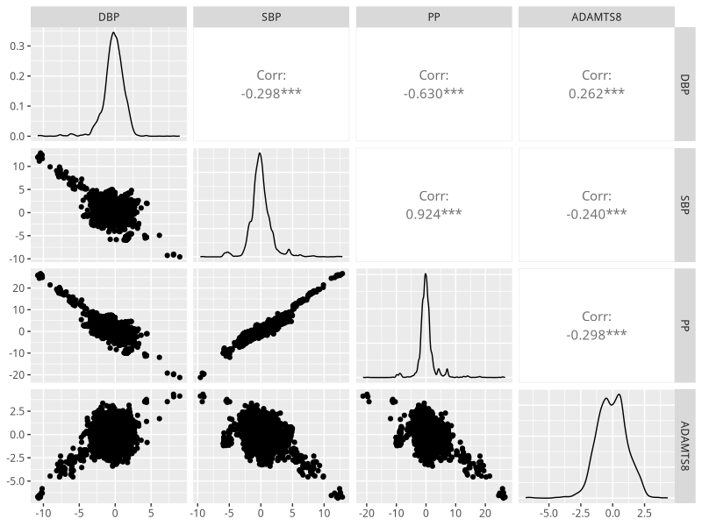
Supplementary Figure 23. Pairwise scatterplots of GWAS and eQTL Z-scores at the ADAMTS8 locus (lower-left panels). Here we show scatterplots of Z-scores for SBP, DBP, PP, and ADAMTS8 gene expression in aortic tissue within the ADAMTS8 locus. Diagonal panels report the effect size distributions of DBP, SBP, PP and ADAMTS8 gene expression in aortic tissue from GTEx. Upper-right panels report simple Pearson correlations computed directly from the Z-scores without accounting for linkage disequilibrium, with significance obtained under the assumption of independent estimates. These correlations are intended only as a visual indication of Z-score similarity.

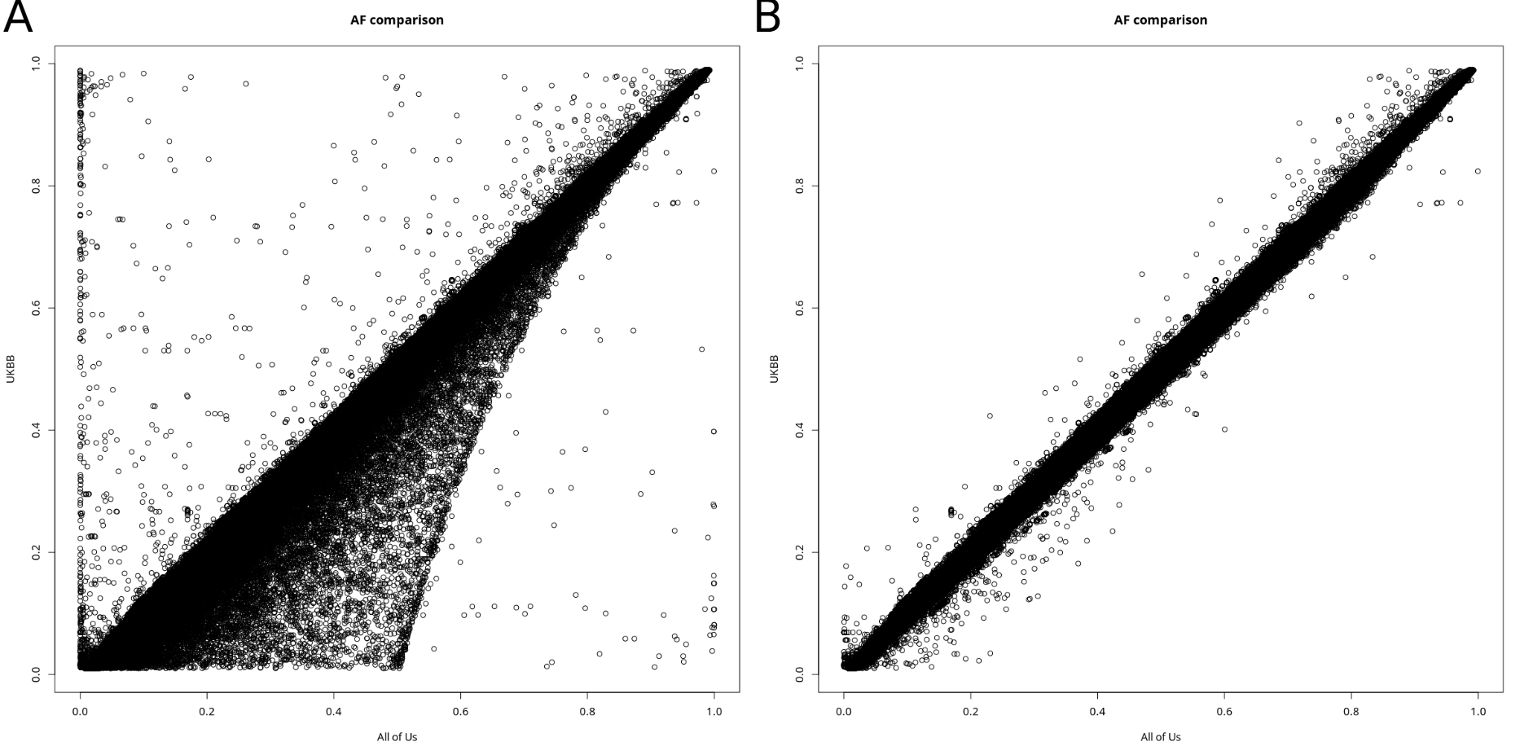
Supplementary Figure 24. Comparison of allele frequencies between the AoU and UKB data. A. Scatterplot of allele frequencies for all variants shared between the AoU and UKB datasets. B. The same scatterplot after removing low-quality variants.

