Supporting Information
S1 Table. Spearman rank correlation coefficients between residue concentrations and resistance proportions (n=70 paired samples).
Residue | AMC resistance | CEF resistance | CIP resistance | TMP-SMX resistance
Chlortetracycline | ρ=0.200 (p=0.097) | ρ=−0.086 (p=0.478) | ρ=−0.032 (p=0.793) | ρ=0.029 (p=0.813)
Tetracycline | ρ=0.176 (p=0.146) | ρ=−0.044 (p=0.717) | ρ=−0.085 (p=0.483) | ρ=0.111 (p=0.361)
Doxycycline | ρ=−0.140 (p=0.247) | ρ=0.022 (p=0.858) | ρ=0.022 (p=0.858) | ρ=0.042 (p=0.729)
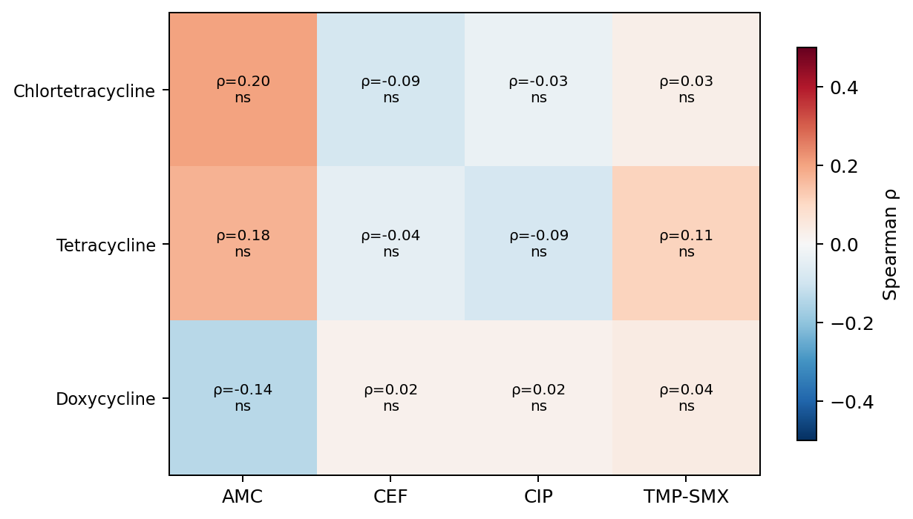
S1 Fig. Spearman correlation matrix (n=70 paired samples). All correlations were non-significant after Benjamini-Hochberg FDR correction. Colour intensity and direction of ellipses indicate the strength and sign of each Spearman rho coefficient. Full results are reported in S1 Table..
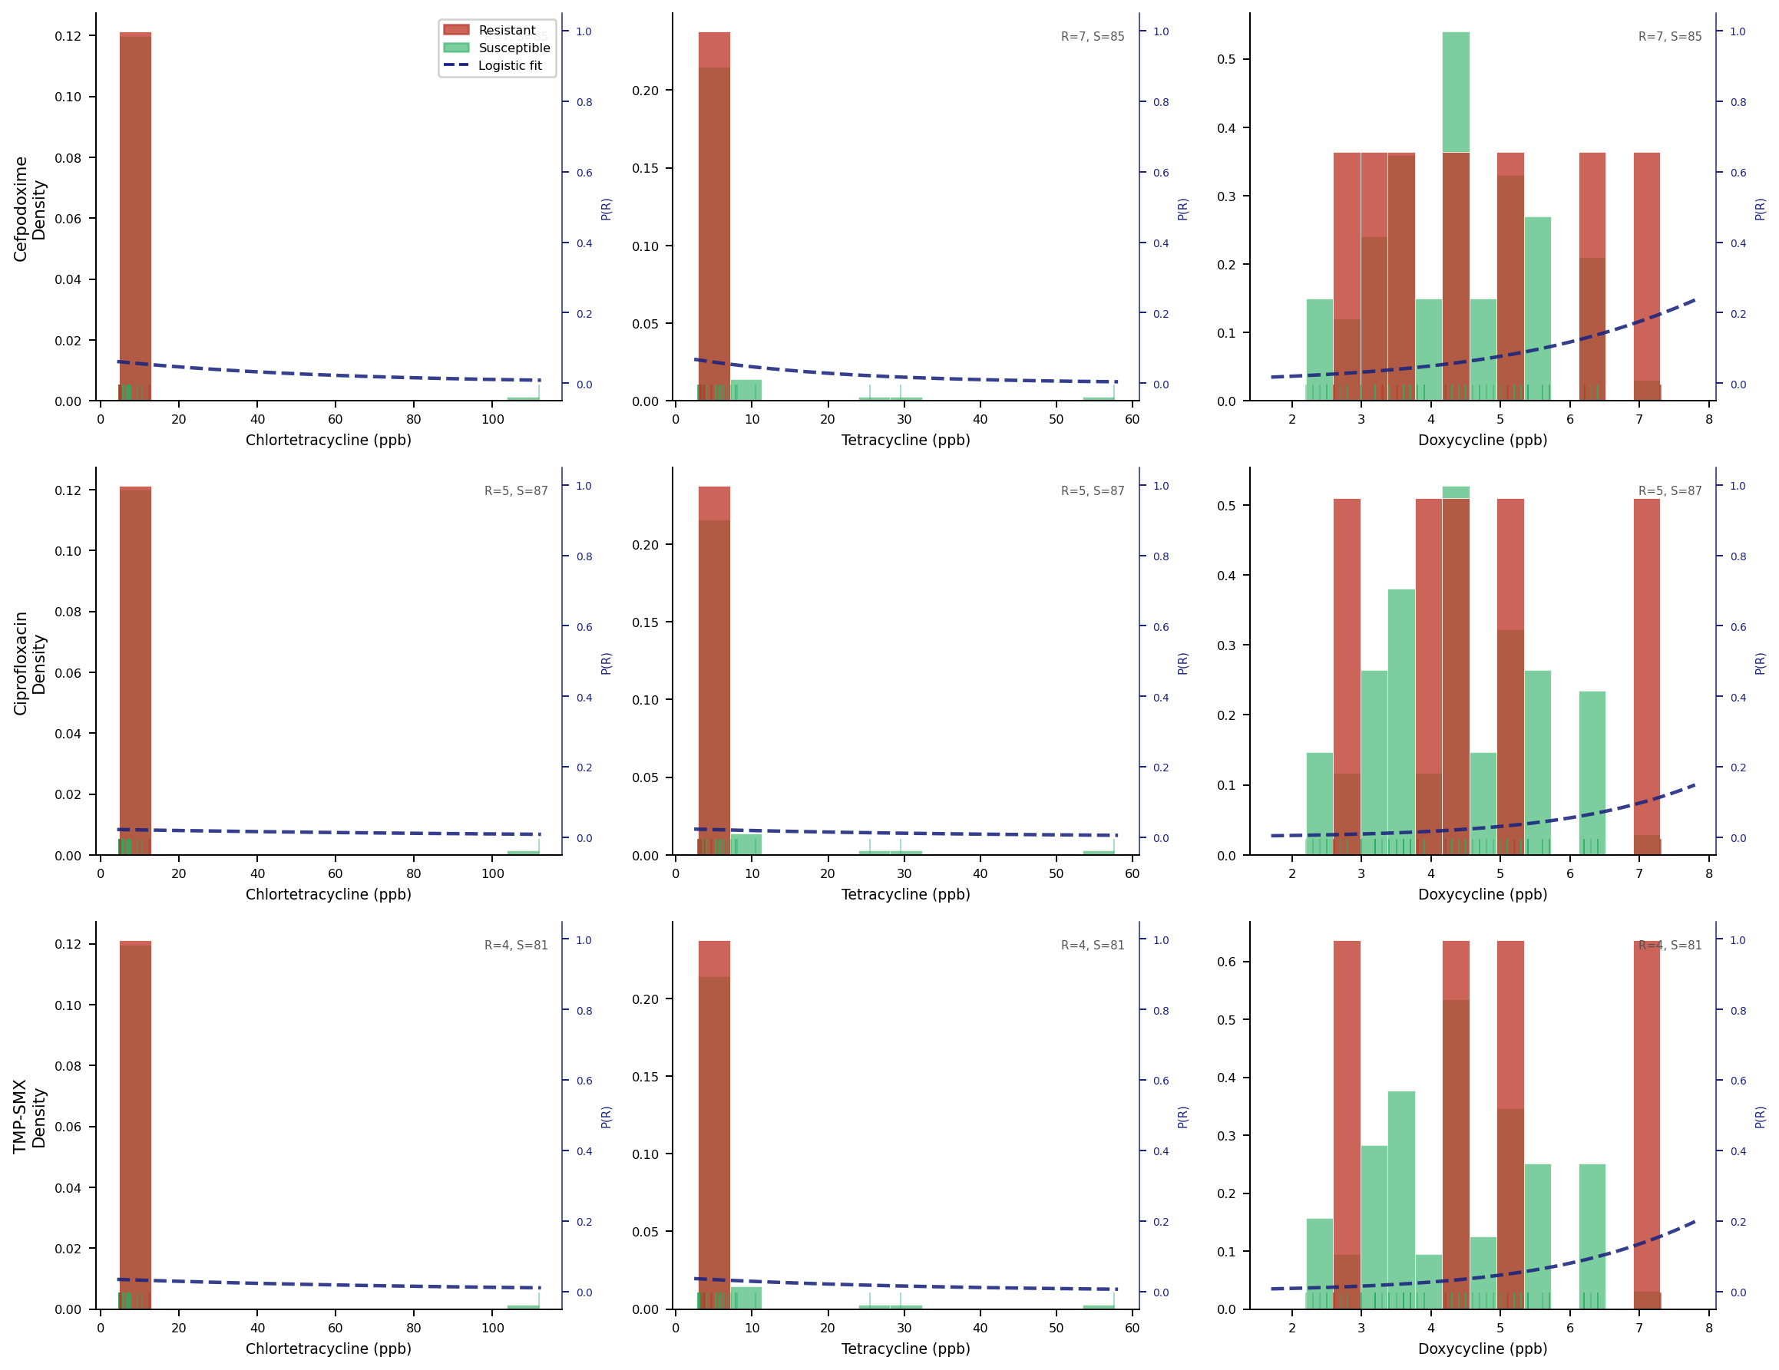
S2 Fig. Conditional density plots of residue concentrations by resistance phenotype (red=Resistant; green=Susceptible). Dashed lines show fitted logistic probability of resistance (right axis). n values within each panel.
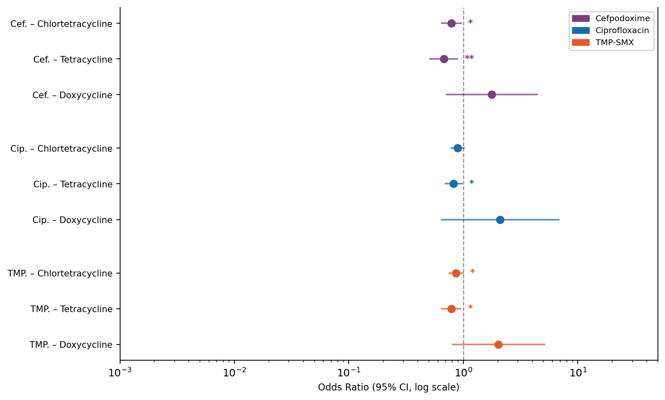
S3 Fig. Binary logistic regression forest plot: odds ratios (95% CI, log scale) per 1 SD increase in standardised residue concentration. All models non-significant (LRT p>0.38).

